Exp.no: 2.a
AIM: Write a HTML program, to explain the working of tables. (use tags: <table>, <tr>, <th>, <td> and attributes: border, rowspan, colspan)
DESCRIPTION:
In HTML, tables are used to arrange data systematically in rows and columns. They are particularly useful for displaying structured information such as timetables, student marks, product lists, or directories.
1. Basic Structure of a Table
- <table>: This is the container tag for creating a table.
- <tr> (Table Row): Each row of the table is defined using <tr>.
- <th> (Table Header): Used inside a row to define a header cell. The content inside <th> is usually bold and center-aligned by default
- <td> (Table Data): Represents a normal data cell inside the row
2. Border Attribute
- The border attribute is used inside the <table> tag to make the grid lines of the table visible.
- Example: <table border="1"> creates a table with borders.
This helps in visually separating rows and columns for clarity.
3. Rowspan Attribute
- The rowspan attribute allows a single cell to extend vertically across multiple rows.
- It is applied to <td> or <th>.
- Example: <td rowspan="2"> merges the cell across 2 rows.
This is useful when one value applies to multiple rows (e.g., a department name spanning multiple employees).
4. Colspan Attribute
- The colspan attribute allows a cell to extend horizontally across multiple columns.
- It is applied to <td> or <th>.
- Example: <td colspan="3"> merges the cell across 3 columns.
This is often used in headings where one title should cover multiple columns.

PROGRAM:
<! DOCTYPE html>
<html>
<body>
<center>
<table border="1" bordercolor="blue" cellspacing="2" cellpadding="5" width="200" height="200">
<caption>24B11CS039</caption>
<tr>
<th>SNO</th>
<th>First Name</th>
<th>second name</th>
</tr>
<tr>
<td>1</td>
<td>Deevena</td>
<td>Baswani</td>
</tr>
<tr>
<td>2</td>
<td>Nani</td>
<td>Penumuchu</td>
</tr>
</table>
</center>
</body>
</html>

OUTPUT:
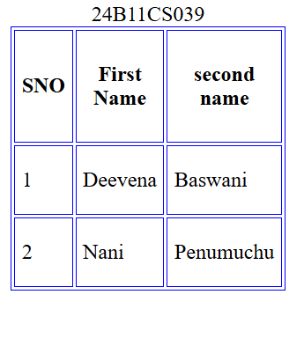
ROWSPAN:
<!DOCTYPE html>
<html lang="en">
<head>
<title>TABLE SPANS</title>
</head>
<body >
<center>
<h2>24B11CS039<h2>
<table border="5" bordercolor="black" bgcolor="purple" align="center" width="25%" height="25%">
<tr>
<th rowspan="2"> Name </th>
<td > Deevena</td>
</tr>
<tr>
<td > Eevs </td>
</tr>
<tr>
<th rowspan="2"> Number </th>
<td > 67669778</td>
</tr>
<tr>
<td > 93905449595 </td>
</tr>
</table>
</center>
</body>
</html>
OUTPUT:

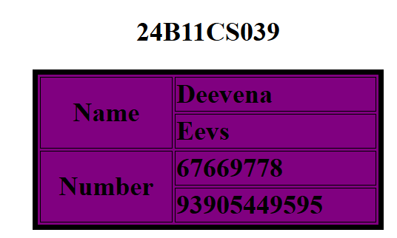

COLSPAN:
<!DOCTYPE html>
<html lang="en">
<head>
<title>TABLE SPANS</title>

</head>
<body >
<center>
<h2>24B11CS039<h2>
<table border="5" bordercolor="black" bgcolor="pink" align="center" width="25%" height="25%">
<tr>
<th colspan="2"> Phone number </th>
<th colspan="2"> Email id </th>
</tr>
<tr>
<th > Phone number1 </th>
<th > Phone number2 </th>
<th > Email Id1 </th>
<th > Email Id2 </th>
</tr>
<tr>
<td > 9390544959</td>
<td > 8976728884 </td>
<td > theebasws@gmail.com </td>
<td > keerbaswani@gmail.com </td>
</tr>
<tr>
<td > 156656789</td>
<td > 972939877 </td>
<td > eevshiah@gmail.com </td>
<td > sjndiudln@gmail.com </td>
</tr>

</table>
</center>
</body>
</html>
OUTPUT:

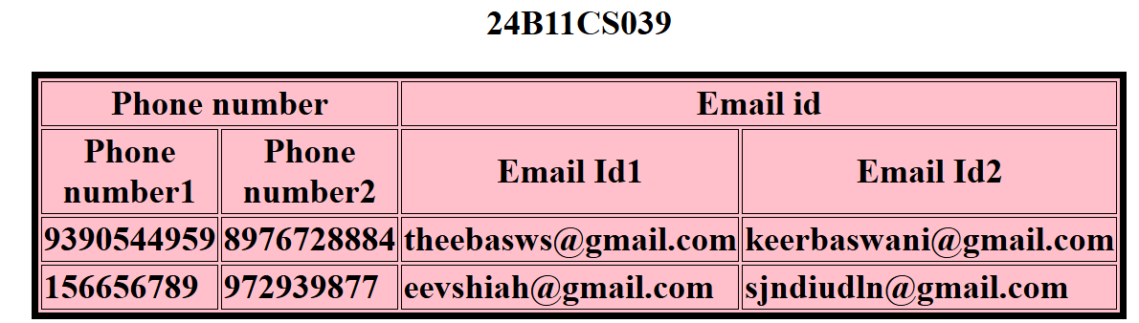

RESULT:

Exp.no: 2.b
AIM: Write a HTML program, to explain the working of tables by preparing a timetable.
DESCRIPTION:
In HTML, tables are used to arrange data systematically in rows and columns. They are particularly useful for displaying structured information such as timetables, student marks, product lists, or directories.
1. Basic Structure of a Table
- <table>: This is the container tag for creating a table.
- <tr> (Table Row): Each row of the table is defined using <tr>.
- <th> (Table Header): Used inside a row to define a header cell. The content inside <th> is usually bold and center-aligned by default.
- <td> (Table Data): Represents a normal data cell inside the row.
2. Border Attribute
- The border attribute is used inside the <table> tag to make the grid lines of the table visible.
- Example: <table border="1"> creates a table with borders.
This helps in visually separating rows and columns for clarity.
3. Rowspan Attribute
- The rowspan attribute allows a single cell to extend vertically across multiple rows.
- It is applied to <td> or <th>.
- Example: <td rowspan="2"> merges the cell across 2 rows.
This is useful when one value applies to multiple rows (e.g., a department name spanning multiple employees).
4. Colspan Attribute
- The colspan attribute allows a cell to extend horizontally across multiple columns.
- It is applied to <td> or <th>.
- Example: <td colspan="3"> merges the cell across 3 columns.
This is often used in headings where one title should cover multiple columns.

5. <caption>
- The <caption> tag is used to give a title or heading to the table.
- It is placed immediately after the opening <table> tag.
- By default, the caption appears above the table, but with CSS it can also be moved below.
- It improves readability and accessibility (screen readers can announce it).
6. Cell Spacing (cellspacing)
- cellspacing is an attribute of <table> used to set the amount of space between adjacent table cells (the external gap).
- Increasing cellspacing spreads cells apart, making the table appear less crowded.
- Value is given in pixels.
7. Cell Padding (cellpadding)
- cellpadding is also an attribute of <table> used to set the amount of space between the cell border and the content inside the cell (the internal padding).
- Increasing cellpadding makes the content look less cramped.
- Value is given in pixels.

PROGRAM:
<!DOCTYPE html>
<html lang="en">
<head>
<meta charset="UTF-8">
<title>TABLE</title>

</head>
<body >
<center>
<h2>24B11CS039<h2>
<table border="1" bordercolor="white" bgcolor="red" cellspacing="5" cellpadding="5" align="center" width="75%" height="75%">

<caption> <strong> Class Timetable - CSE Department </strong> <caption>
<tr>
<th> DAY </th>
<th> 9:00 - 10:00 </th>
<th> 10:00 - 11:00 </th>
<th> 11:00 - 12:00 </th>
<th> 12:00 - 1:00 </th>
<th> 1:00 - 2:00 </th>
<th> 2:00 - 3:00 </th>
<th> 3:00 - 4:00 </th>

</tr>
<tr>
<td> Monday </td>
<td> Maths </td>
<td> Physics </td>
<td> Chemistry </td>
<td rowspan="5" style="text-align:center;"> Lunch Break </td>
<td colspan="2" style="text-align:center;"> CS Lab </td>
<td> English </td>

</tr>
<tr>
<td> Tuesday </td>
<td> English </td>
<td> Maths </td>
<td> physics </td>
<td> Chemistry </td>
<td> Work shop </td>
<td> Sports </td>

</tr>

<tr>
<td> Wednesday </td>
<td colspan="3" style="text-align:center;" > Seminar </td>
<td> Maths </td>
<td> physics </td>
<td> Chemistry </td>

</tr>

<tr>
<td> Thursday </td>
<td> English </td>
<td> Maths </td>
<td> physics </td>
<td> Chemistry </td>
<td> Work shop </td>
<td> Sports </td>

</tr>

<tr>
<td> Friday </td>
<td> English </td>
<td> Maths </td>
<td> physics </td>
<td> Chemistry </td>
<td> Work shop </td>
<td> Sports </td>

</tr>
</table>
</center>
</body>
</html>
OUTPUT:
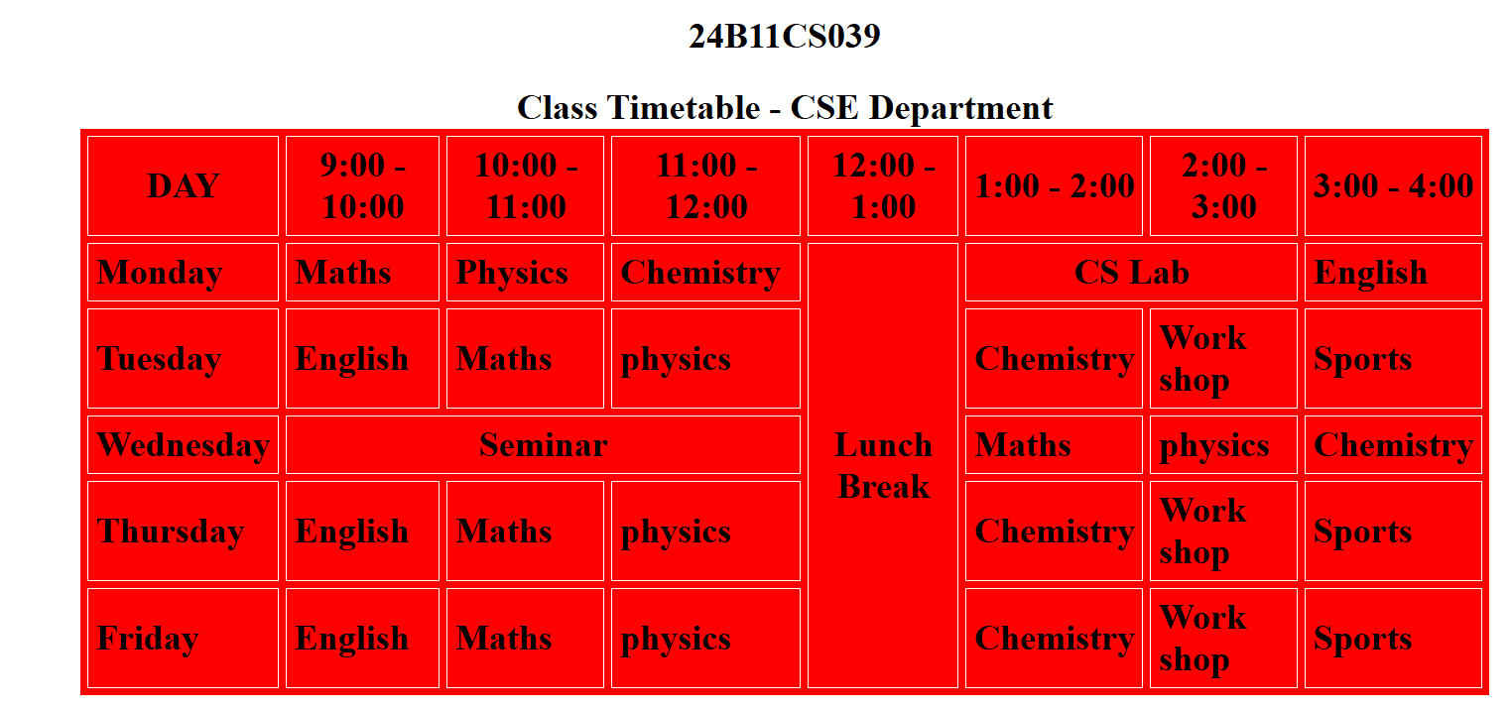

RESULT:

Exp.no: 2.c
AIM: Write a HTML program, to explain the working of forms by designing Registration form.
DESCRIPTION:
1. Form Layout Using <table>
- To make the form look organized, a table is used for alignment.
- Each row (<tr>) of the table holds:
2. Form Controls Used
a) Text Field
- Created with <input type="text">.
- Used for entering general text like name or email.
b) Password Field
- Characters typed are hidden (shown as dots or asterisks).
c) Number Field
- Restricts input to numeric values (e.g., phone, age).
d) Date of Birth Field
- Created with <input type="date">.
- Opens a calendar for selecting a date.
e) Radio Buttons
- Allow the user to select only one option from a group.
f) Checkboxes
- Allow the user to select multiple options.
g) List Box (Dropdown)
- Created using <select> and <option>.
- Used to select one (or more) values from a list.
h) Text Area
- Allows multi-line input (e.g., address, feedback).
i)Buttons
- Submit Button (<input type="submit">) → sends form data.
- Reset Button (<input type="reset">) → clears all fields.

PROGRAM:
<!DOCTYPE html>
<html lang="en">
<head>
<meta charset="UTF-8">
<title>REGISTRATION FORM</title>
</head>
<body bgcolor="green" >
<center>
<h2>24B11CS039<h2>
<h2 align="center"> Student Registration Form</h2>
<form method="post" action="#">
<table border="1" align="center" cellpadding="10" cellspacing="0">
<tr>
<td> <label for="fname"> First Name: </label></td <td> <input type="text" id="fname" name="fname" required> </td>
</tr>
<tr>
<td> <label for="lname"> Larst Name: </label></td>
<td> <input type="text" id="lname" name="lname" required> </td>
</tr>
<tr>
<td> <label for="password"> Password: </label></td>
<td> <input type="password" id="password" name="password" required> </td>
</tr>
<tr>
<td> <label for="age"> Age: </label></td>
<td> <input type="number" id="age" name="age" min="0" max="100" required> </td>
</tr>
<tr>
<td> <label for="dob"> Date Of Birth: </label></td>
<td> <input type="date" id="dob" name="dob" required> </td>
</tr>
<tr>
<td> Gender: </td>
<td>
<input type="radio" id="female" name ="gender" value="male">
<label for="female"> Male </label>
<input type="radio" id="female" name ="gender" value="female">
<label for="female"> Female </label>
</td>
</tr>
<tr>
<td> Languages Known: </td>
<td>
<input type="checkbox" id="english" name ="language" value="English">
<label for="english"> English </label>
<input type="checkbox" id="telugu" name ="language" value="Telugu">
<label for="telugu"> Telugu </label>
<input type="checkbox" id="hindi" name ="language" value="hindi">
<label for="hindi"> Hindi </label>

</td>
</tr>
<tr>
<td> <label for="course"> Course: </label></td>
<td>
<select id="course" name="course">
<option value="">--Select--</option>
<option value="B.Tech">B.Tech</option>
<option value="M.Tech">M.Tech</option>
<option value="MCA">MCA</option>
<option value="MBA">MBA</option>
</select>
</td>
</tr>
<tr>
<td> <label for="address"> Address: </label></td>
<td> <textarea id="dob" name="address" rows="4" cols="30"> </textarea> </td>
</tr>
<tr>
<td colspan="2" align="center">
<input type="submit" value="Submit">
<input type="reset" value="Reset">
</td>
</tr>
</table>
</form>
</center>
</body>
</html>
OUTPUT:
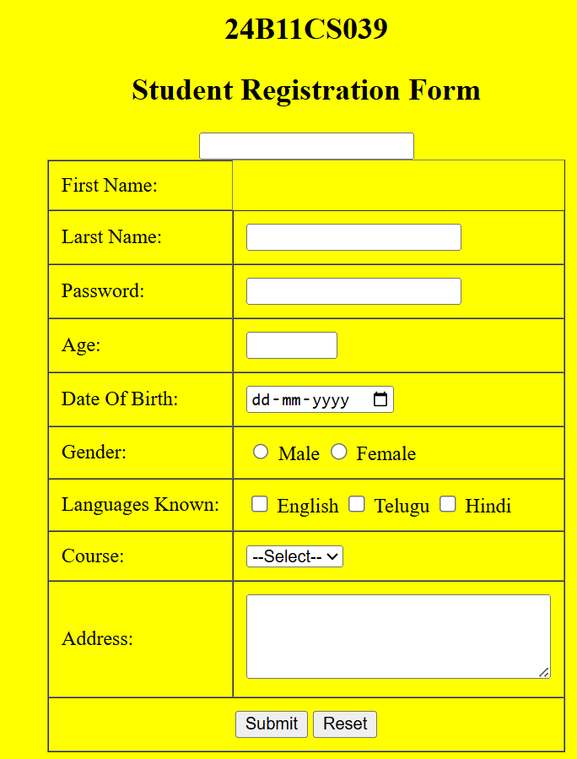

RESULT:

Exp.no: 2.d
AIM: Write a HTML program, to explain the , such that page is to be divided into 3 parts on either direction. (Note: first frame image, second frame paragraph, third frame hyperlink. And also make sure of using "no frame" attribute such that frames to be fixed).
DESCRIPTION:
1. Purpose of Frames
- Frames in HTML allow the browser window to be divided into multiple independent sections.
- Each section can load a different HTML document at the same time.
- They are created using the <frameset> and <frame> tags (instead of <body>).
2.Main Tags Used
<frameset>
- Defines how the page is divided: rows (horizontal) or cols (vertical).
<frame>
- Defines each frame inside the <frameset>.
<noframes>
- Provides alternate content for browsers that do not support frames.
- It is placed inside <frameset>.
3. Frame Division for the Problem
We need 3 frames:
1.First Frame → Image page (image.html)
This page contains an <img> tag displaying a picture.
2.Second Frame → Paragraph page (para.html)
This page contains a simple paragraph.
3.Third Frame → Hyperlink page (link.html)
This page contains a hyperlink.
4. Main Frameset Page (index.html)
- This is the master page that defines the structure.

PROGRAM:
<!DOCTYPE html>
<html lang="en">
<head>
<meta charset="UTF-8">
<title>Frames Example</title>

</head>
<frameset cols="25%,25%,50%">
<frame src="c:\Users\DEEVENA\1.d.html." name="Image Frame" >
<frame src="c:\Users\DEEVENA\1.c.html" name="List Frame" >
<frame src="c:\Users\DEEVENA\1.b.html" name="Link Frame" >
<noframes>
<body>
<p> Your browser does not support frames. Please update your browser.</p>
</body>
</noframes>
</frameset>
</html>
OUTPUT:
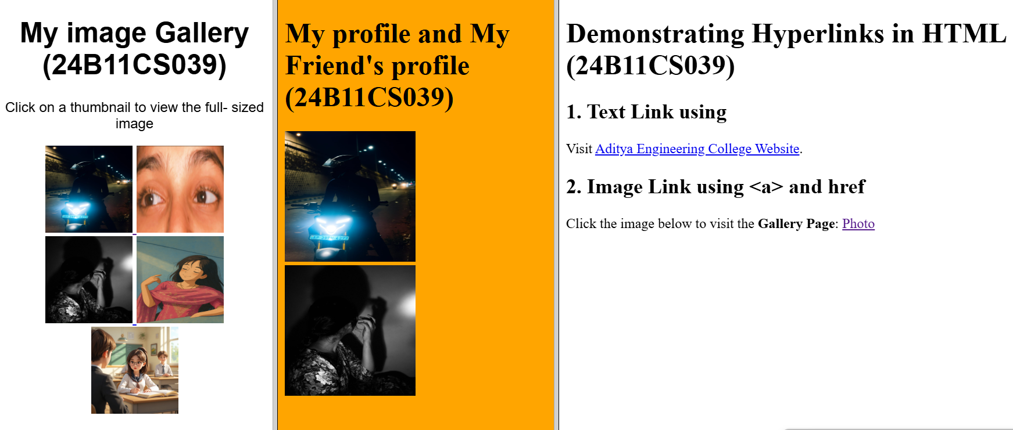

2) Horizontal:
<html lang="en">
<head>
<meta charset="UTF-8">
<title>Frames Example</title>
</head>
<frameset rows="25%,25%,50%">
<frame src="c:\Users\DEEVENA\1.d.html" name="Image Frame" >
<frame src="c:\Users\DEEVENA\1.c.html" name="List Frame" >
<noframes>
<body>
<p> Your browser does not support frames. Please update your browser.</p>
</body>
</noframes>
</frameset>
</html>
OUTPUT:

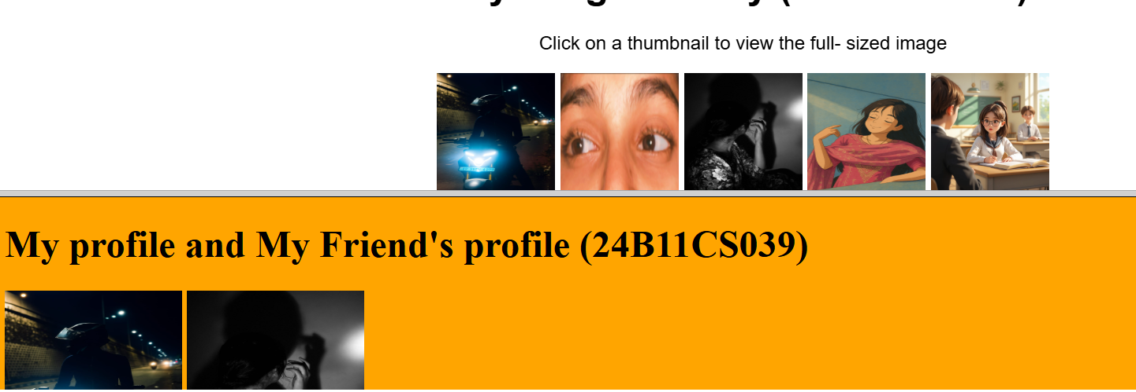
RESULT:

