A Context-Aware Recommendation System for Household Service Providers Using Ensemble Learning in Urban Environments

Student Name: Mbithi, Keith Austine Student No: 164003

Supervisor: Dr. Deperias Kerre

An Informatics and Computer Science Project Proposal Submitted to the School of Computing and Engineering Sciences in partial fulfillment of the requirements for the award of a Degree in Bachelor of Science in Informatics and Computer Science

School of Computing and Engineering Sciences Strathmore University
Nairobi, Kenya

June 2026

Declaration and Approval
I declare that this project proposal has not been presented to Strathmore University or any other institution for the award of a Bachelor of Science in Informatics and Computer Science degree, or any other academic qualification. To the best of my knowledge, this proposal does not contain material previously published or written by another individual, except where proper acknowledgment and references have been provided within the proposal.

Student Admission Number: 164003

Sign:

Date:


Supervisor’s Signature:

Sign: Date: 11/06/2026

Acknowledgment
I would like to express my sincere gratitude to my supervisor, lecturers, family, and friends for their guidance, encouragement, and support throughout the development of this project proposal. Their assistance and motivation have played an important role in the completion of this work. I also thank Strathmore University for providing a conducive environment and resources that supported this research.

Abstract
Rapid urbanization in Nairobi continues to increase the demand for household services such as plumbing, electrical repairs, and cleaning. However, existing service-matching platforms primarily rely on distance and user ratings, often overlooking traffic congestion and varying road conditions, resulting in unreliable provider arrivals and reduced user trust.

This study will propose a context-aware recommendation system that will predict the arrival reliability of household service providers by incorporating environmental and provider-related factors. A synthetic dataset reflecting documented Nairobi traffic patterns and road quality characteristics will be used to represent the realities of urban service delivery.

The proposed model will integrate features such as estimated travel time, congestion levels, road quality, time of day, provider ratings, completion rates, and experience. An ensemble learning approach will be employed to generate a reliability score for candidate providers.

The system will aim to provide more dependable recommendations than traditional rating-based approaches. Ultimately, it will seek to reduce missed appointments, improve user satisfaction, and contribute to a more reliable digital service ecosystem in Nairobi.

Table of Contents

Declaration and Approval ii
Acknowledgment iii
Abstract iv
Table of Contents v
List of Figures viii
Chapter One: Introduction 1
  - Problem Statement 2
  - General Objective 2
    - Specific Objectives 2
    - Research Questions 3
  - Justification 3
  - Scope and Limitations 4
    - Scope of the Project 4
    - Limitations in the Project 4
    - Delimitations in the Project 5
Chapter Two: Literature Review 6
  - Introduction 6
  - Challenges Faced by Users of Service-Matching Platforms 6
  - Related Applications 7
    - Mama Fua App 8
    - Fundis App 9
    - Kazi Konekt 10
    - Context-Aware Recommender Systems 11
    - XGBoost for Travel Time Prediction 12
  - Gaps in the Existing Applications 12
  - Conceptual Framework 13
Chapter Three: Development Methodology 15
  - Introduction 15
  - Research Paradigm 15
    - Data Acquisition 15
    - Data Preprocessing 16
    - Model Training 16
    - Model Validation & Testing 16
  - Software Development Methodology 17
    - Requirements Elicitation 18
    - System Design 18
    - Prototyping 18
    - User Evaluation of Prototype 18
    - Refinement & Integration 18
    - Coding & Development 19
    - Testing & Deployment 19
  - System Analysis and Design 19
    - Use Case Diagram 19
    - Class Diagram 20
    - Entity Relationship Diagram (ERD) 20
    - Database Schema 20
    - System Architecture 20
    - Wireframes 21
  - System Development Tools and Techniques 21
    - Python 21
    - Next.js 21
    - PostgreSQL and PostGIS 22
    - XGBoost Ensemble Learning 22
    - Feature Engineering 22
    - Git and GitHub 22
  - System Deliverables 22
    - System Documentation 22
    - Authentication Module 23
    - Context-Aware Recommendation Engine 23
    - Provider Booking and Ranking Interface 23
    - Geospatial Database Module 23
References 24
Appendix A1: Time Schedule 26

List of Figures
Figure 2.3.1 Mama Fua Booking App 9
Figure 2.3.2 Fundis Service Booking App 10
Figure 2.3.3 Kazi Konnekt Dashboard 11
Figure 2.5.4 Conceptual Framework 14
Figure 3.3.5 Agile-Scrum Framework 17

Chapter One: Introduction

  - Background
The rapid growth of urban populations has increased the demand for on-demand home and facility services, including electrical repairs, plumbing, and general technical maintenance. In Nairobi, informal service economies provides most of these types of services. Customers look to their social network (word of mouth) physical notice boards, or personal referral to find these service providers; however, with the emergence of digital platforms for matching services with digital providers both globally and locally, the hope is to bring formality to the service profession and help users navigate through the discovery, comparison, and booking process for service providers using web and mobile based interfaces.
Despite this digital shift, the quality and reliability of service delivery remains inconsistent. Users continue to experience delays, no-shows, and substandard work even when engaging providers with strong ratings and competitive pricing. This indicates that there is a structural gap in how the current platforms are analysing and ranking service providers; they evaluate providers in isolation without assessing the dynamic environmental and/or contextual conditions to which a provider must operate within so as to successfully deliver on their promises when providing a service. For example, service providers' ability to successfully complete a job and reach a client can be affected by factors such as road conditions, flooding, traffic congestion, and localised safety conditions.(Ricci et al., 2015).
Over time, recommendation systems in e-commerce and media streaming have evolved significantly, transitioning from static, distance-based matching to intelligent, context-aware recommendation models. These advanced theoretical models dynamically assess the situational conditions under which a service is delivered. However, these improved theoretical methods have not been effectively applied to the informal service sector, especially in urban regions of developing countries where there are large variations in the quality of infrastructure. This project bridges that gap by applying context-aware theories to a machine learning algorithm, providing more reliable recommendations by assessing real-time contextual risks.

Problem Statement
Existing service-matching platforms recommend providers based primarily on proximity, availability, and historical user ratings; a limited set of static parameters that do not account for the real-world conditions that determine whether a provider can actually deliver as expected. In Nairobi, where traffic congestion varies significantly by time of day, day of week, and road corridor, straight-line distance is a poor predictor of actual travel time. A provider located three kilometres away across a heavily congested route may take significantly longer to arrive than one located six kilometres away on a clear road, yet current platforms treat both providers identically from a proximity standpoint.
This mismatch between algorithmic rankings and real delivery performance leads to frequent delays, missed appointments, and eroded user trust in service platforms. The core problem is the absence of contextual awareness in provider-matching algorithms: no existing Kenyan platform incorporates traffic conditions, time-based travel patterns, or road quality into its recommendation logic, leaving users without a reliable basis for predicting whether a chosen provider will arrive on time and complete the job successfully.

General Objective

The aim of this project is to design and develop a context-aware recommendation system for household service providers in urban Nairobi that uses ensemble machine learning to integrate traffic conditions, time-of-day travel patterns, road quality, and provider performance history into a provider reliability score, enabling more accurate and dependable service provider recommendations than proximity-based approaches.

Specific Objectives
      - To identify the key factors that influence the reliability of household service providers in urban Nairobi, including traffic conditions, time of day, road quality, and past provider performance.
      - To review existing Kenyan service-matching platforms and ML-based recommendation systems and identify gaps in contextual awareness and travel-time prediction.
      - To develop a machine learning model that combines travel and provider-related factors to predict provider arrival reliability.

      - To evaluate the model's performance against distance-based and rating-based recommendation approaches using RMSE and MAE metrics.

Research Questions
      - What contextual factors including traffic congestion, time-of-day patterns, road quality, and provider history most significantly affect the reliability of household service provider delivery in urban Nairobi?
      - What limitations exist in current Kenyan service-matching platforms and machine learning-based recommendation systems with respect to contextual awareness ?
      - How can XGBoost ensemble machine learning integrate contextual traffic features and provider performance metrics to generate a reliable provider arrival prediction score ?
      - How effective is the proposed context-aware recommendation system in improving provider recommendation accuracy relative to distance-only and rating-only baseline models?

Justification

There are three grounds that justify the development of this system: improved user experience, economic efficiency, and technical contribution. From a user perspective, the persistent gap between expected and actual service delivery represents a significant source of frustration, particularly for households and small businesses that depend on timely technical services. A system that more accurately predicts provider arrival reliability directly reduces the incidence of missed appointments, wasted waiting time, and the cost of rescheduling.
Economically, improved provider matching has positive ripple effects for all parties. Reliable providers gain more consistent work opportunities; platforms reduce user churn caused by poor delivery experiences; and the informal artisan economy becomes more trustworthy and formalised.
From a technical standpoint, while Context-Aware Recommender Systems (CARS) are theoretically well-established in e-commerce, their application to the urban household service domain specifically integrating traffic-based travel time modeling and ensemble learning remains largely unexplored in Kenya. This project contributes a theoretically grounded approach, utilizing Gradient Boosting theory via XGBoost to predict provider arrival reliability as a function of

contextual traffic features, time-of-day patterns, and historical provider performance.

Scope and Limitations

Scope of the Project

The system will be delivered as a responsive web-based application accessible across desktop and mobile browsers. It will cover three categories of household service providers operating in the Nairobi metropolitan area: electricians, plumbers, and cleaners. The core functionality includes user registration and service request submission, context-aware provider ranking using the trained XGBoost model, and booking confirmation with provider profile display.
The machine learning component will encompass data preparation, feature engineering, model training using XGBoost ensemble learning, and model evaluation against distance-only and rating-only baseline models. Contextual features incorporated into the model include traffic congestion multipliers by corridor and time slot, estimated travel time, road quality, day-of-week and time-of-day patterns, and historical provider performance metrics including completion rate, average response time, and rating. A PostgreSQL database will manage provider and spatial data. Provider onboarding and profile management will also be included within the system scope.

Limitations in the Project

The system’s training data is synthetically generated based on realistic Nairobi traffic patterns and provider behaviour distributions. While the data is grounded in documented Nairobi road conditions and congestion characteristics, it does not capture the full complexity of real-world variability. Model performance may differ from projections once deployed against live data, and retraining on real booking outcomes will be necessary over time to improve accuracy.
The system does not integrate real-time traffic APIs in its initial implementation; traffic features are based on time-slot and corridor patterns derived from historical averages. Real-time API integration is identified as a priority extension. The system will not cover all service provider categories, nor extend beyond the Nairobi metropolitan area in its initial release. Payment processing and live provider GPS tracking fall outside the scope of this project.

Delimitations in the Project

The project deliberately excludes mobile application development (iOS/Android), focusing solely on a responsive web-based interface to manage development scope and ensure cross-device accessibility without platform-specific builds. Flood zone analysis, crime risk integration, and real-time weather data while relevant to a broader risk-aware recommendation system are beyond the scope of this project and are identified as future work extensions. The system will not attempt to resolve disputes between users and providers, manage in-person service quality inspection, or integrate with third-party payment gateways. These delimitations allow the project to maintain a focused, technically rigorous implementation within the timeframe provided for the project while delivering a genuinely novel and functional recommendation system.

Chapter Two: Literature Review

Introduction

This chapter reviews existing literature and related systems relevant to the development of a context-aware recommendation system for household service providers in urban Kenya. The review is structured around four areas: the challenges that define the urban service delivery problem in the Kenyan context, with particular focus on traffic congestion and travel time variability; a critical analysis of three existing Kenyan service-matching platforms and how each addresses or fails to address the contextual gap; the specific limitations and gaps that the proposed system is designed to overcome; and a conceptual framework that maps the system’s processing pipeline from raw inputs to ranked provider recommendations. The literature and platform analysis presented in this chapter directly inform the design and architectural decisions described in subsequent chapters.

Challenges Faced by Users of Service-Matching Platforms

The demand for on-demand household services in urban Kenya has grown substantially alongside rapid urbanisation, with Nairobi’s population exceeding five million and continuing to expand into densely populated peri-urban settlements such as Mathare, Kibera, and Ruiru (Kenya National Bureau of Statistics, 2019). This growth has created a large and underserved market for skilled tradespeople electricians, plumbers, cleaners, and general technicians many of whom operate informally, without consistent access to clients or reliable income. The emergence of digital service-matching platforms in Kenya over the past decade has sought to formalise this market, but the platforms that have developed face a structural challenge: matching algorithms designed for well-connected, infrastructure-stable environments do not translate effectively to Nairobi’s complex urban geography.
A fundamental challenge in urban service delivery is the extreme variability of actual travel times across the road network. The majority of service providers commute by public transit or motorcycle, making their journey times highly sensitive to both road surface conditions and prevailing traffic levels. Existing platforms fail to address this because they rely on the naive theoretical approach of using straight-line (Haversine) distance as a proxy for travel time.

Theoretical studies in transportation modeling demonstrate that straight-line distance produces significant errors in dense urban environments where road network topology, congestion, and surface quality dominate actual journey duration. To overcome this structural challenge, travel time must be modeled as a function of distance, free-flow speed, and a contextual congestion multiplier that varies by route corridor and time of day.
Traffic congestion compounds this challenge further. Nairobi is consistently ranked among the most congested cities in Africa, with average rush-hour commute times up to three times longer than off-peak times along major corridors such as Mombasa Road, Thika Road, and Ngong Road (TomTom Traffic Index, 2023). A straight-line or basic GPS distance calculation the standard used by most Kenyan service platforms is therefore a deeply unreliable proxy for actual travel time and provider reachability. A provider located two kilometres away across a congested junction may take longer to arrive than one located five kilometres away on a clear route, yet current platforms rank these providers identically from a distance perspective.
Together, road quality variability and traffic congestion patterns define a category of contextual challenge that is specific to the Nairobi urban environment and that existing recommendation systems are structurally unable to address. Because platforms rely on static proximity as a matching criterion, two providers at equal distances from a client are treated as equivalent regardless of whether one faces a congested corridor and the other a clear bypass. A system that can model these differences using time-of-day traffic patterns, road quality data, and historical provider performance can produce materially more reliable recommendations than any distance-based approach (Adomavicius & Tuzhilin, 2011).

Related Applications
Before analyzing specific local applications, it is necessary to establish the theoretical machine learning frameworks that govern intelligent provider matching. Traditional recommender systems generate suggestions based solely on user preferences and item attributes. However, Context-Aware Recommender Systems (CARS) theory extends this paradigm by incorporating situational variables such as time, location, and environmental conditions directly into the recommendation function, consistently outperforming context-free models. Furthermore, to process these complex, non-linear contextual variables, Ensemble Learning theory is utilized. Techniques like Gradient Boosting

sequentially build decision trees to correct the residual errors of previous models. An optimized implementation of this theory, XGBoost, is particularly effective for structured tabular datasets and forms the theoretical baseline for modern, intelligent matching. Despite these theoretical advancements, current Kenyan platforms exhibit significant gaps in their implementations.

Mama Fua App

Mama Fua is a Kenyan service-matching platform focused on cleaning, laundry, and fumigation services, operating across Nairobi, Mombasa, and Kisumu. The platform is notable for its social mission: it primarily onboards and empowers female workers, partnering with Cleaning School Kenya to deliver standardised skills training before any worker is listed on the platform. Users book services by selecting a service category and providing their location, after which the system matches them with an available, trained provider in their area.
Mama Fua’s approach to service quality is human-centred rather than algorithmic: reliability is guaranteed through vetting and training, not through intelligent matching. While this model addresses the competency dimension of provider quality effectively, it creates a significant contextual gap. The platform relies on standard location-based matching and does not dynamically adjust estimated arrival times, provider rankings, or booking recommendations in response to environmental conditions. During Nairobi’s heavy rainfall periods, when the ability of a cleaner to commute via public transit is severely compromised, the platform offers no mechanism to flag elevated delivery risk, recommend a closer alternative, or communicate realistic adjusted arrival expectations to the user. The system’s quality guarantee is rendered fragile by conditions the algorithm was never designed to consider.


Figure 2.3.1 Mama Fua Booking App

Fundis App

Fundis App, also referred to as Fundilink, is a broad marketplace connecting users with skilled tradespeople including plumbers, electricians, carpenters, and welders across Kenya. The platform incorporates a two-way review system, allowing both clients and providers to rate each other, and offers digital portfolios where providers can showcase completed work. Fundis also provides a work quality guarantee for a defined period following job completion, introducing a degree of accountability beyond the booking transaction.
Despite these features, the Fundis App’s core matching logic is based on straight-line geolocation surfacing the nearest available provider to the user’s pin location. This approach, while intuitive, is fundamentally flawed in the context of Nairobi’s urban geography. A plumber located three kilometres away across a heavily congested corridor or through an area of poor road infrastructure presents a materially higher operational risk than one located six kilometres away on a clear, accessible route.

The application lacks the spatial intelligence to compute route-based accessibility scores or to factor road quality and real-time transit times into its ranking. The consequence is that a metric the platform presents as a measure of convenience proximity is in practice an unreliable and sometimes misleading predictor of actual provider reachability. This is precisely the gap that geospatial analysis using PostGIS is designed to close.

Figure 2.3.2 Fundis Service Booking App

Kazi Konekt

Kazi Konekt is an on-demand service application built around a dual-interface model comprising a Worker App and a Client App, aimed at formalising Kenya’s gig economy. The platform distinguishes itself from competitors through its use of an AI-first intelligent worker dispatch system, which prioritises speed of response and worker availability. Providers are incentivised through a badge and rating system that rewards completed jobs with higher visibility and preferential dispatch, effectively building a dynamic ranking layer on top of availability-based matching.
Kazi Konekt represents the most technically advanced of the Kenyan platforms reviewed, and its AI dispatch layer is a meaningful step toward intelligent provider matching. However, the algorithm is optimised for a single dimension: speed of dispatch based on availability and proximity. It does not account for time-of-day traffic conditions or road quality on the route

between a provider and a client. A concrete illustration of this limitation is the scenario where a client in Embakasi requests a plumber at 8:00 AM on a weekday. Kazi Konekt’s system would dispatch the nearest available provider without considering that Mombasa Road at that hour typically operates at a fraction of its free-flow speed, meaning a provider six kilometres away on a less congested route may realistically arrive sooner and more reliably than the nearest provider across the gridlock. The absence of temporal traffic awareness in an otherwise intelligent system means that the platform’s speed optimisation can, under predictable daily conditions, produce suboptimal matching outcomes for both client and provider.
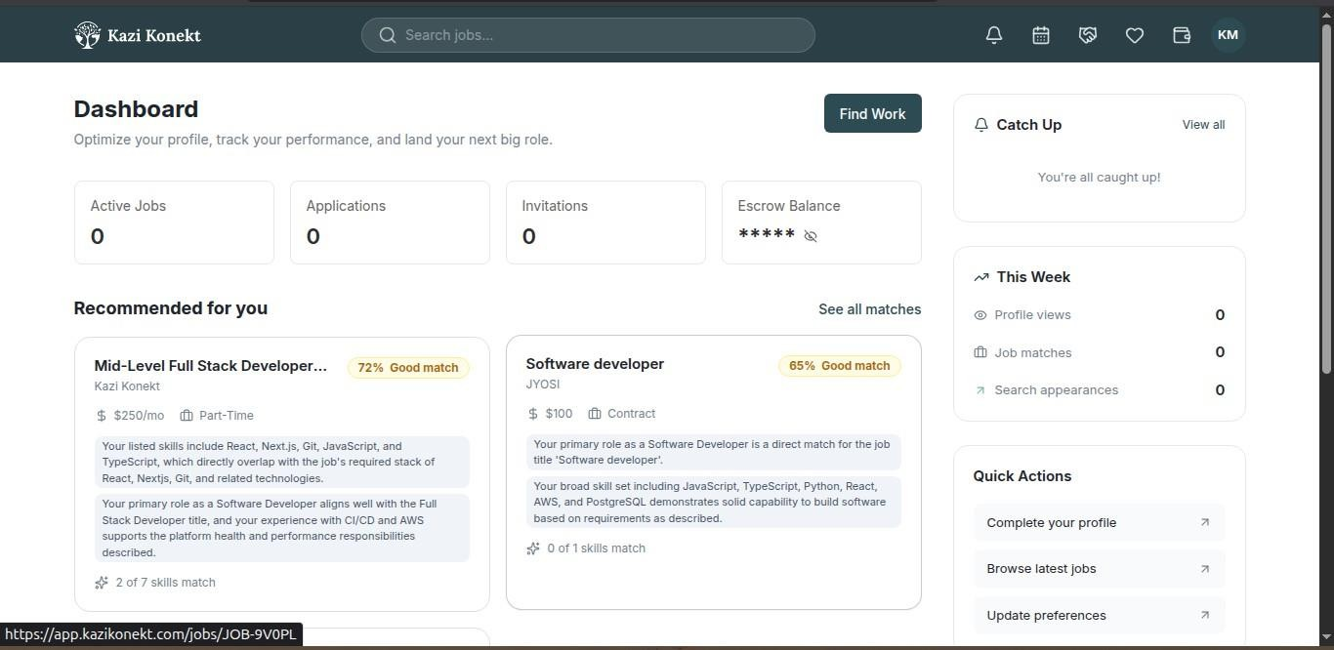
Figure 2.3.3 Kazi Konnekt Dashboard

Context-Aware Recommender Systems
Adomavicius, Mobasher, Ricci, and Tuzhilin (2011) introduced the concept of Context-Aware Recommender Systems (CARS), which extends traditional recommendation methods by incorporating contextual variables such as time, location, and environmental conditions into the recommendation process. The study demonstrated that considering contextual information enables systems to produce recommendations that are more relevant to users' current situations, overcoming the limitations of static recommendation approaches.
However, the work primarily provides a conceptual framework and discusses several application domains rather than focusing on urban service-provider matching. Furthermore, the study does not incorporate transportation variables such as traffic congestion or road quality, which are critical factors

in the Nairobi context. Nevertheless, the theoretical principles established in this work provide the conceptual foundation for the present study.

XGBoost for Travel Time Prediction
Huang et al. (2020) investigated the use of tree-based ensemble methods, including XGBoost, for travel time prediction using structured transportation datasets. Their study showed that ensemble learning models effectively capture nonlinear relationships between temporal and spatial variables and outperform simpler methods in prediction accuracy. The research highlighted the suitability of gradient boosting techniques for handling complex interactions among traffic-related features.
Despite its strong predictive performance, the study focused exclusively on estimating travel duration rather than ranking alternative service providers according to their likelihood of successful service delivery. The work therefore predicts trip characteristics rather than provider reliability. Nonetheless, its feature engineering approach and the demonstrated effectiveness of ensemble learning directly motivate the use of XGBoost in the present study.

  - Gaps in the Existing Applications

A structured comparison of the three platforms reviewed above reveals a consistent and significant pattern of gaps that collectively define the problem this project addresses. The most critical gap, present across all three platforms, is the complete absence of time-of-day traffic awareness in provider matching. None of the reviewed platforms adjusts its recommendations based on when a booking is made relative to known congestion patterns on the likely route between provider and client. Proximity is used as a direct proxy for reachability, and a provider’s aggregate rating is used as a proxy for reliability, when neither correlation holds consistently in Nairobi’s traffic-variable environment. A provider ranked first at 10:00 AM on a Saturday may be the worst choice at 7:30 AM on a Monday morning along the same corridor, yet current platforms make no such distinction.
The second gap is the absence of contextual travel time modelling. Nairobi’s traffic conditions change significantly by time of day, day of week, and road corridor. A booking made at 8:00 AM on a weekday along Mombasa Road involves fundamentally different travel dynamics than one made at 2:00 PM on a Saturday, yet none of the platforms reviewed model this difference. Kazi Konekt comes closest with its AI dispatch system, but even this operates entirely on internal platform data, specifically worker availability and job history, without incorporating any traffic

signal or road quality variable into its matching logic.

Third, while Kazi Konekt employs an AI-based dispatch layer, no reviewed platform uses a machine learning model to generate a multi-factor provider reliability score. The distinction matters: dispatch optimisation selects the fastest-to-respond available provider, whereas reliability scoring predicts which provider is most likely to successfully complete a job under current conditions. The latter requires feature engineering that combines environmental, spatial, and provider-profile data into a single predictive model a capability that XGBoost ensemble learning is well-suited to provide (Chen & Guestrin, 2016).
Finally, no existing Kenyan platform exposes the basis of its matching decisions to users in a transparent or explainable format. Users are presented with a list of providers without understanding why a particular provider was ranked first, what risk factors were or were not considered, or how conditions on the day of booking might affect the recommendation. This opacity undermines informed decision-making and reduces the ability of users to calibrate their expectations appropriately.
  - Conceptual Framework

The conceptual framework for this project describes how the system’s components interact to transform raw inputs into a context-aware, ranked provider recommendation. It is designed to directly address the three gaps identified in Section 2.4 by introducing time-of-day traffic modelling, road quality scoring, ensemble machine learning, and an explainable output layer into a unified processing pipeline.
Three categories of input initiate the pipeline. The first is the user request, capturing the service type required, the client’s location, and the preferred booking time. The second is the provider database, holding structured provider profiles including historical ratings, declared availability, service specialisations, cost, and geographic base location stored in PostgreSQL. The third is contextual traffic data: pre-computed traffic congestion multipliers by road corridor and time slot, and road quality classifications by area, both stored in the PostgreSQL database and used to estimate realistic travel times between each candidate provider and the client.
These inputs are processed through two analytical stages before reaching the machine learning

model. First, travel time estimation combines the provider’s distance from the client with the congestion multiplier for the relevant corridor and time slot, producing a realistic estimated travel time for each candidate provider. Simultaneously, feature engineering assembles the full feature vector for each candidate: estimated travel time, congestion level, road quality, time slot, day type, provider rating, completion rate, experience, and response time history. The XGBoost ensemble model receives these feature vectors and outputs a reliability prediction score for each candidate, which is combined with cost and availability data to produce a final composite ranking.
The output is delivered to the user through the web-based interface, built in Next.js, which presents the ranked provider list alongside the key contextual factors that influenced each provider’s position. This transparency layer is the system’s response to the opacity gap identified in the platform review: users can see not just who is recommended, but whywhether a provider scored well because of a favourable time-of-day traffic profile, a clear route to the client, or a strong historical completion record.
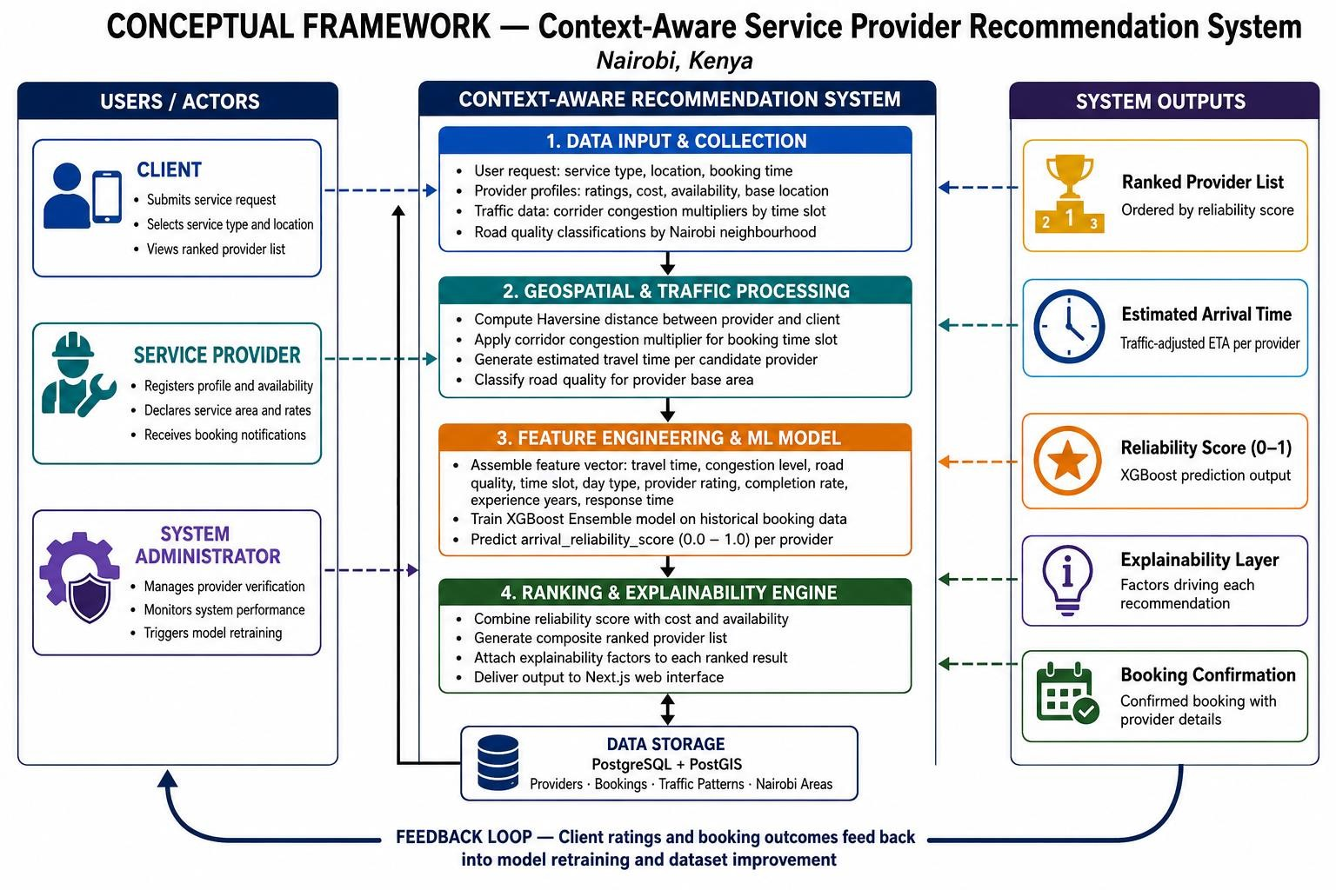
Figure 2.5.4 Conceptual Framework

Chapter Three: Development Methodology

Introduction

This chapter outlines the methodology and strategies that will be employed in the development of the context-aware recommendation system for household service providers. It details the quantitative experimental research paradigm governing the machine learning pipeline, alongside the Agile software development methodology used to build the web-based Interactive Decision Support System (IDSS). Furthermore, the chapter breaks down the system analysis and design components, the specific development tools and techniques utilized, and the expected system deliverables.

Research Paradigm

This project adopts a quantitative experimental research design grounded in the CRISP-DM framework. The experiment is structured around three model conditions that differ only in the set of independent variables (features) provided to the recommendation algorithm. The dependent variable across all conditions is the arrival_reliability_score a composite metric (0.0–1.0) reflecting predicted provider on-time arrival and job completion probability.

Data Acquisition
The synthetic dataset was generated using a rule-based simulation framework implemented in Python. The simulation parameters were derived from documented characteristics of the Nairobi road network. Congestion multipliers and peak-hour time windows were calibrated against TomTom Traffic Index data (TomTom, 2025), which records average rush-hour speeds of 16.7–20.5 km/h and an evening congestion level of 98.8% across the city. Speed reduction factors on major corridors were further validated against Uber Movement data, which confirms speeds on Mombasa Road, Uhuru Highway, and Waiyaki Way run 60–80% below free-flow during peak hours (Shah, 2021). Road quality classifications by neighborhood were grounded in the road access deprivation framework applied to Nairobi by Haer et al. (2025) and surface type data from the Kenya Roads Board's Road Inventory and Conditions Survey (KRB, 2023). The ten modeled road corridors correspond to primary congestion routes identified in the JICA Nairobi Urban Transport Master Plan Study (JICA, 2006) and confirmed by Daily Nation traffic analysis (Daily Nation, 2025). This grounding ensures that while the dataset is

synthetic, its distributional properties reflect the empirically documented realities of Nairobi.

Data Preprocessing
Prior to model training, the dataset undergoes a comprehensive preprocessing pipeline. This involves handling any missing values and encoding categorical variables such as time_slot, day_type, road_quality, and service_type using one-hot encoding. The most critical preprocessing step is feature engineering, which mathematically synthesizes the estimated travel time feature by combining the Haversine (straight-line) distance with the contextually derived corridor congestion multiplier. Finally, numerical features are scaled appropriately to ensure uniformity before being fed into the algorithm.

Model Training
The experimental design involves manipulating independent variables across controlled model conditions. The independent variables encompass contextual features (e.g., congestion multiplier, estimated travel time, road quality, time slot), provider performance features (e.g., rating, completion rate, experience years), and spatial distance. The dependent variable across all conditions is the arrival_reliability_score, a composite metric ranging from 0.0 to 1.0 that reflects the predicted provider on-time arrival and job completion probability.
The models are trained under three distinct conditions to isolate the impact of the contextual features: Baseline A - Distance-Only: Providers are ranked by straight-line distance only, acting as a control condition representative of current platform architectures. No contextual features are included. Baseline B - Rating-Only: Providers are ranked by their aggregate historical rating only, serving as a secondary control condition without spatial or contextual data.
Proposed Model: An XGBoost ensemble model is trained on the complete feature set, integrating contextual traffic variables with provider performance metrics. The XGBoost model utilizes an 80/20 train-test split, with hyperparameter tuning conducted via grid search to optimize the learning rate, maximum tree depth, and minimum child weight.

Model Validation & Testing
All three conditions are evaluated on the same held-out test dataset. The models are assessed using two primary metrics:
- Root Mean Square Error (RMSE): Measures the average magnitude of prediction errors, penalizing large variances heavily. This is crucial for safety-relevant predictions like arrival

reliability.
- Mean Absolute Error (MAE): Measures the average absolute difference between prediction and actual value, indicating how far off predictions are on the 0–1 reliability scale.
Additionally, K-Fold Cross Validation (k=5) is applied to the proposed XGBoost model. This technique splits the dataset into five equal parts, training on four and testing on one, rotating until every record has been tested. This ensures the model generalizes well across different subsets of data and mitigates the risk of overfitting. The core experimental hypothesis is that the proposed model will produce statistically lower RMSE and MAE scores than both baseline conditions, validating the inclusion of contextual traffic features.

Software Development Methodology

The development of the web-based Interactive Decision Support System (IDSS) utilizes the Agile Iterative Prototyping methodology. While the machine learning pipeline is governed by the CRISP-DM framework outlined in Section 3.2, the frontend and API layers require a highly flexible approach. Agile Iterative Prototyping is justified for this project because the requirements for user interface behavior, dynamic provider ranking displays, and the explainability presentation are best refined through repeated evaluation cycles rather than fixed, rigid upfront specifications.

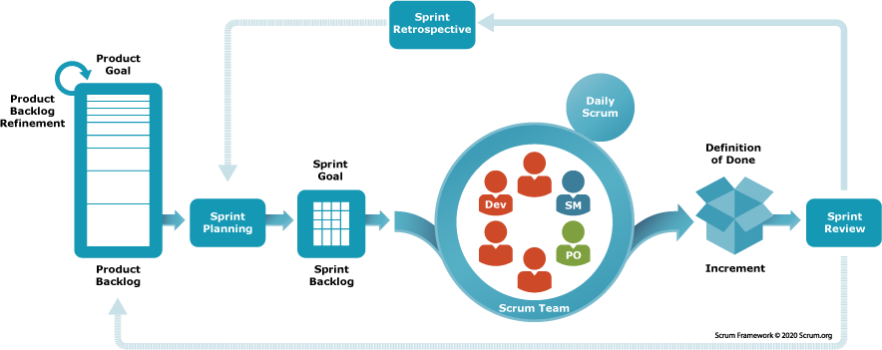

Figure 3.3.5 Agile-Scrum Framework

Requirements Elicitation
This initial phase involves gathering and specifying the core functional and non-functional requirements necessary for the system to operate effectively. Functional requirements include the service request input forms, the context-aware provider ranking display, and the booking confirmation workflows. Non-functional requirements focus on the system's performance, specifically the acceptable latency for the Next.js frontend to securely route a request to the FastAPI backend, process the XGBoost inference, and return the arrival_reliability_score in real-time.

System Design
Following requirements elicitation, the system's structural blueprints are drafted. This phase focuses on designing the overarching software architecture, mapping the PostgreSQL/PostGIS database schemas, and outlining the Object-Oriented Analysis and Design (OOAD) diagrams such as Use Cases, Class Diagrams, and Entity-Relationship Diagrams (ERDs). Additionally, low-fidelity wireframes are constructed to dictate the layout of the user dashboard and the results page.

Prototyping
A minimal, functional Next.js prototype is rapidly developed based on the quick design specifications. In this iteration, the complex machine learning backend and spatial database are temporarily bypassed. Instead, the prototype is populated with static mock data to validate the frontend layout, ensure cross-device responsiveness, and test the user navigational flow from service request to booking confirmation.

User Evaluation of Prototype
The initial prototype is subjected to usability evaluations to gather critical feedback on the user interface. A primary focus during this phase is assessing the effectiveness of the system's "explainability layer" evaluating whether users can easily interpret the visual cues indicating why a specific provider received their reliability score (e.g., highlighting that a provider was ranked higher due to a favorable route congestion multiplier despite being further away).

Refinement & Integration
Based on the evaluation feedback, the prototype undergoes significant refinement and integration. The static mock data is stripped out, and the Next.js frontend is formally connected to the FastAPI backend.

The PostGIS database is integrated to execute efficient spatial queries (Haversine distance calculations), and the live XGBoost prediction endpoints are connected to feed real-time reliability scores directly into the refined user interface.

Coding & Development
This phase encompasses the full-scale, rigorous programming of the integrated system. The backend API and machine learning logic are scripted in Python. The complex geographic calculations and relational data storage are programmed into the PostgreSQL database using the PostGIS extension. Concurrently, the frontend components, state management, and API routing are finalized using the Next.js React framework. Version control is strictly maintained using Git and GitHub throughout this process.

Testing & Deployment
Prior to deployment, the fully integrated system is subjected to comprehensive testing paradigms. Unit testing is applied to individual Python functions and Next.js components to ensure isolated reliability. Integration testing is conducted to verify the seamless data flow between the PostGIS database, the XGBoost scoring engine, and the frontend display. Finally, black-box testing is performed to validate the system against the initial user requirements. Upon passing all testing criteria, the full technology stack is deployed to a secure cloud hosting environment.

System Analysis and Design

System analysis and design form the blueprinting phase of the development lifecycle, translating elicited requirements into structured visual models. This section utilizes standard Object-Oriented Analysis and Design (OOAD) artifacts to map the system’s behavior, static structure, and data flow. These models ensure that the complex interactions between the Next.js frontend, the PostgreSQL database, and the Python-based machine learning engine are logically sound prior to full-scale coding.

Use Case Diagram

A use case diagram models the dynamic behavior of the system by defining the interactions between external actors and the system's core functionalities. In this project, the primary actors are
the Client, the Service Provider, and the System Administrator. The diagram illustrates vital

processes such as the Client initiating a "Service Request" and viewing "Ranked Recommendations," the Provider managing "Availability Schedules," and the System internally executing the "Compute Reliability Score" use case. This visualization is essential for ensuring all user-facing requirements are accounted for in the system logic.

Class Diagram

The class diagram maps the static structure of the system, defining the object-oriented classes, their internal attributes, and the methods they execute. Key classes designed for this system include Client, ServiceProvider, ServiceRequest, and ML_Engine. For instance, the ServiceProvider class will contain attributes like baseLocation and historicalRating, while the ML_Engine class will execute methods such as predictReliability(featureVector). This diagram dictates how the data structures will be programmed within the Next.js and Python environments.

Entity Relationship Diagram (ERD)

The Entity Relationship Diagram visually represents the data architecture, detailing how distinct database tables relate to one another. This is critical for maintaining data integrity across the synthetic Nairobi dataset. The ERD illustrates the primary and foreign key relationships connecting the clients table, service_providers table, nairobi_areas (containing spatial polygons), traffic_patterns, and the central historical_bookings table. This mapping ensures that complex
queries such as fetching a provider's historical performance joined with their base location can be executed efficiently.

Database Schema

The database schema provides the logical, tabular breakdown of the ERD, explicitly defining data types, constraints, and index structures. Because the system relies heavily on geographic calculations, the schema heavily features the PostgreSQL implementation enhanced by the PostGIS extension. It details the specific spatial data types (e.g., GEOMETRY(Point, 4326)) used to store client and provider coordinates, alongside standard relational definitions for strings, integers, and the floating-point constraints of the arrival_reliability_score.

System Architecture

The system architecture diagram provides a high-level topographical view of the entire technology stack and the directional flow of data. It visually separates the system into three distinct tiers: the Client Tier (Next.js web application running in a browser), the API/Application Tier (handling routing and business logic), and the Data/Processing Tier (the PostgreSQL/PostGIS database and the Python/XGBoost execution environment). This diagram justifies the technological choices by showing how user requests are securely routed to the machine learning engine and how predictive responses are returned.

Wireframes

Wireframes serve as the low-fidelity structural blueprints for the user interface. They dictate the layout of information and interactive elements on the screen without addressing aesthetic design choices like color or typography. The wireframes for this IDSS detail the layout of the user dashboard, the location and service input forms, and crucially, the results page. The results wireframe demonstrates how the dynamically ranked list of providers will be displayed alongside the explainability layer, ensuring the user can easily interpret why a provider was assigned a specific reliability score.

System Development Tools and Techniques

The successful implementation of this context-aware recommendation system relies on a specific stack of modern development tools and data science techniques, chosen to handle both web application deployment and complex algorithmic processing.

Python

Python is utilized as the primary programming language for the backend machine learning pipeline. Its extensive ecosystem of data manipulation libraries (such as Pandas and NumPy) makes it the optimal choice for preprocessing the synthetic Nairobi dataset, engineering spatial and temporal features, and training the predictive model.

Next.js

Next.js, a robust React framework, is selected for developing the Interactive Decision Support System (IDSS) frontend. It allows for the rapid construction of a responsive, cross-device web

application. Next.js was chosen for its server-side rendering capabilities and streamlined API route integration, which will handle the communication with the machine learning backend efficiently.

PostgreSQL and PostGIS

PostgreSQL serves as the primary relational database management system. It was selected for its reliability and extensibility. The PostGIS extension is a critical tool utilized within the database to enable advanced geospatial analysis. It allows the system to store Nairobi coordinates natively and execute highly efficient spatial queries to compute the baseline physical proximity between clients and providers.Here is an updated ver

XGBoost Ensemble Learning

eXtreme Gradient Boosting (XGBoost) is the core machine learning technique utilized to generate the provider arrival reliability score. As a decision-tree-based ensemble algorithm, it is highly optimized for structured, tabular data. It was chosen for its execution speed, accuracy, and built-in regularization techniques that prevent model overfitting during the training phase.

Feature Engineering

Feature engineering is a critical data science technique applied during the preprocessing phase. It involves mathematically transforming raw data inputs into highly predictive variables. For this system, the technique is used to synthesize a provider's spatial distance with time-of-day traffic congestion multipliers, creating a dynamic, contextual travel-time feature that drastically improves the XGBoost model's accuracy.

Git and GitHub

Git is utilized as the version control technique to track iterative changes across both the Next.js codebase and the Python machine learning scripts. GitHub serves as the remote repository hosting the project, facilitating secure backups and providing a structured environment for documenting the development process.

System Deliverables

System Documentation

A comprehensive, academically rigorous research report encompassing Chapters One through Six. This documentation details the problem statement, literature review, methodology, implementation procedures, evaluation metrics, and final conclusions drawn from the research.

Authentication Module

A secure, functional user management module integrated into the web application. It enables clients and service providers to register, securely log in, and manage their respective profiles and historical booking records.

Context-Aware Recommendation Engine

The core backend processing module housing the finalized, trained XGBoost machine learning model. This engine is capable of receiving dynamic feature vectors and returning an accurate arrival reliability score based on Nairobi's spatial and traffic realities.

Provider Booking and Ranking Interface

The user-facing Next.js web application. This deliverable allows users to input their service requirements and displays the algorithmic output as a transparent, ranked list of providers, complete with booking confirmation functionalities.

Geospatial Database Module

The fully structured and populated PostgreSQL database instance. This module securely houses the synthetic dataset and is optimized to execute the complex spatial queries required by the recommendation engine in real time.

Chapter Four: System Analysis & Design

4.1 Use Case Diagram

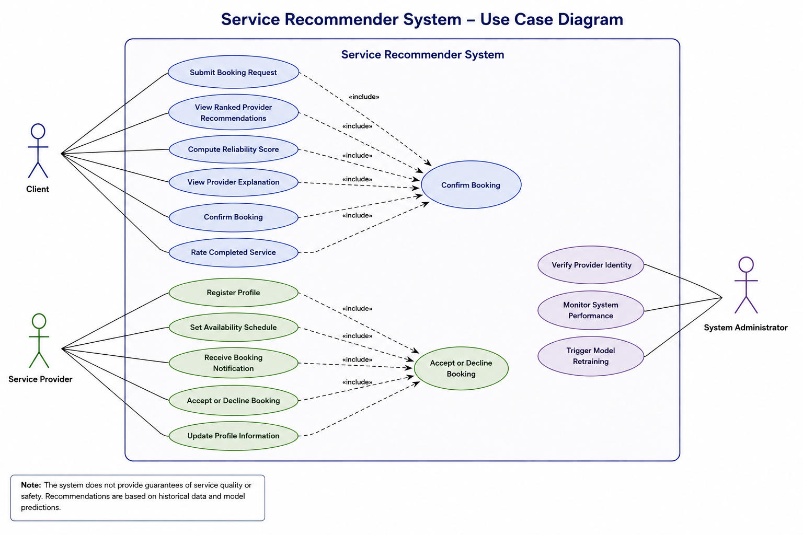

4.2 Class Diagram

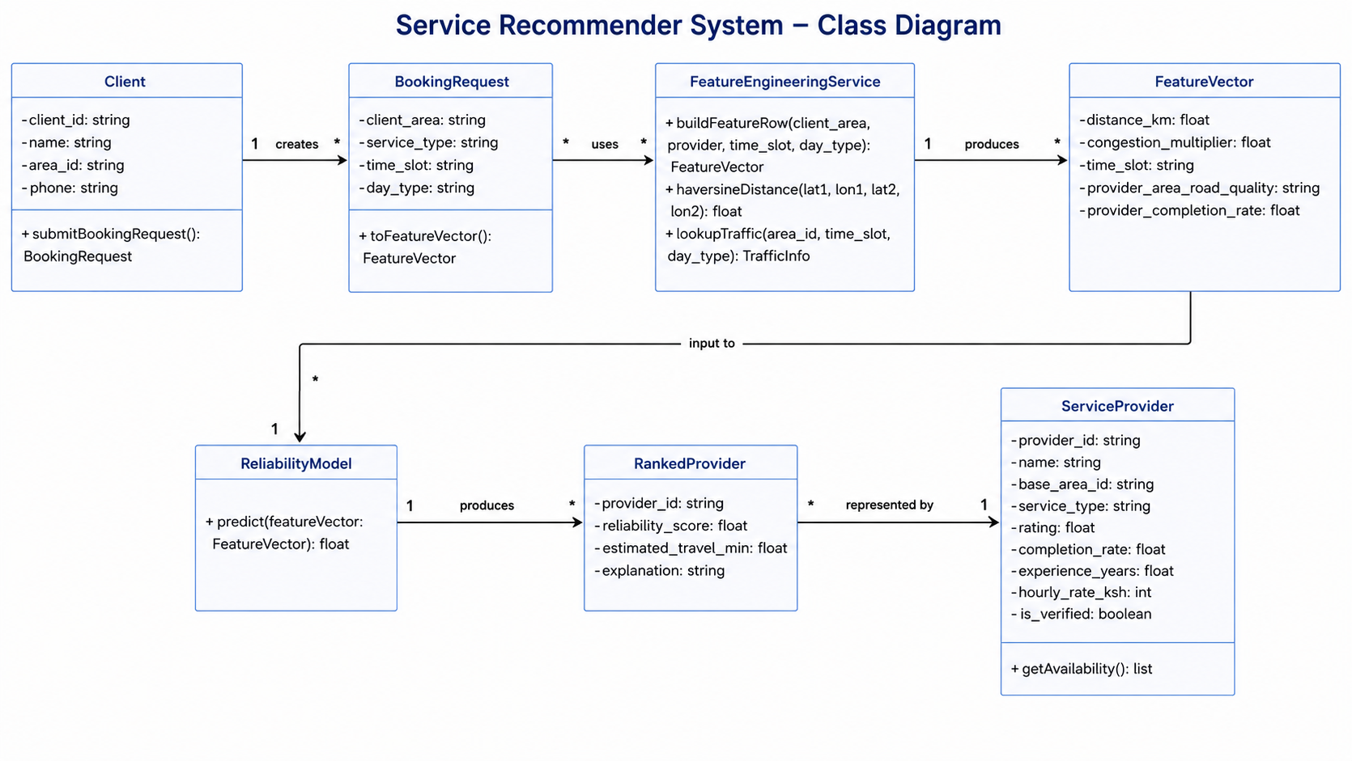

4.3 Entity Relation Diagram

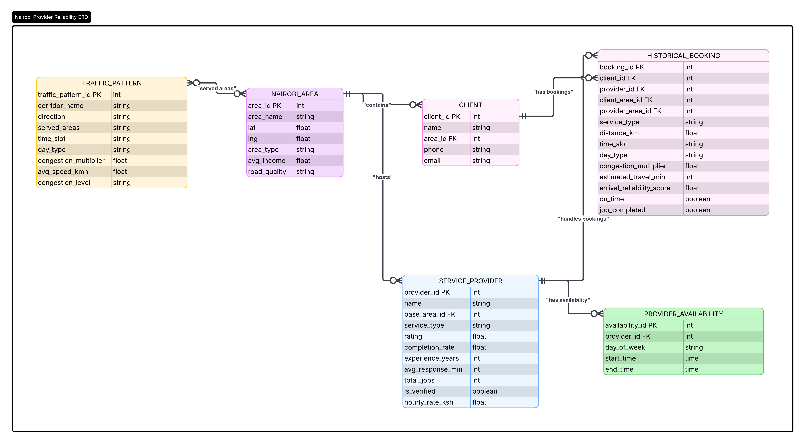

4.4 Database Schema

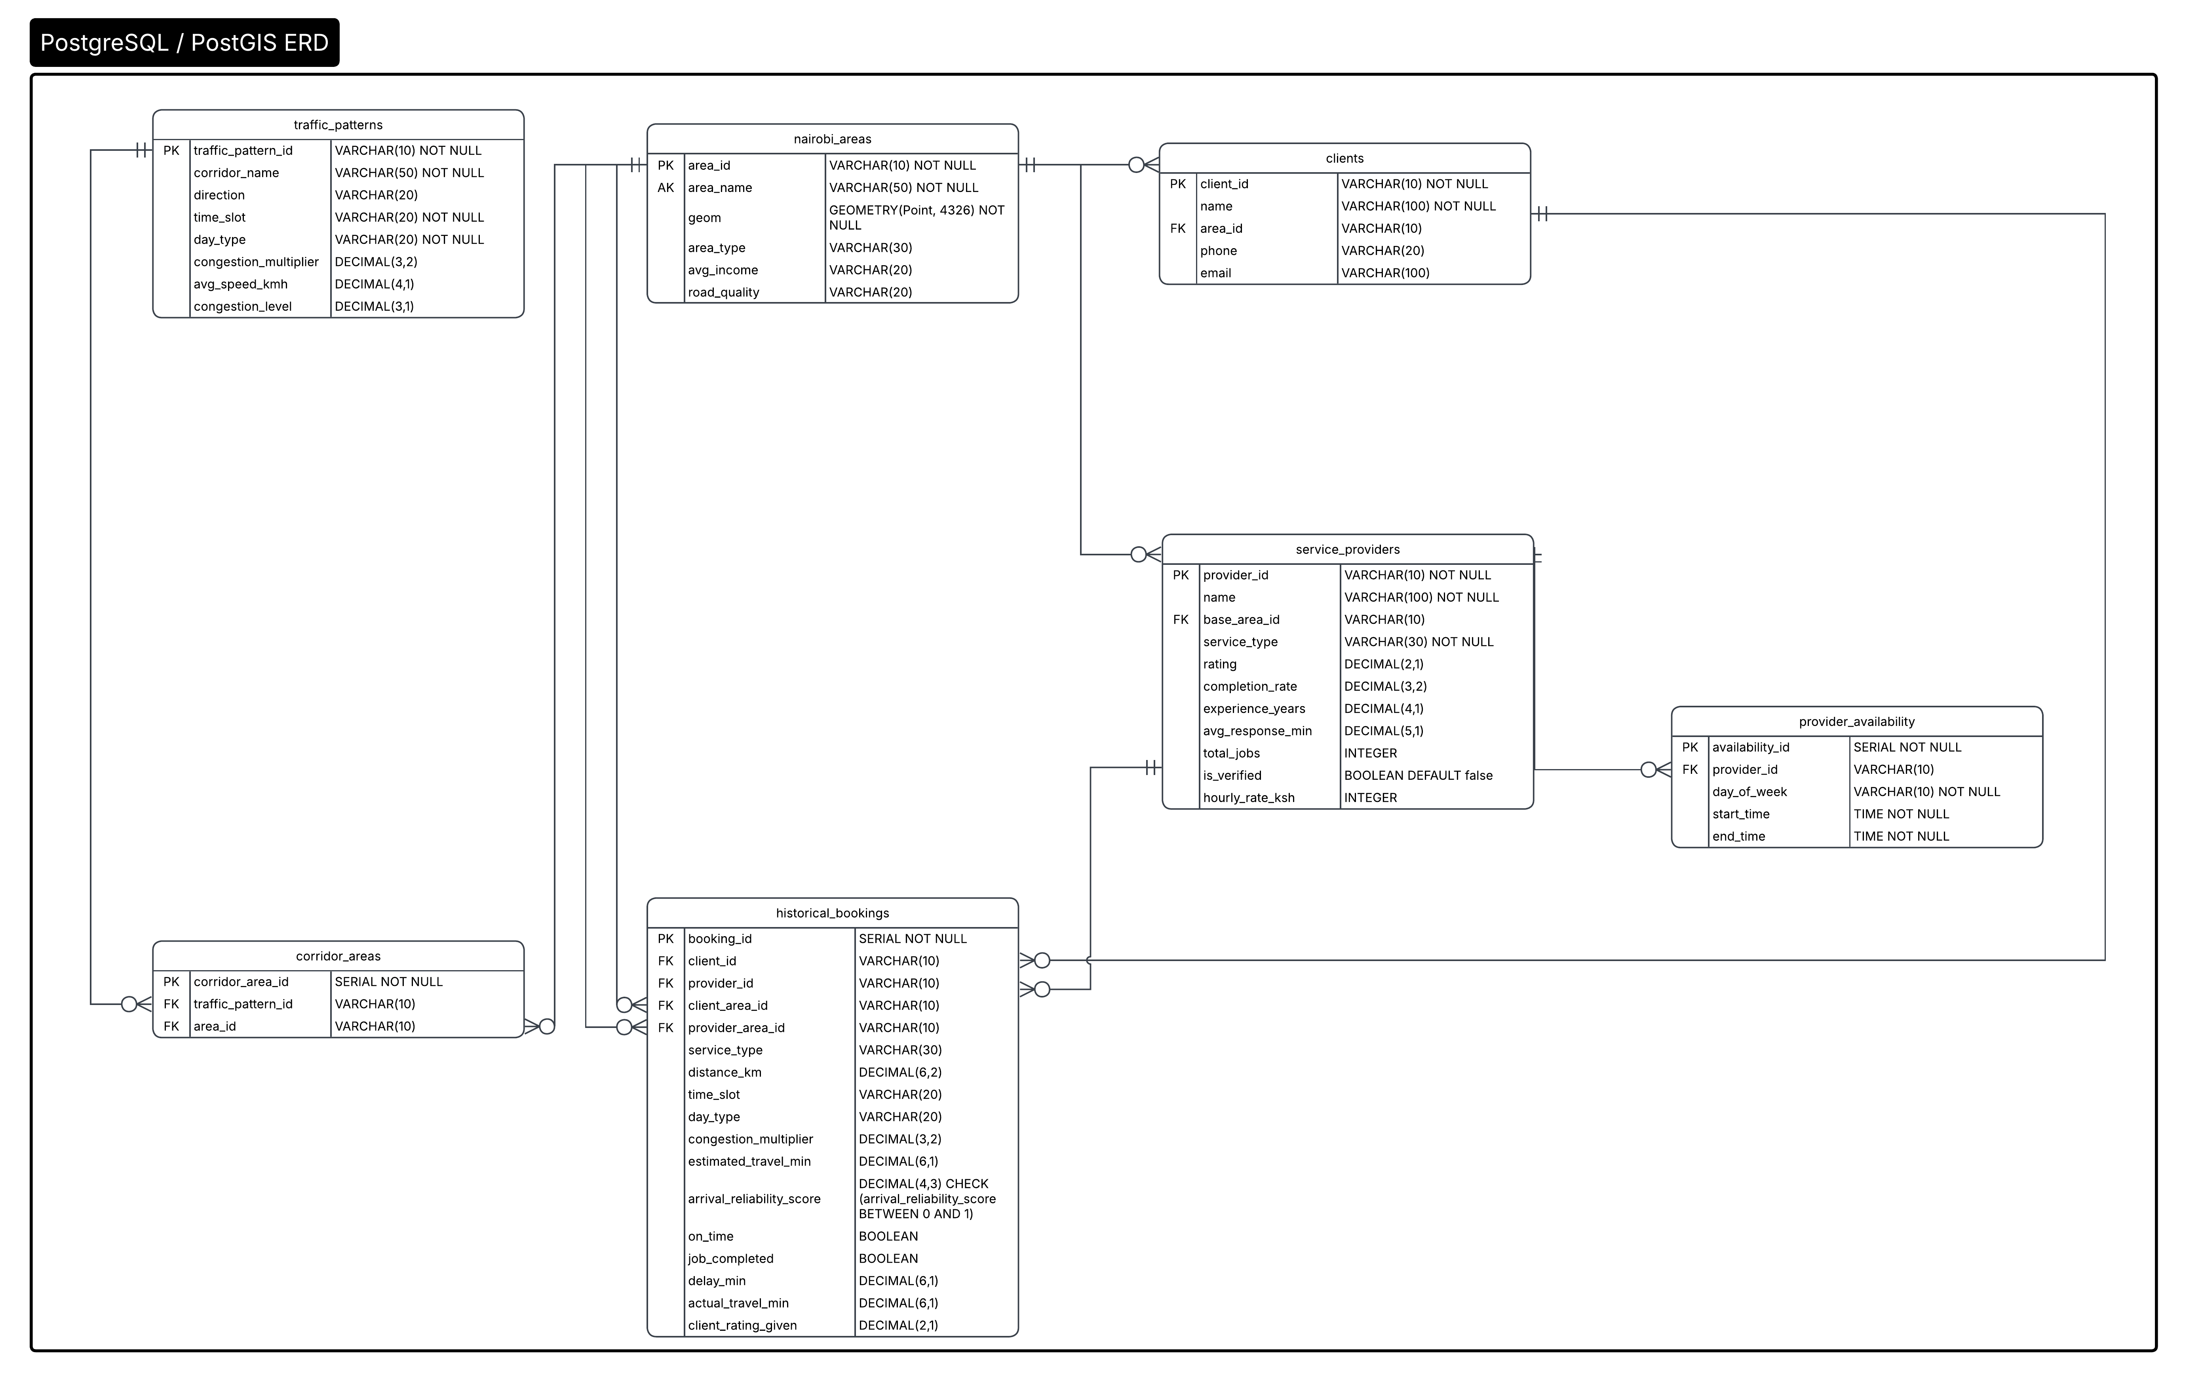

4.5 System Architecture Diagram

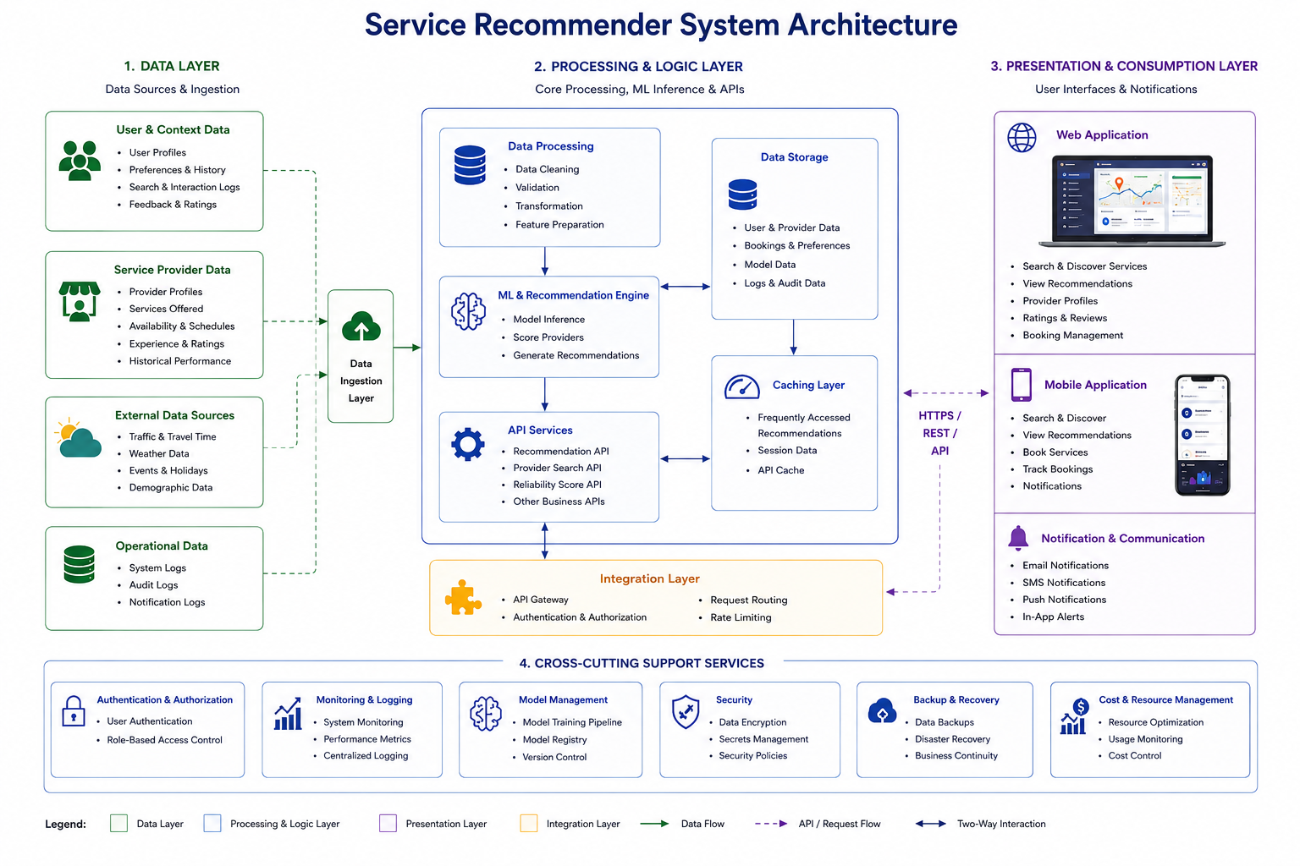

References
Adomavicius, G., Mobasher, B., Ricci, F., & Tuzhilin, A. (2011). Context-aware recommender systems. AI Magazine, 32(3), 67–80.
Bast, H., Delling, D., Goldberg, A. V., Müller-Hannemann, M., Pajor, T., Sanders, P., Wagner, D., & Werneck, R. F. (2016). Route planning in transportation networks. In L. Kliemann & P. Sanders (Eds.), Algorithm engineering (pp. 19–80). Springer. https://doi.org/10.1007/978-3-319-49487-6_2
Chen, T., & Guestrin, C. (2016). XGBoost: A scalable tree boosting system. In Proceedings of the 22nd ACM SIGKDD International Conference on Knowledge Discovery and Data Mining (pp. 785–794). https://doi.org/10.1145/2939672.2939785
Daily Nation. (2025, October 27). Gridlocked capital: Mapping Nairobi's worst traffic hotspots and timings. Nation Media Group. https://nation.africa/kenya/counties/nairobi/
Fundis App. (2023). Fundis: Find skilled workers near you [Mobile application]. Fundilink Technologies.
Haer, T., et al. (2025). Towards modeling road access deprivation in Sub-Saharan Africa based on a new accessibility metric and road quality (arXiv:2512.02190). arXiv. https://arxiv.org/abs/2512.02190
Hastie, T., Tibshirani, R., & Friedman, J. (2009). The elements of statistical learning: Data mining, inference, and prediction (2nd ed.). Springer. https://doi.org/10.1007/978-0-387-84858-7
Huang, H., Pouls, M., Meyer, A., & Pauly, M. (2020). Travel time prediction using tree-based ensembles. In E. Lalla-Ruiz (Ed.), Computational logistics: 11th International Conference, ICCL 2020, Enschede, The Netherlands, September 28–30, 2020, Proceedings (pp. 412–427). Springer. https://doi.org/10.1007/978-3-030-59747-4_27
Japan International Cooperation Agency. (2006). Nairobi urban transport master plan study. Ministry of Roads and Public Works, Kenya. https://openjicareport.jica.go.jp/pdf/11823093_02.pdf
Kazi Connect. (2023). Kazi Konekt: On-demand worker dispatch platform [Mobile application]. Kazi Technologies.
Kenya National Bureau of Statistics. (2019). Kenya population and housing census volume I: Population by county and sub-county. Kenya National Bureau of Statistics. https://www.knbs.or.ke Kenya Roads Board. (2023). Kenya road inventory and conditions survey 2023. Government of Kenya. https://maps.krb.go.ke
Mama Fua. (2023). Mama Fua: Professional cleaning services [Mobile application]. Mama Fua Ltd.

Mutono, N., Wright, J. A., Mutunga, M., Mutembei, H., & Thumbi, S. M. (2022). Impact of traffic congestion on spatial access to healthcare services in Nairobi. Frontiers in Health Services, 2, Article 788173. https://doi.org/10.3389/frhs.2022.788173
Ricci, F., Rokach, L., & Shapira, B. (2015). Recommender systems: Introduction and challenges. In
F. Ricci, L. Rokach, & B. Shapira (Eds.), Recommender systems handbook (2nd ed., pp. 1–34). Springer. https://doi.org/10.1007/978-1-4899-7637-6_1
Shah, U. (2021). Nairobi's growing nucleus and deteriorating speeds. Uber Movement Blog. https://medium.com/uber-movement/nairobis-growing-nucleus
TomTom International BV. (2025). TomTom traffic index 2025: Nairobi. https://www.tomtom.com/traffic-index/city/nairobi
Wirth, R., & Hipp, J. (2000). CRISP-DM: Towards a standard process model for data mining. In Proceedings of the 4th International Conference on the Practical Applications of Knowledge Discovery and Data Mining (Vol. 1, pp. 29–39).

Appendices

Appendix A1: Time Schedule

