Flashlamp Annealing for Improved Ferroelectric Junctions

Master’s Degree Project

**Theodor Blom**

Lund University

Project Duration: 12 months, 60 hp

October 26, 2021



**Mattias Borg**

Division of Nano Electronics,

Department of Electrical and Informations Technology, Faculty of Engineering, LTH,

Lund University

**Rainer Timm**

Division of Synchrotron Radiation, Department of Physics,

Faculty of Science, Lund University

**Contents**

1. Introduction 1
2. Semiconductors and Ferroelectrics 1
   1. III-V Semiconductors 1
   2. Ferroelectricity 1
      1. HfZrO2 1
   3. Energyband Theory and Leakage Mechanics 1
3. Fabrication 1
   1. Processing Methods 1
      1. ALD 1
      2. Flashlamp Annealing 1
   2. Sample Fabrication Process 1
4. Electrical Charcterization 1
   1. PUND and Endurance 2
   2. UniCV 2
5. Results and Analysis 2
6. Conclusion 2
7. References 3

**Abstract**

Abstract here!

# Introduction

M˚al: Introducera omr˚adet och ge en ¨overblick.[1]

# Semiconductors and Ferroelectrics

M˚al: Klarg¨ora varf¨or III-V (utg˚a fr˚an Si) och FE ¨ar intressant. Varf¨or g¨or vi detta? Vad ¨ar applikationern? F˚a med FTJ h¨ar!

## III-V Semiconductors

M˚al: Redog¨or f¨or varf¨or III-V ¨ar intressant. Direkt bandgap, l¨agre DOS –¿ FTJ

## Ferroelectricity

M˚al: Basics of FE; Kristallstrukturer (faser), Polarisation, Dom¨aner och PE-kurvor.

### HfZrO*2*

M˚al: Redog¨or f¨or FE-HfO2 och beskriv hur Zr kommer in i bilden.

## Energyband Theory and Leakage Mechanics

M˚al: Redog¨or f¨or hur energibanden ser ut med Semiconductor-Insulator-Metal-cap och g˚a igenom de olika tunnels¨atten.

# Fabrication

M˚al: Redog¨or f¨or hela processen p˚a LNL.

## Processing Methods

M˚al: Redog¨or f¨or dem mest intressanta/relevanta metoderna. Kanske bara ALD och FLA?

### ALD

### Flashlamp Annealing

## Sample Fabrication Process

M˚al: Redog¨or f¨or hela min process.

# Electrical Charcterization

M˚al: Redog¨or f¨or metoderna p˚a E-huset.

## PUND and Endurance

## UniCV

Fr˚agor att besvara:

* Hur funkar metoden?
* Vilka defekter ser vi med denna metod?

# Results and Analysis

Introduce the concept of film temperature and how that is essential for the crystalisation. Crys- talisation through RTP gives Tpeak = set temperature since crystalisation is done over long time frames (30 sec). For FLA we need to simulate the structure to find the achieved temperature. Bring up the baseline for flashing again since it is important for the simulations (250C preheat, 5ms flash).



Figure 1: Figure showing how flashintensity relates to the peaktemperarure of the films through simulations. From this figure onwards we can then stick to Peak Temperature instead of Flash Intensity.

Establish the baseline for our RTP references with RTP temperatures and times as well as mea- sured *Pr* and *Ec*. Relate the Tpeak in the simulations to what we could expect in terms of differences between FLA and RTP. Awknowledge the data in figure 2 and discuss.

Data shown in figure 2 is promising but lacks the desired *Pr* . Increasing Tpeak further only gives worse results. Introduce the idea of lowering Tpeak and increasing the number of flashes.

# Conclusion

M˚al: Wrap it up. L¨agg fram de fr¨amsta resultaten/ideerna och ge tips p˚a hur man kan unders¨oka vidare.

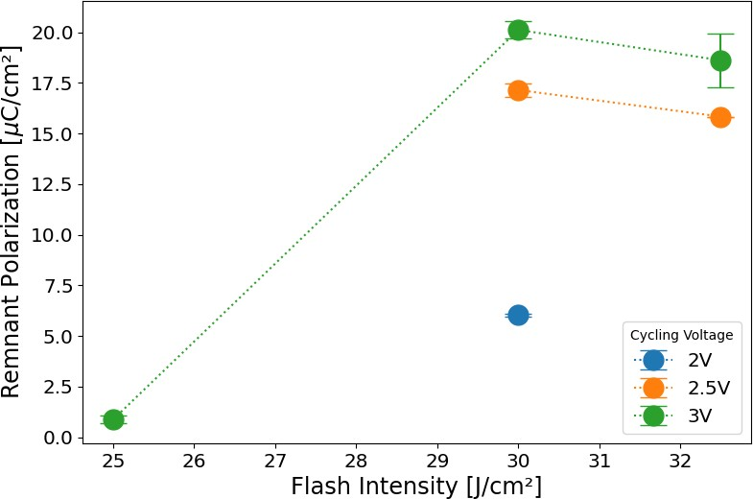

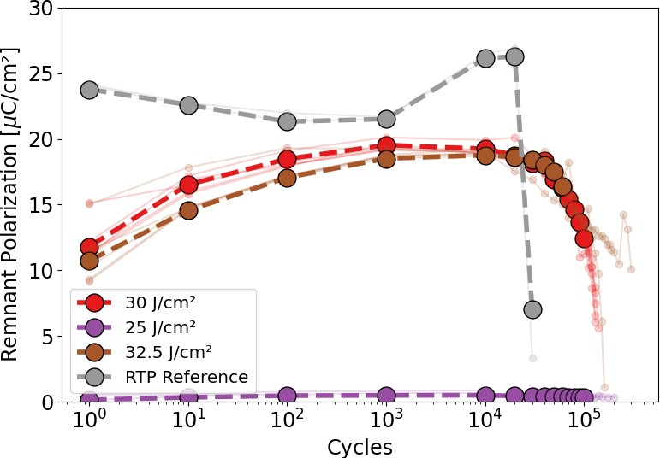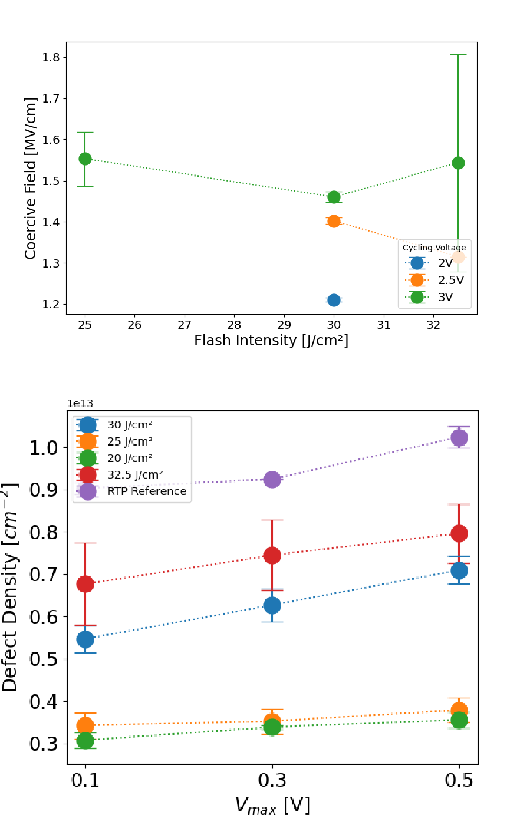Figure 2: Figure showing all measured data from the first intensity-varied batch. Low-doped subtrate, 200C ALD, HZO 1:1, 250C preheat, 5ms flash. RTP refer- ence is included.

# References

[1] R. Atle, “Development of ferroelectric hafnium oxide for negative capacitance field effect tran- sistors,” *LUP Student Papers*, 2019.

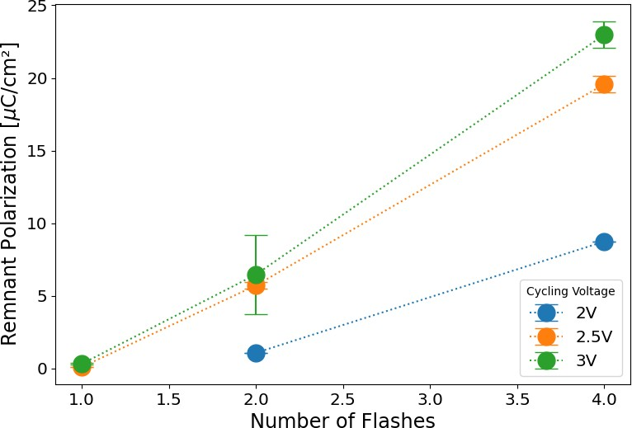

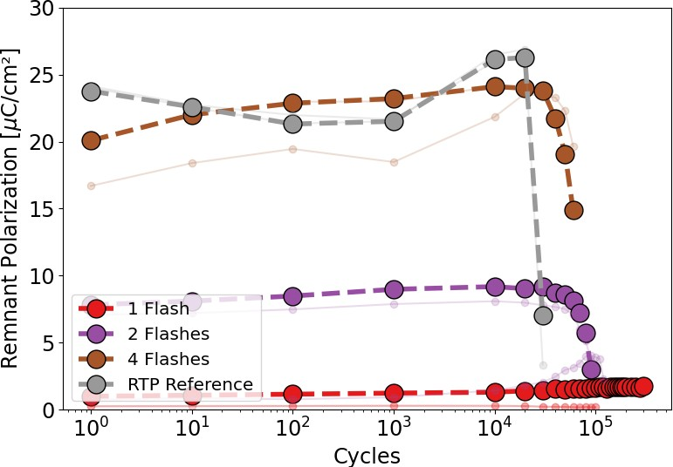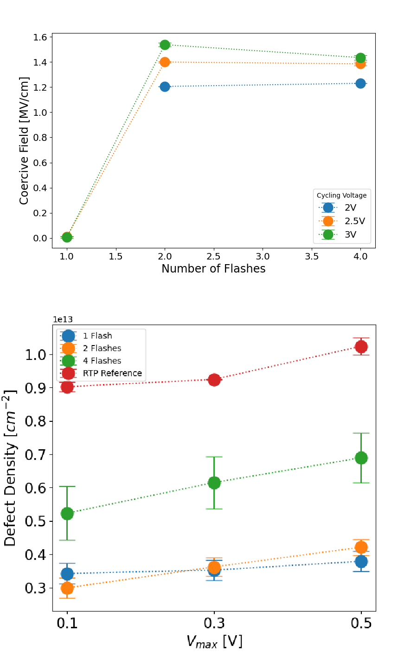Figure 3: Figure showing all measured data from the first flashnumber-varied batch. Low-doped subtrate, 200C ALD, HZO 1:1, 250C preheat, 5ms flash at 25 J*/*cm2. RTP reference is included.

 

Figure 4: Figure showing all measured data from the second flashnumber-varied batch. Low-doped subtrate, 200C ALD, HZO 1:1, 250C preheat, 5ms flash at 20 J*/*cm2. RTP reference is included.