**COIMBATORE INSTITUTE OF TECHNOLOGY**

**2. ANALYSIS ON BRAZIL HOUSE RENT DATA TO PREDICT HOUSE RENT**

- THEEPAN KUMAR G (1832057)

**AIM:**

To predict the house rent of Brazil based on other components in the dataset.

**DESCRIPTION:**

Rent of a house increase or decrease depends on various factors like area, location ,facility, pet, safe and security, etc. But not all factors were responsible to affect the house rent. The project aimed to predict the house rent(Brazil) from the given data. In order to predict the output we have to determine the key factors that affects the house rent. By using such factors , Better results(Rent) can be predicted using it. For this problem Multiple Linear Regression is Best to predict house rent.

**CODE:**

**#IMPORTING PACKAGES**

import numpy as np

import pandas as pd

import seaborn as sns

import matplotlib.pyplot as plt

**#READING DATA FROM LOCAL MACHINE AND STORE IT AS A DATAFRAME**

df = pd.read_csv(r'C:/Users/THEEPAN/Desktop/houses_to_rent.csv')

df.head()

**OUTPUT:**

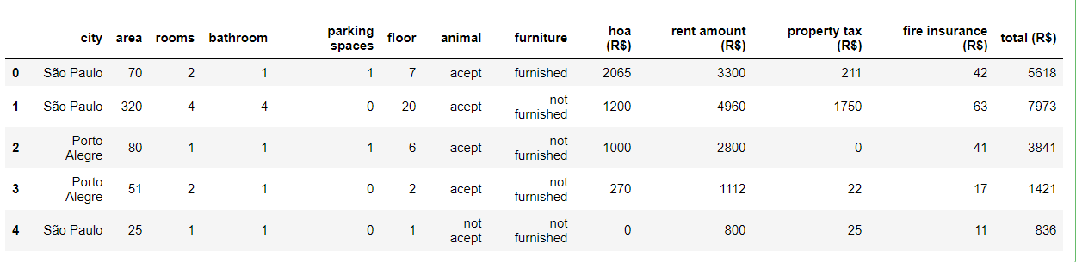

**#EXPLORATORY DATA ANALYSIS**

**#ALL COLUMNS IN DATASET**

all_cols = df.columns

all_cols

**OUTPUT:**

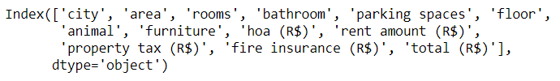

**#INFORMATION ABOUT THE DATA FRAME**

df.info()

**OUTPUT:**

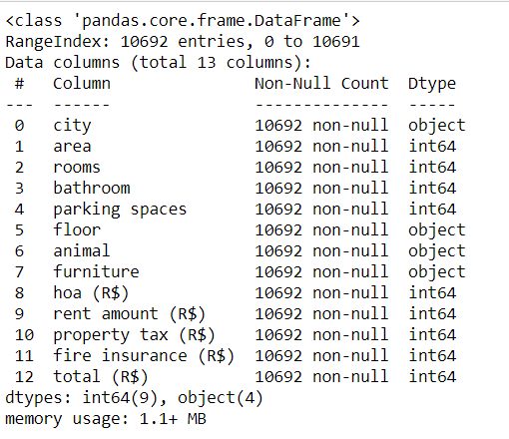

**#SUMMARY STATISTICS**

df.describe()

**OUTPUT:**



**#REPALCING MISSING VALUES**

cols = df.columns

cols = cols.map(lambda x: x.replace(' ','_') if isinstance(x, (str)) else x)

df.columns = cols

**#CHANGE "$" FOR USE QUERIES**

df.rename(columns={'hoa_(R$)' : 'hoa',

'rent_amount_(R$)' : 'rent_amount',

'property_tax_(R$)' : 'property_tax',

'fire_insurance_(R$)' : 'fire_insurance',

'total_(R$)' : 'total'}, inplace = True)

df.head()

**OUTPUT:**

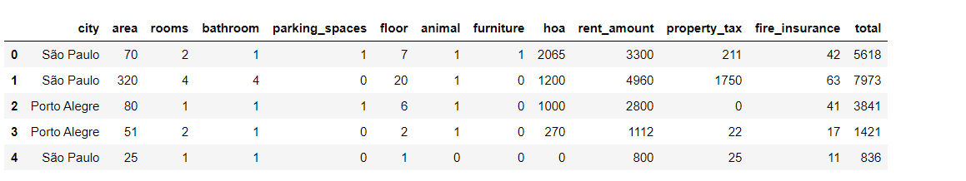

**#COUNT PLOT FOR FURNITURE**

fc = sns.countplot(df['furniture'], hue = df['city'])

fc.figure.set_size_inches(12, 8)

fc.set_title('Furniture Count',fontsize=15)

fc.set_xlabel('Furniture',fontsize=13)

fc.set_ylabel('Count', fontsize=13)

fc.set_xticklabels(['No','Yes'], fontsize=13)

**OUTPUT:**

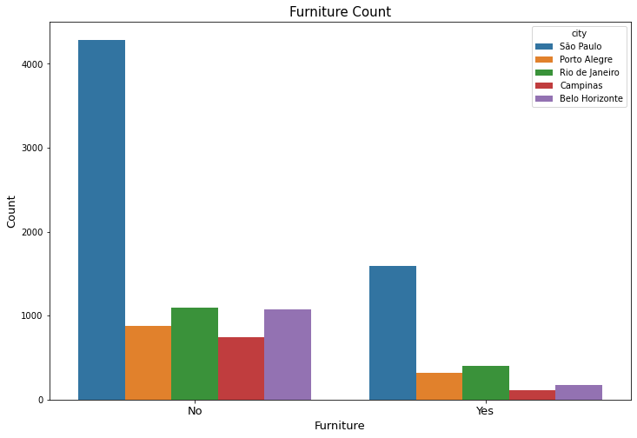

**#BARPLOT FOR NUMBER OF ROOMS WITH SIZE OF AREA**

bs = sns.barplot(x='rooms', y='area', data = df, palette = 'Accent’)

bs.figure.set_size_inches(15, 10)

bs.set_title('Rooms vs Area size',fontsize=15)

bs.set_xlabel('Number of rooms', fontsize=13)

bs.set_ylabel('Area Size', fontsize=13)

**OUTPUT:**

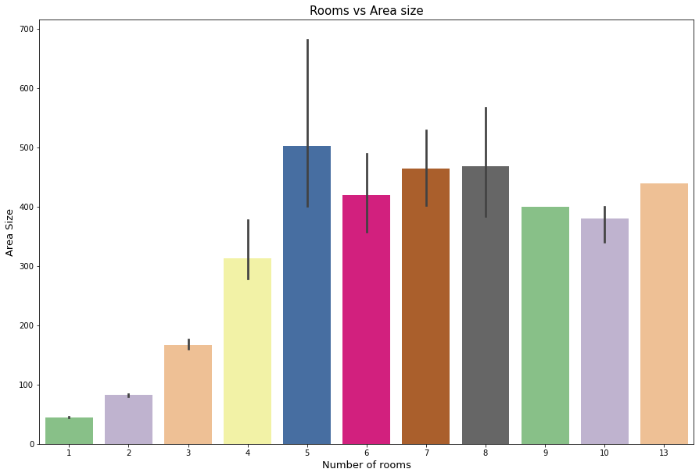

**#SCATTER PLOT FOR TOTAL RENT VS HOA TAX**

df = df.drop(labels=df[(df['hoa'] > 300000)].index)

df = df.drop(labels=df[(df['total'] > 30000)].index)

th = sns.scatterplot(x = 'total', y = 'hoa', data = df)

th.figure.set_size_inches(15, 10)

th.set_title('Total Rent vs HOA Tax',fontsize=15)

th.set_xlabel('Total Rent(R$)', fontsize=13)

th.set_ylabel('HOA Tax (R$)', fontsize=13)

**OUTPUT:**

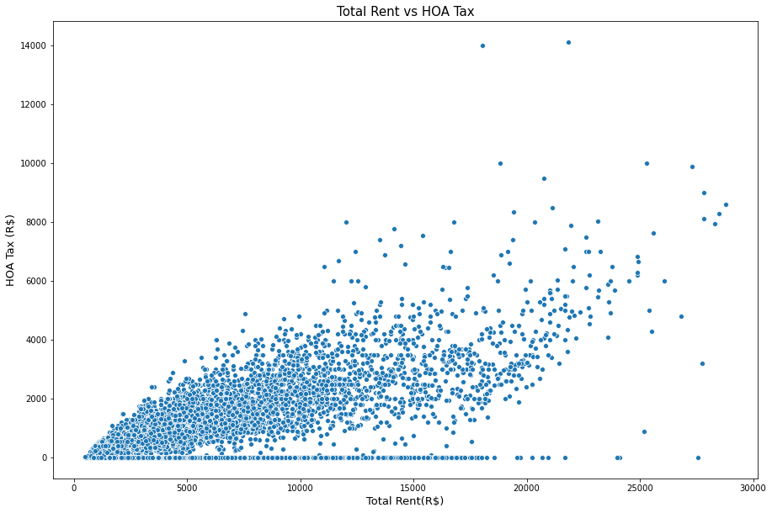

**#HEAT MAP TO FIND BETTER CORRELATED VALUES FOR TOTAL RENT**

cor = df.corr()

plt.figure(figsize=(15,10))

sns.heatmap(df.corr(), annot=True )

**OUTPUT:**

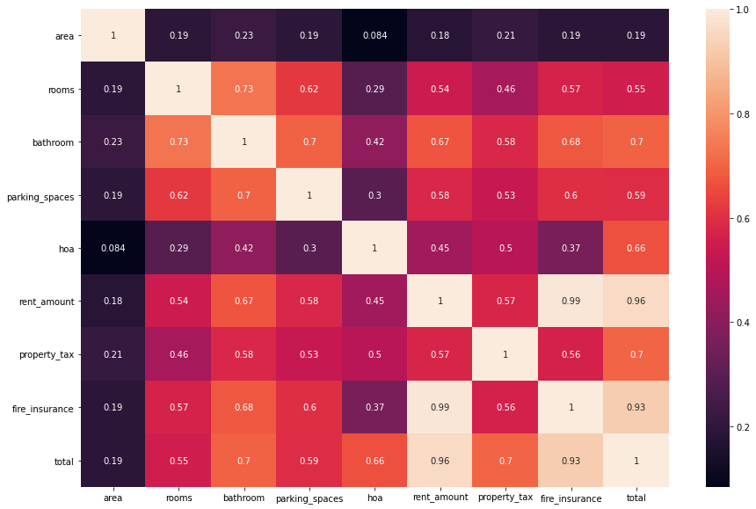

**#BATROOMS, HOA PROPERTY_TAX, FIRE_INSURANCE WERE MORE CORRELATED WITH RENT_AMOUNT**

req_cols = cor[cor.loc['rent_amount']>0.5].T.columns

req_cols

**OUTPUT:**

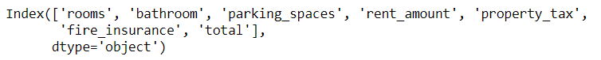

**#PAIRPLOT FOR RENT_AMOUNT WITH REQ_COLS**

ax = sns.pairplot(df, y_vars='rent_amount', x_vars=req_cols)

ax.fig.suptitle('Scatter plots between variables(rent_amount vs other selected attributes)', fontsize=20, y=1.1)

ax

**OUTPUT:**

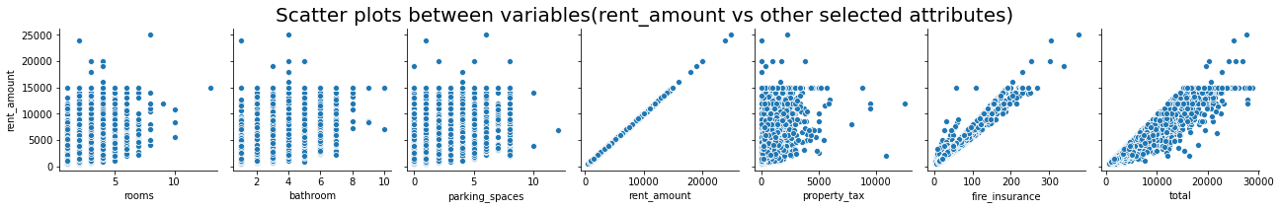

**#SELECTING X AND Y VALUES**

metrics = []

y = df['rent_amount']

x = df[req_cols]

**#IMPORTING PACKAGES FOR MODELS, SPLIT AND ACCURACY SCORES**

from sklearn.model_selection import train_test_split

from sklearn.linear_model import LinearRegression

from sklearn.metrics import mean_squared_error, mean_absolute_error, r2_score

**#SPLITTING INTO TRAINING AND TEST DATA USIG TRAIN_TEST_SPLIT**

x_train, x_test, y_train, y_test = train_test_split(x, y, test_size=0.3, random_state = 8)

**#FITTING AND TRAINING MODEL**

lr = LinearRegression()

lr.fit(x_train, y_train)

predict = lr.predict(x_test)

**#ADD A CONSTANT AND LOOKING THE SUMMARY**

import statsmodels.api as sm

x_train_constant = sm.add_constant(x_train)

model_sm = sm.OLS(y_train, x_train_constant, hascont = True).fit()

print(model_sm.summary())

#looking the metrics

print('MAE: ', mean_absolute_error(y_test, predict).round(3))

print('RMSE: ', np.sqrt(mean_squared_error(y_test, predict)).round(3))

print('R2:', r2_score(y_test, predict).round(3))

metrics.append(np.sqrt(mean_squared_error(y_test, predict)))

**OUTPUT:**

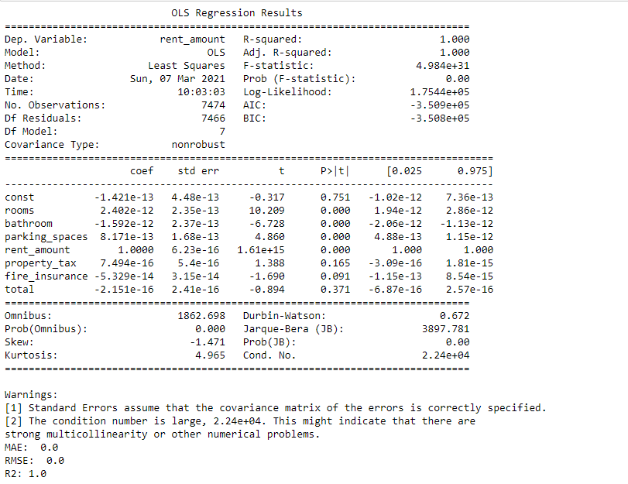

**INFERENCE:**

The test results shows that the r-square values(R2) is 1.00 with 0 RMSE and )MAE, which means the model is good enough to predict the house rent.

**RESULT:**

The value of r2(r-square) resembles 91% of accuracy score, which means the model is perfectly ready to predict the output(House rent). From my observation bathrooms, HOA propertytax, fireinsurance are the major factors that affects the house rent in Brazil. If this factors are high the rent of the house will be high, Otherwise the rent will decrease depends on the factors variation.