2. Display future leap years from current year to a final year entered by user.

PROGRAM
import datetime
date=datetime.date.today()
currentyear=int(date.strftime("%Y"))
print("enter the lastyear")
endyear=int(input())
print("list of leapyear")
for year in range(currentyear,endyear):
if((year%4==0)and(year%100!=0)or(year%400==0)):
print(year)

OUTPUT:

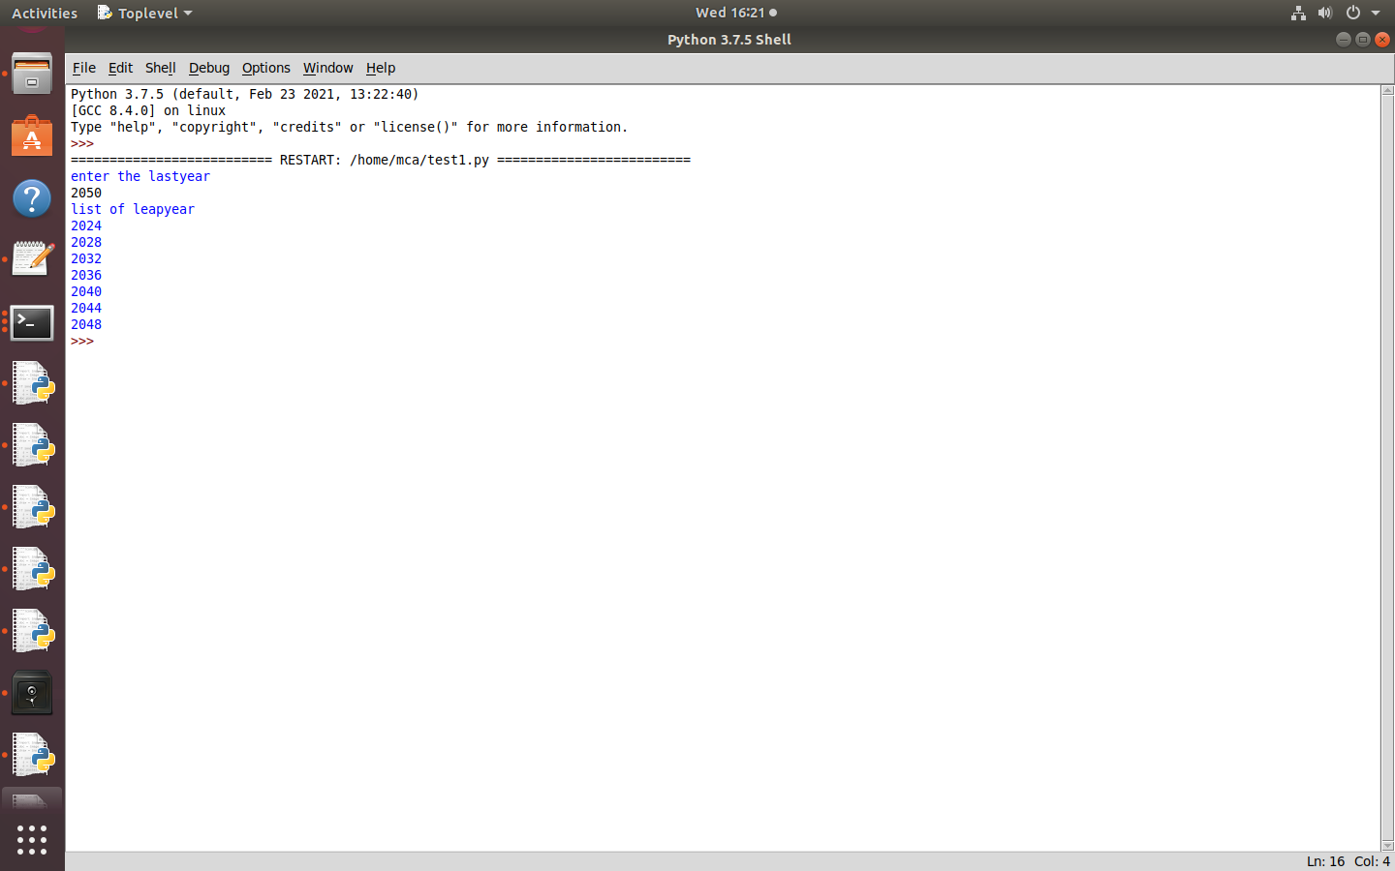

3. List comprehensions:
(a) Generate positive list of numbers from a given list of integers
(b) Square of N numbers

PROGRAM

numbers=[34.6,-203.4,44.9,68.3,-12.2,44.6,12.7]
newlist=[n for n in numbers if n>0]
print(newlist)

OUTPUT:

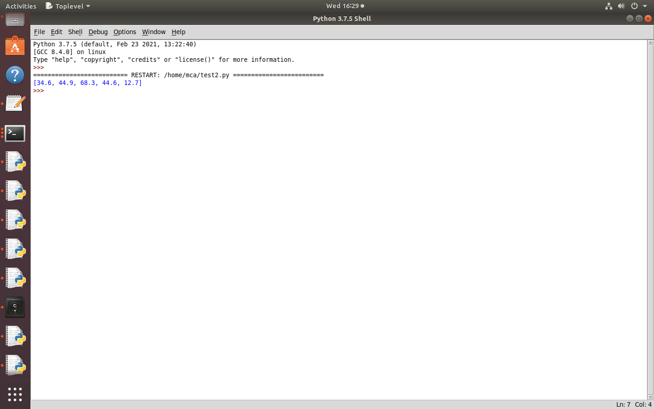

(b)Square of N numbers

PROGRAM

print(“Enter the limit”)
n=int(input())
squares=[i*i for i in range(n)]
print(“Square of “,n,”numbers:”,squares)

OUTPUT:

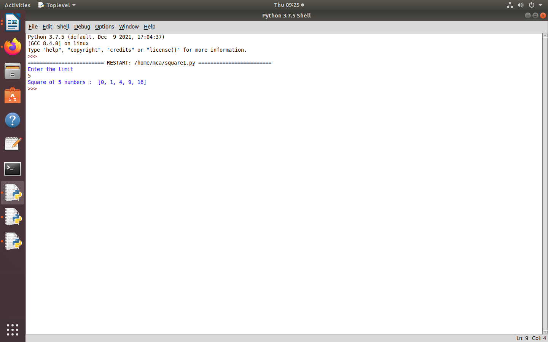

3. List comprehensions:
(c) Form a list of vowels selected from a given word

PROGRAM

word=input("Enter the sentence\n")
vowels=['a','e','i','o','u']
vow=[let for let in word if let in vowels]
print(vow)

OUTPUT:

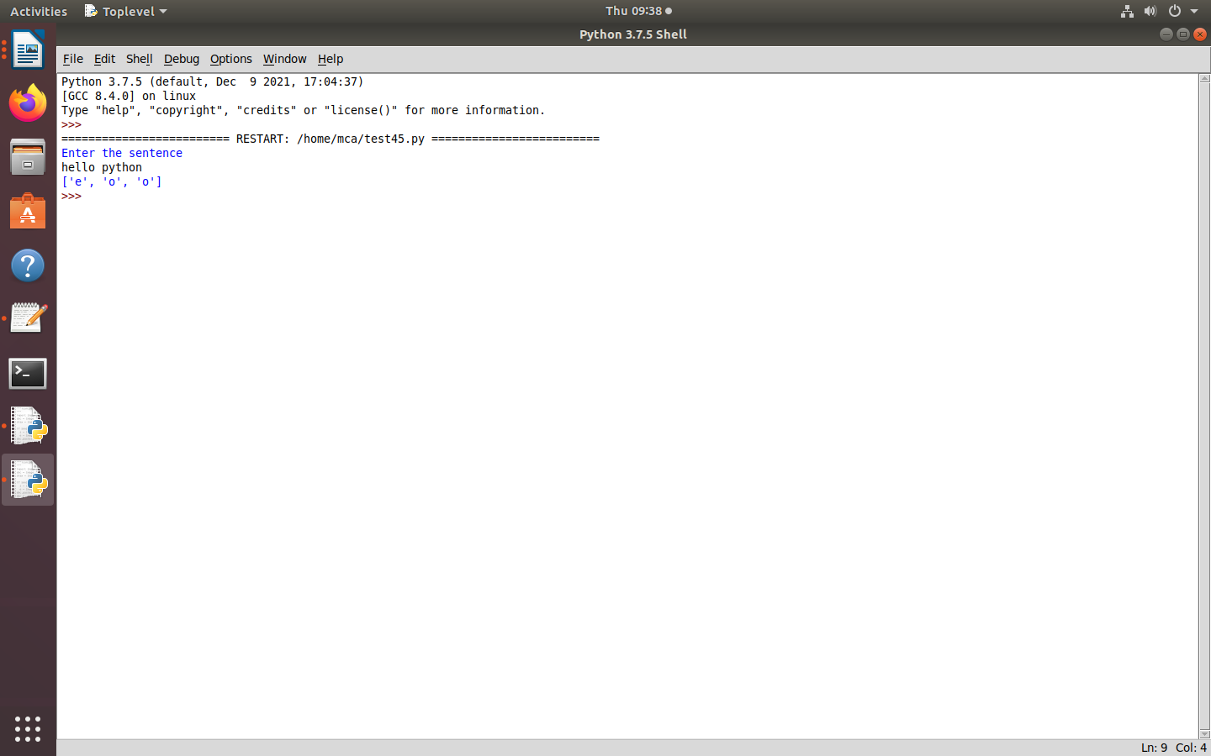

(d) List ordinal value of each element of a word (Hint: use ord() to get ordinal values)

PROGRAM

4. Count the occurrences of each word in a line of text.

PROGRAM

line=input("Enter the line:")
counts={}
sentence=line.split()
for word in sentence:
if word in counts:
counts[word]+=1
else:
counts[word]=1
for k,v in counts.items():
print(k,v)

OUTPUT:
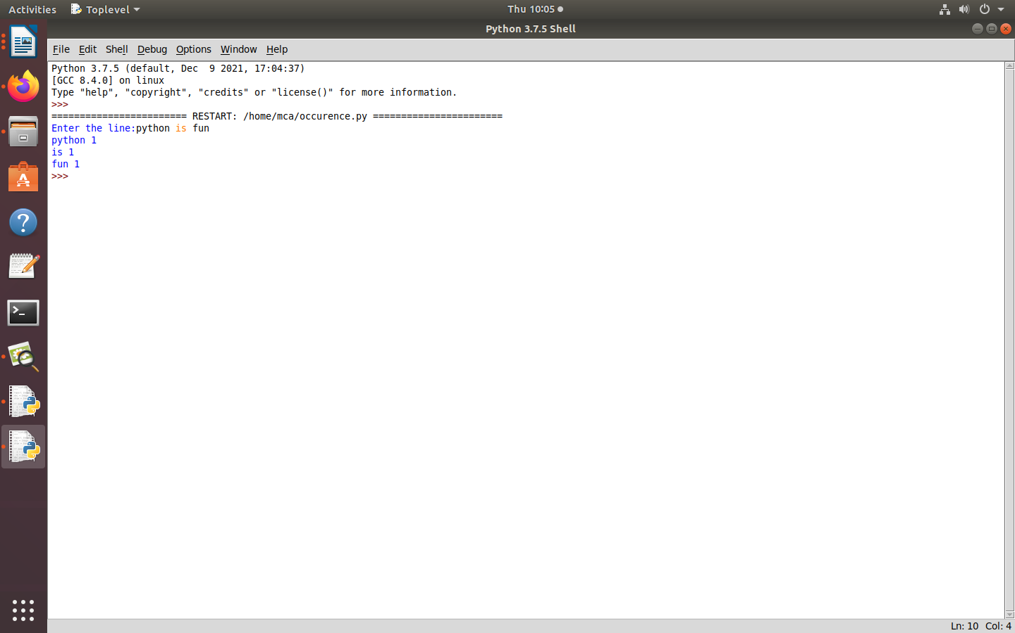

5.Prompt the user for a list of integers. For all values greater than 100, store ‘over’ instead.

PROGRAM

list=[10,20,50,70,140]
result=[]
for i in list:
if i>100:
result.append('over')
else:
result.append(i)
print(result)

OUTPUT:

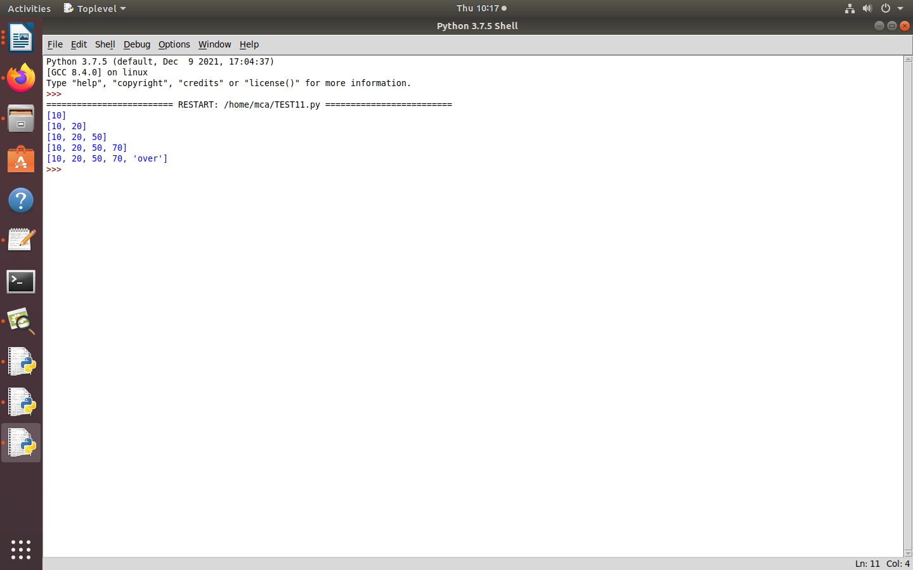

6. Store a list of first names. Count the occurrences of ‘a’ within the list

PROGRAM

Astr=input("Enter the string\n")
char=input("Enter the character\n")
print("Given string:\n",Astr)
print("Given character:\n",char)
res=0
for i in range(len(Astr)):
if(Astr[i]==char):
res=res+1
print("Number of time charecter is present in string:\n",res)

OUTPUT:

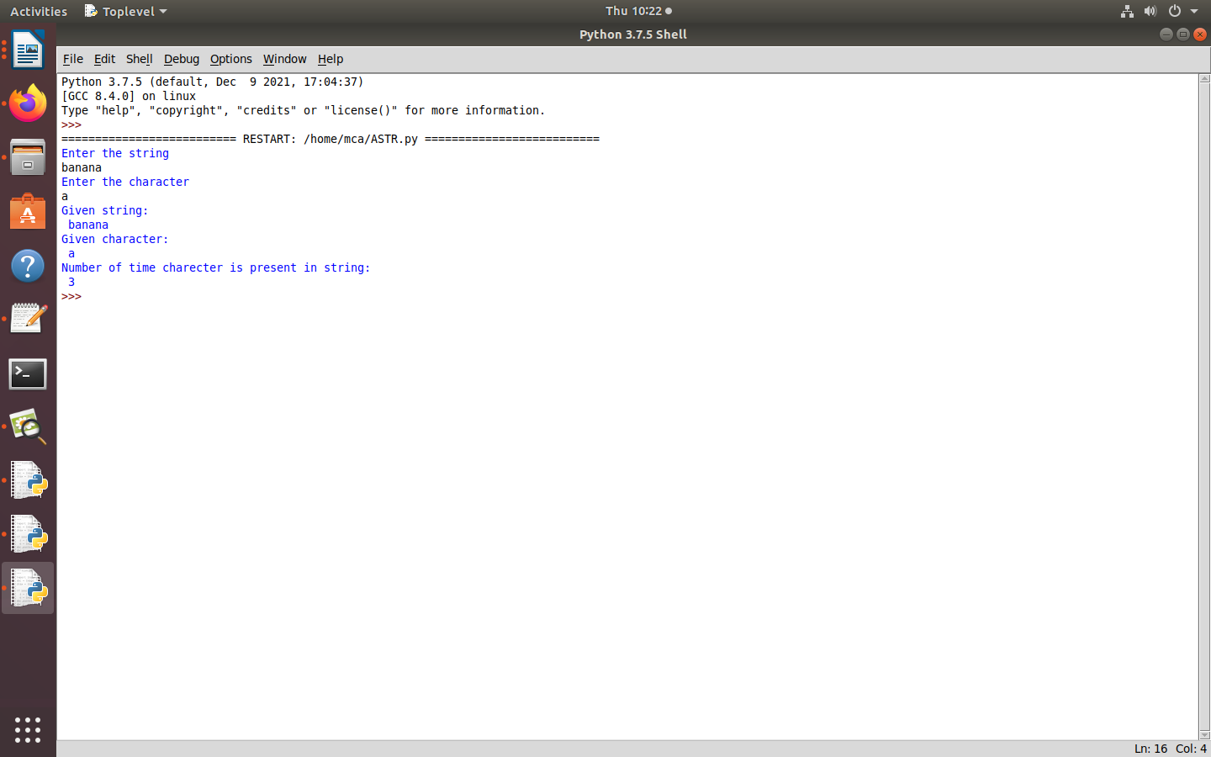

7. Enter 2 lists of integers. Check (a) Whether list are of same length (b) whether list sums to same value (c) whether any value occur in both

8. Get a string from an input string where all occurrences of first character replaced with ‘$’, except first character. [eg: onion -> oni$n]

PROGRAM

str1=input("Enter a string:")
char=str1[0]
str1=str1.replace(char,'$')
str1=char+str1[1:]
print("replace string",str1)

OUTPUT:

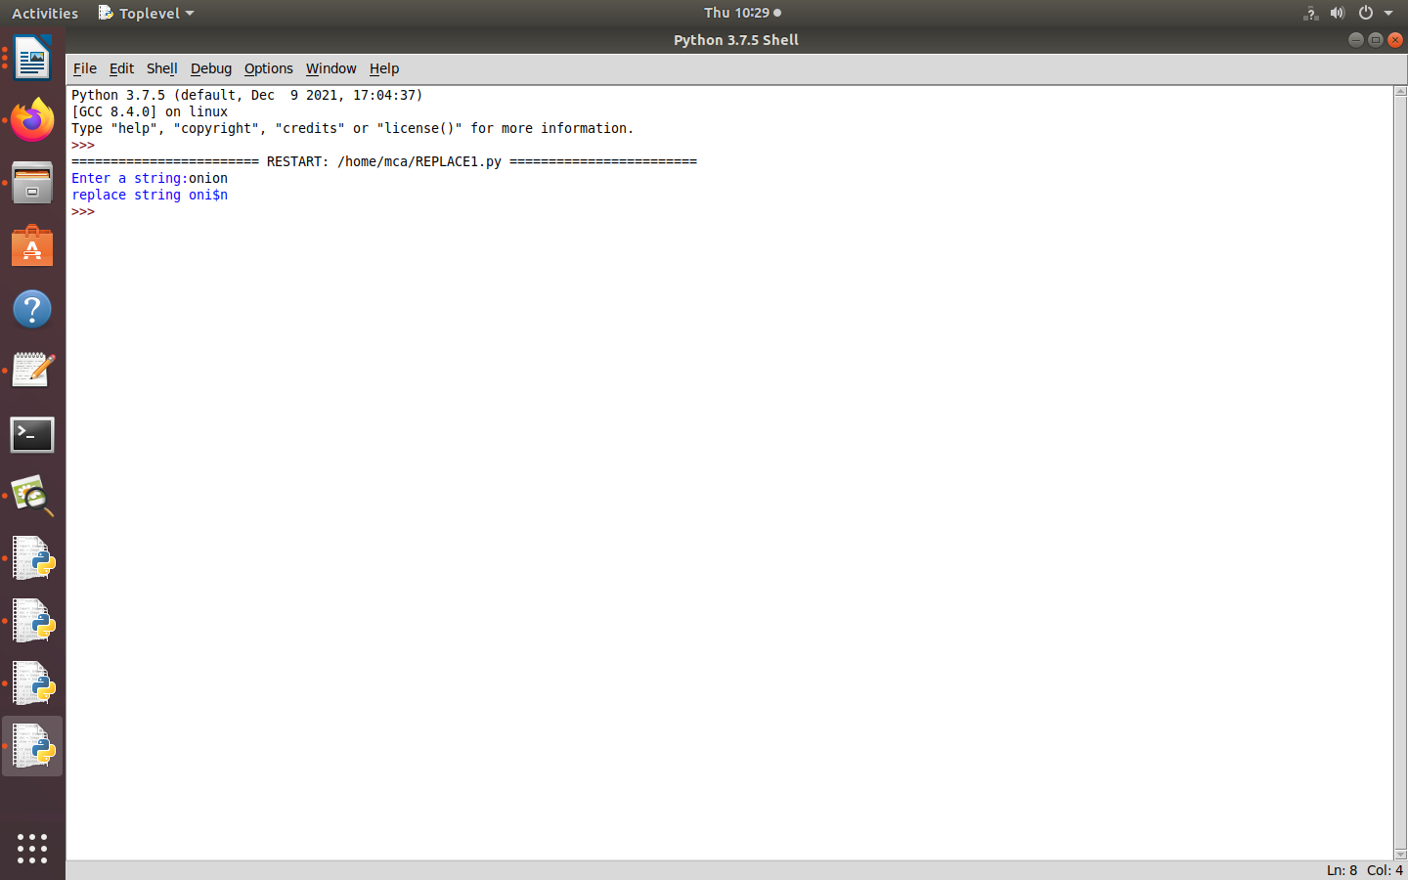

10. Accept the radius from user and find area of circle.

PROGRAM

import math
print("Enter the radius")
r=int(input())
area=math.pi*r*r
print("Area of circle",area)

OUTPUT:

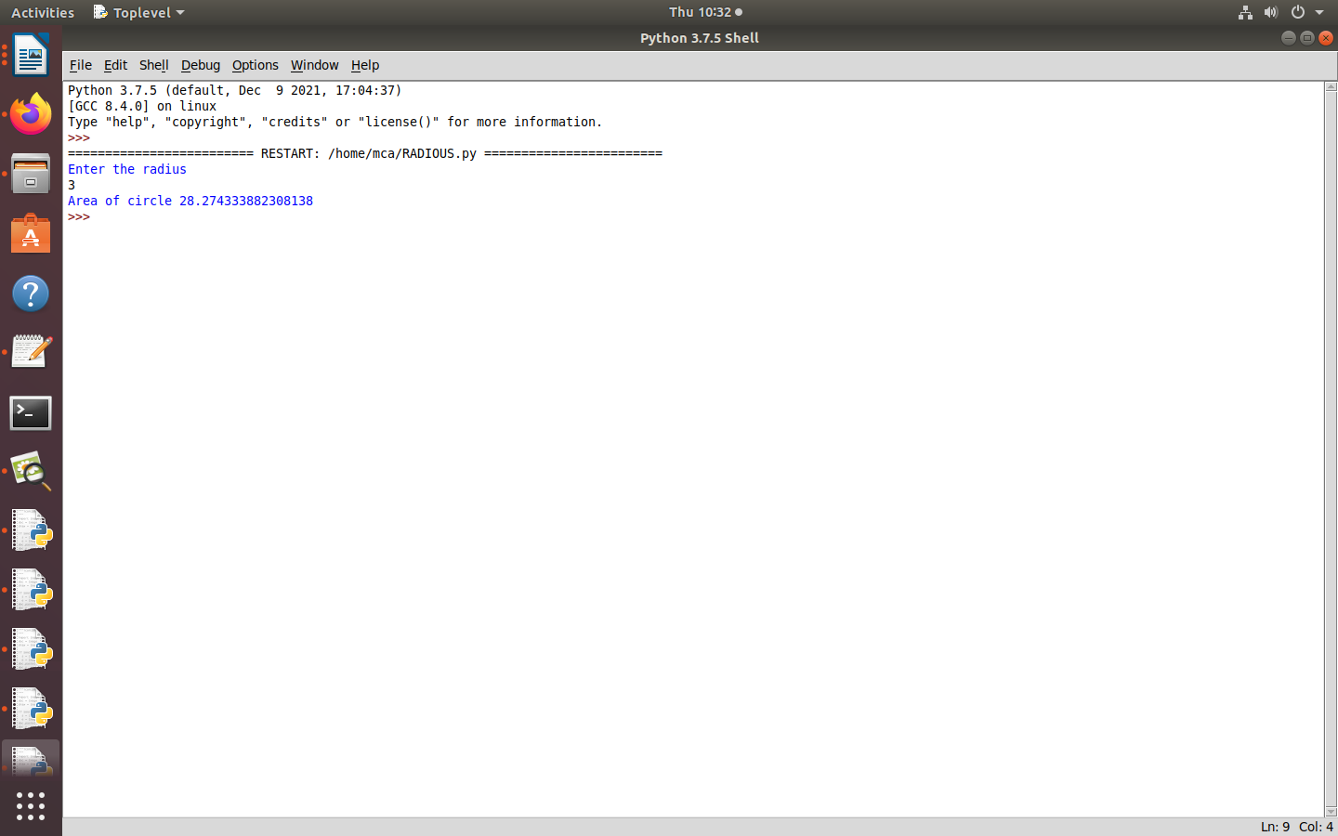

11. Find biggest of 3 numbers entered

PROGRAM

