# **EXPERIMENT 1**

**Aim**: To identify the major components of a computer system such as motherboard, ram modules, daughter cards, SMPS, bus loads, internal storage devices and interfacing ports. Specification of desktop and server class computers. Installation of common operating system for desktop and server use.

**COMPUTER HARDWARE**

Computer hardware includes the physical parts of a computer, such as the case, central processing unit (CPU), monitor, mouse, keyboard, computer data storage, graphic cards, sound card, speakers and motherboard.

Computer hardware can be categorized as being either internal or external components. Generally, internal hardware components are those necessary for the proper functioning of the computer, while external hardware components are attached to the computer to add or enhance functionality.

**MOTHERBOARD**

A motherboard is the main printed circuit board in general-purpose computers and other expandable systems. It holds and allows communication between many of the crucial electronic components of a system, such as the central processing unit and memory, and provides connectors for other peripherals.

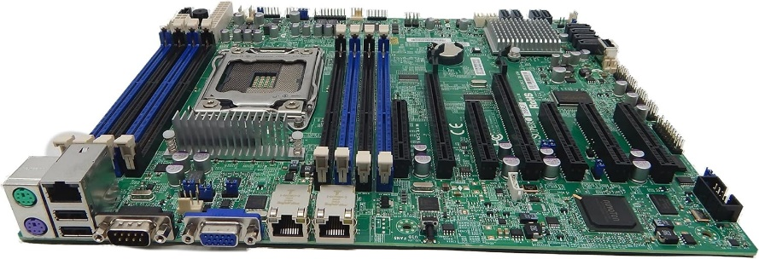

**RAM MODULES**

In computing, a memory module or RAM stick is a printed circuit board on which memory integrated circuits are mounted. Memory modules permit easy installation and replacement in electronic systems, especially computers such as personal computers, workstations, and servers.

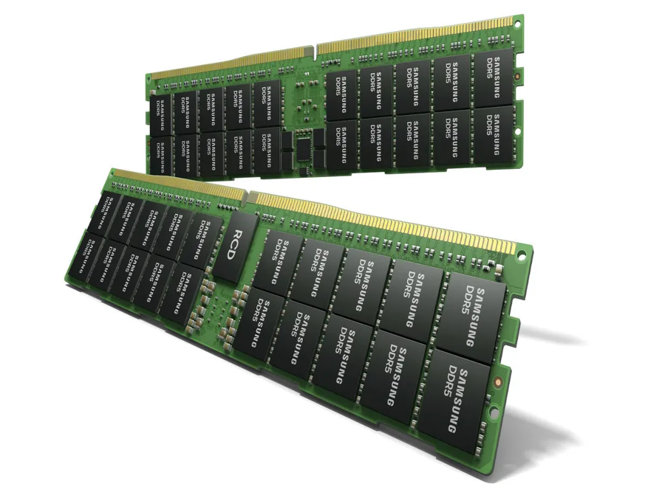

**DAUGHTER CARDS**

A daughter card (otherwise known as a controller card) is a variation of circuit boards. It gets ads

to the motherboard on a device to improve the device's functionality.

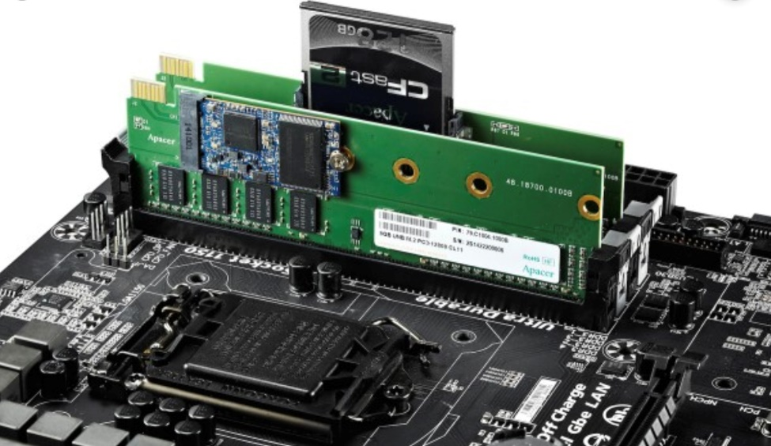

**BUS SLOTS**

Alternatively known as a bus slot or expansion port. A daughterboard (or *daughter board* , *daughter card* , or *daughtercard* ) is a circuit board that plugs into and extends the circuitry of another circuit board. The other circuit board may be the computer's main board (its motherboard ) or it may be another board or card that is already in the computer, often a [sound card](https://www.techtarget.com/whatis/definition/sound-card). The term is commonly used by manufacturers of wavetable daughterboards that attach to existing sound cards.

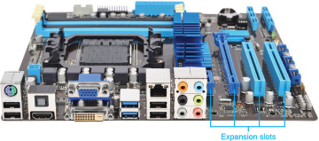

**SMPS**

A switched-mode power supply (SMPS), also called switching-mode power supply, switch-mode power supply, switched power supply, or simply switcher, is an electronic power supply that incorporates a switching regulator to convert electrical power efficiently.

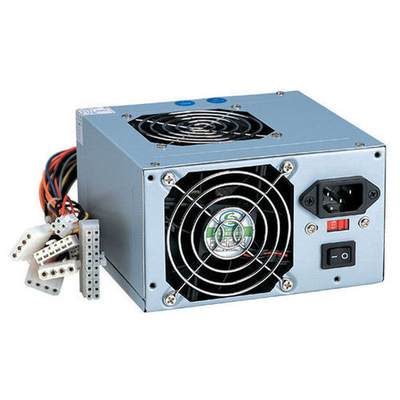

**INTERNAL STORAGE DEVICES**

Internal storage devices in a computer refer to components that are used to store and retrieve digital data within the computer system. These devices are essential for storing the operating system, applications, and user data. Here are some common types of internal storage devices found in computers.

**Hard Disk Drive (HDD):** HDDs are magnetic storage devices that use spinning disks to store data. They are a traditional and relatively inexpensive form of storage, but they are generally slower compared to newer technologies

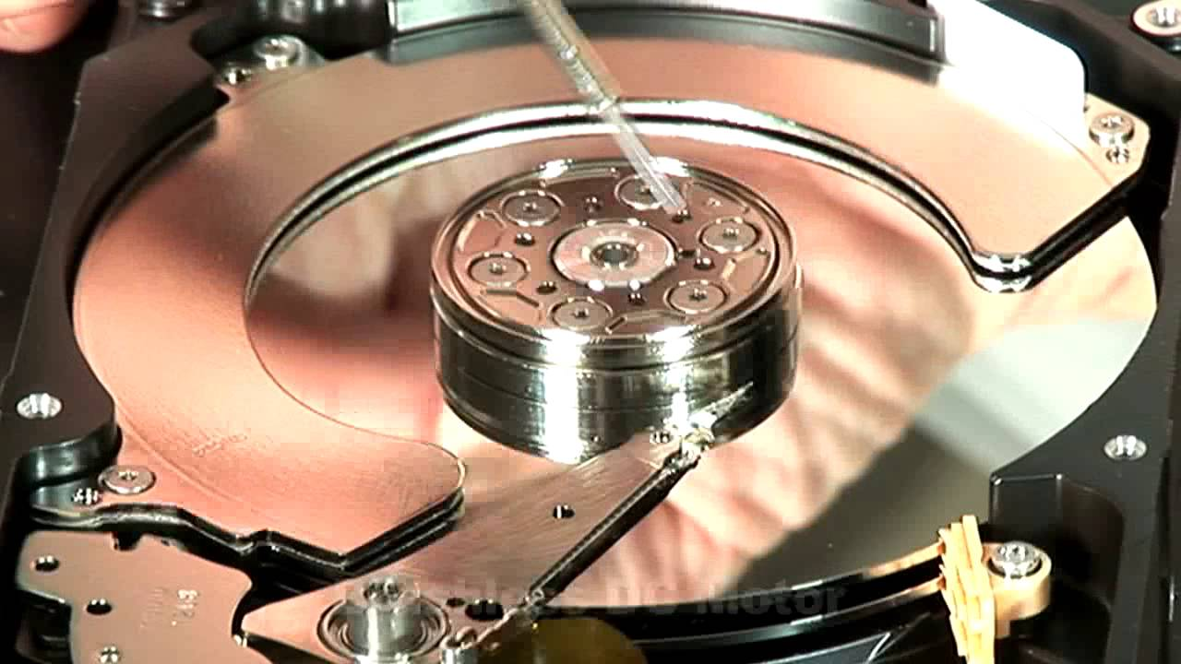

**Solid State Drive (SSD**): SSDs use NAND-based flash memory to store data. They are faster, more durable, and generate less heat than HDDs. SSDs have become increasingly popular for their improved performance, especially in terms of read and write speeds**.**

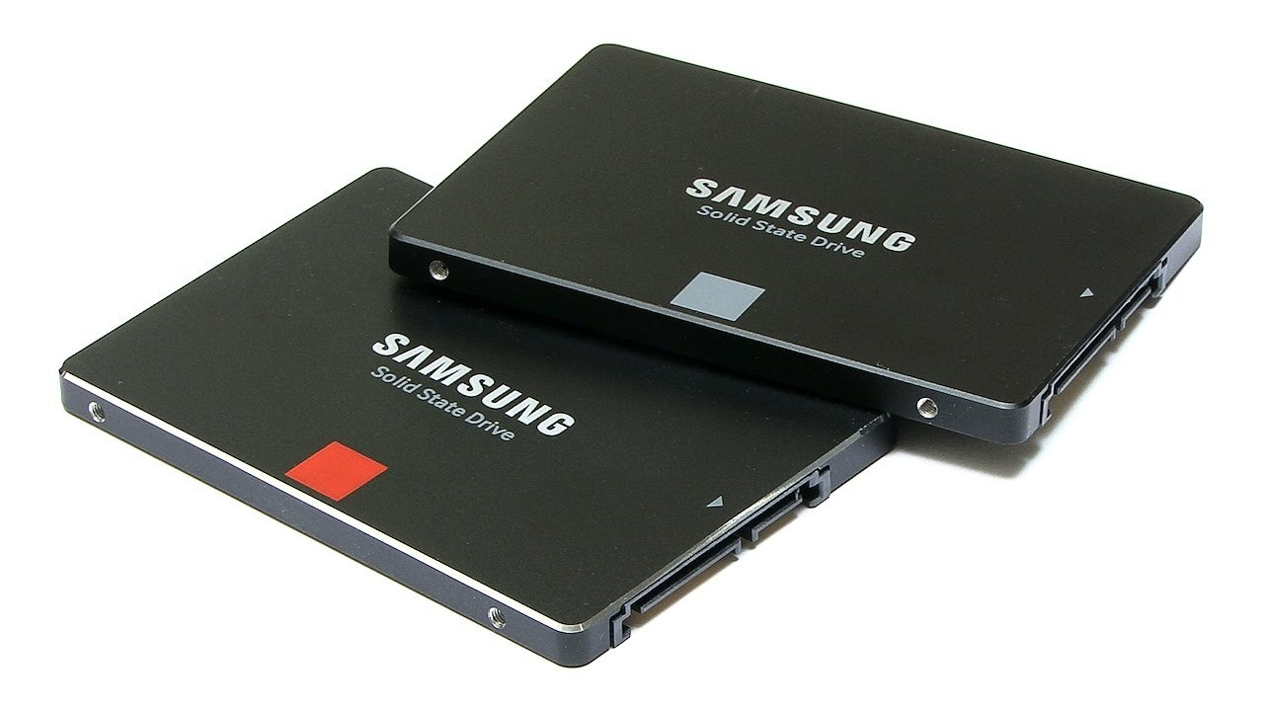

**PENDRIVES** : Secondary storage devices: They are those that handle and transfer information independently. USB sticks. Pendrives. CD. RAM memory . ROM memory.

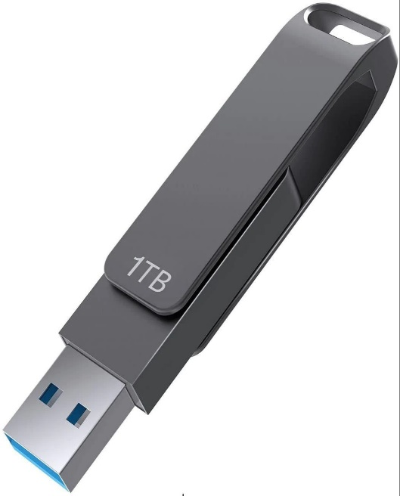

**CD:** The compact disc (CD) is a digital optical disc data storage format that was co-developed by Philips and Sony to store and play digital audio recordings.

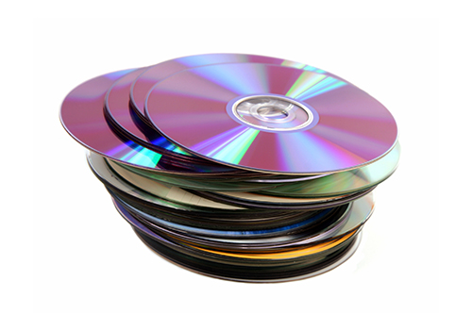

**INTERFACING PORTS**

A port is a physical docking point using which an external device can be connected to the computer. It can also be programmatic docking point through which information flows from a program to the computer or over the Internet

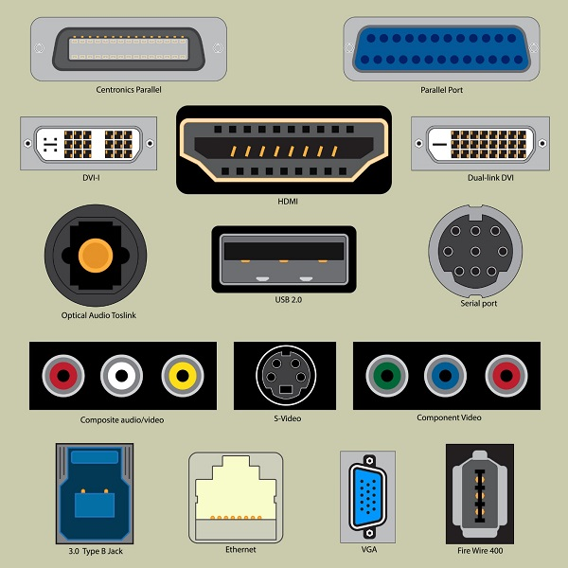

**DESKTOP**

A desktop computer (often abbreviated desktop ) is a personal computer designed for regular use at a stationary location on or near a desk (as opposed to a portable computer) due to its size and power requirements. Unlike portable computers, desktops are larger and have specific power requirements. A typical desktop system includes the following components:

Monitor: Displays visual output.

Keyboard: Used for input.

Mouse: Another input device.

Computer Case: Contains the motherboard, processor, memory, and other electronic components.

Disk Storage: Usually one

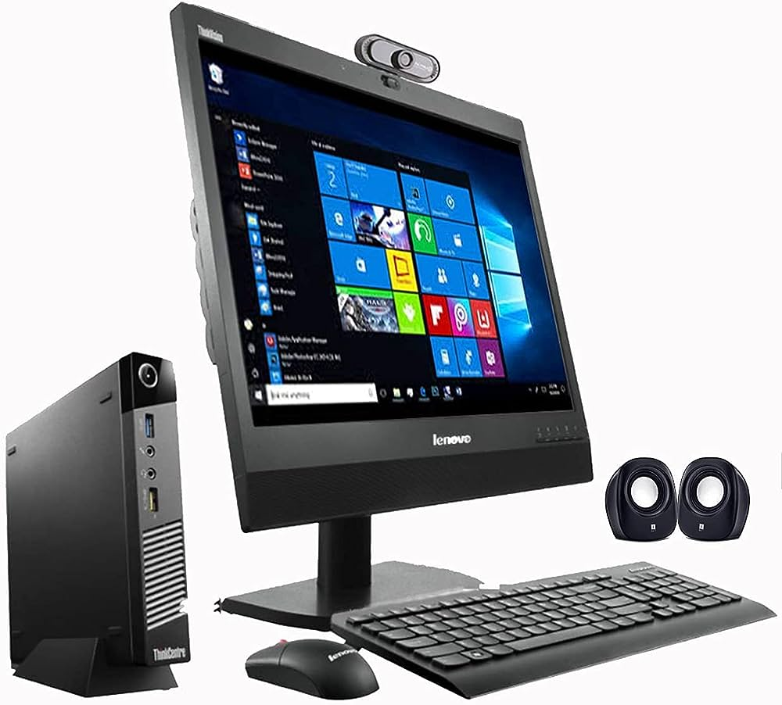

**INPUT DEVICES**

Input devices are the parts of the computer that we interact with daily and are used to input data to the computers. An input device is a hardware device that transfers data to a computer system and allows us to control it

1**)KEYBOARD**: The keyboard is one of the primary input devices, which helps in entering data and commands in a computer. A normal keyboard is usually has a variety of keys, such as alphabetic character keys, function keys, number keys, arrow keys, and control keys. The keyboard can be connected to a computer using USB or BLUETOOTH.

2**)MOUSE**: Mouse is the most common and very popular pointing device that helps interact with a common through a process called ‘point and click’. This is mainly used to move a cursor on the computer’s screen and click on the corresponding object using buttons (usually left, right, and middle key roller buttons).

3)**SCANNER**: Scanner is an input device, which works more like a photocopy machine. It used when some information is available on paper and it is to be transferred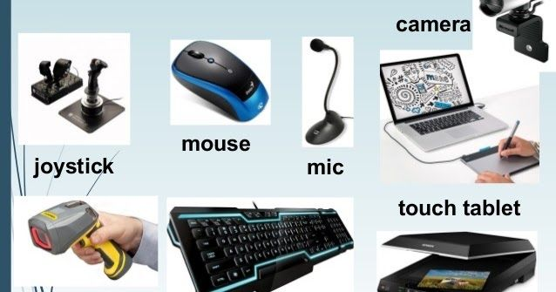rre to the hard disk of the computer for further manipulation.

**OUTPUT DEVICES**

The output device displays the result of the processing of raw data that is entered in the computer through an input device. There are a number of output devices that displays output in different ways such as text, images, hard copies, and audio or video. Some popular output devices are:

**SPEAKER**: The most common output devices, speakers accept sound data from a computer and play the sounds for users to hear.

**PROJECTOR**: Projector is an output device that accepts data from a computer and projects that data or information as a picture onto a wall or screen or any large surface.

**INSTALL UBUNTU ON VIRTUALBOX**

Virtual box by Oracle is a powerful virtualization software that allows users to run multiple operating systems on one physical computer. VirtualBox is open-source software for virtualizing the x86 computing architecture. It acts as a hypervisor, creating a VM (virtual machine) where the user can run another OS (operating system).The operating system where VirtualBox runs is called the "host" OS. The operating system running in the VM is called the "guest" OS. VirtualBox supports Windows, Linux, or macOS as its host OS. Before we begin with installation process, we need to download ISO for Ubuntu.

VirtualBox Installation: sudo apt-get install virtual box 9 sudo apt-get update Create virtual machine by just clicking on this new Click -> new we can install ubuntu so type ubuntu And choose the type 1

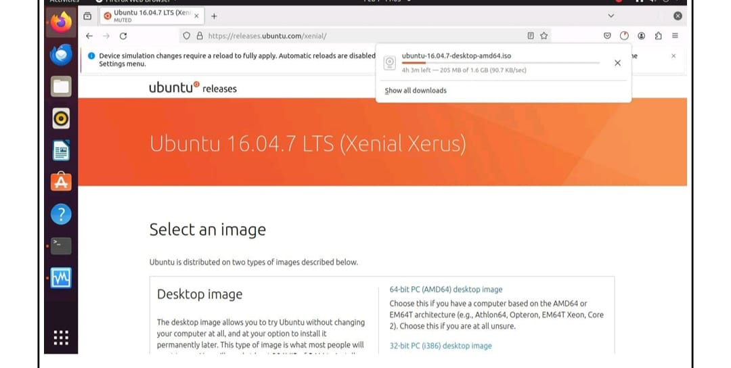

**Virtual box installation:**

sudo apt-get install virtual box

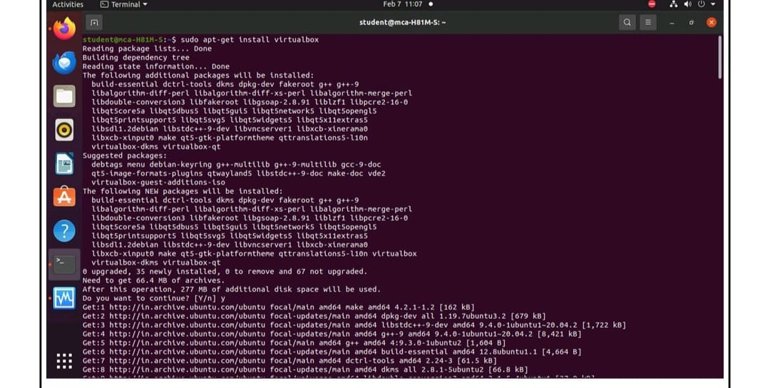

sudo apt-get update

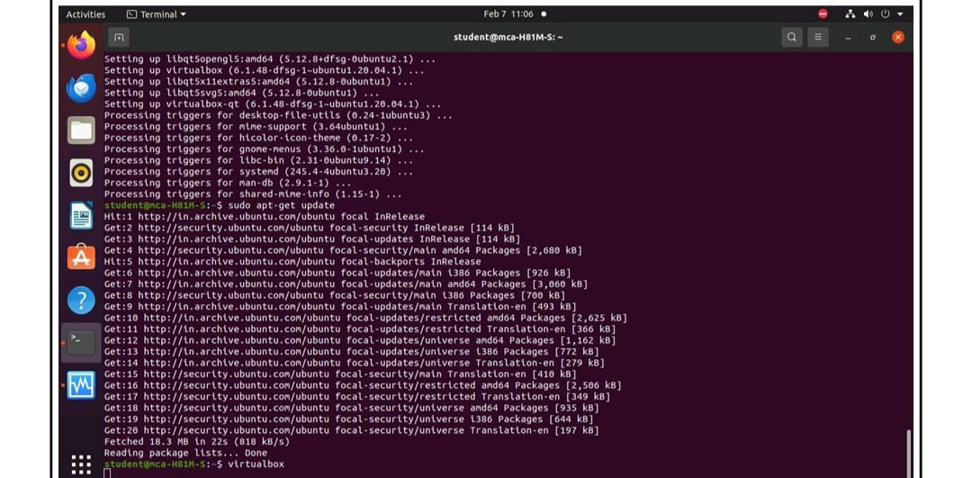

create virtual machine by just clicking on this new click->new we can install ubundu so type ubundu and choose the type.

