HealthcareAppointmentManagementPlatform

Name: Theertha N S
Batch 2 Data Engineer

INTRODUCTION

The Healthcare Appointment Management Platform is a Flask-based healthcare application developed as part of the DevOps Capstone Project. The project demonstrates Agile planning, source code management, CI automation, automated testing, and build verification using Trello, GitHub, GitHub Actions, Python Flask, and Pytest.

The application provides APIs for:
• Appointment Service Health Check
• Patient Appointment Status
• Doctor Availability

The project also implements Continuous Integration using GitHub Actions to automate testing and build validation whenever code is pushed to the repository.

PROJECT OBJECTIVE

The objective of this project is to:
• Develop a healthcare appointment management application using Flask
• Implement Agile planning using Trello
• Manage source code using GitHub
• Configure CI automation using GitHub Actions
• Perform automated testing using Pytest
• Validate successful build execution through CI pipelines

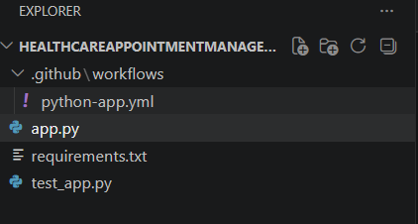

FLASK APPLICATION DEVELOPMENT

The Healthcare Appointment Management Platform was developed using Python Flask framework. Multiple API endpoints were created to simulate healthcare appointment services.

The APIs implemented are:
• Home API
• Health Check API
• Appointment Status API
• Doctor Availability API

The application was tested locally using Flask development server.

API TESTING

The Flask application APIs were executed successfully in the local environment. Each endpoint returned the expected response confirming successful implementation of the healthcare services.

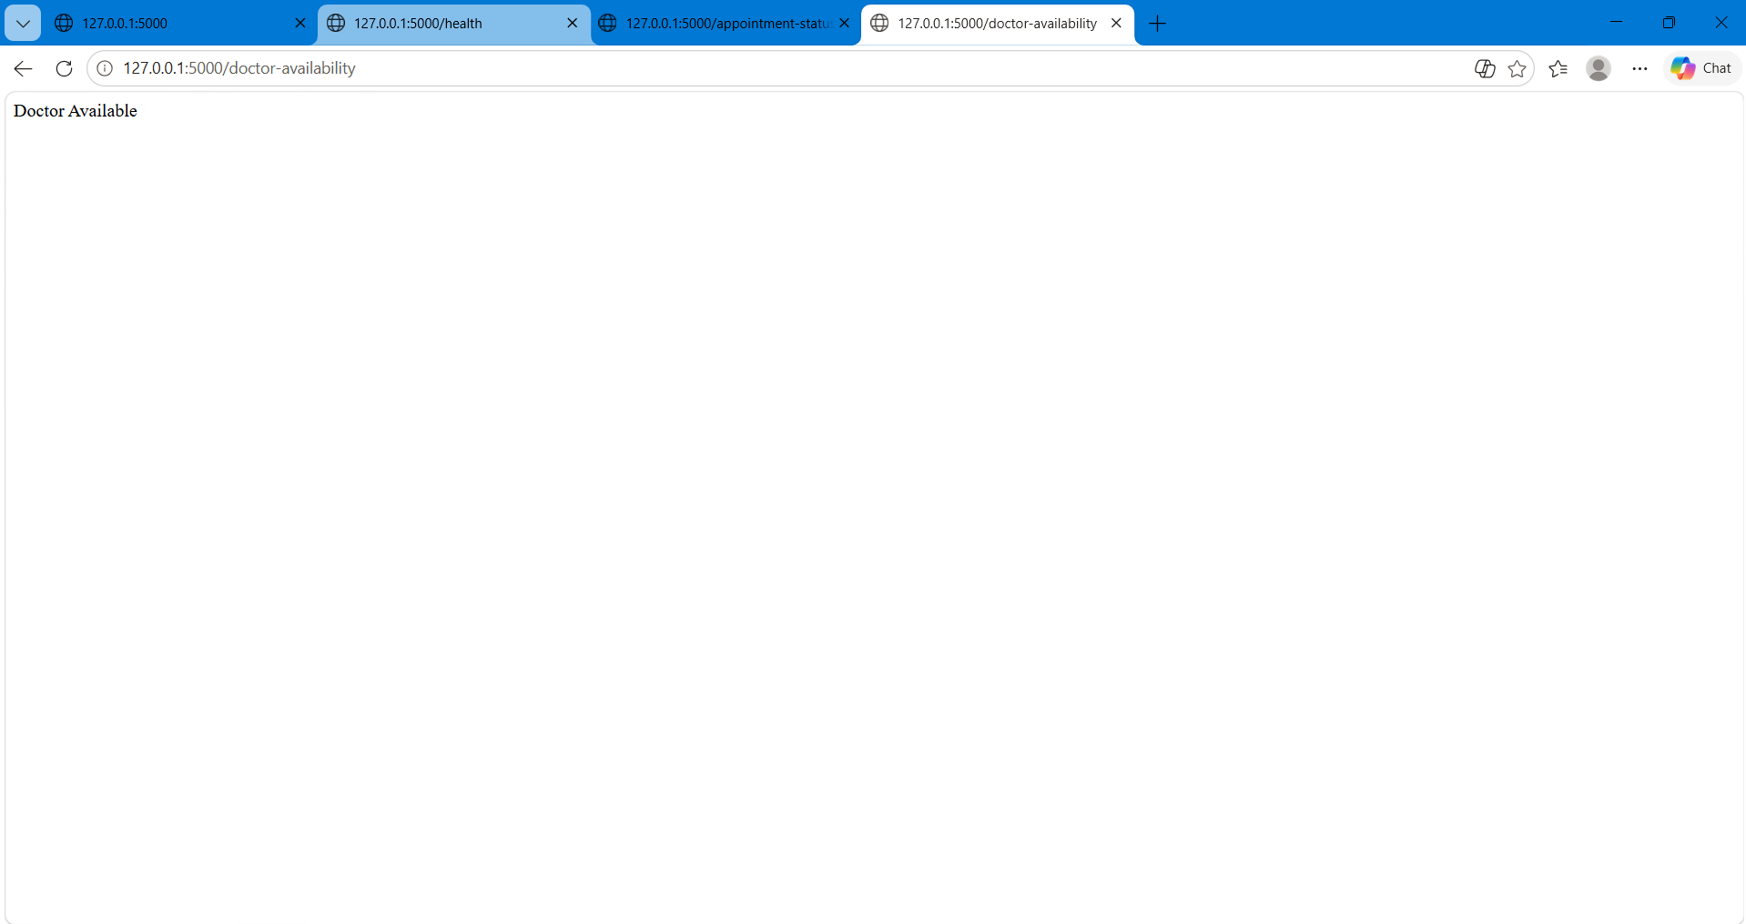

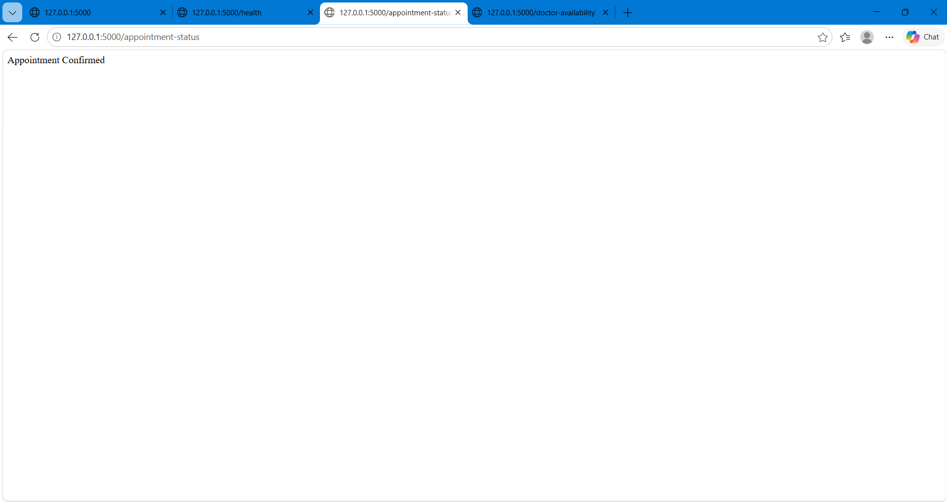

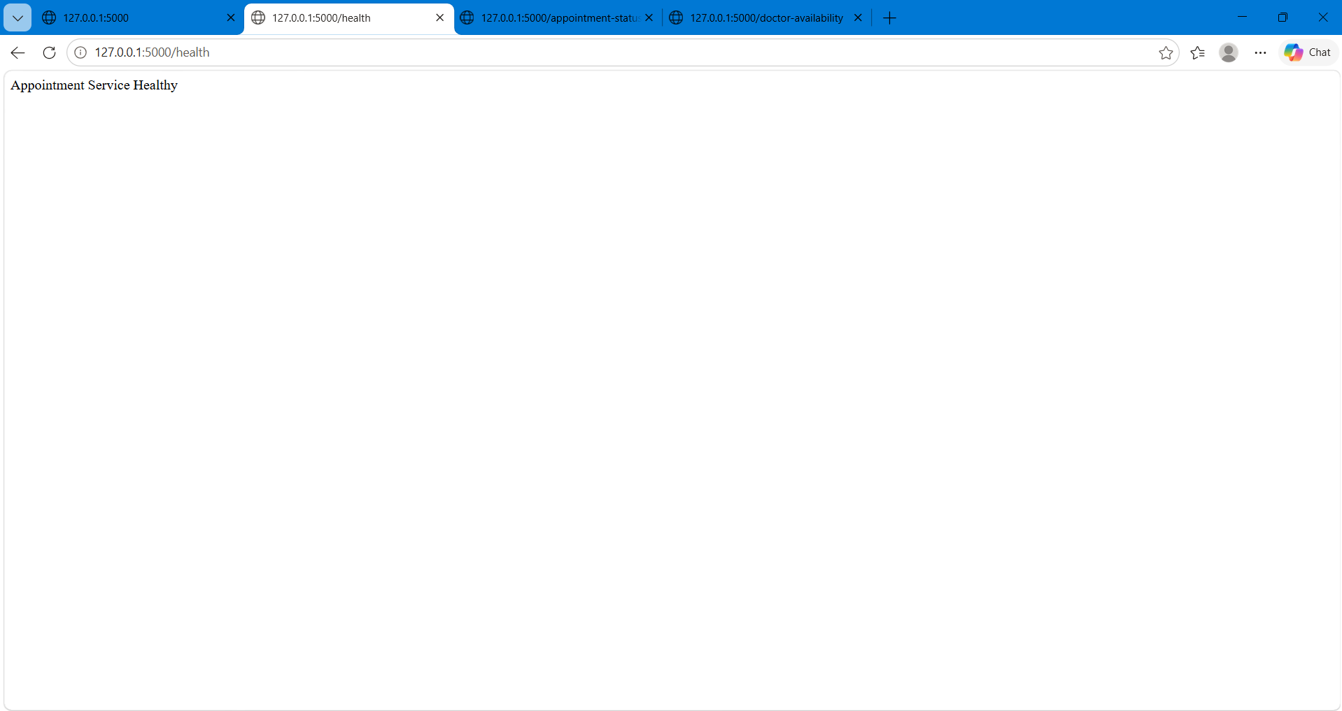

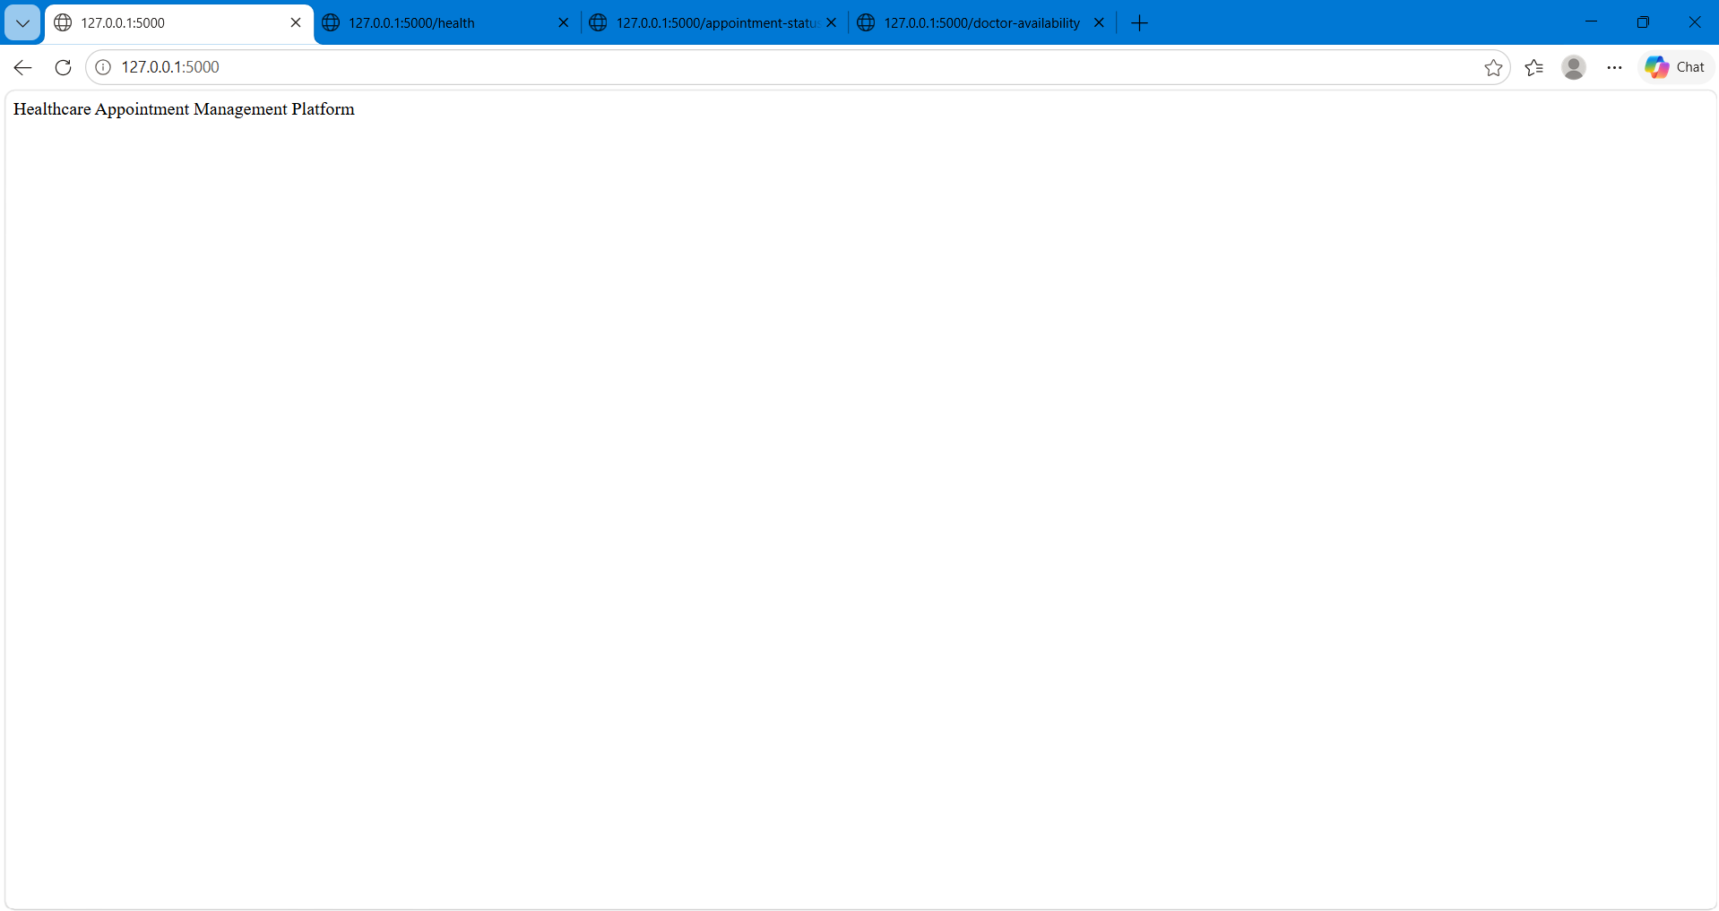

GITHUB REPOSITORY MANAGEMENT

The project source code was pushed into a GitHub repository for version control and repository management. Proper project structure and commit practices were followed during repository creation and code upload.

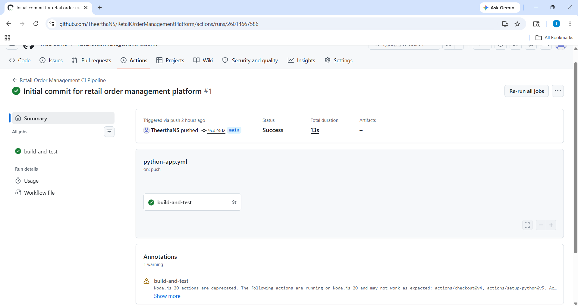

GITHUB ACTIONS CI PIPELINE

Continuous Integration was implemented using GitHub Actions. A workflow file was created inside the .github/workflows directory to automate dependency installation and test execution.

The CI workflow performs the following operations:
• Checkout source code
• Setup Python environment
• Install dependencies
• Execute automated test cases using Pytest

The pipeline was automatically triggered whenever code was pushed to the main branch.
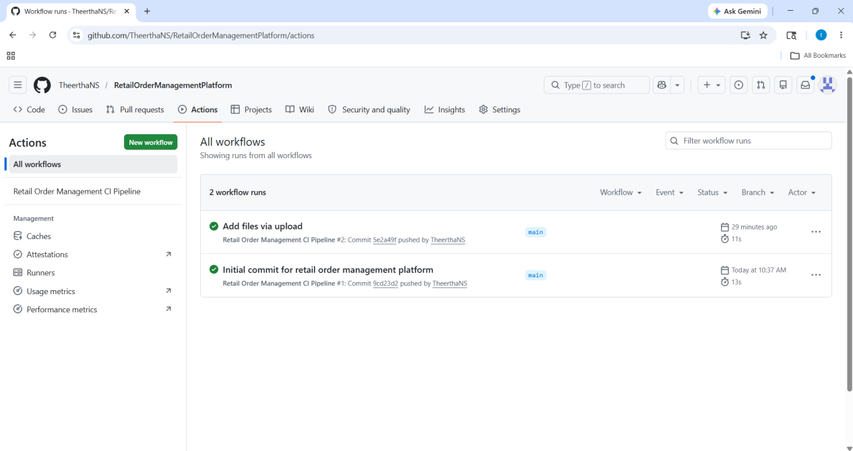

TEST CASE VALIDATION

Automated test cases were created using Pytest to validate all API endpoints of the healthcare application. The GitHub Actions pipeline executed all test cases successfully and verified the build without errors.
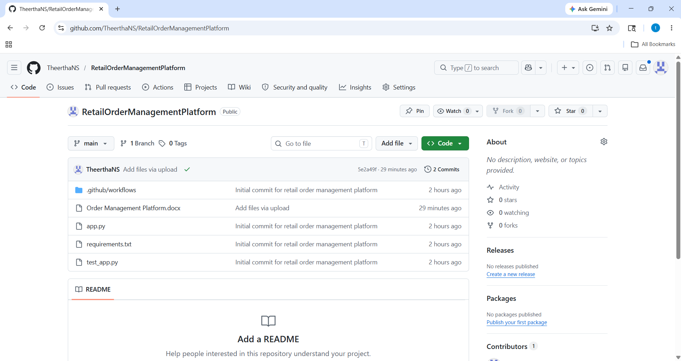

AGILE PLANNING USING TRELLO

The project planning activities were managed using Trello. The board was divided into multiple lists to represent different stages of software development lifecycle.

The following lists were created:
• Backlog
• Features
• User Stories
• Tasks
• In Progress
• Completed

The board helped in organizing development activities, tracking project progress, and managing tasks efficiently.

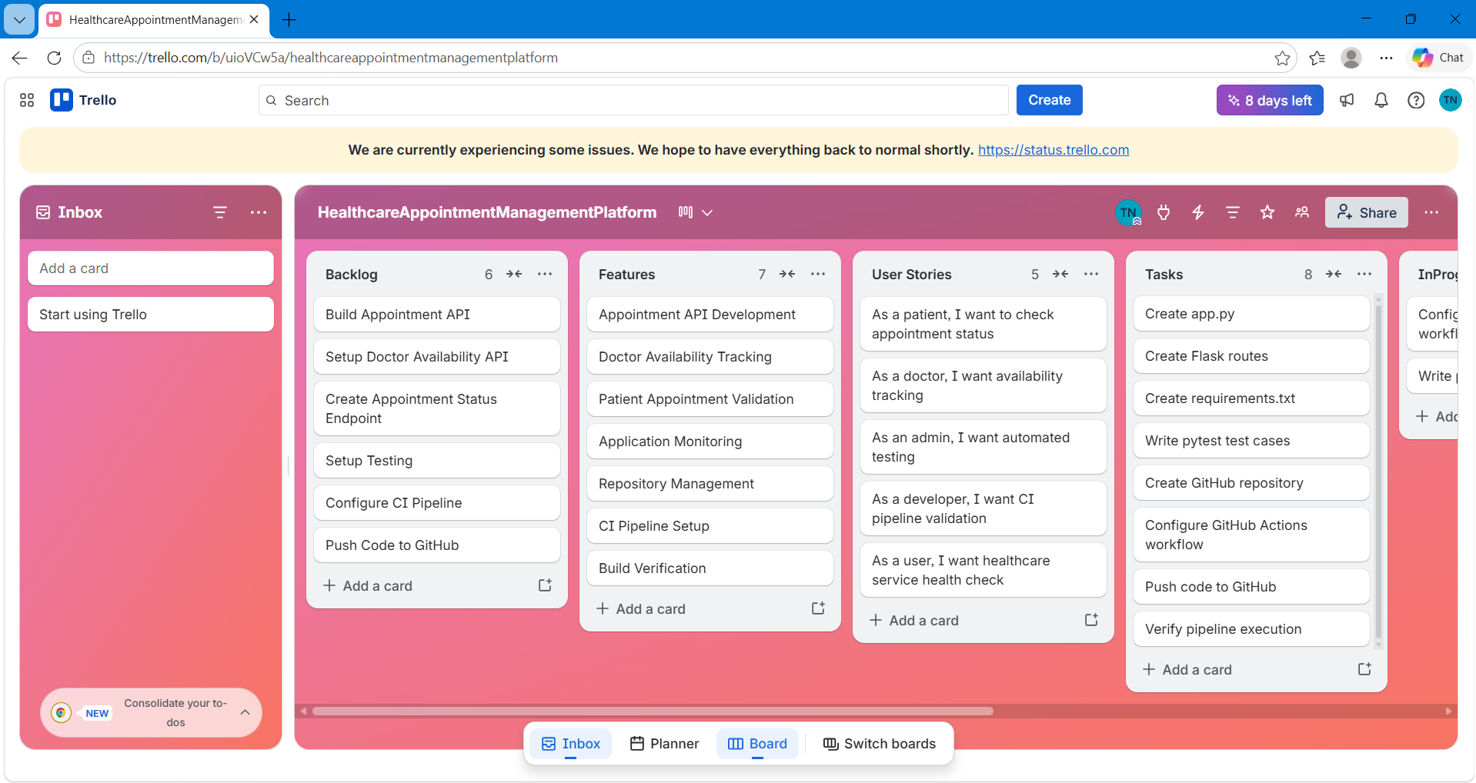

FEATURES AND USER STORIES

The following major features were planned for the project:
• Appointment API Development
• Doctor Availability Tracking
• Patient Appointment Validation
• Application Monitoring
• Repository Management
• CI Pipeline Setup
• Build Verification

User stories were created to represent real-world healthcare application requirements such as checking appointment status, tracking doctor availability, and validating healthcare service health checks.

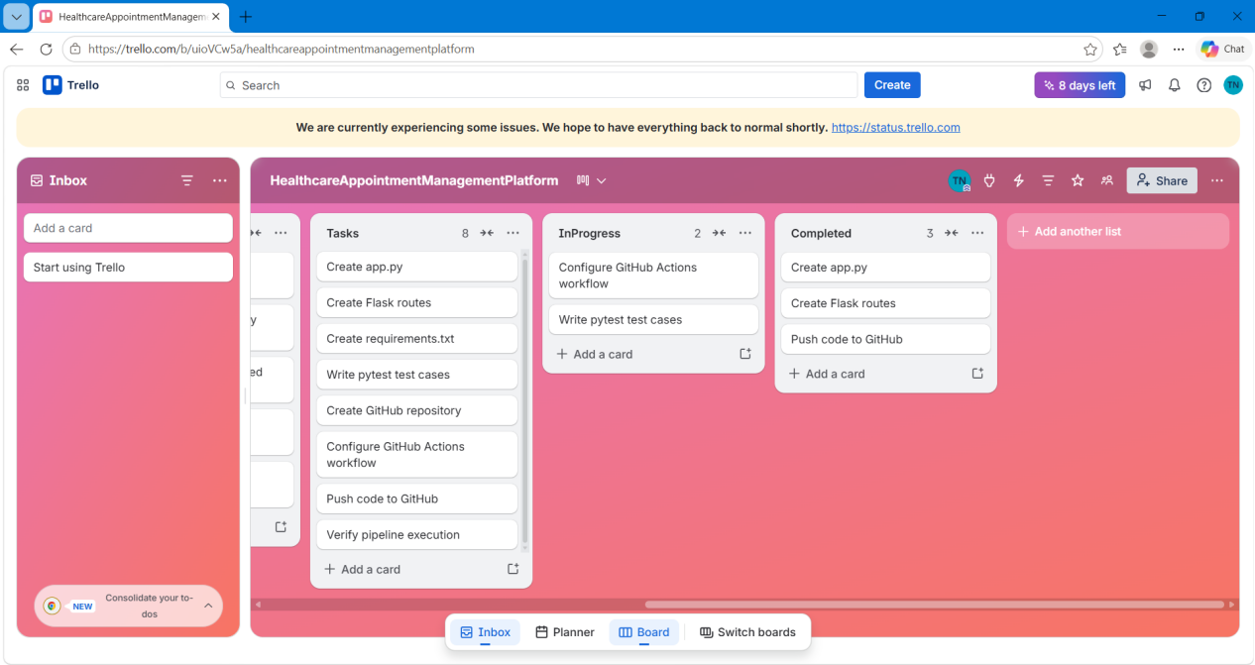

CONCLUSION

The Healthcare Appointment Management Platform project was completed successfully by implementing Agile planning, source code management, automated testing, and CI automation.

The project demonstrated:
• Agile project planning using Trello
• Source code management using GitHub
• Flask-based healthcare API development
• Automated testing using Pytest
• Continuous Integration using GitHub Actions

All APIs were tested successfully, and the CI pipeline executed successfully validating the project build process.

