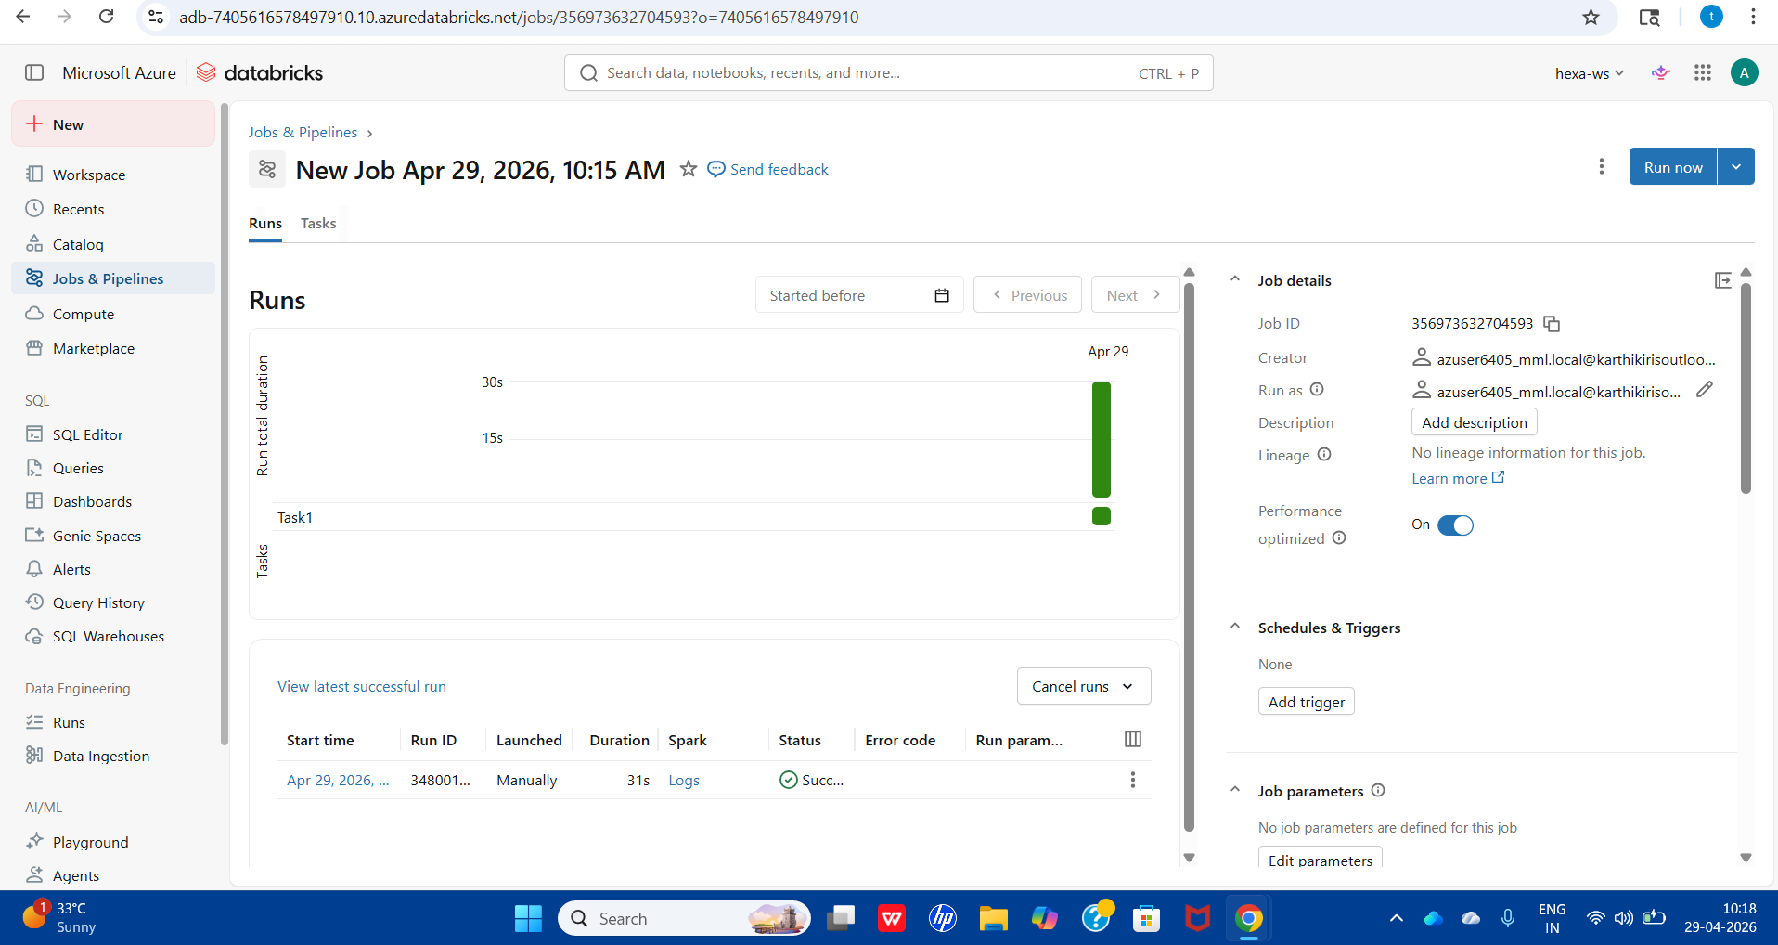
SALES REVENUE SUMMARY

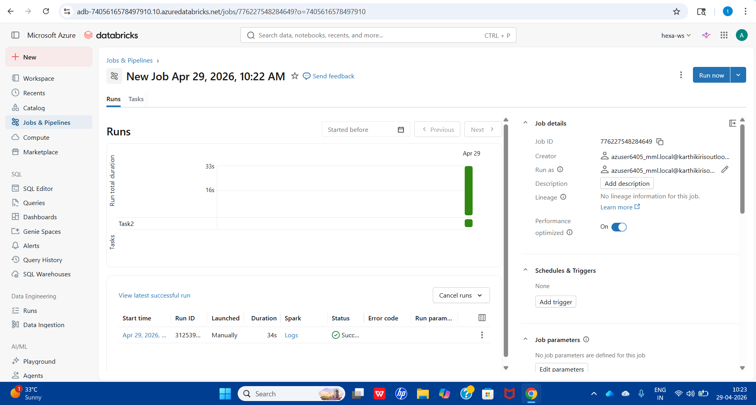
STUDENT PERFORMANCE

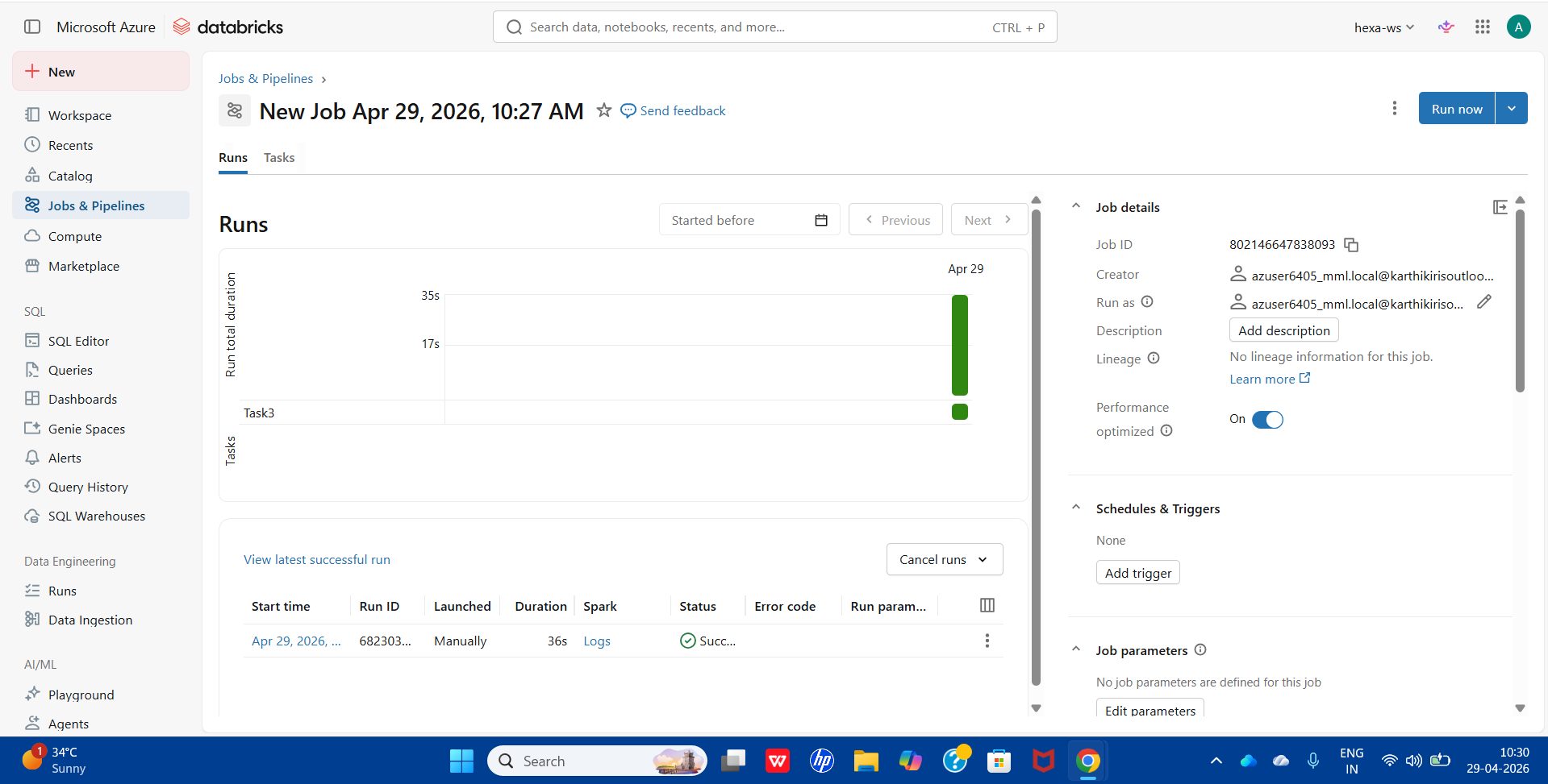
EMPLOYEE DEPARTMENT RANKING

