KANNUR UNIVERSITY

SCHOOL OF INFORMATION SCIENCE AND TECHNOLOGY

KANNUR UNIVERSITY CAMPUS

MANGATTUPARAMBA

KANNUR – 670567

2024 – 2026



SEMINAR REPORT WORK ON

MCCSA04DSE29
ELECTIVE V

KANNUR UNIVERSITY

SCHOOL OF INFORMATION SCIENCE AND TECHNOLOGY

KANNUR UNIVERSITY CAMPUS
MANGATTUPARAMBA

KANNUR-670567

2024-2026


CERTIFICATE

This is to certify that is a bonafide record of the work on MCCSA04DSE29 ELECTIVE V Done by
KEERTHANA P K Reg No. IT24GMCAD28 Of School of Information Science and Technology, Kannur University, for the completion of IV semester of MCA.

Ms. Reema I V Dr. Abdul Haleem P P
(Internal Guide) (Head of the Department)

Place: Mangattuparamba External Examiner

Date:

ACKNOWLEDGMENT
Firstly, I would like to express my sincere gratitude to the Almighty for his solemn presence throughout the report study. I would like to extend my heartfelt gratitude to the Teachers and co-students of Department of Information Technology for their constructive support and cooperation at every juncture of the Technical Elective study on “LangGraph”.
I would like to express my sincere thanks to Head of Department, Dr Abdul Haleem PP, as well as my project guide Reema I V for their valuable suggestions and guidance and for providing the necessary details.
The knowledge acquired during the presentation of the project report would help me in my future ventures.

KEERTHANA P K : IT24GMCAD28

LangGraph

CONTENTS

- INTRODUCTION 05
- HISTORY OF LANGGRAPH 06
- BASIC DESCRIPTION OF TECHNOLOGY 07
3.1 KEY FEATURES OF LANGGRAPH 07
3.2 WORKING OF LANGGRAPH 08
3.3 LANGGRAPH VS OTHER FRAMEWORKS 08
3.4 REASONS FOR CHOOSING LANGGRAPH 09
4. LANGGRAPH COMPONENTS 10
5. LANGGRAPH ARCHITECTURE 12
6. LANGGRAPH PROJECT STRUCTURE 15
7. LANGGRAPH STATE MANAGEMENT AND WORKFLOW
EXECUTION 18
8. LANGGRAPH INSTALLATION AND SETUP 21
9. ADVANTAGES AND DISADVANTAGES 23
10. REAL-WORLD APPLICATIONS 25
11. CASE STUDY 26
11.1 OBJECTIVE 26
11.2 TECHNOLOGIES USED 27
11.3 FUNCTIONALITY 28
11.4 DATABASE MODELS 30
11.5 SYSTEM WORKFLOW 31
11.6 PROGRAM 32
12. CONCLUSION 38
13. REFERENCES 39

1. INTRODUCTION

Artificial Intelligence has transformed the way modern software systems operate by enabling automation, intelligent decision-making, and natural language interaction. Traditional software applications mainly follow predefined logic and workflows, whereas modern AI-powered systems can reason, analyze data, and generate dynamic responses. With the advancement of Large Language Models (LLMs), AI systems are becoming more capable of solving real-world business problems such as customer support, workflow automation, diagnostics, and intelligent communication.
One of the major challenges in AI application development is orchestrating multiple AI operations together in a structured and reliable manner. While LLMs can generate responses effectively, enterprise applications require more than simple text generation. They need memory handling, workflow execution, tool integration, multi-step reasoning, and state management. To solve these challenges, frameworks like LangChain and LangGraph were introduced.
LangGraph is an advanced framework built on top of LangChain that enables developers to create stateful, multi-agent AI workflows using graph-based execution models. Unlike simple chatbot systems, LangGraph enables complex agentic AI applications with decision-making capabilities and workflow orchestration.
This report focuses on LangGraph as a technology-specific elective study. The report also includes a case study implementation of an AI-powered Email Manager system developed using LangGraph. The system classifies incoming emails, identifies complaints or product inquiries, and automatically generates professional AI-based responses.

HISTORY OF LANGGRAPH
As AI applications became more advanced, developers realized that traditional prompt-based systems were insufficient for complex enterprise workflows. LangChain introduced chains and agents for LLM orchestration, but managing long-running workflows and state transitions remained challenging.
To address these limitations, LangGraph was introduced as a graph-based orchestration framework. It allows developers to create cyclic workflows, persistent states, and conditional transitions between AI operations.
LangGraph expanded the capabilities of LangChain by introducing:
- Stateful workflow execution
- Graph-based agent orchestration
- Memory persistence
- Human-in-the-loop workflows
- Multi-agent collaboration
Today, LangGraph is widely used in AI assistant platforms, autonomous AI systems, enterprise workflow automation, and intelligent support systems.

- BASIC DESCRIPTION OF TECHNOLOGY

3.1 Key Features of LangGraph
Graph-Based Workflow Architecture
LangGraph represents AI workflows as graphs where nodes represent operations and edges represent transitions.
Stateful Execution
The framework maintains workflow states throughout execution, enabling memory-aware AI systems.
Multi-Agent Support
Multiple AI agents can collaborate and exchange information within a workflow.
Tool Integration
LangGraph supports integration with APIs, databases, external tools, and enterprise systems.
Human-in-the-Loop Capability
Human approval or intervention can be added during workflow execution.
LLM Flexibility
Supports multiple AI models including OpenAI, Gemini, Claude, and local LLMs.
Conditional Routing
Workflow execution can dynamically change based on conditions and outputs.
Scalability
Suitable for enterprise-scale AI workflow deployment.

3.2 Working of LangGraph
LangGraph works using a graph-based workflow where nodes perform tasks and edges control the execution flow. The framework maintains a shared state that stores data throughout the workflow execution.
Working Process
- The user provides an input such as a query or email.
- The workflow starts from the START node.
- Nodes execute specific tasks like reading data, classification, or generating responses.
- The shared state is updated after each node execution.
- Edges determine the next node based on workflow conditions.
- External tools, APIs, and AI models can be integrated during execution.
- The workflow reaches the END node and returns the final response to the user.

3.3 Langgraph vs Other Frameworks
Langgraph is a powerful framework designed for building stateful, multi-agent AI workflows, making it different from many traditional AI frameworks. Unlike simpler frameworks that mainly focus on single-step prompt execution or basic chatbot creation, LangGraph allows developers to create complex agent systems with memory, decision-making, looping, and conditional flows. Compared to LangChain, which is mainly used for chaining prompts and tools together, LangGraph provides better control over workflow logic through graph-based architecture. When compared with CrewAI, LangGraph offers more flexibility and lower-level control for designing custom multi-agent interactions, while CrewAI focuses more on role-based collaborative agents with easier setup. In comparison to Microsoft AutoGen, LangGraph emphasizes structured state management and reliable execution of long-running workflows. Overall, LangGraph is highly suitable for advanced AI applications that require scalability, persistent memory, agent coordination, and complex workflow orchestration, whereas other frameworks may be better for simpler or faster-to-build AI solutions.

3.4 Reasons For Choosing Langgraph
LangGraph is chosen for AI application development because it provides powerful workflow management, better state handling, and strong support for multi-agent systems. One major reason for choosing LangGraph is its graph-based architecture, which allows developers to design complex AI workflows with conditional branching, looping, and decision-making capabilities. It also supports persistent memory, enabling applications to remember previous interactions and maintain context over long conversations. Another important advantage is its ability to coordinate multiple AI agents efficiently, making it suitable for advanced systems such as intelligent assistants, research agents, and automated business workflows. Compared to many traditional frameworks, LangGraph offers greater flexibility, scalability, and reliability for long-running tasks. It integrates well with large language models, external APIs, databases, and tools, helping developers build highly customized AI solutions. Additionally, its modular structure improves debugging, monitoring, and maintenance, which makes development easier and more organized for complex projects.

LANGGRAPH COMPONENTS
- Nodes
Individual processing units that perform specific tasks such as calling an LLM, executing tools, or processing data.
- Edges
Connections between nodes that define the flow of execution from one step to another.
- State
Shared memory used to store and manage information throughout the workflow execution.
- Graph
The complete workflow structure containing nodes and edges connected together.
- Conditional Routing
Enables dynamic decision-making by selecting different execution paths based on conditions.
- Agents
AI-driven components that can reason, plan, and perform tasks autonomously.
- Memory Management
Stores conversation history and contextual information for long-running interactions.
- Tool Integration
Allows connection with APIs, databases, search engines, calculators, and external services.
- Execution Engine
Controls workflow execution, task scheduling, and state transitions.
- Loops and Iterations
Supports repeated execution of tasks until a condition is satisfied.
- Checkpoints
Save workflow progress to improve reliability and recovery during failures.
- Human-in-the-Loop Support
Enables human approval or intervention during workflow execution.
- Streaming Support
Allows real-time response generation and continuous output streaming.
- Multi-Agent Coordination
Helps multiple AI agents collaborate and share information efficiently.
- Debugging and Monitoring Tools
Provides tracking and visualization of workflow execution for easier maintenance.

LANGGRAPH ARCHITECTURE
LangGraph follows a graph-based workflow architecture designed for building stateful and multi-agent AI applications. It organizes application flow using Nodes, Edges, and State management, enabling developers to create flexible and dynamic AI workflows.
This architecture ensures modularity, scalability, and efficient execution of complex AI processes.
Node
A Node represents a single task or operation in the workflow.
Each node performs a specific action such as:
• Calling an LLM (Large Language Model)
• Reading emails or documents
• Processing user input
• Making decisions
• Updating the workflow state
Nodes are usually implemented as JavaScript or Python functions.
Each node receives the current state as input and returns updated state information.
Edge
Edges define the connection between nodes and control the flow of execution.
They determine which node should execute next based on conditions or workflow logic.
Edges can be:
• Sequential – moving directly to the next node
• Conditional – choosing different paths based on results
• Parallel – executing multiple nodes simultaneously
Edges help create dynamic and intelligent workflows.
State
State is the central data storage shared across all nodes in the workflow.
It stores information such as:
• User queries
• Email data
• AI-generated responses
• Workflow progress
• Intermediate outputs
LangGraph continuously updates the state as nodes execute.
This enables context-aware and memory-based AI applications.
State is commonly defined using objects, TypedDict, or annotations.
Workflow Graph
The workflow graph combines nodes and edges into a structured execution pipeline.
LangGraph workflows typically begin with a START node and end with an END node.
The graph architecture allows:
• Multi-step reasoning
• AI agent collaboration
• Conditional routing
• Looping and retries
• Human-in-the-loop interaction
This makes LangGraph suitable for advanced AI automation systems.
Step-by-Step Flow of Request
1. Client Request
The client (user) sends a request to the AI application, such as asking a question or triggering an automation workflow.
2. START Node
The workflow begins from the START node, which initializes the execution process.
3. Node Execution
The first node processes the request and performs a specific task such as classification, data retrieval, or LLM interaction.
4. State Update
The node updates the shared state with newly generated information or processed results.
5. Edge Routing
Based on workflow conditions, edges determine the next node to execute.
The workflow may follow sequential, conditional, or parallel paths.
6. Multiple Node Processing
Additional nodes continue processing tasks while sharing and updating the workflow state.
7. END Node and Response
Once all tasks are completed, the workflow reaches the END node.
The final output is returned to the client as the response.

- LANGGRAPH PROJECT STRUCTURE
A LangGraph project developed using JavaScript follows a modular folder structure where each file handles a specific part of the AI workflow.
This structure improves code organization, scalability, debugging, and maintenance.

Key Files and Directories
• .env
Stores environment variables and secret credentials such as API keys.
Example:
• Gemini API Key
• OpenAI API Key
• Email credentials
This keeps sensitive data secure and separate from source code.
• package.json
Contains project metadata, dependencies, and scripts required for the LangGraph application.
It manages libraries such as:
• LangGraph
• LangChain
• Google Generative AI SDK
• dotenv
• package-lock.json
Automatically generated file that stores the exact dependency versions installed in the project.
It ensures consistent package installation across systems.
• server.js

Acts as the main server file of the application.
It starts the backend server and handles API requests or frontend communication.
• maillanggraph.js
This is the core workflow file where the LangGraph architecture is defined.
It contains:
• StateGraph initialization
• Node definitions
• Edge connections
• Conditional routing logic
• START and END nodes
This file controls the complete execution flow of the AI workflow.
• classifymail.js
Contains logic for classifying emails into categories such as:
• Sales
• Maintenance
• Complaint
This node helps determine the workflow path using conditional edges.
• readmails.js
Responsible for reading incoming emails from the mail service or inbox.
It extracts email content and updates the workflow state.
• replygenerator.js
Generates AI-based email responses using the LLM.
It drafts replies based on the classified email type and retrieved context.
- frontend/
Contains frontend-related files for the user interface.
This directory may include:
• HTML files
• CSS files
• JavaScript files
• React/Vue frontend code
It handles user interaction and displays workflow results.
• node_modules/
Stores all installed project dependencies and external libraries required for the application.
This folder is automatically generated using npm.

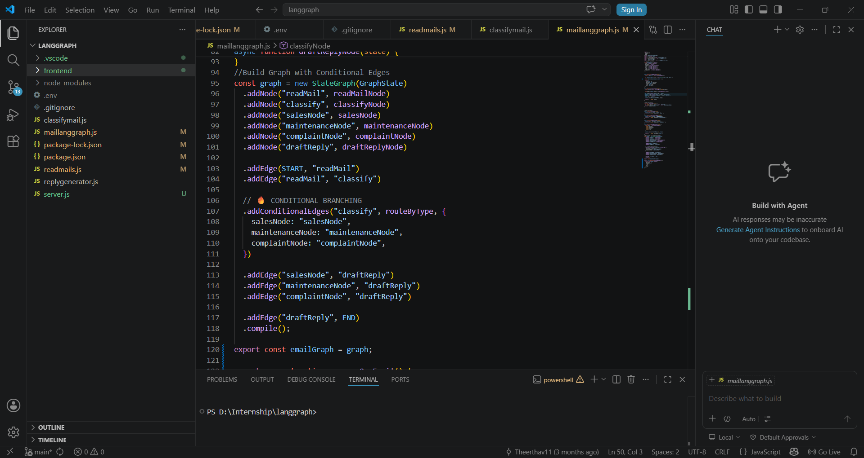

- LANGGRAPH STATE MANAGEMENT AND WORKFLOW EXECUTION
In LangGraph, State Management is a core feature that allows different nodes in the workflow to share and update data during execution.
Instead of directly writing database queries like Django ORM, LangGraph focuses on managing workflow state and passing information between AI agents, tools, and nodes.
The state acts as a central memory store for the workflow and helps maintain context throughout execution.
Example
const GraphState = Annotation.Root({
email: Annotation(),
category: Annotation(),
response: Annotation(),
});
This state definition stores workflow data such as email content, classification category, and generated response.
How LangGraph State Management Works
• Developers define a shared state structure using objects, annotations, or schemas.
• Each node receives the current state as input.
• Nodes process data and return updated state values.
• LangGraph automatically passes the updated state to the next node in the workflow.
• Conditional edges use state values to determine the next execution path.
• The workflow continues until it reaches the END node.
Example Workflow
.addNode("readMail", readMailNode)
.addNode("classify", classifyNode)
.addNode("draftReply", draftReplyNode)
.addEdge(START, "readMail")
.addEdge("readMail", "classify")
.addEdge("classify", "draftReply")
.addEdge("draftReply", END)
This workflow:
- Reads the email
- Classifies the email type
- Generates a draft reply
- Ends the workflow
Benefits of LangGraph State Management
• Centralized Workflow Memory
All nodes can access and update shared workflow data, enabling context-aware AI applications.
• Modular Workflow Design
Each node performs an independent task, making the system easier to maintain and scale.

• Conditional and Dynamic Execution
LangGraph supports intelligent routing using conditional edges based on state values.
• Multi-Agent Collaboration
Multiple AI agents or tools can work together while sharing the same workflow state.
• Easy Integration with LLMs and Tools
LangGraph can integrate with APIs, databases, email systems, vector stores, and LLMs seamlessly.
• Stateful AI Applications
Unlike traditional sequential pipelines, LangGraph maintains memory and context throughout the workflow execution process.

- LANGGRAPH INSTALLATION AND SETUP

LangGraph can be installed and configured in a JavaScript environment using Node.js and npm.
The setup process involves installing required packages, configuring API keys, and creating the workflow files.

Step-by-Step Installation

1. Install Node.js
Download and install Node.js from the official website.
Node.js includes npm (Node Package Manager), which is required to install dependencies.
Verify installation using:
node -v
npm -v

2. Create Project Folder
Create a new folder for the LangGraph project and open it in VS Code.

3. Initialize Node Project
Initialize the project using npm:
npm init -y
This creates the package.json file.

4. Install LangGraph and Required Packages
Install LangGraph, LangChain, dotenv, and Google Generative AI SDK:
npm install @langchain/langgraph @langchain/core
npm install @google/generative-ai dotenv

5. Create Environment File
Create a .env file to store API keys securely.
Example:
GEMINI_API_KEY=your_api_key

6. Create Project Files
Create the required JavaScript files for the workflow.

7. Define LangGraph Workflow
Inside maillanggraph.js, define nodes, edges, and workflow logic using StateGraph.
Example:
const graph = new StateGraph(GraphState)
.addNode("readMail", readMailNode)
.addNode("classify", classifyNode)
.addEdge(START, "readMail")
.addEdge("readMail", "classify");

8. Run the Application
Start the LangGraph application using Node.js:
node server.js

9. View Output
The output can be viewed in the terminal, browser, or frontend application depending on the project setup.

- ADVANTAGES AND DISADVANTAGES

Advantages of LangGraph
- Supports complex AI workflows and multi-step reasoning
- Provides graph-based workflow architecture
- Enables conditional branching and dynamic decision-making
- Supports loops and iterative task execution
- Offers strong state and memory management
- Maintains conversation context effectively
- Supports multi-agent collaboration and coordination
- Easily integrates with APIs, databases, and external tools
- Works efficiently with large language models (LLMs)
- Provides scalability for large AI applications
- Improves reliability with checkpoint and recovery features
- Supports human-in-the-loop interactions
- Allows real-time streaming responses
- Simplifies debugging and workflow monitoring
- Enhances flexibility for custom AI system design
- Reduces development complexity for advanced AI projects
- Suitable for intelligent assistants and automation systems
- Helps build long-running and persistent AI applications

Disadvantages of LangGraph
- Has a steeper learning curve for beginners
- Workflow design can become complex for large projects
- Requires good understanding of graph-based architecture
- Debugging complex multi-agent systems can be difficult
- Higher memory and processing usage for large workflows
- Development may take more time compared to simple frameworks
- Requires proper state management to avoid workflow errors
- Integration with multiple tools can increase system complexity
- Long-running workflows may need additional monitoring and maintenance
- Performance may decrease if too many agents are used simultaneously
- Limited community resources compared to older frameworks
- Frequent updates in AI ecosystems may require continuous adaptation
- Advanced features may be difficult for non-technical users
- Deployment and scaling can become complicated in enterprise systems
- Requires careful testing to ensure workflow reliability
- Not ideal for very small or simple AI applications
- Dependency on external APIs and LLM services can increase operational costs

- REAL-WORLD APPLICATIONS

- AI-powered customer support systems
- Intelligent virtual assistants and chatbots
- Multi-agent research and analysis systems
- Automated business workflow management
- Healthcare diagnosis and medical assistance systems
- Financial analysis and fraud detection applications
- Smart recommendation systems
- AI-based document processing and summarization
- Software development assistants and code generation tools
- Educational tutoring and personalized learning platforms
- Legal document analysis and compliance checking
- Cybersecurity monitoring and threat detection systems
- Supply chain and logistics optimization
- Human resource automation and resume screening
- Content generation and marketing automation
- Knowledge management and enterprise search systems
- Data analysis and report generation tools
- Autonomous decision-making systems
- E-commerce customer interaction and product recommendation systems
- AI-driven project management and task automation systems

11. CASE STUDY
AI-Powered Email Manager using LangGraph
11.1 Objective
The primary objective of the project is to develop an AI-powered Email Manager
system capable of automating enterprise email handling processes using LangGraph
workflow orchestration and Large Language Models (LLMs).
This case study focuses on the development of an intelligent Email Manager backend
that can read unread emails, classify emails into different categories, route them
dynamically to appropriate departments, and generate professional AI-powered
replies automatically.
The system is designed to reduce manual customer support workload and improve
response efficiency in enterprise communication systems.
The project integrates:
• Artificial Intelligence
• Agentic AI Workflow Orchestration
• LangGraph
• Large Language Models
• Email Automation
• Conditional Workflow Routing
to create an intelligent enterprise support system.
The developed system demonstrates how LangGraph can be used for:
- Stateful workflow execution
- AI agent orchestration
- Dynamic decision-making
- Automated customer communication

11.2 Technologies Used

COMPONENT | TECHNOLOGY USED
Frontend | React.js, TypeScript
Backend | Node.js
AI WorkflowFramework | LangGraph
AI Framework | LangChain
AI Model API | OpenAI API
Development Tools | VS Code, GitHub
Email Service | Gmail API / MailService
Build Tool | Vite
Styling | Styling

11.3 Functionality
- Email Reading
  - The system automatically reads unread emails from the mailbox.
  - Email details such as subject, sender information, date, and email content are extracted.
  - The extracted information is stored in the workflow state.
Example
Email Subject: Washing Machine Not Working
Sender: customer@gmail.com
The system reads the email automatically and forwards it to the AI workflow.
- Email Classification
  - The AI model analyzes email content and classifies emails into categories such as:
- Sales
o Maintenance
- Complaints
  - The classification determines the workflow routing path.
Example
Email Content:
“My washing machine is making unusual noise and not spinning properly.”
Classification Result: Maintenance
- Conditional Workflow Routing
  - LangGraph dynamically routes the workflow based on email classification.
  - Different department nodes handle different email categories.
Example
Email Type Routed Department
Sales Inquiry Sales Department
Machine Repair Issue Maintenance Department
Customer Complaint Complaints Department
- AI Reply Generation
  - The system automatically generates professional AI-powered replies.
  - The generated response depends on:
    - Email content
    - Department type
    - Customer issue
Example AI Reply
“Dear Customer,
Thank you for contacting our maintenance department. We apologize for the inconvenience caused. Our support team will review your washing machine issue and contact you shortly.”
- Stateful Workflow Execution
  - LangGraph maintains workflow state throughout execution.
  - The state stores:
o Email content
o Sender details
o Classification result
o Department information
- Generated AI reply
This enables context-aware workflow processing.
- Dashboard Display
  - The frontend dashboard displays:
o Email details
o Classification result
o Department routing
o Generated AI reply
o Workflow status
This helps users monitor workflow execution easily.
- Enterprise Workflow Automation
  - The system demonstrates enterprise-level AI workflow automation.
  - Customer support operations can be automated efficiently using Agentic AI workflows.

11.4 Database Models
EmailRecord
Stores processed email details including:
- Email UID
- Sender information
- Subject
- Email content
- Date and time
ClassificationRecord
Stores email classification information including:
- Email reference
- Classification type
- Department assigned
- Processing timestamp
ReplyRecord
Stores AI-generated replies including:
- Email reference
- Generated AI reply
- Department type
- Reply timestamp
WorkflowState
Stores LangGraph workflow execution state including:
- Current workflow node
- Email processing state
- Classification status
- Workflow completion status

11.5 System Workflow
- The system connects to the mailbox and reads unread emails.
- Email details such as subject, sender information, email content, and date are extracted.
- The extracted data is stored in the LangGraph workflow state.
- The AI model analyzes the email content.
- The system classifies the email into:
  - Sales
  - Maintenance
  - Complaints
- LangGraph routes the workflow dynamically based on the classification result.
- The email is sent to the corresponding department node.
- The AI model generates a professional reply automatically.
- The generated reply and classification result are displayed on the frontend dashboard.
- The workflow execution ends after successful email processing and response generation.
The developed Email Manager system successfully demonstrates the practical implementation of LangGraph in building intelligent AI-powered workflow automation systems. The project integrates email handling, AI classification, conditional workflow execution, and automated reply generation into a single enterprise automation platform.

11.6 Program
import {
StateGraph,
START,
END,
} from "@langchain/langgraph";
import { z } from "zod";
import { classifyMail } from "./classifymail.js";
import { getUnreadEmails } from "./readmails.js";
import "dotenv/config";
import { generateReply } from "./replygenerator.js";
// 🧠 State definition
const GraphState = z.object({
uid: z.number().optional(),
mailText: z.string(),
subject: z.string().optional(),
from: z.string().optional(),
date: z.string().optional(),
type: z.string().optional(),
department: z.string().optional(),
replyDraft: z.string().optional(),
});
async function readMailNode(state) {
const { emails } = await getUnreadEmails();
if (emails.length === 0) throw new Error("No unread emails");
const mail = emails[emails.length - 1];
return {
uid: mail.uid,
mailText: mail.mailText,
subject: mail.subject,
from: mail.from,
date: mail.date,
};
}
async function classifyNode(state) {
const result = await classifyMail(state.mailText);
let type = (result.type || "").toLowerCase().trim();

if (type.includes("sale")) type = "sale";
else if (type.includes("maint")) type = "maintenance";
else if (type.includes("complaint")) type = "complaint";
else type = "complaint";
console.log("Normalized TYPE →", type);
return { ...state, type };
}
//Department Router
function routeByType(state) {
if (state.type === "sale") return "salesNode";
if (state.type === "maintenance") return "maintenanceNode";
return "complaintNode";
}
//Department Nodes
async function salesNode(state) {
console.log("📦 Routed to SALES");
return { ...state, department: "sales" };
}
async function maintenanceNode(state) {
console.log("🛠 Routed to MAINTENANCE");
return { ...state, department: "maintenance" };
}

async function complaintNode(state) {
console.log("⚠ Routed to COMPLAINTS");
return { ...state, department: "complaints" };
}
async function draftReplyNode(state) {
const reply = await generateReply(
state.mailText,
state.department,
state.subject,
state.from
);
console.log("✉️ Draft Reply:\n", reply);
return { ...state, replyDraft: reply };
}
//Build Graph with Conditional Edges
const graph = new StateGraph(GraphState)
.addNode("readMail", readMailNode)
.addNode("classify", classifyNode)
.addNode("salesNode", salesNode)
.addNode("maintenanceNode", maintenanceNode)
.addNode("complaintNode", complaintNode)
.addNode("draftReply", draftReplyNode)

.addEdge(START, "readMail")
.addEdge("readMail", "classify")
// CONDITIONAL BRANCHING
.addConditionalEdges("classify", routeByType, {
salesNode: "salesNode",
maintenanceNode: "maintenanceNode",
complaintNode: "complaintNode",
})
.addEdge("salesNode", "draftReply")
.addEdge("maintenanceNode", "draftReply")
.addEdge("complaintNode", "draftReply")
.addEdge("draftReply", END)
.compile();
export const emailGraph = graph;
export async function processOneEmail() {
return await graph.invoke({
mailText: "",
subject: "",
from: "",
date: "",
type: "",
});}

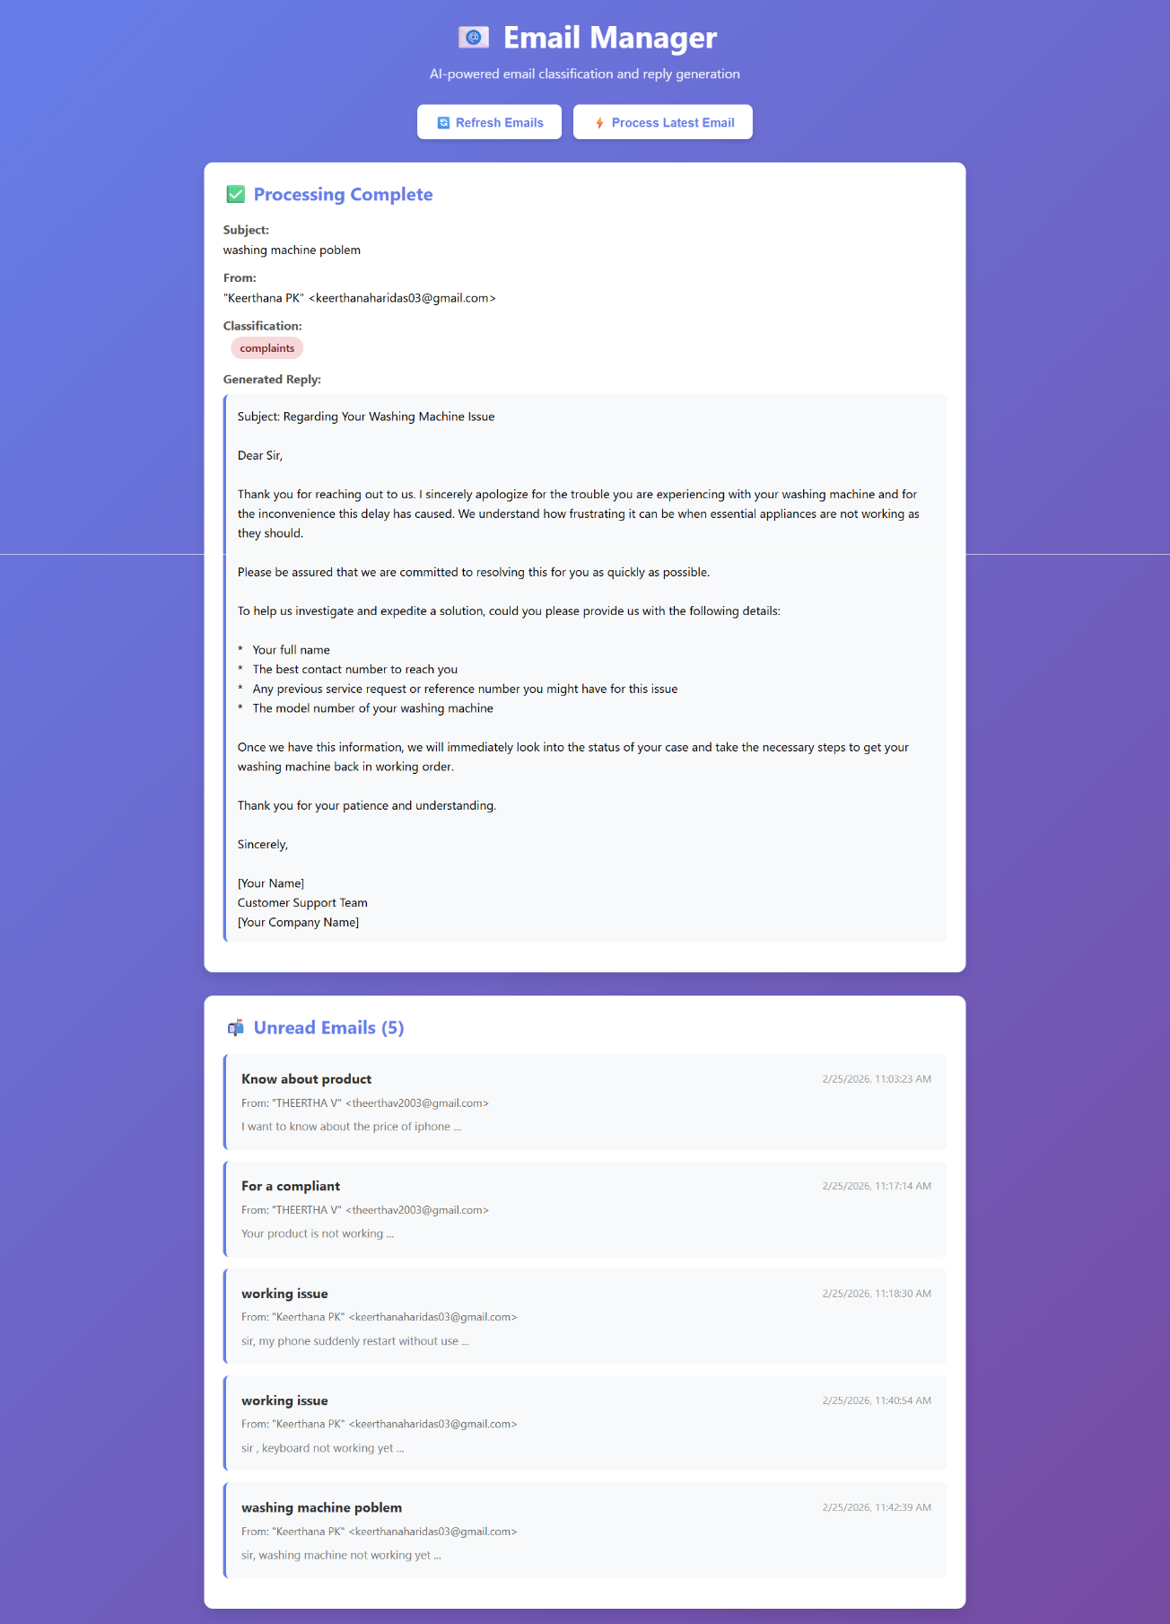

12. CONCLUSION

LangGraph is a powerful framework for building intelligent AI workflow systems and agentic applications. The Email Manager project successfully demonstrated how LangGraph can be used for workflow orchestration, email classification, conditional routing, and AI-based response generation.
The project highlighted the advantages of stateful AI execution and graph-based workflow management in enterprise automation systems. By integrating LangGraph with Large Language Models, the system was able to automate customer support tasks efficiently and reduce manual workload.
The implementation also demonstrated:
• AI agent orchestration
• Dynamic workflow execution
• Context-aware response generation
• Enterprise workflow automation
Overall, the project proves that LangGraph is highly suitable for developing scalable and intelligent AI-powered business applications.

13. REFERENCES

1. https://docs.langchain.com/oss/javascript/langgraph/overview
2. LangChain Official Documentation
3. https://www.w3schools.com/typescript/index.php
4. https://www.geeksforgeeks.org/machine-learning/what-is-langgraph/
5. https://www.geeksforgeeks.org/artificial-intelligence/introduction-to-langchain/
6. Various Authors, YouTube Tutorials on LangGraph and AI Workflow Automation.
7. https://www.ijcrt.org/papers/IJCRT2510239.pdf

