SurveyFlow V1
WhatsApp-Native Survey SaaS for Cameroon and Africa

Reverse-Engineered Build Blueprint
Product, architecture, data model, API, payments, WhatsApp integration and a full testing plan
Written from the working V1 implementation, for AI builders (Emergent, v0, Cursor and similar).
Tech Stack rows Frontend, Backend, Database and Auth are intentionally left empty (Section 3.4).
18 October 2026
Contents

If the contents list looks empty, right-click it in Word and choose "Update field".
Section | What it contains
1 to 3 | Product overview, feature inventory (core, growth, platform, not built), architecture, Tech Stack table (four rows left empty), capabilities and simulators
4 to 7 | WhatsApp integration and state machine, WhatsApp Business API path, reminders engine, gifts and the gift wallet
8 to 11 | Dashboard screens and UX rules, plans and billing, multi-PSP payments, geography and currency
12 to 14 | Analytics definitions, the Analytics Bot and alerts, exports and integrations
15 to 19 | Data model, API reference, background jobs, security, configuration
20 | Testing plan: unit, integration, contract, end-to-end, smoke, stress, security, resilience, UAT, accessibility, data, gates, traceability, real-Meta runbook
21 to 22 | Build milestones and invariants for AI builders; differences from the former blueprint, decisions, risks, open questions
A to C | Message templates and system messages, error codes, glossary

Document Control and How To Use This Blueprint
Item | Value
Product | SurveyFlow V1: a WhatsApp-native survey SaaS (build, send, collect and analyse surveys entirely inside WhatsApp)
Document type | Reverse-engineered build blueprint: written FROM the working V1 implementation, so that it can be rebuilt from scratch by an AI builder (Emergent, v0, Cursor or similar)
Replaces | The former "SurveyFlow V1" blueprint (pre-build). Every place where the built product differs from that blueprint is listed in Section 22.1
Source of truth | The implemented system: 22 database models, about 80 HTTP endpoints, 11 background jobs, 264 API tests, 62 shared-logic tests and 6 real-browser end-to-end scripts (all passing at the time of writing)
Markets | Cameroon first (FCFA/XAF, French and English); also priced for the CFA zone, Nigeria, Kenya and Ghana
Date | 17 October 2026

How to read this document
Words are used with fixed meanings so that an AI builder can treat them as requirements:
Term | Meaning
MUST / MUST NOT | A requirement that a test in Section 20 checks. Breaking it is a defect.
SHOULD | A strong default. Deviate only with a written reason.
[BUILT] | Implemented in V1 and covered by automated tests.
[UNVERIFIED] | Implemented from the provider's documentation but never run against the real provider (Meta, a payment provider, Google). Needs a sandbox pass before launch.
[NOT BUILT] | Decided out of scope for V1, or deliberately removed. Do not build unless the owner asks.
Owner | The survey owner: the paying customer who builds and sends surveys.
Participant | The person who receives and answers a survey on WhatsApp.
Platform / SurveyFlow | The SaaS itself and its operator.
Explore | The free tier (internal plan key trial). It has no time limit and is capped by usage.
Activate | The act of choosing a paid plan (Starter, Growth or Business).

How to use this blueprint with an AI builder
- Give the builder this whole document, not excerpts. Sections 15 (data model), 16 (API) and 20 (testing plan) are the contract.
- Fill the four empty rows of the Tech Stack table in Section 3.4 (Frontend, Backend, Database, Auth) with the stack you want. Everything else in the document is stack-neutral: it states the capabilities the stack must provide (Section 3.5) instead of naming products.
- Ask the builder to follow the milestone order in Section 21 and to run the matching test group of Section 20 at the end of each milestone before starting the next.
- Treat Section 22 (gaps and risks) as the launch checklist. Nothing marked [UNVERIFIED] has run against a real provider.
Honest status. The built product has never sent a message through the real Meta WhatsApp Cloud API, never charged a real payment and never paid a real gift. All three run against built-in simulators (a mock WhatsApp gateway, a mock payment provider and a mock gift provider) that the builder MUST also implement, because every automated test depends on them (Section 3.6).

1. Product Overview
SurveyFlow lets a business owner in Cameroon build, distribute and analyse surveys entirely through WhatsApp: no app to install, no link to open, no friction for the participant. The owner works in a web dashboard (in English or French); the participant only ever sees WhatsApp.
Stakeholder | Experience
Survey Owner | Signs up, picks a segment, connects their own WhatsApp Business number, builds a survey with a live WhatsApp preview, imports contacts (with consent), sends, watches live analytics, exports to PDF/Excel/Google Sheets, optionally rewards participants with airtime, Mobile Money, a discount code or a prize draw, and can ask a WhatsApp bot for their numbers.
Participant | Receives a WhatsApp message from the business, taps Start, answers question by question with taps (or typed text), gets a thank-you and an optional gift. Can type STOP at any time to be removed.
Platform | Operates the web app and API, SurveyFlow's own WhatsApp number (for the Analytics Bot and alerts), payment providers, exchange rates, billing and the background jobs. Never pays for participant gifts (the owner funds a prepaid wallet).

1.1 Why Cameroon, why now
- 78 to 88 percent of Cameroonian internet users use WhatsApp daily, and 71 percent have already ordered a product or service through it (figures from the former blueprint; not re-verified).
- Mobile Money (MTN MoMo, Orange Money) is the natural payment rail for both subscriptions and participant gifts.
- Web survey tools force the participant out of WhatsApp into a browser, which lowers completion.

1.2 Customer segments
At onboarding the owner chooses one segment. It is stored and available as a hook for segment-specific features; V1 does not change behaviour by segment.
Segment key | Meaning | Typical use
business | Businesses | Customer satisfaction, order and delivery feedback
institution | Institutions (NGOs, agencies, public bodies) | Field surveys, beneficiary feedback
academic | Academics and students | Research questionnaires

1.3 Product principles (these drove design decisions)
- Never lose or double-spend money. Payments are verified server to server; gifts are idempotent; the wallet cannot go negative (Sections 7 and 10).
- Never promise what is not paid for. A participant is told about a gift only after the wallet debit succeeded.
- Respect the participant. Opt-in is required to be contacted, STOP is honoured immediately, and reminders are limited to one reminder plus one closing note per person, inside polite hours (Section 6).
- The numbers must agree everywhere. The dashboard, the exports and the WhatsApp bot use the same definitions, and a test asserts that the bot equals the dashboard (Sections 12 and 13).
- Customer effort stays low. Two required onboarding steps, everything else skippable and completed later from a "Getting started" box. Every screen works from 320 px wide.
- Cash first. A free tier without a time limit (Explore) that stops at "reach everyone", and three paid plans. No trial clock, no founding-member price, no money-back guarantee.

2. Feature Inventory
Everything below exists in V1 and is covered by tests, unless marked otherwise. Section numbers point to the detailed specification.

2.1 Core features
Area | Feature | Section
Accounts | Register with email and password (or Google); login; profile; French/English interface; country-aware currency, phone format and time zone; customer segment | 9, 11
Onboarding | Two required steps (segment, connect WhatsApp); everything else skippable; "Getting started" checklist on the dashboard; one shared "finish connecting WhatsApp first" dialog for any action that needs the number | 8.2
Survey builder | Five question types (buttons, list, free text, rating 1-5, multi-select), required/optional, up to 25 questions, drag-and-drop and keyboard reordering, validation of every WhatsApp limit, three templates, duplicate, French/English participant language, live WhatsApp preview exactly as participants will see it | 8.3
Survey lifecycle | draft, active, paused, closed; publish checks; deadline and scheduled send; delete only when not active | 8.3, 9
Contacts | Add one (with a consent tick), import CSV (owner attests consent; phone normalised to E.164; per-row errors), tags, bulk tag, bulk delete, opted-out flag; STOP handling | 4.7, 8.4
Sending | Audience selector (all, tags, chosen contacts), exact count before sending, schedule for later, queue with rate limit and retry, plan quota and Explore cap checks, invitation template approval check | 4.5, 9
Participant experience | Template invitation, Start or Not now, one question at a time with buttons, lists, text or rating, resume where they stopped, skip optional questions, thank-you message, STOP | 4
Session engine | Pure state machine; Redis sessions; idempotent webhook handling; 24-hour abandonment sweeper | 4.3, 4.4
Analytics | Live dashboard: sent, started, completed, abandoned, no reply, declined, opted-out, in-progress; funnel; per-question results with the question type shown next to each title; drop-off alert with advice; paged "haven't replied" list with complete numbers and CSV; responses table | 12
Exports | PDF report with charts, Excel workbook (3 sheets), Google Sheets sync (optional auto-sync) | 14
Billing | Explore plus Starter, Growth, Business; monthly or annual (11 months charged); upgrade, cancel at period end, reactivate; invoices; renewal notices | 9
Payments | Six real payment providers behind one adapter interface, silent cheapest-first routing with failover, verified webhooks, reconciliation job, review queue, operator tool | 10

2.2 Growth and engagement features
Area | Feature | Section
Automatic reminders | Two independent switches (non-responders, abandoners); standard and live-event timing rules; business days and quiet hours; one reminder plus one closing note per person | 6
Manual reminders | Buttons on the analytics page, enabled only when the automatic window has opened | 6
Gifts | Airtime, Mobile Money, discount code, prize draw, custom thank-you; gift cap per survey; immediate or hourly batch delivery; PDF receipt link | 7
Gift wallet | Owner-funded prepaid wallet in the owner's own currency, top-up through the payment layer, append-only ledger, pass-through fee, refund on definite failure, release of unfunded gifts after a top-up | 7
Analytics Bot | The owner asks SurveyFlow's WhatsApp number for STATS, RESULTS, DROP, NONRESP, STARTED, COMPLETED, SURVEYS, MORE, HELP; linked phones only (one-time code); masked numbers; French and English | 13
Push alerts | Milestone (100, 500, 1,000, 5,000, 10,000 completed) and slowdown alerts; free reply inside the 24-hour window, capped template outside it; mute per phone | 13.5
Builder preview of the bot | A switch above the phone shows the owner's side of WhatsApp with example or live numbers; the simulator has an Owner mode (visible on Explore, locked to paid plans in production) | 8.3, 13.6
Funnel measurement | First occurrence of each milestone per owner (signup to paid) to measure conversion | 9.6

2.3 Platform, safety and operations features
Area | Feature | Section
Multi-currency | Prices, wallet and gifts in the owner's currency from a live exchange rate with last-known-good fallback; CFA francs and euro fixed | 11
Geolocation | Country from the CDN header drives currency, phone prefix and example, time zone for reminders | 11
Security | Internal-secret gate (API reachable only through the website), signed webhooks, encrypted tokens, rate limits, no user enumeration, locked-down PDF renderer | 18
Resilience | Idempotent everything; DB-backed queue with lease and backoff; circuit breaker per payment provider; leader-only jobs; Redis-loss recovery from SQL | 4, 10, 17
Operator tools | Payment review CLI, Meta check script, FX stub, mock providers, simulator | 10.8, 20
Responsive UI | Every screen verified from 320 to 1920 px with no horizontal scroll; sticky menu bars; hamburger side menu on the public site below 640 px | 8.8

2.4 Deliberately NOT in V1
- [NOT BUILT] Team members, API access, white-label: shown on the plan table as "Coming soon". Only the plan flags exist.
- [NOT BUILT] Founding-member pricing, a time-limited trial, a money-back guarantee (removed by decision).
- [NOT BUILT] WhatsApp Flows (the multi-select question is answered by typing numbers), loyalty points, charity donations, voucher APIs.
- [NOT BUILT] Collecting overage charges automatically (overage is calculated and shown; no code path charges it).
- [NOT BUILT] Automatic refunds and payouts to the owner; provider-statement reconciliation; public holidays in reminder timing.
- [NOT BUILT] Survey logic branching (every participant sees every question in order).

3. End-to-End Architecture
+-------------------------------------------------------------+
| SURVEY OWNER (web dashboard) |
| Survey Builder | Contacts | Analytics | Billing | Settings |
+-------------------------------------------------------------+
| HTTPS: the website server forwards the call + shared secret
v
+-------------------------------------------------------------+
| WEBSITE SERVER (front door) |
| session cookie -> bearer token, visitor country header, |
| x-internal-secret, /proxy/* -> API |
+-------------------------------------------------------------+
v
+-------------------------------------------------------------+
| SURVEYFLOW API |
| Auth | Surveys | Contacts | Analytics | Billing | Wallet |
| Survey Engine (pure state machine) | WhatsApp Gateway |
| Payment Orchestrator + PSP adapters | Gift worker |
| Analytics Bot | Alert service | Exports | FX service |
| Background jobs (leader-elected where needed) |
+-------------------------------------------------------------+
| | |
v v v
Relational DB Key-value store Outbound HTTPS
(durable truth) (sessions, locks, (Meta Graph API, payment
rate limits, dedupe, providers, Google, FX source)
one-time codes)
^
| signed webhooks
+-------------------------------------------------------------+
| Meta WhatsApp Cloud API | Payment providers (webhooks) |
+-------------------------------------------------------------+
|
v
PARTICIPANTS and OWNERS on WhatsApp

3.1 Components
Component | Responsibility
Website server | Serves the marketing site and the app. It is the only caller of the API: it attaches the visitor's session token, the visitor's country (from the CDN header) and a shared secret. Public pages (marketing, login, register, pricing, legal) need no session.
API | All business logic. Stateless; any number of replicas. Refuses every request that lacks the shared secret except four public paths (Section 18.1).
Survey engine | A pure function step(survey, session, recipientStatus, answeredIds, inbound, now) -> {event, session, messages, saveAnswer}. No I/O, so every transition is unit-testable.
WhatsApp gateway | One interface (sendMessage, sendTemplate, createTemplate, listTemplates, subscribeApp, getPhoneInfo) with two implementations: the real Cloud API client and a mock that writes to an in-memory chat log. Selected by WHATSAPP_MODE.
Send queue | A database table of jobs claimed with FOR UPDATE SKIP LOCKED-style locking, rate-limited per WhatsApp number, retried with backoff.
Payment orchestrator | Creates a payment record, picks the cheapest capable provider, fails over, verifies outcomes, settles in one transaction, reconciles lost webhooks.
Analytics Bot and alerts | Answers owners on SurveyFlow's own WhatsApp number and pushes milestone alerts.
Scheduler | In-process timers that run the background jobs (Section 17). Disabled with RUN_JOBS=false for web-only replicas.

3.2 Process model
- The API and the workers can run in one process (development) or the workers can be split out. Jobs marked "leader" MUST run on one replica at a time (a lock in the key-value store).
- Webhook handlers MUST acknowledge quickly and be idempotent: Meta and every payment provider retry.
- All timestamps are stored in UTC. Business-day and quiet-hour rules use the owner's fixed UTC offset (no supported country observes daylight saving).

3.3 Request flow of the participant journey
Owner clicks Send
-> API validates (plan quota, Explore cap, template approved)
-> one SurveyRecipient + one SendJob (kind=invitation) per contact
-> send worker claims jobs, rate-limits, calls Meta template send
-> Meta delivers; status webhooks update delivery state
Participant taps "Start"
-> Meta webhook -> signature check -> dedupe by message id
-> lock per (phone number, participant) -> engine.step()
-> persist answer + recipient status + session -> send next question
Last answer
-> one DB transaction: mark completed + plan gift (+ wallet debit)
-> thank-you message; gift worker pays; Sheets auto-sync; milestone check

3.4 Tech Stack
The first four rows are intentionally left empty: the builder (or the owner) chooses them. The other rows are fixed by the integrations the product depends on.
Layer | Choice | Notes
Frontend
Backend
Database
Auth
WhatsApp Integration | Meta WhatsApp Business Cloud API (official), Graph API version configurable (V1 was written against v22.0). Customers connect their OWN number through Meta Embedded Signup (Tech Provider model). SurveyFlow's own number (platform number) is used for the Analytics Bot and alerts. A BSP such as 360Dialog or Twilio is the fallback if Tech Provider approval is slow. | Webhook signature header X-Hub-Signature-256 (HMAC-SHA256 of the raw body with the app secret) MUST be verified. Templates are per WABA. Interactive limits: 3 buttons, 10 list rows, button title 20 chars, row title 24, body 1,024 (Section 4.2).
Payments | Multi-PSP orchestration with six providers behind one adapter interface: Campay, NotchPay, CamerPay, PayUnit, CinetPay, Flutterwave (plus a mock for development). Mobile Money (MTN, Orange) and international cards. Cheapest-first routing from documented fees with failover. Gifts are paid out through Campay (airtime and Mobile Money) with a mock provider for development. | Webhooks are only a signal: the outcome always comes from a server-to-server verification of amount and currency (Section 10). Charge currencies: XAF, XOF, ZAR, GHS, KES, NGN, UGX, USD, GBP, EUR.
Exports | Excel: a library that writes real text cells (never formulas), 3 sheets. PDF: a headless-browser render of an HTML report with charts, with every network request blocked. Google Sheets: Sheets API v4 over REST, OAuth2 with an encrypted refresh token, values written RAW. | Free-text answers are untrusted input in all three exports (Section 14).

3.5 Capabilities the chosen stack MUST provide
Because Frontend, Backend, Database and Auth are left open, the builder MUST pick technologies that can do all of the following. Each item is exercised by a test in Section 20.
Capability | Why it is needed
Relational database with transactions and unique constraints | Gift uniqueness, payment settlement and wallet debits rely on compare-and-set updates and unique keys inside one transaction.
Guarded atomic update (UPDATE ... WHERE balance >= x) | The wallet balance MUST NOT go negative under concurrency.
Row-level locking with skip-locked semantics (or an equivalent queue claim) | Several workers claim send jobs and gifts without taking the same one twice.
Key-value store with expiry, atomic set-if-absent, increment, sorted sets and a lock primitive | Participant sessions, webhook de-duplication, rate limits, one-time link codes, FX cache, job leader election.
Raw request body access in the webhook route | Signatures are computed over the exact bytes received.
Server-side rendering or a server proxy that can hold a secret | The browser MUST NOT be able to call the API directly or learn the shared secret.
Symmetric encryption (AES-256-GCM or equivalent) | WhatsApp access tokens and Google refresh tokens are stored encrypted.
Password hashing (bcrypt cost 12 or stronger) and signed tokens (HS256 or stronger) | Authentication (Section 18.2).
A headless browser for PDF | PDF report and receipts.
Scheduled in-process or external jobs with a lease/leader lock | Section 17.

3.6 Simulators the builder MUST also build
All automated tests and the demo mode use these. They are part of the product, not test code.
Simulator | Behaviour
Mock WhatsApp gateway | Selected when WHATSAPP_MODE=mock. Every outbound message and template is appended to a per-(phone number, participant) chat list in the key-value store. Template sends record name, language, parameters and button payloads. createTemplate returns APPROVED instantly. A "platform-mock" phone number id represents SurveyFlow's own number.
Dev simulator API (development and test only; 404 in production) | GET/POST /api/dev/simulator/:contactId[...] plays a participant against the REAL webhook code path; /expire fast-forwards 25 hours and runs the sweeper; /api/dev/jobs/run runs the send queue and gift worker once; /api/dev/owner[/send] plays an owner against the Analytics Bot.
Mock payment provider (PSP_MOCK=true) | A hosted checkout page with "Pay (success)", "Pay (fail)" buttons and a settle endpoint. Refused in production.
Mock gift provider | Returns a fake provider reference. GIFT_PROVIDER=mock is refused in production.
FX stub | A tiny HTTP server serving fixed rates in the same JSON shape as the live source (1 XAF = 2.4 NGN, 0.2 KES, and so on) so currency tests are deterministic.

4. WhatsApp Integration: How It Works

4.1 The participant journey
Participant receives (TEMPLATE message, utility category):
+--------------------------------------------------+
| Hello Aicha! Boulangerie Akwa invites you to a |
| short survey. It takes about 2 minutes. |
| [Start survey] [Not now] |
+--------------------------------------------------+
| taps "Start survey" (quick-reply payload START:<surveyId>)
v
+--------------------------------------------------+
| *Question 1 of 3* |
| How satisfied are you with our service? |
| [Very satisfied] [Neutral] [Unsatisfied] | <- reply buttons (<= 3 options)
+--------------------------------------------------+
| taps a button (reply id a:<questionId>:<optionId>)
v
+--------------------------------------------------+
| *Question 2 of 3* Which product do you use most?|
| [See options] -> list of up to 10 rows | <- list message
+--------------------------------------------------+
v
+--------------------------------------------------+
| *Question 3 of 3* Any suggestions? |
| _Type your answer below._ _Reply SKIP to skip._ | <- plain text (optional question)
+--------------------------------------------------+
v
Thank-you + gift line (plain message inside the 24 h window)
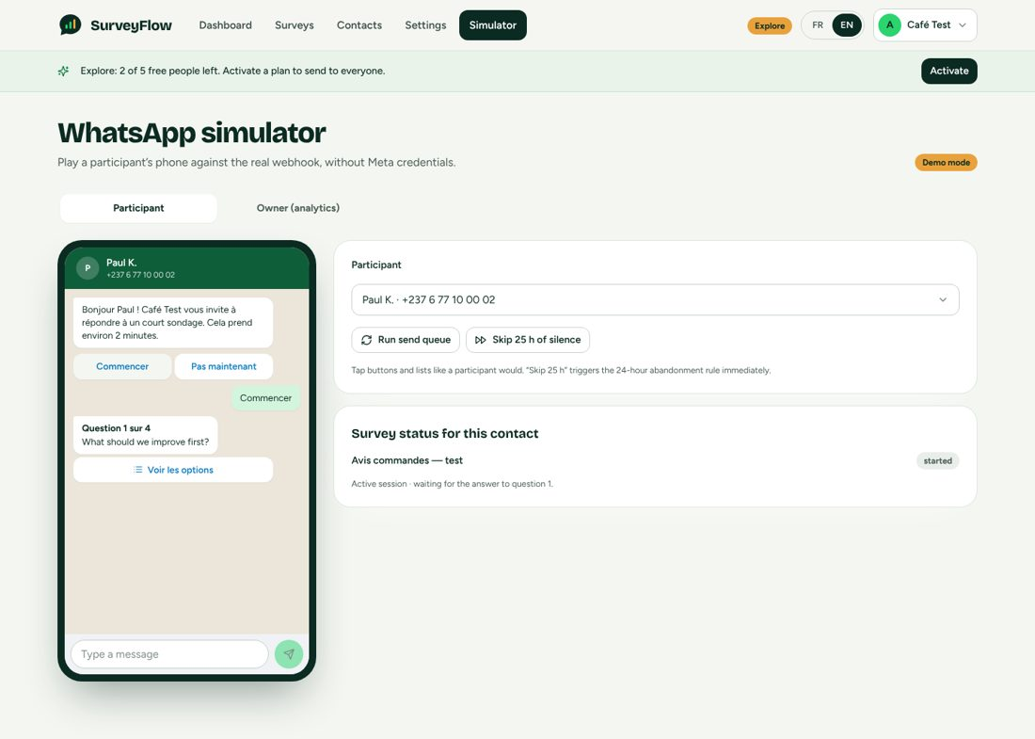
The simulator playing a participant: the same message objects the real gateway sends (French survey).

4.2 WhatsApp message types used
Survey element | WhatsApp message type | Limit or rule
Invitation | Template message, UTILITY category, 2 quick-reply buttons | First business-initiated message MUST be an approved template. Payload START:<surveyId> and DECLINE:<surveyId>.
Multiple choice, 2 to 3 options (button) | Interactive reply buttons | At most 3 buttons; button title at most 20 characters; id a:<questionId>:<optionId>.
Multiple choice, 2 to 10 options (list) | Interactive list message, button label "See options" | At most 10 rows; row title at most 24 characters.
Rating 1 to 5 (rating) | Interactive list (5 rows). Row 1 carries the description "Very poor" and row 5 "Excellent" | Buttons cannot hold 5 options, so a list is used. Option ids and labels are "1" to "5".
Multi-select (multi) | Plain text with a numbered list; the participant replies with numbers separated by commas (for example 1,3) | No WhatsApp Flow in V1. Answer stored as a JSON array of labels. Option label at most 60 characters.
Free text (text) | Plain text message | Answer capped at 2,000 characters.
Thank-you and gift line | Plain text inside the 24-hour window | Gift line differs by gift type (Section 7).
Gift receipt (in window) | "Link" message: one call-to-action URL button "Download receipt" | Free inside the window, unlike a template.
Gift notice outside the window | Template with a URL button (suffix = receipt token) | Used after a wallet top-up releases unfunded gifts.
Reminders | Templates in the MARKETING category (see Section 6 and Appendix A) | Meta bills marketing messages at a higher rate and may cap frequency per person.

Limits that shape the product (WA_LIMITS): body 1,024 characters for interactive messages; our own cap of 900 characters for the question text so that "Question 3 of 5" plus the text always fits; at most 25 questions per survey; text body 4,096.

4.3 Survey logic: the state machine
Each participant-survey pair has a durable recipient record (the funnel status) and, while the participant is answering, a short-lived session in the key-value store.
status (SurveyRecipient) meaning
queued invitation job created, not yet sent
sent template accepted by Meta
delivered delivery receipt received
started participant tapped Start (or answered after a Redis loss)
completed all questions answered (or optional ones skipped)
abandoned no reply for 24 h (configurable) while started
declined tapped "Not now"
failed invitation could not be sent (or opted out while queued)

Transitions
queued --send--> sent --delivery--> delivered
sent|delivered --Start--> started
started --answer Qn (n < total)--> started
started --answer last--> completed
started --24 h silence--> abandoned (sweeper; stores abandonedAtQuestion)
sent|delivered --Not now--> declined
abandoned|declined --Start/Continue--> started (resume at first unanswered question)
any --STOP--> contact opted out (see 4.7)
Deliberate deviations from the former blueprint. (1) A participant becomes "started" when they tap Start, not when they answer Q1: otherwise someone who taps Start, sees Q1 and leaves would count as "no reply" forever and the biggest drop-off (Q1) would be invisible. (2) status is funnel progress and never goes backwards: sending a reminder to an abandoned participant must not remove them from the "abandoned" count; delivery work lives in the send queue instead. (3) The two extra statuses queued and failed exist because "sent" cannot be computed without them.

Session record (key-value store)
key sf:sess:{phoneNumberId}:{waId}
value { surveyId, contactId, recipientId, phoneNumberId,
currentIndex (0-based), startedAt, lastInteractionAt }
index sorted set sf:deadlines (score = lastInteractionAt + timeout)
Durable truth is the recipient record plus the stored responses, so a lost key-value store can be rebuilt from the database: the sweeper has an SQL fallback pass, and an answer arriving with no session picks the thread back up from the first unanswered question.

Engine rules (every one is a unit test)
- Start or Continue: if the recipient is completed, answer "already completed". A paused survey finishes in-flight participants but does not accept new ones. Resume at the first unanswered question, prefixed by "Welcome back".
- Repeated Start mid-survey re-sends the current question.
- Decline is ignored when the participant already started or finished (it must not wipe progress).
- Stale tap: a button or row belonging to an earlier question re-sends the current question and changes nothing.
- Invalid answer: a hint ("Please pick one of the options") followed by the same question; the session stays on that question.
- Typed answers: for button, list and rating questions, a number matches a rating label first, otherwise a 1-based position for button/list; an option label typed in any case also matches. Multi-select accepts numbers separated by spaces, commas or semicolons, de-duplicated and range-checked, stored sorted as a JSON array of labels. Text must be non-empty.
- Optional questions accept SKIP, PASSER or PASS and store an empty answer (the question counts as passed, not answered).
- Closed or draft survey: "This survey has ended. Thank you!" and no session.
- All questions already answered but completion not recorded (crash): complete immediately.

4.4 The inbound webhook
GET /api/webhook/whatsapp verification handshake: hub.mode=subscribe, hub.verify_token ==
configured token -> echo hub.challenge, else 403
POST /api/webhook/whatsapp 1. verify X-Hub-Signature-256 over the RAW body (401 if wrong; refuse
unsigned in live mode or production)
2. for every entry, every change, every message and every status (Meta
batches):
- field "message_template_status_update": update the template row
(status, reason)
- statuses: update delivery state of the invitation (and record
failures)
- messages: handleMessage()
3. 200 {ok:true}; on any processing error answer 500 so Meta retries
(handlers are idempotent)

handleMessage(phoneNumberId, msg)
a. claim msg.id with SET NX EX 120 (duplicate delivery -> return); on success mark done for 7
days; on error release
b. take a lock on (phoneNumberId, from) and run turn():
- if phoneNumberId is SurveyFlow's OWN number -> Analytics Bot (Section 13), never a
participant
- find the WhatsApp account by phoneNumberId (unknown -> warn and stop)
- the sender MUST be an existing contact of that owner (no walk-ins, no gift farming)
- STOP words (stop, arret, unsubscribe, desabonner) -> opt out (4.7)
- find the survey: from the template payload surveyId; else from the live session;
else a typed START word picks the most recent invitation; else (session lost) the started
recipient in SQL
- the survey MUST belong to the same owner as the number
- an explicit START on a different survey turns the in-progress one into "abandoned"
- build runtime survey, call engine.step(), persist in ONE transaction, then send replies
Differences from the pseudo-code of the former blueprint: the real handler iterates all entries and messages; it distinguishes button replies from list replies; it handles template quick-reply buttons (message type button); it de-duplicates by message id; it verifies the signature; it never trusts unknown senders.

4.5 The outbound pipeline
- Business-initiated messages (invitations, reminders, closing notes, out-of-window gift notices) are rows in a send-job table: invitation, reminder, gift_notice, nudge, deadline_note, progress_saved, progress_saved_deadline, and session_message (a reply parked after an inline send failed).
- Claiming: a single statement sets status processing and lockedAt for jobs that are queued and due, or processing with an expired lease (5 minutes), ordered by due time, skipping rows locked by another worker.
- Rate limit: 15 messages per second per WhatsApp number (counter per number per second).
- Retry: only transient failures (HTTP 429/5xx or network) are retried, up to 6 attempts with back-off of 30 s, 2 min, 10 min, 1 h, 6 h. A permanent failure marks the job failed and, if the invitation never left, the recipient failed. A token problem marks the WhatsApp account error and surfaces in Settings.
- Quota: every business-initiated template message writes one message-log row; the plan's "WhatsApp messages per month" counts those rows. Free-form replies inside the 24-hour window are not counted.
- Nobody is invited twice: invitations are only created for new or previously failed recipients; a unique (survey, contact) key enforces it.
- Replies inside a live conversation are sent inline; if one fails after the participant's answer was saved, the unsent remainder is parked as a session_message job.
- Survey kinds only make sense while the survey runs: if the survey is no longer active when a job is claimed, the job is cancelled.

4.6 Delivery status and template status
- Delivery webhooks (sent, delivered, read, failed) are matched to the invitation by the stored message id. delivered moves a sent recipient to delivered; a failure stores the error text.
- Template status webhooks update the template row (PENDING, APPROVED, REJECTED, PAUSED) and a reason. Sending an invitation is refused with template_not_approved until the owner's invitation template is approved for the survey language.

4.7 Consent and opt-out
- A contact MUST have consent recorded (consentAt, consentSource) before it is invited. Adding a contact in the UI requires ticking an opt-in box; importing a CSV requires the owner to attest consent for every row.
- STOP (also arret, unsubscribe, desabonner, with or without accents): the contact is marked opted out immediately; queued invitations and send jobs for that contact are cancelled; an in-progress session becomes abandoned; the participant receives a one-line confirmation. Opted-out contacts are never invited, reminded or listed as "no reply" (Section 12).
- A STOP typed by a contact applies to that owner only.

4.8 SurveyFlow's own WhatsApp number
SurveyFlow has one WhatsApp number of its own (configured by WHATSAPP_PHONE_NUMBER_ID, WHATSAPP_ACCESS_TOKEN, WHATSAPP_BUSINESS_ACCOUNT_ID and WHATSAPP_PLATFORM_PHONE). It is used for the Analytics Bot and its alerts (Section 13), for renewal notices and for the empty-wallet notice. Messages arriving on it are routed to the bot and never to the survey engine. In mock mode its id is platform-mock and its display number defaults to 237600000001.

5. WhatsApp Business API: Technical Path

5.1 Becoming a Tech Provider
To let customers connect their own numbers, SurveyFlow registers as a Meta Tech Provider (requirements quoted from the former blueprint and not re-verified: complete onboarding, sustained daily message volume, at least 10 active business clients, number quality score of 90 percent or more). A faster alternative is to start through a BSP such as 360Dialog, Twilio or 8x8 and migrate later. The gateway interface (Section 3.1) is what makes that swap possible.

5.2 Embedded Signup: what the customer does and what SurveyFlow does
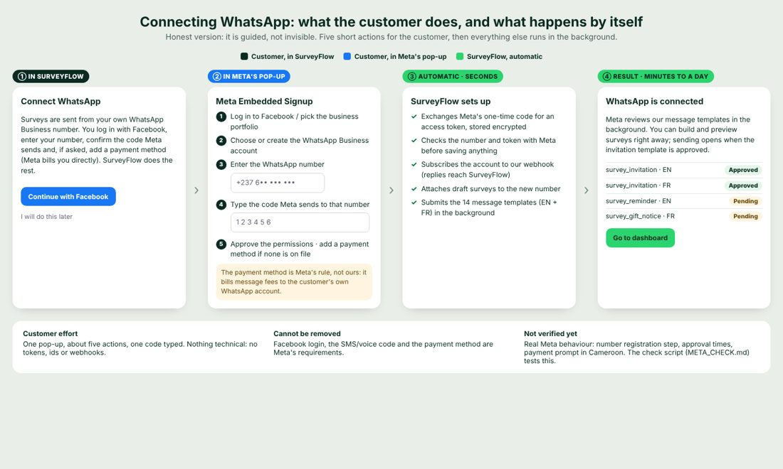
Connecting WhatsApp: who does what. The payment-method step is Meta's rule, not SurveyFlow's.
Step | Actor | Detail
1 | Owner | Opens "Connect WhatsApp" (onboarding step 2, or Settings, WhatsApp tab) and clicks "Continue with Facebook".
2 | Owner in Meta's pop-up | Logs in to Facebook, selects or creates a WhatsApp Business account, enters the WhatsApp number, types the code Meta sends to it, approves the permissions, and adds a payment method if none is on file (Meta bills conversation fees to the customer's own account).
3 | Browser | Receives the one-time code and the ids from the pop-up's message event (waba_id, phone_number_id) and posts them to POST /api/whatsapp/embedded-signup.
4 | SurveyFlow, automatic | Exchanges the code for an access token; asks Meta for the number's details (proves the token and ids work BEFORE storing anything); subscribes the account to SurveyFlow's webhook; stores the account with the token encrypted; attaches any draft surveys to it; records the whatsapp_connected funnel event.
5 | SurveyFlow, background (live mode) | Submits the 14 message templates (7 names in English and French) to Meta. Approval is asynchronous (minutes to a day); the Settings page shows each template's status as webhooks arrive.
6 | SurveyFlow | Sending opens when the invitation template for the survey language is approved. Until then the owner can build and preview.

Is it silent? No. It is guided: one pop-up, about five actions, one code typed. Facebook login, the SMS or voice code and the payment method are Meta's requirements and cannot be removed. Everything technical (token, webhook, templates) is automatic.
[UNVERIFIED] Never run against real Meta. In particular: number registration (POST /{phone-number-id}/register with a PIN) is NOT implemented and Embedded Signup may require it; approval times; the payment prompt for customers in Cameroon. docs/META_CHECK.md and scripts/meta-check.mts exist to test a Meta test app (token scopes, phone number, all 14 templates, one message of every kind, webhook signature handling).

Fallback: manual connection
POST /api/whatsapp/accounts accepts wabaId, phoneNumberId and a long-lived accessToken pasted by the owner. The same checks (token proof, webhook subscription, template submission) run. In mock mode POST /api/whatsapp/accounts/mock creates a simulated number so the whole product can be explored without Meta credentials.
- One WhatsApp account per owner in V1 (409 already_connected); a phone number id can belong to one owner only (409 number_in_use).
- Deleting the account detaches it from surveys (they are kept).
- Templates are per WABA: each connected account submits its own copies; the pre-approved library of the former blueprint cannot be shared across customers' accounts.

5.3 Message templates
Seven template names, each in English and French (14 in total). Full texts are in Appendix A. Categories: survey_invitation and survey_gift_notice UTILITY; every reminder-type template MARKETING (by owner decision: they ask someone to do something they did not do). Meta may re-categorise; the check script reports it.
Template | Category | Variables | Buttons
survey_invitation | UTILITY | 1 name, 2 business, 3 minutes | Start / Not now (quick replies)
survey_reminder | MARKETING | 1 name, 2 business | Continue
survey_gift_notice | UTILITY | 1 name, 2 gift | URL button "Download receipt" (suffix = receipt token)
survey_nudge | MARKETING | 1 name, 2 business, 3 minutes | Start / Not now
survey_deadline_note | MARKETING | 1 name, 2 business, 3 deadline | Start
survey_progress_saved | MARKETING | 1 name | Continue
survey_progress_saved_deadline | MARKETING | 1 name, 2 deadline | Continue

Quick-reply payloads are START:<surveyId>, DECLINE:<surveyId> and CONTINUE:<surveyId>. A button payload that does not match is ignored (it belongs to another template of the same WABA).

6. Reminders Engine
Owners who are not used to surveying often chase people too fast. SurveyFlow therefore decides WHEN a reminder is allowed, not the owner. The rules are pure functions (no database, no clock) so they can be tested to the minute.

6.1 Settings per survey
Setting | Values | Rule
kind | general (default) or event | An event survey is about something happening now or within 7 days. It REQUIRES a deadline date.
deadlineAt | End of the chosen local day, or none | The survey closes by itself at the deadline. A past date is refused.
autoRemindNonResponders | false by default | Independent switch.
autoRemindAbandoners | false by default | Independent switch.

6.2 The rules
Group | Standard rule | Live-event rule
Non-responders (invited, never tapped Start) | ONE warm reminder between 3 and 5 business days after the invitation. | ONE reminder 24 hours after the invitation, then, if still nothing 24 h after that reminder, ONE closing note mentioning the deadline.
Abandoners (started, silent 24 h) | ONE reminder 2 to 3 business days after the survey reached them (never before they were flagged abandoned), then, if not finished 24 h after the reminder, ONE closing note ("thanks, your progress is saved"). | Same logic with urgent timing: reminder as soon as they are flagged, closing note 24 h later, note mentions the deadline.

- At most one reminder plus one closing note per person, ever.
- Nothing is sent outside 08:00 to 19:00 local time; the standard rule runs Monday to Friday only. Public holidays are NOT modelled.
- A reminder is never scheduled less than 4 hours before the deadline. Nobody who opted out, completed or declined is reminded.
- Reminder templates are MARKETING and each one counts as a message in the plan's quota.
- Manual reminders ("Remind non-responders", "Remind abandoners" on the analytics page) obey the same windows: the buttons are disabled until the automatic window has opened, and an explanatory note shows when it will. The API answers 409 reminder_not_yet with the date, or 400 nobody_to_remind.

6.3 Implementation
- A leader-only job (every 5 minutes) selects eligible recipients, claims each one atomically (remindedAt, reminderRule, reminderAuto, followupAt are set in the same statement that creates the send job), and queues the template.
- Time arithmetic uses the owner's fixed UTC offset from the country table (Section 11). addBusinessDays keeps the same time of day.

7. Gifts and the Gift Wallet

7.1 Gift types
Type | What the participant gets | Needs wallet | Plans
none | Thank-you only | No | All
airtime | Airtime or data sent to the participant's number through the payout provider | Yes | Growth, Business
momo | Mobile Money transfer to the number | Yes | Growth, Business
discount | A unique code generated by SurveyFlow, sent in the thank-you | No | Growth, Business
prize_draw | Entry in a draw; the owner draws a winner later (POST /api/surveys/:id/draw) | No | Growth, Business
custom | Only the owner's custom thank-you text | No | All

Explore and Starter have no gift automation (giftAutomation=false): a free tier that can pay out real money is a farming vector. If a plan stops including gifts, a participant gets a plain thank-you: nothing is promised that will not be delivered.

7.2 When a participant completes (one transaction)
- Mark the recipient completed only if it was not already (a concurrent delivery returns without a second gift).
- Plan the gift. If the survey has a gift cap and it is reached, or the participant already has a gift row, the result is "none". Each gift type is handled in exactly ONE branch (the former blueprint's switch had no break and would also have paid a discount code to an airtime winner).
- Airtime or Mobile Money: create a gift row pending (delivery now, or at the next top of the hour for batch), then debit the wallet by amount plus fee with a guarded update. If the balance is too low the row becomes unfunded and the participant gets a plain thank-you.
- Discount: create the row sent with the generated code (unique per survey).
- Prize draw: create the draw entry and a sent gift row.
- Commit, send the thank-you text (gift line included), and let the gift worker pay.
A unique key on (survey, contact) makes a second gift for the same person impossible at database level, even if the webhook is retried.

7.3 The wallet
- The SURVEY OWNER pays for gifts from a prepaid wallet kept in the owner's own currency (whole units). The currency is fixed by the first top-up.
- The balance never goes negative: it changes only by a guarded atomic update (... WHERE balance >= amount). The append-only ledger (WalletEntry: topup, gift_debit, gift_refund) is the audit trail.
- Top-up goes through the normal payment layer (purpose=gift_topup). Limits (defined in FCFA and converted at the live rate to tidy 1-2-5 values): minimum 2,000, maximum 1,000,000; presets 5,000, 10,000, 25,000, 50,000, 100,000; gift minimum 100, maximum 20,000 per participant.
- Fee: each gift also costs a pass-through fee of GIFT_FEE_PERCENT (default 5 percent, rounded up) debited with it. The default is a placeholder until real provider tariffs are known.
- Refund: a DEFINITE payout failure returns amount plus fee to the wallet (ledger gift_refund). An ambiguous failure (timeout after the request left, reset) is NEVER retried and is NOT refunded: a retry could pay twice. It is marked for an operator.
- Release: after a top-up the owner can release unfunded gifts (POST /api/surveys/:id/gifts/release); they are paid and the participant is told by template because the 24-hour window is closed. POST .../gifts/retry re-queues retryable failures.
- Warnings: the send panel shows the worst-case exposure (invited x unit cost, bounded by the gift cap) before sending; an empty wallet raises an in-app banner and a WhatsApp notice (a job checks every 10 minutes).
- The payout provider speaks CFA francs only: each gift also stores its XAF equivalent at the moment it is paid (payoutXAF).

7.4 Delivery worker
- Every 5 seconds claim up to 20 due pending airtime/momo gifts (lease by pushing scheduledFor 5 minutes ahead).
- Up to 3 attempts with delays of 10 minutes and 1 hour for retryable failures.
- Provider contract: throw GiftError(ambiguous=false) ONLY when the provider definitely did not pay; ambiguous=true when unknown.
- Campay is the V1 payout provider (airtime transfer and Mobile Money withdrawal) [UNVERIFIED against its live or demo API]; a mock provider exists for development and is refused in production.

7.5 Receipts
- After a paid gift (airtime or Mobile Money) is delivered, a signed receipt link is sent to the participant: a "Download receipt" button (link message inside the window, URL-button template outside it).
- GET /api/receipts/:token is public (the token is signed and carries the gift id) and rate-limited to 30 per minute; it renders a small PDF with the same locked-down renderer as the report.
- The owner sees receipt links only for gifts that were really delivered; the API sends null otherwise.
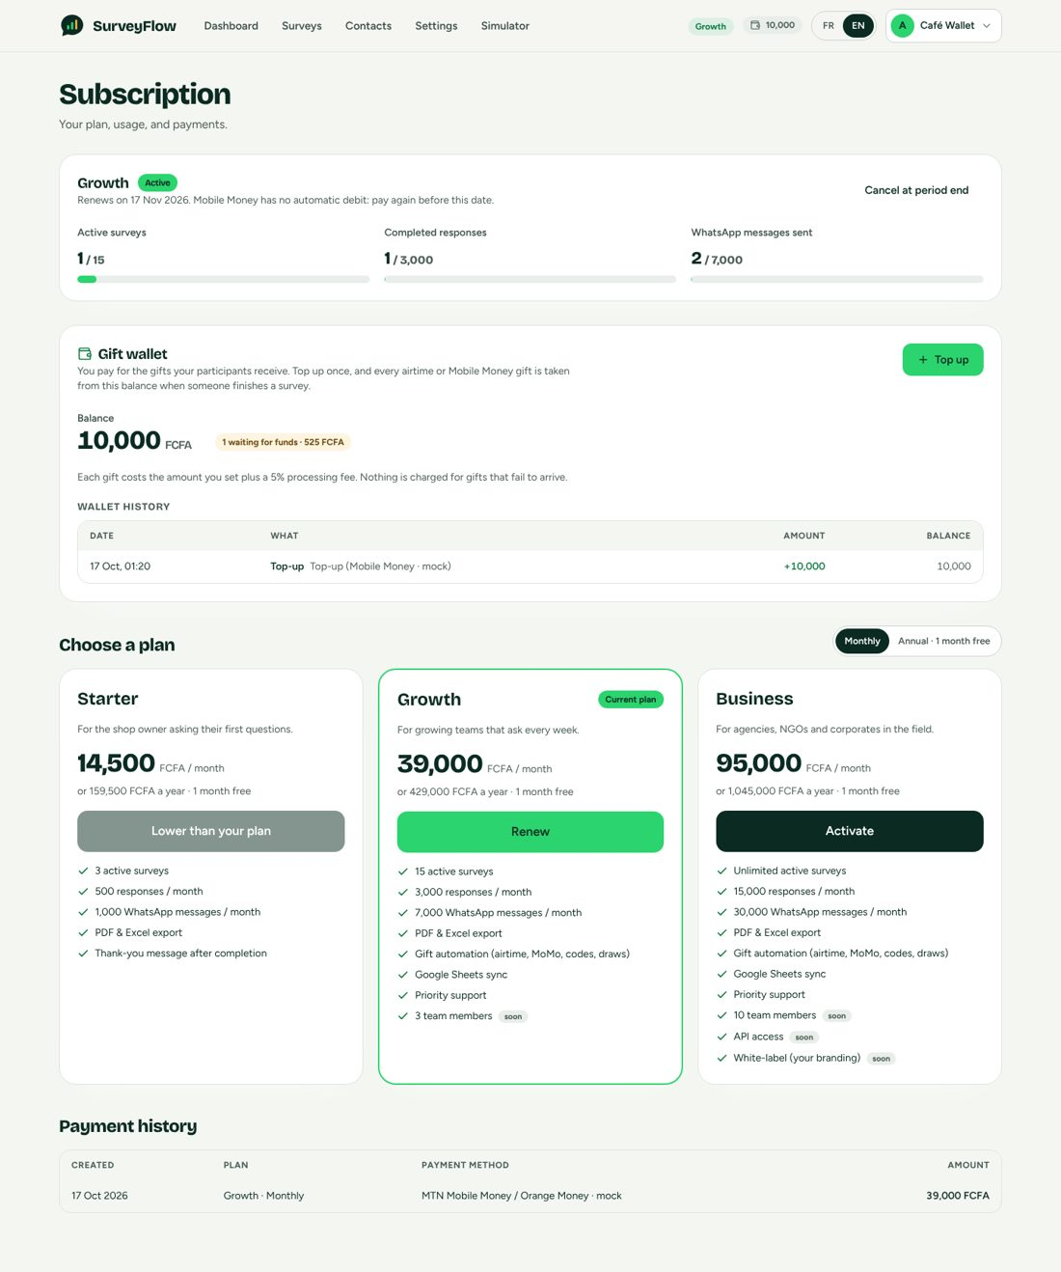
Billing page with a funded gift wallet.

8. SaaS Dashboard: Functional Specification

8.1 Site map and access
Route | Access | Purpose
/ | Public | Marketing home: hero, how it works, "Explore free" call to action
/pricing | Public | Explore card plus Starter, Growth, Business; monthly/annual toggle ("Annual, 1 month free"); price in the visitor's currency with the rate note; response-volume slider that recommends a plan; trust row; FAQ
/privacy, /terms | Public | Legal pages
/login, /register | Public | Sign in (email/password or Google); sign up (business name, name, phone with country prefix, email, password)
/onboarding | Session | Two steps: segment, connect WhatsApp
/dashboard | Session | Usage meters, Getting started box, recent surveys, WhatsApp-needed card
/surveys, /surveys/new | Session | List (table; cards on phones) and creation (templates gallery or blank)
/surveys/[id] | Session | Builder with live preview, timing and reminders, gift settings, send panel
/surveys/[id]/analytics | Session | Live analytics
/surveys/[id]/export | Session | PDF, Excel and Google Sheets sync
/contacts | Session | Contact manager
/billing | Session | Plan, usage, gift wallet, plan cards, payment history, payments in progress
/billing/mock-checkout, /billing/return | Session | Demo checkout page; return page after a payment (pending, waiting, review, expired, success views)
/settings | Session | Tabs: Profile, WhatsApp, Analytics on WhatsApp, Integrations
/simulator | Session (demo mode) | Participant tab and Owner tab
/integrations/google/callback | Session | OAuth return for Google Sheets

- Every app route is protected by session middleware; unauthenticated visitors are redirected to /login. A new account whose segment is not yet chosen is redirected to /onboarding from any app page.
- The browser never talks to the API directly: it calls /proxy/* on the website, which forwards with the bearer token, the shared secret and the visitor's country header.

8.2 Onboarding (exactly two steps)
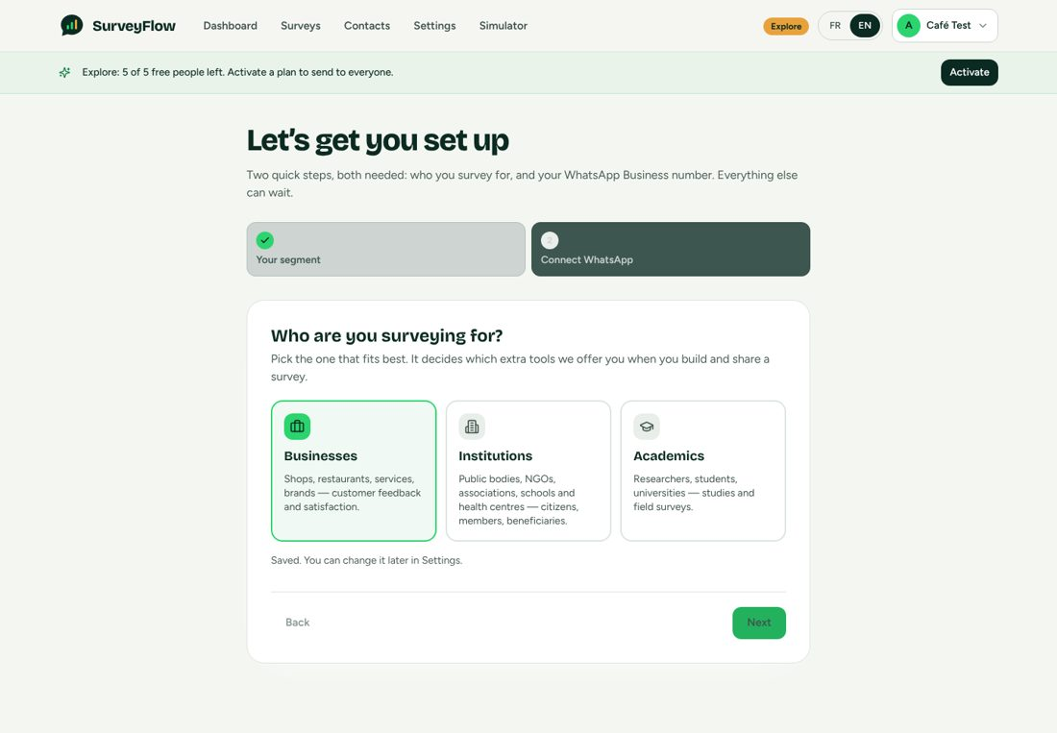
Onboarding step 1: the customer segment.
- Your segment (required): three cards (Businesses, Institutions, Academics). Choosing one saves it and moves straight to step 2. The rest of the app is locked until a segment exists.
- Connect WhatsApp (required to create surveys, add or import contacts, top up, publish, send or remind; may be postponed with "I will do this later"): the Embedded Signup button in live mode, or "Use a simulated number" in demo mode. When connected the page says Meta reviews the templates in the background and sending opens when the invitation template is approved, and offers "Go to dashboard".
- Gate: every endpoint that needs the number answers 409 whatsapp_not_connected ("Finish connecting your WhatsApp Business number first"). The web client turns that response into ONE shared dialog with a button to the connect step, whatever screen the action came from.
- Getting started box on the dashboard, with four steps and live ticks: connect WhatsApp, add contacts, create a survey, choose a plan. Each links to the screen that completes it. A prominent card at the top of the dashboard appears while WhatsApp is not connected.
- If the owner arrived with a plan chosen on the pricing page (?plan=growth&interval=annual), "Go to dashboard" continues to the billing page for that plan.

8.3 Survey builder
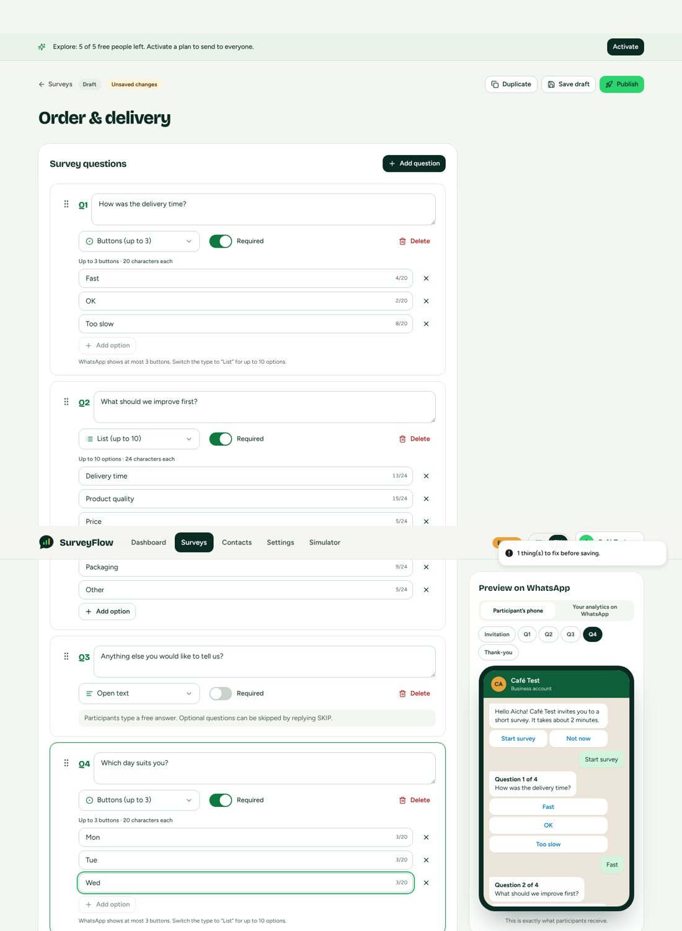
Builder: questions on the left, "Preview on WhatsApp" on the right (cropped).
- Title (max 120), questions (max 25) each with text (max 900), type, required switch and options. Defaults: required.
- Type rules are enforced as the owner types and again on save (shared validation): buttons need 2 to 3 options of at most 20 characters, lists 2 to 10 of at most 24, multi 2 to 10 of at most 60, labels unique (case-insensitive), ids unique and URL-safe; text takes no options; rating options are generated. Messages explain the fix ("WhatsApp shows at most 3 buttons: switch the type to List").
- Reordering by drag and drop AND by keyboard (focus the handle, Space, arrows, Space).
- Templates gallery: Customer satisfaction, Order and delivery, Event feedback, each in the interface language, plus "Start from scratch".
- Survey language (participant messages): French or English; the preview and the templates follow it.
- Timing and reminders card (Section 6): general or live-event, closing date (min = today), two reminder switches that spell out exactly what will be sent when ON.
- Gift settings (Section 7): gift type radio list; on Explore and Starter the paid types are locked with an upgrade link; amount and description fields; cap; delivery mode; cost panel with worst-case exposure in the owner's currency; wallet warnings.
- Send panel (visible once active): audience (all contacts, by tags, or chosen contacts), exact count ("About N message(s) will be used"), people left on Explore, schedule for later, plan and wallet warnings, the Send button. A published survey's questions are LOCKED (a notice offers "Duplicate to edit").
- Actions: Save draft (disabled until a change), Publish (checks publishProblems), Pause, Resume, Close, Duplicate, Analytics link. A survey that is active cannot be deleted.
- Live preview renders the SAME message objects the gateway sends (shared package), with chips for Invitation, each question and Thank-you, a sample answer per question and the gift line.

Preview switch: "Participant's phone" and "Your analytics on WhatsApp"
A two-tab switch above the phone changes the preview to the owner's side of WhatsApp: a chat with "SurveyFlow Analytics" with chips STATS, RESULTS, DROP, NONRESP, STARTED, COMPLETED, HELP and a bell chip that shows an example alert. A draft (or a survey nobody was invited to) shows labelled example numbers built from ITS questions ("Example numbers: this is how the answers look once people reply"); a survey with invitations shows live numbers with an as-of time. It uses the same formatter as the real bot. On Explore a note says the bot is included in Starter, Growth and Business.
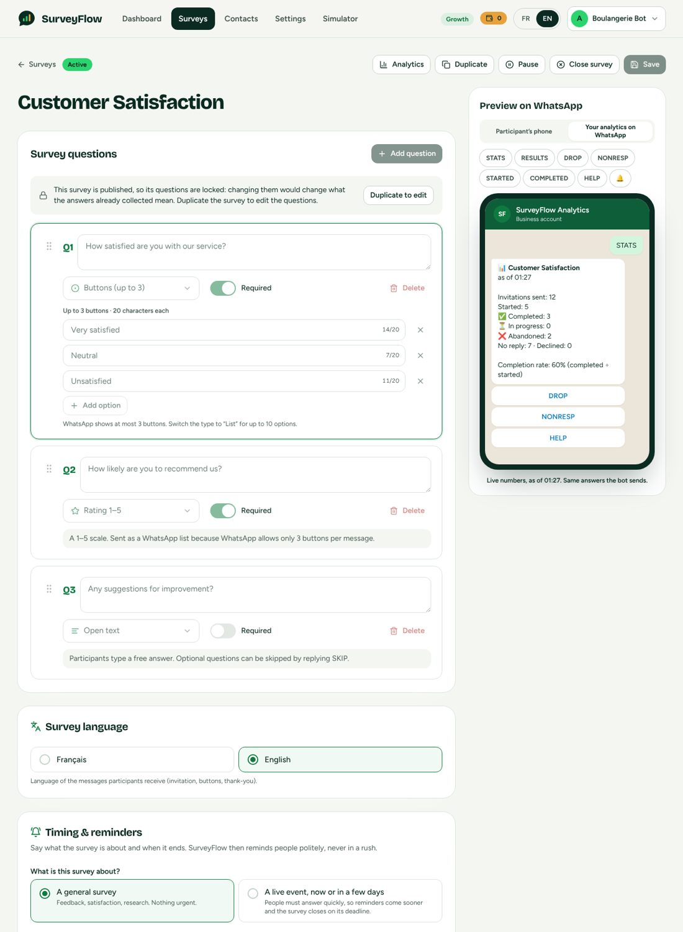
Builder preview switched to "Your analytics on WhatsApp" with live numbers (cropped).

8.4 Contacts
- Table with name, phone, tags, consent badge (Consented, No consent, Opted out), search and tag filter, pagination.
- Add contact: name, phone (country prefix prefilled, local example as placeholder), tags, and a REQUIRED opt-in tick (the Add button stays disabled until ticked). Duplicate phone for the same owner is refused.
- Import CSV: semicolon or comma delimited; columns recognised in English and French (name/nom, phone/téléphone, tags); the owner ticks "all these people agreed to receive WhatsApp messages"; the result lists added, updated and skipped rows with the reason per skipped row (for example an invalid number). Phones are normalised to E.164 with the owner's country as default.
- Bulk tag, bulk delete (blocked while gifts for that contact are in flight), single edit and delete.
- All of the above require a connected WhatsApp number.

8.5 Live analytics page
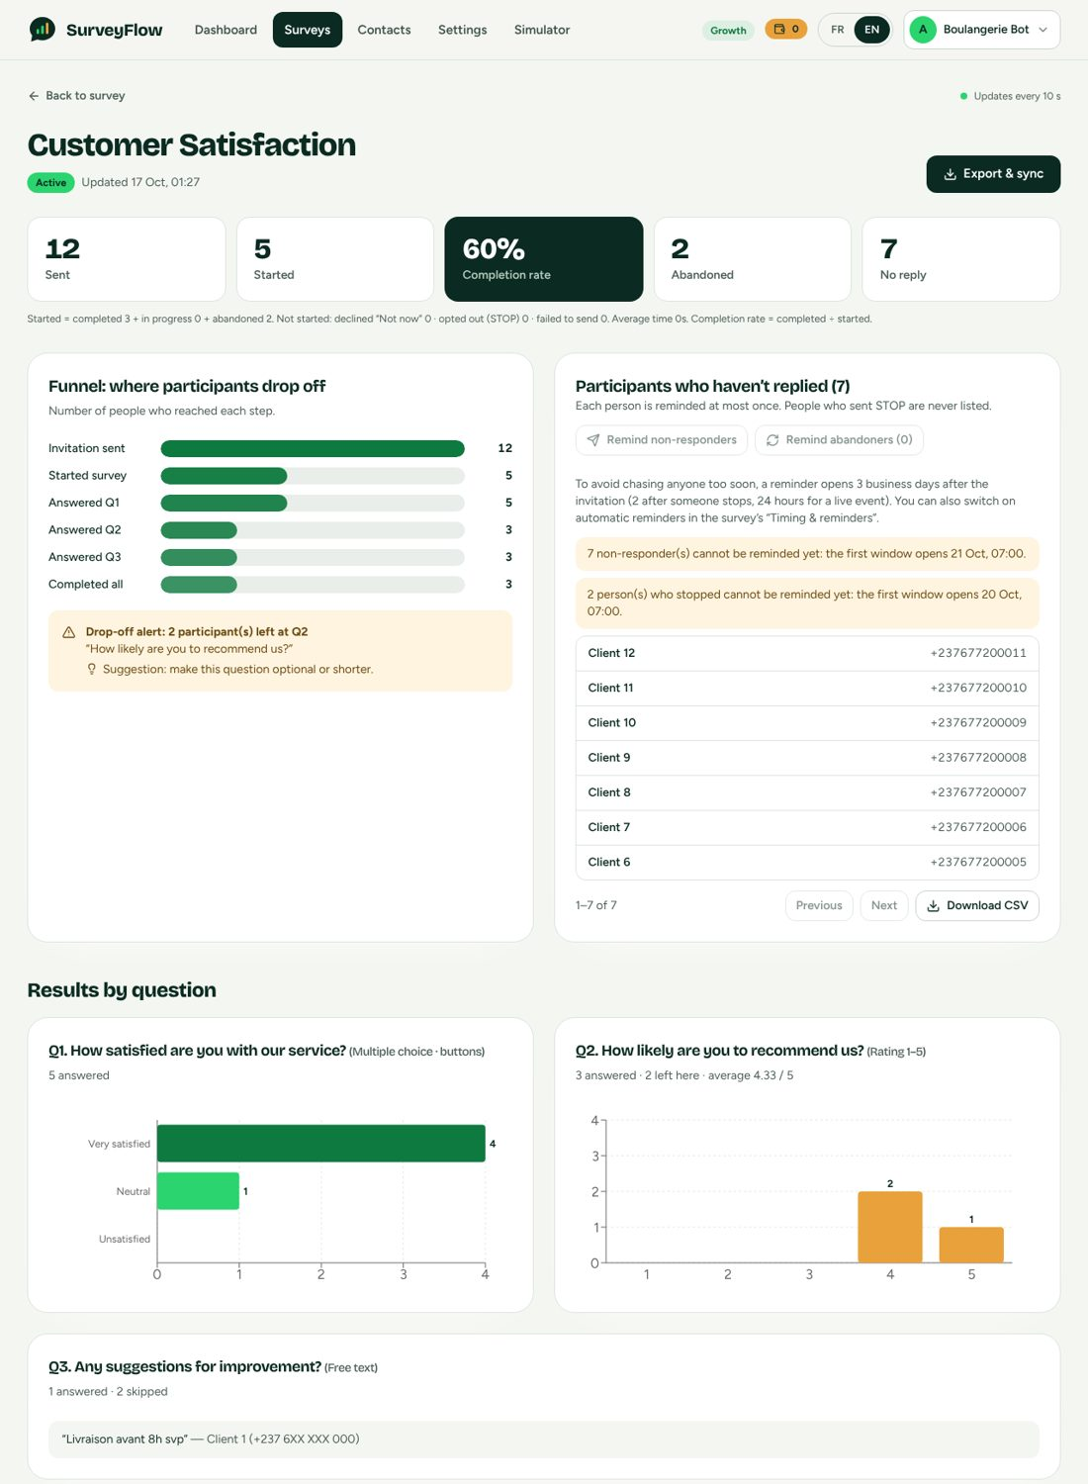
Analytics: metrics, funnel with drop-off alert, results per question with the type next to each title (cropped).
- Header: survey title, status badge, "Updated at", Export and sync link. The data refreshes every 10 seconds.
- Five metric tiles (Sent, Started, Completion rate, Abandoned, No reply) and a footnote that shows the arithmetic: "Started = completed X + in progress Y + abandoned Z. Not started: declined, opted out (STOP), failed to send. Average time. Completion rate = completed / started."
- Funnel bars (Invitation sent, Started, Answered Q1..Qn, Completed all) and a drop-off alert naming the worst question with one piece of advice (Section 12.4).
- Haven't replied card: manual reminder buttons (disabled until the window opens, with the reason), then a paged list (10 per page) of name plus COMPLETE phone number, and a "Download CSV" button. People who sent STOP are never listed. The card has the anchor #not-started (the bot links to it).
- Gifts card (paid gifts only): delivered, pending, failed, unfunded, refunded, needs-check counts; amount spent; delivered receipts; retry, release and prize draw buttons; a banner when gifts wait for funds.
- Results per question: every question title is followed by its type in the interface language, for example "How satisfied are you with our service? (Multiple choice, buttons)", "How likely are you to recommend us? (Rating 1-5)". Choice questions show a bar chart with count and percentage of THAT question's answers; rating questions show a column chart and the average; text questions list recent answers with name and number.
- Responses table: one row per participant with status (and "abandoned at Q2"), one column per question, paged.

8.6 Billing page
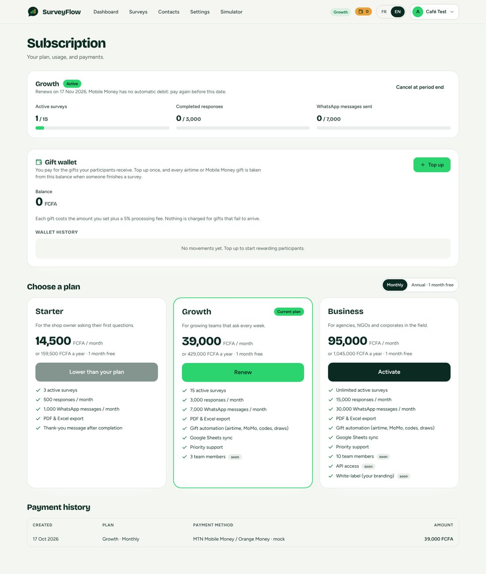
Billing: current plan, wallet, plan cards and payment history.
- Current plan card with usage meters; on Explore: active surveys 0 of 1, people reached 0 of 5, messages 0 of 25; on paid plans: active surveys, completed responses, messages.
- Choose a plan: Monthly/Annual toggle ("Annual, 1 month free"); each card shows the price in the owner's currency, the annual price underneath, the feature list (with "soon" tags on team members, API access and white-label) and an "Activate" button. A note explains that prices in another currency are converted from FCFA at today's rate and that card payments may add the bank's conversion fee.
- Checkout dialog: payment method (Mobile Money with a phone field, or card), exact amount, and the notice that an upgrade starts today and does not credit the days left on the current plan.
- Payment states the customer can see: waiting on the phone ("Approve the payment on your phone"), "Still waiting for the provider" with the reference and "do not pay again", "Payments in progress" card with "Check now", a calm "we received your payment but could not apply it automatically, nothing is lost" for review, and a clear "do not pay again yet" error when a start could not be confirmed.
- Renewal banner: when 3 days or fewer remain, or when overdue, in English and French.
- Gift wallet: balance, limits, top-up dialog with presets, history of every movement, and the lock message on plans without gifts.
- Explore banner across the app: "Explore: N of 5 free people left. Activate a plan to send to everyone."

8.7 Settings, simulator, language
- Profile: business name, name, phone (with the country example), read-only currency ("Cameroon (XAF)": country follows the visitor's location and the currency is that country's official one), segment. There is NO country picker and NO payment-provider picker.
- WhatsApp tab: account status, phone, template status table, "Sync templates", disconnect.
- Analytics on WhatsApp tab: Section 13.7.
- Integrations tab: Google Sheets connect and disconnect.
- Simulator: Participant tab (pick a contact, run the send queue, tap buttons and lists, type, "Skip 25 h of silence"; shows the contact's survey statuses) and Owner tab (Section 13.6).
- Language toggle FR / EN in the header; every user-visible string exists in both languages; the choice is stored on the user and also drives platform messages (renewal notices, bot replies).

8.8 UX and responsive rules
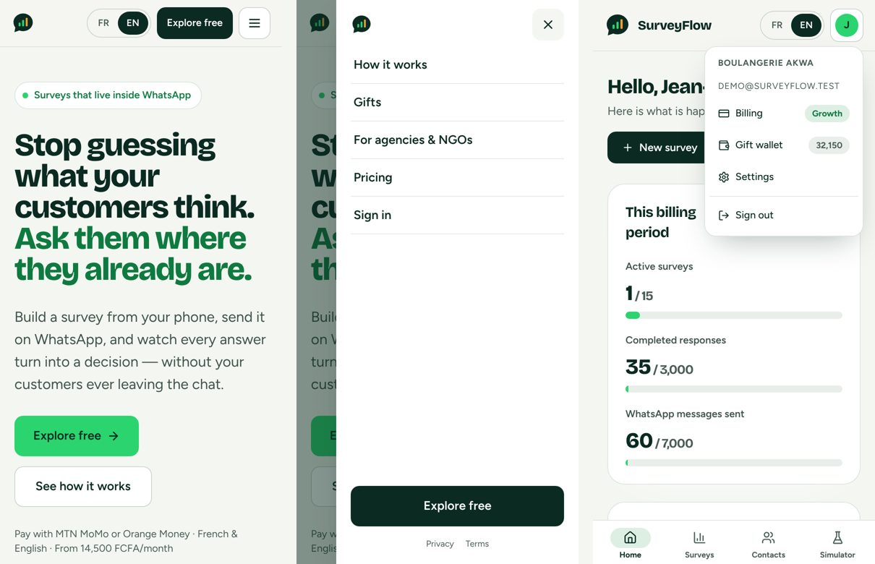
Phone navigation: public site bar, its side menu, and the app with the account menu open and the tab bar below.
- Every screen MUST have no horizontal page scroll from 320 to 1920 px (checked by an automated sweep: the 16 app screens at 8 widths, the public and sign-in screens at 12 widths). Tables scroll inside their own wrapper; below 640 px the survey list is a list of cards (title, status, date, sent, completed, completion). A grid that becomes two columns at a breakpoint declares one column below it, so that a long unbreakable item cannot widen it past the screen.
- Menu bars stay put. The public site menu bar and the app header are sticky at every width; in-page anchors stop below the bar. Below 640 px neither bar wraps to a second row.
- Public site, below 640 px: one row with the logo, the FR / EN language switch, a short "Explore free" button ("Explorer" in French) and a 44 px hamburger. The hamburger opens a side menu from the right (about 86 percent of the width, at most 340 px, full height, dimmed page behind it) with the four page links, Sign in, a full-width "Explore free" button and the Privacy and Terms links; it closes on a link, the X, the overlay or Escape. Below 480 px the wordmark is hidden and below 360 px the switch and the button use tighter padding, so that the language switch and the call to action are always visible and never overlap. From 640 px the bar shows the text links, the language switch, Sign in and "Explore free" in one row (a compact row from 640 to 767 px: no wordmark, and the longest link, "For agencies & NGOs", stays in the footer).
- App, from 640 px: the header holds the logo, a text menu (Dashboard, Surveys, Contacts, and Simulator where it exists), the plan and wallet badges, the language switch and the account menu. Settings is not in the text menu: Billing, Settings and Sign out are reached only through the account menu.
- App, below 640 px: a fixed bottom tab bar with Home, Surveys, Contacts and, where it exists, Simulator, and the same header (logo, language switch, 44 px account button). There is no "More" sheet: the account menu carries Billing (with the plan badge), the gift wallet balance, Settings and Sign out, and Analytics on WhatsApp is a tab of Settings. The onboarding wizard shows no tab bar.
- Never use colour alone to carry meaning; every control has an accessible name; dialogs trap focus; toasts for success and errors; skeletons while loading; an explicit retry on error.
- The owner must always know the next step: empty states say what to do and link to it.
- Typography and design tokens are the builder's choice; V1 used a dark-green and bright-green palette with rounded cards.

9. Accounts, Plans and Billing

9.1 Registration and sign-in
- POST /api/auth/register: business name, name, email (lower-cased, unique), phone (normalised for the detected country), password (8 to 128 characters), locale. The country comes from the visitor's location header (supported countries only), else the body, else Cameroon. Creates the user on Explore with a subscription record (status trial, no end in practice) and records the signup funnel event. Returns a bearer token and the user.
- POST /api/auth/login: constant-time behaviour for unknown emails (a fixed dummy hash is compared); 10 attempts per minute per (email, IP), and a per-account budget of 30 failures per 15 minutes regardless of IP.
- POST /api/auth/oauth: Google sign-in, callable only by the website server with the shared secret; creates an Explore account on first use (no password).
- GET /api/auth/me, PATCH /api/auth/me (name, business name, phone, segment, locale, onboardingDone). Currency and country are never accepted from the client.

9.2 Plans and limits (single source of truth)
All plan numbers live in one shared module. The marketing site, the dashboard, the payment layer and the limit checks import it, so they cannot drift.
 | Explore | Starter | Growth | Business
Price per month (FCFA) | Free | 14,500 | 39,000 | 95,000
Annual (11 months charged) | n/a | 159,500 | 429,000 | 1,045,000
Active surveys | 1 | 3 | 15 | Unlimited
Completed responses per month | 5 (cap is on people, see below) | 500 | 3,000 | 15,000
Business-initiated messages per month | 25 | 1,000 | 7,000 | 30,000
Different people ever reached | 5, for the life of the account | No cap | No cap | No cap
Team members | 1 | 1 | 3 (coming soon) | 10 (coming soon)
PDF and Excel export | Yes | Yes | Yes | Yes
Google Sheets sync | No | No | Yes | Yes
Gift automation | No | No | Yes | Yes
Analytics on WhatsApp (bot) | No (preview and simulator only) | Yes | Yes | Yes
API access | No | No | No | Coming soon
Priority support | No | No | Yes | Yes
White-label | No | No | No | Coming soon

- Prices are the owner's decision (14,500 / 39,000 / 95,000 FCFA), which superseded the former blueprint's 9,500 / 29,000 / 75,000. Change them in the single plans module only.
- Annual = 11 times the monthly price ("1 month free"), converted once at the end for non-CFA currencies. The former blueprint's "2 months free" was replaced.
- Overage: responses beyond the plan's allowance are never blocked (a participant's answers cannot be dropped mid-survey). They accrue 500 FCFA per 100 extra responses on paid plans, calculated and displayed on the billing summary. [NOT BUILT] No code path collects the overage.
- Messages are enforced where they cost money: at send time (402 plan_limit with limit: messagesPerMonth). The former blueprint's "pass-through Meta cost plus 15 percent" is NOT built: customers pay Meta directly through their own WhatsApp account.
- Explore's response cap of 5 is descriptive: the cap that really bounds usage is the 5 different people.

9.3 Where each limit is enforced
Limit | Enforcement point | Response
Active surveys | Publish and Resume | 402 plan_limit with details {limit:"activeSurveys", max, current, upgrade:{recommendedPlan, priceFCFA}}
People reached (Explore) | Send, and the audience preview (counts only people never invited before, in any survey) | 402 plan_limit with limit:"recipients"; the send panel shows an Activate link and records a paywall_view event
Messages per month | Send and manual reminders | 402 plan_limit with limit:"messagesPerMonth", remaining, requested
Plan feature (Sheets, gifts, bot) | Route pre-handler | 402 plan_feature
Suspended subscription | Publish, send, top-up | 402 subscription_suspended (read-only otherwise: viewing and exporting still work)
WhatsApp not connected | Create/publish/send/remind, contacts add/import, top-up | 409 whatsapp_not_connected

9.4 Subscription lifecycle
Explore (no clock) --pay--> active (paid)
active --period ends, cancelAtPeriodEnd--> Explore (data kept; 1 survey, 5 people)
active --period ends--> past_due (3-day grace; renew = pay again)
past_due --grace over--> suspended (read-only until paid)
suspended --pay--> active

Nobody keeps a free Starter: a lapsed or cancelled paid plan returns to Explore.
- Mobile Money has no card-on-file auto-debit, so "renewal" means the owner pays again during the grace window. There is NO automatic renewal.
- Paying while already on a paid plan starts the new plan today and does not credit the days left. Downgrades are refused (inside the payment service, so no route can bypass it, and again at settlement, which parks the payment in review). A lower plan is chosen by cancelling and re-subscribing after the period.
- POST /api/subscription/cancel sets cancelAtPeriodEnd; reactivate clears it.
- Renewal notices: a WhatsApp message and an in-app banner 3 days before the end, and one when overdue (each once per period, claimed atomically, re-armed by a payment). WhatsApp is best effort (24-hour window); the banner is the dependable channel.

9.5 Pricing page requirements
- Names on the page: Explore and Activate. Explore card: free, no card, no time limit; build and preview without limit; 1 live survey to 5 real people; results dashboard and export; see the Analytics Bot in the simulator.
- A response-volume slider recommends a plan from the monthly response volume (500 or fewer Starter, up to 3,000 Growth, otherwise Business) and shows the effective cost per answer.
- FAQ (English and French): Is there a free trial? (No countdown.) What happens if I stop paying? (You keep everything and return to Explore.) Do I need a WhatsApp Business number? (Yes, your own; includes the payment-method sentence.) Who pays for WhatsApp messages? (Meta bills your WhatsApp Business account at its own rates.)
- Prices show in the visitor's currency with the live-rate note and the rate source attribution; GET /api/pricing returns the prices, the currency, the overage per block and the quote.

9.6 Funnel events
One row per owner and milestone, written the first time it happens, to measure where sign-ups stop: signup, onboarding_done, whatsapp_connected, survey_created, first_send, first_response, paywall_view, checkout_start, paid. Writing an event never blocks or fails the action that caused it.

10. Multi-PSP Payment Integration
The money rail. The goal that shaped everything: a customer's money is never lost, never taken twice, and never left unexplained.

10.1 The three-phase flow and how SurveyFlow follows it
Phase | What happens | Where
1. Initialisation | The browser sends only plan, interval, method and phone. THE SERVER fixes the price and currency (never the client), creates a payment record pending with a unique reference (sf plus 22 characters, alphanumeric only), then calls the provider. | Payment service
 | The record stores the provider's reference and either a hosted checkout URL (the browser is redirected) or a payment token for push flows ("approve on your phone").
2. Authentication | Entirely at the provider and the telecom (USSD or SMS push, PIN). SurveyFlow only waits and says so honestly ("Still waiting for the provider", never "failed"). | Payment states UI
3. Verification | A webhook arrives; its signature is checked and then NOT believed. The provider is asked server to server (verifyPayment) and the amount AND currency are compared with what was asked. | Webhook route, adapters
 | One database transaction: compare-and-set pending/failed/expired -> success AND activate the plan or credit the wallet. A replay changes nothing. | Settlement

10.2 Adapter interface (the contract every provider implements)
interface PSPAdapter {
name: 'notchpay'|'cinetpay'|'campay'|'payunit'|'flutterwave'|'camerpay'|'mock'
push?: boolean // true when starting a payment makes the PROVIDER push a prompt to the
payer's phone (Campay)
isConfigured(): boolean
initiatePayment(p: { amount, currency, method, reference, customerName, customerEmail,
customerPhone /*digits, no +*/, description, returnUrl, notifyUrl })
-> { checkoutUrl? , paymentToken? , pspReference? }
verifyPayment({ reference, pspReference? }) -> { status: 'success'|'failed'|'pending', amount,
currency, pspReference? }
parseWebhook({ rawBody, headers, body, query }) -> { reference?, pspReference?, signatureValid }
}
PspError(message, psp, retryable = true, ambiguous = false)
retryable = safe to try the next provider
ambiguous = the provider MAY have created the payment although we got an error
(timeout after the request left, reset, 408/500/502/504)
certainly-not-created = connection refused, DNS, TLS, 4xx, 429, 503
Deliberate change from the former blueprint: parseWebhook only extracts identifiers and checks the signature. The webhook body can never assert "success".

10.3 Router: silent choice and failover
- The owner NEVER chooses a provider. For each payment the router builds an ordered chain: providers that are configured AND support the buyer's country, currency and method, ordered cheapest first for this payment (percentage plus fixed part on the amount in XAF), then the rest as failover. With the mock provider enabled the chain is only the mock.
- Mobile Money is local to the buyer's country; cards are not tied to the buyer's country (the merchant is in Cameroon, the buyer pays with an international card in their own currency and the provider settles in XAF), so any card-capable provider can serve any buyer.
- A push provider (Campay) that may already have sent the prompt is NEVER followed by a second provider (the customer could approve both).
- Circuit breaker per provider: 3 failures move it to the end of the chain for 2 minutes, then one trial.
- The database write after the provider accepted is outside the failover try, so a database error never starts a second provider.
Provider | Methods | Countries | Currencies | Documented fee
Campay | Mobile Money (push) | CM | XAF | Mobile Money 2.0 percent; cards not supported; also the gift payout provider
NotchPay | Mobile Money, card, bank | CM, CI, SN, NG, GH, KE | All ten | Mobile Money 1.0 percent; cards 3.9 percent plus 0.30 USD
CamerPay | Mobile Money, card | CM | All ten | Mobile Money 0 to 3 percent by plan (default plan Starter 3.0); cards plan commission plus 2.9 percent plus 0.25 EUR. No status endpoint: only signed webhooks.
PayUnit | Mobile Money, card | CM | All ten | Not in the fee document: ranks after providers with a known fee
CinetPay | Mobile Money, card | CI, SN, CM, ML, BF, BJ, TG, NE | All ten | Mobile Money 2.5 percent (upper bound of 2.0 to 2.5); cards 3.5 percent
Flutterwave | Mobile Money, card, bank | Any | All ten | Mobile Money 2.0 percent; cards 4.8 percent

Charge currencies: XAF, XOF, ZAR, GHS, KES, NGN, UGX, USD, GBP, EUR. Fees are overridable at run time with the PSP_FEES JSON setting (your negotiated rates win); CAMERPAY_PLAN selects which CamerPay plan is paid for. Fees come from the owner's contract-fee document of 2026; payout and withdrawal fees are not collection costs and are not used for ranking.

10.4 Payment states
+------ provider says paid, amount + currency OK ------+
| v
(created) -> pending --provider says failed--> failed --late "paid"--> success (plan active /
wallet credited)
| \-24 h, provider says nothing happened--> expired --late "paid"--> success
\--paid but underpaid / wrong currency / lower plan than active / activation
error--> review --operator--> success | failed
- failed and expired are OUR conclusions, not the provider's: a hosted page lets the payer retry after a decline, and a payer may approve a Mobile Money prompt hours later. A provider-verified success is credited from pending, failed or expired.
- success and review are final for the machine. review is resolved only by the operator tool. The customer sees review as "we received your payment but could not apply it automatically, nothing is lost", never as a failure, and never sees the operator detail.
- The browser receives only a failCode (declined, unavailable, other); the provider's raw text stays in the database and logs.

10.5 Rules that prevent double charges and stuck money
Rule | Value
Reuse of an identical in-flight payment | Card 10 minutes; Mobile Money 90 seconds; a row never sent to a provider is not reused; per-customer lock around "find identical or create one" (eight clicks produce one payment)
Maximum payments in flight per customer | 4
Status poll coalescing | 1.5 s for pending, 30 s for failed/expired (every browser poll can become a provider call, so they are coalesced); webhooks and the job always verify
Reconciliation job (every minute, leader only) | Asks the provider on a cadence that follows age: every 1 min for the first 10 min, every 5 min up to 2 h, every 30 min up to 24 h; failed/expired payments that reached a provider are re-asked for 7 days (every 6 h). A signed webhook is always honoured.
Webhook answers | 401 when the signature is wrong; 404 for an unknown or mock provider; 200 for an unknown reference (so providers stop retrying); 503 when the provider could not be asked (it retries); 200 once verified, whatever the outcome
Webhook rate limit | 600 per minute per address (only Meta's webhook is exempt from rate limiting)
Phone validation | Parsed against the owner's country; invalid gives 400 invalid_phone with an example
Overpayment | Credited at the amount asked; an excess above 15 percent is logged
Production start-up | The API refuses to start with no payment provider configured, and warns for each provider that has a key but no webhook secret

10.6 Webhook endpoints and per-provider setup
- POST|GET /api/payments/webhook/:psp (CinetPay and Campay also notify by GET). Register PUBLIC_API_URL/api/payments/webhook/<psp> in each provider's dashboard and set its webhook secret: NOTCHPAY_WEBHOOK_HASH, FLUTTERWAVE_WEBHOOK_HASH, CAMPAY_WEBHOOK_KEY, CAMERPAY_WEBHOOK_SECRET (HMAC-SHA256), CinetPay by its secret key.
- The provider list, their credentials and the optional mode switches are in Section 19.
- [UNVERIFIED] No adapter has ever run against a real provider (the build environment cannot reach them). The ambiguity classification, each provider's verify semantics and Campay's external_reference check are written from documentation. A sandbox pass per provider is the biggest remaining risk.

10.7 Endpoints
Endpoint | Purpose
POST /api/payments/initiate | Body {plan, interval, method, phone?}. Returns the payment (checkout URL or payment token). 20 per minute.
PUT /api/subscription/upgrade | Same body; thin wrapper that exists for the UI. The downgrade guard is in the service.
POST /api/wallet/topup | Body {amount (whole units), method, phone?}. Requires WhatsApp connected, not suspended, and a plan with gift automation.
GET /api/payments, GET /api/payments/:id | List (50 latest) and status poll by id or reference; the poll verifies with the provider (self-healing).
POST /api/payments/mock/:reference | Demo only (PSP_MOCK=true): body {outcome:"success"|"fail"}.

10.8 Operator tool
scripts/payments-review.mts is a command-line tool for payments in review and for stuck ones.
Command | Does
list | payments in review, oldest first, with the reason and the customer
list pending | pending for more than 2 hours
list unconfirmed | pending after an unconfirmed push start (the customer was told not to pay again)
show <ref> | the whole row including every provider tried (attempts)
credit <ref> --note "why" | apply it as paid (the amount ASKED is credited), once, only from review
reject <ref> --note "why" | close as failed and tell the customer it will be returned. Does NOT move money: refund in the provider's dashboard

failReason starts with | Meaning | Usual decision
underpaid: | the provider collected less than the price | ask for the rest then credit, or reject and refund
currency_mismatch: | collected in another currency | check at the provider, then credit or reject
lower_plan_than_active: | a lower plan landed after an upgrade | normally reject and refund
activation_failed: | a defect applying the payment | engineering fixes, then credit

10.9 What is not covered
- [NOT BUILT] Refunds and payouts to the owner are manual; no provider-statement reconciliation (amountXAF is stored for it).
- CamerPay has no status endpoint: a lost CamerPay webhook is recovered by re-sending it from their dashboard.
- A Campay start whose answer was lost, with no webhook afterwards, cannot be found by code (no provider reference is held); the operator finds it by our reference (sent as external_reference).
- The reconciliation job is single-leader: if jobs are disabled everywhere, late payments wait.

11. Geography, Currency and Exchange Rates

11.1 Countries
Eighteen countries are supported. The visitor's country comes from the CDN header (forwarded by the website); an unknown or unsupported country becomes Cameroon. The country decides the currency owners are billed in, the phone prefix and example, the time zone offset and the preferred Mobile Money providers.
Group | Countries | Currency | UTC offset
CEMAC | Cameroon (default), Gabon, Congo, Chad, Central African Republic, Equatorial Guinea | XAF | +1
UEMOA | Cote d'Ivoire, Senegal, Mali, Burkina Faso, Benin, Togo, Niger, Guinea-Bissau | XOF | 0 (Benin, Niger +1)
Others | Nigeria, Kenya, Ghana | NGN, KES, GHS | +1, +3, 0

- None of these countries observes daylight saving, so a fixed offset is used for business days and quiet hours.
- Phones are stored in E.164 with a leading "+"; Meta uses the same digits without the plus (toWaId and fromWaId at that boundary only). Masked form for the bot: +237 6XX XXX 456.

11.2 Prices and exchange rates
- Canonical prices are in FCFA. Every other currency is derived from a LIVE rate (units of currency per 1 XAF); nothing is typed per currency. XAF and XOF are 1:1; both are pegged to the euro at 655.957 per EUR, so XAF, XOF and EUR never need a live rate.
- Rounding: a price people pay has three significant digits from 1,000 up, whole units from 10 up, and two decimals only below 10 (display only: a charged amount is always a whole number of units). Annual is 11 times the exact monthly value, rounded once.
- Rate source: an open exchange-rate endpoint (base XAF, one call returns every currency, refreshed about once a day, attribution required). Cache in the key-value store for 6 hours (FX_CACHE_MINUTES), a durable last-known-good copy in the database, and a maximum age of 72 hours (FX_MAX_STALE_HOURS) after which a rate is NOT used and prices fall back to FCFA.
- The checkout and pricing pages show the rate and its date ("1 FCFA = 0.2 KES on 17 Oct 2026") and, for non-CFA currencies, that only international cards are offered.
- The wallet and gifts are kept in the owner's currency; each gift also records its XAF equivalent at the live rate for the payout provider.

12. Analytics Engine: How Metrics Are Computed
One function (computeAnalytics) feeds the analytics page, the exports and the WhatsApp bot, so the numbers cannot disagree. A test asserts that the bot's numbers equal the dashboard's.

12.1 Definitions
Metric | Formula | Source and note
Sent | Recipients whose status is one of sent, delivered, started, completed, abandoned, declined | NOT "status = delivered": status is funnel progress, so a person who has since replied would drop out of the count and "no reply" would go negative. Queued and failed are excluded.
Started | started + completed + abandoned (recipient statuses) | A participant is started when they tap Start.
Completed | status = completed
In progress | status = started | Counted as abandoned only after 24 hours of silence.
Abandoned | status = abandoned | Per question: abandonedAtQuestion = n.
Declined | status = declined | Tapped "Not now". NOT part of "no reply".
No reply | (sent + delivered) minus opted-out | A person who typed STOP is counted apart.
Opted out | sent or delivered recipients whose contact has opted out | Excluded from every list and from reminders.
Completion rate | completed / started x 100, one decimal | Reported as "completed / started" in the footnote.
Response rate | started / sent x 100
Average completion time | AVG(completedAt - startedAt) over completed | Seconds; shown as seconds or minutes.
Distribution per question | COUNT(answer) grouped by answer | Percentages are relative to the answers to THAT question. Multi-select: denominator = respondents, so the sum can exceed 100.
Rating average | sum(label x count) / answered, 2 decimals | Only when at least one answer.
Skipped | responses with an empty answer | Counts as "passed", not "answered".
Timeline | completed per day for the last 14 days

Two identities that always hold (tested): started = completed + in progress + abandoned; sent = started + no reply + declined + opted out. The footnote on the analytics page prints the first one.

12.2 Result shape (GET /api/surveys/:id/analytics)
{ survey:{id,title,status,giftType,language},
totals:{ sent, started, completed, abandoned, declined, noReply, optedOut, inProgress, failed,
queued,
completionRate, responseRate, avgCompletionSeconds },
funnel:[ {key:'sent'|'started'|'q1'..'qn'|'completed', label, count} ],
perQuestion:[ { id, number, text, type, required, optionCount, answered, skipped, abandonedHere,
distribution:[{label,count,pct}], average,
texts:[{answer,answeredAt,name,phone(masked)}] } ],
dropOff: { questionNumber, questionText, count,
suggestion:'make_optional'|'simplify_options'|'shorten' } | null,
nonStarters:[ {recipientId,name,phone(masked),status,sentAt} ] // first 50; the full list is
/not-started
gifts:{pending,sent,failed,unfunded},
remind:{ noReply:{eligibleNow,waiting,nextAt}, abandoned:{eligibleNow,waiting,nextAt} },
timeline:[{day,completed}], generatedAt }

12.3 Lists
- GET /api/surveys/:id/not-started?page&pageSize (page size up to 100): the people who have not replied, with COMPLETE phone numbers, paged. People who sent STOP are excluded. This is the one place the full list exists.
- GET /api/surveys/:id/not-started.csv (20 per minute): the same list as a CSV with a byte-order mark and the columns name,phone,invited_at,status. Every cell is quoted; a cell that starts with =, +, -, @, tab or carriage return is prefixed with an apostrophe so a contact named =HYPERLINK(...) stays text in a spreadsheet. A plain international number such as +237677123456 is NOT a formula and is not prefixed.
- GET /api/surveys/:id/responses?page&pageSize: one row per participant with masked phone, status, abandonedAtQuestion and the displayed answer per question (multi-select answers are joined for display).
- GET /api/surveys/:id/recipients: delivery view used by the send panel.

12.4 The drop-off advice (one rule, everywhere)
Condition at the worst question | Advice
More than 6 options | simplify_options: "simplify the options or add an Other choice"
Required question | make_optional: "make this question optional or shorter"
Already optional | shorten: "shorten the question" (the old rule told owners to make an optional question optional)

The same function (dropSuggestion) is used by the dashboard and by the bot.

13. The Analytics Bot and Push Alerts
The owner asks SurveyFlow's own WhatsApp number how a survey is doing. Included in Starter, Growth and Business; on Explore the bot is visible only in the builder preview and the simulator (with example numbers), so the owner can see what a paid plan gives.
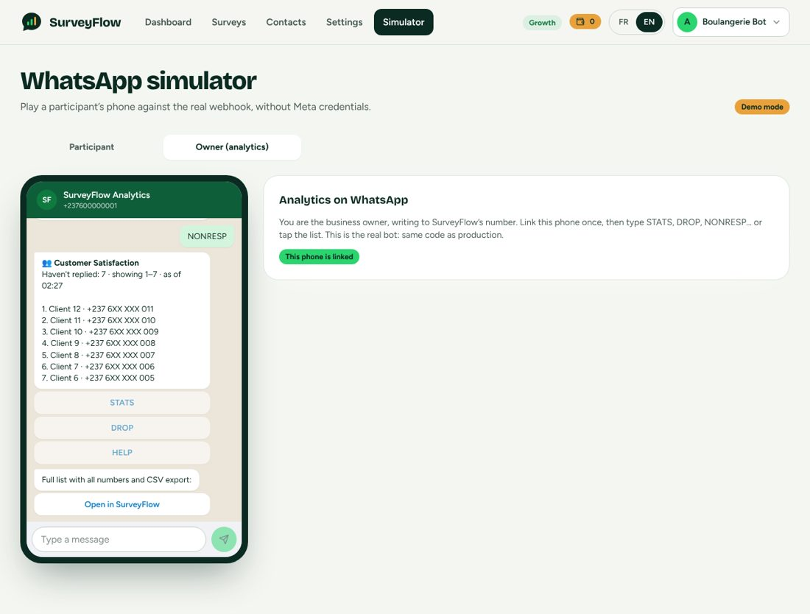
The simulator's Owner tab: the real bot answering STATS, RESULTS and NONRESP.

13.1 Who may ask: one-time linking
- The phone in the owner's profile is NEVER trusted (it is not verified anywhere and SIMs get recycled: participants' names and numbers could reach a stranger).
- In Settings, "Analytics on WhatsApp", the owner taps "Link a phone": the API creates a one-time code (8 characters from an alphabet without 0, O, 1, I, L), valid 15 minutes, one live code per owner (POST /api/analytics-bot/link-code, 10 per minute, plan feature required, 409 link_limit at 3 phones, 409 bot_unavailable when SurveyFlow's number is not configured). The page shows LINK 7K2M9QXP, an "Open WhatsApp" button (wa.me link with the text prefilled) and a copy button.
- Sending LINK <code> from a phone links it. The code works once (whoever deletes it first wins). A phone belongs to ONE account (linkTaken message otherwise) and an account holds at most 3 phones. A code used while the plan has no bot answers "locked" and is kept, so activating a plan and trying again within the window works.
- UNLINK (from the phone) or DELETE /api/analytics-bot/phones/:id (from the SaaS) removes a phone. The SaaS list shows masked numbers.
- A stranger (unlinked phone) receives ONE answer per hour ("This phone is not linked to a SurveyFlow account...") and nothing else, and no data is revealed.

13.2 Commands
English and French keywords, any case, with or without accents, extra spaces and punctuation ignored. A tapped list row or button is identical to typing the word (button ids ab:STATS, ab:DROP, and so on). A glued number (STATS2) means STATS 2.
Command (aliases) | Answer
STATS (STAT, STATISTIQUES, RESUME, BILAN, SUMMARY) | Card: invitations sent, started (with completed, in progress, abandoned beneath it), no reply and declined, opted out when above zero, completion rate with its definition, a note that people in progress count as abandoned after 24 h; chips DROP, NONRESP, HELP.
RESULTS (RESULTAT, RESULTATS) | One block per question with its type: choice questions "Top: Very satisfied · 80% (4/5)" (share and count, never the name alone), rating "Average 4.33 (3 answers)", text "1 comment"; a note that percentages are of the people who answered that question; a "Full charts and filters" button to the analytics page.
DROP (PERQ, ABANDONS, ABANDON, QUESTIONS) | Per question: "N got past it · M stopped here" (confirmed abandons only, which add up to the abandoned total), a line for people still in progress, and the highest drop-off with the shared advice.
NONRESP (NONREP, NOREPLY, SANSREPONSE, PASREPONDU, NONREPONDANTS; "no reply", "sans reponse" are two words) | "Haven't replied: 22 · showing 1-10" then rows 1. Contact 15 · +237 6XX XXX 014, a MORE hint and an "Open in SurveyFlow" button to #not-started. ALL NONRESP answers with that button only.
STARTED (COMMENCE, ENCOURS) | Started but not finished (abandoned plus in progress) with "stopped at Q3" or "at Q2 now"; completed people are NOT here.
COMPLETED (TERMINES, DONE, FINIS) | Who finished.
SURVEYS (SONDAGES, LISTE) | Up to 10 surveys, active first then most recently published: "1. Customer Satisfaction · active · 3/12 (completed/sent)"; instructions to pick one with STATS 2.
MORE (PLUS, SUITE, NEXT) | The next 10 of the last list (state kept 30 minutes per owner); "There is no list to continue" otherwise.
HELP (AIDE, MENU, COMMANDES, ?) | A list message with one row per command (10 rows: STATS, RESULTS, DROP, NONRESP, STARTED, COMPLETED, SURVEYS, MUTE, ALERTS ON, UNLINK).
MUTE (SILENCE, ALERTS OFF, ALERTES NON) / ALERTS ON (UNMUTE, ALERTES OUI) | Turn alerts off or on for this phone. Work on any plan.
LINK <code> / UNLINK (DELIER, DISSOCIER) | Section 13.1.

- Which survey: with no number, the owner's most recently published ACTIVE survey (then paused, then closed). STATS 2 picks the second in the SURVEYS order. Every card names its survey in its first line. There is no survey 9 for an invalid index. An owner never sees another owner's survey.
- Names and masked numbers on WhatsApp; complete numbers only in SurveyFlow. Mask form +237 6XX XXX 456.
- "As of HH:MM" on every card, in the owner's country time.
- Language: the reply follows the owner's interface language (French or English); an unknown phone gets the language of the word it used.
- Rate limit: 20 commands per 10 minutes per owner; the 21st gets one polite "You are asking too fast" and then silence.
- Interactive body limit: a card longer than 1,000 characters is sent as plain text without the chips.
- Cost: every reply is inside the 24-hour window the owner just opened by writing, so it is free.
- Plan check on every command: after a downgrade to Explore a linked phone stays linked but receives only the "included in Starter, Growth and Business" notice and no numbers.

13.3 Reply layouts (reference)
STATS DROP
📊 *Customer Satisfaction* 📉 *Customer Satisfaction*
as of 14:32 Where people stop · as of 14:32
Invitations sent: 247 Q1 (How satisfied are you with our se...) -> 189
got past it · 4 stopped here
Started: 189 Q2 (Which product do you use most?) -> 160 got past
it · 22 stopped here
✅ Completed: 130 Q3 (Any suggestions) -> 130 got past it · 8 stopped
here
⏳ In progress: 25 ⏳ 25 still in progress: not counted as dropped
until 24 h of silence.
❌ Abandoned: 34 ⚠️ Highest dropoff at Q2: consider making it
optional.
No reply: 51 · Declined: 7
Completion rate: 68.8% (completed ÷ started)
[DROP] [NONRESP] [HELP] [STATS] [NONRESP] [HELP]
(The numbers above are the "example numbers" used for a draft survey: 247 sent, 189 started, 130 completed, 34 abandoned, 25 in progress, 51 no reply, 7 declined.)

13.4 Shared formatter
The card text, the command parser, the question-type labels, the example numbers and the as-of label live in ONE shared module that the API (real bot), the builder preview and the simulator all import. A test compares the bot's numbers with the dashboard's for the same survey.

13.5 Push alerts
Alert | Trigger | Dedupe key
Milestone | After a real completion, the highest of 100, 500, 1,000, 5,000, 10,000 completed responses that is now reached and was not alerted yet | survey + milestone + threshold (unique row; racing completions send once)
Slowdown | Every hour: an ACTIVE survey with at least 10 completed responses and no completion for 48 hours | survey + slowdown + ISO week (once a week at most)

- Who gets them: every linked phone of an owner on a plan with the bot whose alerts switch is on (default ON when a phone is linked; MUTE, ALERTS ON or the switch in Settings change it per phone).
- How it is sent: if that phone wrote to SurveyFlow's number in the last 24 hours, the alert is a free message with buttons (STATS or NONRESP, and MUTE). Otherwise it is the approved template owner_alert (UTILITY, English and French) with the text in a single variable (no line breaks) and two quick replies: STATS and Mute alerts. Tapping STATS opens the window and returns the card.
- Who pays: the bot speaks from SurveyFlow's own number, so an alert OUTSIDE the window is a template billed to SurveyFlow, not to the owner. Hence the caps: at most 3 template alerts per owner per day and 15 per month (counters in the key-value store; a capped alert is simply skipped), five milestones per survey at most, one slowdown per week, and the mute switch.
- The template is submitted to Meta on SurveyFlow's own WhatsApp account by a job (live mode only). Until Meta approves it, only free in-window alerts go out. [UNVERIFIED]
- Each decided alert is one row (BotAlert: survey, kind, key, channel window, template or skipped): the unique key is the lock and the rows are the audit trail.

13.6 Preview and simulator
- Builder preview: Section 8.3. Example numbers for a draft (clearly labelled), live numbers with an as-of time for a sent survey; the bell chip shows an example milestone alert.
- Simulator, Owner tab: on a paid plan it is the REAL bot through the real webhook path (/api/dev/owner and /api/dev/owner/send): a "Link this phone" button creates a code and sends LINK for you; list rows and quick replies are tappable; alert templates sent outside the window show with their two quick replies. On Explore the tab shows the same cards with example numbers and a note that it is included in Starter, Growth and Business.

13.7 Settings tab
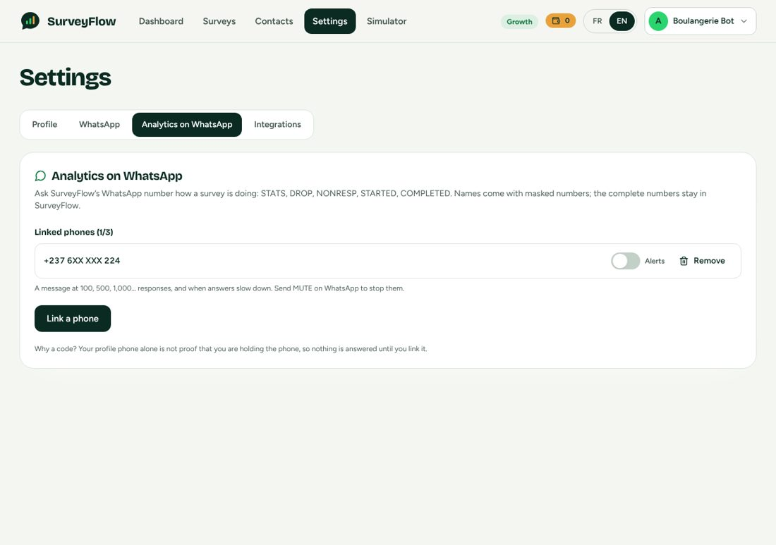
Settings, Analytics on WhatsApp: one linked phone (masked) with its alerts switch.
- On Explore: the card explains the feature and offers "See it in the simulator" and "Activate a plan"; no link button.
- On a paid plan: linked phones with masked numbers, the alerts switch per phone, Remove, "Link a phone" (disabled at 3), and the generated code box with the one-time rules ("works once, expires in 15 minutes"). An error state with Retry replaces the card if the status call fails.
- GET /api/analytics-bot returns {included, available, platformPhone, maxPhones, phones:[{id, phone(masked), alerts, createdAt}]}; PATCH /api/analytics-bot/phones/:id {alerts}.

14. Exports and Integrations

14.1 PDF report
- GET /api/surveys/:id/export/pdf (10 per minute). Cover, executive summary, funnel, a chart per question, response list. A headless browser renders an HTML template with a charting library inlined from the package (it works offline).
- Security: participants' answers are untrusted text going into HTML that a headless browser renders. Everything is HTML-escaped, JSON for charts is embedded with < escaped, and ALL network requests from the page are aborted (no server-side request forgery or exfiltration through injected markup). The same locked-down page renders receipts.
- Needs a Chromium executable (PUPPETEER_EXECUTABLE_PATH in container images).

14.2 Excel workbook
- GET /api/surveys/:id/export/excel (20 per minute). Sheet 1 Summary (metrics), sheet 2 Raw responses (one row per participant, one column per question), sheet 3 Contacts who did not start.
- Free text is written as TEXT cells, never formulas, so =HYPERLINK(...) stays inert; cell length is capped.

14.3 Google Sheets sync (Growth and Business)
- OAuth2 consent once (GET /api/integrations/google/auth-url returns a URL with a signed 15-minute state; POST /api/integrations/google/connect completes it; DELETE disconnects). The refresh token is stored encrypted.
- POST /api/surveys/:id/sync/google-sheets creates the spreadsheet on first use and appends one row per COMPLETED participant not yet written (the SheetRow table makes re-sync idempotent). With auto-sync on, each completion appends its row in real time (never throws into the webhook path). GET /api/surveys/:id/sync reports status; DELETE stops it.
- Values are written with valueInputOption=RAW so =IMPORTXML(...) is stored as literal text. The Sheets API v4 is used over plain REST.
- [UNVERIFIED] Never run against Google. Requires GOOGLE_CLIENT_ID, GOOGLE_CLIENT_SECRET, GOOGLE_REDIRECT_URI.

14.4 Export page
One page per survey with three cards: Download PDF report, Download Excel, Google Sheets (connect, sync now, auto-sync, open the sheet; a lock message with an upgrade link on Explore and Starter).

15. Data Model (logical schema)
This section is generated from the schema of the working implementation (22 tables, 9 enumerations). Types are logical: map them to your database. Identifiers are opaque strings (V1 used collision-resistant ids). Every foreign key cascades on delete from the owner unless stated. Column names below are the application's field names.
Rules the database MUST enforce (the application relies on them): the unique keys listed per table; transactions for settlement and completion; guarded updates for the wallet; a unique (surveyId, contactId) on both recipients and gifts so retries cannot double-invite or double-pay. The key-value store (Section 15.3) holds only ephemeral state: a lost key-value store must be recoverable from these tables.

15.1 Enumerations
Enumeration | Values | Notes
Plan | trial, starter, growth, business | trial is the free tier shown to people as Explore.
SurveyStatus | draft, active, paused, closed | draft, active, paused, closed.
QuestionType | button, list, text, rating, multi | button (up to 3 options), list (up to 10), text, rating (1 to 5), multi (typed numbers).
GiftType | none, airtime, momo, discount, prize_draw, custom | See Section 7.
GiftDeliveryMode | immediate, batch | immediate or at the next top of the hour.
RecipientStatus | queued, sent, delivered, started, completed, abandoned, declined, failed | Funnel progress; queued and failed were added to the former blueprint's list.
GiftStatus | pending, sent, failed, unfunded | unfunded: finished but the wallet could not cover the gift.
SubscriptionStatus | trial, active, past_due, suspended, cancelled | trial = Explore (no clock).
TransactionStatus | pending, success, failed, expired, review | review: money received, a person decides.

15.2 Tables

Accounts
User: The survey owner. Also holds the prepaid gift wallet balance and currency.
Field | Type | Constraints | Notes
id | text | primary key
email | text | unique
passwordHash | text, nullable |  | null for Google-only accounts
name | text
businessName | text
phone | text
plan | enum Plan | default trial
createdAt | timestamp (UTC) | default now
preferredCurrency | text | default XAF
preferredPSP | text, nullable
country | text | default CM
locale | text | default fr | ADDED: UI + platform-message language
trialEndsAt | timestamp (UTC), nullable |  | ADDED
onboardingDoneAt | timestamp (UTC), nullable |  | ADDED
giftBalance | integer | default 0 | (column historically named giftBalanceFCFA) ADDED: prepaid gift wallet. The SURVEY OWNER funds gifts (airtime / Mobile Money), never SurveyFlow. Only ever changed with a guarded UPDATE (see services/wallet.ts), so it cannot go negative. Kept in the OWNER'S currency (whole units, giftCurrency); the database column keeps its historical name.
giftCurrency | text, nullable |  | set by the first top-up and never changed afterwards; null = no wallet money yet
segment | text, nullable |  | ADDED: who the owner is (business | institution | academic), chosen in onboarding. Hook for segment-specific features.

WhatsApp
WhatsAppAccount: A connected WhatsApp Business number (one per owner in V1). The access token is stored as ciphertext (AES-256-GCM), never plaintext.
Field | Type | Constraints | Notes
id | text | primary key
userId | text
wabaId | text
phoneNumberId | text | unique
displayPhone | text, nullable |  | ADDED
accessToken | text |  | AES-256-GCM ciphertext (see lib/crypto.ts) — never plaintext
status | text | default active | active | error | disconnected
createdAt | timestamp (UTC) | default now

Keys and indexes: index (userId).
MessageTemplate: One row per (account, template name, language) with its Meta approval state.
Field | Type | Constraints | Notes
id | text | primary key
accountId | text
name | text
language | text |  | "fr" | "en"
category | text | default UTILITY
status | text | default PENDING | PENDING | APPROVED | REJECTED | PAUSED
metaTemplateId | text, nullable
reason | text, nullable
updatedAt | timestamp (UTC)
createdAt | timestamp (UTC) | default now

Keys and indexes: unique (accountId, name, language).

Surveys
Survey: A survey with its gift and reminder settings.
Field | Type | Constraints | Notes
id | text | primary key
userId | text
title | text
description | text, nullable
status | enum SurveyStatus | default draft
giftType | enum GiftType | default none
giftValue | text, nullable |  | display label, e.g. "500 MB MTN data bundle"
giftDeliveryMode | enum GiftDeliveryMode | default immediate
createdAt | timestamp (UTC) | default now
publishedAt | timestamp (UTC), nullable
language | text | default fr | ADDED language of participant-facing messages
customThankYou | text, nullable |  | referenced by the spec's gift code but missing from its schema
giftAmount | integer, nullable |  | (column historically named giftAmountFCFA) numeric value for airtime / momo gifts, in whole units of the owner's wallet currency
giftMaxCount | integer, nullable |  | hard cap on gifts, protects the owner's budget
kind | text | default general | ADDED (automatic reminders). kind = general | event; deadlineAt is required for events. The two switches are independent and OFF by default: SurveyFlow, not the owner, decides when a reminder is polite (shared/reminders.ts).
deadlineAt | timestamp (UTC), nullable
autoRemindNonResponders | boolean | default false
autoRemindAbandoners | boolean | default false
scheduledAt | timestamp (UTC), nullable
closedAt | timestamp (UTC), nullable
whatsappAccountId | text, nullable

Keys and indexes: index (userId, status).
Question: Ordered questions. options is a JSON array [{id,label}] (generated for rating, null for text).
Field | Type | Constraints | Notes
id | text | primary key
surveyId | text
order | integer
text | text
type | enum QuestionType
options | json, nullable |  | [{ id, label }]
required | boolean | default true

Keys and indexes: index (surveyId, order).
Response: One answer per (survey, contact, question). Empty string means "skipped an optional question".
Field | Type | Constraints | Notes
id | text | primary key
surveyId | text
contactId | text
questionId | text
answer | text |  | option label, rating "1".."5", free text, or JSON array for multi
answeredAt | timestamp (UTC) | default now

Keys and indexes: unique (surveyId, contactId, questionId), index (questionId).

Contacts
Contact: A person an owner may invite. Unique per owner and phone.
Field | Type | Constraints | Notes
id | text | primary key
userId | text
name | text
phone | text |  | E.164 with leading "+", e.g. +237677123456
tags | json | default []
createdAt | timestamp (UTC) | default now
consentAt | timestamp (UTC), nullable |  | ADDED: WhatsApp policy requires opt-in; STOP must be honoured.
consentSource | text, nullable
optedOutAt | timestamp (UTC), nullable

Keys and indexes: unique (userId, phone).

Delivery
SurveyRecipient: The funnel record of one contact in one survey. status is progress only and never regresses.
Field | Type | Constraints | Notes
id | text | primary key
surveyId | text
contactId | text
status | enum RecipientStatus | default queued
sentAt | timestamp (UTC), nullable
completedAt | timestamp (UTC), nullable
abandonedAtQuestion | integer, nullable |  | 1-based question number
startedAt | timestamp (UTC), nullable |  | ADDED. status is strictly FUNNEL progress and never regresses; delivery work (invitations, reminders) lives in SendJob so that re-sending a reminder to an abandoned participant does not erase them from the "abandoned" count.
lastError | text, nullable
waMessageId | text, nullable |  | id of the invitation message (delivery status webhooks)
remindedAt | timestamp (UTC), nullable
createdAt | timestamp (UTC) | default now
abandonedAt | timestamp (UTC), nullable |  | ADDED (automatic reminders): when the participant was flagged abandoned; which rule produced the reminder (standard | event); whether it was automatic (only automatic reminders get a closing note); when the note went out.
reminderRule | text, nullable
reminderAuto | boolean | default false
followupAt | timestamp (UTC), nullable

Keys and indexes: unique (surveyId, contactId), index (surveyId, status), index (waMessageId).
SendJob: The database-backed outbound queue.
Field | Type | Constraints | Notes
id | text | primary key
userId | text
recipientId | text, nullable
kind | text |  | invitation | reminder | gift_notice | nudge | deadline_note | progress_saved | progress_saved_deadline
status | text | default queued | queued | processing | done | failed
scheduledFor | timestamp (UTC) | default now
attempts | integer | default 0
lastError | text, nullable
lockedAt | timestamp (UTC), nullable
payload | json, nullable
createdAt | timestamp (UTC) | default now

Keys and indexes: index (status, scheduledFor), index (userId, createdAt).

Gifts
GiftDelivery: One gift per participant per survey (unique), with its payout trail.
Field | Type | Constraints | Notes
id | text | primary key
surveyId | text
contactId | text
giftType | enum GiftType
giftValue | text, nullable
status | enum GiftStatus | default pending
sentAt | timestamp (UTC), nullable
errorMessage | text, nullable
amount | integer, nullable |  | (column historically named amountFCFA) ADDED what the participant receives, in currency
currency | text | default XAF | the owner's wallet currency when the gift was paid
payoutXAF | integer, nullable |  | the same amount in CFA francs at the live rate when it was debited: what the payout provider is asked to send
code | text, nullable |  | discount code
providerRef | text, nullable
attempts | integer | default 0
scheduledFor | timestamp (UTC) | default now
createdAt | timestamp (UTC) | default now
fee | integer | default 0 | (column historically named feeFCFA) ADDED (gift wallet) pass-through fee charged to the owner's wallet on top of amount (same currency)
refundedAt | timestamp (UTC), nullable |  | set when a DEFINITE failure returned amount+fee to the wallet (ambiguous failures stay debited)
notifyViaTemplate | boolean | default false | released after a top-up: the 24h window is closed, so notify with a template

Keys and indexes: unique (surveyId, contactId), unique (surveyId, code), index (status, scheduledFor).
PrizeDrawEntry: Entries of a prize draw; isWinner set by the draw.
Field | Type | Constraints | Notes
id | text | primary key
surveyId | text
contactId | text
isWinner | boolean | default false
createdAt | timestamp (UTC) | default now

Keys and indexes: unique (surveyId, contactId).
WalletEntry: Append-only ledger of the gift wallet.
Field | Type | Constraints | Notes
id | text | primary key
userId | text
delta | integer |  | (column historically named deltaFCFA) + top-up / refund, − gift debit, in the owner's wallet currency
balanceAfter | integer
kind | text |  | topup | gift_debit | gift_refund
refId | text, nullable |  | PaymentTransaction.id or GiftDelivery.id
note | text, nullable
createdAt | timestamp (UTC) | default now

Keys and indexes: index (userId, createdAt), index (refId).

Billing
Subscription: One per owner. Explore is a subscription with status trial and amount 0.
Field | Type | Constraints | Notes
id | text | primary key
userId | text | unique
plan | enum Plan
status | enum SubscriptionStatus
currentPeriodStart | timestamp (UTC)
currentPeriodEnd | timestamp (UTC)
paymentMethod | text, nullable |  | mobile_money | card | bank_transfer
amountFCFA | integer | default 0
pspProvider | text, nullable
pspTransactionId | text, nullable
interval | text | default monthly | ADDED monthly | annual
cancelAtPeriodEnd | boolean | default false
graceEndsAt | timestamp (UTC), nullable
reminderSentAt | timestamp (UTC), nullable |  | "your plan renews in 3 days" notice sent for this period (reset by every payment)
pastDueNoticeAt | timestamp (UTC), nullable |  | "payment overdue, renew before …" notice sent for this lapse (reset by every payment)
createdAt | timestamp (UTC) | default now
updatedAt | timestamp (UTC)

PaymentTransaction: Every payment attempt (subscription or wallet top-up), with the trail of providers tried.
Field | Type | Constraints | Notes
id | text | primary key
subscriptionId | text
pspProvider | text
amount | integer
currency | text
status | enum TransactionStatus | default pending
pspReference | text, nullable
createdAt | timestamp (UTC) | default now
userId | text |  | ADDED
reference | text | unique | our internal id sent to the PSP
purpose | text | default subscription | subscription | gift_topup
plan | enum Plan, nullable |  | null for gift top-ups
interval | text | default monthly
method | text |  | mobile_money | card | bank_transfer
phone | text, nullable
checkoutUrl | text, nullable
paidAt | timestamp (UTC), nullable
failReason | text, nullable
amountXAF | integer, nullable |  | ADDED (multi-currency): the plan / top-up value in CFA francs at initiation, and the live rate used (null for CFA payments).
fxRate | float, nullable
lastCheckedAt | timestamp (UTC), nullable |  | ADDED (reconciliation): when the provider was last asked about this payment, and every provider we tried to start it at ([{psp, at, ok, ambiguous?, error?}]) — the trail an operator needs when "did the customer pay?" is the question.
attempts | json, nullable

Keys and indexes: index (userId, createdAt), index (pspProvider, pspReference), index (status, createdAt).
MessageLog: One row per business-initiated message: the unit of the monthly message quota.
Field | Type | Constraints | Notes
id | text | primary key
userId | text
kind | text |  | invitation | reminder | gift
waMessageId | text, nullable
createdAt | timestamp (UTC) | default now

Keys and indexes: index (userId, createdAt).
FxRate: Last-known-good exchange rates (XAF to currency).
Field | Type | Constraints | Notes
currency | text | primary key
rate | float
sourceUpdatedAt | timestamp (UTC), nullable |  | when the rate source published it
fetchedAt | timestamp (UTC) | default now

Integrations
GoogleConnection: Google OAuth refresh token (encrypted).
Field | Type | Constraints | Notes
id | text | primary key
userId | text | unique
email | text, nullable
refreshToken | text |  | AES-256-GCM ciphertext
scope | text, nullable
createdAt | timestamp (UTC) | default now

SheetSync: Google Sheets sync state per survey.
Field | Type | Constraints | Notes
id | text | primary key
surveyId | text | unique
userId | text
spreadsheetId | text
spreadsheetUrl | text
autoSync | boolean | default false
lastSyncedAt | timestamp (UTC), nullable
rowsSynced | integer | default 0
createdAt | timestamp (UTC) | default now

SheetRow: Which participants were already written to the sheet.
Field | Type | Constraints | Notes
id | text | primary key
surveyId | text
contactId | text
createdAt | timestamp (UTC) | default now

Keys and indexes: unique (surveyId, contactId).

Analytics
FunnelEvent: First occurrence of each milestone per owner.
Field | Type | Constraints | Notes
id | text | primary key
userId | text
name | text
meta | json, nullable
createdAt | timestamp (UTC) | default now

Keys and indexes: unique (userId, name), index (name, createdAt).

Analytics Bot
OwnerPhone: A phone proven to belong to an owner (one-time code). One account per phone, at most 3 per account.
Field | Type | Constraints | Notes
id | text | primary key
userId | text
phone | text | unique
alerts | boolean | default true | Milestone and slowdown alerts to this phone (MUTE / ALERTS ON, or the switch in Settings).
lastInboundAt | timestamp (UTC), nullable |  | Last message this phone sent to SurveyFlow's number: an alert inside the following 24 h is a free reply, outside it needs a template.
createdAt | timestamp (UTC) | default now

Keys and indexes: index (userId).
BotAlert: One row per alert decided; the unique key is the lock.
Field | Type | Constraints | Notes
id | text | primary key
userId | text
surveyId | text
kind | text
key | text |  | "100" for a milestone, "2026-W42" for a slowdown.
channel | text |  | 'window' (free reply), 'template' (billed to SurveyFlow), 'skipped' (muted / capped / no phone).
createdAt | timestamp (UTC) | default now

Keys and indexes: unique (surveyId, kind, key), index (userId, createdAt).

15.3 Key-value store keys (ephemeral state)
Key pattern | Content | TTL / notes
sf:sess:{phoneNumberId}:{waId} | Participant session JSON | Removed on completion; swept by deadline
sf:deadlines (sorted set) | Session keys scored by their abandonment deadline | Swept every minute
sf:wamid:{messageId} | Webhook de-duplication (processing, then done) | 120 s while processing, 7 days when done
sf:rl:{phoneNumberId}:{second} | Send rate-limit counter per number per second | 3 s
lock {phoneNumberId}:{waId} | Per-participant lock around one turn | Short lease
sf:loginfail:{email} | Failed-login counter per account | 15 minutes
sf:botlink:{code} and sf:botlink:user:{userId} | One-time Analytics Bot link code (value = user id) and the owner's current code | 15 minutes
sf:bot:list:{userId} | State of the last bot list for MORE | 30 minutes
sf:bot:rate:{userId} | Bot command counter | 10 minutes window, 20 max
sf:bot:stranger:{waId} | Marker so a stranger gets one answer | 1 hour
sf:bot:tpl:d:{userId}:{date} and sf:bot:tpl:m:{userId}:{month} | Template-alert counters (caps 3 a day, 15 a month) | 2 days and 32 days
FX cache {currency} | Rate table from the exchange-rate source | 6 hours (configurable)
Job leader locks | One replica runs leader-only jobs | Lease
Payment mock outcome {reference} | Demo checkout result | Demo only

15.4 Money rules in the data
- Money columns are integers in WHOLE UNITS of the stated currency (a historical column name still says FCFA for wallet and gift amounts that are now in the owner's currency).
- PaymentTransaction.amount and currency are what the provider is asked; amountXAF and fxRate record the CFA-franc value and the rate at initiation (for later statement reconciliation).
- Subscription.amountFCFA is the canonical FCFA amount of the plan period (monthly: the plan price; annual: 11 times it), so a Kenyan owner paying 7,800 KES for Growth still shows 39,000 FCFA. An annual plan gives 12 months of access (currentPeriodEnd) for 11 months charged.
- The wallet balance is only ever changed by the guarded update in the wallet service, inside the transaction that creates the ledger row.

16. API Reference
JSON over HTTPS, all under /api. Authenticated routes need Authorization: Bearer <token>. When the shared secret is configured every request needs x-internal-secret, except the public paths of Section 18.1. Errors are { "error": "<code>", "message": "<text>", "details": {...} } with the status shown in Appendix B.

16.1 Endpoints
Method and path | Auth | Purpose
GET /healthz | Public | Liveness
POST /api/auth/register | Public (rate limited) | Create an Explore account; returns token and user
POST /api/auth/login | Public (rate limited) | Sign in
POST /api/auth/oauth | Website secret | Google sign-in (called by the website server)
GET, PATCH /api/auth/me | Bearer | Account summary (user, plan, usage, onboarding flags); update profile
GET /api/plans, GET /api/pricing | Public | Plan table in FCFA; prices in the visitor's currency with the rate quote
GET /api/subscription | Bearer | Plan, usage, prices in the owner's currency, methods, overage, invoices
PUT /api/subscription/upgrade | Bearer | Start a plan payment (downgrades refused)
POST /api/subscription/cancel, POST /api/subscription/reactivate | Bearer | Set or clear cancel-at-period-end
POST /api/payments/initiate | Bearer | Start a plan payment
GET /api/payments, GET /api/payments/:id | Bearer | List; status poll (verifies with the provider)
POST, GET /api/payments/webhook/:psp | Public, signature | Provider webhooks (signal only)
POST /api/payments/mock/:reference | Bearer, demo | Settle a mock payment
GET /api/wallet, POST /api/wallet/topup | Bearer | Wallet summary, limits, history; start a top-up
GET /api/whatsapp/config | Bearer | Mode, graph version, Embedded Signup ids, webhook URL
GET, POST /api/whatsapp/accounts | Bearer | List; connect manually
POST /api/whatsapp/embedded-signup | Bearer | Complete Embedded Signup {code, wabaId, phoneNumberId}
POST /api/whatsapp/accounts/mock | Bearer, demo | Create a simulated number
POST /api/whatsapp/accounts/:id/templates/sync | Bearer | Submit missing templates and refresh statuses
DELETE /api/whatsapp/accounts/:id | Bearer | Disconnect
GET, POST /api/webhook/whatsapp | Public, signature | Meta verification and events
GET, POST /api/contacts | Bearer | List (search, tag, paging) with all tags; add one (consent required)
PATCH, DELETE /api/contacts/:id | Bearer | Edit; delete (blocked while gifts are in flight)
POST /api/contacts/import | Bearer | CSV import with consent attestation
POST /api/contacts/bulk-tag, /bulk-delete | Bearer | Bulk operations
GET, POST /api/surveys | Bearer | List with counts; create (questions, gift, reminder settings)
GET, PUT, DELETE /api/surveys/:id | Bearer | Read; update (questions locked once published); delete (not while active)
POST /api/surveys/:id/duplicate, /publish, /pause, /resume, /close | Bearer | Lifecycle (publish checks problems; resume checks the active-survey limit)
POST /api/surveys/:id/audience | Bearer | Exact audience, quota, Explore people left, gift readiness
POST /api/surveys/:id/send | Bearer | Queue invitations {all | tags | contactIds, scheduledAt?}
POST /api/surveys/:id/remind | Bearer | Manual reminders {target: abandoned | no_reply}
GET /api/surveys/:id/recipients | Bearer | Delivery view
GET /api/surveys/:id/analytics | Bearer | Section 12.2
GET /api/surveys/:id/responses | Bearer | Participants table
GET /api/surveys/:id/not-started and .csv | Bearer | Complete "haven't replied" list; CSV
GET /api/surveys/:id/gifts; POST /gifts/retry, /gifts/release | Bearer | Gift money summary and list; retry; release unfunded
POST /api/surveys/:id/draw | Bearer | Draw a prize-draw winner
GET /api/surveys/:id/export/pdf, /export/excel | Bearer | Downloads
GET /api/surveys/:id/sync; POST, DELETE /sync/google-sheets | Bearer | Sheets sync
GET /api/integrations/google, /auth-url; POST /connect; DELETE | Bearer | Google connection
GET /api/receipts/:token | Public, signed token | Gift receipt PDF
GET /api/analytics-bot; POST /link-code; PATCH, DELETE /phones/:id | Bearer | Section 13
GET, POST /api/dev/simulator/:contactId[...], POST /api/dev/jobs/run, GET, POST /api/dev/owner[/send] | Bearer, dev only | Simulators (404 in production)

16.2 Key request and response shapes
POST /api/surveys (and PUT)
{ title, description?, language:'fr'|'en', customThankYou?, scheduledAt?,
kind:'general'|'event', deadlineAt?, autoRemindNonResponders, autoRemindAbandoners,
gift:{ giftType, giftValue?, giftAmount?, giftDeliveryMode:'immediate'|'batch', giftMaxCount? },
questions:[ { text, type:'button'|'list'|'text'|'rating'|'multi', options?:[{id,label}], required
} ] } // max 25

POST /api/surveys/:id/send
{ all?:true | tags?:[...] | contactIds?:[...], scheduledAt? }
-> { queued, scheduledFor, messagesRemaining, gift, giftWarning }

POST /api/payments/initiate | PUT /api/subscription/upgrade
{ plan:'starter'|'growth'|'business', interval:'monthly'|'annual',
method:'mobile_money'|'card'|'bank_transfer', phone? }
-> payment { id, reference, status, amount, currency, method, checkoutUrl?, paymentToken?, failCode?
}

POST /api/wallet/topup { amount:int (whole units), method, phone? }
POST /api/contacts { name, phone, tags, consent:true }
POST /api/contacts/import multipart CSV + consent attestation -> { added, updated, skipped,
errors:[{row,reason}] }
POST /api/whatsapp/embedded-signup { code, wabaId, phoneNumberId }
Validation uses a shared schema (the same module validates in the browser and on the server). Question rules are in Section 8.3; publish returns the list of human-readable problems when a survey is incomplete.

17. Background Jobs
All jobs are idempotent and safe to run from any replica; jobs marked "leader" run on one replica at a time. They are started in-process unless RUN_JOBS=false.
Job | Every | Leader | Does
send-queue | 2 s | No | Claims up to 40 due send jobs, rate limits per number, sends templates, retries transient failures (Section 4.5)
gifts | 5 s | No | Pays up to 20 due airtime and Mobile Money gifts (Section 7.4)
abandon-sweeper | 1 min | No | Turns sessions silent for 24 h into abandoned (deadline set, with an SQL fallback pass for a lost key-value store)
auto-reminders | 5 min | Yes | Queues automatic reminders and closing notes (Section 6)
wallet-alerts | 10 min | Yes | Notifies owners whose gift wallet ran empty
fx-refresh | 3 h | Yes | Refreshes exchange rates and the durable copy
billing-lifecycle | 15 min | Yes | Past-due after the period, suspension after the grace, cancelled plans back to Explore
payment-reconcile | 1 min | Yes | Asks providers about payments whose webhook never came (Section 10.5)
renewal-notices | 6 h | Yes | Renewal and overdue notices (WhatsApp and banner)
owner-alert-templates | 6 h | Yes | Submits the owner_alert template on SurveyFlow's own account (live mode only)
bot-slowdown-alerts | 1 h | Yes | Sends slowdown alerts (Section 13.5)

18. Security and Compliance

18.1 The API is reachable only through the website
The website's server is the front door: it reads the visitor's real country from the platform header, attaches the session token and forwards the call with a shared secret (x-internal-secret). When INTERNAL_API_SECRET is set the API refuses everything that does not carry it, EXCEPT four public paths protected by their own signature or token: GET /healthz, POST|GET /api/webhook/whatsapp, POST|GET /api/payments/webhook/:psp, GET /api/receipts/:token. This is the application-level half; the network-level half (private network or firewall admitting only the website plus those paths) is a deployment setting.

18.2 Authentication
- Passwords hashed with bcrypt cost 12; login compares against a dummy hash for unknown emails (no user enumeration by timing); HS256 access tokens, issuer surveyflow, 12-hour lifetime; a deleted account's token stops working immediately (the existence check on every request).
- Rate limits: credential endpoints 10 per minute per (email, IP) plus 30 failures per 15 minutes per account; payments initiate, upgrade, top-up and bot link code 10 to 20 per minute; exports 10 to 20 per minute; receipts 30; payment webhooks 600; everything else a global default; Meta's webhook is exempt.
- OAuth state tokens are signed, purpose-bound and expire in 15 minutes.

18.3 Secrets and data
- WhatsApp access tokens and Google refresh tokens are encrypted at rest (AES-256-GCM, key TOKEN_ENCRYPTION_KEY, 32 bytes).
- Webhooks: Meta's X-Hub-Signature-256 over the raw body with META_APP_SECRET (an unsigned request is refused in live mode and in production); each payment provider's own signature scheme; signatures compared in constant time.
- Payment webhook bodies are never believed (Section 10). Only the browser-safe failCode leaves the server.
- Production refuses to start without: a strong JWT_SECRET (32+ characters), TOKEN_ENCRYPTION_KEY, live WhatsApp mode, META_APP_SECRET, PSP_MOCK off, a non-mock gift provider, INTERNAL_API_SECRET (32+ characters), an https non-local PUBLIC_API_URL, and at least one configured payment provider.
- Participant data: only contacts imported by the owner can interact; every contact needs recorded consent; STOP is honoured at once; the full phone list is never sent over WhatsApp (masked); exports defuse spreadsheet formulas; the PDF renderer blocks all network access.

18.4 Input handling
- All inputs are validated with shared schemas; phone numbers are parsed against the country; CSV rows are validated one by one with a reason per rejected row (and a cap on rows).
- Free text from participants is untrusted everywhere it is displayed or exported (HTML escaping, text cells, RAW values).
- Unique constraints, not application checks alone, prevent duplicate invitations, duplicate gifts and duplicate link codes.

19. Configuration (environment variables)
Validated at start-up; an invalid value stops the process. "Required in production" is enforced.
Variable | Default | Meaning
NODE_ENV | development | development, test or production
PORT, HOST | 4223, 0.0.0.0 | API listen address
DATABASE_URL | required | Relational database
REDIS_URL | local | Key-value store
WEB_ORIGIN | local web origin | CORS origin(s), comma separated
PUBLIC_API_URL | local | Public https base URL of the API (webhook and receipt links are built from it). Required in production, not local
JWT_SECRET | dev default | Required in production, 32+ characters
TOKEN_ENCRYPTION_KEY | none | Required in production, 32 bytes base64 or hex
INTERNAL_API_SECRET | none | Shared secret of the website server. Required in production, 32+ characters
WHATSAPP_MODE | mock unless a token exists | mock or live; production requires live
WHATSAPP_PHONE_NUMBER_ID, WHATSAPP_ACCESS_TOKEN, WHATSAPP_BUSINESS_ACCOUNT_ID | none | SurveyFlow's own number (Analytics Bot, notices)
WHATSAPP_PLATFORM_PHONE | mock: 237600000001 | Digits of that number as people dial it (where owners send LINK)
WHATSAPP_VERIFY_TOKEN | none | Meta webhook verification token
META_APP_SECRET | none | Required to verify webhook signatures (required in production)
META_APP_ID, META_EMBEDDED_SIGNUP_CONFIG_ID | none | Embedded Signup
META_GRAPH_VERSION | v22.0 | Graph API version
SESSION_TIMEOUT_HOURS | 24 | Abandonment timeout
PSP_MOCK | off | Demo checkout; refused in production
NOTCHPAY_API_KEY, NOTCHPAY_WEBHOOK_HASH | none | NotchPay
CINETPAY_API_KEY, CINETPAY_SITE_ID, CINETPAY_SECRET_KEY | none | CinetPay
CAMPAY_API_KEY, CAMPAY_APP_ID, CAMPAY_ENV (demo or prod), CAMPAY_WEBHOOK_KEY | demo | Campay (collections and gift payouts)
PAYUNIT_API_KEY, PAYUNIT_API_USERNAME, PAYUNIT_API_PASSWORD, PAYUNIT_MODE (test or live) | test | PayUnit
FLUTTERWAVE_SECRET_KEY, FLUTTERWAVE_WEBHOOK_HASH | none | Flutterwave
CAMERPAY_API_KEY, CAMERPAY_WEBHOOK_SECRET, CAMERPAY_BASE_URL, CAMERPAY_PLAN (starter, business, pro, byok) | starter | CamerPay
PSP_FEES | documented fees | JSON override of provider fees per provider and method
GIFT_PROVIDER | campay if keyed else mock | mock or campay; mock refused in production
GIFT_FEE_PERCENT | 5 | Pass-through fee on each paid gift (0 to 30)
FX_API_URL, FX_CACHE_MINUTES, FX_MAX_STALE_HOURS | open endpoint, 360, 72 | Exchange rates
GOOGLE_CLIENT_ID, GOOGLE_CLIENT_SECRET, GOOGLE_REDIRECT_URI | none | Google Sheets and Google sign-in
PUPPETEER_EXECUTABLE_PATH | none | Chromium for PDF
RUN_JOBS | on | Run background jobs in this process

The website additionally needs the API address, the shared secret, its own session secret and the Google sign-in credentials if Google sign-in is enabled.

20. Testing Plan
This plan is written for an AI builder that will run unit, integration, end-to-end, smoke, stress and user-acceptance tests on its own build. Every test case has an identifier, so the builder can report results as a traceable matrix (Section 20.16). The reference implementation passes the equivalent of everything in 20.4 to 20.7 and 20.13 to 20.14; the stress, security, resilience and UAT groups are specified here but were run only partly (20.3 says which).

20.1 Principles
- Test the rules, not the framework. The product's risk is in money, consent and counting: payments, gifts, wallet, STOP, quotas, analytics identities. Those get the deepest coverage.
- Deterministic by construction. All external services have simulators (Section 3.6): mock WhatsApp gateway, mock payment provider, mock gift provider, FX stub. No automated test may call Meta, a payment provider, Google or the internet. A clock can be injected into the pure functions (now parameters) and tests set stored timestamps directly for time-dependent rules.
- Real database, real key-value store, real HTTP route. Integration tests drive the actual webhook route with correctly signed payloads, not internal functions. Run DB-backed test files serially (they share tables) or give each file its own database.
- Mutation-check the important tests. For each safety rule, temporarily break the code (remove the guard, flip the comparison) and confirm a test fails. The reference suite was mutation-checked this way for payments, the wallet, masking, opt-out filtering, the alert window and caps; several tests were found too weak and strengthened.
- One reproduction per bug. A fixed defect gets a test that failed before the fix.
- Idempotency is a test category of its own: every webhook, every claim and every settlement is replayed at least twice.
- Numbers must agree. Wherever two surfaces show the same figure (dashboard, export, bot, preview), one test compares them.

20.2 Environments and test data
Environment | Purpose | Configuration
Unit | Pure functions, no I/O | None
Integration | API + relational database + key-value store (own database and key-value index, for example separate numbers) with simulators | WHATSAPP_MODE=mock, PSP_MOCK on or provider fakes, GIFT_PROVIDER=mock, NODE_ENV=test (rate limits relaxed 1,000 times), fixed secrets, RUN_JOBS=false (tests call the workers explicitly)
E2E | Browser against the running web app and API | Same simulators, FX stub on a local port, the database reseeded; unique email and unique owner phone per run (a phone links to one account only)
Staging (smoke, stress, UAT) | Production-like deployment | Real database and key-value store sizes, NODE_ENV=production start-up checks active, sandbox credentials for Meta and providers where available
Real-provider checks | Close the [UNVERIFIED] list | Meta test app, each provider's sandbox, Google test project (Section 20.6)

Fixtures every suite needs
- registerOwner({plan?, whatsapp?}): creates an owner (default connected to a mock WhatsApp number) on a given plan by writing the plan and subscription directly.
- buildWorld({plan, contacts, questions?, gift?, country?, wallet?, send?}): owner, N contacts with phones +2376771000NN, a published survey (default: one button question with 3 options, one list question with 4 options, one optional text question) and the invitations queued and sent.
- Webhook helpers: metaPayload, textMsg, replyMsg, templateBtn, postWebhook (signs with the test app secret), say(contactIndex, message), chatOf(contactIndex) (reads the mock chat log).
- setPlan, fundWallet, walletState, direct updates of stored timestamps (to age a session 25 hours or move a send date).
- Contact phones in E.164 and in raw forms ("677 10 00 01", "00237677100001", "+237 677-10-00-01").

20.3 What the reference implementation ran
Group | Files and counts | Status
Unit and shared logic (62 tests) | plans, prices, phone, reminders rules, countries, FX, fees, wallet cost rules, bot parser, formatters | Passing
API integration (264 tests, 16 files) | auth, survey builder rules, participant flow through the signed webhook, gifts, plan limits, client isolation, engine, typed answers, wallet, payments (20), payments hardening (49), CamerPay (12), multi-currency (17), FX (12), geo and receipts (14), reminders (23), exports (5), internal gate (6), link messages (2), Explore (10), Analytics Bot (18), alerts and RESULTS (9) | Passing
Browser E2E (6 scripts) | main flow 29 steps, Analytics Bot 14 steps, wallet 13, payments 8, currency 6, responsive sweep 16 screens x 4 widths | Passing
Smoke | Not scripted as a separate suite (the E2E main flow doubles as one). Section 20.8 specifies it | To build
Stress and load | Not run. Section 20.9 specifies it | To build and run
Security tests beyond the unit and integration checks | Section 20.10 | Partly covered (signatures, gate, injection in exports)
Real-provider contract checks | A check script exists for Meta (scripts/meta-check.mts); none for payment providers or Google | Not run: environment cannot reach them

A builder SHOULD reproduce the integration suite first (it encodes every rule), then the E2E scripts, then add the groups marked "To build".

20.4 Unit tests (pure logic, no I/O)
Each row is one or more test cases. IDs are stable so results can be traced.
ID | Module | Cases and expected results
U-01 | Plans | The plan table equals Section 9.2 exactly (every limit and flag); getPlan("unknown") returns Explore; recommendPlan(500)=starter, (501)=growth, (3000)=growth, (3001)=business; planPriceXAF(growth,"annual")=429000; annual is always 11 x monthly; responseOverageFCFA(growth, 3001)=500, (3100)=500, (3101)=1000.
U-02 | Money formatting | formatFCFA(14500,"en")="14,500", ("fr")="14 500"; formatPrice gives "14,500 FCFA", "34,800 NGN", "0.86 USD" (two decimals only below 10).
U-03 | FX | XAF and XOF are 1:1; EUR uses the fixed peg 655.957 (22 EUR for 14,500 FCFA); roundPrice has three significant digits from 1,000 up, whole units from 10, two decimals below 10; roundNice returns 1-2-5 values; convertToXAF(convertFromXAF(x)) is within rounding; annual non-CFA = 11 x exact monthly rounded once (NGN 383,000 for Starter at 2.4).
U-04 | Phone | normalizePhone accepts "677 12 34 56", "+237677123456", "00237677123456", "237677123456" with default CM; rejects "12", "", letters; other countries use their own default; toWaId/fromWaId round trip; maskPhone("+237677123456")="+237 6XX XXX 456"; numbers shorter than 8 digits are returned unchanged.
U-05 | Countries and PSP capabilities | Unknown country becomes CM; every supported country has currency, prefix, example, offset; XAF countries have offset +1; Campay supports only CM and XAF; mobile money is local, card is not.
U-06 | Fee ranking | rankByFee orders by percent; with an amount the fixed part counts (0.30 USD matters on 14,500 FCFA); providers with no known fee go last in configured order; PSP_FEES overrides merge per provider and method; invalid entries are ignored.
U-07 | Wallet math | giftFee(500, 5)=25, rounded UP (giftFee(101,5)=6); zero for non-positive input; worstCaseGiftCost respects the cap and gifts already given; limits convert to tidy values and never below 1.
U-08 | Survey validation | Button: 2 to 3 options, 20-character labels; list: 2 to 10, 24; multi: 2 to 10, 60; duplicate labels (case-insensitive) rejected; text with options rejected; rating options generated; more than 25 questions rejected; event survey needs a deadline; publishProblems lists "Add at least one question" and a past deadline.
U-09 | Message builders | buildQuestionMessage returns buttons, list, text or rating-list per type, with ids a:<q>:<o>; titles truncated to limits; optional questions append the SKIP hint; rating list has descriptions on rows 1 and 5; thank-you builder produces the right gift line per type and language; French and English strings match Appendix A.
U-10 | Engine: transitions | Every row of the engine rules in Section 4.3, one case each: start, resume, repeated start, decline ignored after progress, stale tap, invalid answer, completed, already completed, paused survey with a new participant, closed survey, all answered but not completed.
U-11 | Engine: typed answers | Number matches rating label first; button/list 1-based position; label in any case; out-of-range rejected; multi accepts "1,3", "1 3", "1;3", de-duplicates and sorts, rejects "0", "9" and words; SKIP/PASSER/PASS only for optional questions; text trimmed to 2,000.
U-12 | Reminder rules | Business-day arithmetic across weekends; 19:00 cut-off; quiet hours 08:00 to 19:00 local; standard window 3 to 5 business days (non-responders) and 2 to 3 (abandoners); event rule 24 h plus 24 h; nothing less than 4 hours before the deadline; fixed UTC offsets (CM +1, KE +3, GH 0); at most one reminder and one closing note.
U-13 | Webhook normalisation | Template quick reply START:<id> becomes start; DECLINE decline; CONTINUE continue; foreign payloads ignored; interactive.button_reply and list_reply both handled; STOP words (stop, arret, arrêt, unsubscribe, desabonner, désabonner) detected case-insensitively; media types become unsupported.
U-14 | Analytics helpers | Percent rounding to one decimal; dropSuggestion: more than 6 options gives simplify, required gives make optional, optional gives shorten; toBotStats conversion; exampleBotStats obeys started = completed + abandoned + in progress and sent = started + no reply + declined for any question count (0 to 25).
U-15 | Bot parser and cards | Every alias of Section 13.2 parses, in French and English, with accents, case and punctuation; "no reply" and "sans reponse" two-word forms; STATS2 equals STATS 2; "ALERTS OFF" and "ALERTES NON" mute; unknown text gives null; RESULTS card shows "Top: X · 62% (n/m)" for choices, "Average 4.2" for ratings, "N comments" for text; STATS card never leaves a number unexplained; cards over 1,000 characters drop the chips; template text has no line break or asterisk.
U-16 | CSV cell escaping | Quotes doubled; a cell starting with =, +, -, @, tab or CR gets an apostrophe; +237677123456 does NOT.
U-17 | Crypto and signatures | AES-256-GCM round trip; tampered ciphertext rejected; HMAC-SHA256 hex and constant-time compare; discount code generator produces codes of the expected alphabet and length.
U-18 | Receipt token | A signed token verifies and carries the gift id; an altered token is rejected.
U-19 | Payment classification | pspFetch marks connection refused, DNS, TLS, 4xx, 429 and 503 as certainly-not-created, and timeout-after-send, reset, 408, 500, 502, 504 as ambiguous.
U-20 | Circuit breaker | Three failures move a provider to the end for two minutes; a success resets; one trial after the pause.

20.5 Integration tests (API + database + key-value store + simulators)
Format: Given / When / Then. Every case runs against the real HTTP routes. "Signed webhook" means the test signs the body with the test app secret exactly as Meta would.

A. Accounts, onboarding and gates
ID | Given / When | Then
I-A01 | New visitor registers with valid data | 201, token, user on Explore, subscription status trial, funnel event signup; currency and locale from the visitor country; phone normalised
I-A02 | Register with an existing email (any case) | 409 email_taken
I-A03 | Register with phone "12" or password of 7 characters | 400 invalid_phone with an example; validation error
I-A04 | Login with a wrong password and with an unknown email | Same 401 and message for both; comparable response time (dummy hash)
I-A05 | 31 wrong passwords for one account from different IPs | 429 rate_limited for that account
I-A06 | Token of a deleted account | 401 on the next request
I-A07 | PATCH profile with a country, currency or preferredPSP field | Ignored: country and currency are never accepted from the client
I-A08 | Owner without a segment calls a feature route | segment_required (and the web app redirects to onboarding)
I-A09 | Owner without WhatsApp: create survey, publish, send, remind, add contact, import contacts, top up | Each answers 409 whatsapp_not_connected with the same message
I-A10 | Same owner connects a mock number | All of I-A09 now succeed; templates exist with status APPROVED; funnel event whatsapp_connected; draft surveys attached to the account
I-A11 | Second connect, or a phone number id already used by another owner | 409 already_connected / number_in_use
I-A12 | Client isolation: owner B requests owner A's survey, contact, payment, analytics, export, gift, not-started list | 404 for every one

B. Survey builder and lifecycle
ID | Given / When | Then
I-B01 | Create with a button question of 4 options; with a 21-character label; with duplicate labels; with 26 questions | 400 with the specific message each time
I-B02 | Create a rating question with options supplied | Options replaced by 1..5
I-B03 | Publish an empty survey; publish with a past deadline | 400 cannot_publish with problems listed; 400 deadline_past
I-B04 | Publish, then PUT a changed question | 409 questions_locked; non-question fields (title, reminder switches, gift) still update where allowed
I-B05 | Pause, resume, close; resume a closed survey | Allowed transitions only; invalid_transition otherwise; closing sets closedAt
I-B06 | Delete an active survey; delete a draft | 409 survey_active; 204
I-B07 | Duplicate a published survey | New draft with the same questions and settings, no recipients
I-B08 | Event survey without a deadline | 400 asking for the date
I-B09 | Starter owner publishes a 4th active survey | 402 plan_limit with limit:"activeSurveys", max:3, upgrade.recommendedPlan:"growth"

C. Contacts
ID | Given / When | Then
I-C01 | Add a contact without the consent flag | 400 consent_required; with consent: 201, consentSource recorded
I-C02 | Add the same phone twice (different formats) | Second refused: unique per owner and E.164 phone
I-C03 | Import a CSV with semicolons and French headers (nom;téléphone;tags), one bad row | Added and skipped counts, per-row reasons; consent attestation required; phones normalised; more than the row cap gives too_many_rows
I-C04 | Import the same CSV again | Rows updated, not duplicated
I-C05 | Search by name and by partial phone; filter by tag; paging | Correct totals; case-insensitive
I-C06 | Delete a contact that has a gift in flight | 409 gifts_in_flight
I-C07 | Bulk tag and bulk delete only the caller's ids | Other owners' ids untouched

D. Sending and quotas
ID | Given / When | Then
I-D01 | Send to all, 3 contacts | queued:3; three recipients queued; three invitation jobs; after the worker runs: sent, three message-log rows, quota decreases by 3
I-D02 | Send again to the same contacts | No new invitations (nobody invited twice); no_eligible_contacts
I-D03 | Contact opted out, or without consent | Excluded from the audience and from the send
I-D04 | Invitation template not yet approved | 409 template_not_approved; nothing queued
I-D05 | Draft or paused survey | 409 not_active
I-D06 | Starter with 995 of 1,000 messages used sends to 10 | 402 plan_limit with limit:"messagesPerMonth", remaining:5, requested:10
I-D07 | Suspended subscription | 402 subscription_suspended on publish, send, top-up; read and export still 200
I-D08 | Scheduled send in the future | Jobs have scheduledFor in the future; the worker ignores them until due
I-D09 | Worker failure modes: Meta 429, 500, network error; permanent 400; token error | Transient: job re-queued with the back-off schedule, up to 6 attempts; permanent: job failed and recipient failed; token error: account status error
I-D10 | Two workers claim jobs concurrently | No job is processed twice
I-D11 | More than 15 jobs for one number within a second | Excess waits for the next second

E. Participant flow through the signed webhook
ID | Given / When | Then
I-W01 | Webhook with a wrong or missing signature | 401; nothing processed. Missing META_APP_SECRET in live or production: 401 webhook_not_configured
I-W02 | GET verification with the right and wrong token | Challenge echoed; 403
I-E01 | Tap Start, answer button, list and text questions, finish | Recipient started on Start, completed at the end; three responses stored; thank-you sent; session removed; completedAt set; funnel event first_response
I-E02 | The same message id delivered twice (Meta retry) | Processed once (one answer, one reply)
I-E03 | A batch containing two entries, two changes and three messages | All processed
I-E04 | Message from a phone that is not a contact of the owner | Ignored, no session, no reply
I-E05 | STOP mid-survey | Contact opted out, queued jobs cancelled, recipient abandoned at the current question, one confirmation message; later invitations excluded
I-E06 | Not now | Recipient declined; later Start resumes normally
I-E07 | Session older than 24 h and the sweeper runs | Recipient abandoned with the right question number; reminder state untouched
I-E08 | Key-value store wiped mid-survey, participant answers | Thread picked up from SQL at the first unanswered question; sweeper SQL fallback also abandons stale sessions
I-E09 | Start on survey B while survey A is in progress | A becomes abandoned at its current question; B starts
I-E10 | Tap an old question's button | Current question re-sent, nothing saved
I-E11 | Answer a paused survey as a new participant / as an in-flight participant | Refused politely / allowed to finish
I-E12 | Two messages from one participant at the same instant | Serialised by the per-participant lock; no double answer
I-E13 | Delivery status webhook (delivered, failed with error) | Recipient delivered; failure text stored
I-E14 | Template status webhook APPROVED, REJECTED with reason | Template row updated; sending allowed or blocked accordingly
I-E15 | Reply fails after the answer was saved | Remainder parked as a session_message job and delivered by the worker
I-E16 | Link message (cta_url) sent | Gateway payload has one URL button with the label

F. Gifts and wallet
ID | Given / When | Then
I-F01 | Starter or Explore survey with an airtime gift | Cannot be created (402 plan_feature); if the plan drops later, participants get a plain thank-you
I-F02 | Growth survey, airtime 500, wallet 10,000, participant completes | Wallet debited 525 (amount + 5 percent fee) in the completion transaction; gift pending; worker pays; gift sent; thank-you promises the gift; receipt link sent
I-F03 | Wallet 100 only | Gift unfunded; participant gets a plain thank-you (no promise); wallet unchanged; analytics shows the unfunded count
I-F04 | Top up, then release unfunded | Paid; participant told by template (window closed); wallet debited once; second release does nothing more
I-F05 | Webhook for the completion delivered twice, or two simultaneous completions | One gift row, one debit (unique key)
I-F06 | Provider definite failure | Amount plus fee refunded to the wallet with a gift_refund ledger row; gift failed
I-F07 | Provider ambiguous failure (timeout after send) | Not retried, not refunded, flagged "needs check"
I-F08 | Concurrent debits on a wallet that covers only one | Exactly one succeeds; balance never negative
I-F09 | Gift cap giftMaxCount reached | Next participants get a plain thank-you
I-F10 | Discount code gift | Unique code per participant, unique per survey; sent in the thank-you
I-F11 | Prize draw, then draw | Entries recorded; draw selects one winner among entries, once (not_a_draw for other types)
I-F12 | Batch delivery mode | Gift scheduledFor at the next top of the hour
I-F13 | Receipt URL: valid, altered, unknown, rate limit | PDF; 404; 404; 429 after 30 per minute (checked with the production limits, because the test environment relaxes them)
I-F14 | Top-up amount below minimum, above maximum, in the wrong currency after the first top-up | 400 invalid_amount; topup_in_other_currency
I-F15 | Top-up on a plan without gift automation | 402 plan_feature, no payment created
I-F16 | Empty-wallet job | The owner is told the wallet is empty (banner and WhatsApp notice) without repeated notices for the same empty state
I-F17 | Gift in a non-CFA wallet (Nigerian owner) | Debit in naira; payoutXAF stored at the live rate; provider receives XAF

G. Subscription and payments
ID | Given / When | Then
I-G01 | Initiate Growth monthly by card, Cameroon owner | Payment pending with reference of 24 characters, amount 39,000 XAF decided by the SERVER (a client-sent amount is ignored); provider chain recorded in attempts
I-G02 | Settle by signed webhook, verification says paid with the right amount and currency | Payment success, plan Growth active for one period (annual: 12 months of access for 11 months charged), invoice listed, funnel paid
I-G03 | Webhook says "success" but verification says pending or failed | Nothing activates (the webhook body is never believed)
I-G04 | Verification cannot be reached | Webhook answers 503 (provider retries); payment unchanged
I-G05 | Wrong signature | 401; unknown provider or the mock: 404; unknown reference: 200
I-G06 | The same success delivered ten times, concurrently | Plan activated once, period extended once, wallet credited once
I-G07 | Underpaid, wrong currency, or lower plan than the active one | Status review with a failReason; the customer's DTO shows only the calm review wording; operator credit applies it once; reject closes it
I-G08 | Failed, then a verified success later (retry on the hosted page); expired, then success | Credited from failed and from expired
I-G09 | No webhook, no browser: the reconciliation job runs | The provider is asked on the age-based cadence; the payment settles; failed or expired payments are re-asked for 7 days
I-G10 | Eight identical initiate clicks | One payment (reused); more than 4 in flight gives too_many_pending
I-G11 | Mobile Money prompt older than 90 s, card older than 10 min | A new payment is created instead of reusing
I-G12 | First provider fails certainly-not-created | Next provider in the chain is tried; trail recorded
I-G13 | Push provider (Campay) times out after sending | No second provider; 502 psp_unconfirmed; customer told not to pay again; payment visible to the operator as unconfirmed
I-G14 | Database error after the provider accepted | No second provider is started
I-G15 | Three failures of one provider | It moves to the end of the chain for two minutes
I-G16 | Downgrade (Business to Starter), by upgrade route and by initiate route | downgrade_not_supported on both; a late lower-plan payment parks in review
I-G17 | Invalid Mobile Money phone | 400 invalid_phone with an example
I-G18 | Overpayment above 15 percent | Credited at the amount asked; excess logged
I-G19 | Cancel at period end, then the period ends (job) | Back to Explore, data intact, 1 survey and 5 people; not a free Starter
I-G20 | Unpaid period ends; grace; suspension | past_due with a 3-day grace; then suspended; paying restores active
I-G21 | Renewal notices | One notice 3 days before and one when overdue, once each per period; a payment re-arms them
I-G22 | Production boot with no provider configured | The process refuses to start; a provider with a key but no webhook secret logs a warning
I-G23 | Kenyan owner (KES): billing, methods, wallet | Price 7,800 KES for Growth at 0.2; only card offered; invoice in KES with amountFCFA 39,000; wallet in KES with limits converted
I-G24 | Rate source down for longer than 72 h for a non-CFA owner | Prices fall back to FCFA flagged fallback; wallet top-up refused with 503 fx_unavailable

H. Explore and funnel
ID | Given / When | Then
I-H01 | Explore owner sends a survey to 5 people | Allowed; the 6th different person: 402 plan_limit limit:"recipients"; people already invited in other surveys cost nothing new
I-H02 | Explore owner publishes a second active survey | 402 plan_limit activeSurveys max 1
I-H03 | Audience preview on Explore | Reports recipientsRemaining and newPeople
I-H04 | Explore usage window | Never rolls over (the period ends about 100 years out)
I-H05 | Funnel events | Each milestone written once per owner; repeated actions do not duplicate; failure to write never fails the action
I-H06 | Explore sees gift, Sheets and bot features | 402 plan_feature

I. Analytics
ID | Given / When | Then
I-I01 | World of 12 contacts: 3 completed, 2 abandoned at Q2, 1 in progress, 1 declined, 1 opted out, 4 no reply | sent 12, started 6, completed 3, abandoned 2, in progress 1, declined 1, no reply 4, opted out 1; both identities hold
I-I02 | A person completes after being "sent" | sent does not shrink; noReply does not go negative
I-I03 | STOP contact | Not in noReply, not in the not-started list, not reminded, counted in optedOut
I-I04 | Per-question distribution | Percentages of that question's answers; multi-select denominator = respondents; rating average two decimals; skipped counted separately; text shows 20 latest with masked phones
I-I05 | Drop-off advice | More than 6 options gives simplify; required gives make optional; optional gives shorten
I-I06 | Not-started list paging and full numbers | Complete numbers, total, pages; CSV with BOM, quoted cells, formula defusing, plus-number not prefixed; another owner gets 404
I-I07 | Responses table | One row per engaged participant, masked phones, multi answers displayed as joined text
I-I08 | Manual reminders before the window opens | 409 reminder_not_yet with availableAt; after it opens, queued once per person; nobody_to_remind when everyone was reminded
I-I09 | Automatic reminders (Section 6 table) | Each rule (standard and event, both groups): nothing before the window, one reminder inside, quiet hours and weekends respected, one closing note, never twice, never for opted-out, completed or declined people; switches default OFF

J. Analytics Bot and alerts
ID | Given / When | Then
I-J01 | LINK <code> from a phone; the same code from a second phone; a bad code; an expired code | Linked once; "not valid any more" for the others; one account holds at most 3 phones (link_limit); a phone linked to another account is refused
I-J02 | The owner's PROFILE phone writes STATS without linking | One "not linked" answer, no data; a second message gets no echo
I-J03 | Plans: Starter, Growth, Business | STATS answers on each
I-J04 | Explore cannot create a code; a linked owner downgraded to Explore asks STATS | 402 plan_feature; only the "included in Starter, Growth and Business" notice, no numbers
I-J05 | STATS equals the dashboard for the same survey | Every number identical; "as of HH:MM" present; the survey is named
I-J06 | NONRESP excludes STOP; DROP adds up to abandoned and shows in-progress apart; PERQ equals DROP | As specified
I-J07 | Survey selection: default most recent active; SURVEYS; STATS 2; STATS 9; another owner's survey | Order active first then newest; "no survey 9"; never another owner's data
I-J08 | French keywords with accents and case; chips tapped | Replies in the owner's language; a tapped chip equals the typed word
I-J09 | 24 commands in a row | First 20 answered; one "asking too fast"; then silence
I-J10 | Lists with 30 contacts: NONRESP then MORE then MORE | Pages of 10, ranges 1-10, 11-20, 21-N; masked numbers; no complete number anywhere in any message; "Open in SurveyFlow" link to #not-started; MORE with no list says so
I-J11 | STARTED and COMPLETED | STARTED shows abandoned and in progress with "stopped at Qn" / "at Qn now" and not completed people; COMPLETED only completed
I-J12 | RESULTS | Top choice with share and count; rating average; comment count; equals the dashboard distribution; French works
I-J13 | Milestone: 99 completed plus one real completion through the webhook | One alert, free reply, buttons STATS and MUTE; a second check sends nothing (duplicate)
I-J14 | Alert outside the window | Template owner_alert with one-line text and payloads ab:STATS, ab:MUTE; tapping STATS returns the card and updates lastInboundAt
I-J15 | Template caps | Three per day send; the fourth is skipped; a free in-window alert still goes
I-J16 | MUTE typed, MUTE from the template button, ALERTS ON, the Settings switch, another owner's phone id | Alerts off or on accordingly; another owner gets 404; commands keep working while muted
I-J17 | No alert for an owner without the bot plan or without a linked phone | Skipped, nothing sent
I-J18 | Slowdown sweep | One alert for an active survey with 10 or more completions and none for 48 h; none within the same week; none for a fresh completion or a small survey
I-J19 | Simulator Owner endpoints | Same behaviour as the webhook path; 404 in production

K. Exports, integrations, geography, security gate
ID | Given / When | Then
I-K01 | Excel export | Three sheets; counts equal analytics; a participant answer =HYPERLINK("http://evil","x") is a TEXT cell; very long text capped
I-K02 | PDF export | A non-empty PDF with cover, funnel and charts; an answer containing <script> and <img src=http://...> renders as text and makes NO network request
I-K03 | Google Sheets sync (Growth), then re-sync, then auto-sync on a new completion | One row per completed participant, never duplicated; values RAW; Explore and Starter get plan_feature; a revoked token gives google_reauth_required
I-K04 | Country from header | NG header: NGN prices and Nigerian phone example; unknown or unsupported: CM and FCFA; register stores the country and currency
I-K05 | FX | Fresh rate used; stale beyond 72 h not used; fixed rates for XAF, XOF, EUR; the durable copy used when the source is down
I-K06 | Internal gate | With the secret configured: a call without it 403, with it passes; the four public paths pass without it; OPTIONS passes; OAuth sign-in needs the secret
I-K07 | Production start-up validation | Each missing production requirement (Section 18.3) stops the process with a clear list

20.6 Contract tests against the real providers (sandbox, run by a person)
These close the [UNVERIFIED] list. They cannot run in the build environment. Run each once before launch and whenever a provider changes its API. Keep them as a script that prints a secret-free report.
ID | Provider | What to prove | Pass condition
C-01 | Meta Cloud API (test app and test number) | Token scopes and expiry; phone number details; business verification state | Script reports each as OK
C-02 | Meta templates | All 14 customer templates submit and are approved; categories are not re-classified unexpectedly; the 2 owner_alert templates on the platform account | Statuses APPROVED; report lists any re-categorisation
C-03 | Meta messages | One of every kind we send: template with quick replies, template with URL button, reply buttons, list, text, cta_url link | Delivered to a test phone and rendered as in the preview
C-04 | Meta webhook | Signature handling with Meta's own test events; GET verification; message, status and template-status events | Correct acceptance and rejection
C-05 | Meta Embedded Signup | The pop-up, code exchange, number registration requirement (the PIN step), webhook subscription, behaviour when no payment method is on file | A real test customer connects end to end; document any extra step
C-06 | Each payment provider | Initiate (hosted and push), verify (success, failed, pending), amount and currency echo, webhook signature, GET and POST webhooks, behaviour of a timed-out start | Matches the adapter's assumptions; fix the adapter where it does not
C-07 | Campay payouts | Airtime and Mobile Money transfer, idempotency by external_reference, ambiguity on timeout | One gift paid once on a test wallet
C-08 | Google | OAuth consent, refresh, spreadsheet creation, append | A sheet with the expected rows
C-09 | Exchange-rate source | JSON shape and attribution requirement | Parses; stub is faithful

20.7 End-to-end tests (real browser)
Run against the running web app and API with the simulators. Use a headless Chromium driven by Playwright or Puppeteer. Each script fails on any uncaught page error, any console error (except aborted prefetches) and any HTTP 5xx, and saves a screenshot on failure. Unique email and unique owner phone per run.
ID | Scenario (steps) | Expected
E-01 | Register (business, name, +237 phone, email, password) then the duplicate-email attempt in a second tab | Lands on onboarding; the second attempt shows "already exists" on the field
E-02 | Onboarding: Next is disabled and later steps locked until a segment is chosen; any app URL redirects back to onboarding; choose Businesses; step 2 appears by itself; Back shows the saved choice | Exactly two steps in the stepper; selection persists
E-03 | Connect the simulated number; "Go to dashboard" | Connected card with the template message; dashboard shows Getting started with WhatsApp ticked
E-04 | Skip WhatsApp ("I will do this later"), then try to create a survey, add a contact, top up | The shared "finish connecting WhatsApp" dialog every time, with a button to the connect step
E-05 | Contacts: add one with the opt-in unticked (button disabled) then ticked; import a French-header CSV with one bad row | Added; "2 added, 0 updated, 1 skipped"; "3 contacts"
E-06 | Create from the "Order and delivery" template | Builder opens with "Question 1 of 3"
E-07 | Builder validation: empty question text, 4 buttons, 21-character label | Inline messages, count of things to fix, save blocked; Add option disabled at 3 buttons with the List hint
E-08 | Reorder a question with the keyboard only | Order changes; preview follows
E-09 | Switch the survey to French; preview chips Q1 | "Question 1 sur 4"
E-10 | Publish; send panel shows "About 3 message(s) will be used"; Send | "3 invitation(s) queued"
E-11 | Simulator Participant tab: run the queue, tap Commencer, answer every question (buttons, a list, rating, free text), finish | Thank-you in French; status completed
E-12 | A second participant answers Q1 then "Skip 25 h of silence" | Status abandoned (at Q2)
E-13 | Analytics page | Sent 3; drop-off alert at Q2; completion rate 50%; manual remind buttons disabled with explanatory notes; question types shown next to titles; footnote arithmetic correct
E-14 | Not-started card: complete numbers, paging, CSV download | Numbers unmasked here; CSV has BOM and quoted phones without an apostrophe
E-15 | Exports page: PDF and Excel downloads | Files larger than minimum sizes; Sheets locked on Explore with an upgrade link
E-16 | Billing: pay Growth through the mock checkout (success) | "Payment received"; plan Growth; "Renews on" shown; invoice 39,000 FCFA
E-17 | Payment states: still waiting (poll shortened), "Payments in progress" with Check now, review wording without operator detail, renewal banner EN and FR, unconfirmed-start message | As in Section 8.6; never the words "failed" or "not charged" for a pending or review payment
E-18 | Wallet: top-up dialog, history, send-panel warnings with an empty wallet, unfunded gift banner, release after top-up, receipt button in the simulator | As in Section 7
E-19 | Analytics Bot as owner on Explore: builder preview switch, simulator Owner tab, Settings tab | Example numbers labelled; locked notes; no link button
E-20 | Analytics Bot on Growth: Settings link code; simulator Owner: stranger STATS, LINK, STATS equals the analytics page, RESULTS, NONRESP masked with an "Open in SurveyFlow" link, MORE, tap DROP | As in Section 13; no complete number in the chat
E-21 | Alerts: MUTE in the simulator then the Settings switch is off; switch it on | In sync both ways
E-22 | Builder preview for a sent survey | Live numbers with the as-of time and no plan note
E-23 | Language toggle FR and EN on dashboard, builder, billing, bot replies | Fully translated, no raw keys
E-24 | Settings profile: currency read-only "Cameroon (XAF)", no country or payment-provider picker; the PATCH body carries no country, provider or currency | As specified
E-25 | Geography: visitor headers for NG, KE, US and none | Naira prices (annual 383,000 NGN for Starter at the stub rate), shillings, FCFA fallback; phone prefixes; card-only checkout and the rate note for non-CFA
E-26 | Resilience: an unreadable /auth/me response | No white screen; no TypeError
E-27 | Timing and reminders card: event without a date, past-date min, switches explain the promise, values persist after reload without a one-day shift | As in Section 6
E-28 | Sign out; protected pages redirect to login | Yes
E-29a | Menu bars: scroll a long page at every width; open the hamburger below 640 px; open the account menu at every width | Both menu bars stay at the top of the screen; one row below 640 px; the side menu holds the page links, Sign in and the full call to action and closes on a link, Escape or the X; the app text menu has no Settings; the account menu has Billing, Settings and Sign out; no "More" button anywhere
E-29 | Responsive sweep: the 16 app screens at 320, 360, 390, 600, 768, 1024, 1280, 1920 px and the public and sign-in screens (home, pricing, privacy, terms, sign in, register) at 12 widths from 320 to 1920 px, including 639 and 640 | No horizontal scroll and no element outside the viewport (unless inside its own scroll wrapper); the language switch and the call to action are visible and never overlap at any width

Mapping to the reference scripts: E-01 to E-15, E-23 to E-28 are e2e-ui; E-16, E-17 e2e-payments; E-18 e2e-wallet; E-19 to E-22 e2e-bot; E-25 also e2e-currency; E-29 e2e-responsive. Run order: seed, main flow, then the others (each registers its own account).

20.8 Smoke tests (after every deployment, under 15 minutes)
ID | Check | Pass condition
S-01 | GET /healthz | 200
S-02 | Website home, pricing, login, register load | 200, no console errors, prices in FCFA for an unknown country
S-03 | API refuses a direct call without the shared secret (and accepts the four public paths) | 403 / reachable
S-04 | Register a throwaway owner, log in, GET /api/auth/me | Explore account, usage meters
S-05 | Meta webhook verification handshake from the Meta console | Challenge echoed
S-06 | Signed test event posted to the webhook | 200; an unsigned one 401
S-07 | Connect a test WhatsApp number (or confirm the production one is active) | Account active; templates APPROVED
S-08 | Send one invitation to a team phone; tap Start; answer; finish | Completed; thank-you received
S-09 | Link a team phone to the Analytics Bot; send STATS | Card with correct numbers
S-10 | One small real payment through each configured provider (or the sandbox), webhook received, plan active | Settled once
S-11 | Background jobs are running (send-queue tick, reconcile tick in logs) | Log lines present within 2 minutes; leader elected once
S-12 | Exchange rate fresh | GET /api/pricing for NG shows source: live
S-13 | PDF export of the test survey | Non-empty PDF (Chromium present)
S-14 | Database migrations applied, no drift | Migration status clean
S-15 | Error budget: logs of the last 15 minutes | No unexpected 5xx; no PAYMENT_REVIEW, no repeated signature failures

20.9 Stress, load, soak and spike tests
The reference implementation was NOT stress-tested. The targets below are proposals derived from the design limits (15 messages per second per number, 40 jobs per claim, 10-second dashboard polling). Measure first, then tighten or relax them and record the result as the baseline.

Workload model
- A large campaign: one owner invites 10,000 people; 30 percent start within the first hour; each answers 5 questions. That is about 3,000 participants x 6 inbound messages = 18,000 webhook messages in an hour (5 per second average) with bursts of 10 times that (50 per second) right after the send.
- Platform scale for the first year: 500 owners, 20 active surveys concurrently, 200 dashboards open at once polling every 10 seconds.
- Data size for query tests: 50,000 recipients and 500,000 responses in one survey; 1,000,000 recipients across the database.
ID | Scenario | Load | Pass condition
L-01 | Webhook ingestion | 50 signed inbound messages per second for 10 minutes across 20 surveys | p95 handler time under 300 ms and p99 under 800 ms (outbound send mocked at 100 ms); error rate under 0.1 percent; zero lost and zero duplicate answers (compare stored responses with sent messages); no growth in lock waits
L-02 | Duplicate delivery storm | Every message delivered 3 times, interleaved | Exactly one effect per message id
L-03 | Same-participant concurrency | 20 parallel messages from each of 100 participants | Serialised by the lock; no double answer; no deadlock
L-04 | Send queue throughput | 10,000 invitations queued for one number, 4 workers | Never more than 15 sends per second for that number; all sent in about 11 minutes; no job processed twice; no job stuck in processing beyond the 5-minute lease
L-05 | Send queue fairness | Two owners, one with 10,000 jobs, one with 10 | The small owner's invitations are not delayed by more than one batch cycle (note the claim is by due time; document the observed delay)
L-06 | Analytics under polling | 200 clients polling the analytics endpoint every 10 s on a survey with 50,000 recipients and 500,000 responses | p95 under 1 s; database CPU stable; consider caching for 5 s if it fails
L-07 | Large lists | Not-started list pages and CSV for 50,000 people; Excel export for 50,000 participants | List page under 500 ms; CSV and Excel complete with bounded memory (streaming or a row cap with a clear message)
L-08 | PDF concurrency | 10 simultaneous PDF exports on a 25-question survey | The 10-per-minute limit holds; memory within the container limit; no zombie browser processes
L-09 | Gift burst | 1,000 completions within one minute with immediate Mobile Money gifts and a wallet covering only 600 | Exactly 600 gifts pending, 400 unfunded; each paid once; balance never negative; ledger sums to the balance
L-10 | Payment webhooks | 600 per minute for 5 minutes, half duplicates, with a slow verification endpoint (2 s) | No double activation; webhook timeouts answered 503 not 200; rate limit enforced above 600 per minute
L-11 | Reconciliation at scale | 5,000 pending payments of mixed ages | The job finishes within its minute or carries over cleanly; provider call volume follows the age cadence; no provider gets more than its allowed rate
L-12 | Bot burst | 500 owners ask STATS within one minute | Each answered once within 5 s of arrival; rate limits and one-answer-to-strangers hold
L-13 | Soak | 24 hours at 20 percent of peak | Memory and connections flat; key-value store key count bounded (sessions and dedupe keys expire); disk growth matches data; no timer drift
L-14 | Spike | 10 times peak for 60 seconds then back | No crash; queue drains; error rate back to baseline within 2 minutes
L-15 | Failure under load | Kill the key-value store for 30 s during L-01; restart | Webhooks return 5xx (Meta retries) rather than losing data; after restart sessions rebuild from SQL; no duplicate answers
L-16 | Database failover | Restart the database during L-01 | In-flight transactions roll back cleanly; after recovery counts reconcile

Suggested tools: k6 or Artillery for HTTP (with a signer helper for webhooks), a script that fakes Meta's batches, and database and key-value store metrics. Record p50, p95, p99, error rate, CPU, memory and the queue depth over time.

20.10 Security tests
ID | Test | Pass condition
X-01 | Call every non-public route without the shared secret and without a token | 403 then 401 as appropriate; no data
X-02 | Forged webhooks: wrong signature, missing signature, replay with a valid signature | 401 for the first two; the replay has no second effect
X-03 | Authorization matrix: owner B against every :id route of owner A (surveys, contacts, payments, gifts, exports, not-started, phones) | 404 everywhere
X-04 | Mass assignment: send plan, giftBalance, country, currency, userId, status in create and update bodies | Ignored or rejected; no privilege or balance change
X-05 | Price tampering: send an amount in the payment body; change the plan price client-side | Server ignores; charged amount equals the server price
X-06 | Injection: SQL metacharacters in search, tags, names, CSV cells; HTML and script in survey titles, options, answers, business name; formulas in CSV and Excel and Sheets cells | No SQL error; output escaped; formulas inert; the PDF makes no network request
X-07 | SSRF and exfiltration through the PDF renderer | All requests blocked
X-08 | Brute force and enumeration on login and register | Rate limits and constant behaviour hold
X-09 | Token handling: expired, tampered, wrong issuer, wrong algorithm (none) | 401
X-10 | Secrets: search logs, responses and the client bundle for tokens, keys, provider messages and operator detail | None present; payments return only failCode
X-11 | Encrypted columns | WhatsApp tokens and Google refresh tokens are ciphertext in the database; a changed byte fails to decrypt
X-12 | Bot privacy | A stranger gets one reply and no data; a linked phone cannot see another owner's survey; no complete number in any bot message; link codes single-use and expire; the profile phone is not trusted
X-13 | Consent and STOP | No invitation, reminder or alert to an opted-out contact; STOP works from any message case and accent
X-14 | Dependency and container scan | No critical vulnerabilities; production start-up checks active
X-15 | CSRF and CORS | Only the configured origin is allowed; state-changing calls need the bearer token

20.11 Resilience and chaos tests
ID | Fault | Expected behaviour
R-01 | Meta Graph API returns 429 then 500 then recovers | Invitations retried with back-off; none lost; none duplicated
R-02 | Meta token revoked mid-send | Account marked error, owner told in Settings; jobs fail without endless retry
R-03 | A payment provider is down for 10 minutes | Circuit breaker moves it last; customers still pay through the next provider; no customer waits the full timeout repeatedly
R-04 | Payment provider answers slowly after sending a push prompt | No second provider; the customer is told not to pay again; the payment is visible to the operator
R-05 | Webhook never arrives, browser closed | The reconciliation job settles the payment within its cadence
R-06 | Two API replicas with jobs on | Leader-only jobs run on one; claims never double-process
R-07 | Process killed during a gift payout | The lease expires and the gift is re-claimed; no double payout (provider idempotency reference); an ambiguous failure is never auto-retried
R-08 | Clock skew between replicas of up to 2 minutes | No duplicate reminders or alerts (atomic claims, unique keys)
R-09 | Exchange-rate source down for 80 hours | Fallback to FCFA, flagged; top-ups in non-CFA refused with fx_unavailable
R-10 | Chromium missing or crashing | PDF returns a clean error; other routes unaffected; receipts degrade gracefully

20.12 User acceptance testing (UAT)
UAT is run by people, on staging, with real devices and sandbox or test accounts. Each persona runs its script cold (no coaching) while an observer notes hesitations. A script passes when the person reaches the goal without help and can state what happened.
Persona | Context | Goal and script | Acceptance criteria
P1 Awa, bakery owner in Douala | Android phone, mobile data, French interface, no prior survey experience | 1. Sign up. 2. Pick a segment, connect WhatsApp. 3. Add 5 customers (consent). 4. Build "customer satisfaction" from the template. 5. Send to all 5. 6. Look at results on her phone. | Done in under 20 minutes (excluding Meta's review wait); she explains what the payment-method step is; she can find "Getting started" and the results without help; no horizontal scrolling on her phone
P2 Jean-Paul, NGO programme officer (Growth) | Laptop, English or French, 300 beneficiaries in a CSV | 1. Import the CSV. 2. Build a 6-question survey with a rating and a list. 3. Add a 500 FCFA airtime gift, top up the wallet, read the cost warning. 4. Send. 5. Export PDF and Excel. 6. Link a phone to the Analytics Bot and ask STATS, RESULTS, NONRESP. | Understands the worst-case cost before sending; the bot numbers equal the dashboard; sees masked numbers on WhatsApp and complete ones only in SurveyFlow; exports open in Excel with no formula execution
P3 Researcher (Explore) | Student, wants to try before paying | 1. Sign up, build a survey, preview it. 2. Send to 5 people. 3. Try to send to a 6th. 4. Open the simulator Owner tab. | The cap is understood ("5 free people"), the Activate path is obvious, no feeling of a hidden trial clock; the bot preview makes the paid plan's value clear
P4 Participant, low-end phone | Weak network, WhatsApp only, French | 1. Receive an invitation. 2. Tap Start. 3. Answer buttons, a list, a rating and a typed answer. 4. Leave halfway, come back next day. 5. Type STOP. | Every message readable on a small screen; resumes at the right question; STOP confirmed and no further messages; gift line matches what is delivered
P5 Operator | Runs the platform | 1. Find a payment in review and resolve it with the tool. 2. Find an unconfirmed push payment. 3. Read the logs for a failed webhook. 4. Rotate a webhook secret. | Each task completed from the docs alone, without reading code
P6 Finance owner | Pays for a plan | 1. Pay by Mobile Money and by card. 2. Close the page mid-payment and return. 3. Read the invoice and the renewal banner. | Never sees "failed" for a pending payment; knows not to pay twice; invoice amount and currency are right

Business acceptance checklist (sign-off)
- All smoke tests pass on production-like staging.
- Pricing and plan limits on the website equal Section 9.2.
- French and English are complete; no raw translation keys; the financial wording avoids "failed" for pending states.
- Legal pages and the consent wording are approved.
- The [UNVERIFIED] list of Section 22.3 has either been verified (Section 20.6) or accepted as a launch risk by the owner in writing.

20.13 Accessibility, internationalisation and responsive checks
ID | Check | Pass condition
A-01 | Keyboard only: complete onboarding, build and publish a survey, reorder questions, send, pay (mock) | Every control reachable and operable; visible focus; dialogs trap and restore focus
A-02 | Screen reader names | Every icon button, switch, radio and tab has an accessible name; status regions announce saved, error and live-update changes
A-03 | Contrast and colour | Text meets WCAG AA; meaning never carried by colour alone (status badges have text)
A-04 | Zoom to 200 percent and 320 px width | No loss of content or function; no horizontal page scroll
A-05 | Language completeness | Walk every screen in FR and EN; every string translated; plural and number formats (thousands separator space in French, comma in English)
A-06 | Dates and times | Owner-local times for as-of labels, deadlines (end of the chosen local day), reminder windows; no off-by-one day after save and reload
A-07 | Right-sized targets | Interactive controls at least 32 px; primary buttons 44 px high
A-08 | Device matrix | Chrome and Safari on phone; Chrome, Edge, Firefox, Safari on desktop; low-end Android with throttled network for the pricing page and the dashboard
A-09 | WhatsApp rendering | The preview matches a real device for each message type (buttons, list, text, link); long option labels truncated where WhatsApp truncates

20.14 Data and migration tests
ID | Check | Pass condition
D-01 | Apply all migrations to an empty database, then diff against the model | No drift
D-02 | Upgrade a database seeded at the previous version with realistic data | Migrations apply; counts equal; defaults filled (for example alerts on, no last inbound)
D-03 | Rebuild participant sessions from SQL after a key-value store wipe (I-E08 at scale) | Every started participant can continue at the right question
D-04 | Backup and restore the relational database | Restored system passes the smoke tests; no payment or gift is processed twice after restore (provider references and unique keys)
D-05 | Cascade deletes | Deleting an owner removes all of their data; deleting a contact with gifts in flight is blocked
D-06 | Idempotent seed | The demo seed can run repeatedly
D-07 | Money invariants audit (run as a query after any load test) | wallet balance = sum of ledger deltas; no negative balance; one gift per (survey, contact); one success per provider reference; sum of subscription periods has no overlap

20.15 Quality gates and pipeline
Stage | Runs | Gate to pass
1. On every commit | Lint, typecheck, unit tests (U-01 to U-20) | All green, zero lint warnings
2. On every pull request | Integration suite (Section 20.5) with the database and key-value store; coverage report | All green; no skipped test; coverage on money and consent modules (payments, wallet, gifts, engine, webhook, opt-out, analytics) at least 90 percent of lines and branches
3. Nightly | E2E (Section 20.7), responsive sweep, security checks X-01 to X-13 that need no staging, dependency scan | All green; screenshots archived
4. Before a release | Smoke on staging, stress L-01 to L-12, resilience R-01 to R-10, accessibility, data D-01 to D-07, security X-14 | Thresholds of Section 20.9 met or the exception recorded
5. Before launch (once) | Real-provider contract checks C-01 to C-09, UAT scripts P1 to P6, sign-off checklist | Every [UNVERIFIED] item resolved or accepted
6. After deployment | Smoke S-01 to S-15; watch the payment-review and webhook-signature logs for an hour | Clean

- Mutation gate (monthly or on changes to money code): break the guard in payments, wallet, gift uniqueness, masking, opt-out filtering and the alert window and caps; each break MUST fail at least one test.
- Flaky test policy: a test that fails once in 50 runs is fixed or deleted within a day. Tests must never depend on wall-clock sleeps longer than a few hundred milliseconds; the reference tests wait for asynchronous work with a bounded poll.

20.16 Traceability matrix (feature to tests)
Feature (Section) | Unit | Integration | E2E | Other
Accounts and onboarding (8.2, 9.1) | U-04 | I-A01 to I-A12 | E-01 to E-04, E-24, E-28 | X-08, UAT P1
Survey builder (8.3) | U-08, U-09 | I-B01 to I-B09 | E-06 to E-09, E-27 | A-01, A-09
Contacts and consent (4.7, 8.4) | U-04, U-16 | I-C01 to I-C07 | E-05 | X-13
Sending and quotas (4.5, 9.3) | U-01 | I-D01 to I-D11, I-H01 to I-H06 | E-10 | L-04, L-05, R-01
Participant flow (4) | U-10, U-11, U-13 | I-E01 to I-E16, I-W01 to I-W02 | E-11, E-12 | L-01 to L-03, UAT P4
Reminders (6) | U-12 | I-I08, I-I09 | E-13, E-27 | UAT P1
Gifts and wallet (7) | U-07, U-17, U-18 | I-F01 to I-F17 | E-18 | L-09, R-07, D-07
Plans and billing (9) | U-01, U-02 | I-G16 to I-G21 | E-16, E-17 | UAT P6
Payments (10) | U-06, U-19, U-20 | I-G01 to I-G15, I-G22 | E-16, E-17 | C-06, L-10, L-11, R-03 to R-05, X-05
Currency and geography (11) | U-03, U-05 | I-G23, I-G24, I-K04, I-K05 | E-25 | R-09
Analytics (12) | U-14 | I-I01 to I-I07 | E-13, E-14 | L-06, L-07, D-07
Analytics Bot and alerts (13) | U-15 | I-J01 to I-J19 | E-19 to E-22 | X-12, L-12
Exports and integrations (14) | U-16 | I-K01 to I-K03 | E-15 | X-06, X-07, L-07, L-08, C-08
Security (18) | U-17 | I-K06, I-K07, I-A05, I-A06 | E-26 | X-01 to X-15
Responsive and accessibility (8.8) |  |  | E-29 | A-01 to A-09

20.17 Runbook: closing the [UNVERIFIED] list on a real Meta test app
Summary of docs/META_CHECK.md so that the owner can run it without reading the code. It takes about 30 minutes once; templates then wait for Meta's review (minutes to a day).
- Create a Meta developer app of type Business and add the WhatsApp product. Meta provides a test business account and a free test number; add your own phone as a recipient and confirm the code (a test number can message only verified recipients, up to 5).
- Get a token: the temporary 24-hour token is fine for a first run; for longer use a system user with the scopes whatsapp_business_messaging and whatsapp_business_management.
- Put WHATSAPP_ACCESS_TOKEN, WHATSAPP_PHONE_NUMBER_ID, WHATSAPP_BUSINESS_ACCOUNT_ID, META_APP_ID, META_APP_SECRET, WHATSAPP_VERIFY_TOKEN (any string you choose) in the environment file; add META_EMBEDDED_SIGNUP_CONFIG_ID only for Embedded Signup.
- Expose the API with a tunnel, set PUBLIC_API_URL to the https address, restart, then in the Meta app configure the webhook callback https://<address>/api/webhook/whatsapp with your verify token and subscribe to the fields messages and message_template_status_update.
- Run the check script read-only; then with the options that submit templates and subscribe the app; wait for approval and run it again; finally send "hi" to the test number from your phone (this opens the 24-hour window) and run it with --to <your number> so that one message of every kind arrives on your phone.
- Read the report: OK, WARN (works, look at it: pending template, local webhook address, low quality rating) or FAIL (Meta's message and what to do).
- Then do what no script can: Tech Provider status (business verification and app review, days to weeks), the Embedded Signup pop-up by a person who has a role on the app, and a real inbound round trip (tap Start on your phone and watch the survey begin).
The check script covers the 14 customer templates but NOT yet the two owner_alert templates on SurveyFlow's own account, nor number registration. Add both before relying on a green run (Section 22.3).

21. Build and Deployment Guide for AI Builders

21.1 Ground rules for the builder
- Build the simulators first (Section 3.6) and make every feature work against them. Real providers come last (Section 20.6).
- Put all rules that both the browser and the server need in one shared module: plans and limits, validation of questions and surveys, message builders, reminder rules, country table, currency conversion, fee ranking, phone parsing, bot parser and formatters. The preview, the bot and the real sender MUST use the same functions.
- Do not "simplify" the invariants of Section 21.2 even if they look heavy: each one exists because a simpler version lost money, double-paid, or contradicted itself.
- Write the test of a rule before the rule for money, consent and counting (payments, wallet, gifts, opt-out, quotas, analytics identities).
- After each milestone run its tests (Section 20) and fix failures before starting the next. Report results by test id.
- Do not add features that are not in this document. Items marked [NOT BUILT] stay out.
- Keep every user-visible string in two languages from the first screen: adding French later is far more expensive.

21.2 Invariants that MUST NOT change
# | Invariant | Where
1 | A webhook never decides an outcome: the provider is asked server to server and amount and currency are checked. | 10
2 | The server fixes every price and currency; the client sends only plan, interval, method, phone. | 10
3 | One database transaction both marks a payment success and applies its effect; replays change nothing. | 10
4 | A provider-verified success is honoured from pending, failed and expired. | 10
5 | A push provider that may have prompted the payer is never followed by another provider. | 10
6 | The wallet balance changes only by a guarded atomic update with a ledger row; it never goes negative. | 7
7 | One gift per (survey, contact) at database level; an ambiguous payout failure is never retried or refunded automatically. | 7
8 | A participant is never promised a gift that was not debited. | 7
9 | Only imported contacts with recorded consent can be invited or interact; STOP is honoured at once and everywhere. | 4.7
10 | Webhook signatures are verified over the raw body; message ids are de-duplicated; handlers are idempotent. | 4.4
11 | Recipient status is funnel progress and never regresses; delivery work lives in the queue. | 4.3
12 | Sent, started, completed, abandoned, no reply, declined and opted-out obey the two identities; the bot, dashboard and exports use one function. | 12
13 | Complete phone numbers are shown only inside SurveyFlow; WhatsApp shows masked numbers. | 13
14 | Free text is untrusted in HTML, Excel, CSV and Sheets output. | 14
15 | The API is reachable only through the website (shared secret) except four signed or tokened public paths. | 18
16 | At most one reminder plus one closing note per person, in polite hours; the owner does not choose the timing. | 6
17 | Explore never ends by time; a lapsed paid plan returns to Explore, never to a free Starter. | 9
18 | An unlinked phone gets no data from the bot; the profile phone is never trusted. | 13

21.3 Milestones
# | Deliverable | Done when
M0 | Repository, configuration validation (Section 19), shared module (plans, validation, message builders, reminder rules, countries, FX, fees, phone, wallet math), simulators skeleton, CI | Unit tests U-01 to U-09, U-12, U-16, U-17 pass; production start-up validation test passes
M1 | Database schema and migrations (Section 15), accounts (register, login, me), geo detection, internal gate, website proxy, onboarding shell with the WhatsApp gate | I-A01 to I-A12, I-K04, I-K06, X-01, E-01 to E-04
M2 | WhatsApp core: gateway interface with mock and real client, accounts connect (mock, manual, Embedded Signup), templates, webhook with signature and dedupe, survey engine, sessions, abandonment sweeper, send queue | U-10, U-11, U-13, I-D01 to I-D11, I-E01 to I-E16, I-W01, I-W02
M3 | Survey builder and contacts (API and UI) with the live preview and templates gallery; send panel; plan checks for active surveys | I-B01 to I-B09, I-C01 to I-C07, E-05 to E-12
M4 | Analytics (definitions, page, lists, CSV) and exports (PDF, Excel, Sheets) | I-I01 to I-I07, I-K01 to I-K03, U-14, E-13 to E-15
M5 | Explore, plans and limits, subscription lifecycle, billing page (mock checkout), funnel events | I-H01 to I-H06, I-G16 to I-G21, E-16
M6 | Payments: adapter interface, six adapters, router with fees and failover, settlement, webhooks, reconciliation job, review states, operator tool, payment-state UI | I-G01 to I-G15, I-G22, U-06, U-19, U-20, E-17; sandbox contract checks C-06 scheduled
M7 | Gifts and wallet: gift planning, wallet, top-up, delivery worker, receipts, release, warnings | I-F01 to I-F17, E-18, D-07
M8 | Reminders: rules, automatic job, manual buttons, builder card | U-12, I-I08, I-I09, E-27
M9 | Multi-currency and geography: FX service with fallbacks, prices in the visitor's currency, wallet in owner currency | U-03, I-G23, I-G24, I-K05, E-25, R-09
M10 | Analytics Bot, alerts, builder preview switch, simulator Owner tab, Settings tab | U-15, I-J01 to I-J19, E-19 to E-22, X-12
M11 | Polish: French and English completeness, responsive and accessibility pass, empty states, error states | E-23, E-26, E-29, A-01 to A-09
M12 | Hardening and launch: stress, security, resilience, real-provider checks, UAT, runbooks | Section 20.15 stages 4 and 5 pass; Section 22.3 resolved or accepted

21.4 Deployment
- Topology: website server and API as two services; the API on a private network reachable only from the website, plus the four public paths exposed through the platform's edge. A relational database and a key-value store as managed services. Chromium available to the API container for PDF.
- Run background jobs on at least one API replica (RUN_JOBS on); leader locks make several safe.
- Secrets in the platform's secret manager; production start-up refuses to run with a missing or weak secret (Section 18.3).
- Webhooks to register: Meta (/api/webhook/whatsapp, fields messages, message_template_status_update) and each payment provider (/api/payments/webhook/<psp>).
- Accounts to create before launch: Meta app and Tech Provider status; SurveyFlow's own WhatsApp number and its templates; each payment provider with its webhook secret; Campay for payouts; Google project for Sheets and sign-in; the exchange-rate source (or its stub in non-production).
- Observability: log the payment review marker, provider verification failures, reconciliation actions, webhook signature failures, template status changes and job ticks; alert when the reconciliation job stops.

22. Differences, Decisions, Risks and Open Questions

22.1 What changed from the former blueprint
Topic | Former blueprint | Built V1
Free tier | 14-day trial: 1 survey, 50 responses | Explore: no time limit; 1 live survey, 5 different people for the life of the account, 25 messages
Prices | 9,500 / 29,000 / 75,000 FCFA | 14,500 / 39,000 / 95,000 FCFA (owner's decision)
Annual discount | 2 months free | 1 month free (11 months charged); no founding members; no money-back guarantee
Lapsed plan | Trial then auto-downgrade to Starter | Return to Explore; nobody keeps a free Starter
Onboarding | Connect WhatsApp, import contacts, build survey, choose plan | Two required steps (segment, connect WhatsApp); the rest skippable; Getting started box; one gate for any action needing the number
Message cost to the owner | Pass-through of Meta cost plus 15 percent | Not built: customers pay Meta directly through their own WhatsApp account
Overage | 500 FCFA per 100 responses | Calculated and displayed; not collected
Participant state | Started when answering Q1 | Started when tapping Start; funnel status never regresses; extra statuses queued and failed
Webhook | Reads only the first message; reads list_reply unconditionally; trusts any POST | Handles batches, buttons and lists and template replies; signature verified; de-duplicated; unknown senders ignored
Analytics formulas | Sent = delivered count; no reply = sent minus started | Corrected (Section 12); opted-out and declined counted apart; drop-off advice by one rule
Gifts | Switch statement without breaks; no payer defined | One branch per type; one gift per participant; the owner pays from a prepaid wallet in their currency
Payments | One PSP per country, webhook body trusted | Ordered failover chain by cost, verification server to server, states failed/expired/review, reconciliation job, circuit breaker
Currencies | FCFA and USD | Owner's currency from a live rate; euro on its fixed peg; eighteen countries
Reminders | Template sent after 24 h of inactivity | Owner-switched, platform-timed rules with business days and quiet hours, one reminder plus one closing note, MARKETING templates
Multi-select | WhatsApp Flow | Typed numbers in a plain message
Team, API access, white-label | Listed as plan features | Flags only: "Coming soon"
New in V1 | n/a | Explore/Activate, funnel events, Analytics Bot with RESULTS and alerts, builder preview of the bot, simulators, responsive sweep, internal-secret gate, consent and STOP, receipts

22.2 Decisions recorded
- Cash-first model: free tier without a clock, paid plans, annual with 1 month free; conversion data decides whether a trial is ever added later.
- WhatsApp is required before anything that needs the number; it can be postponed from onboarding. The cost is that a newcomer cannot build until Meta setup is done: the dashboard card and "do this later" soften it.
- The Analytics Bot is a paid feature (Starter and above); RESULTS shows the share and count with each top choice; alerts are rare, capped and mutable because out-of-window alerts are billed to SurveyFlow.
- Complete phone numbers only inside SurveyFlow.
- The owner never chooses a payment provider or a currency.

22.3 [UNVERIFIED] and open risks (the launch checklist)
# | Risk | Why it matters | How to close it
1 | Real Meta never exercised (sending, webhooks, templates, Embedded Signup) | The core product | Section 20.17 and C-01 to C-05
2 | Number registration (PIN step) after Embedded Signup is not implemented and may be required | A connected number might not be able to send | C-05; add the register call if Meta requires it
3 | No payment provider has run against a real sandbox; ambiguity and verify semantics are from documentation | Money | C-06 per provider
4 | Campay payouts for airtime and Mobile Money not verified | Gifts | C-07
5 | Customers must add a payment method to their WhatsApp account (Meta rule); behaviour in Cameroon unverified | Onboarding drop-off | C-05, UAT P1
6 | Meta may re-categorise templates (especially invitations as marketing) or approve slowly | Cost and time to first send | C-02
7 | The owner_alert template (SurveyFlow's own account) is submitted by a job but never run live; the check script does not cover it | Out-of-window alerts | Add to the check script; C-02
8 | The Explore cap of 5 people and the conversion assumptions are guesses | Revenue | Funnel events; review after the first weeks of sign-ups
9 | Requiring WhatsApp before any survey can build blocks exploration while Meta setup is pending | Activation | Watch the funnel between signup and whatsapp_connected
10 | Stress and soak never run | Capacity | Section 20.9
11 | Gift fee of 5 percent is a placeholder | Margin | Set from real provider tariffs
12 | Overage is not collected | Revenue leakage on paid plans | Decide: bill on renewal, or block at a cap
13 | Google Sheets and Google sign-in never run against Google | Integrations | C-08
14 | Refunds, payouts and provider-statement reconciliation are manual | Operations | Operator runbook; build later

22.4 Known limitations
- One WhatsApp number per owner. No survey branching. No WhatsApp Flows. Public holidays are not considered for reminders.
- The bot shows names and masked numbers; searching for a person by name is not supported.
- No automatic renewal: Mobile Money has no card-on-file debit, so renewal means paying again.
- The simulator and mock providers exist only outside production.

22.5 Questions only the owner can answer before building further
- Which stack for Frontend, Backend, Database and Auth (the four empty rows of Section 3.4)?
- Which payment providers will be contracted first, and which Campay plan for payouts?
- Should alerts be on by default when a phone is linked (V1) or opt-in?
- What happens to overage: bill it, cap it, or leave it informational?
- Which legal entity and wording for the privacy policy, terms and the consent text participants rely on?

Appendix A: Message Templates and System Messages

A.1 Customer templates (submitted per connected WhatsApp account)
14 templates extracted from the implementation. Variables are written {{1}}, {{2}}, {{3}}; Meta requires an example value for each at submission.
Template | Lang | Category | Body | Buttons
survey_invitation | en | UTILITY | Hello {{1}}! {{2}} invites you to a short survey. It takes about {{3}} minutes. | Start survey, Not now
survey_invitation | fr | UTILITY | Bonjour {{1}} ! {{2}} vous invite à répondre à un court sondage. Cela prend environ {{3}} minutes. | Commencer, Pas maintenant
survey_reminder | en | MARKETING | Hi {{1}}, thank you for starting {{2}}'s survey! Whenever you're ready, you can pick up right where you left off. | Continue survey
survey_reminder | fr | MARKETING | Bonjour {{1}}, merci d'avoir commencé le sondage de {{2}} ! Quand vous le souhaitez, vous pouvez reprendre là où vous vous étiez arrêté(e). | Continuer
survey_gift_notice | en | UTILITY | Thank you {{1}}! Your gift for completing the survey ({{2}}) has been sent to this number. | | URL: Download receipt
survey_gift_notice | fr | UTILITY | Merci {{1}} ! Votre cadeau pour avoir répondu au sondage ({{2}}) a été envoyé sur ce numéro. | | URL: Télécharger le reçu
survey_nudge | en | MARKETING | Hi {{1}}, a friendly reminder: {{2}} would really value your opinion in a short survey. It takes about {{3}} minutes, whenever it suits you. Thank you! | Start survey, Not now
survey_nudge | fr | MARKETING | Bonjour {{1}}, un petit rappel amical : {{2}} aimerait vraiment avoir votre avis dans un court sondage. Cela prend environ {{3}} minutes, quand cela vous convient. Merci ! | Commencer, Pas maintenant
survey_deadline_note | en | MARKETING | Hi {{1}}, you still have until {{3}} to share your thoughts with {{2}}, and your input is truly valued. We would love for you to start and complete the survey. | Start survey
survey_deadline_note | fr | MARKETING | Bonjour {{1}}, vous avez encore jusqu’au {{3}} pour partager votre avis avec {{2}}, et votre contribution est vraiment précieuse. Nous serions ravis que vous commenciez et terminiez le sondage. | Commencer
survey_progress_saved | en | MARKETING | Thank you for starting the survey, {{1}}! Your answers so far are saved, so you can continue whenever you like. | Continue survey
survey_progress_saved | fr | MARKETING | Merci d’avoir commencé le sondage, {{1}} ! Vos réponses sont enregistrées : vous pouvez continuer quand vous le souhaitez. | Continuer
survey_progress_saved_deadline | en | MARKETING | Thank you for starting the survey, {{1}}! Your answers so far are saved, and you can finish until {{2}} whenever it suits you. | Continue survey
survey_progress_saved_deadline | fr | MARKETING | Merci d’avoir commencé le sondage, {{1}} ! Vos réponses sont enregistrées et vous pouvez terminer jusqu’au {{2}}, quand cela vous convient. | Continuer

A.2 SurveyFlow's own template (platform account)
Template | Lang | Category | Body | Buttons (quick replies)
owner_alert | en | UTILITY | SurveyFlow alert: {{1}} Tap STATS for the full summary. | STATS, Mute alerts
owner_alert | fr | UTILITY | Alerte SurveyFlow : {{1}} Touchez STATS pour le résumé complet. | STATS, Couper les alertes

A.3 In-conversation messages (participant side)
Situation | English | French
Question header | Question 2 of 5 | Question 2 sur 5
Text question hint | Type your answer below. | Écrivez votre réponse ci-dessous.
Optional hint | Reply SKIP to skip this question. | Répondez PASSER pour ignorer cette question.
Multi hint | Reply with the numbers of your choices, separated by commas (e.g. 1,3). | Répondez avec les numéros de vos choix, séparés par des virgules (ex. 1,3).
List button | See options | Voir les options
Rating row 1 / 5 | Very poor / Excellent | Très mauvais / Excellent
Thank-you | 🎉 Thank you for completing our survey! | 🎉 Merci d’avoir répondu à notre sondage !
Declined | No problem — thank you anyway. If you change your mind, reply START. | Pas de souci, merci quand même. Si vous changez d’avis, répondez START.
Opted out | You've been unsubscribed and won't receive more surveys from us. | Vous êtes désinscrit(e) et ne recevrez plus de sondages de notre part.
Already completed | You've already completed this survey. Thank you! | Vous avez déjà répondu à ce sondage. Merci !
Resumed | Welcome back! Let's continue where you left off. | Bon retour ! Reprenons là où vous vous étiez arrêté(e).
Bad choice / text / multi | Please pick one of the options in the previous message. / Please type your answer as a text message. / Please reply with numbers from the list, e.g. 1,3. | Merci de choisir l’une des options du message précédent. / Merci de répondre par un message texte. / Merci de répondre avec des numéros de la liste, ex. 1,3.
Gift lines | Airtime: "🎁 Your gift: {v}. It will be sent to this number." Mobile Money: "...sent to your Mobile Money wallet." Code: "🎁 Your code: *CODE* — {v}". Draw: "🎟️ You're entered in the prize draw ({v}). Good luck!" Sent: "✅ Your gift ({v}) has been sent. Thank you for taking part!" | Cadeau crédit : "🎁 Votre cadeau : {v}. Il sera envoyé à ce numéro." Mobile Money : "...sur votre compte Mobile Money." Code : "🎁 Votre code : *CODE* — {v}". Tirage : "🎟️ Vous participez au tirage au sort ({v}). Bonne chance !" Envoyé : "✅ Votre cadeau ({v}) a été envoyé. Merci de votre participation !"
Receipt button | Download receipt | Télécharger le reçu
Survey ended / paused | This survey has ended. Thank you! / This survey is paused for now. | Ce sondage est terminé. Merci ! / Ce sondage est en pause pour le moment.

Words that the engine recognises: START (start, commencer, démarrer, demarrer), STOP (stop, arret, arrêt, unsubscribe, desabonner, désabonner), SKIP (skip, passer, pass).

Appendix B: Error Codes
Format { "error": code, "message": text, "details": {...} }. Status in the first column.
Status | Code | Meaning
400 | validation / invalid_phone, invalid_csv, too_many_rows, no_recipients, no_eligible_contacts, cannot_publish, deadline_past, consent_required, invalid_amount, gift_amount_range, nobody_to_remind, whatsapp_rejected, code_exchange_failed, not_live, not_a_draw, no_entries, no_file, method_unavailable, currency_unsupported | Invalid input; the message says how to fix it
401 | unauthorized, invalid_signature, webhook_not_configured | Missing or invalid token; bad webhook signature
402 | plan_limit (details: limit = activeSurveys, messagesPerMonth or recipients, max, current, remaining, requested, upgrade), plan_feature, subscription_suspended | Plan or payment required
403 | forbidden | Missing shared secret, or not allowed
404 | not_found, unknown_psp | Not found, or not yours
409 | whatsapp_not_connected, whatsapp_unavailable, already_connected, number_in_use, template_not_approved, not_active, survey_active, questions_locked, invalid_transition, bad_state, email_taken, downgrade_not_supported, too_many_pending, payment_busy, topup_in_other_currency, gifts_in_flight, reminder_not_yet, nothing_to_cancel, link_limit, bot_unavailable, segment_required, google_not_connected, google_not_configured, google_reauth_required | State conflict
429 | rate_limited and the platform limiter | Too many requests
502 / 503 | psp_unconfirmed (502), psp_unavailable, no_psp_available, fx_unavailable, verification_unavailable (503) | Provider or rate source unavailable; for psp_unconfirmed the customer is told not to pay again

Appendix C: Glossary
Term | Meaning
WABA | WhatsApp Business Account: the Meta object that owns phone numbers and templates
Cloud API | Meta's hosted WhatsApp Business API
Tech Provider / Embedded Signup | Meta programme and sign-up flow that let a SaaS connect customers' own numbers
Template | A message pre-approved by Meta, required to start a conversation outside the 24-hour window
24-hour window | After a person writes to a business number, the business may send free-form messages for 24 hours
Platform number | SurveyFlow's own WhatsApp number (Analytics Bot, alerts, notices)
PSP | Payment service provider
Push provider | A provider that sends a payment prompt to the payer's phone itself (Campay)
Ambiguous failure | An error after which the provider may nevertheless have processed the request
Reconciliation | Asking a provider about payments whose webhook never arrived
Review | A payment state: money received, a person decides
Explore / Activate | The free tier and the act of choosing a paid plan
Funnel status | The recipient's progress through the survey; it never regresses
Masked number | +237 6XX XXX 456: the form shown on WhatsApp
FCFA / XAF / XOF | CFA franc (Central African and West African); pegged 1:1 to each other and to the euro at 655.957

End of document.

