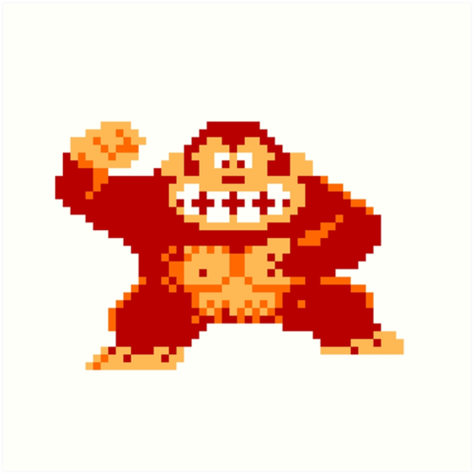

Donkey Kong 8 bit

Year 4 Game Design and Development

Howie Lynch | X00125128

# Evaluation

Donkey Kong was released in 1981 to huge acclaim. Released by Nintendo, it was one off the first platform games. Its focus was on moving the character Mario from the bottom of the screen to the top while dodging missiles or barrels that were thrown by the nemesis donkey Kong. The end of the game was to save the princess in which donkey Kong had captured. There were platforms and ladders that Mario could interreact with to be able to “climb” up the screen. Any time Mario was hit with a barrel he would lose a life and start back at the start(bottom) of the screen. It would prove to be a mainstream hit and the two Nintendo characters would become the backbone of Nintendo’s future success with plenty of success.

For my assignment I was asked to replicate the original Donkey Kong level in Phaser. This would be my 1st time in trying to replicate a game so it was a good learning curve for me. In evaluating this game in a modern context and make recommendations that would improve the game I have come to the following conclusions.

# Animation & Graphics

As this game was originally a 2d game made on an 8 – bit machine, if it was to be made in this era the graphics of the game would be much better. Characters and levels would all be 3-d and the sprites themselves would have lot more animation to them. In this game Mario has 8 animations while donkey Kong has 6. These would be greatly improved in numbers. As modern games have so many more animations. Also, the levels in this game were fairly straight forward, the game designers (due to no fault of their own, but mainly restrictions in computers) went with the rinse repeat element of the levels. Where each level was pretty much the same as the last level, except that ladders were strategically placed in harder positions and the barrels that were thrown by Donkey Kong went at a faster speed as the player moved through the levels.

# Game Play

# User Interaction

# Final Thoughts

If all the recommendations I have stated in the above, where to happen in this game, I do not they think they would improve it. As this was a game that was built in the early 90’s where the production of games was at a much smaller scale than it is today.