Howie lynch x00125128 | Web and User | November 19, 2015
Chris McConnell x00128141

CA 2
middle earth website
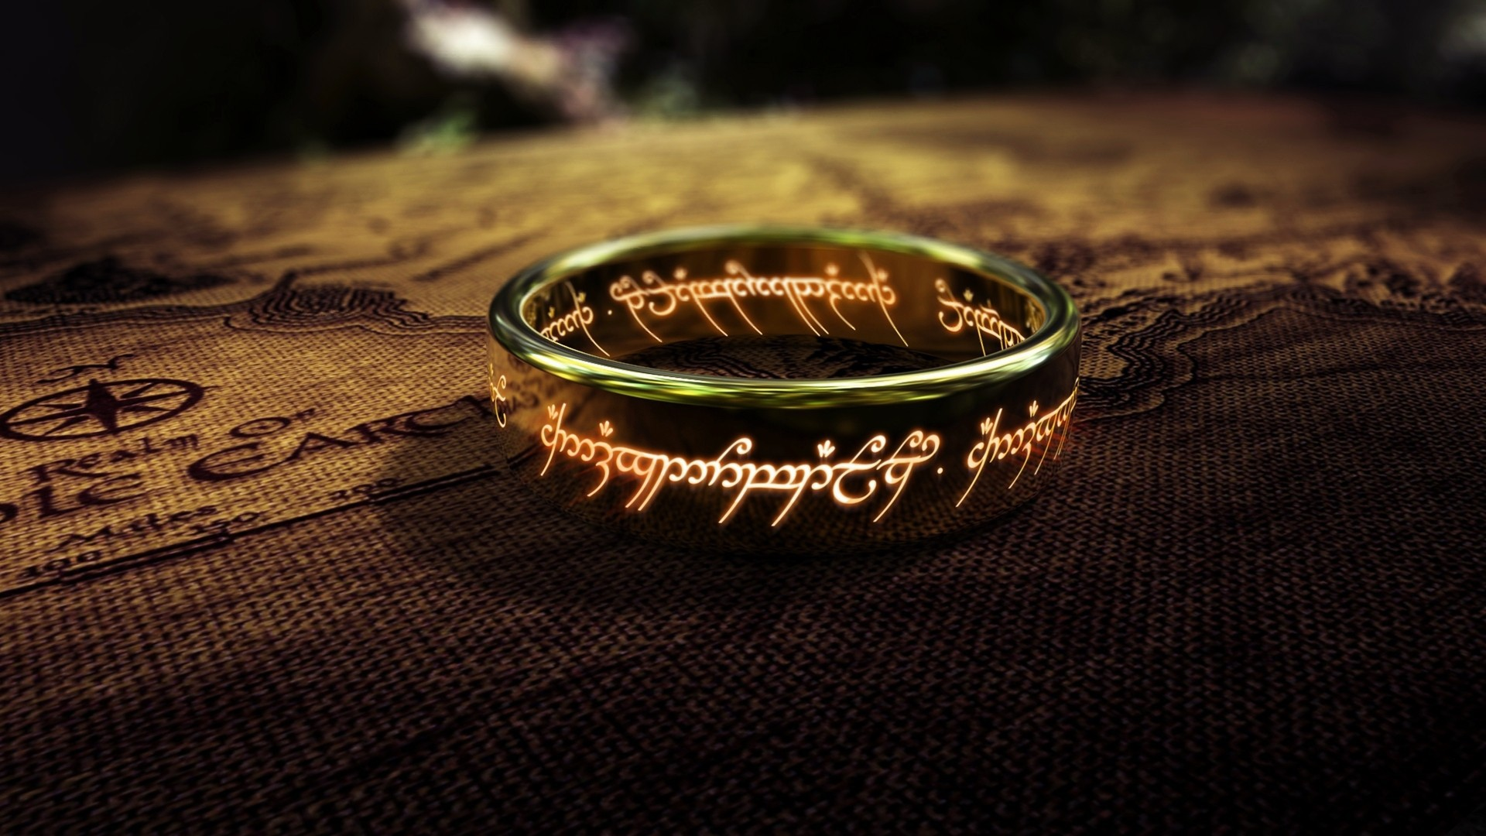

Design Document for Web and User CA2

When we were issued with this CA we sat down as a group and discussed the possibilities in which we could approach the situation. We had a choice off different topics but decided to choose middle earth and J.R.R Tolkien The Lord of the Rings and The Hobbit. These included the books and also the motion pictures of the books. This gave us a possible of 4 pages in our website. After a discussion we chose to add a few extra pages which included a character’s page which would briefly describe the characters in both books, a page about the author J.R.R. Tolkien, a map which would include a middle earth image map and also a homepage.
In deciding how our website would look we chose to have a logo which would act as a banner for the website. This would be a 100% of the container and would be shown on all the pages. Underneath this banner we would have a navigation bar which would incorporate links to all the pages we have in our site.
At first we decided to have all the pages the exact same but with different content on each. The original concept was to have two sections, one which would float to the left and take up 25% and another which would take up 75% and sit beside it. At the end would be a footer and would also incorporate links to the pages on our site.
This at first seemed like it was a good idea but after creating the basic structure of the website we thought that each page was too similar so we decided to change some of the pages.
We decided to have the two books the hobbit and the lord of the rings and also the J.R.R.Tolkien to be the same these would take the original design. In that design on the content that goes to the right would incorporate. Details on each book and author and also a picture that floats to the right.
On the left column we decided to put in some fan art of the hobbit and lord of the rings that would change depending on what page you were on. On the authors page it would have pictures of Tolkien from his early days to his old days.
On the two pages that have details of the film we chose to slightly alter the basic design. Instead of having a column on the left we floated it to the right of the container. This meant that we had a content box of 75% and also a right column of 24%. In the content we would have details about all three films with a picture of the book that floated with the content to the right. On the right hand side column, we decided to insert the trailers of each film in chronological order in which they were released.
We then had a character’s page which separated the container into two separate columns of equal size. One column would have details off The Hobbit and the other would have details about The Lord of the Rings. As the left column was notably shorter than the right we decided to incorporate a bit of a bio on peter Jackson the director of the films.
Finally, we chose to have a different style of homepage. Instead of a usual page that would be similar to all the other pages, we chose to have a page that would resemble a “shelf” off a library. To do this we got a lot of images that related to each off our pages on the site. This was very problematic at first but eventually after a lot of trial and error we got it to work.
The entire color scheme we chose for the website was all based on the background picture we chose to use for the site. This was a picture of the ring in which ties both The Lord of the Rings and the hobbit books together. We uploaded this picture on to colr.org and took a number of colors from the picture. We took the color #170007 which is a dark brown color. The reason for taking this color was that it went well with the background image. The headers used this color also. In the headers we used a different font style "Lucida Sans Unicode", "Lucida Grande", sans-serif, the reason for using this was we thought that it was more stylish and stood out more than the style font on the paragraphs were we used Times New Roman", Times, serif.
The Background image which covers the container in every page and also is used on the navigation bar and the footer. The reason we chose old style paper look was to give the user the feeling that they were reading a book as they scrolled through our website.
During the design of our site we changed backgrounds quite a lot, at first we had a black background with gold writing this was changed as it was very strong and gave the user sore eyes after a while off looking at it. We also had a white background with black writing but felt that it did not give the look we desired. In the end we were delighted with the background image and also the way the font blended into the image.
We chose the background image which is on every page and takes up the whole body. We chose the” ring “as again we felt it ties both the hobbit and The Lord of the Rings together.
In choosing where to place images on the site and in certain pages specifically we had a few dis agreements. In the hobbit book and also The Lord of the Rings book which have the same css and design, at first we chose to have and image off the book which would be in the center off the page and then the details underneath it. After producing this way and actually viewing it we decided to change it. We changed it so the image floated to the right and the paragraph was beside it to the left. We feel this is a much better layout. As your reading you have a view off the book image beside it. We chose to put a border around the image as it looked a lot more stylish and also gives the user a feeling that it’s a painting on display.

The navigation from our site is in two parts. One is the navigation bar which is located underneath the logo. This holds links to all the pages in our site. In the design off the website we chose to have the navigation bar in the same place but in the design and unlike in the website we chose not to have drop down menu inside the navigation bar. The reason for this was when we looked at how to do the code for the down navigation bar, a lot of it we did not understand. Because of this reason it was left out, instead of taking somebody else’s code and copy and paste it in and taking credit for it we chose not to.
Also we used the footer for a quick link navigation bar. The reason for having links at the bottom of the site was as the navigation bar was not always fixed to the top (which we could do but chose not to) we chose to give the footer links to quickly get back to the top or to a different page for ease off the user.

On some of the pages there are headings h2 which hold quotes from the books. This was implemented after the actually design of the website. This gives the user an insight into the books if they never have read them and also gives the user who has read the books a feeling off nostalgia which we thought was a nice touch.
We added an image map at the end to have a link to externals sites which has information on the maps locations of middle earth.
Below are some images from the site and confirm the reasons stated above why we chose them.

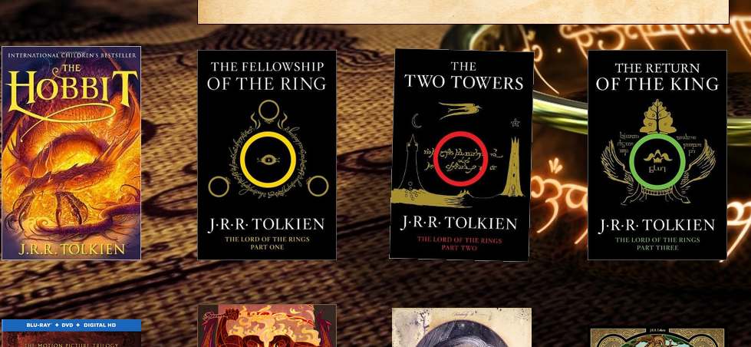

The homepage giving the user the Library or shelf look.

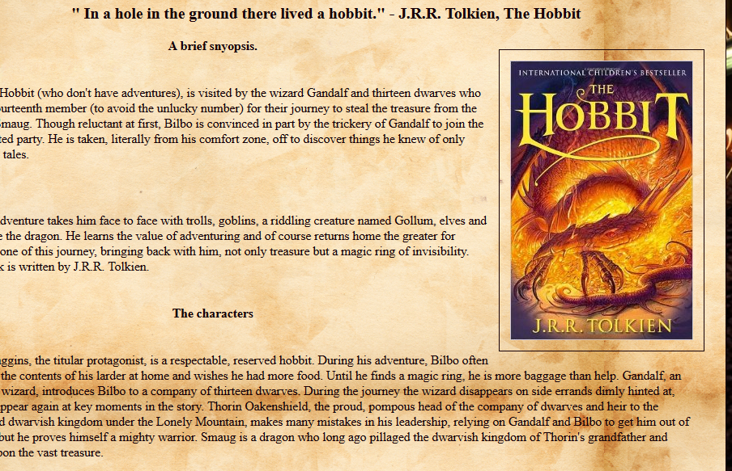
On the hobbit page the image floating to the right with the text flowing around it to the left. Also the image has a border around it giving it the feel of a painting with a frame.

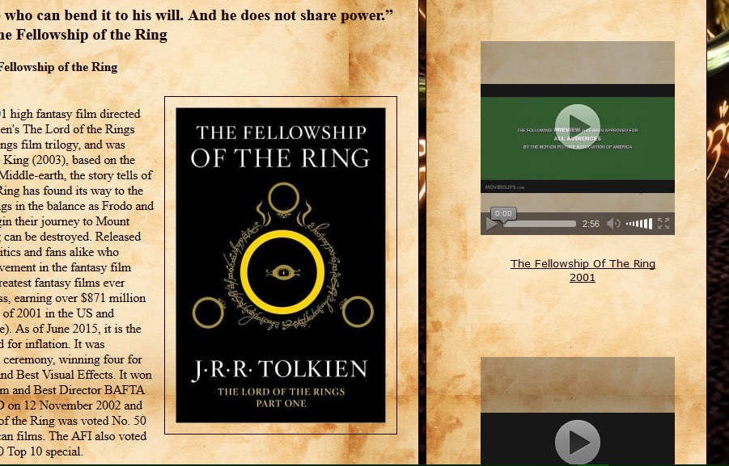
This is an image of the film pages these show how the videos line up nicely with the synopsis from the film. And also how the images float to the right.

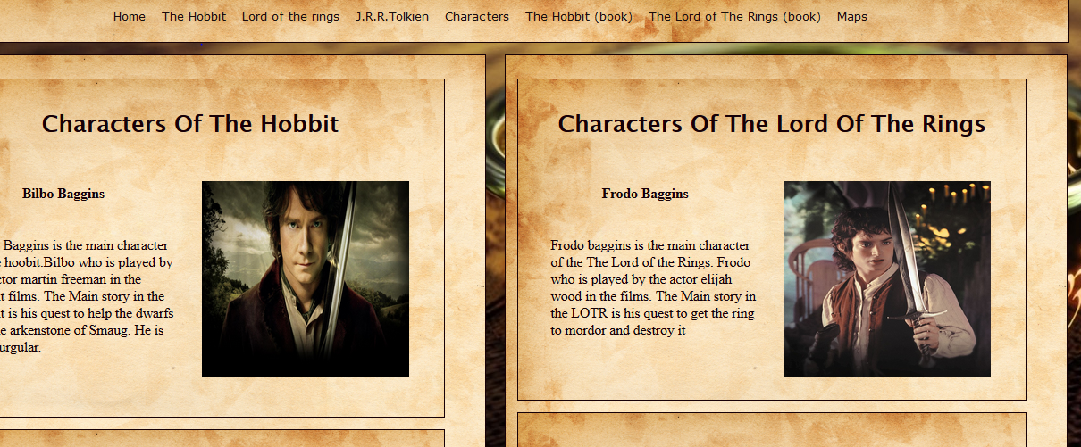
This page is the character’s page which has to contents of equal size

