| WEB AND USER | November 26, 2015
Howie Lynch X00125128
Chris McConnell X00128141

CA2
MIDDLE EARTH WEBSITE
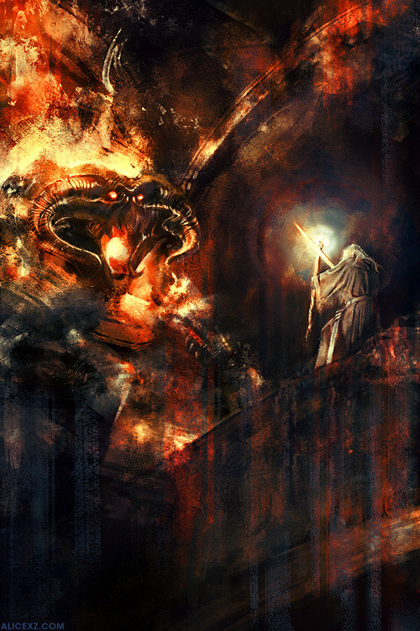

Lifecycle for Web and User CA2

Our website will be a website that’s it is made for fans of middle earth or fans of either lord of the rings and the hobbit. In creating this website, we made sure that it was a website that was understood by the users. Being fans of middle earth we already had a good idea the user wanted. We predicted that the average user would be a fan of middle earth but we also wanted to be able to have an accessible site for a non-fan of middle earth. We were planning to have descriptions of each book and also each film with trailers of videos. We didn’t want to overdo it with too much information on each page that would give the user of being overblown with all the information they were processing. We got together as a group and did a few hand drawn pages of what we wanted the site to look like (The images are on the next page).

In these hand drawings we gave ourselves an idea of what the pages would look. In the top image we have a welcome page with multiply links which we thought could be images of books and the films off the Hobbit and The Lord Of the Rings.
In the bottom left image is an idea of what we wanted both the hobbit and The Lord of the Rings book pages to look like. These would have information on the books and also maybe characters on the left which could be used to bring you somewhere else on the site.
The bottom right image is one that all the films would use. A sidebar on the left which would hold the videos, and then a main content page that would hold the information off the film.
We original started off with a five-page website. A homepage and two pages for the books off The Lord of the Rings and The Hobbit and two Pages for the films off the Hobbit and The Lord of the Rings.

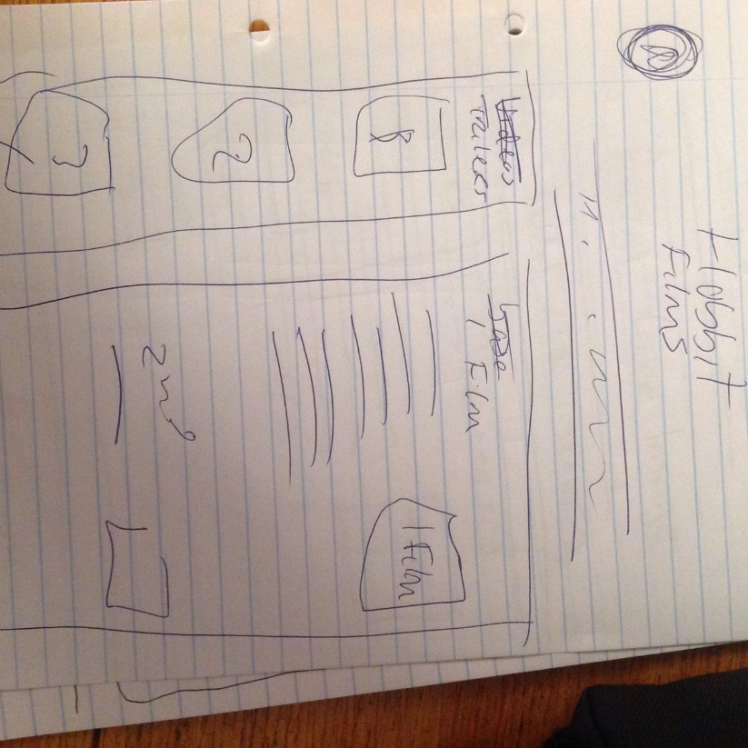
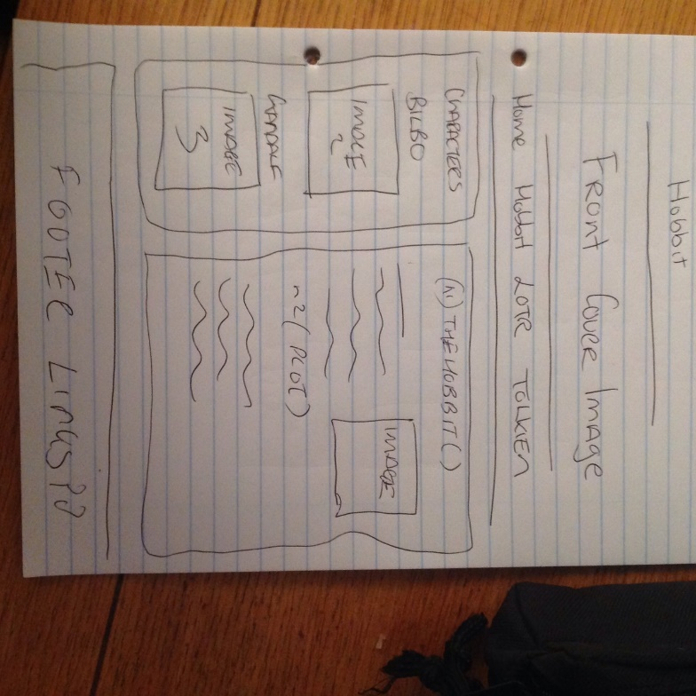
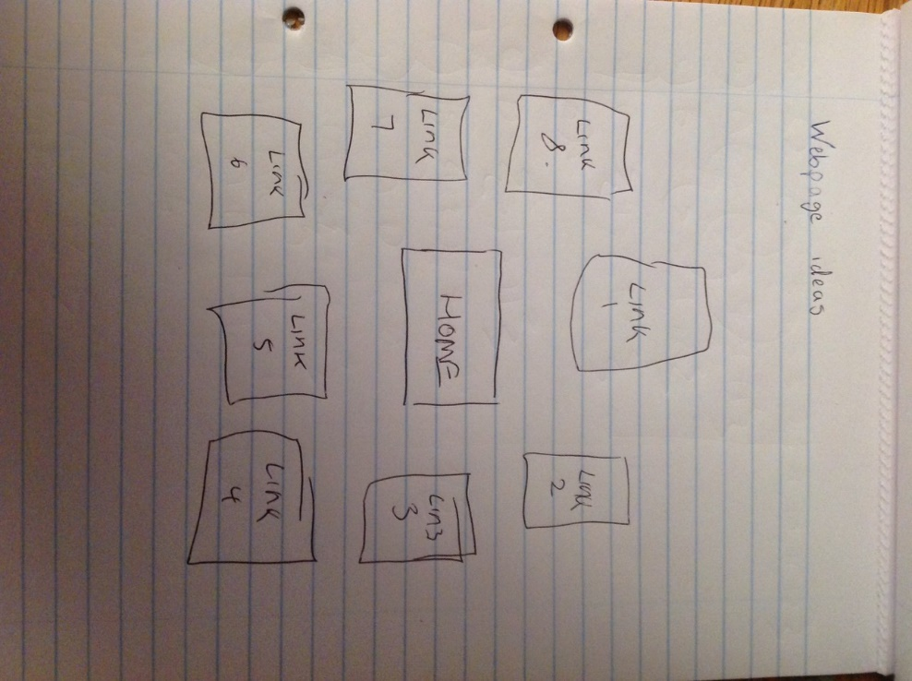

Analysis
In analysing our website, we listed down points in what the user would want to see when coming onto our website. We also listed down information that we as fans would like to see if we were able to insert more pages onto our website. They were as follows
- Information on the hobbit the books
- Information on The Lord of the Rings books
- Information on the Hobbit the films
- Information on The Lord of the Rings books
- Information on J.R.R. Tolkien
- Information on peter Jackson
- Images from the Hobbit / The Lord of the Rings
- Videos from the Hobbit / The Lord of the Rings
- A map of Middle Earth

Target Audience
Our Target audience would be fans of middle earth. People who are interested in Tolkien’s LOTR (The Lord of the Rings and The Hobbit) Films and books. Also people who are looking for information on either or both topics of middle earth. Also for people who have no information on any of the middle earth stories we wanted are website to be able to give a brief synopsis of the books and films.

What Do they need
In making our website we felt that it was easy to access interface. We had a few arguments over the home page but tested it a few times and thought it was accessible even by a novice internet user. All the information on our website was to be clear and easy to read information. We also wanted to all the information to be descriptive but not over the top detail. We have both seen too many websites that have information on books or films and with all the detail they give it is nearly too much and can give the user a feeling of overwhelming.
We incorporated the four click rule into our website as well. This meant that all webpages are able to be accessed in four clicks. We have a navigation bar which shows up on all the pages the user can access on our webpages. This makes it easy for the user to navigate.

What We Have

We have a similar uniform to all the other webpages. We have our text easy to read and also so its nots to over whelming on the user. We feel we chose a good contrast off colours.

Concepts

Using colours from the hobbit and the LOTR franchises, a darker mood would require darker colours, however we needed to be careful not to use too many colours or colours that are too dark.
Have the area where any text will be as if it is written on old parchment paper, this would mimic the story being an inbound book
Make sure that the navigation is on a different background or different coloured area so it can be distinguished easily.

Prototype 1
Features:
- Lots of information about the Hobbit and The Lord of the Rings
- Easy to understand welcome page
- Videos for those who don’t like to read
- Lots of relevant pictures

Disadvantages
- Yellow text on black background makes reading difficult
- Almost in your face with pictures
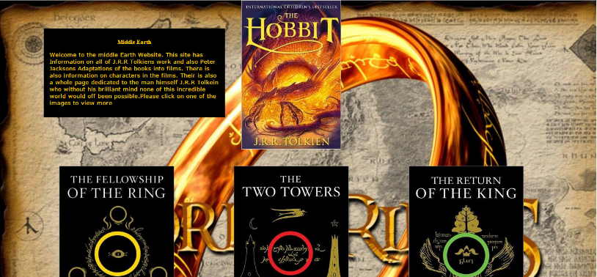
- Welcome page not really needed

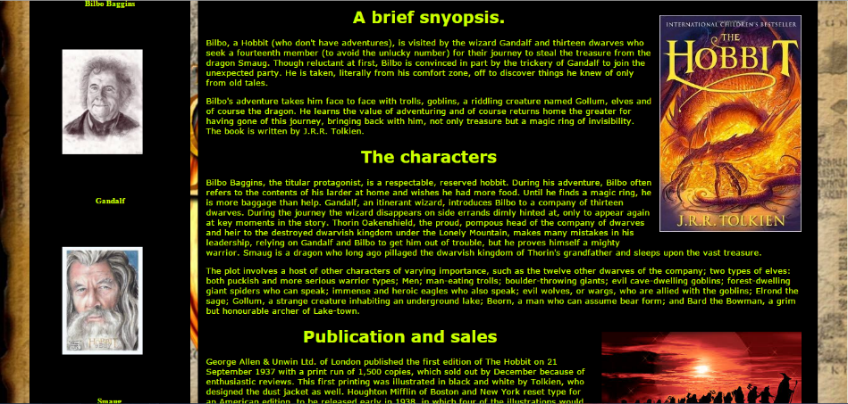
Prototype Two :
Changed
- Now black text on white/very light brown, much easier to read.
- Reduced number of picture but have added one or two more videos.
- Removed the welcome page entirely.
- Added a bit more information about J.R.R. Tolkien and the characters in the movies and the books
Features
- Easy to navigate the website
- Plenty of information about J.R.R. Tolkien and the characters in the movies and the books.

Disadvantage’s
- The Videos look a bit out of place and need to be moved
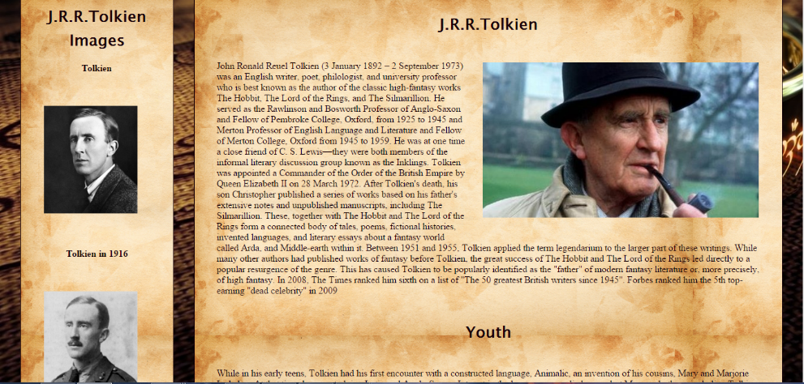
- New Images of the characters should be put into the character page.

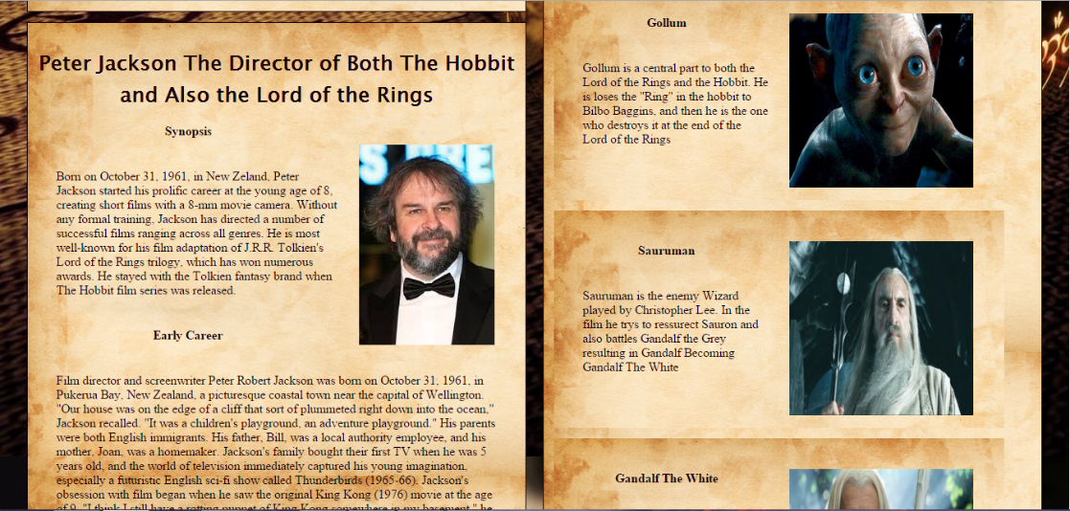
Finished Website
Changed
- Now black text on an image of a worn book page.
- Put borders around the pictures on the character’s page this gives them the look of a picture in a book.
- Added a map to the website. This holds an image map with external links to pages with information about the areas.
- Altered the homepage so that when you hover over one of the image links they twirl in a 360 degrees and shrink down to a border of 50%.
- Added footer links at the bottom of the page. This will give the user easy of navigation.

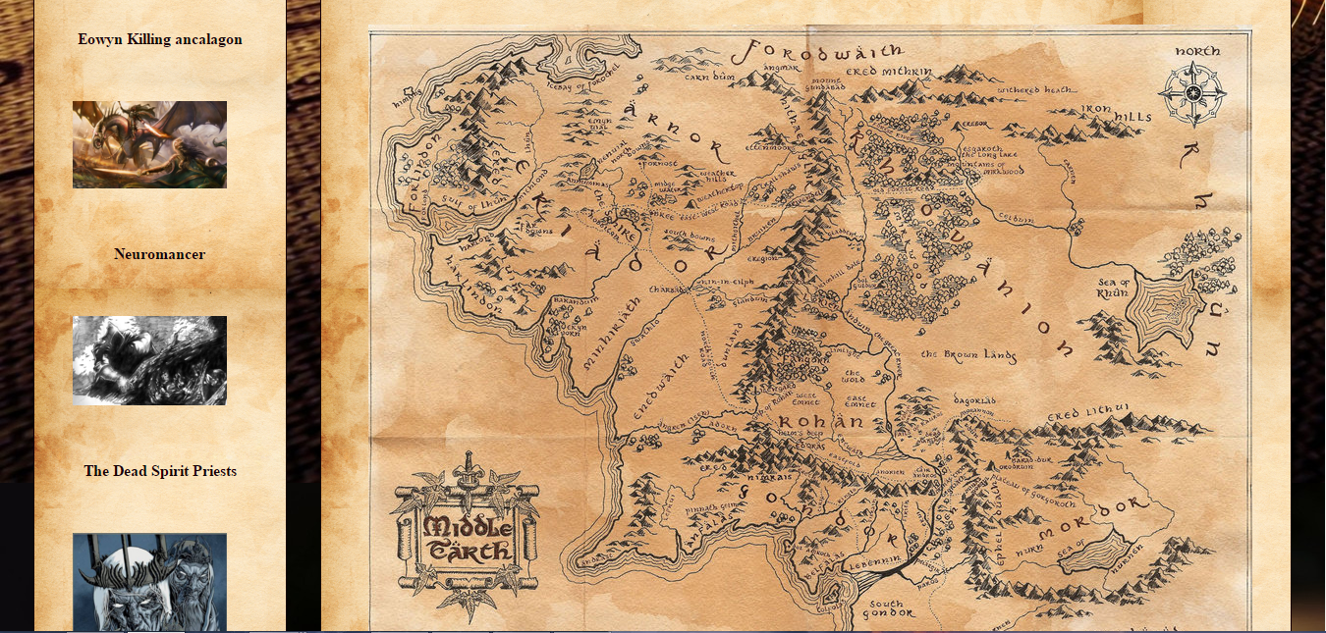
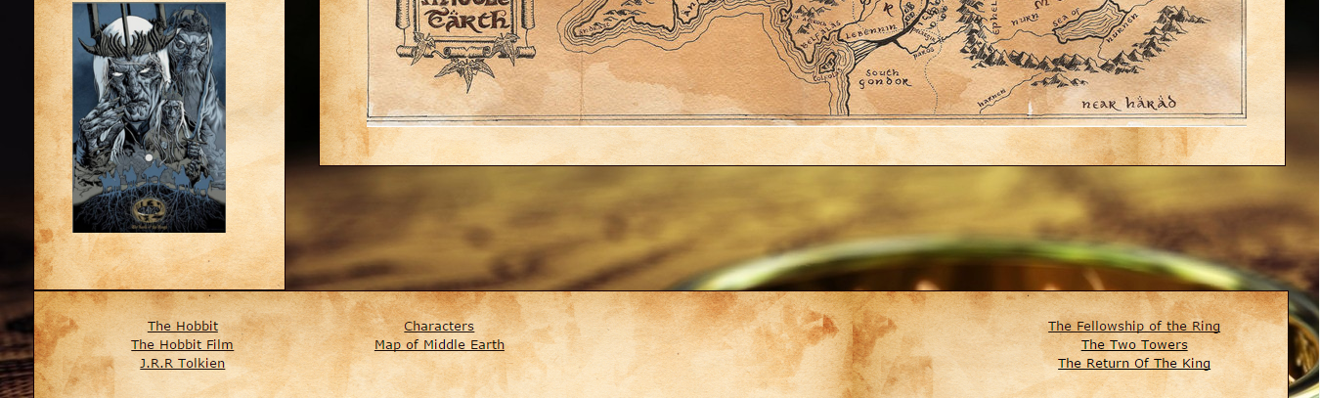
Visual Map
Homepage
Hobbit
LOTR
J.R.R
CHAR
Hobbit Book
LOTR BOOK
MAP
A Visual map representing each page on the website all pages are accessible through the home page. We have it so that all pages are accessible wherever the user is on the website. Thus using the four click rule.
Usability and Testing
After our website was completed we put it through some rigorous testing this was to insure that the site itself had no bugs or anything that would cause the user to feel “lost” while using the site.
The first test was to ensure all links on the homepage were working. This was tested by clicking on each link to make sure that each link brought you to the correct page on the site.
The second test was to check all links on all pages are working and correct. This was tested by clicking on all links. All links came back fine with no exceptions.
The 3rd test was to make sure that the map links worked they all did also.
The 4th test was to ensure the videos played which they all do.
The 5th test was to make sure on the character’s page that the JavaScript worked well with no faults and it did seamlessly.
Test Scenario 1: Was to click into the character’s page then to click on Bilbo Baggins.
Test Result 1: Was able to click on the character’s link and then able to click on the Bilbo Baggins image to enlarge it.
Test Scenario 2: Was to click on The Lord of the Rings the two towers Link, then to scroll down to the footer and click on the J.R.R Tolkien Page.
Test result 2: Clicked on The Lord of the Rings the two towers link brought to the two towers film. Scrolled down to the footer clicked on the J.R.R Tolkien link brought to the Tolkien page.

Overall the site seems to be working well.

Faults and Recommendations
Faults Found 1: A fault found while testing was that once a link is clicked on the welcome page then the user goes to the clicked link if the user is to then go back to the welcome page the link that was previously clicked has a “hover” red border line around it.
Fault Found 2: On the navigation bar, there is too many links that make the navigation bar feel and look crowded. Recommended that the navigation bar has a drop down menu for each topic (e.g. lord of the rings has a book and film drop down).
Faults Found 3: As the site is not a responsive website when viewed on different sizes other than a laptop size some of the videos and images are in the wrong places. This could of being fixed if the site was made responsive, for example if we had four different sizes phone, tablet, laptop, and desktop.
Recommendation/idea: on the welcome page originally wanted the links/images to circle around the introduction to the site so they formed a type of “ring” which would have represented the ring from The Lord of the Rings.
Recommendation/ idea 2; For the logo banner to change when a user clicked on The Lord of the Rings or the hobbit either book or film.

Bibliography
Code used from internet
<script type="text/javascript"><!--inserts JavaScript into the website-->
var started;
function showLightBox()
{
if (started) return;
started = setTimeout(function(){
Lightbox.start(document.getElementById('firstImage'));
started;
},500);
}
function stopShowLightBox(){
if (started) {
clearTimeout(started)
started = 0;
}
}
</script>
Visuallightbox.com,. 'Click One Image To Start The Simple Lightbox'. N.p., 2015. Web. 1 Dec. 2015.
All Images on the website were found on google.com
All Images are related to Lord of the rings or the Hobbit
https://www.google.ie/search?q=the+lord+of+the+rings&source=lnms&tbm=isch&sa=X&ved=0ahUKEwjci4To3L_JAhWEKw8KHXTqCT8Q_AUIBygB&biw=1366&bih=619
All Videos were taking from youtube.com
All videos are trailers relating to Lord of the Rings and the hobbit
https://www.youtube.com/watch?v=V75dMMIW2B4
All content was taking from Wikipedia.com
All content related to the lord of the rings the hobbit J.R.R.Tolkien or peter Jackson
https://en.wikipedia.org/wiki/The_Hobbit_%28film_series%29
no copyright intended.

