Restaurant Management System
System Requirement Definition
2023-12-04 09:41:22 PM

System Purpose
A restaurant management system (RMS) is an essential tool for any new restaurant. These systems are designed to keep your restaurant running by tracking employees, inventory and sales.
A restaurant management system is a type of point-of-sale (POS) software specifically designed for restaurants, bars, food trucks and others in the food service industry. Unlike a POS system, RMS encompasses all back-end needs, such as inventory and staff management. These systems also handle payment processing, order management and other tasks staff would typically perform.

System Configuration

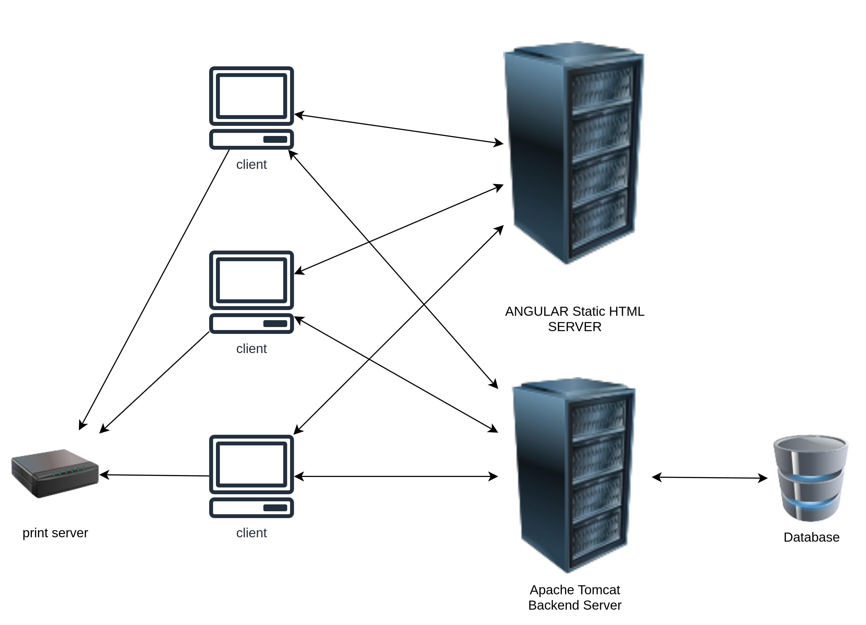Figure 1: System configuration

Yes - there’s automatic memory management for variables on the stack (e.g. when a function exits, memory for local variables is freed, and destructors are called, letting you use patterns like RAII), and now there’s also automatic memory management for variables on the heap (with std::shared_ptr, std::unique_ptr, std::weak_ptr).

Functions
- User Management System
- Employee Management System
- Customer Management System
- Inventory Management System
- Easy Menu Setup
- Table Finding System
- Menu Management System
- Ordering System
- Business Reporting ability
- Task Managing system

Non Functions

Constraints

