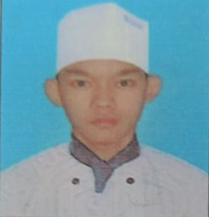**CURRICULUM VITAE**

Applied position : Commis – 1

Name : Mg Khine Htet Aung

N.R.C No. : 12/ Ka Ma Ya ( N ) 067209

Date of Birth : 27.9.1999

Father Name : U Myint Swe

Nationality : Myanmar

Religion : Burma / Buddhist

Gender : Male

Marital Status : Single

Height : 5’ 7”

Address : No.(115), Yadanar Myaing Street, No.(1) Quarter, Kamayut Township, Yangon

Contact Phone : +959772746252

Email : [khinehtetaung22@gmail.com](mailto:khinehtetaung22@gmail.com)

**Education Qualification**

|  |  |  |
| --- | --- | --- |
| **Year** | **Certificate/Diploma/Degree** | **School** |
| 2015 | 10th Standard | B.E.H.S (4) Kamayut |

**Other Qualification**

|  |  |  |
| --- | --- | --- |
| **Year** | **Certificate/Diploma/Degree** | **School** |
| 2018 | International Culinary Course | Star Acedamy |

**Work Experiences**

|  |  |
| --- | --- |
| Black Canyon Coffee | 5 Months as Kitchen Helper |
| Avenue 64 Hotel | 1 Year and 7 Months as Commis – 2 |
| Best Western Greenhill Hotel | 6 Months as Commis – 2 |
| Genki Sushi | 6 Months as Commis – 2 |
| Orng Kitchen ( Fine Dining ) | 1 Year as Commis – 1 |