## **Theint Wuit Yee Thaung**

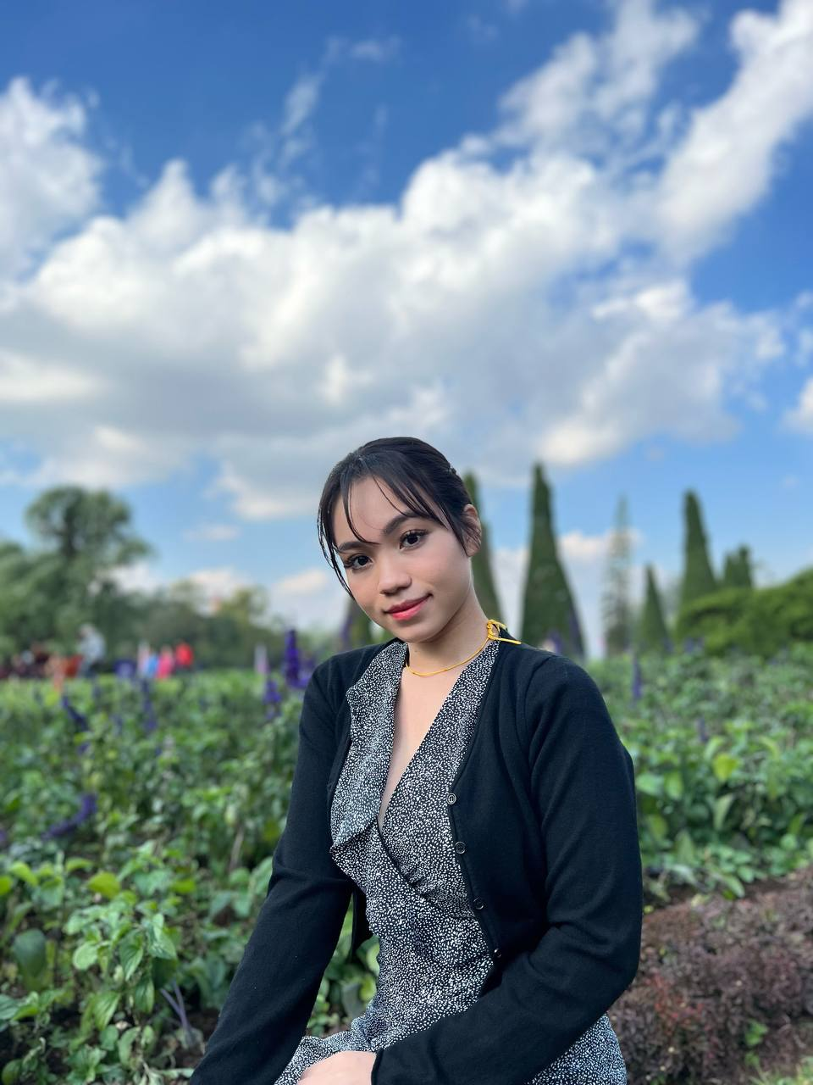

Choa Chu Kang Central Block 208 #10-70 Singapore, S(680208)

• (65) 8825 6743

[Theintthaung00@gmail.com](mailto:Theintthaung00@gmail.com)

* <https://www.linkedin.com/in/theint-thaung-1605ba25a/>
* <https://theintthaung.github.io/Portfolio/>

Self-motivated and highly reliable graduate who has completed formal education based in Singapore with proven leadership skills and an efficient worker who demonstrates strong discipline and prioritization skills by understanding business etiquette. Pays attention to detail and excellent verbal & written skills. Highly successful at delivering superb service with a smile. Able to troubleshoot and apply

critical thinking when needed. Received many appraisals from past company GM. Fluent in English, Chinese, Burmese, and Korean. Seeking work experience and professional development opportunities.

**Education**

**TeeSide University (UK)**, Graduation Year, February 2021

Singapore,Singapore

* Electrical and Electronic Engineering
* Engineering Design & CAD, Engineering Mathematics, Properties of Material, Electrical & Electronic Principles, Professional skills for EEE
* Calculus, Digital Electronics & logic gates, Group Design Project
* Electrical Machines, Management skills for engineer
* Member of GEARS club. Participated in Hosting of Engineering Night
* Achieved A’s for most modules

**Diploma in Engineering (Management Development Institute Singapore)**

Singapore,Singapore Graduation Year, 2019

* Participated in organizing Graduation Night for School of Engineering
* Volunteered in Community Service such as Youth Corp
* Good Academic Results throughout diploma course

**Serangoon Secondary School**, ‘O’ Level

Singapore,Singapore Graduation Year, 2019

* GCE ‘O’ Level 20points
* Member of School Prefectorial Board as Events Team Leader
* Calculus, Digital Electronics & logic gates, Group Design Project
* Represented Singapore for National Stamp Collection & won 2nd Prize (Silver) 2013
* Represented Singapore for National Stamp Collection & won 1st Runner Up (Gold) 2014
* 1st in Cohort from secondary 1 to secondary 4. Distinction in Chinese
* Maintained good teacher & student relationship in school.
* Received many good appraisals from lecturers.
* Hosted events in school such as Orientation camps & Prefect Exco camps
* Took Up Red Cross as CCA
* Participated in Interclass Sport competition.
* Participated in New South Wales Math’s & Science Exam

**Mayflower Primary School**, ‘PSLE’

Singapore, Singapore Graduation Year, 2012

* Received positive feedback from Teachers.
* Distinction in mother tongue
* Participated in Science Competition collaborated with Ngee Ann Poly

## **Relevant [Industry] Experience**

**Samsung DigitalLife**, Myanmar

*Admin & Personal As*sistant (PA) (02/2022)-(11/2022)

My task is to handle administrative operations, phone support, calendar maintenance, scheduling, document processing and correspondence. I've received compliment emails from my clients for the ability to render admin support in a deadline-driven atmosphere while streamlining operations and facilitating Organization goals.

**Bayshore Park Management Office**, Myanmar

*Accounts & Admin Assistant* (01/2021)-(02/2022)

Responsible for providing help and support with day-to-day tasks in office. Include taking notes in meetings, answering phone calls Responding to questions and requests for information. Knowledge in using AutoCount & help to assist Senior Accountants. Processing invoices, tracking receipts, inputting expenses and other basic bookkeeping tasks.

## **Additional Work Experience**

**Heritage Partners Pte Ltd**, Singapore

*Hospitality Service Professionals* (01/2018)-(01/2021)

**Sheraton Towers Singapore**, Singapore

*Service Crew* (12/2016)-(01/2018)

Greeting customers and serving customers. Maintain cleanliness and housekeeping of work areas.Taking orders and serving food and Maintain a dining ambience with an enthusiastic attitude. Ability to use the POS system. Having excellent customer service, Maintaining Cleanliness & housekeeping.Received personal acknowledgment for ‘Excellent Service’ by Prive CEO MR YUEN.

## **Professional Skillset**

* Manage calendar schedules.
* Keep all sensitive work-related discussions, materials, and files strictly confidential.
* Prepare email correspondence as dictated and keep them organized and maintained accurate records with a high degree of confidentiality.
* Maintain renewal of business registration and business licenses and some certifications
* Manage credit cards and expenses of the Vice President as needed.
* Assist in the planning and execution of various company events and functions including annual holiday dinners.
* Assistance with travel, vehicle maintenance, errands, etc.
* Assist with mail and resolve any issues if needed.
* Assist other departments as needed (Accounting & HR) with efficiency and accuracy for the higher management.