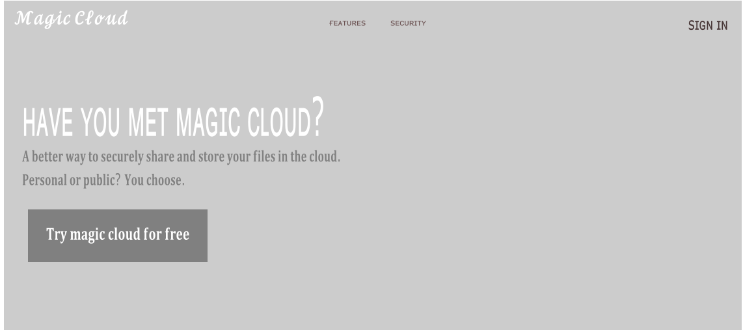**Magic Cloud**

Website

The whole point of this website is to simplify file sharing. This is only achieved by making it stored to a cloud. The benefit of a cloud is that it stores it for the user and nothing will get lost. The reason why this is such an advantage is because many people generally stress about losing a computer or loss of data due to hard drive failure. Guess what, magic cloud has come to the rescue. Now there’s no more stress in the work of file sharing.

The main reason it’s called “magic cloud” is since it’s not only a storage website. It’s used to also share securely. No hackers inbound! Therefore, users can just contact each other, ask to share, once permissions have been allowed, access has been granted. No one likes sharing files if the cloud is easily accessible and if anyone can just hop in and grab whatever they like. This is not GitHub!

There will be many features that will help the user and guide to have the best possible experience while using ‘magic cloud’. These features involve storage, sharing, permission, and collaboration. Many of these features also have its own characteristics which I will introduce on the upcoming versions of the website. All the features will be written on the features page of my website. Just grab your coffee and enjoy life!

Another page that I have added is the ‘security’ page. The ‘features’ and ‘security’ page will not have any special JavaScript or HTML stuff. It will only have text and will just explain the importance of ‘magic cloud’. I’m also planning to add an ‘about’ page that will explain the reason for creating this website, which summarises the whole project that I am working on.

**Page**

I completely decided to remove all my pages as they weren’t useful in this project. This project is supposed to be a single web page for file sharing. Therefore, I will only be showing my single web page. My page only includes the list of files that I will be sharing. This is my early prototype of the web page.

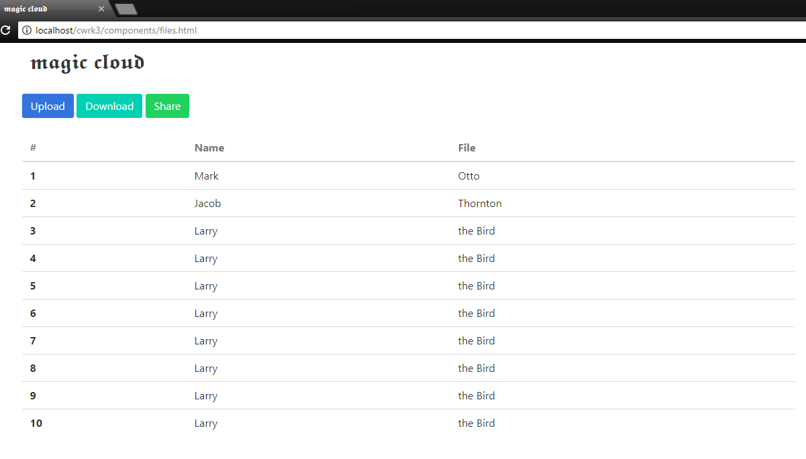

Cloud database

A cloud database is a database that will generally run on a cloud computing platform, access to its provided as a service. Database services take care of high availability and scalability of the database. Database services make the underlying software stack transparent to users. A will most likely use MySQL.



**MySQL Database**

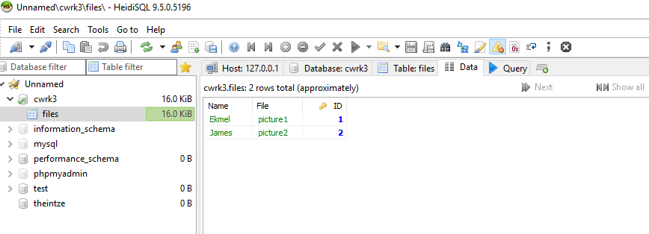

**Connect MySQL**

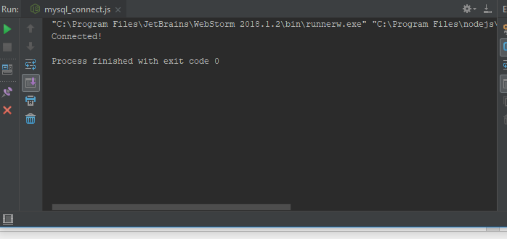

This message shows that I was successfully able to connect MySQL to my project

**Select MySQL**

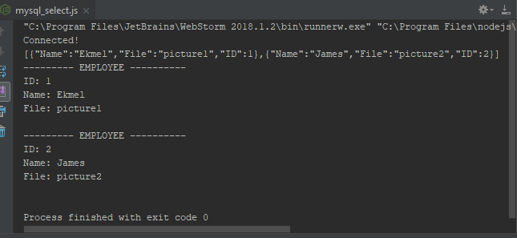

This is my select JavaScript file. This selects the items from my MySQL Database. This shows that my code was able to access MySQL and get the items needed.

**Delete MySQL**

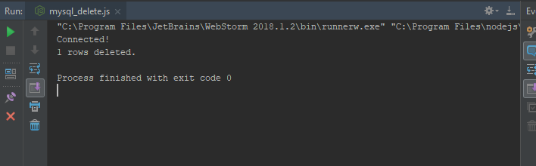

This is the code for delete. I was successfully able to pick one of my rows from MySQL and delete in on the database. Here it shows what happened:

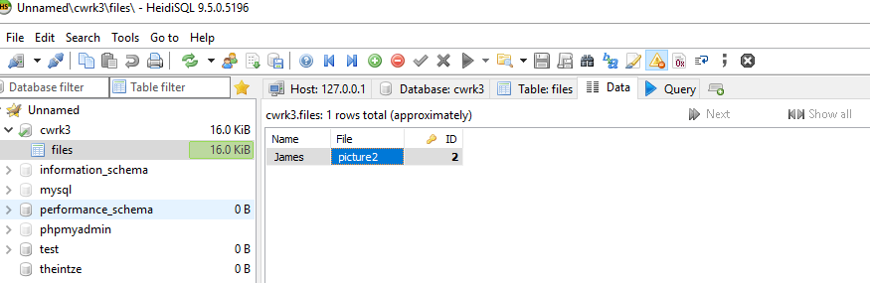

**Insert MySQL**

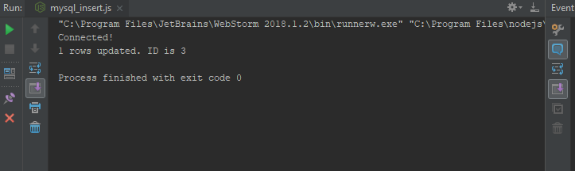

This is the part of inserting items to my database. I was successfully able to add another item into my ‘files’ database. Here it shows the changes that were made:

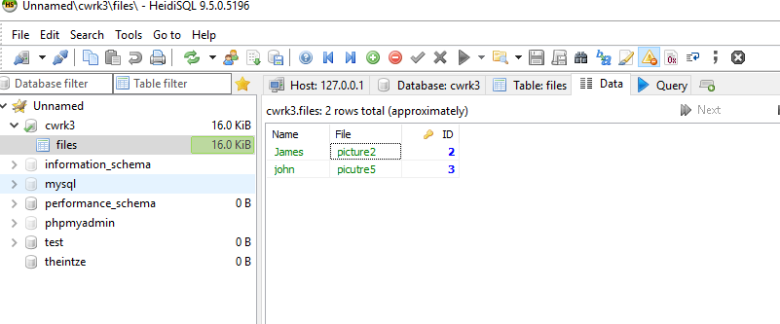

**Update MySQL**

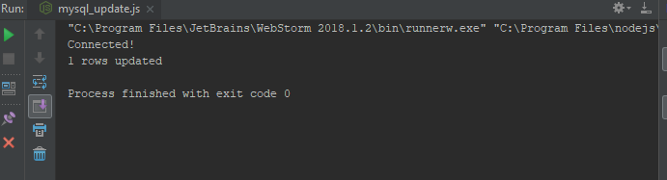

I was able to successfully link the update in order to update files on MySQL database. Here it shows the changes that I made:

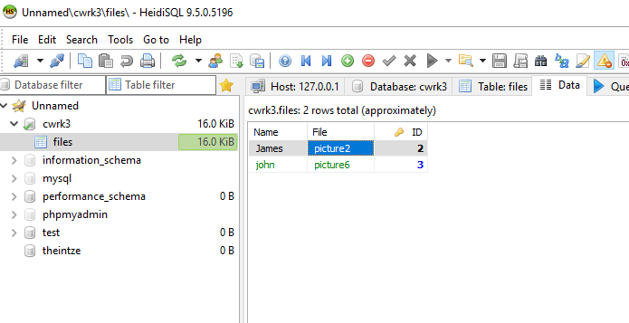

John’s file was modified to ‘picture6’.

This is my latest version of the website:

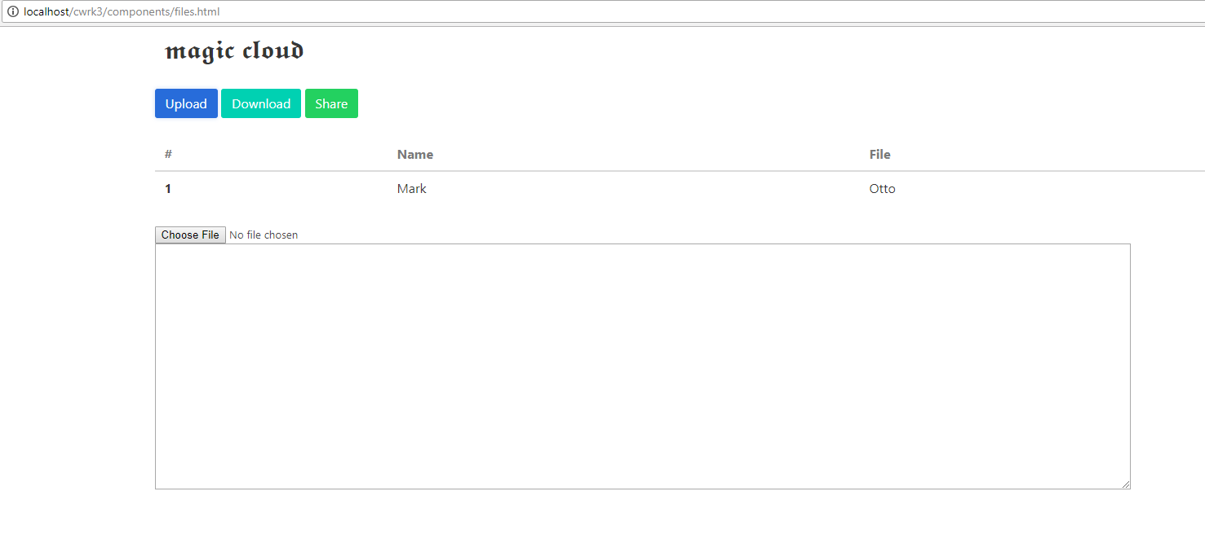

I was not able to achieve getting the database and importing to the actual website. I wanted to use PHP but no marks would have been given. I was not able to get the buttons to work unfortunately as I couldn’t link the JS files.

**Third party libraries**

List of third party libraries used:

* MySQL
* Bootstrap
* Bulma
* Node js
* HeidiSQL