EXPERIMENT-01

FIND-S Algorithm: Dataset-Based Python Programs
Name: MURE THEJASRI Reg.No: 192311298
- Implement and demonstrate the FIND-S algorithm for finding the most specific hypothesis based on a given set of training data samples.
Problem 1: Enjoying Sport

Aim
To implement FIND-S using a sport-related dataset stored in a separate CSV file and identify the most specific hypothesis consistent with positive examples.

Procedure
- Save the training examples in sport_data.csv with the target class in the last column.
- Run the Python program from the same folder as the CSV file.
- Read the CSV rows and initialize the hypothesis from the first positive example.
- Ignore negative examples; replace differing attribute values with '?' for each later positive example.
- Display the final hypothesis.

Dataset File / Input
File name: sport_data.csv
The CSV file contains a header row followed by these training examples:
Sky | AirTemp | Humidity | Wind | Water | Forecast | EnjoySport
Sunny | Warm | Normal | Strong | Warm | Same | Yes
Sunny | Warm | High | Strong | Cool | Same | Yes
Rainy | Cold | High | Strong | Warm | Change | No
Sunny | Warm | High | Light | Warm | Change | Yes

Code
import csv
filename = "sport_data.csv"
with open(filename, "r", newline="", encoding="utf-8") as file:
reader = csv.reader(file)
headers = next(reader)
data = list(reader)
hypothesis = None
for row in data:
if row[-1].strip().lower() == "yes":
attributes = row[:-1]
if hypothesis is None:
hypothesis = attributes.copy()
else:
for i in range(len(hypothesis)):
if hypothesis[i] != attributes[i]:
hypothesis[i] = "?"
print("Attributes:", headers[:-1])
print("Final Hypothesis:", hypothesis)

Output
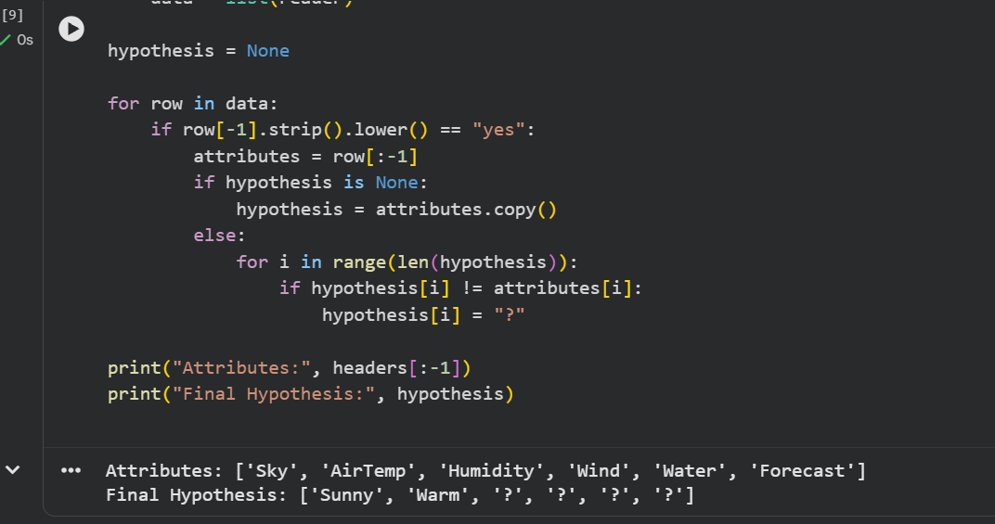

Result
The final hypothesis keeps Sky = Sunny and AirTemp = Warm; the remaining attributes vary across positive examples.

Problem 2: Choosing a Laptop

Aim
To apply FIND-S to a laptop-selection dataset stored in a CSV file and determine which attributes remain common to positive selections.

Procedure
- Create laptop_data.csv with laptop attributes and Selected as the target column.
- Keep the CSV file and Python script in the same folder.
- Read the dataset and initialize the hypothesis from the first row labelled Yes.
- Skip rows labelled No and generalize differing attributes in positive rows to '?'.
- Print the resulting hypothesis.

Dataset File / Input
File name: laptop_data.csv
The CSV file contains a header row followed by these training examples:
Budget | Weight | Battery | Purpose | Selected
High | Light | Long | Study | Yes
High | Heavy | Long | Gaming | Yes
Low | Light | Short | Study | No
High | Light | Short | Work | Yes

Code
import csv
filename = "laptop_data.csv"
with open(filename, "r", newline="", encoding="utf-8") as file:
reader = csv.reader(file)
headers = next(reader)
data = list(reader)
hypothesis = None
for row in data:
if row[-1].strip().lower() == "yes":
attributes = row[:-1]
if hypothesis is None:
hypothesis = attributes.copy()
else:
for i in range(len(hypothesis)):
if hypothesis[i] != attributes[i]:
hypothesis[i] = "?"
print("Attributes:", headers[:-1])
print("Final Hypothesis:", hypothesis)

Output
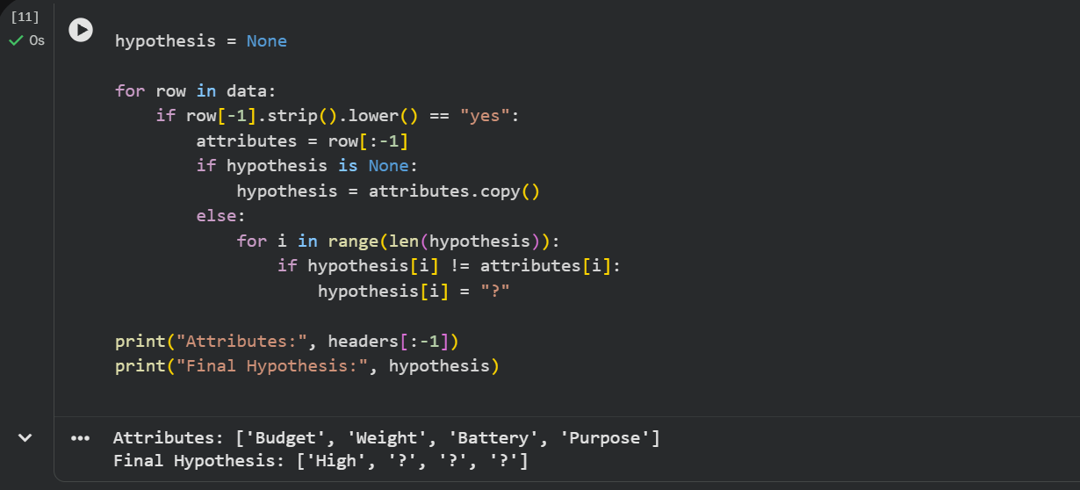

Result
Budget = High is the only attribute shared by all positive laptop selections.

Problem 3: Selecting a Planting Location

Aim
To demonstrate the FIND-S algorithm on a plant-growth dataset and find the most specific hypothesis from positive plant-growth examples.

Procedure
- Store soil, sunlight, watering, season, and target labels in plant_data.csv.
- Run the Python script from the directory containing the dataset.
- Load each CSV row and use the first PlantGrows = Yes example to initialize the hypothesis.
- Ignore No examples and replace attributes that differ across Yes examples with '?'.
- Display the final hypothesis.

Dataset File / Input
File name: plant_data.csv
The CSV file contains a header row followed by these training examples:
Soil | Sunlight | Watering | Season | PlantGrows
Loamy | Full | Moderate | Spring | Yes
Loamy | Partial | Frequent | Summer | Yes
Sandy | Full | Low | Summer | No
Clay | Full | Moderate | Autumn | Yes

Code
import csv
filename = "plant_data.csv"
with open(filename, "r", newline="", encoding="utf-8") as file:
reader = csv.reader(file)
headers = next(reader)
data = list(reader)
hypothesis = None
for row in data:
if row[-1].strip().lower() == "yes":
attributes = row[:-1]
if hypothesis is None:
hypothesis = attributes.copy()
else:
for i in range(len(hypothesis)):
if hypothesis[i] != attributes[i]:
hypothesis[i] = "?"
print("Attributes:", headers[:-1])
print("Final Hypothesis:", hypothesis)

Output
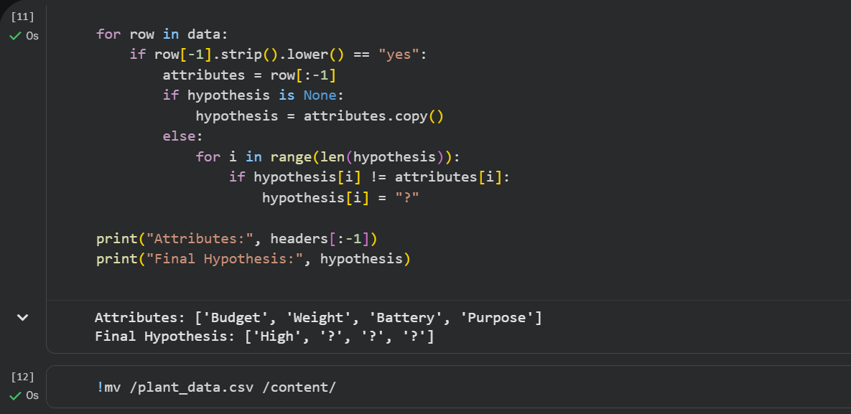

Result
All four attributes differ among the positive examples, so none remains a fixed attribute in the final hypothesis.

Problem 4: Selecting a Travel Plan

Aim
To implement FIND-S for a travel-plan dataset stored separately and determine the common attribute values among positive trip decisions.

Procedure
- Save the travel examples in travel_data.csv.
- Place travel_data.csv beside problem4_travel.py.
- Read the dataset and initialize the hypothesis with the first GoTrip = Yes example.
- Ignore negative examples and generalize any mismatching attributes in positive examples to '?'.
- Print the final hypothesis.

Dataset File / Input
File name: travel_data.csv
The CSV file contains a header row followed by these training examples:
Weather | Distance | Transport | Companions | GoTrip
Clear | Short | Train | Friends | Yes
Clear | Long | Car | Family | Yes
Stormy | Short | Bus | Alone | No
Cloudy | Short | Flight | Friends | Yes

Code
import csv
filename = "travel_data.csv"
with open(filename, "r", newline="", encoding="utf-8") as file:
reader = csv.reader(file)
headers = next(reader)
data = list(reader)
hypothesis = None
for row in data:
if row[-1].strip().lower() == "yes":
attributes = row[:-1]
if hypothesis is None:
hypothesis = attributes.copy()
else:
for i in range(len(hypothesis)):
if hypothesis[i] != attributes[i]:
hypothesis[i] = "?"
print("Attributes:", headers[:-1])
print("Final Hypothesis:", hypothesis)

Output
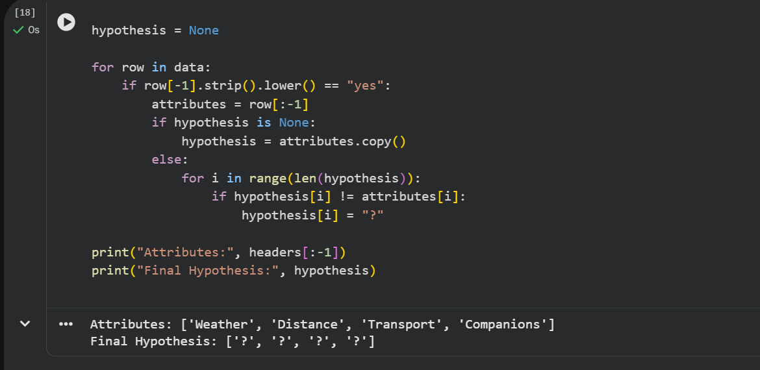

Result
Each attribute differs across the positive trip examples, so the final hypothesis has '?' for all attributes.

Problem 5: Choosing a Fitness Activity

Aim
To demonstrate FIND-S with a fitness-activity dataset in a separate CSV file and calculate the most specific hypothesis consistent with positive choices.

Procedure
- Create fitness_data.csv with the activity attributes and target labels.
- Keep the CSV and Python file in the same folder.
- Read the data and initialize the hypothesis from the first ChooseActivity = Yes row.
- Ignore No rows and replace differing values in positive examples with '?'.
- Display the final hypothesis.

Dataset File / Input
File name: fitness_data.csv
The CSV file contains a header row followed by these training examples:
Goal | Intensity | Location | Duration | ChooseActivity
Cardio | Moderate | Outdoor | 30min | Yes
Strength | High | Indoor | 45min | Yes
Flexibility | Low | Indoor | 20min | No
Cardio | High | Indoor | 30min | Yes

Code
import csv
filename = "fitness_data.csv"
with open(filename, "r", newline="", encoding="utf-8") as file:
reader = csv.reader(file)
headers = next(reader)
data = list(reader)
hypothesis = None
for row in data:
if row[-1].strip().lower() == "yes":
attributes = row[:-1]
if hypothesis is None:
hypothesis = attributes.copy()
else:
for i in range(len(hypothesis)):
if hypothesis[i] != attributes[i]:
hypothesis[i] = "?"
print("Attributes:", headers[:-1])
print("Final Hypothesis:", hypothesis)

Output
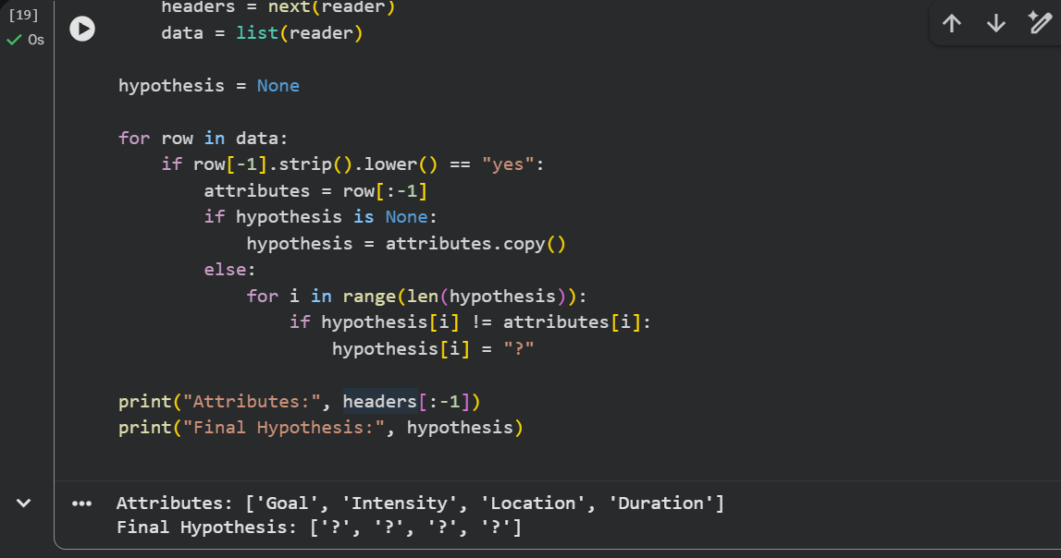

Result
All attributes vary across the positive choices, so the algorithm generalizes every attribute to '?'.

