EXPERIMENT-02
Candidate-Elimination Algorithm: Dataset-Based Python Programs
Name: MURE THEJASRI Reg.No: 192311298
- For a given set of training data examples stored in a .CSV file, implement and demonstrate the Candidate-Elimination algorithm in Python to output a description of the set of all hypotheses consistent with the training examples.

Problem 1: Enjoying Sport

Aim
To implement the Candidate-Elimination algorithm on a sport-related dataset stored in a CSV file and output the set of all hypotheses consistent with the training examples (the version space).

Procedure
- Save the training examples in sport_data.csv with the target class (Yes / No) in the last column.
- Run the Python program from the same folder as the CSV file.
- Read the CSV rows; initialize S with the first positive example and G with the all-'?' hypothesis.
- For a positive example, replace the attributes of S that differ with '?' and remove from G the hypotheses that do not cover the example.
- For a negative example, specialize every hypothesis in G that covers it using the values in S, and drop any hypothesis that is more general than another member of G.
- Print S and G after each example; the last line gives the final version space.

Dataset File / Input
File name: sport_data.csv
The CSV file contains a header row followed by these training examples:
Sky | AirTemp | Humidity | Wind | Water | Forecast | EnjoySport
Sunny | Warm | Normal | Strong | Warm | Same | Yes
Sunny | Warm | High | Strong | Warm | Same | Yes
Rainy | Cold | High | Strong | Warm | Change | No
Sunny | Warm | High | Strong | Cool | Change | Yes

Code
import csv

data = list(csv.reader(open("sport_data.csv")))[1:]
n = len(data[0]) - 1
S = data[0][:-1] # first example is positive
G = [["?"] * n]

for row in data:
x = row[:-1]
if row[-1] == "Yes":
S = [S[i] if S[i] == x[i] else "?" for i in range(n)]
G = [g for g in G if all(g[i] in ("?", x[i]) for i in range(n))]
else:
new = []
for g in G:
if all(g[i] in ("?", x[i]) for i in range(n)):
for i in range(n):
if g[i] == "?" and S[i] not in ("?", x[i]):
h = g.copy(); h[i] = S[i]; new.append(h)
else:
new.append(g)
G = [g for g in new if not any(t != g and all(t[i] in ('?', g[i]) for i in range(n)) for t in new)]
print("S =", S, " G =", G)

Output

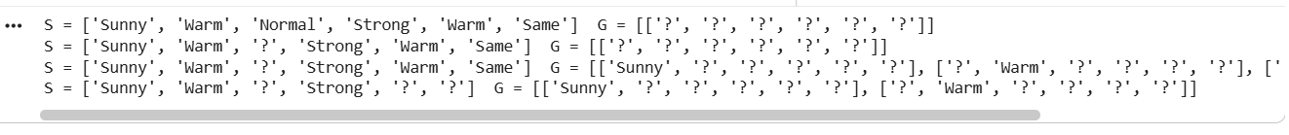

Result
The version space is bounded by S = ['Sunny', 'Warm', '?', 'Strong', '?', '?'] and G = {['Sunny', '?', '?', '?', '?', '?'], ['?', 'Warm', '?', '?', '?', '?']}. The six hypotheses lying between these boundaries are all consistent with the four training examples.

Problem 2: Choosing a Laptop

Aim
To apply the Candidate-Elimination algorithm to a laptop-selection dataset stored in a CSV file and find the specific and general boundaries of the version space.

Procedure
- Save the training examples in laptop_data.csv with the target class (Yes / No) in the last column.
- Run the Python program from the same folder as the CSV file.
- Read the CSV rows; initialize S with the first positive example and G with the all-'?' hypothesis.
- For a positive example, replace the attributes of S that differ with '?' and remove from G the hypotheses that do not cover the example.
- For a negative example, specialize every hypothesis in G that covers it using the values in S, and drop any hypothesis that is more general than another member of G.
- Print S and G after each example; the last line gives the final version space.

Dataset File / Input
File name: laptop_data.csv
The CSV file contains a header row followed by these training examples:
Budget | Weight | Battery | Purpose | Selected
High | Light | Long | Study | Yes
High | Light | Short | Work | Yes
Low | Heavy | Short | Gaming | No
Medium | Light | Long | Study | No
High | Light | Long | Work | Yes

Code
import csv

data = list(csv.reader(open("laptop_data.csv")))[1:]
n = len(data[0]) - 1
S = data[0][:-1] # first example is positive
G = [["?"] * n]

for row in data:
x = row[:-1]
if row[-1] == "Yes":
S = [S[i] if S[i] == x[i] else "?" for i in range(n)]
G = [g for g in G if all(g[i] in ("?", x[i]) for i in range(n))]
else:
new = []
for g in G:
if all(g[i] in ("?", x[i]) for i in range(n)):
for i in range(n):
if g[i] == "?" and S[i] not in ("?", x[i]):
h = g.copy(); h[i] = S[i]; new.append(h)
else:
new.append(g)
G = [g for g in new if not any(t != g and all(t[i] in ('?', g[i]) for i in range(n)) for t in new)]
print("S =", S, " G =", G)

Output

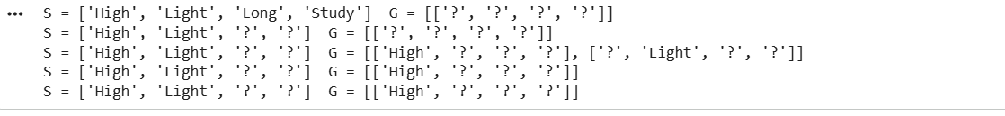

Result
The negative example (Medium, Light, Long, Study) removes ['?', 'Light', '?', '?'] from G, leaving S = ['High', 'Light', '?', '?'] and G = {['High', '?', '?', '?']}. Only two hypotheses remain consistent with the data.

Problem 3: Plant Growth

Aim
To use the Candidate-Elimination algorithm on a plant-growth dataset stored in a CSV file and determine all hypotheses consistent with the growing conditions observed.

Procedure
- Save the training examples in plant_data.csv with the target class (Yes / No) in the last column.
- Run the Python program from the same folder as the CSV file.
- Read the CSV rows; initialize S with the first positive example and G with the all-'?' hypothesis.
- For a positive example, replace the attributes of S that differ with '?' and remove from G the hypotheses that do not cover the example.
- For a negative example, specialize every hypothesis in G that covers it using the values in S, and drop any hypothesis that is more general than another member of G.
- Print S and G after each example; the last line gives the final version space.

Dataset File / Input
File name: plant_data.csv
The CSV file contains a header row followed by these training examples:
Soil | Sunlight | Watering | Season | PlantGrows
Loamy | Full | Moderate | Spring | Yes
Loamy | Partial | Moderate | Spring | Yes
Sandy | Full | Low | Summer | No
Clay | Partial | Frequent | Autumn | No
Loamy | Full | Moderate | Summer | Yes

Code
import csv

data = list(csv.reader(open("plant_data.csv")))[1:]
n = len(data[0]) - 1
S = data[0][:-1] # first example is positive
G = [["?"] * n]

for row in data:
x = row[:-1]
if row[-1] == "Yes":
S = [S[i] if S[i] == x[i] else "?" for i in range(n)]
G = [g for g in G if all(g[i] in ("?", x[i]) for i in range(n))]
else:
new = []
for g in G:
if all(g[i] in ("?", x[i]) for i in range(n)):
for i in range(n):
if g[i] == "?" and S[i] not in ("?", x[i]):
h = g.copy(); h[i] = S[i]; new.append(h)
else:
new.append(g)
G = [g for g in new if not any(t != g and all(t[i] in ('?', g[i]) for i in range(n)) for t in new)]
print("S =", S, " G =", G)

Output
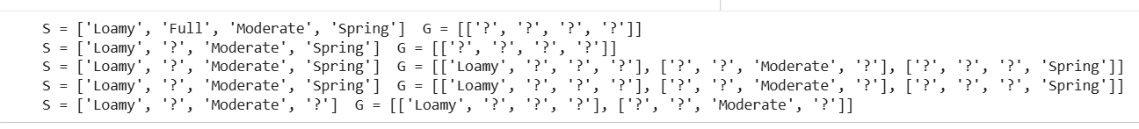

Result
The final boundaries are S = ['Loamy', '?', 'Moderate', '?'] and G = {['Loamy', '?', '?', '?'], ['?', '?', 'Moderate', '?']}. Three hypotheses are consistent: soil = Loamy, watering = Moderate, or both together.

Problem 4: Going on a Trip

Aim
To implement Candidate-Elimination on a travel-decision dataset stored in a CSV file and observe whether the version space converges to a single hypothesis.

Procedure
- Save the training examples in travel_data.csv with the target class (Yes / No) in the last column.
- Run the Python program from the same folder as the CSV file.
- Read the CSV rows; initialize S with the first positive example and G with the all-'?' hypothesis.
- For a positive example, replace the attributes of S that differ with '?' and remove from G the hypotheses that do not cover the example.
- For a negative example, specialize every hypothesis in G that covers it using the values in S, and drop any hypothesis that is more general than another member of G.
- Print S and G after each example; the last line gives the final version space.

Dataset File / Input
File name: travel_data.csv
The CSV file contains a header row followed by these training examples:
Weather | Distance | Transport | Companions | GoTrip
Clear | Short | Train | Friends | Yes
Clear | Long | Car | Friends | Yes
Stormy | Short | Bus | Alone | No
Clear | Short | Train | Family | No
Cloudy | Long | Car | Friends | Yes

Code
import csv

data = list(csv.reader(open("travel_data.csv")))[1:]
n = len(data[0]) - 1
S = data[0][:-1] # first example is positive
G = [["?"] * n]

for row in data:
x = row[:-1]
if row[-1] == "Yes":
S = [S[i] if S[i] == x[i] else "?" for i in range(n)]
G = [g for g in G if all(g[i] in ("?", x[i]) for i in range(n))]
else:
new = []
for g in G:
if all(g[i] in ("?", x[i]) for i in range(n)):
for i in range(n):
if g[i] == "?" and S[i] not in ("?", x[i]):
h = g.copy(); h[i] = S[i]; new.append(h)
else:
new.append(g)
G = [g for g in new if not any(t != g and all(t[i] in ('?', g[i]) for i in range(n)) for t in new)]
print("S =", S, " G =", G)

Output
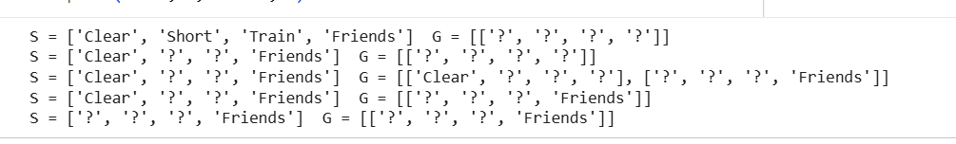

Result
The S and G boundaries converge to the same hypothesis, ['?', '?', '?', 'Friends']. The target concept is learned exactly: the trip is chosen whenever the person travels with friends.

Problem 5: Choosing a Fitness Activity

Aim
To apply the Candidate-Elimination algorithm to a fitness-activity dataset stored in a CSV file and output the complete set of consistent hypotheses.

Procedure
- Save the training examples in fitness_data.csv with the target class (Yes / No) in the last column.
- Run the Python program from the same folder as the CSV file.
- Read the CSV rows; initialize S with the first positive example and G with the all-'?' hypothesis.
- For a positive example, replace the attributes of S that differ with '?' and remove from G the hypotheses that do not cover the example.
- For a negative example, specialize every hypothesis in G that covers it using the values in S, and drop any hypothesis that is more general than another member of G.
- Print S and G after each example; the last line gives the final version space.

Dataset File / Input
File name: fitness_data.csv
The CSV file contains a header row followed by these training examples:
Goal | Intensity | Location | Duration | ChooseActivity
Cardio | Moderate | Outdoor | 30min | Yes
Cardio | High | Outdoor | 30min | Yes
Flexibility | Low | Indoor | 20min | No
Strength | Moderate | Indoor | 45min | No
Cardio | Moderate | Outdoor | 45min | Yes

Code
import csv

data = list(csv.reader(open("fitness_data.csv")))[1:]
n = len(data[0]) - 1
S = data[0][:-1] # first example is positive
G = [["?"] * n]

for row in data:
x = row[:-1]
if row[-1] == "Yes":
S = [S[i] if S[i] == x[i] else "?" for i in range(n)]
G = [g for g in G if all(g[i] in ("?", x[i]) for i in range(n))]
else:
new = []
for g in G:
if all(g[i] in ("?", x[i]) for i in range(n)):
for i in range(n):
if g[i] == "?" and S[i] not in ("?", x[i]):
h = g.copy(); h[i] = S[i]; new.append(h)
else:
new.append(g)
G = [g for g in new if not any(t != g and all(t[i] in ('?', g[i]) for i in range(n)) for t in new)]
print("S =", S, " G =", G)

Output
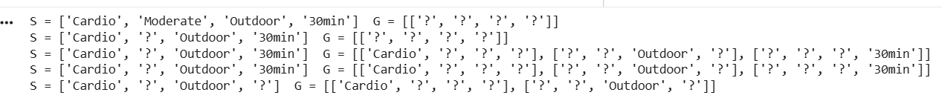

Result
The final boundaries are S = ['Cardio', '?', 'Outdoor', '?'] and G = {['Cardio', '?', '?', '?'], ['?', '?', 'Outdoor', '?']}. Three hypotheses are consistent with the five training examples.

