EXPERIMENT-04
Backpropagation Neural Network: Dataset-Based Python Programs
Name: MURE THEJASRI Reg.No: 192311298
- Build an Artificial Neural Network by implementing the Backpropagation algorithm and test the same using appropriate data sets.

Problem 1: XOR Gate

Aim
To build an Artificial Neural Network using the Backpropagation algorithm that learns the XOR function stored in a CSV file.

Procedure
- Save the training examples in xor_data.csv with numeric input attributes and the 0/1 target in the last column.
- Run the Python program from the same folder as the CSV file.
- Read the data, normalize the inputs, and initialize the weights randomly and the biases to zero.
- Forward pass: compute the hidden layer and the output using the sigmoid function.
- Backward pass: compute the output and hidden errors, then update the weights and biases (learning rate 0.5); repeat for 10000 epochs.
- Print the error during training, then compare the predicted outputs with the actual outputs and display the accuracy.

Dataset File / Input
File name: xor_data.csv
The CSV file contains a header row followed by these training examples:
Input1 | Input2 | Output
0 | 0 | 0
0 | 1 | 1
1 | 0 | 1
1 | 1 | 0

Code
import numpy as np
import pandas as pd

df = pd.read_csv("xor_data.csv")
X = df.iloc[:, :-1].values.astype(float)
y = df.iloc[:, -1].values.reshape(-1, 1)
X = X / X.max(axis=0) # normalize inputs

np.random.seed(1)
W1 = np.random.uniform(-1, 1, (X.shape[1], 4)) # input -> hidden weights
b1 = np.zeros((1, 4))
W2 = np.random.uniform(-1, 1, (4, 1)) # hidden -> output weights
b2 = np.zeros((1, 1))
sigmoid = lambda z: 1 / (1 + np.exp(-z))
lr = 0.5

for epoch in range(10001):
h = sigmoid(X @ W1 + b1) # forward pass
out = sigmoid(h @ W2 + b2)
d2 = (y - out) * out * (1 - out) # backward pass
d1 = (d2 @ W2.T) * h * (1 - h)
W2 += lr * h.T @ d2 / len(X)
b2 += lr * d2.mean(axis=0)
W1 += lr * X.T @ d1 / len(X)
b1 += lr * d1.mean(axis=0)
if epoch % 2000 == 0:
print("Epoch", epoch, "Error:", round(float(np.mean((y - out) ** 2)), 4))

print("Predicted:", out.round(3).ravel())
print("Actual :", y.ravel())
print("Accuracy :", (out.round() == y).mean() * 100, "%")

Output
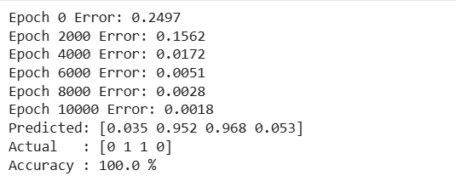

Result
The network (2 inputs, 4 hidden neurons, 1 output) learns the non-linear XOR function. The error falls from 0.2497 to 0.0018 over 10000 epochs, and the predictions (0.035, 0.952, 0.968, 0.053) round to the actual outputs 0, 1, 1, 0, giving 100% accuracy.

Problem 2: Student Pass Prediction

Aim
To train a backpropagation neural network to predict whether a student passes from study hours and sleep hours stored in a CSV file.

Procedure
- Save the training examples in studyhours_data.csv with numeric input attributes and the 0/1 target in the last column.
- Run the Python program from the same folder as the CSV file.
- Read the data, normalize the inputs, and initialize the weights randomly and the biases to zero.
- Forward pass: compute the hidden layer and the output using the sigmoid function.
- Backward pass: compute the output and hidden errors, then update the weights and biases (learning rate 0.5); repeat for 10000 epochs.
- Print the error during training, then compare the predicted outputs with the actual outputs and display the accuracy.

Dataset File / Input
File name: studyhours_data.csv
StudyHours | SleepHours | Pass
1 | 7 | 0
2 | 6 | 0
3 | 8 | 0
4 | 5 | 0
5 | 7 | 1
6 | 6 | 1
7 | 8 | 1
8 | 5 | 1
9 | 7 | 1
3 | 4 | 0
6 | 8 | 1
8 | 6 | 1
The CSV file contains a header row followed by these training examples:
Pass: 1 = Pass, 0 = Fail.

Code
import numpy as np
import pandas as pd

df = pd.read_csv("studyhours_data.csv")
X = df.iloc[:, :-1].values.astype(float)
y = df.iloc[:, -1].values.reshape(-1, 1)
X = X / X.max(axis=0) # normalize inputs

np.random.seed(1)
W1 = np.random.uniform(-1, 1, (X.shape[1], 4)) # input -> hidden weights
b1 = np.zeros((1, 4))
W2 = np.random.uniform(-1, 1, (4, 1)) # hidden -> output weights
b2 = np.zeros((1, 1))
sigmoid = lambda z: 1 / (1 + np.exp(-z))
lr = 0.5

for epoch in range(10001):
h = sigmoid(X @ W1 + b1) # forward pass
out = sigmoid(h @ W2 + b2)
d2 = (y - out) * out * (1 - out) # backward pass
d1 = (d2 @ W2.T) * h * (1 - h)
W2 += lr * h.T @ d2 / len(X)
b2 += lr * d2.mean(axis=0)
W1 += lr * X.T @ d1 / len(X)
b1 += lr * d1.mean(axis=0)
if epoch % 2000 == 0:
print("Epoch", epoch, "Error:", round(float(np.mean((y - out) ** 2)), 4))

print("Predicted:", out.round(3).ravel())
print("Actual :", y.ravel())
print("Accuracy :", (out.round() == y).mean() * 100, "%")

Output
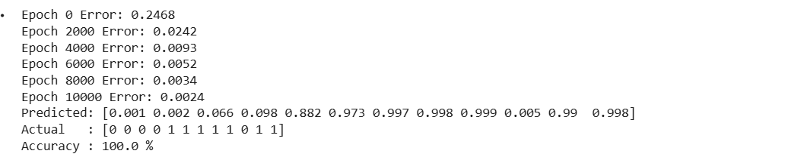

Result
The error falls from 0.2468 to 0.0024 during training. All 12 predictions round to the actual class, so the accuracy is 100%.

Problem 3: Diabetes Prediction

Aim
To train a backpropagation neural network to predict diabetes from glucose level and BMI stored in a CSV file.

Procedure
- Save the training examples in glucose_data.csv with numeric input attributes and the 0/1 target in the last column.
- Run the Python program from the same folder as the CSV file.
- Read the data, normalize the inputs, and initialize the weights randomly and the biases to zero.
- Forward pass: compute the hidden layer and the output using the sigmoid function.
- Backward pass: compute the output and hidden errors, then update the weights and biases (learning rate 0.5); repeat for 10000 epochs.
- Print the error during training, then compare the predicted outputs with the actual outputs and display the accuracy.

Dataset File / Input
File name: glucose_data.csv
The CSV file contains a header row followed by these training examples:
Glucose | BMI | Diabetic
85 | 22.5 | 0
92 | 24.1 | 0
110 | 26.0 | 0
100 | 23.4 | 0
120 | 27.5 | 0
130 | 31.2 | 1
150 | 33.5 | 1
145 | 29.8 | 1
165 | 35.2 | 1
140 | 32.0 | 1
105 | 25.3 | 0
155 | 30.1 | 1
90 | 28.0 | 0
175 | 36.8 | 1
Diabetic: 1 = Yes, 0 = No.

Code
import numpy as np
import pandas as pd

df = pd.read_csv("glucose_data.csv")
X = df.iloc[:, :-1].values.astype(float)
y = df.iloc[:, -1].values.reshape(-1, 1)
X = X / X.max(axis=0) # normalize inputs

np.random.seed(1)
W1 = np.random.uniform(-1, 1, (X.shape[1], 4)) # input -> hidden weights
b1 = np.zeros((1, 4))
W2 = np.random.uniform(-1, 1, (4, 1)) # hidden -> output weights
b2 = np.zeros((1, 1))
sigmoid = lambda z: 1 / (1 + np.exp(-z))
lr = 0.5

for epoch in range(10001):
h = sigmoid(X @ W1 + b1) # forward pass
out = sigmoid(h @ W2 + b2)
d2 = (y - out) * out * (1 - out) # backward pass
d1 = (d2 @ W2.T) * h * (1 - h)
W2 += lr * h.T @ d2 / len(X)
b2 += lr * d2.mean(axis=0)
W1 += lr * X.T @ d1 / len(X)
b1 += lr * d1.mean(axis=0)
if epoch % 2000 == 0:
print("Epoch", epoch, "Error:", round(float(np.mean((y - out) ** 2)), 4))

print("Predicted:", out.round(3).ravel())
print("Actual :", y.ravel())
print("Accuracy :", (out.round() == y).mean() * 100, "%")

Output
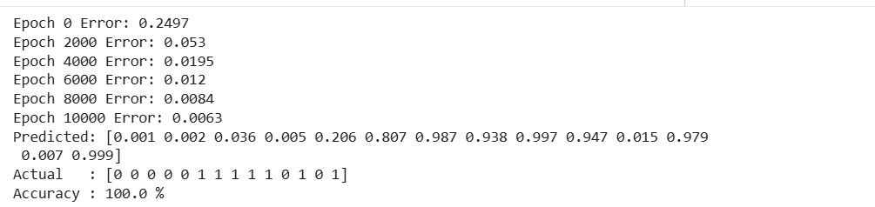

Result
The error falls from 0.2497 to 0.0063. All 14 predictions round to the actual class, so the accuracy is 100%; the least confident prediction is 0.206 for a sample whose actual class is 0.

Problem 4: Loan Approval

Aim
To train a backpropagation neural network to predict loan approval from income and credit score stored in a CSV file.

Procedure
- Save the training examples in loan_data.csv with numeric input attributes and the 0/1 target in the last column.
- Run the Python program from the same folder as the CSV file.
- Read the data, normalize the inputs, and initialize the weights randomly and the biases to zero.
- Forward pass: compute the hidden layer and the output using the sigmoid function.
- Backward pass: compute the output and hidden errors, then update the weights and biases (learning rate 0.5); repeat for 10000 epochs.
- Print the error during training, then compare the predicted outputs with the actual outputs and display the accuracy.

Dataset File / Input
File name: loan_data.csv
The CSV file contains a header row followed by these training examples:
Income | CreditScore | Approved
25 | 550 | 0
30 | 600 | 0
45 | 650 | 1
60 | 700 | 1
80 | 750 | 1
35 | 580 | 0
55 | 680 | 1
70 | 720 | 1
28 | 520 | 0
90 | 780 | 1
40 | 630 | 0
65 | 710 | 1
Approved: 1 = Yes, 0 = No.

Code
import numpy as np
import pandas as pd

df = pd.read_csv("loan_data.csv")
X = df.iloc[:, :-1].values.astype(float)
y = df.iloc[:, -1].values.reshape(-1, 1)
X = X / X.max(axis=0) # normalize inputs

np.random.seed(1)
W1 = np.random.uniform(-1, 1, (X.shape[1], 4)) # input -> hidden weights
b1 = np.zeros((1, 4))
W2 = np.random.uniform(-1, 1, (4, 1)) # hidden -> output weights
b2 = np.zeros((1, 1))
sigmoid = lambda z: 1 / (1 + np.exp(-z))
lr = 0.5

for epoch in range(10001):
h = sigmoid(X @ W1 + b1) # forward pass
out = sigmoid(h @ W2 + b2)
d2 = (y - out) * out * (1 - out) # backward pass
d1 = (d2 @ W2.T) * h * (1 - h)
W2 += lr * h.T @ d2 / len(X)
b2 += lr * d2.mean(axis=0)
W1 += lr * X.T @ d1 / len(X)
b1 += lr * d1.mean(axis=0)
if epoch % 2000 == 0:
print("Epoch", epoch, "Error:", round(float(np.mean((y - out) ** 2)), 4))

print("Predicted:", out.round(3).ravel())
print("Actual :", y.ravel())
print("Accuracy :", (out.round() == y).mean() * 100, "%")

Output
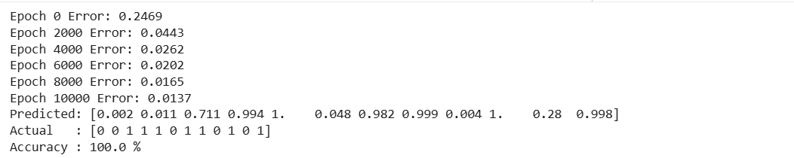

Result
The error falls from 0.2469 to 0.0137. All 12 predictions round to the actual class, so the accuracy is 100%; the borderline applicants (0.711 and 0.28) are the least confident predictions.

Problem 5: Flower Classification

Aim
To train a backpropagation neural network to classify flowers as Setosa or Versicolor from petal measurements stored in a CSV file.

Procedure
- Save the training examples in flower_data.csv with numeric input attributes and the 0/1 target in the last column.
- Run the Python program from the same folder as the CSV file.
- Read the data, normalize the inputs, and initialize the weights randomly and the biases to zero.
- Forward pass: compute the hidden layer and the output using the sigmoid function.
- Backward pass: compute the output and hidden errors, then update the weights and biases (learning rate 0.5); repeat for 10000 epochs.
- Print the error during training, then compare the predicted outputs with the actual outputs and display the accuracy.

Dataset File / Input
File name: flower_data.csv
The CSV file contains a header row followed by these training examples:
PetalLength | PetalWidth | Species
1.4 | 0.2 | 0
1.3 | 0.2 | 0
1.5 | 0.2 | 0
1.7 | 0.4 | 0
1.4 | 0.3 | 0
4.7 | 1.4 | 1
4.5 | 1.5 | 1
4.9 | 1.5 | 1
4.0 | 1.3 | 1
4.6 | 1.5 | 1
3.9 | 1.1 | 1
1.6 | 0.2 | 0
Species: 0 = Setosa, 1 = Versicolor.

Code
import numpy as np
import pandas as pd

df = pd.read_csv("flower_data.csv")
X = df.iloc[:, :-1].values.astype(float)
y = df.iloc[:, -1].values.reshape(-1, 1)
X = X / X.max(axis=0) # normalize inputs

np.random.seed(1)
W1 = np.random.uniform(-1, 1, (X.shape[1], 4)) # input -> hidden weights
b1 = np.zeros((1, 4))
W2 = np.random.uniform(-1, 1, (4, 1)) # hidden -> output weights
b2 = np.zeros((1, 1))
sigmoid = lambda z: 1 / (1 + np.exp(-z))
lr = 0.5

for epoch in range(10001):
h = sigmoid(X @ W1 + b1) # forward pass
out = sigmoid(h @ W2 + b2)
d2 = (y - out) * out * (1 - out) # backward pass
d1 = (d2 @ W2.T) * h * (1 - h)
W2 += lr * h.T @ d2 / len(X)
b2 += lr * d2.mean(axis=0)
W1 += lr * X.T @ d1 / len(X)
b1 += lr * d1.mean(axis=0)
if epoch % 2000 == 0:
print("Epoch", epoch, "Error:", round(float(np.mean((y - out) ** 2)), 4))

print("Predicted:", out.round(3).ravel())
print("Actual :", y.ravel())
print("Accuracy :", (out.round() == y).mean() * 100, "%")

Output
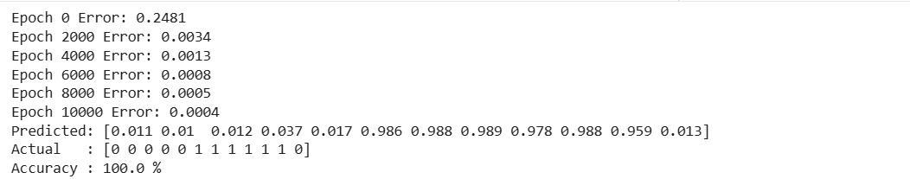

Result
The error falls from 0.2481 to 0.0004, the lowest of the five problems because the two classes are well separated. All 12 predictions round to the actual class, so the accuracy is 100%.

