ASSEMBLY STEPS

1. FILE->NEW PROJECT->VISUALC#-> CLASSLIBRARY.

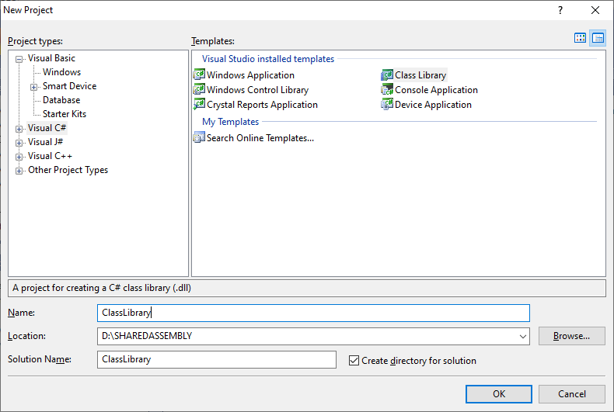

FOR THIS GIVE NAME AS **CLASSLIBRARY** AND RENAME THE CLASS AS **STRINGOPERATIONS.CS.**AND WRITE THE RELATED PROGRAM…

(Change the name and give the location in exam it is **D** drive...... For convenience create a folder in Ddrive named assembly, sharedassembly…as you wish make a note while giving name to created folder make sure that no space is given or else it would lead to an error…..in that folder you can 3 files **CLASSLIBRARY,MYLIBRARAYCLIENT,MYLIBRARYVBCLIENT**).

2. FILE->NEW PROJECT->VISUALC#-> CONSOLE APPLICATION.

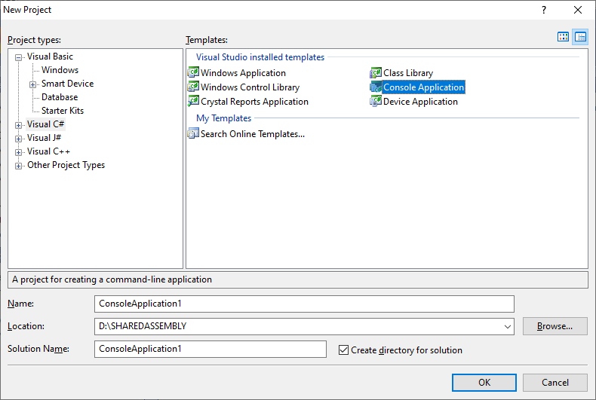

FOR THIS GIVE NAME AS **MYLIBRARYCLIENT** AND THE CLASS IS **PROGRAM.CS.**AND WRITE THE RELATED PROGRAM…

3. FILE->NEW PROJECT->VISUAL BASIC->CONSOLE APPLICATION.

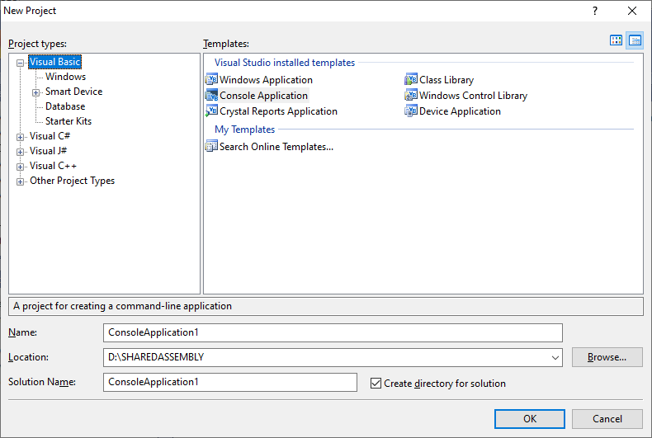

FOR THIS GIVE NAME AS **MYLIBRARYVBCLIENT** AND WRITE CODE IN **MODULE.VB.**AND WRITE THE RELATED PROGRAM…

**[MINIMIZE ALL THE PROJECTS].**

4. START->MICROSOFT VISUAL STUDIO COMMAND PROMPT->RIGHT CLICK->RUN AS ADMINISTRATOR -> GIVE THE SYSTEM NUMBER(MSC-COMP-**\MR[WINDOWS 7]) **OR** (MSC-COMP-**\USER[WINDOWS 10]).

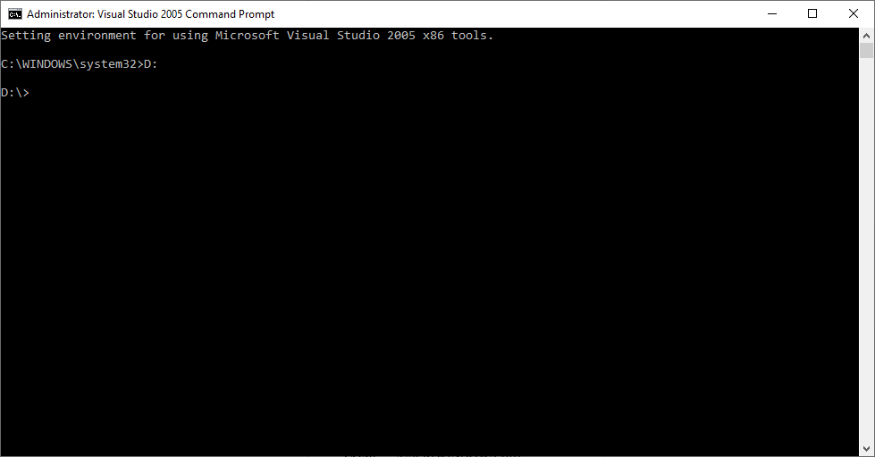

C:\WINDOWS\system32>D:

D:\>sn -k mykeyfile.snk (press enter)

[Key file will be generated].

5. GO TO **CLASSLIBRARY ->**PROPERTIES->CLICK ON **+** SYMBOL

->CLICK ON **assemblyinfo.cs.**

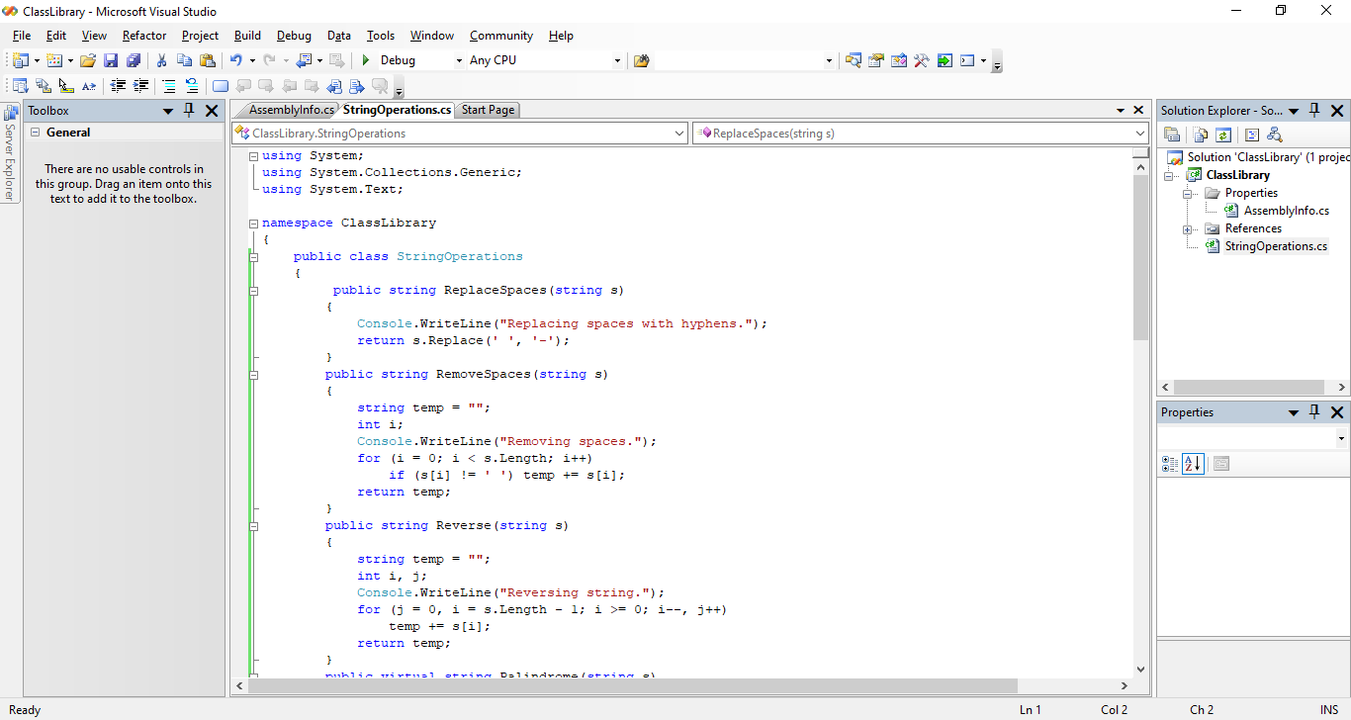

AT THE END OF **ASSEMBLYINFO.CS**->

WRITE-> [assembly:AssemblyKeyFile("d:/mykeyfile.snk")]

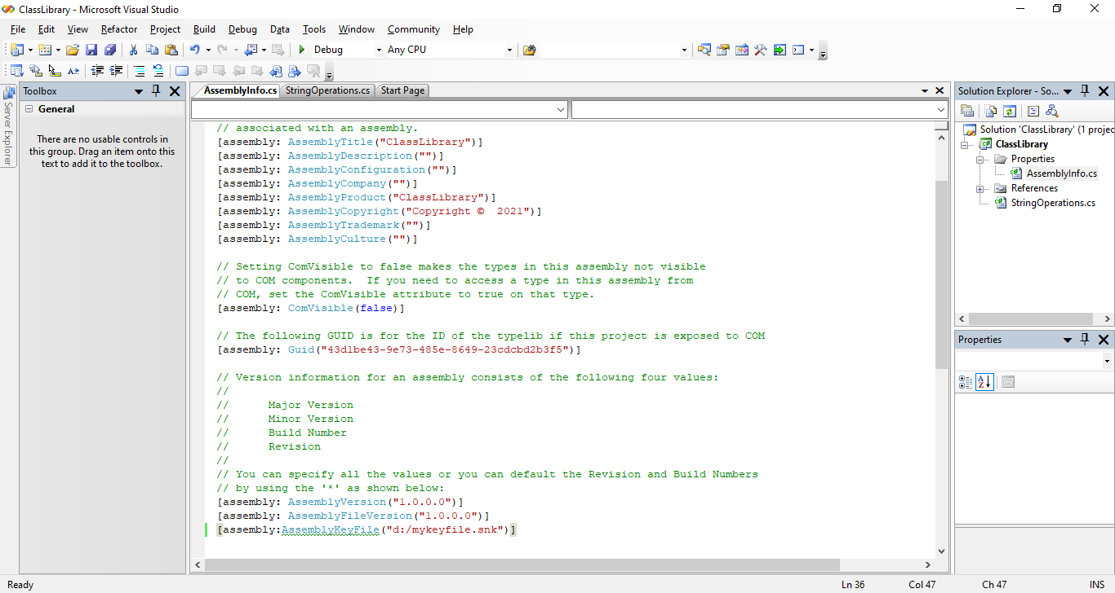

THEN RIGHT CLICK ON **CLASSLIBRARY ->**BUILD (IF ANY ERROR SOLVE)

6. GO TO VISUAL STUDIO COMMAND PROMPT AGAIN AND WRITE…

D:\>**gacutil –i <path of .dll file>\<name of .dll file>.**

Eg: **D:\>gacutil -i D:\SHAREDASSEMBLY\ClassLibrary\ClassLibrary\bin\Debug\ClassLibrary.dll**

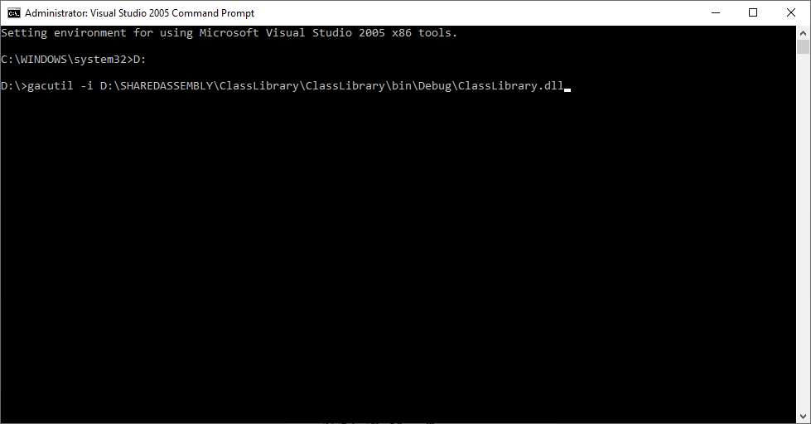

NEXT PRESS ENTER ->**ASSEMBLY SUCESSFULLY ADDED INTO CACHE.** [MESSAGE SHOULD BE PRINTED].

7. GO TO **MYLIBRARYVBCLIENT->** RIGHT CLICK ON **MYLIBRARYVBCLIENT** WHICH IS AT SOLUTION EXPLORER->ADD REFERENCE->BROWSE->D DRIVE-> SAP (folder name) -> CLASSLIBRARY-> CLASSLIBRARY-> BIN->DEBUG-> CLASSLIBRARY.DLL (dll file name)(double click on it)(reference is added now).

NOW AT TOP ADD IMPORTS CLASSLIBRARY.

8. DEBUG **MYLIBRARYVBCLIENT.**

9.GO TO **MYLIBRARYCLIENT->** RIGHT CLICK ON **MYLIBRARYCLIENT** WHICH IS AT SOLUTION EXPLORER->ADD REFERENCE->BROWSE->D DRIVE-> SAP (folder name) -> CLASSLIBRARY-> CLASSLIBRARY-> BIN->DEBUG-> CLASSLIBRARY.DLL (dll file name)(double click on it)(reference is added now).

AT TOP ADD **USING CLASSLIBRARY;**

10. DEBUG **MYLIBRARYCLIENT.**

**************END****************