Name:- thejas
Srn :- pes1ug24am306

Se lab
Req id | type | description | priorty | Acceptance criteria | rationale
Fr-001 | Functional | The system shall recommend alumni mentors to students based on domain, skills, interests, experience, and mentorship preferences, and shall allow students to view matched mentor profiles | High |  | Intelligent matching reduces the effort students spend searching for suitable alumni and improves mentorship relevance.
  Pass: At least three relevant mentors are recommended when matching mentors are available, with domain relevance visible. Fail: Students are shown mentors with no relevant domain/skill match without justification.
Fr-002 | Functional | The system shall allow students to view a mentor's available time slots and book an available mentorship or mock-interview session. | High | Pass: A selected available slot is reserved and the session is added to the student's and mentor's calendars with a meeting link. Fail: The same slot can be booked by two students
  Calendar-based booking provides a convenient scheduling mechanism and prevents mentor double-booking.
Fr-003 | Functional | the system shall allow students and mentors to view, confirm, reschedule, or cancel upcoming sessions and shall send notifications for booking-related events. | Medium
  Pass: Booking, cancellation, and rescheduling generate notifications and update both users' schedules. Fail: A user sees outdated session information after a successful change.
  Session changes must remain synchronized so that both participants have accurate schedules.
Fr-004 | Functional |  | High
  The system shall allow mentors to record structured post-interview feedback using a scorecard containing criteria such as technical knowledge, communication, problem-solving, and overall performance.
  Pass: A mentor can submit a completed scorecard and the student can view the permitted feedback afterward. Fail: A submitted scorecard is lost, incomplete without required fields, or visible to unauthorized users.
  Structured feedback makes mock interviews measurable and gives students actionable improvement areas.
Fr-005 | Functional |  | Medium | Pass: Completed sessions and associated feedback are displayed chronologically to the authorized student. Fail: Unrelated students can access another student's session history or scorecards.
  The system shall maintain a student's completed mentorship/interview history and allow students to review previous feedback and session outcomes.
  Maintaining history enables students to track progress across multiple mentorship sessions.
Nfr-001 | Non functional | The system shall provide mentor search, matching, and availability results within 2 seconds for at least 95% of requests under the expected peak concurrent-user load. | High
  Pass: Load testing demonstrates that at least 95% of matching and availability requests complete within 2 seconds under simulated peak load. Fail: The 95th-percentile response time exceeds 2 seconds.
  Fast responses are essential for a smooth booking experience, especially during high-demand periods such as placement and recruitment seasons.
Nfr-002 | Non functional |  | High | Pass: Security testing confirms that students can access only authorized information, mentors can access only permitted mentee/session information, and approved deletion requests result in soft-deletion within 24 hours. Fail: Unauthorized data access occurs or deletion exceeds the specified timeframe.
  The system shall maintain a student's completed mentorship/interview history and allow students to review previous feedback and session outcomes.
  Mentorship profiles and interview feedback contain personal and potentially sensitive academic information, requiring controlled access and privacy protection.

Uml diagram
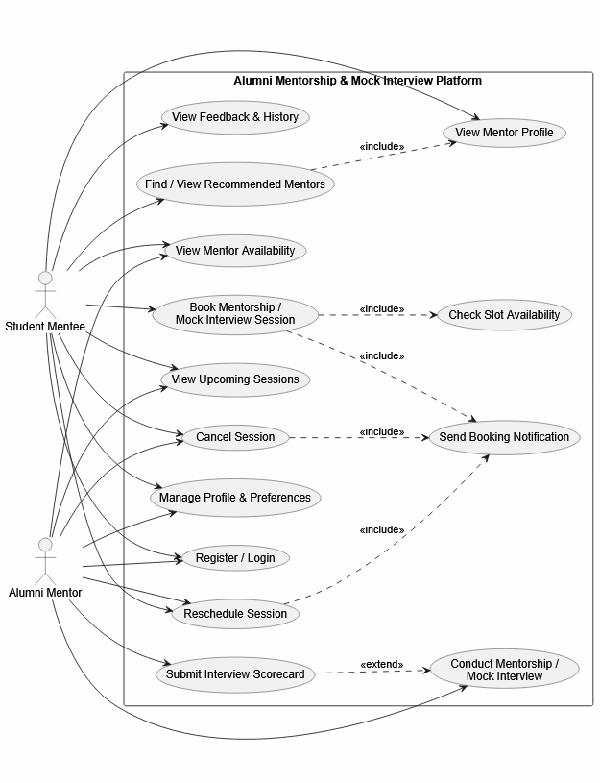

Use-Case Flow Specification

Use Case: Book Mentorship / Mock Interview Session
Use Case ID: UC-06
Primary Actor: Student Mentee
Supporting Actor: Alumni Mentor
Goal: Allow a student to book an available mentorship or mock-interview slot with a selected alumni mentor.

Preconditions
- The student is registered and successfully logged into the platform.
- The student has selected or been recommended an alumni mentor.
- The mentor has configured their available time slots.
- The student has access to the mentor's availability calendar.
- The mentor's account is active and eligible to receive bookings.

Postconditions
Success:
- A mentorship/mock-interview session is created.
- The selected time slot is marked unavailable.
- The session appears on both the student's and mentor's calendars.
- A meeting link is associated with the session.
- Both participants receive a booking confirmation.
Failure:
- No session is created.
- The selected slot remains available if booking was unsuccessful.
- The student receives an appropriate error message.

Main Success Scenario
- The student logs into the platform.
- The student searches for or selects a recommended alumni mentor.
- The system displays the mentor's profile, domain expertise, and available time slots.
- The student selects a suitable date and time.
- The system checks whether the selected slot is still available.
- The system temporarily reserves the selected slot.
- The student selects the session type, such as Mentorship or Mock Interview, and confirms the booking.
- The system creates the session and generates/associates a meeting link.
- The system marks the selected mentor slot as unavailable.
- The system adds the session to the student's and mentor's calendars.
- The system sends booking confirmation notifications to both participants.
- The system displays the confirmed session details to the student.

Alternate Flow: Selected Slot Becomes Unavailable
A1. At Step 5, the system determines that another student has already booked the selected slot.
A2. The system rejects the booking request and does not create a session.
A3. The system informs the student that the selected slot is no longer available.
A4. The system displays the mentor's currently available alternative slots.
A5. The student selects another available slot and returns to the booking confirmation step.
Expected Result: No double-booking occurs, and the student can successfully select another available time.

