Day-1 Basics
Operators
Operation: it is a task or an action that is performed on values based on the operators used.
Operands: it is a values on which the operations are performed.
Operators: It is a special characters (symbols) or keywords that is in-built functionality based on which the task is performed on values.
Expression: A statement that performers an operation
Eg:- 10/2, 5*8
Operation: Multiplication
Operands: 5,8
Operators: *
Expression: 5*8
There are 7 types of operators
- Arithmetic Op:
- Relational / Comparison Op:
- Logical op:
- Bitwise Op:
- Assignment Op:
- Membership Op:
- Identity Op:
Arithmetic Op:
- It is used to perform mathematical operations on num(dec and non-dec).
- Types: +, -, *, **[Exponentiation], // [Floor Div], /[Float div], %[Modulo].

- +: operator
- When used with a min of 2 num it performs addition.
- When used with a single num, it represents “+ve num”
- Eg:-
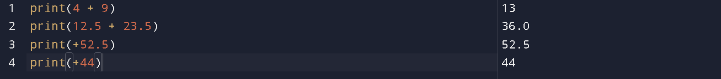

- -: operator
- When used with a min of 2 num it performs Subtraction.
- When used with a single num, it represents “-ve num”
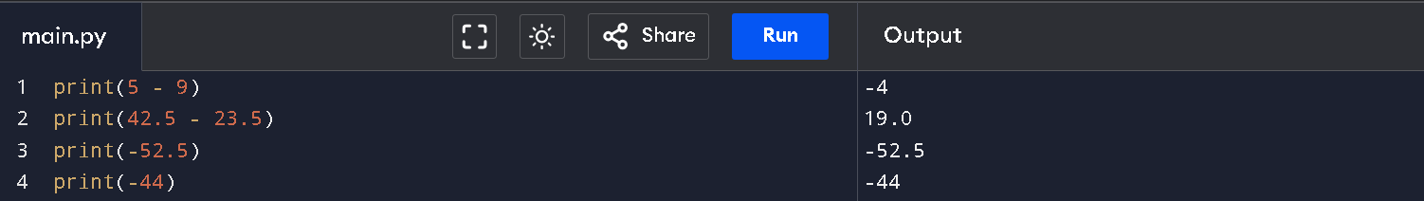

- *: operator
- Compulsory used with 2 num; it performs Multiplication
- When it is used with a single num, it throws an error.
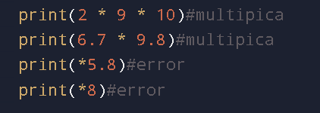

- **[Exponentiation]: operator
- It returns the exponent value of the provided 2 num.

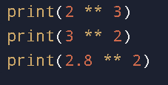

- Division operator:
- // [Floor Div]:
- When we want a non-decimal quotient we use // op
- / [Float Div]:
- When we want a decimal quotient we use / op
- %[modulo]:
- When ever the numerator is greater than the denominator the answer will the numerator.
- We % op to get reminder only

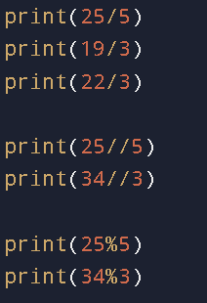

Day-2
2. Relational Operators:
- It is used when there is a need to compare the given “n” values or to find any kind of relativity between the values.
- It returns a Boolean value (True-1 or False-0)
- It can be used on Boolean Condition:
a. Direct value or variable holding value.
b. Boolean Value or anything that represents the Boolean value.
c. An Expression that returns a Boolean value.
- Types of Relational operators are (>, <, >=, <=, ==, !=)

3. Logical Operators:
- It is used to combine and check multiple Boolean conditions.
- It returns a Boolean value or anything that represents the Boolean value
- It can be used on Boolean conditions:
a. Direct value or variable holding value.
b. Boolean Value or anything that represents a Boolean value.
c. An Expression that returns a value.
- Types of Logical Operators are (and, or, not)

Note: Anything that represents a Boolean value: Any other value/number apart from [0 or None or “”] is considered to be True.

Logical Not (Inversion)
- It requires only one single operand to perform the operation.
- It returns only Boolean values.

. True, False, None
- They are a special kind of keywords, because unlike the other keywords, they hold “built-in” values.
- These are the only 3 keywords that initially start with uppercase.

4. Bitwise Operator:
- Bitwise and (&)
- Bitwise or (|)
- Bitwise not / Complement / Negation (~) -> requires only a single operand
- Bitwise xor (^)
- Bitwise left Shift (<<)
- Bitwise right shift (>>)
- Bitwise unsigned right shift (>>>)
5. Assignment Operator:
- It helps to assign(Initialize) and re-assign(re-Initialize) and copy a value present in one variable to another variable
- It does not return any value
- Syntax:-
Var_name = value
Var_name = Initialized_var_name
Var_name = (expression)

Day-3
Variables
- It is a named memory location that holds single valued data
- It is a container that holds a value
- Note:
  - In Python, every variable should follow 2 steps: 1. Initialization 2. Utilization
  - It is compulsory to initialize a variable before utilization
- If we try to store the same value into multiple different variables, then internally PVM will provide one single shared memory location to all the variables
- [PVM]: it is a Python virtual machine that reads the Python code and returns an o/p based on the provided instruction through code
- If we try to re-initialise a variable that is already pointing to a shared memory loc then PVM will assign a new memory to it
- If we try to store different values one after the other into the variable, then
  - Internally, a new memory keeps getting provided for each value
  - The variable will hold the latest updated value
- If we try to store multiple values into the same variable at the same time, then PVM will convert it into a tuple, and the tuple's address will get held by the variable, making it a reference variable.

- Id: It is a unique integer representation assigned by the PVM during execution time based on the value stored and memory allocated.

- Id Function or id(): It is a predefined function that returns the id of the value passed

- Type function or type(): It is a predefined function that returns the data type of the value passed.

Varieties of Assignment operators / Compound statements:
- The combination of Arithmetic / Bitwise operator with assignment operator is said to be compound stat
- In such a statement first the Arithmetic / Bitwise operator occurs first at the last assignment will happen
- Arithmetic + Assignment: +=, -=, *=, **=, //=, %=
- Bitwise +Assignment: &=, |, ^=, <<=, >>=, >>>=
- Whenever the operand used on RHS of the operation and LHS side for updating are the same
- The same operand should be present on the LHS and RHS of the operation.
- Minimum of 2 operands are required tp replace the operation with compound statements
- The expression can include constants, but a minimum of a single variable, which same on the RHS for the operation and the LHS for the updating
Membership Operators: [in, not in]
- Returns a Boolean Value
- Syntax: -
Value / inerrable object in inerrable object / group of elements
- It helps to check whether a value is present in a group or not.
- It does not support single object data
- It can be used only on iterrable object and group of values.
- Iterrable Object: An object that can hold multiple individual elements into the same shared memory location.
  - Eg: - list, tuple, dict, sets, string

Day-3
Identity Operator

Control Flow Statements
- It controls the execution flow of the program
- Types: -
  - 1. Conditional Statements
    - Simple “if” condition
    - “if-else” condition
    - “elif” ladder / “if-else-if” condition
    - Shorthand “if”

- Note: “nested-if” is the combined form of other conditional statements.

  - 2. Looping statements
    - For loop
      - For with range():- increment and decrement loop
      - For without range()
    - While Loop: - increment and decrement loop
  - 3. Jumping statements:
    - Break
    - Continue
    - Return

Day-4
Looping Concepts
Range(): It is a predefined function that can set up a user-defined sequence of values. But internally, it cannot return a sequence of numbers together. Therefore, a “for” loop is used with range() to access each value individually.
Without range():
Syntax:
For var_name in group_of_elements/data structure
#logic
# remaining statements
- The inputs can only be given as an iterable object or a group of elements segregated by a comma
- The cursor moves only in the forward direction, meaning it doesn’t implement increment or decrement orders
- We can pass direct values of any data type
- Even an empty iterrable object or even a single space is valid, but a “single-valued data” is not accepted
Allocate the separate block of memory The PVM allocate the Separate bloc of memory With on Vitan memory address Aperia Allocate the separate block of memory With With an memory address Second step a baby Start searching for innit constructor PDM starts searching for unique constructor Once it found Once it Allocate the Variable Variable Values And my thoughts Inner memory In a memory 3rd step is The reference variable Stored in Reference variable The address of an object stored in a reference variable at a point The address of an object The address of an object Stored in Reference

Day-5
Break: It is a keyword that instructs the PVM to exit the current executing loop in which it is present.

Continue: It is a keyword that instructs the PVM to skip the current executing loop in which it is present

Function
- It is an independent block of code that includes logic which is executed only when it is called.
- A Function is built only to perform a specific task.
  - Syn: -
Def fun_name (parameters):
#logic
Return val/val’s
Var_name = fun_name(Arguments)
- Def it is a keyword that helps to define a block of code.
- Fun_name It is decided based on the action to be performed
- Parameters The input required by a function to perform an action.
- Returnit is a keyword that instructs the PVM to take back the execution flow from called function back to the function call.
  - It can help to return a value or values from the called function back to the function call.
  - It is the last executable line of code within a function, i.e., once a “return” statement is executed, then no other line of code within that function works.
- Argument The value that is passed to a function to perform an action during a function call
- The order of arguments should match the order of parameters; if not, there can be unexpected output.
Day- 8

