App Development Project Report
Trekking Management Application — MAD 1

1. Student Details
Name: Thejashwini M
Roll Number: 23f1000787
Email: 23f1000787@ds.study.iitm.ac.in
About Me: I am an Electronics and Communication Engineering student with a strong interest in software development, IoT, and full-stack web application development. I chose this Trekking Management Application project to strengthen my understanding of Flask, Vue.js, databases, and backend technologies such as Redis and Celery while gaining hands-on experience in building a role-based web application. Working on this project has helped me improve my skills in designing scalable applications, database management, and implementing real-world features.

2. Project Details

Project Title
Trekking Management Application

Problem Statement
Adventure organizations require efficient systems to manage trekking activities involving trek organizers, staff, and participants. Currently, many trekking groups rely on spreadsheets, phone calls, or manual coordination, which makes it difficult to manage trek approvals, track bookings, avoid overbooking, and maintain trek history. This is a Trekking Management Application web application that allows Admin, Trek Staff, and Users (Trekkers) to interact with the system based on their roles.

Approach
I built this as a single Flask application using Jinja2 templates, Bootstrap 5, and SQLite, without any JavaScript for the core flow, exactly as the assignment specifies. There's one User table with a role column (admin / staff / user) that covers login and access for all three kinds of accounts, so a single login form works for everyone and each view simply checks session["role"] before rendering. I self-register both Trek Staff and Users, but a new staff account stays Pending until the Admin approves it, which keeps unverified staff out of the system until someone has vetted them. Every rule that actually matters — no double-booking, no booking a closed or full trek, only the assigned staff member can manage a given trek — is checked inside the route handler in app.py, not just hidden by disabling a button in the template. Once the booking flow, admin approvals, and staff assignment were all working end to end, I added the smaller touches: the admin/staff/user dashboards with live counts, a shared search page for the Admin, and the automatic cascade that marks all bookings on a trek Completed once the trek itself is marked Completed.

3. AI/LLM Declaration
I used AI assistance for around 20–25% of the development, mainly for solving complex problems, understanding a few new concepts, and debugging, not for generating the project wholesale. It helped with guidance and brainstorming when I got stuck, but all the actual code and logic were written and implemented by me hands-on, so I understand the project fully and can explain any part of it.

4. Frameworks and Libraries Used
Technology / Library | Why I used it
Flask | The only backend framework used — handles routing, sessions, and rendering for every page
Flask-SQLAlchemy | ORM layer over SQLite for the User, Trek and Booking models, and for creating the tables programmatically
SQLite | The project's database, as required — a single trekking.db file created at first run
Jinja2 | Server-side templating for every page — template inheritance via base.html, conditional rendering by role
Bootstrap 5 | The only CSS framework used, for a clean, responsive layout without writing a large custom stylesheet
Bootstrap Icons | Small icon set used in the nav bar and buttons
No JavaScript is used anywhere in the core flow — every interaction is a plain form submission or a link, handled entirely by Flask and re-rendered with Jinja2, per the project's requirement.

5. Database Schema / ER Diagram
The database has three tables, matching the Trek, Booking, and Staff/User entities described in the problem statement:
- users (id, name, email, password, contact, role, status) — one shared table for the Admin, Trek Staff, and User accounts, separated by the role column. status tracks Pending / Approved / Blacklisted for staff, and Approved / Blacklisted for users.
- treks (id, name, location, difficulty, duration, available_slots, staff_id, status, start_date, end_date, description) — staff_id is a foreign key to users, and stays empty until the Admin assigns a staff member.
- bookings (id, user_id, trek_id, booking_date, status) — user_id and trek_id are foreign keys back to users and treks.
Relationships: one User (staff) can be linked to many Treks through staff_id. One User (trekker) can have many Bookings through user_id. One Trek can have many Bookings through trek_id, up to its available_slots.
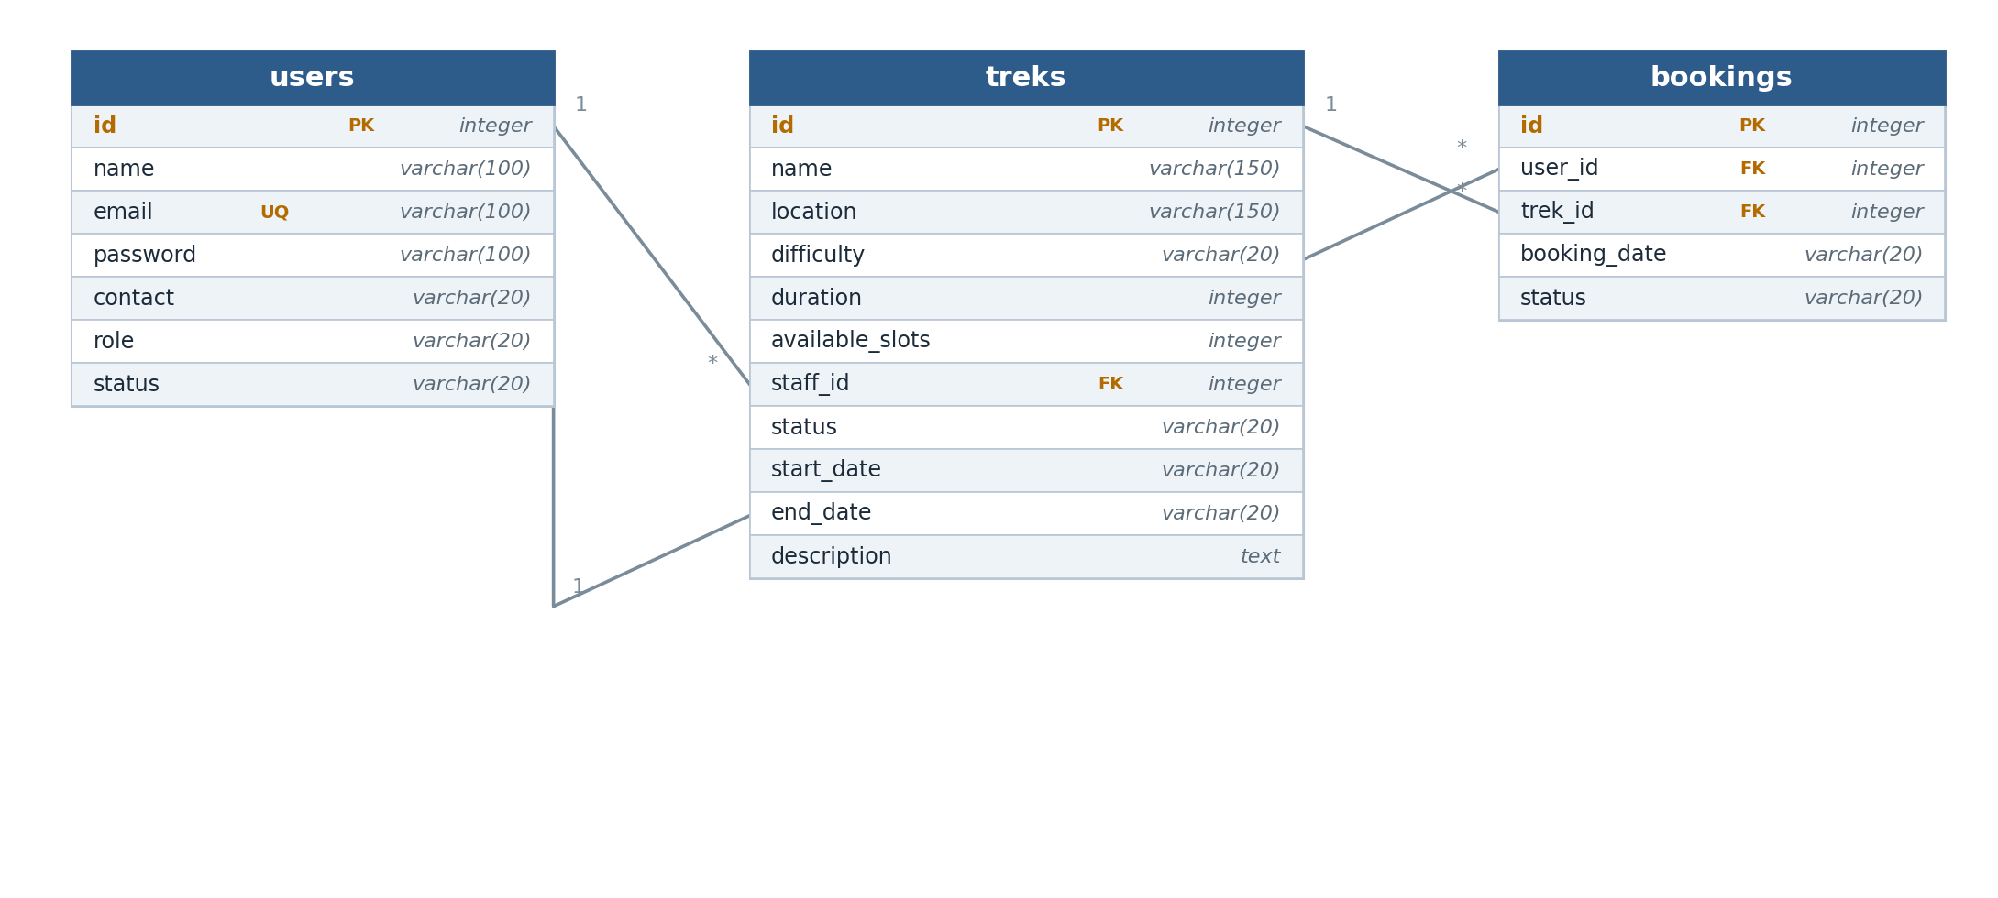
Figure 1: ER diagram of the users, treks and bookings tables

6. API Resource Endpoints
This project doesn't expose a separate JSON API — per the mandatory frameworks, everything is server-rendered through Flask + Jinja2, and every 'endpoint' is a normal page route that either shows a template or handles a form POST and redirects. The main routes are grouped below by role.
Route | Method | Description
/login | GET, POST | Login form for Admin, Staff, and Users
/register | GET, POST | Self-registration for Trek Staff and Users
/logout | GET | Clears the session
/admin/dashboard | GET | Admin's live counts and recent bookings
/admin/treks | GET | List all treks
/admin/treks/add | GET, POST | Create a new trek
/admin/treks/edit/<id> | GET, POST | Edit a trek, e.g. assign staff or change status
/admin/treks/delete/<id> | GET | Delete a trek
/admin/staff | GET | List all staff, with approve/blacklist actions
/admin/staff/approve/<id> | GET | Approve a pending staff registration
/admin/staff/blacklist/<id> | GET | Blacklist a staff account
/admin/users | GET | List all users, with blacklist actions
/admin/bookings | GET | View every booking in the system
/admin/search | GET, POST | Search treks, staff, or users by name/ID
/staff/dashboard | GET | Staff's assigned treks and participant counts
/staff/trek/<id> | GET, POST | Update a trek's slots/status; view its participants
/user/dashboard | GET | User's open treks and their own bookings
/user/treks | GET | Browse/filter open treks by difficulty and location
/user/trek/<id> | GET, POST | View trek details and book it
/user/bookings | GET | User's current bookings
/user/bookings/cancel/<id> | GET | Cancel a booking and free the slot
/user/history | GET | User's completed treks
/user/profile | GET, POST | View/edit the logged-in user's profile

7. Video Presentation
Drive Link https://drive.google.com/file/d/1VrFvgV8aEnriHRUqzSHHFHDHeu9Gd8-T/view?usp=sharing

