App Development Project Report
Trekking Management Application (TMA) — MAD 2

1. Student Details
Name: Thejashwini M
Roll Number: 23f1000787
Email: 23f1000787@ds.study.iitm.ac.in
About Me: I am an Electronics and Communication Engineering student with a strong interest in software development, IoT, and full-stack web application development. I chose this Trekking Management Application project to strengthen my understanding of Flask, Vue.js, databases, and backend technologies such as Redis and Celery while gaining hands-on experience in building a role-based web application. Working on this project has helped me improve my skills in designing scalable applications, database management, and implementing real-world features.
2. Project Details

Project Title
Trekking Management Application (TMA)

Problem Statement

Adventure organizations require efficient systems to manage trekking activities involving trek organizers, staff, and participants. Currently, many trekking groups rely on spreadsheets, calls, or manual coordination, which makes it difficult to manage trek approvals, participant registrations, slot availability, and booking tracking. This project builds a Trekking Management Application (TMA) — a web application that allows the Admin, Trek Staff, and Users (Trekkers) to interact with the system based on their roles, with every booking, assignment, and status rule enforced automatically on the server rather than left to manual coordination.

Approach
I built the backend as a Flask REST API and the frontend as a Vue 3 single-page app, and the two talk to each other only through JSON, so they stay cleanly separated. There is one User table with a role column (admin / staff / user) that handles login and access for all three types of users, instead of building three separate login systems. Every important rule is checked on the server itself, not just hidden in the UI — for example, a trekker can't book a trek that is full or closed, the same trek can't be booked twice by the same person, and marking a trek as Completed automatically updates every booking on it to Completed as well. Once this core booking flow was working properly, I added Redis caching on the trek-listing page and three Celery background jobs (booking reminders, a monthly report, and an on-demand CSV export) to handle the async parts of the project without slowing down the main app.

3. AI/LLM Declaration
I used AI assistance for around 20–25% of the development, mainly for solving complex problems, understanding a few new concepts, and debugging, not for generating the project wholesale. It helped with guidance and brainstorming when I got stuck, but all the actual code and logic were written and implemented by me hands-on, so I understand the project fully and can explain any part of it.

4. Technologies and Frameworks Used
Technology / Library | Why I used it
Flask | Core backend framework that serves the JSON API
Flask-SQLAlchemy | ORM layer over SQLite for the User, Trek and Booking models
SQLite | Simple file-based database, easy to set up and demo
Werkzeug security helpers | Hashing and checking passwords safely
Vue 3 (CDN build) | Reactive frontend, works without a build step
Vue Router (CDN build) | Client-side routing and role-based route guards
Redis | Caches the trek listing page, and acts as the Celery broker/result backend
Celery | Runs the background jobs — daily reminders, monthly report, CSV export
smtplib (Python stdlib) | Sends the reminder and monthly report emails
Hand-written CSS | Basic styling without needing a CSS build pipeline

5. Database Schema / ER Diagram
I kept the database intentionally small — just three tables cover every role and every workflow in the app.
- User (id, name, email, password_hash, contact, role, status, created_at) — one shared table for the Admin, Trek Staff and Trekker accounts, separated by the role column. The status column tracks whether an account is Approved or Blacklisted.
- Trek (id, name, location, difficulty, duration, available_slots, staff_id, status, start_date, end_date, description) — staff_id is a foreign key to User, and it stays empty until the Admin assigns a staff member to that trek.
- Booking (id, user_id, trek_id, booking_date, status, payment_status, reminder_sent) — user_id and trek_id link back to User and Trek. reminder_sent stops the daily reminder job from emailing the same booking twice.
Relationships: one User (staff) can be linked to many Treks through staff_id. One User (trekker) can have many Bookings through user_id. One Trek can have many Bookings through trek_id, up to its available_slots.
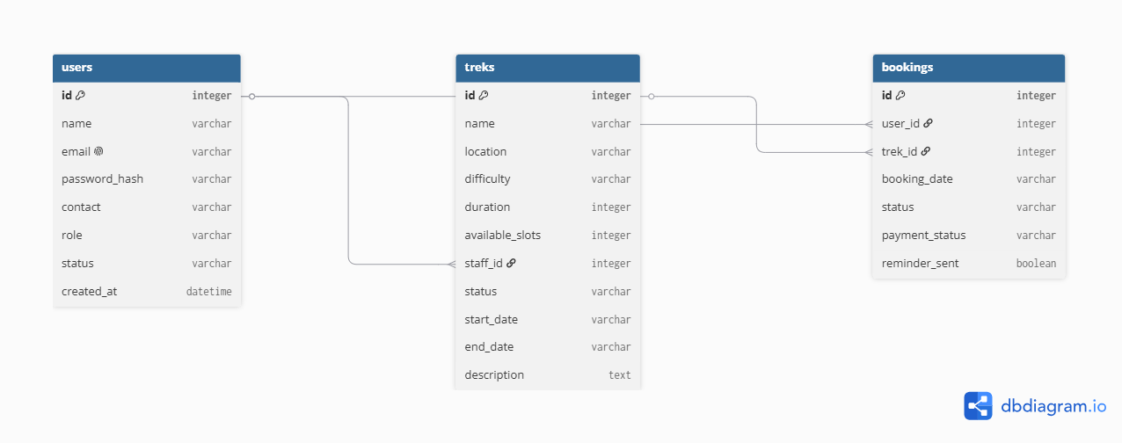
Figure 1: ER diagram of the users, treks and bookings tables

6. API Resource Endpoints
All endpoints are prefixed with /api and return JSON. Here is a representative subset — the full list of routes is in backend/routes/.
Endpoint | Method | Description
/api/auth/register | POST | Trekker self-registration
/api/auth/login | POST | Session login for any role
/api/auth/me | GET | Returns the current logged-in session, if any
/api/treks | GET | Lists open treks (Redis-cached, filterable)
/api/admin/treks | POST | Admin creates a new trek
/api/admin/treks/<id> | PUT | Admin edits a trek, e.g. assigns staff
/api/admin/staff | POST | Admin creates a Trek Staff account
/api/staff/treks/<id> | PUT | Staff updates slots/status on their own trek
/api/bookings | POST | Trekker books a trek
/api/bookings/<id>/cancel | PUT | Trekker cancels a booking, freeing the slot
/api/bookings/history | GET | Trekker's full booking history, including past and cancelled bookings
/api/user/export | POST | Starts the async CSV export Celery job
/api/user/export/status/<task_id> | GET | Checks the export job's status
/api/user/export/download/<file> | GET | Downloads the finished CSV

7. Architecture and Features

Architecture Overview
- backend/app.py — the Flask app factory. It registers every blueprint, creates the SQLite tables, and seeds the Admin account the first time the app runs.
- backend/routes/ — one blueprint per area (auth, admin, staff, trek, booking, user), each protected by a role-aware @login_required decorator.
- backend/models.py — the three SQLAlchemy models: User, Trek and Booking.
- backend/tasks.py and celery_app.py — the three Celery background jobs, plus the beat schedule that triggers two of them automatically.
- frontend/js/components/ — one Vue component per screen. frontend/js/router.js maps each route to a component and blocks access based on the logged-in user's role.

Implemented Features
- Role-based login and registration using a single, shared User model
- Admin: trek CRUD, hiring and assigning staff, blacklisting/unblacklisting accounts, a live dashboard with counts, and search
- Trek Staff: a dashboard scoped only to their assigned treks, slot/status updates, and a list of who's booked on their treks
- Trekker: browsing and filtering open treks, booking, cancelling, and viewing full booking history
- Server-side checks for no double-booking, slot availability, and the Open-status-required rule
- Automatic booking-status cascade when a trek is marked Completed
- Redis-cached trek listing with automatic cache clearing on every write
- Three Celery background jobs: daily reminder emails, a monthly HTML report to the admin, and an on-demand CSV export of a trekker's history

Additional / Stretch Features
- If SMTP isn't configured, emails are written to a local log file instead of failing silently, so the email jobs still work for a demo without a real mail account
- Extra checks for staff overlap and duplicate treks, to catch data-entry mistakes before they reach the database

8. Video Presentation
Drive Link: https://drive.google.com/file/d/1cgJDbu3ISaIcLtRhy3TyijwfaJGzWbjv/view

