Database stored data in the form of tables and we can access it using SQL(Structured query language)

SQL:

DDL (data definition language)🡪create,alter,drop 🡪works with tables

DML (data manipulation language) 🡪select,insert,update,delete 🡪works with datas in the table

TCL 🡪commit,rollback

DCL 🡪grant,revoke 🡪database admin commands.

Here,as a functional tester ,we are concentrating on DML commands



Client/user system Remote server where database is stored

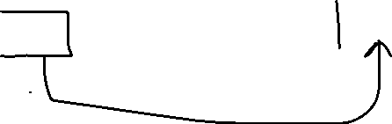

Db client software db server

To access the remote server,we need to install db client software in our system.

Here,we are using SQL developer🡪db client software

Oracle 🡪database

Database connection requirements:

1.in java,if we need to connect to a database ,then it is known as JDBC(Java Database Connection)

JDBC:

1.download jdbc drivers or jar file and associate to the project

jdbc drivers contains special classes and methods to access database.

2.establish a connection btw eclipse and database using connection class

3.execute the statement(create,update,delete) query using statement class

4.statemnt query is executed with the help of execute method available within statement class

5.Close the connection

1.Establish the connection: