What is maven?

It’s a open source and anyone can add their jar file or updated version.

It is a central repository..lik a library,stores all jar files and latest version of all frameworks,.i.e. selenium,tetsng,cucumber,sikuli etc.and stores all jar files for these technologies to be used in a project

Maven project request(dependencies)

Maven repository

1.jdk

2.selenium webdrivers

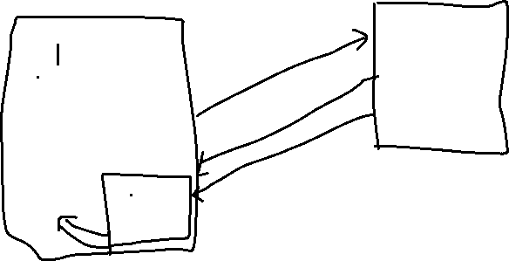

3.sikuli

4.testng Response(jar files)



5.cucumber .M2 repository Local repository/company repo



1.java project🡪where we use so many frameworks in a single project🡪so we need to download many jar files and update the version often..in order to make it easy,we create a maven project -🡪which sends request in the form of dependencies to maven repository,

And the response would be jar files or version needed..or anything

Where would it be downloaded?

It would be downloaded and stored in ur local machine in a folder called .M2 repository -🡪from here,jar files will be sent to maven project.

It also creates a pom.xml file

Request or dependencies:

Consists of three parts:

1.groupid

2.artifactid

3.version

Advantages of maven project?

1.  If you are using selenium version 2.35 and any later point of time you have to use some other version, then same can be managed easily by Maven. For this, you have to update the dependency in pom file and later update your maven project. Below is the example:

<dependency>

<groupId>org.seleniumhq.selenium</groupId>

<artifactId>selenium-java</artifactId>

<version>2.41.0</version>

</dependency>

2.  Many a times, we end up working in a project where a large bunch of developers and testers are working together on different modules. Developers and Testers work on their modules thereby developing executables. These work products are then integrated at regular intervals. Thus, every time we create a development code, it needs to be integrated, tested and built to ensure that the code developed doesn’t break or introduces errors or defects.

This process of building and testing the development work integrated at regular intervals is known as Continuous Integration (CI).

To be able to use any CI tool(Hudson, Jenkins etc), we need the following things to be in place before we get started:

* Source Code Repository (SVN/Git/CVS etc.)
* Build Script (Ant/Maven etc.)

3. Each and every engineers in a project use the same jar dependencies due to the

centralized POM.

How to install maven?

Mkyong.com ---to download and install maven

1.download and unzip in a folder

2.computer🡪properties🡪advanced system setting

Or windows symbol🡪type adv.system setting



Env.variable-🡪JAVA_HOME🡪Path of java (without bin)



Sys.variable

1.JAVA_HOME🡪JAVA PATH WITHOUT BIN

2.MAVEN_HOME-🡪 PATH OF MAVEN(WITHOUT BIN)



3.M2_HOME🡪-PATH OF MAVEN(WITHOUT BIN) BOTH POINTING TO SAME PATH

4.PATH🡪new🡪%M2_home%\bin; %M2_home%\bin

Set Path to both java and m2 variable separated by ;(delimiter)

Verification

Ctrl+R🡪Cmd🡪java,javac,mvn—v

How to chk whether maven plugin is already available in ur eclipse?

File🡪new🡪proj🡪if maven is listing 🡪available already

Or u need to download latest eclipse version or help🡪eclipse marketplace🡪search maven🡪and download **maven integration for eclipse** plugin

**Maven life-cycle:**

**Maven—build automation tool**

**Other build automation tool-🡪graddle,Ant**

**1.Maven compile------------🡪compiles different classes,codes into single unit**

**(**maven compiler plugin **is used)**

**2.Maven test-----------🡪test unit,functional,integration test cases**

**(maven surefire plugin is used)**

**3.maven resources—jar --------🡪generates JARs/WARs/EARs file**

**(maven resources plugin)**

How to create a maven proj?

File🡪new🡪maven proj🡪give names for artifactid and groupid

🡪finish



Maven proj will be created.in a folder🡪main/java and test/java will be created in which each contains a dummy package which can be deleted.and our own package can be created.



Pom.xml-🡪dependencies can be added..dependencies for anything..e.g.selenium,testing can be downloaded in site-🡪testng.org



Ctrl+save🡪all jar files will be automatically added in maven dependencies folder automatically

**Clean install**

Sometimes dependencies will not be installed properly,so we need to execute a command for successful build

Maven proj🡪right click🡪run as maven build🡪write a command🡪clean install in goals option🡪console🡪msg will be displayed(build successful)

These operations can be done using commands in maven proj.but when we are using some server machine,we have to execute through passing commands in command prompt.

Command prompt🡪cd maven workspace

1.mvn clean install-🡪execute all maven lifecycles and runs testcases🡪generates jar files which can be given for testing team to test

2.mvn test🡪does not do a clean install,just executes test cases

3.maven package -Dskiptests🡪does not execute test case,just to build the proj.test cases can be skipped

Or

Properies can be added in pom.xml file like..<maven.test.skip>true</maven.test.skip>

What shd we do when we get an error in pom.xml(red color error)

Rigyht click maven proj🡪maven🡪update proj

How to execute all test classes in a single shot?

1.Create->xml file in a separate package and include all classes in it.

2.pom.xml🡪add all three plugins under build tag

3.in surefire plugin🡪add config tag and add xml path in it

What happens if we does not add plugins in pom>

Only first class will be executed.all other classes under the proj will be skipped