2303A510H4
NAME: T Meghana
Batch -23
Assinment-3.3
Task 1: AI-Generated Logic for Reading Consumer Details
Scenario
An electricity billing system must collect accurate consumer data.
Task Description
Use an AI tool (GitHub Copilot / Gemini) to generate a Python program that:
• Reads:
o Previous Units (PU) o Current Units (CU) o Type of Customer
- Calculates units consumed
- Implements logic directly in the main program (no functions)
Expected Output
- Correct input reading
- Units consumed calculation
- Screenshot showing AI-generated code
- Sample input and output
Prompt1 : Write a python program for an electricity billing system that reads previous units and current units and type of customer it should calculate units consumed. It should implements logic directly in main program and the energy charges depend on number of units consumed and customer type
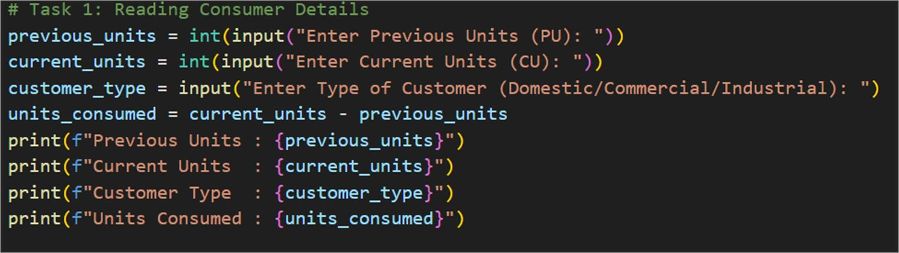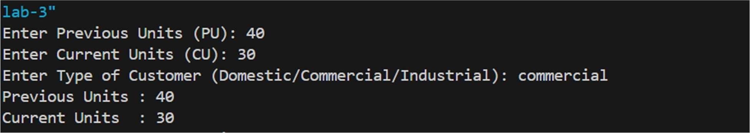
Task 2: Energy Charges Calculation Based on Units Consumed
Scenario
Energy charges depend on the number of units consumed and customer type.
Task Description
Review the AI-generated code from Task 1 and extend it to:
- Calculate Energy Charges (EC)
- Use conditional statements based on:
o Domestic o Commercial o Industrial consumers
- Improve readability using AI prompts such as: o “Simplify energy charge calculation logic” o “Optimize conditional statements”
Expected Output
- Correct EC calculation
- Clear conditional logic
- Original and improved versions (optional)
- Sample execution results
Prompt2: In above code energy charges depend on number of units consumed and customer type .now it should calculate energy charge on domestic commercial industrial consumers

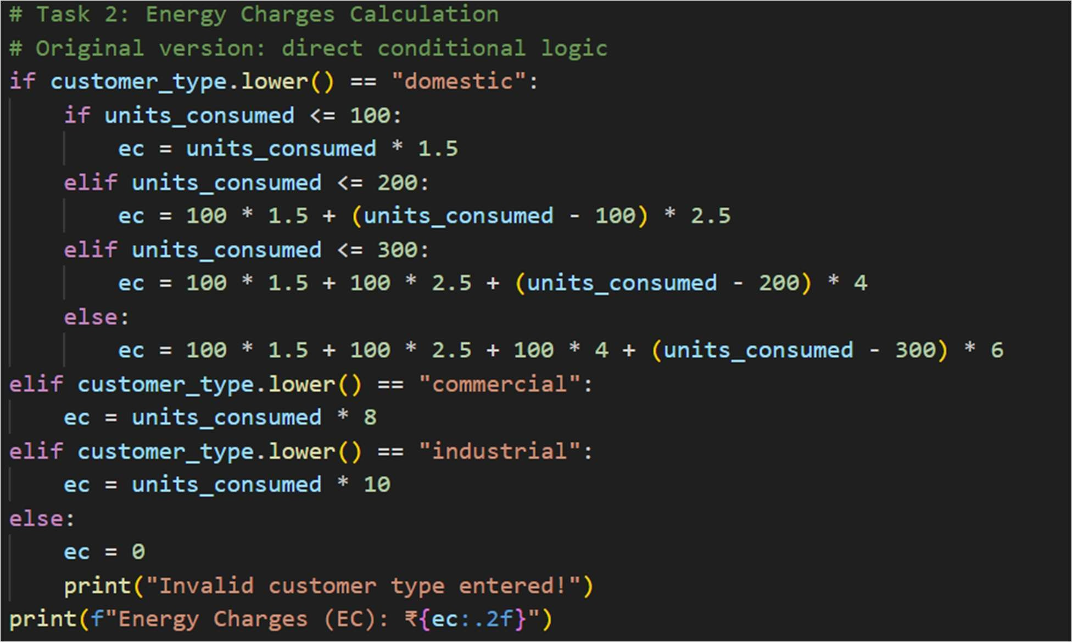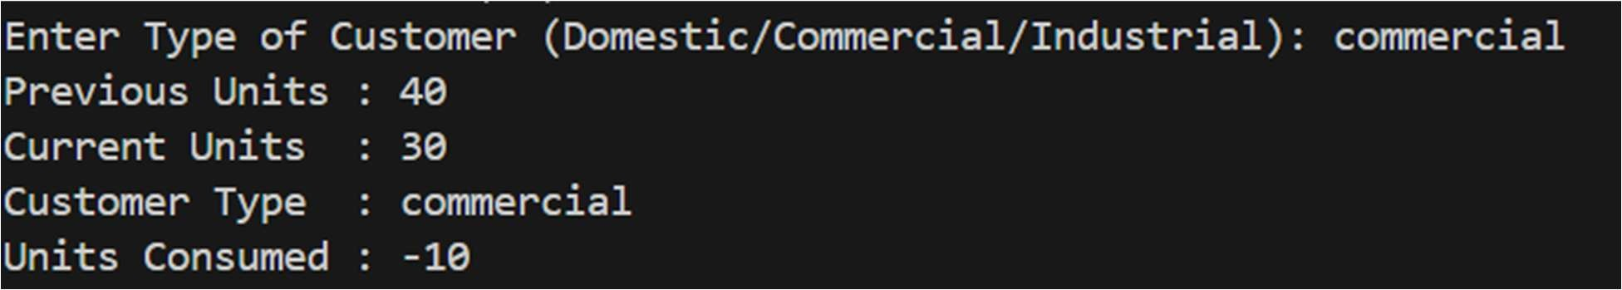
Task 3: Modular Design Using AI Assistance (Using Functions)
Scenario
Billing logic must be reusable for multiple consumers.
Task Description
Use AI assistance to generate a Python program that:
- Uses user-defined functions to:
o Calculate Energy Charges o Calculate Fixed Charges
- Returns calculated values
- Includes meaningful comments
Expected Output
- Function-based Python program
- Correct EC and FC values
- Screenshots of AI-assisted function generation
- Test cases with outputs
Prompt3: In above code billing logic must be reusable for multiple consumers it should use defined functions to calculate energy charges, fixed charges and it return calculated value.
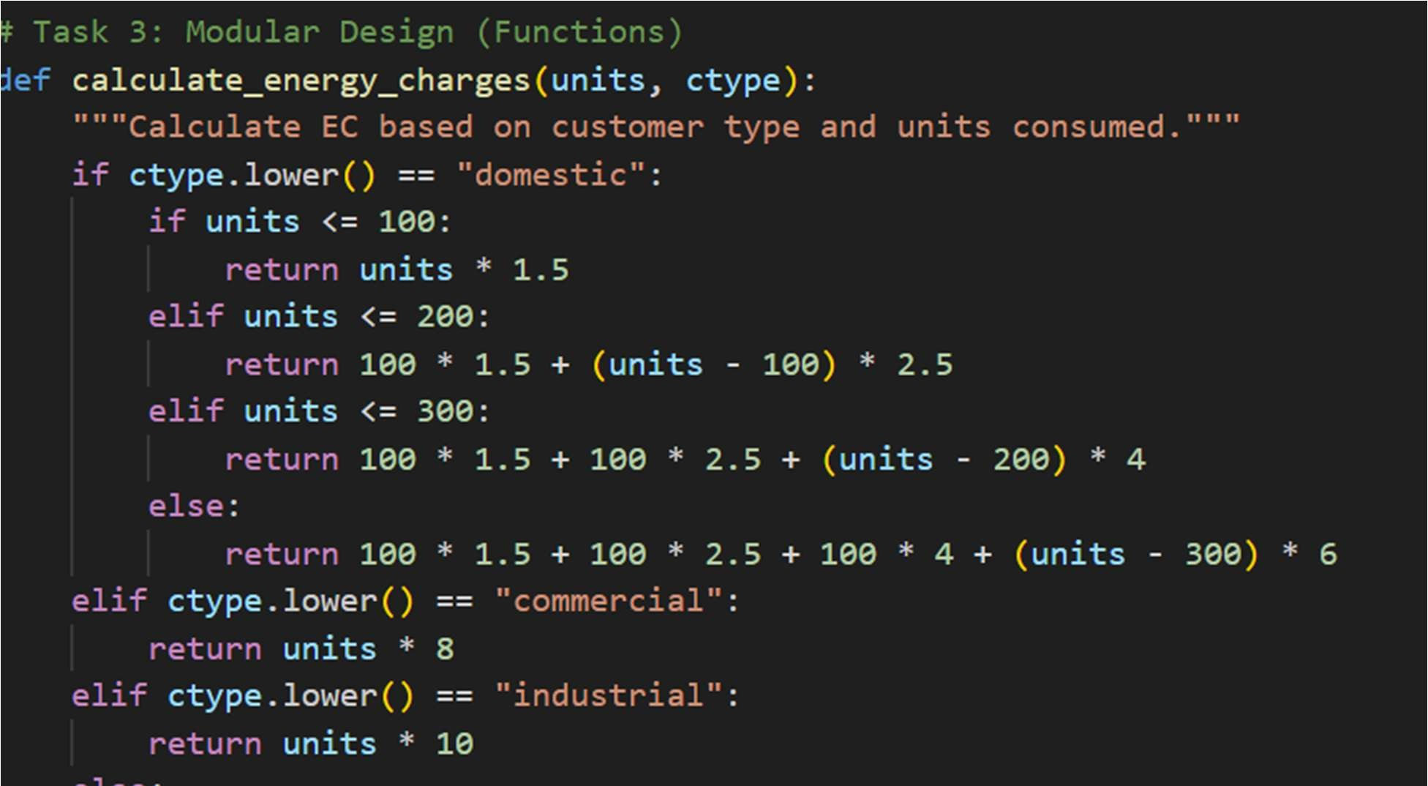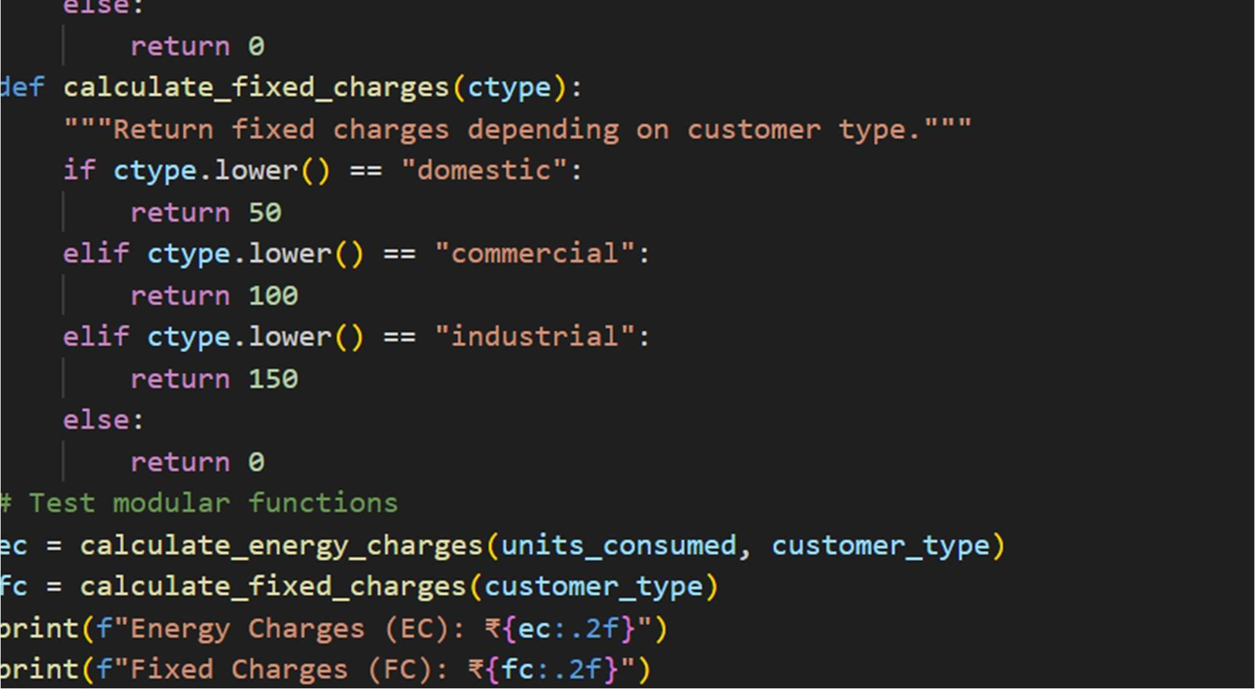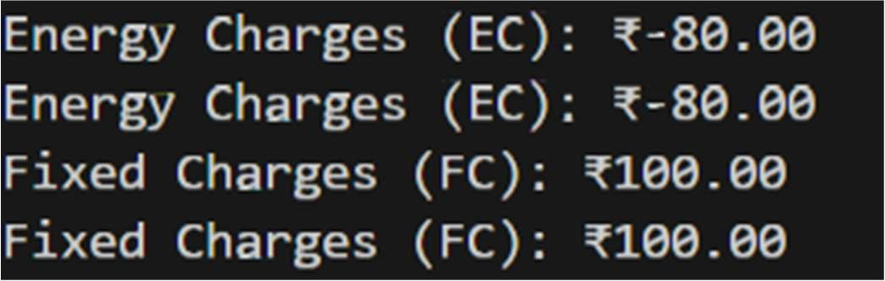

Task 4: Calculation of Additional Charges
Scenario
Electricity bills include multiple additional charges.
Task Description
Extend the program to calculate:
- FC – Fixed Charges
- CC – Customer Charges
- ED – Electricity Duty (percentage of EC) Use AI prompts like:
- “Add electricity duty calculation”
- “Improve billing accuracy”
Expected Output
- Individual charge values printed
- Correct duty calculation
- Well-structured output
- Verified intermediate results
Prompt: In above code it should include multiple additional charges liked fixedcharge , customercharge , electrictyduty.

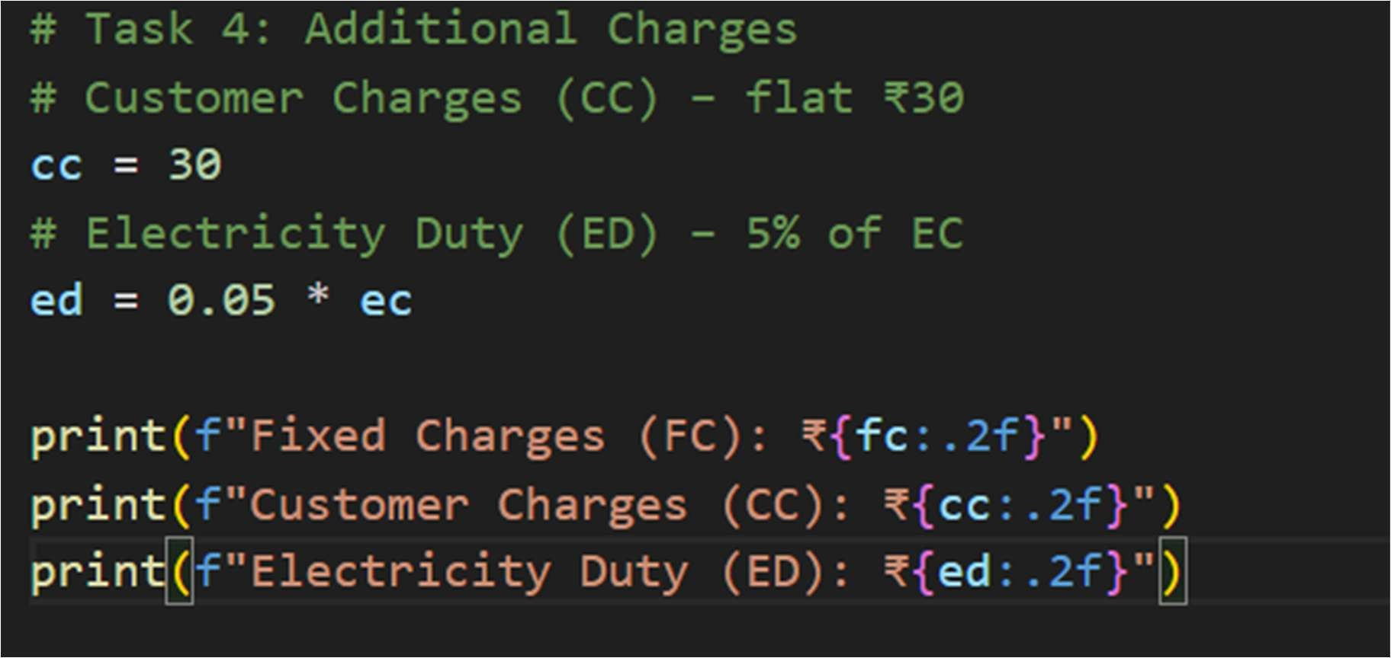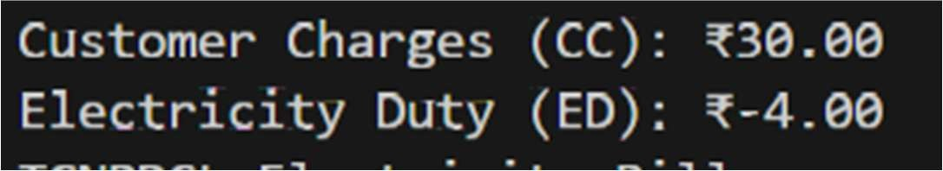

Task 5: Final Bill Generation and Output Analysis
Scenario
The final electricity bill must present all values clearly.
Task Description
Develop the final Python application to:
- Calculate total bill:
- Total Bill = EC + FC + CC + ED
- Display:
o Energy Charges (EC) o Fixed Charges (FC) o Customer Charges (CC) o Electricity Duty (ED) o Total Bill Amount
• Analyze the program based on:
- Accuracy
- Readability o Real-world applicability
Expected Output
- Complete electricity bill output
- Neatly formatted display
- Sample input/output
- Short analysis paragraph
Prompt: #In above code it should print energy charges , fixed charges , customer charge ,electricity duty ,total bill amount.

