T Meghana
2303A510H4
Batch-23
Assignment-1.1
Task 1: AI-Generated Logic Without Modularization (String Reversal Without
Functions)
- Scenario
You are developing a basic text-processing utility for a messaging application.
- Task Description
Use GitHub Copilot to generate a Python program that:
- Reverses a given string
- Accepts user input
- Implements the logic directly in the main code
- Does not use any user-defined functions
❖ Expected Output
- Correct reversed string
- Screenshots showing Copilot-generated code suggestions
- Sample inputs and outputs
Prompt : write a python program a string reversal without function
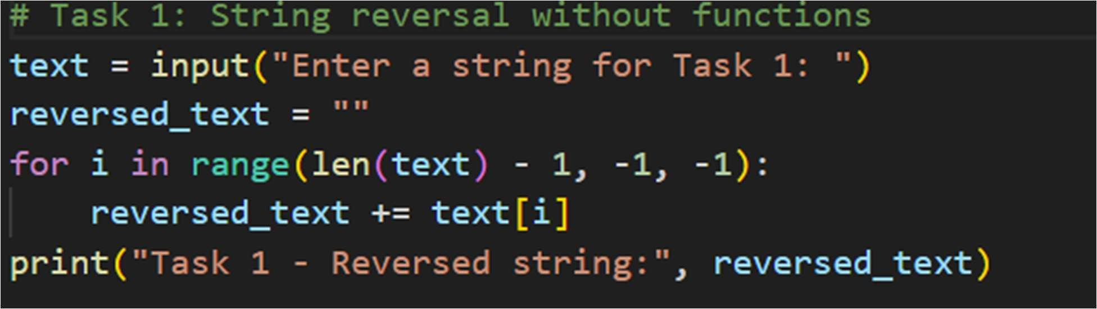
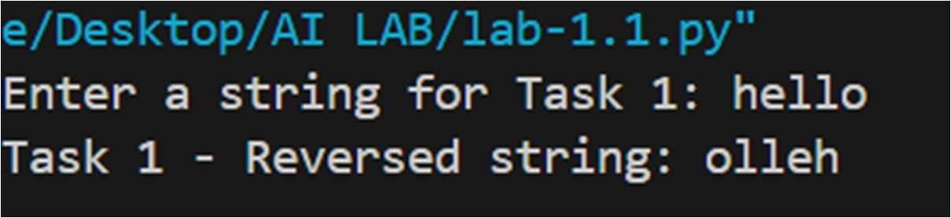
Task 2: E iciency & Logic Optimization (Readability Improvement)
- Scenario
The code will be reviewed by other developers.
- Task Description
Examine the Copilot-generated code from Task 1 and improve it by:
- Removing unnecessary variables
- Simplifying loop or indexing logic
- Improving readability
- Use Copilot prompts like:
▪ “Simplify this string reversal code” ▪ “Improve readability and e iciency” Hint:
Prompt Copilot with phrases like
“optimize this code”, “simplify logic”, or “make it more readable”
❖ Expected Output
- Original and optimized code versions
- Explanation of how the improvements reduce time complexity
Prompt: In the above code string reversal without function add optimized string reversal(readability & e iciency)
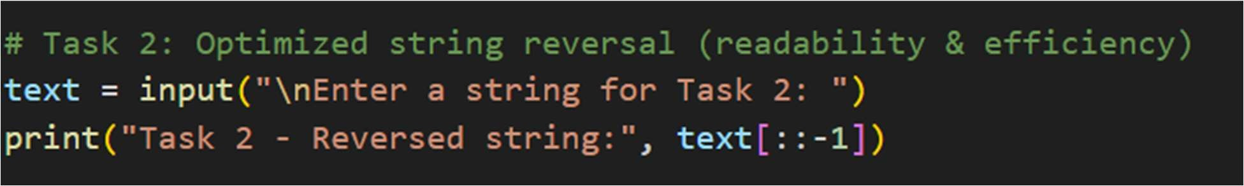
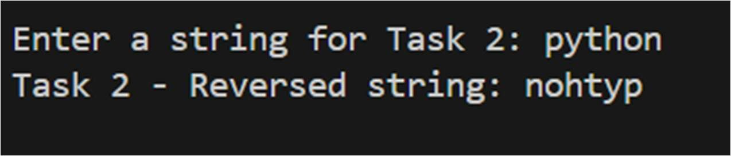
Task 3: Modular Design Using AI Assistance (String Reversal Using Functions)
- Scenario
The string reversal logic is needed in multiple parts of an application.
- Task Description
Use GitHub Copilot to generate a function-based Python program that:
- Uses a user-defined function to reverse a string
- Returns the reversed string
- Includes meaningful comments (AI-assisted)
❖ Expected Output
- Correct function-based implementation
- Screenshots documenting Copilot’s function generation
- Sample test cases and outputs
Prompt: in the above it should include modular design using functions
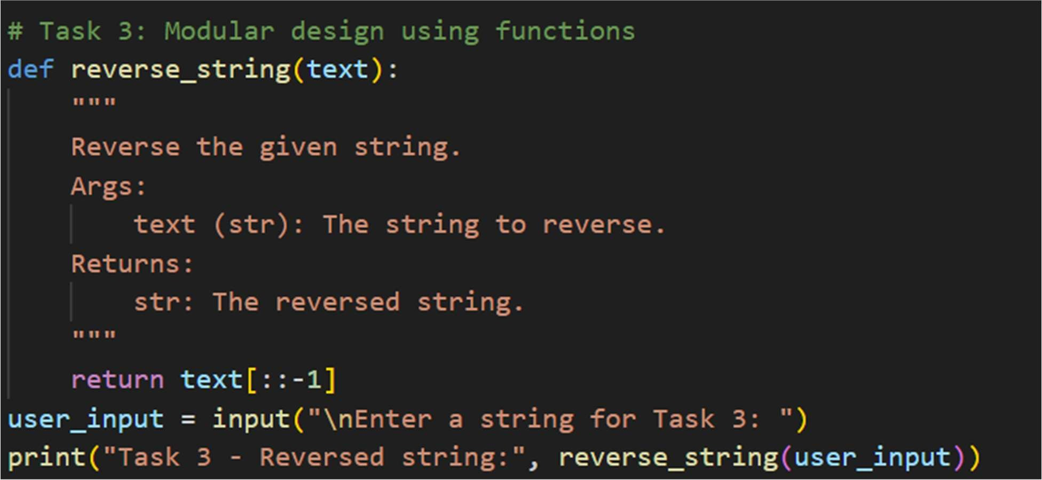
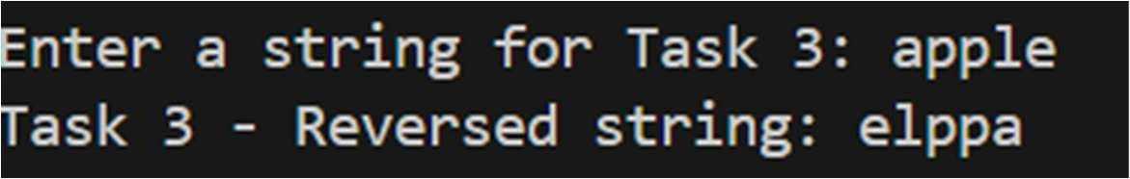
Task 4: Comparative Analysis – Procedural vs Modular Approach (With vs
Without Functions)
- Scenario
You are asked to justify design choices during a code review.
- Task Description
Compare the Copilot-generated programs:
- Without functions (Task 1)
- With functions (Task 3) Analyze them based on:
- Code clarity
- Reusability
- Debugging ease
- Suitability for large-scale applications
- Expected Output
Comparison table or short analytical report
Prompt: in the above it should include comparative analysis-procedural approach
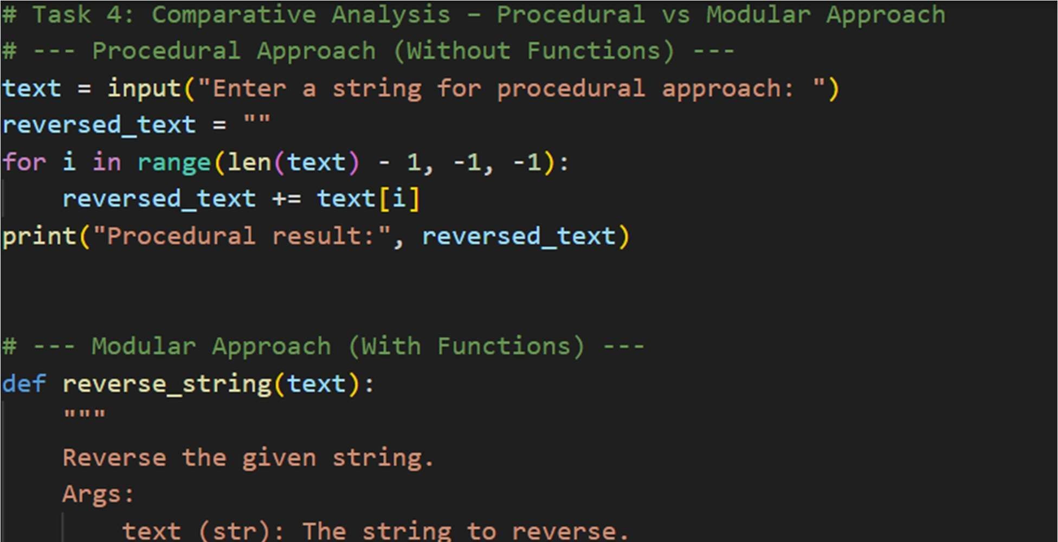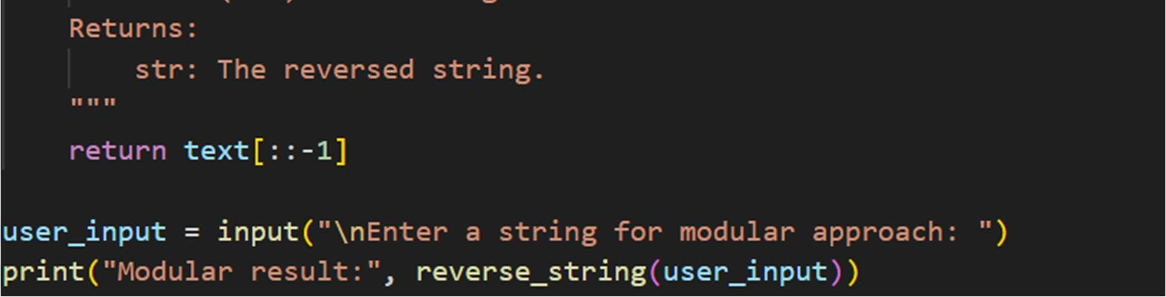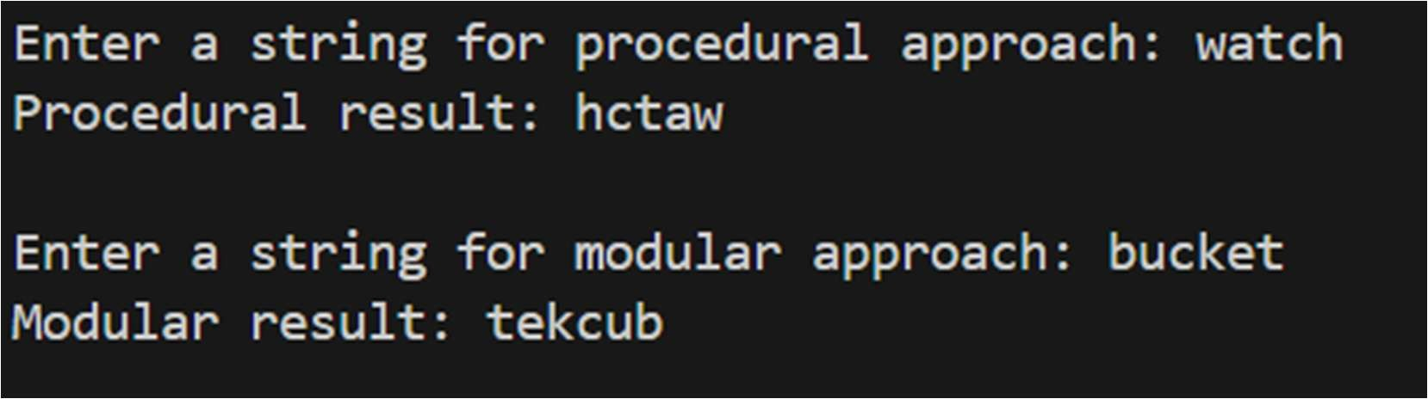

Task 5: AI-Generated Iterative vs Recursive Fibonacci Approaches (Di erent
Algorithmic Approaches to String Reversal)
- Scenario
Your mentor wants to evaluate how AI handles alternative logic paths.
- Task Description
Prompt GitHub Copilot to generate:
- A loop-based string reversal approach
- A built-in / slicing-based string reversal approach
❖ Expected Output
- Two correct implementations
- Comparison discussing:
▪ Execution flow
▪ Time complexity
▪ Performance for large inputs
▪ When each approach is appropriate
Prompt: in the above it should include itractive vs slicing approaches
