**Ex. No. : 06 Date :**

**Register No. : 221701503 Name : THEJESH N S**



**SD Card**

**Aim**

Implement an application to write the Register Number, Name and CGPA to the SD card in text file format.

***Procedure:***

**Step 1 :** File → New Project  
 Provide the application name (e.g.,"SD Card") and click “Next”.

**Step 2 :** Select the target Android devices  
 Select the minimum SDK to run the application. Click “Next”.

**Step 3 :** Choose the activity for the application  
 By default, choose “Blank Activity”. Click “Next”.

**Step 4 :** Enter activity name and click “Finish”.

**Step 5 :** Edit the program

Request storage permissions in the manifest file.

Use file input/output streams in MainActivity.kt to read from and write to

SD card or internal storage.  
**Step 6 :** Run the application  
 Two ways to run the application:

1. Running through emulator (with SD card configured)  
  
 2. Running through mobile device

***AndroidManifest.xml***

***<?*xml version="1.0" encoding="utf-8"*?>***

**<manifest xmlns:android="http://schemas.android.com/apk/res/android"**

**xmlns:tools="http://schemas.android.com/tools">**

**<application**

**android:allowBackup="true"**

**android:dataExtractionRules="@xml/data_extraction_rules"**

**android:fullBackupContent="@xml/backup_rules"**

**android:icon="@mipmap/ic_launcher"**

**android:label="@string/app_name"**

**android:roundIcon="@mipmap/ic_launcher_round"**

**android:supportsRtl="true"**

**android:theme="@style/Theme.SdCard"**

**tools:targetApi="31">**

**<activity**

**android:name=".MainActivity"**

**android:exported="true">**

**<intent-filter>**

**<action android:name="android.intent.action.MAIN" />**

**<category android:name="android.intent.category.LAUNCHER" />**

**</intent-filter>**

**</activity>**

**</application>**

**</manifest>**

***Activity_main.xml***

**<?xml version="1.0" encoding="utf-8"?>**

**<LinearLayout xmlns:android="http://schemas.android.com/apk/res/android"**

**xmlns:app="http://schemas.android.com/apk/res-auto"**

**xmlns:tools="http://schemas.android.com/tools"**

**android:layout_width="match_parent"**

**android:layout_height="match_parent"**

**android:orientation="vertical"**

**android:padding="16dp"**

**tools:context=".MainActivity">**

**<TextView**

**android:layout_width="match_parent"**

**android:layout_height="wrap_content"**

**android:text="SD Card"**

**android:textSize="24sp"**

**android:textStyle="bold"**

**android:textColor="@android:color/white"**

**android:background="#6200EE"**

**android:padding="12dp"/>**

**<LinearLayout**

**android:layout_width="match_parent"**

**android:layout_height="wrap_content"**

**android:orientation="vertical"**

**android:layout_marginTop="16dp">**

**<EditText**

**android:id="@+id/editTextRegisterNumber"**

**android:layout_width="match_parent"**

**android:layout_height="wrap_content"**

**android:hint="Enter the register number..."**

**android:inputType="text"**

**android:padding="12dp"**

**android:background="@drawable/edit_text_background"**

**android:layout_marginBottom="8dp"/>**

**<EditText**

**android:id="@+id/editTextName"**

**android:layout_width="match_parent"**

**android:layout_height="wrap_content"**

**android:hint="Enter the name..."**

**android:inputType="textPersonName"**

**android:padding="12dp"**

**android:background="@drawable/edit_text_background"**

**android:layout_marginBottom="8dp"/>**

**<EditText**

**android:id="@+id/editTextCGPA"**

**android:layout_width="match_parent"**

**android:layout_height="wrap_content"**

**android:hint="Enter the CGPA..."**

**android:inputType="numberDecimal"**

**android:padding="12dp"**

**android:background="@drawable/edit_text_background"**

**android:layout_marginBottom="16dp"/>**

**<Button**

**android:id="@+id/buttonSave"**

**android:layout_width="match_parent"**

**android:layout_height="wrap_content"**

**android:text="Save"**

**android:textColor="@android:color/white"**

**android:backgroundTint="#6200EE"**

**android:padding="12dp"**

**android:layout_marginBottom="8dp"/>**

**<Button**

**android:id="@+id/buttonLoad"**

**android:layout_width="match_parent"**

**android:layout_height="wrap_content"**

**android:text="Load"**

**android:textColor="@android:color/white"**

**android:backgroundTint="#6200EE"**

**android:padding="12dp"/>**

**</LinearLayout>**

**</LinearLayout>**

***MainActivity.kt***

**package com.example.sdcard**

**import android.Manifest**

**import android.content.pm.PackageManager**

**import android.os.Bundle**

**import android.os.Environment**

**import android.widget.Button**

**import android.widget.EditText**

**import android.widget.Toast**

**import androidx.appcompat.app.AppCompatActivity**

**import androidx.core.app.ActivityCompat**

**import androidx.core.content.ContextCompat**

**import java.io.File**

**import java.io.FileOutputStream**

**import java.io.IOException**

**class MainActivity : AppCompatActivity() {**

**private lateinit var registerNumberEditText: EditText**

**private lateinit var nameEditText: EditText**

**private lateinit var cgpaEditText: EditText**

**private lateinit var saveButton: Button**

**private lateinit var loadButton: Button**

**private val STORAGE_PERMISSION_CODE = 100**

**override fun onCreate(savedInstanceState: Bundle?) {**

**super.onCreate(savedInstanceState)**

**setContentView(R.layout.activity_main)**

**// Initialize UI components**

**registerNumberEditText = findViewById(R.id.editTextRegisterNumber)**

**nameEditText = findViewById(R.id.editTextName)**

**cgpaEditText = findViewById(R.id.editTextCGPA)**

**saveButton = findViewById(R.id.buttonSave)**

**loadButton = findViewById(R.id.buttonLoad)**

**// Request storage permissions**

**requestStoragePermission()**

**// Set click listeners**

**saveButton.setOnClickListener {**

**saveDataToSD()**

**}**

**loadButton.setOnClickListener {**

**loadDataFromSD()**

**}**

**}**

**private fun requestStoragePermission() {**

**if (ContextCompat.checkSelfPermission(**

**this,**

**Manifest.permission.WRITE_EXTERNAL_STORAGE**

**) != PackageManager.PERMISSION_GRANTED**

**) {**

**ActivityCompat.requestPermissions(**

**this,**

**arrayOf(**

**Manifest.permission.WRITE_EXTERNAL_STORAGE,**

**Manifest.permission.READ_EXTERNAL_STORAGE**

**),**

**STORAGE_PERMISSION_CODE**

**)**

**}**

**}**

**private fun saveDataToSD() {**

**// Validate inputs**

**val registerNumber = registerNumberEditText.text.toString().trim()**

**val name = nameEditText.text.toString().trim()**

**val cgpa = cgpaEditText.text.toString().trim()**

**if (registerNumber.isEmpty() || name.isEmpty() || cgpa.isEmpty()) {**

**Toast.makeText(this, "Please fill all fields", Toast.LENGTH_SHORT).show()**

**return**

**}**

**try {**

**// Try multiple storage options for emulator compatibility**

**val file = try {**

**// Option 1: Using app-specific external storage (works on most emulators)**

**val appDir = getExternalFilesDir(null)**

**val dir = File(appDir, "SDCardApp")**

**if (!dir.exists()) {**

**dir.mkdirs()**

**}**

**File(dir, "$registerNumber.txt")**

**} catch (e: Exception) {**

**// Option 2: Using legacy external storage as fallback**

**val dir = File(Environment.getExternalStorageDirectory(), "SDCardApp")**

**if (!dir.exists()) {**

**dir.mkdirs()**

**}**

**File(dir, "$registerNumber.txt")**

**}**

**// Create file**

**val fileOutputStream = FileOutputStream(file)**

**val data = "Register Number: $registerNumber\nName: $name\nCGPA: $cgpa"**

**fileOutputStream.write(data.toByteArray())**

**fileOutputStream.close()**

**Toast.makeText(this, "Data saved successfully to ${file.absolutePath}", Toast.LENGTH_LONG).show()**

**// Clear fields after saving**

**registerNumberEditText.text.clear()**

**nameEditText.text.clear()**

**cgpaEditText.text.clear()**

**} catch (e: IOException) {**

**e.printStackTrace()**

**Toast.makeText(this, "Error saving data: ${e.message}", Toast.LENGTH_SHORT).show()**

**}**

**}**

**private fun loadDataFromSD() {**

**val registerNumber = registerNumberEditText.text.toString().trim()**

**if (registerNumber.isEmpty()) {**

**Toast.makeText(this, "Please enter a register number", Toast.LENGTH_SHORT).show()**

**return**

**}**

**try {**

**// Try to find the file in multiple storage locations**

**val file = findDataFile(registerNumber)**

**if (file == null || !file.exists()) {**

**Toast.makeText(this, "No data found for this register number", Toast.LENGTH_SHORT).show()**

**return**

**}**

**val fileContent = file.readText()**

**val lines = fileContent.split("\n")**

**// Parse the data**

**for (line in lines) {**

**when {**

**line.startsWith("Name:") -> {**

**val name = line.substring(line.indexOf(":") + 1).trim()**

**nameEditText.setText(name)**

**}**

**line.startsWith("CGPA:") -> {**

**val cgpa = line.substring(line.indexOf(":") + 1).trim()**

**cgpaEditText.setText(cgpa)**

**}**

**}**

**}**

**Toast.makeText(this, "Data loaded successfully from ${file.absolutePath}", Toast.LENGTH_SHORT).show()**

**} catch (e: IOException) {**

**e.printStackTrace()**

**Toast.makeText(this, "Error loading data: ${e.message}", Toast.LENGTH_SHORT).show()**

**}**

**}**

**private fun findDataFile(registerNumber: String): File? {**

**// Try app-specific external storage first**

**val appDir = getExternalFilesDir(null)**

**val appSpecificDir = File(appDir, "SDCardApp")**

**var file = File(appSpecificDir, "$registerNumber.txt")**

**if (file.exists()) {**

**return file**

**}**

**// Try legacy external storage**

**try {**

**val externalDir = File(Environment.getExternalStorageDirectory(), "SDCardApp")**

**file = File(externalDir, "$registerNumber.txt")**

**if (file.exists()) {**

**return file**

**}**

**} catch (e: Exception) {**

**// Ignore and continue to other options**

**}**

**// Try cache directory as last resort**

**val cacheDir = File(cacheDir, "SDCardApp")**

**if (!cacheDir.exists()) {**

**cacheDir.mkdirs()**

**}**

**file = File(cacheDir, "$registerNumber.txt")**

**if (file.exists()) {**

**return file**

**}**

**return null**

**}**

**// Checks if external storage is available for read and write**

**private fun isExternalStorageWritable(): Boolean {**

**return Environment.getExternalStorageState() == Environment.MEDIA_MOUNTED**

**}**

**// Checks if external storage is available to at least read**

**private fun isExternalStorageReadable(): Boolean {**

**return Environment.getExternalStorageState() in**

**setOf(Environment.MEDIA_MOUNTED, Environment.MEDIA_MOUNTED_READ_ONLY)**

**}**

**override fun onRequestPermissionsResult(**

**requestCode: Int,**

**permissions: Array<String>,**

**grantResults: IntArray**

**) {**

**super.onRequestPermissionsResult(requestCode, permissions, grantResults)**

**if (requestCode == STORAGE_PERMISSION_CODE) {**

**if (grantResults.isNotEmpty() && grantResults[0] == PackageManager.PERMISSION_GRANTED) {**

**Toast.makeText(this, "Storage permission granted", Toast.LENGTH_SHORT).show()**

**} else {**

**Toast.makeText(this, "Storage permission denied", Toast.LENGTH_SHORT).show()**

**}**

**}**

**}**

**}**

***Output***

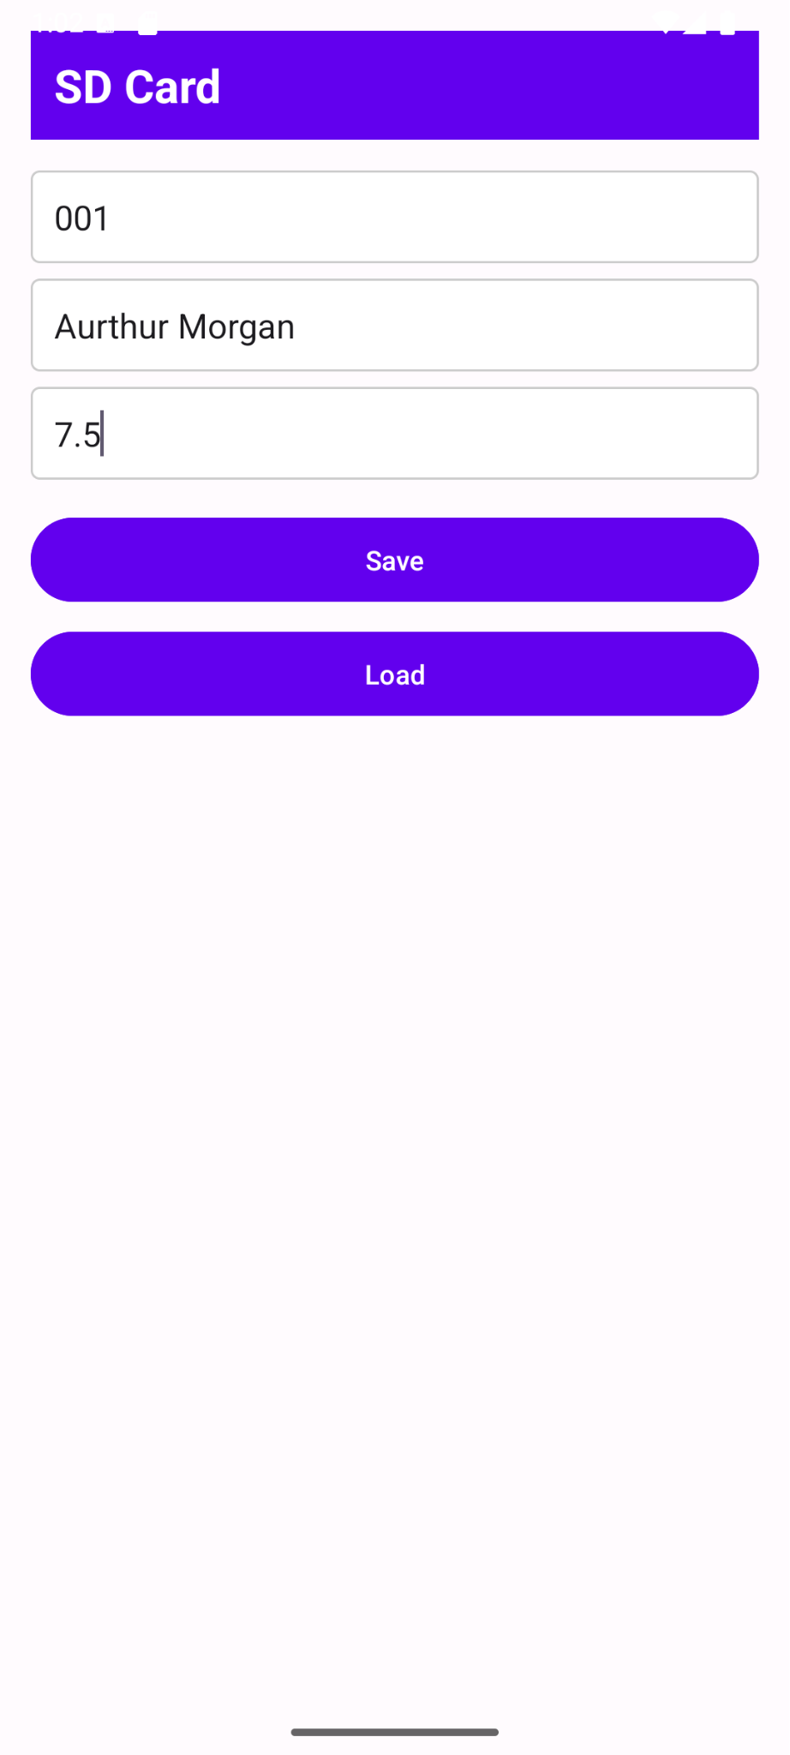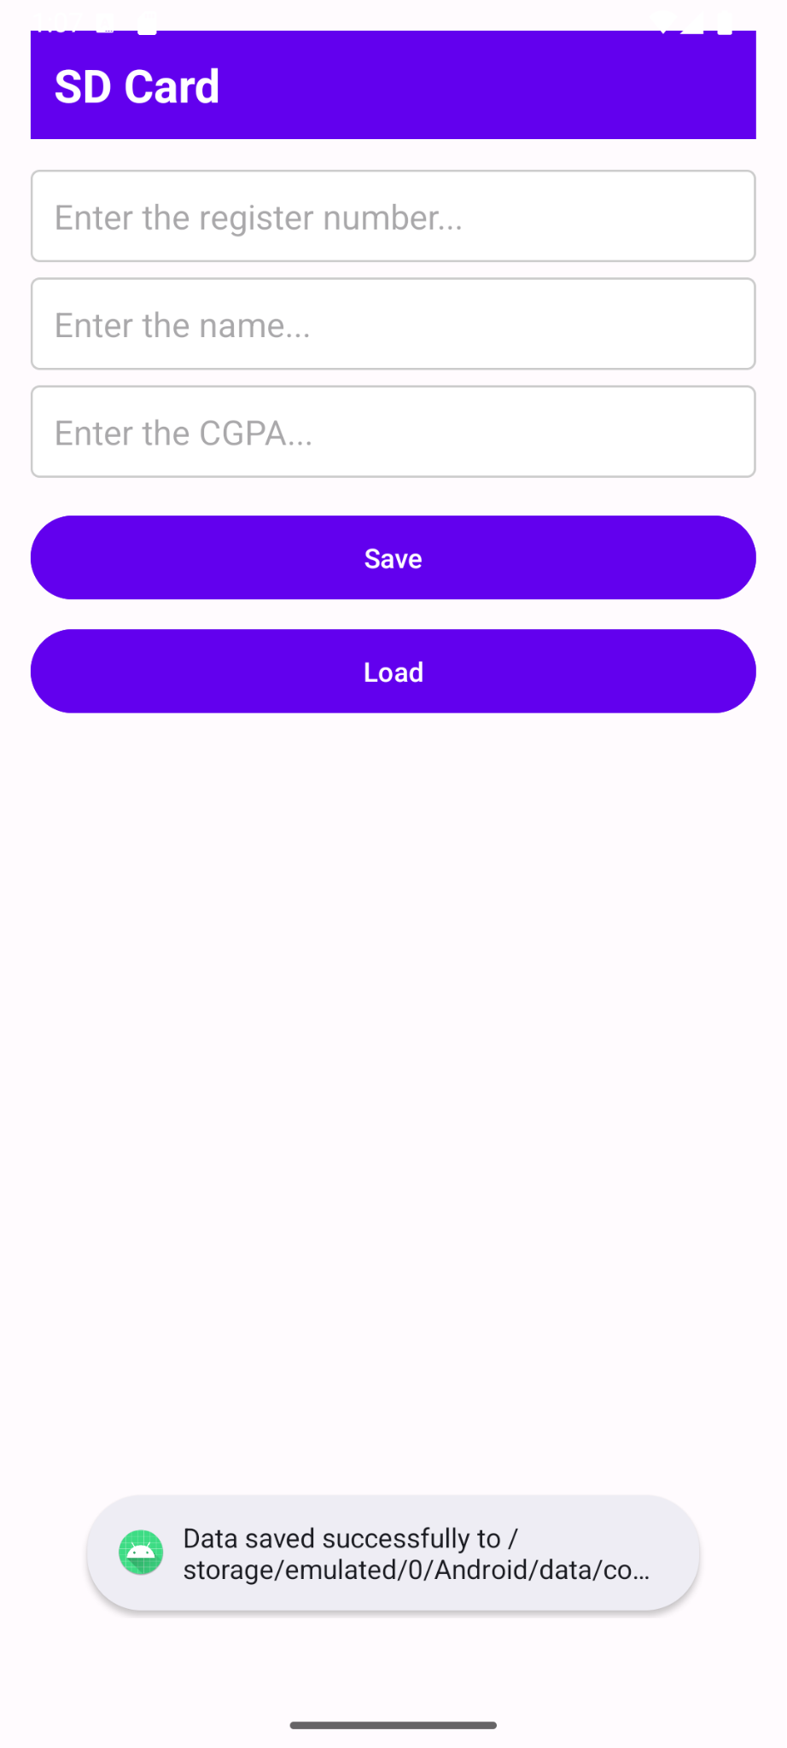

**Result:**

The SD Card Access application successfully reads and writes data to the SD card or internal storage when tested on a mobile device with appropriate permissions.