from itertools import permutations

# Function to check if a given assignment is valid for SEND + MORE = MONEY

def is_valid(s, e, n, d, m, o, r, y):

send = s * 1000 + e * 100 + n * 10 + d

more = m * 1000 + o * 100 + r * 10 + e

money = m * 10000 + o * 1000 + n * 100 + e * 10 + y

return send + more == money

# Function to solve the cryptarithmetic problem

def solve_cryptarithmetic():

letters = 'sendmory'

for perm in permutations(range(10), 8): # Generate permutations of 8 digits

s, e, n, d, m, o, r, y = perm

if s != 0 and m != 0: # Leading digits can't be zero

if is_valid(s, e, n, d, m, o, r, y):

print(f"SEND = {s}{e}{n}{d}")

print(f"MORE = {m}{o}{r}{e}")

print(f"MONEY = {m}{o}{n}{e}{y}")

return

# Call the solver

solve_cryptarithmetic()

Output:  
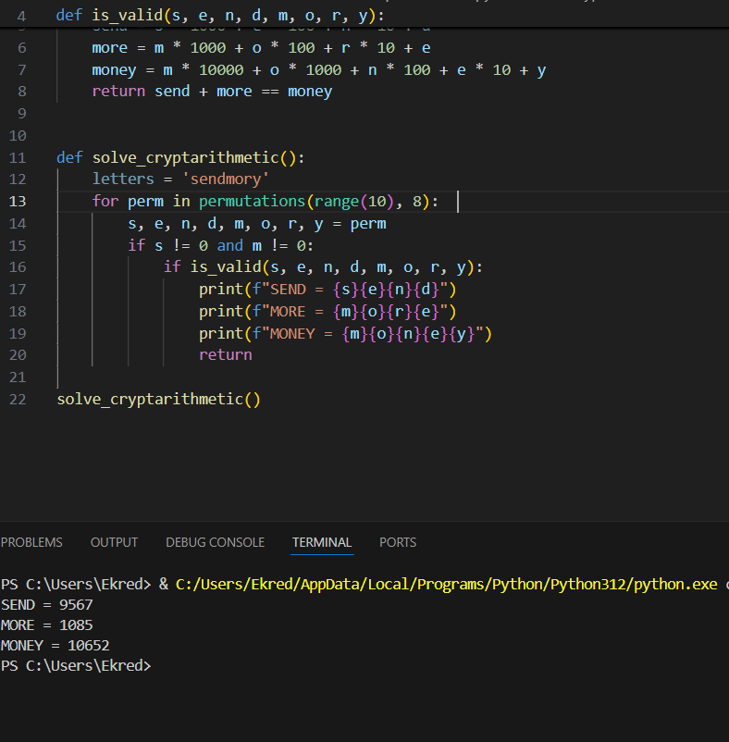n