**MS BUILD PROJECT**

* Open Developer Command Prompt for Visual Studio, browse to the Folder where you want to create the application. Go to \Desktop\

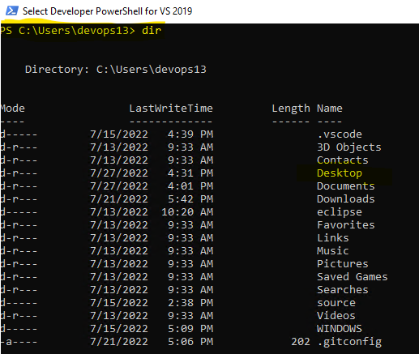

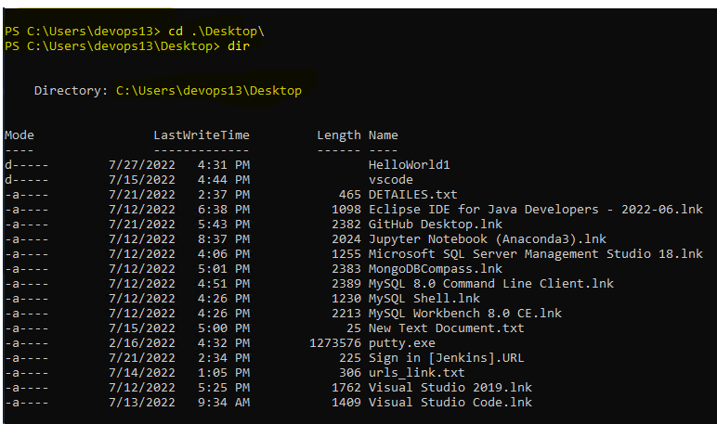

* Type md HelloWorld to create a subfolder name Helloworld

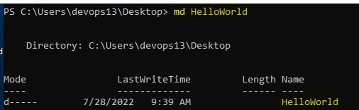

* Type cd Helloworld to go into new dir



* Start Notepad and type code



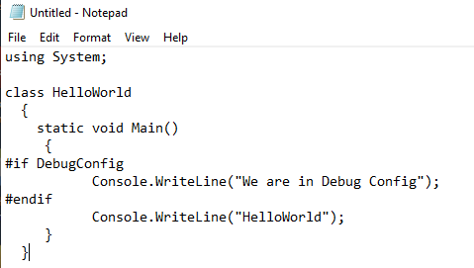

* Save the Source Code file and name it Helloworld.cs

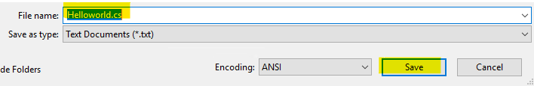

* Build the application by typing csc helloworld at the cmd prompt



* Test the application by typing helloworld at cmd prompt



* Delete the application by typing del helloworld.exe at cmd



**Create a minimal MSBuild Project File**

* In the text editor, Create a new file and Insert ItemGrop node as a child element of the project node.
* Add a Target Node as a child element of the project node, Name the node Build
* Insert this task element as a child element of the Target node.

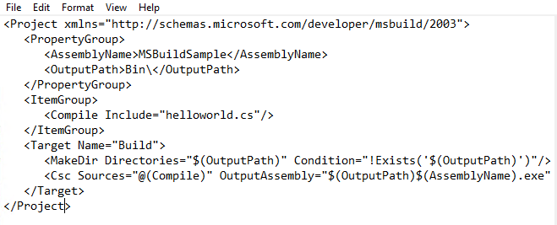

* Save this project file and name it Helloworld.csproj

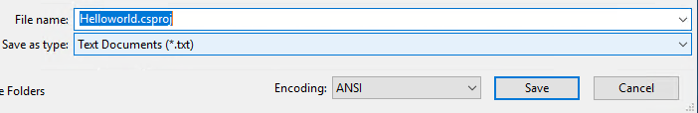

**Build The Application**

* **At cmd prompt type msbuild helloworld.csproj –t:Build**

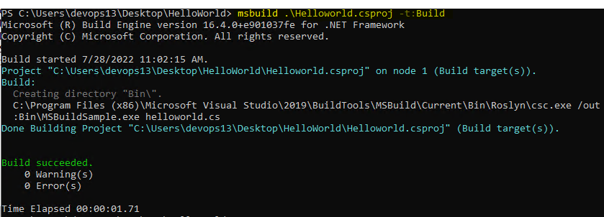

* Check whether Bin dir created or not, Type dir

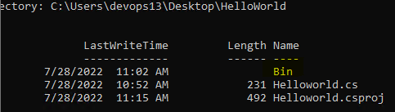

* To Check MSBuildSample created are not go to DIR type cd bin

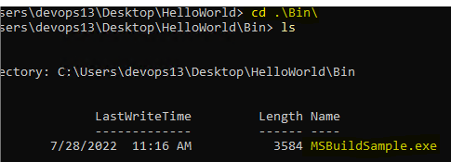

* Test the application by Typing MSBuildSample.exe



To ADD BUILDS TARGETS

* In the project file add two targets and add DefaultTargets attribute to the opening project element

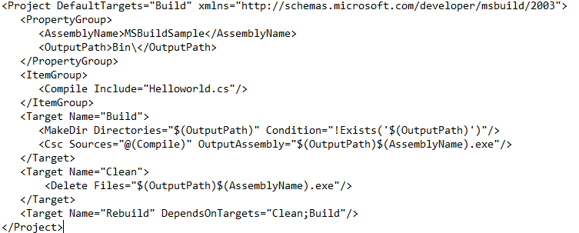

TEST THE BUILD TARGETS:

* Build the default build, at the cmd prompt type msbuild helloworld.csproj –p:AssemblyName=Greeting

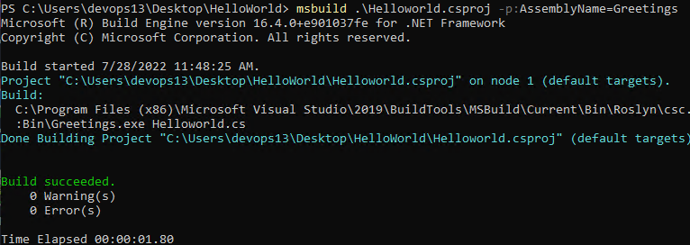

* To verify that the \bin\folder contains both the MSBuildsample application both new and old

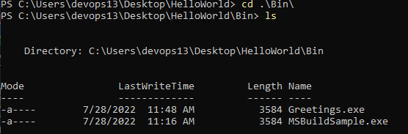

* Test the greeting application ./Greeting.exe



* Delete MsBuildSample Application by typing msbuild helloworld.csproj –t:clean

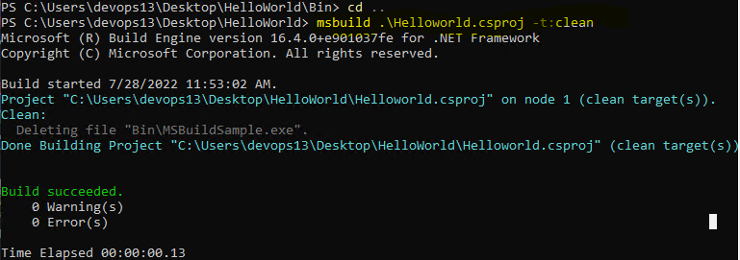

* Now delete the Greetings file by typing msbuild helloworld.csproj –t:clean –p:AssemblyName=Greetings

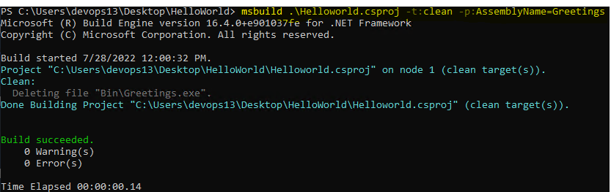

* To check whether the project clean or not got to \Bin\folder should be empty type dir Bin



* Type msbuild

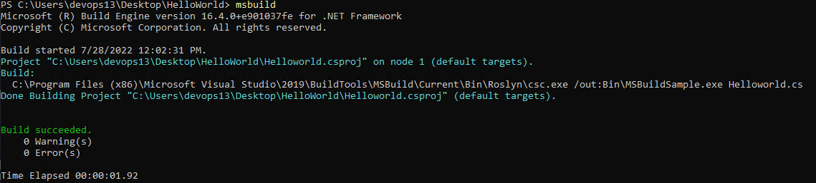

* Although a project is not specified, MSBuild builds the helloworld.csproj file because only one project file in the current folder, To check Type cd ./Bin/ and Type ls

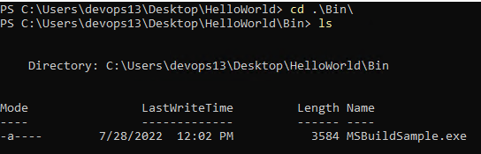

BUILD INCREMENTALLY:

* In the project file, add these attributes to the opening Build target

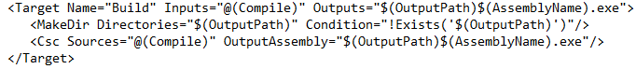

* Test the Build target by typing msbuild –v:d at the cmd prompt

