Connect to your Azure SQL Database server

1. The first time you run Azure Data Studio the Welcome page should open. If you don't see the Welcome page, select **Help > Welcome.** Select **New Connection** to open the Connection pane:

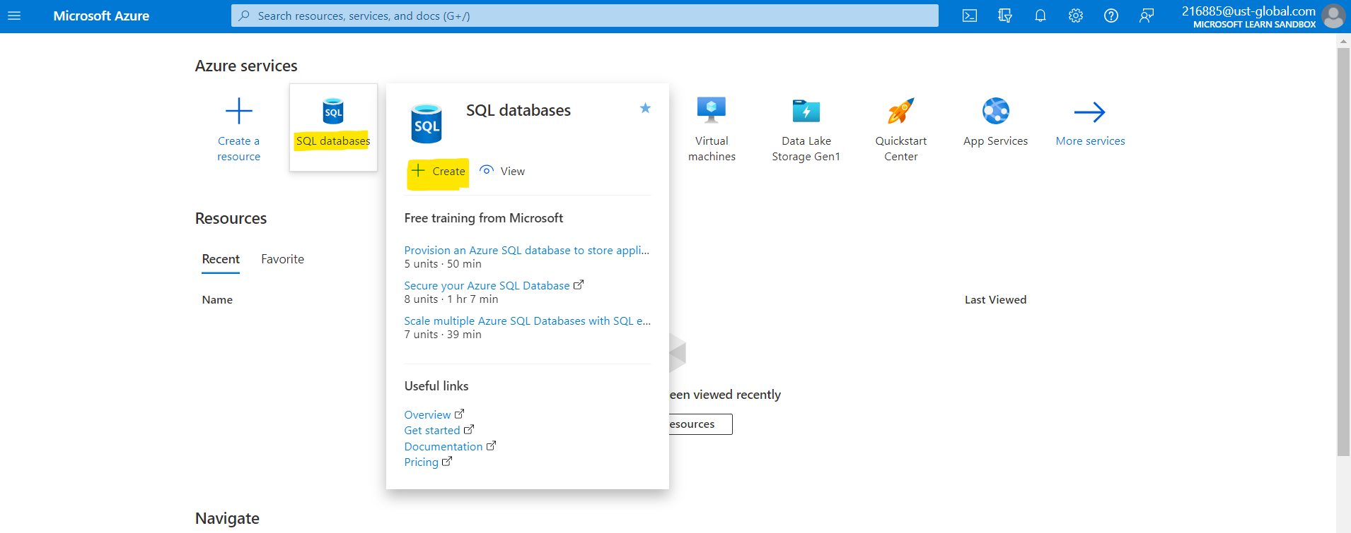

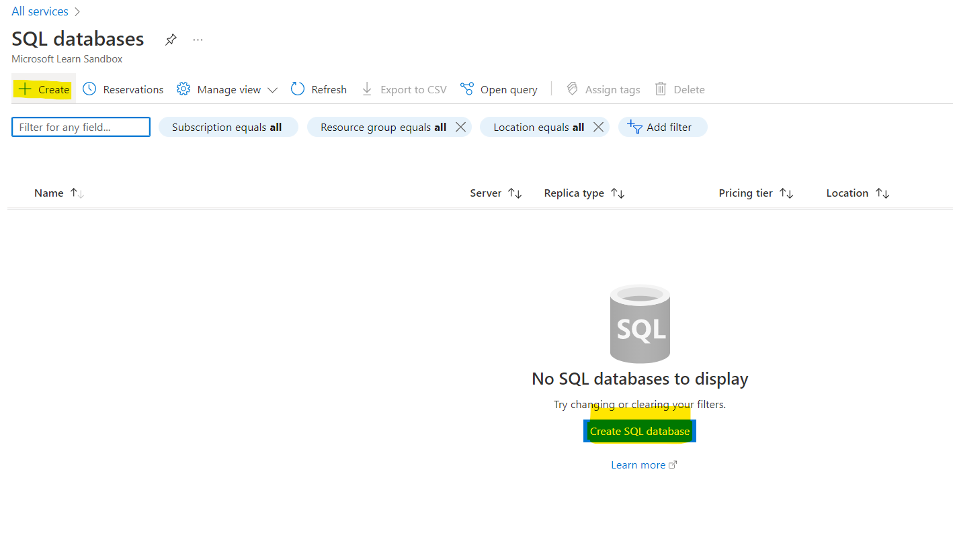

2. This article uses SQL sign-in, but also supports Windows authentication. Fill in the following fields

using the server name, user name, and password for your Azure SQL server:

|  |  |  |
| --- | --- | --- |
| Setting Server name | Suggested value | Description |
| Authentication | SQL Login | This tutorial uses SQL Authentication |
| User name | The server admin account  user name | The user name from the account used to create the  Server |
| Password (SQL  Login) | The server admin account  password | The password from the account used to create the  server. |

|  |  |  |
| --- | --- | --- |
| Save Password? | Yes or No | Select Yes if you don't want to enter the password each time. |
| Database name | leave blank | You're only connecting to the server here. |
| Server Group | Select <Default> | You can set this field to a specific server group you  created. |

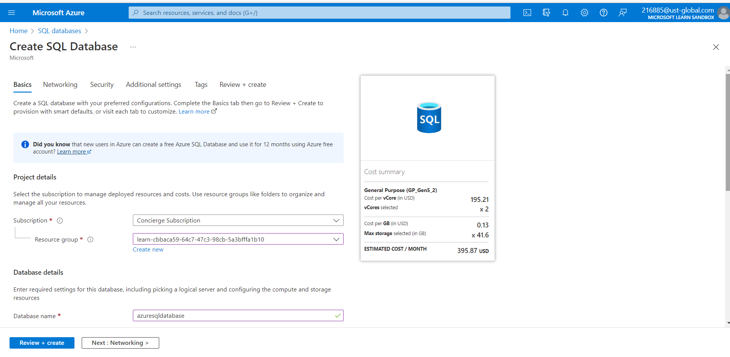

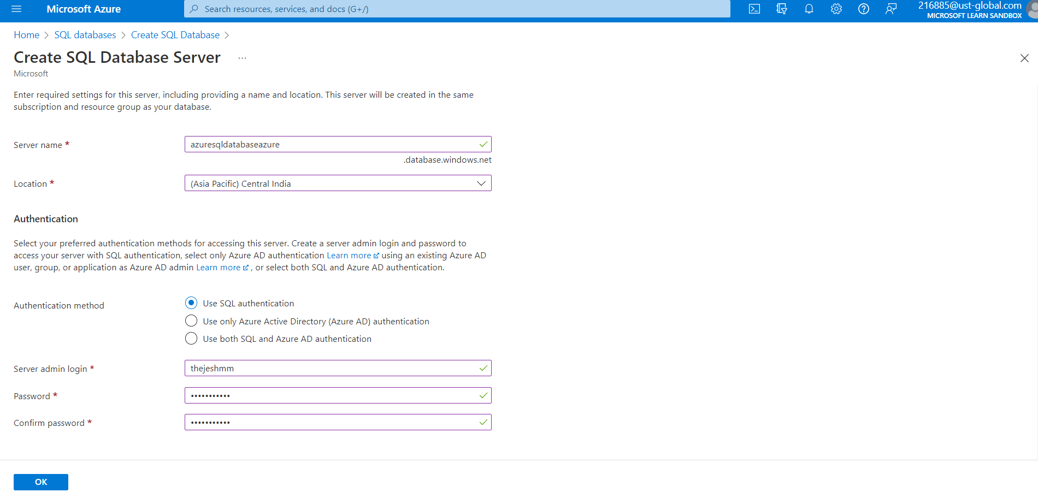

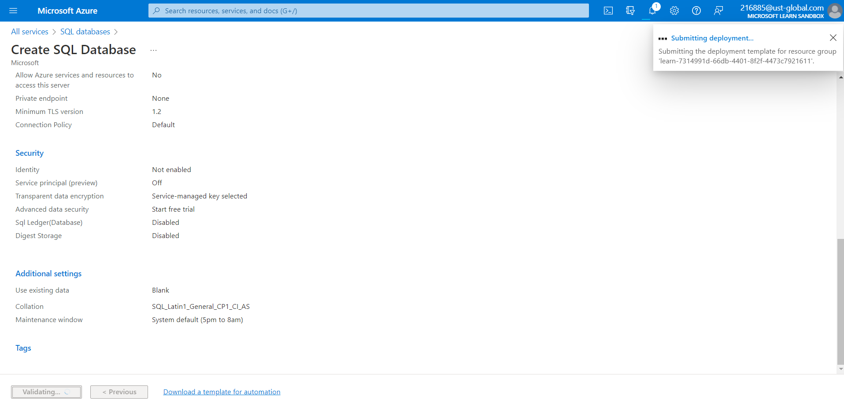

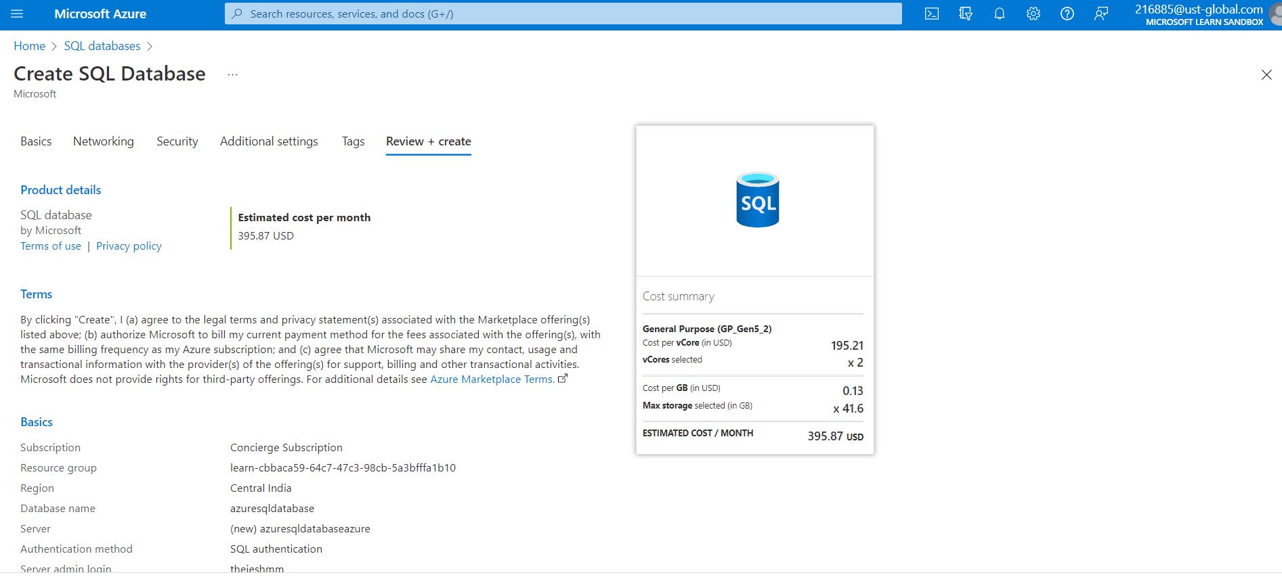

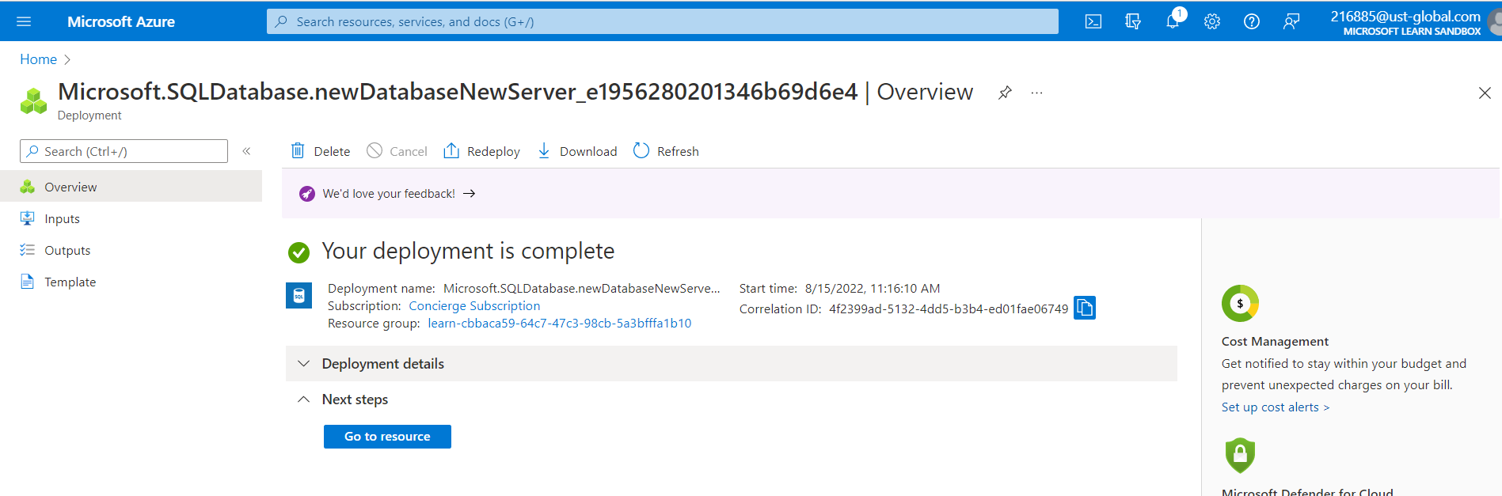

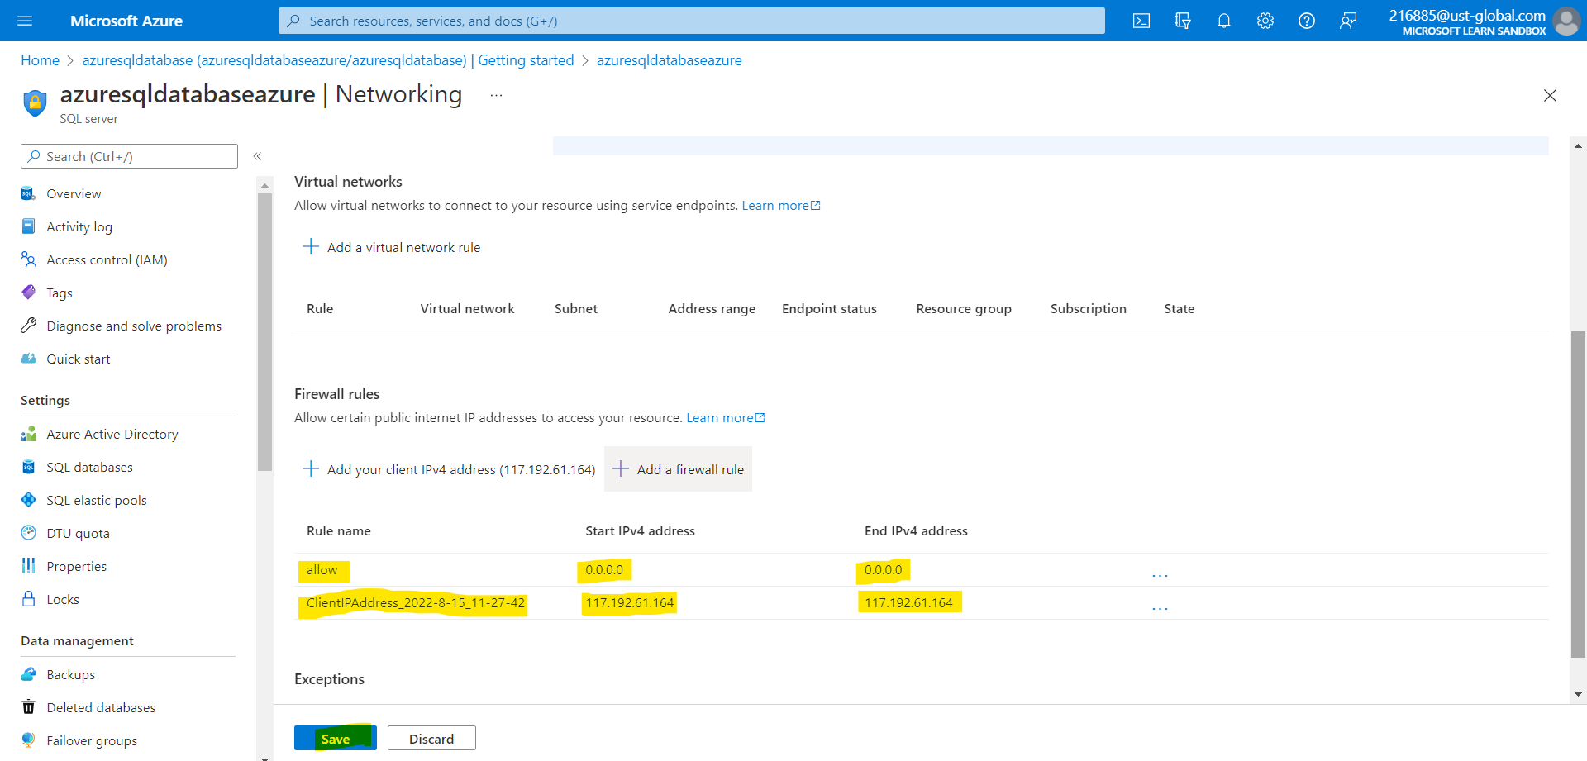

Create the tutorial database

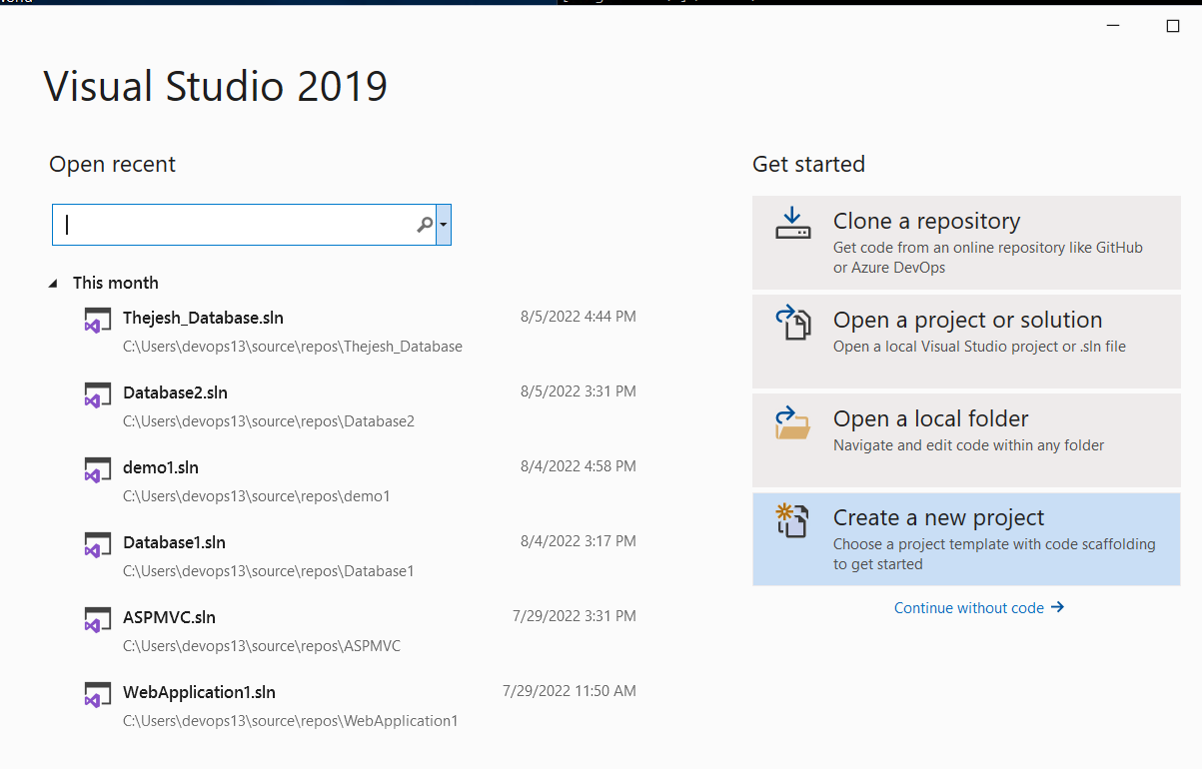

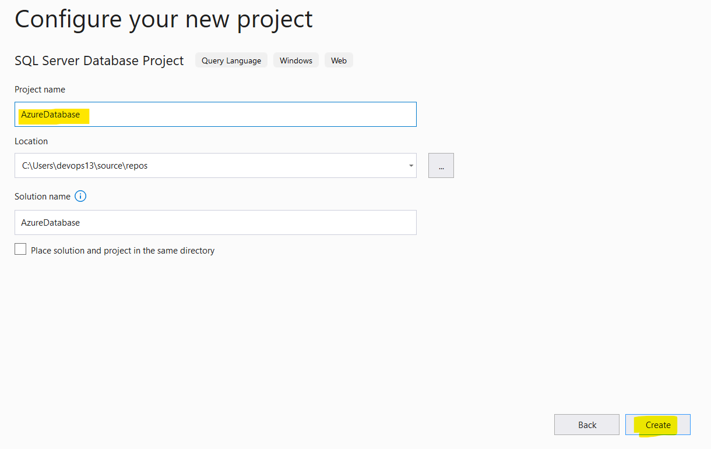

1. Go to Query editor > New Query

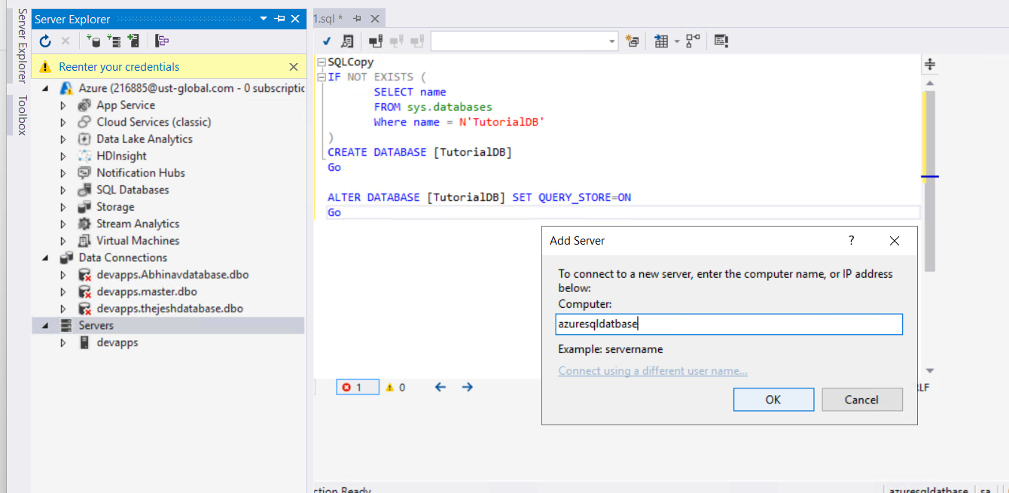

1. Paste this SQL into the query editor

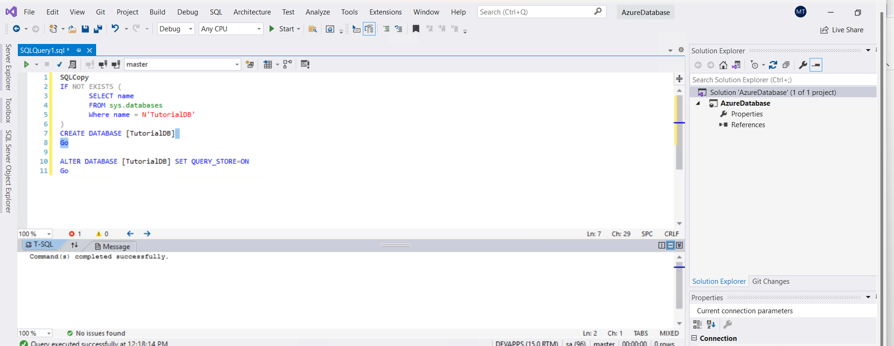

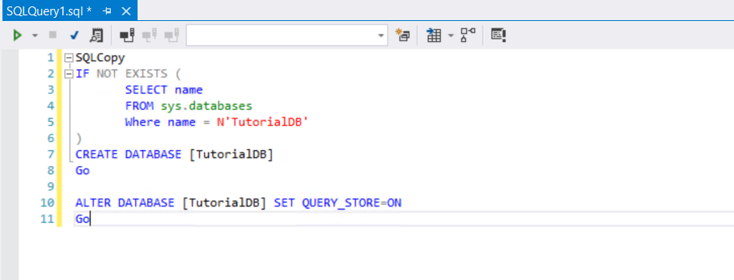

2.Create a Customers table.

Replace the previous query in the query editor with this one and select Run.

