Azure SQL Database

STEP1: Select of project type as asp.net mvc

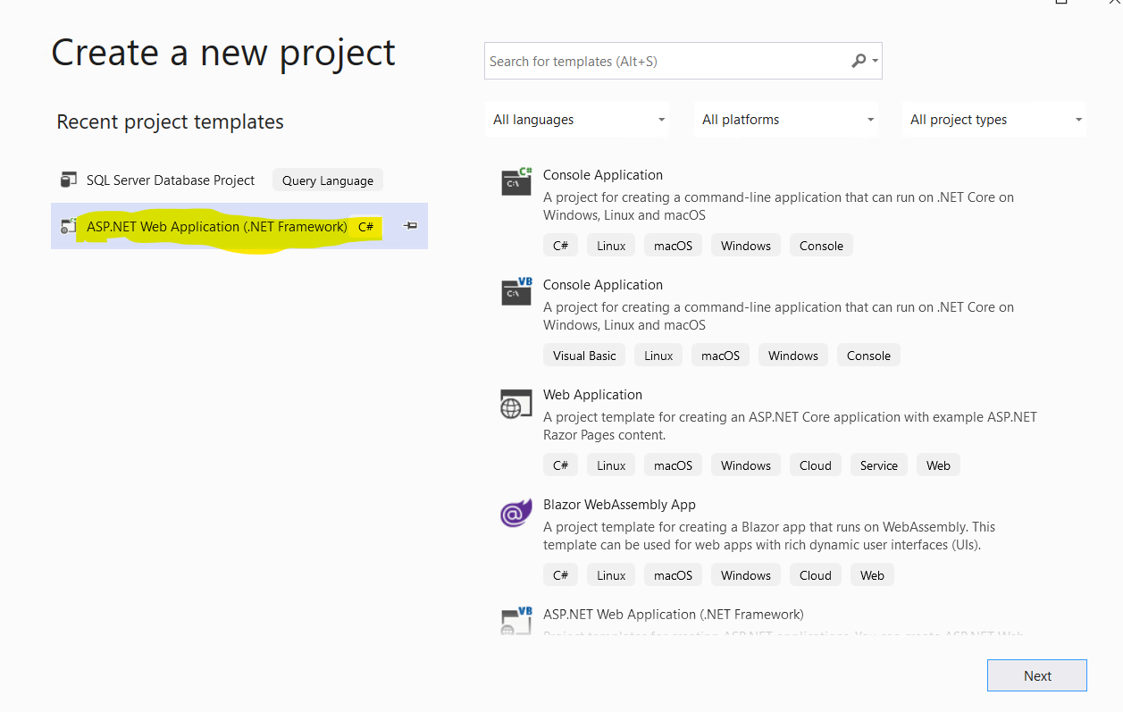

STEP2: Selecting project template as MVC

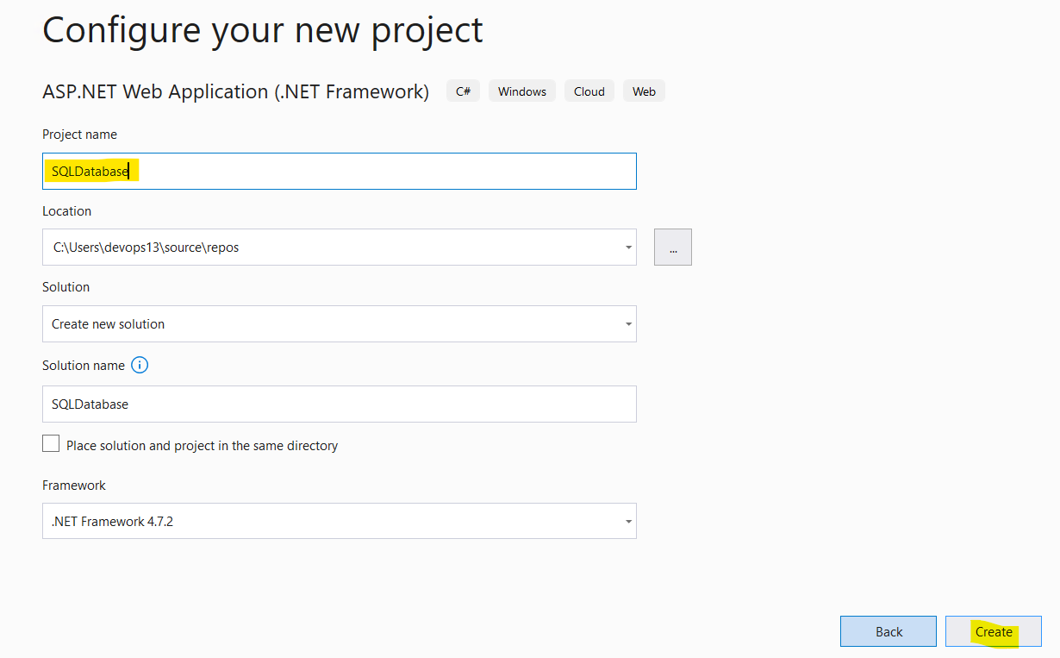

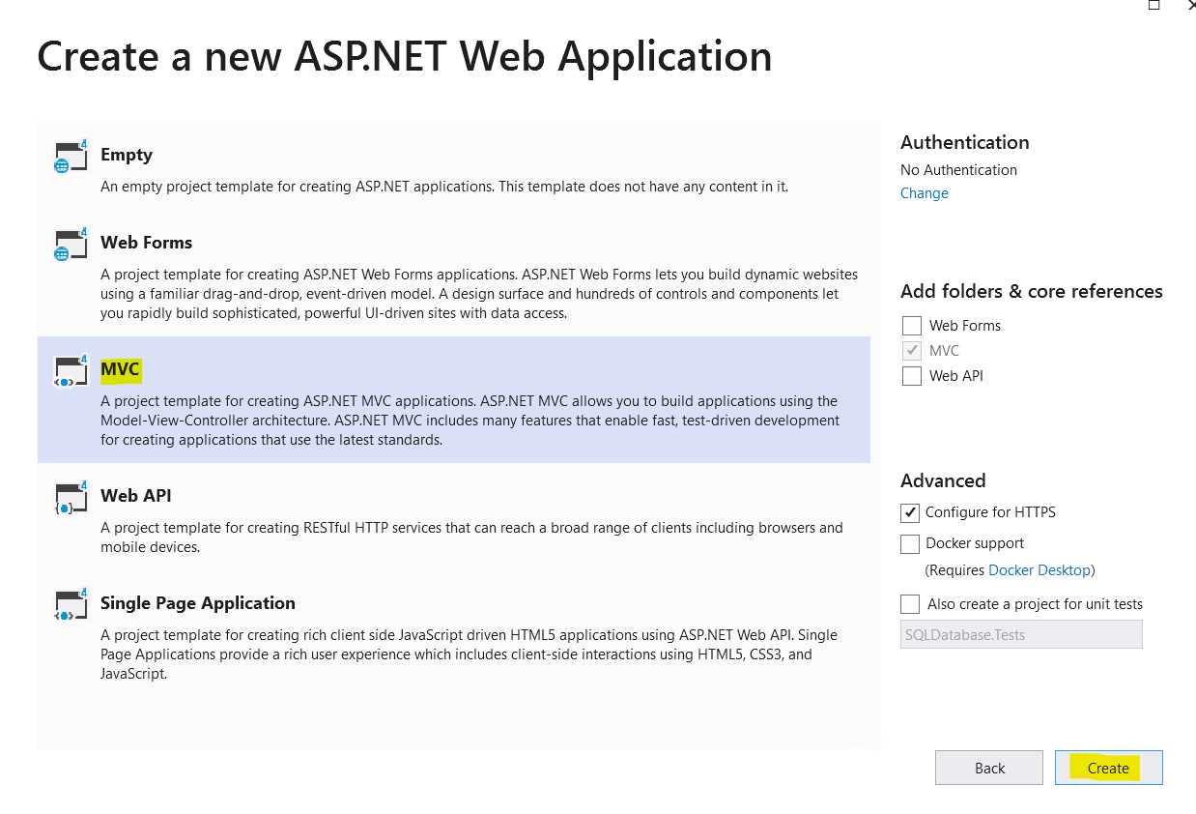

STEP3: Open project in Visual Studio

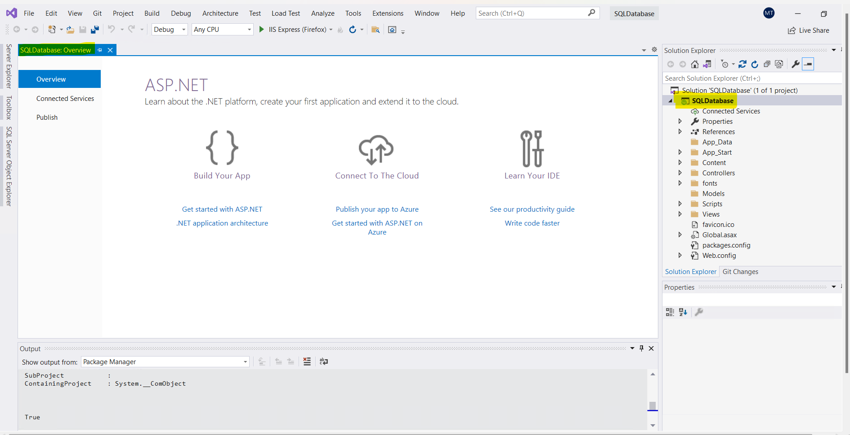

STEP4: In Solution Explorer > Connected Services node > Add Connected Service

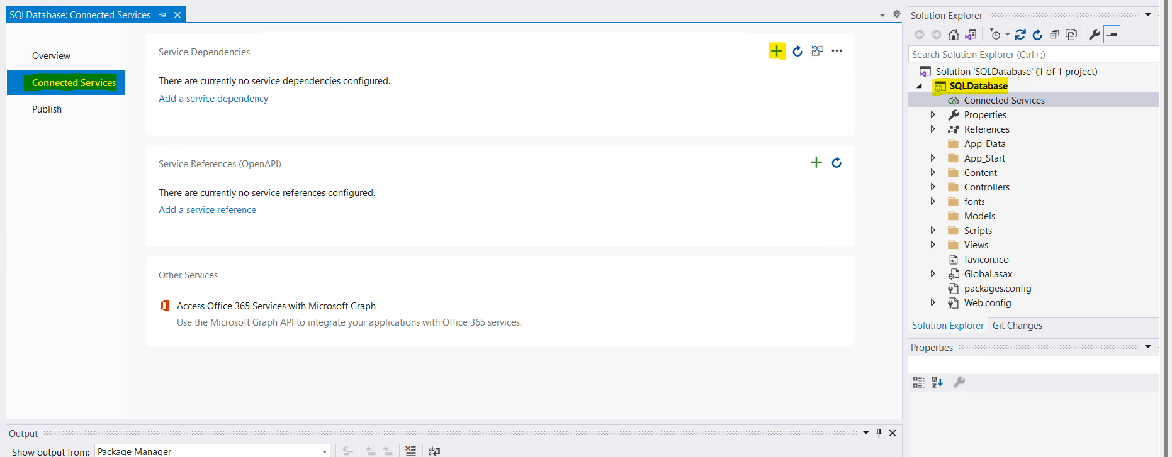

STEP5: In the Add Dependency page, select Azure SQL Database.

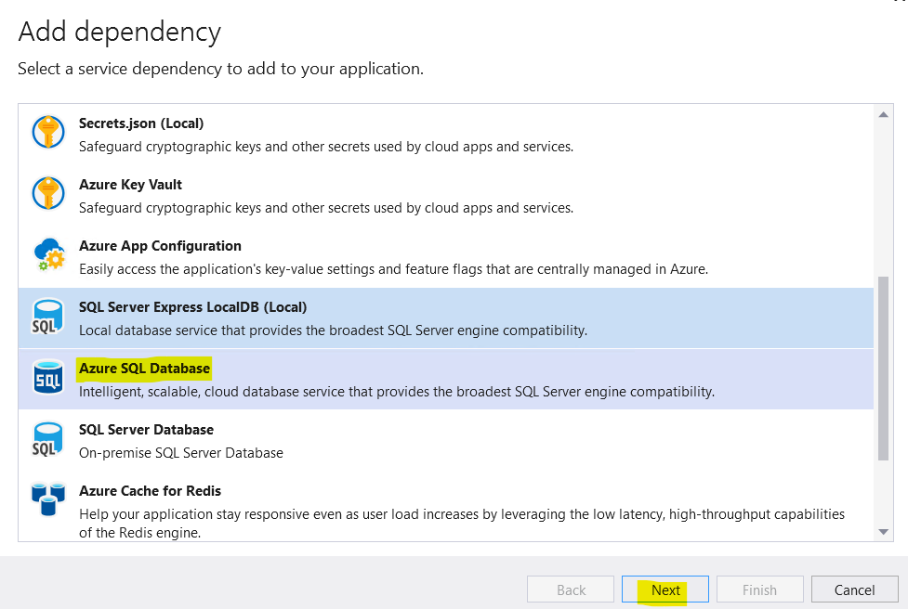

STEP6: In the Configure Azure SQL Database screen, select an existing Azure SQL Database, and

select Next

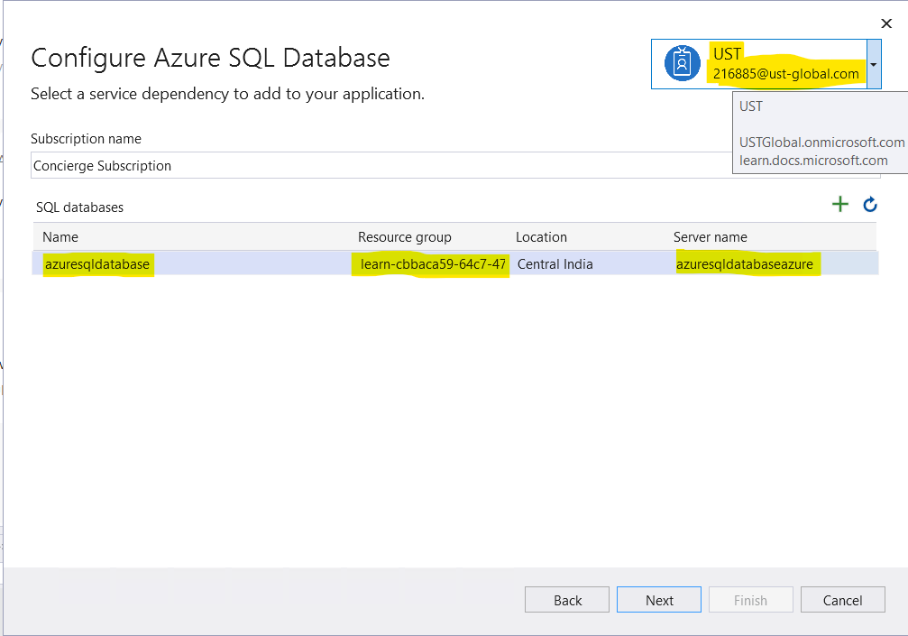

STEP7: create an Azure SQL Database

STEP8: Enter a connection string name, or choose the default, and choose whether you want the connection string stored in a local secrets file

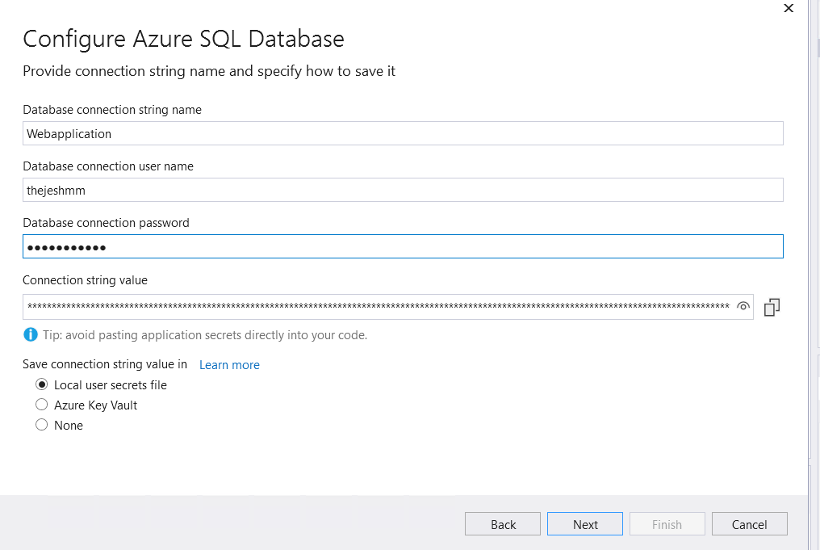

STEP9: The Summary of changes screen shows all the modifications that will be made to your project if you complete the process. Finish

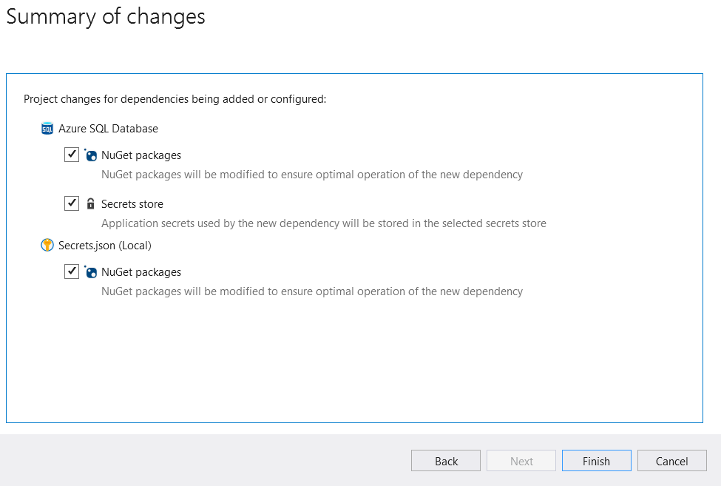

STEP10: If prompted to set a firewall rules, choose Yes.

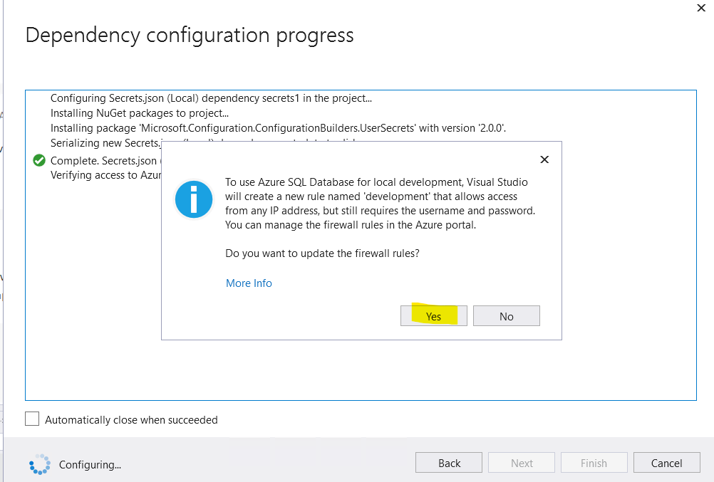

STEP11: The connection appears under the Service Dependencies section of the Connected Services tab

