JENKINS MAVEN INTEGRATION

1. Run Jenkins as a standalone application
2. Log in to the Jenkins.
3. Click on “New Item” on the Jenkins dashboard

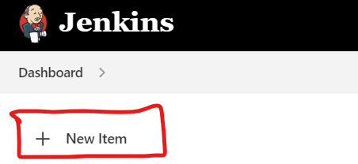

1. Upon clicking on a New Item, it will give the list of different Jenkins jobs
2. 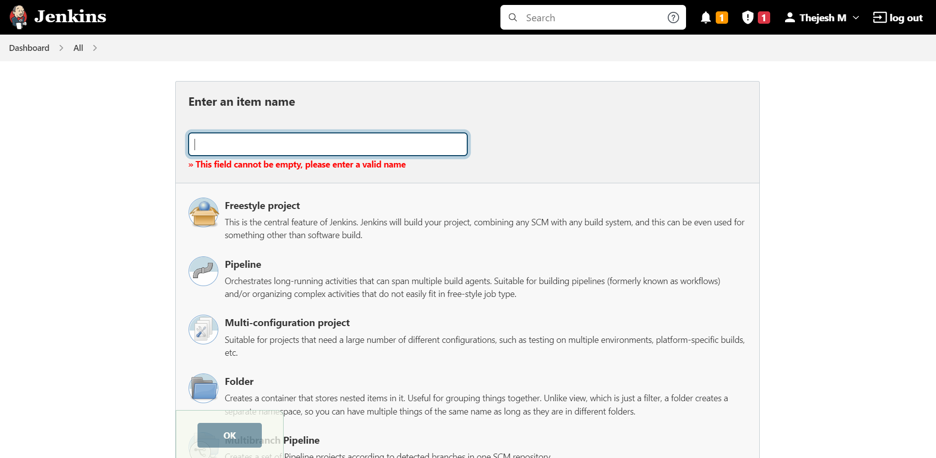

Configuring Source Code Management

1. First, log in to the GitHub repository and select the repository created.

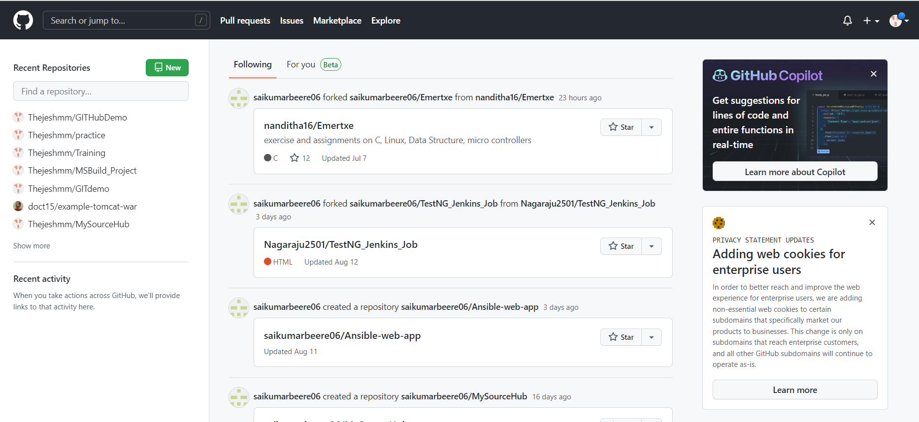

2) Click on the repository and make sure that the latest code is present

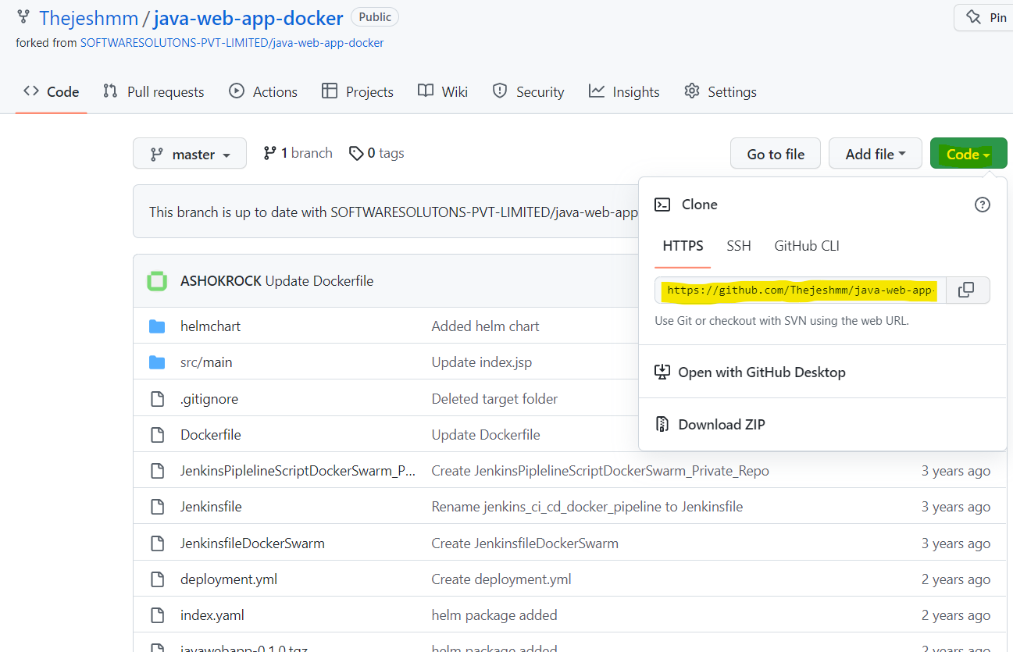

1. Now in Jenkins dashboard click on “New Item”.
2. Type a project name and select Freestyle project from a list of jobs enlisted

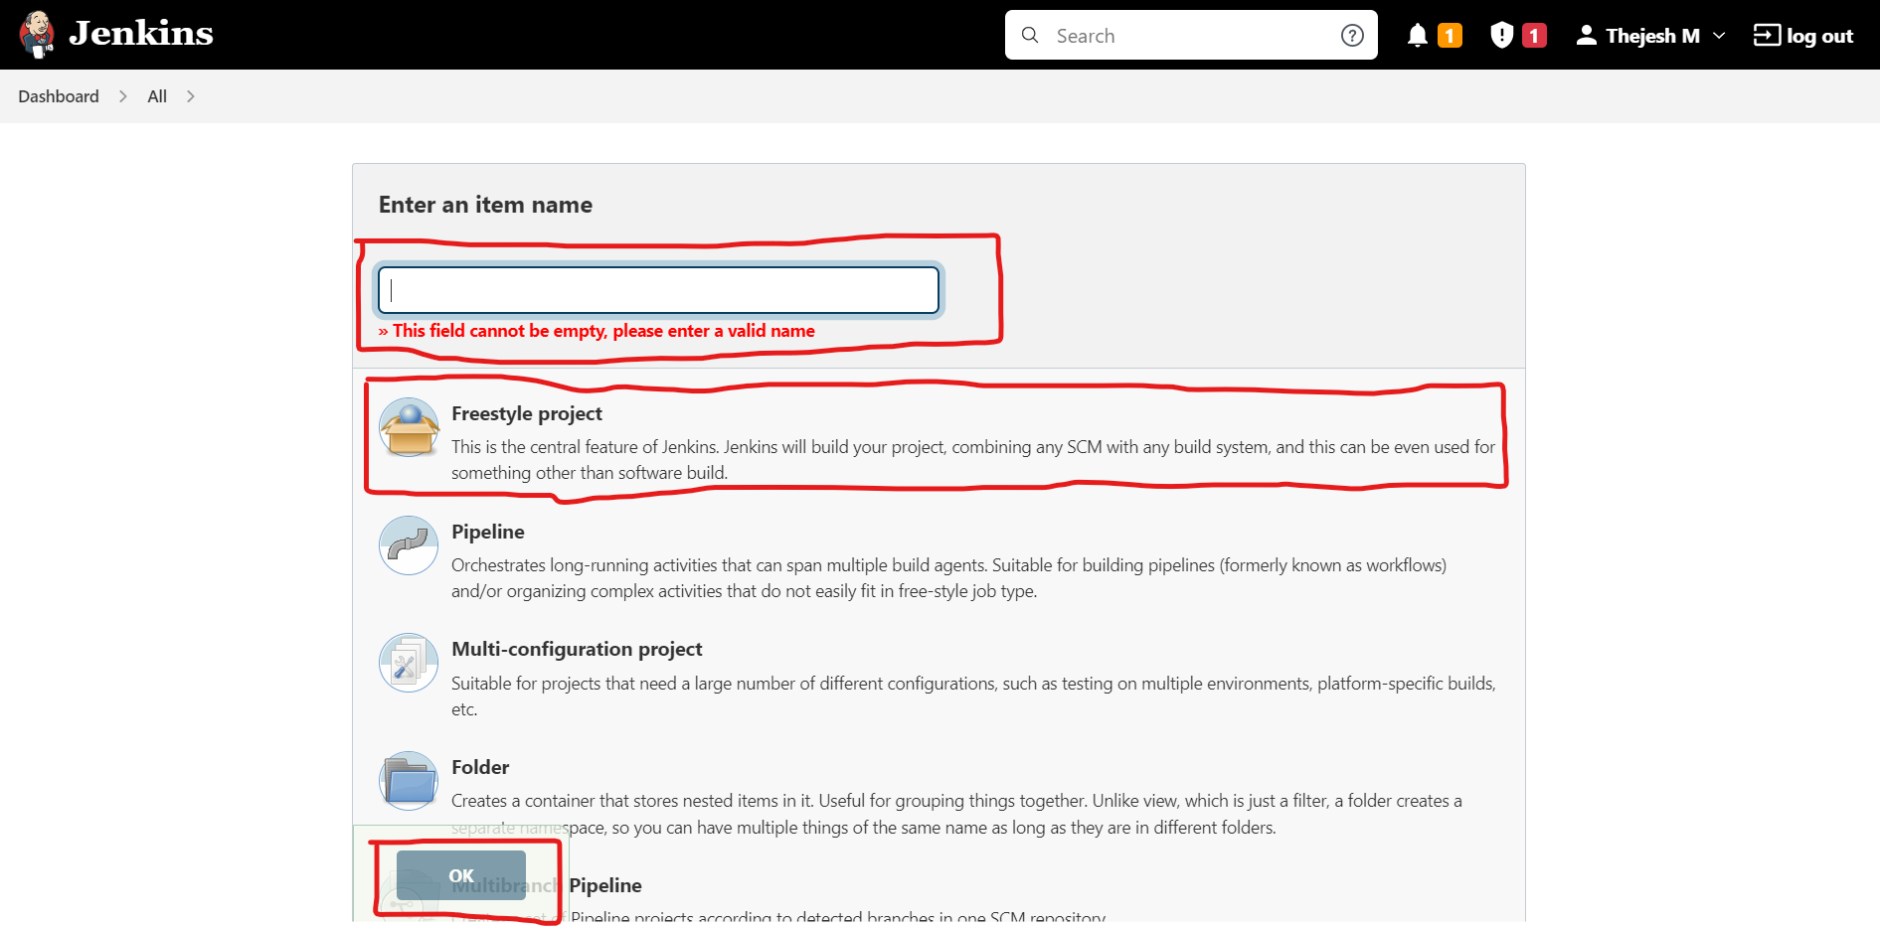

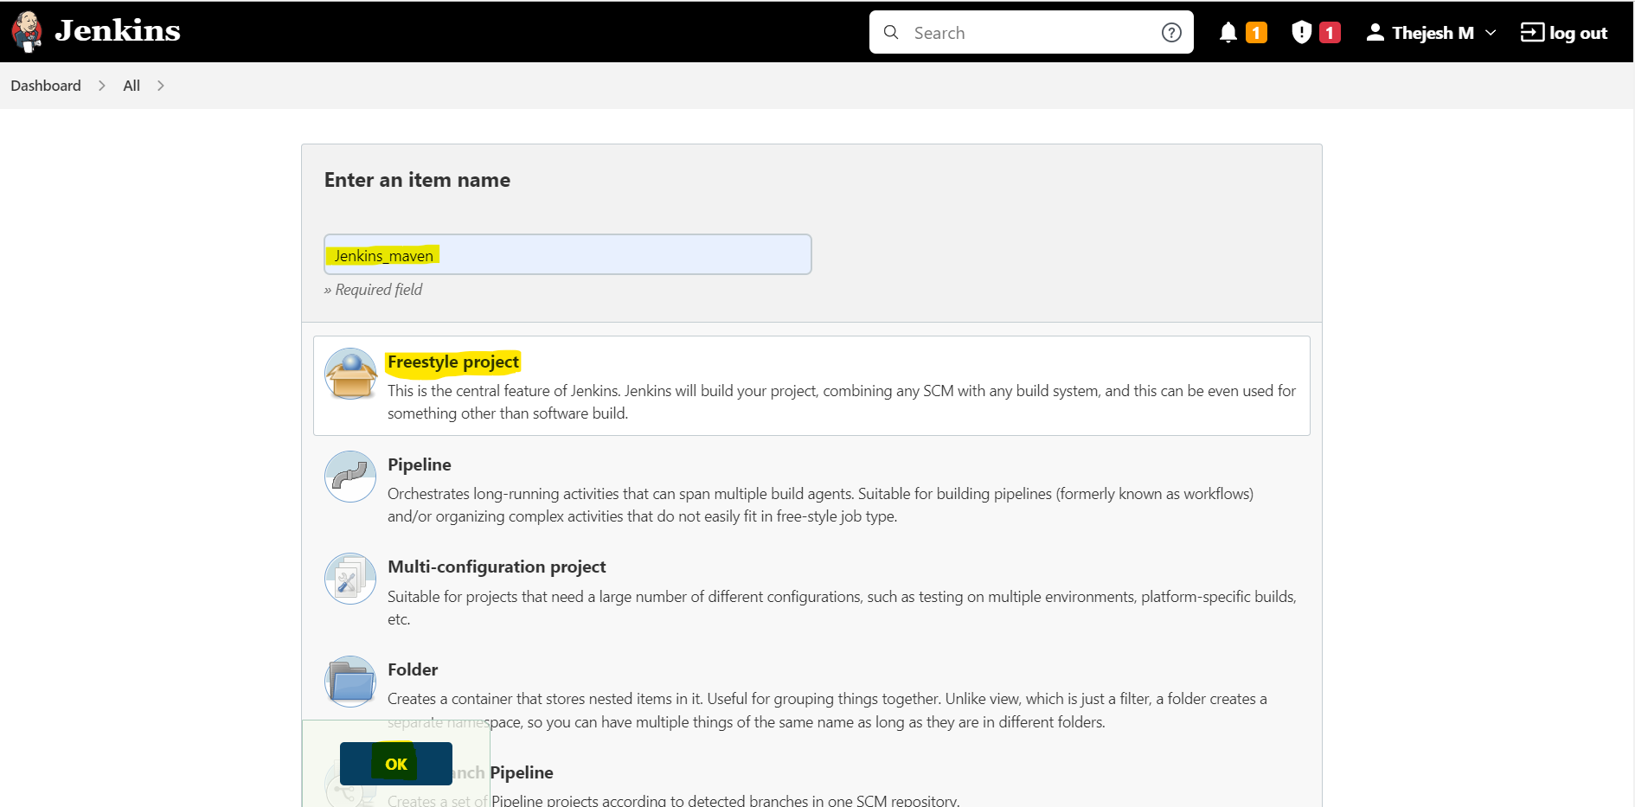

1. Select Git under source code management and provide the Github repository URL

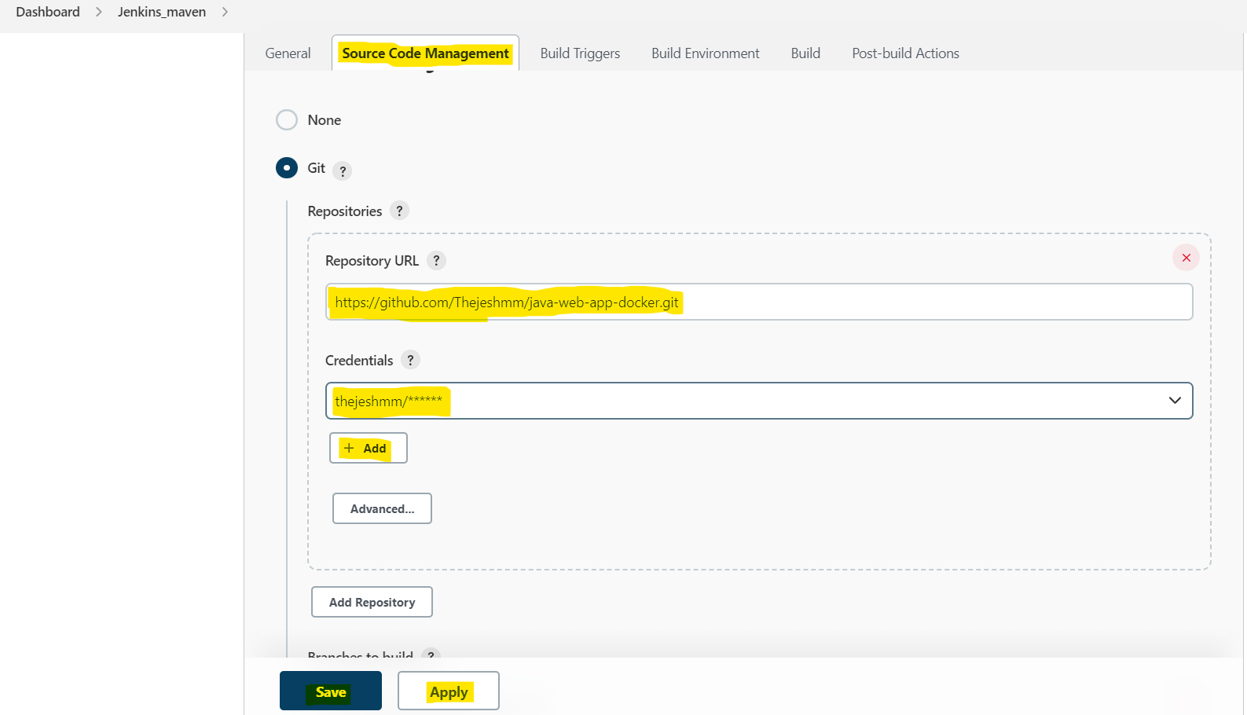

6) Provide the required build commands to run the code. Here we have used execute windows batch Command