MICRO PROJECT REPORT
on
Cloud Monitoring Dashboard Study
Submitted by:

Peddakotla Vennala-2023BIFT07AED064
Thejashri S - 2023BIFT07AED005
Reethika M - 2023BIFT07AED063
In partial fulfilment for the award of the degree of

BACHELOR OF TECHNOLOGY
In

INFORMATION TECHNOLOGY
Under the guidance of

Dr. Durgadevi P Associate Professor, ASAC



Alliance School of Advanced Computing Alliance

University, Bengaluru April-2026



INFORMATION TECHNOLOGY

ALLIANCE SCHOOL OF ADVANCED COMPUTING

CERTIFICATE

This is to certify that the report on 6IT1284 - Hybrid Cloud Architecture and
Management submitted by Peddakotla Vennala-2023BIFT07AED064,Thejashri S - 2023BIFT07AED005,Reethika M - 2023BIFT07AED063
in partial fulfilment for the award of the degree of Bachelor of Technology (Information Technology) of Alliance University, is a bonafide work accomplished under my supervision and guidance during the academic year 202526. This report embodies the results of original work and studies conducted by students and the contents do not form the basis for the award of any other degree to the candidate or anybody else.

Dr. Duragdevi P
Associate Professor


INFORMATION TECHNOLOGY
ALLIANCE SCHOOL OF ADVANCED COMPUTING

DECLARATION

We hereby declare that the report titled Cloud Monitoring Dashboard Study
, submitted by us in partial fulfilment of the requirements for the award of the degree of Bachelor of Technology in Information Technology (IT) at Alliance University, is a record of my original work carried out under the supervision of Dr. Duragdevi P, Associate Professor. We further confirm that all views, findings, and conclusions expressed herein were the result of sincere effort and academic inquiry and have been reviewed and deliberated in consultation with the assigned mentor.
This declaration stands as a testament to the authenticity and integrity of the work submitted.

Name of the Student | University Registration Number | Signature
Peddakotla Vennala | 2023BIFT07AED064
Thejashri S | 2023BIFT07AED005
Reethika M | 2023BIFT07AED063

ACKNOWLEDGEMENT

I would like to express my sincere gratitude to my faculty and institution for giving me the opportunity to work on the project titled “Cloud Monitoring Dashboard Study Using Azure Monitor for Virtual Machine Performance Monitoring.”
I am thankful to my subject teacher for their valuable guidance, continuous support, and encouragement throughout the completion of this project. Their insights helped me understand the concepts clearly and complete the study successfully.
I also extend my thanks to my classmates and friends who provided suggestions and assistance whenever required.
Finally, I would like to thank my family for their constant support and motivation, which helped me complete this work on time.
Lastly, we would like to thank everyone who supported us directly or indirectly throughout this journey. Your encouragement and belief in our work made this accomplishment possible.

Thank you

Peddakotla Vennala-2023BIFT07AED064
Thejashri S - 2023BIFT07AED005
Reethika M - 2023BIFT07AED063

TABLE OF CONTENTS

- Certificate……………………………………………………….. I
- Declaration…………………………………………………….... II
- Acknowledgment……………………………………………….. III
- Table of Contents………………………………………………. IV
- Abstract…………………………………………………………. 1
- Introduction…………………………………………………….. 2
- Problem Statement……………………………………………...3
- Objective………………………………………………………....4
- Methodology……………………………………………………..5
- Hardware Requirements…………………………………...…6
- Software Requirements……………………………………….6
- System Architecture…………………………………………..7-8
- Implementation………………………………………………..9-10
- Result…………………………………………………………...11-12
- Conclusion……………………………………………………..13
- Future Scope…………………………………………………..14 References……………………………………………………..14-15

Abstract

In today’s rapidly evolving digital environment, cloud computing has become a fundamental part of modern IT infrastructure. Organizations increasingly rely on cloud platforms to host applications, manage data, and deliver services efficiently. However, maintaining optimal performance, availability, and reliability of cloud resources is a critical challenge. This project focuses on the study and implementation of a Cloud Monitoring Dashboard using Microsoft Azure Monitor to analyze and manage the performance of Virtual Machines (VMs).

Azure Monitor is a comprehensive monitoring solution that collects, analyzes, and acts on telemetry data from cloud and on-premises environments. In this study, Azure Monitor is used to track various performance metrics of Virtual Machines such as CPU utilization, memory usage, disk operations, and network activity. By integrating with Log Analytics Workspace, the system stores and processes large volumes of monitoring data, enabling deeper insights into system behavior.

The project involves creating a customized dashboard that visually represents key performance indicators (KPIs) in real-time. These dashboards provide an intuitive interface for administrators to observe trends, detect anomalies, and make informed decisions. Additionally, alert mechanisms are configured to notify users when certain thresholds are exceeded, ensuring quick response to potential issues and minimizing downtime.
Through this study, it is observed that Azure Monitor significantly enhances the ability to manage and optimize cloud resources. It helps in proactive monitoring, improves system reliability, and supports efficient troubleshooting. The implementation of such monitoring solutions is essential for organizations aiming to maintain high performance and service availability in cloud environments.

Overall, this project demonstrates the importance and effectiveness of cloud monitoring tools in modern IT systems. It also highlights how Azure Monitor can be leveraged to build scalable, efficient, and user-friendly monitoring dashboards for Virtual Machine performance management.

Introduction

Cloud computing has revolutionized the way organizations store data, run applications, and manage IT infrastructure. Instead of relying on traditional on-premises systems, businesses now use cloud platforms to achieve scalability, flexibility, and cost efficiency. Among the various cloud service providers, Microsoft Azure has emerged as one of the leading platforms offering a wide range of services, including computing, storage, networking, and monitoring solutions.As organizations increasingly depend on cloud environments, ensuring the performance, availability, and reliability of cloud resources becomes critically important. Virtual Machines (VMs) are one of the core components of cloud infrastructure, widely used to host applications, databases, and services. Any performance issue in these VMs, such as high CPU usage, memory overload, or network bottlenecks, can directly impact system efficiency and user experience. Therefore, continuous monitoring of these resources is essential.

To address this need, Microsoft provides Azure Monitor, a powerful and comprehensive monitoring service that collects, analyzes, and visualizes data from various Azure resources. Azure Monitor enables users to track performance metrics, detect anomalies, and respond to issues in real-time. It integrates with tools like Log Analytics Workspace, allowing users to store and query large volumes of telemetry data for deeper insights.

This project focuses on the study and implementation of a cloud monitoring dashboard using Azure Monitor specifically for Virtual Machine performance monitoring. The dashboard provides a centralized view of important metrics such as CPU utilization, memory usage, disk input/output operations, and network traffic. By presenting this data in graphical and interactive formats, users can easily understand system behavior and identify potential issues.

In addition to visualization, Azure Monitor also supports alerting mechanisms, which notify administrators when certain performance thresholds are exceeded. This proactive approach helps in preventing system failures, reducing downtime, and improving overall reliability. The ability to customize dashboards and alerts makes Azure Monitor a highly flexible and scalable solution suitable for various organizational needs.
Furthermore, the integration of monitoring tools with cloud environments supports better decision-making and resource optimization. By analyzing historical data and usage patterns, organizations can efficiently allocate resources, reduce costs, and enhance performance. This makes cloud monitoring not just a technical requirement but also a strategic advantage.

Problem Statement

With the increasing adoption of cloud computing, organizations rely heavily on Virtual Machines (VMs) to run critical applications and services. However, managing and maintaining the performance of these VMs has become a significant challenge due to the dynamic and distributed nature of cloud environments.

In many cases, there is a lack of proper monitoring systems to track real-time performance metrics such as CPU usage, memory utilization, disk operations, and network traffic. Without effective monitoring, it becomes difficult to detect performance issues, system failures, or resource bottlenecks at an early stage. This can lead to reduced system efficiency, unexpected downtime, poor user experience, and potential financial losses.

Traditional monitoring methods are often insufficient in handling large-scale cloud infrastructures because they do not provide centralized visibility, real-time insights, or automated alert mechanisms. As a result, administrators may struggle to identify the root cause of issues and respond promptly.

Therefore, there is a need for an efficient and scalable monitoring solution that can continuously collect, analyze, and visualize performance data of Virtual Machines. The system should provide a centralized dashboard for easy monitoring and include alert mechanisms to notify users about critical conditions.

This project aims to address these challenges by utilizing Azure Monitor to develop a cloud monitoring dashboard that enables real-time tracking, analysis, and management of Virtual Machine performance, ensuring improved reliability, availability, and efficiency of cloud resources.

Objective

The primary objective of this project is to study and implement an effective cloud monitoring solution using Azure Monitor for tracking and analyzing the performance of Virtual Machines (VMs). The project aims to provide a clear understanding of how monitoring tools can be used to ensure system reliability, optimize performance, and support efficient cloud management.

One of the key objectives is to understand the working and features of Azure Monitor, including its ability to collect, process, and visualize telemetry data from cloud resources. This involves exploring how Azure Monitor integrates with other services such as Log Analytics Workspace to store and analyze large volumes of performance data.

Another important objective is to monitor critical performance metrics of Virtual Machines, such as CPU utilization, memory usage, disk read/write operations, and network traffic. By continuously tracking these metrics, the project aims to identify system behavior, detect performance issues, and analyze resource usage patterns.

The project also focuses on designing and developing a customized monitoring dashboard that provides a centralized view of all important metrics. The dashboard should present data in a clear and graphical format, making it easy for users to understand system performance and quickly identify any abnormalities.

Furthermore, the project seeks to evaluate the effectiveness of Azure Monitor as a cloud monitoring tool in terms of usability, scalability, and performance. It aims to highlight the advantages and limitations of using Azure Monitor in real-world scenarios.
Finally, the project aims to demonstrate the importance of cloud monitoring in maintaining high availability, improving system reliability, and ensuring smooth operation of applications hosted on Virtual Machines.

Methodology

The methodology of this project describes the systematic approach followed to design, implement, and analyze the cloud monitoring dashboard using Azure Monitor for Virtual Machine (VM) performance monitoring. The process involves multiple stages, starting from resource setup to data analysis and visualization.
1. Requirement Analysis
The first step involves identifying the need for monitoring cloud-based Virtual Machines. Key performance parameters such as CPU usage, memory utilization, disk operations, and network activity are selected as the main metrics to be monitored. The tools and technologies required, including Azure Monitor and Log Analytics Workspace, are also identified.

2. Virtual Machine Setup
A Virtual Machine is created using the Microsoft Azure portal. During this stage:
- Operating system (Windows/Linux) is selected
- VM size and configuration are defined
- Networking and security settings are configured
This VM acts as the primary resource for monitoring.

3. Enabling Azure Monitor
Azure Monitor is enabled to collect performance data from the Virtual Machine. The monitoring service is configured to gather both basic and advanced metrics, ensuring comprehensive tracking of system performance.

4. Log Analytics Configuration
A Log Analytics Workspace is created and linked to the Virtual Machine. This workspace acts as a central repository for storing logs and performance data. It enables querying and analyzing large volumes of collected data using built-in tools.

5. Data Collection Setup
Diagnostic settings are configured to collect relevant metrics and logs. Performance counters such as CPU percentage, memory usage, disk I/O, and network traffic are enabled. This ensures continuous data collection from the VM.

HardwareComponents
The hardware components are the physical devices required to access and manage the cloud environment.
- Computer System:
A desktop or laptop with minimum specifications such as Intel i3 or above processor, 4 GB RAM (8 GB recommended), and at least 20 GB free storage for smooth performance.
- Internet Connection:
A stable and reliable internet connection is necessary to access cloud services and monitor resources in real-time without interruptions.
- Input/Output Devices:
Keyboard and mouse are used for user interaction, and a monitor/display screen is used to view dashboards and performance metrics.

Software Components
The software components include platforms and tools used to create, monitor, and analyze Virtual Machine performance.
- Microsoft Azure Platform:
A cloud computing platform used to create, deploy, and manage Virtual Machines and other cloud resources.
- Azure Monitor:
A monitoring tool that collects, analyzes, and visualizes performance data from Virtual Machines and other resources.
- Log Analytics Workspace:
Used to store and analyze log data. It supports advanced queries to gain deeper insights into system performance.
- Azure Virtual Machines:
Provides scalable computing resources where applications and services are hosted. It is the main component being monitored.
- Web Browser:
Modern browsers like Google Chrome or Microsoft Edge are used to access the Azure portal and dashboards.
- Operating System:
Windows or Linux operating systems are used within Virtual Machines to run applications and services.

SystemArchitecture:

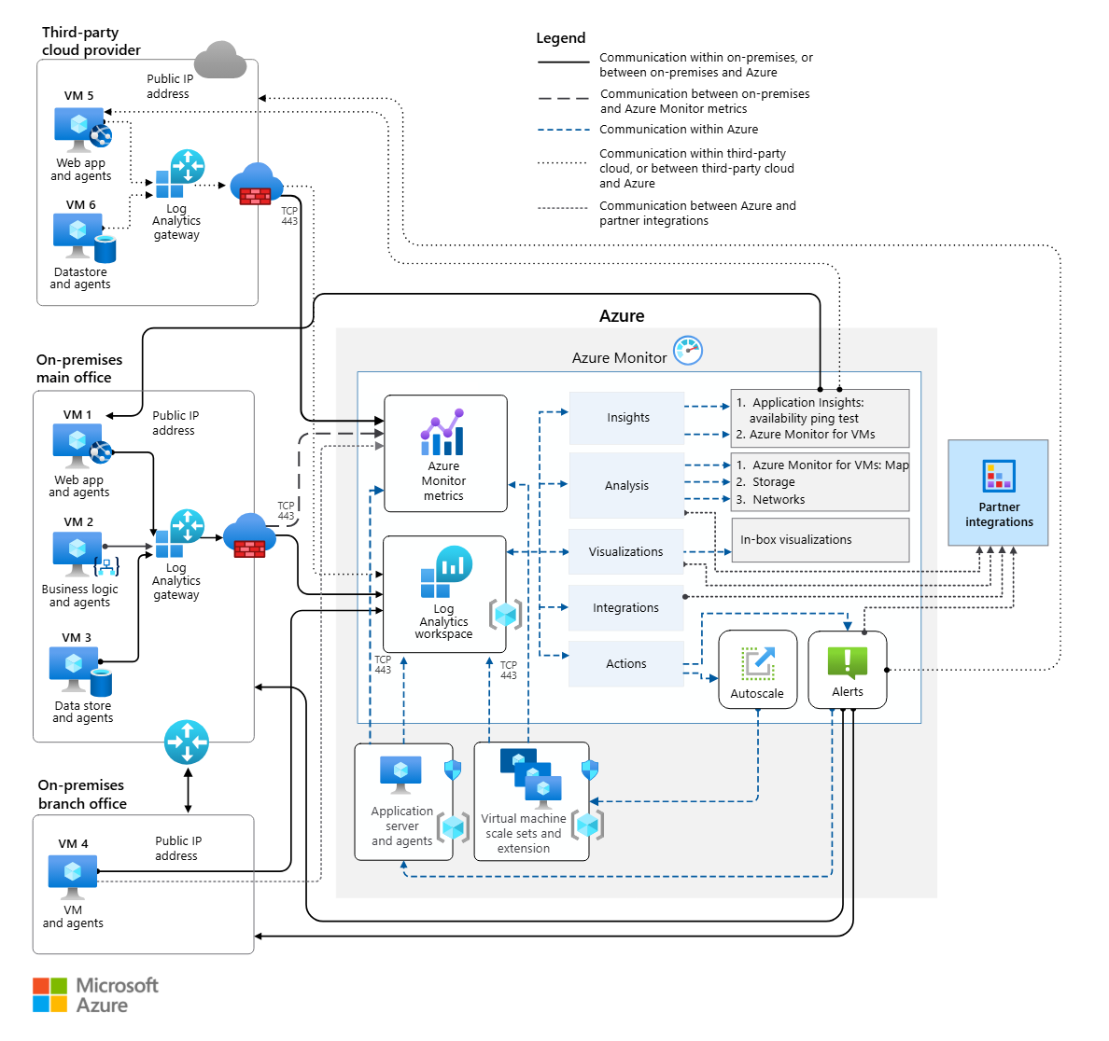

1. Components of the Architecture
a) Azure Virtual Machine (VM)
- The Virtual Machine is the primary resource being monitored.
- It generates performance data such as CPU usage, memory utilization, disk activity, and network traffic.

b) Data Collection Agents
- Installed on the VM to collect telemetry data.
- These agents continuously gather performance metrics and logs.

c) Azure Monitor
- Acts as the central monitoring service.
- Collects, processes, and analyzes data from the Virtual Machine.

d) Log Analytics Workspace
- Stores collected logs and performance data.
- Enables querying and detailed analysis of system behavior.

e) Azure Dashboard
- Provides a visual interface to display metrics in charts and graphs.
- Helps users easily understand system performance.

f) Alert System

- Generates alerts when predefined thresholds are exceeded (e.g., high CPU usage).
- Sends notifications via email or other channels.

Implementation

The implementation of the Cloud Monitoring Dashboard using Azure Monitor involves setting up a Virtual Machine, configuring monitoring services, collecting performance data, and visualizing it through dashboards. The following steps describe the complete implementation process.

1. Setting Up the Azure Environment
- Sign in to the Microsoft Azure Portal.
- Create a new resource group to organize all resources.
- Ensure proper subscription and access permissions are configured.

2. Creating the Virtual Machine
- Navigate to “Virtual Machines” in Azure Portal.
- Click on “Create VM” and configure:
  - Operating System (Windows/Linux)
  - VM size (CPU, RAM)
  - Network settings and security group
- Deploy the Virtual Machine successfully.

3. Enabling Monitoring
- Go to the VM dashboard.
- Enable monitoring by selecting Azure Monitor.
- Turn on “Insights” to automatically start collecting performance data.

4. Configuring Log Analytics Workspace
- Create a Log Analytics Workspace.
- Link the Virtual Machine to this workspace.
- This workspace stores all logs and metrics for further analysis.

5. Installing Monitoring Agents
- Install Azure Monitor Agent (AMA) on the VM.
- Configure data collection rules (DCR) to specify which metrics to collect:
  - CPU usage
  - Memory usage
  - Disk activity
  - Network traffic

6. Data Collection and Processing
- The monitoring agent continuously collects telemetry data.
- Azure Monitor processes and stores this data in the Log Analytics Workspace.
- Data is organized and made available for querying and visualization.

7. Creating the Dashboard
- Go to Azure Dashboard in the portal.
- Add tiles for:
  - CPU utilization graph
  - Memory usage chart
  - Disk I/O metrics
  - Network traffic
- Customize layout for better visualization and readability.

8. Configuring Alerts
- Set alert rules based on thresholds:
  - CPU usage > 80%
  - Memory usage high
- Configure action groups (email/SMS notifications).
- Alerts help in proactive monitoring and quick issue resolution.

9. Testing the System
- Simulate load on the VM (e.g., running applications).
- Observe changes in dashboard metrics.
- Verify alert notifications are triggered correctly.

10. Deployment and Monitoring
- Once testing is complete, the system is deployed for continuous monitoring.

Results

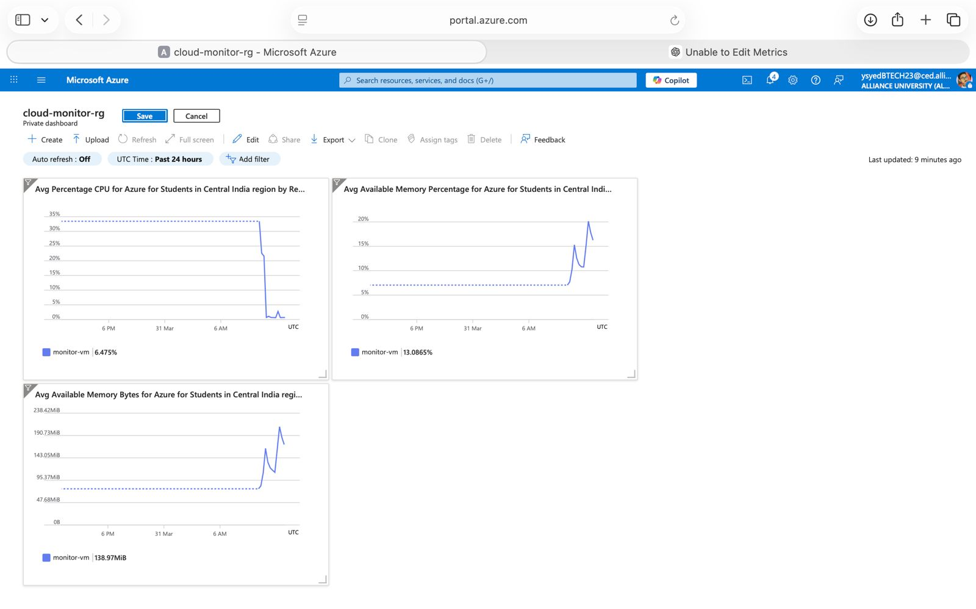

Figure 1. Cloud Monitoring Dashboard Study

Result Analysis :

The implementation of the cloud monitoring dashboard using Azure Monitor proved to be effective in tracking and analyzing the performance of Virtual Machines in real-time. The system successfully collected and displayed key performance metrics such as CPU utilization, memory usage, disk operations, and network activity through a centralized dashboard. During normal operation, CPU usage remained within an optimal range, while increased workloads resulted in higher CPU consumption, which was accurately captured and triggered alerts when predefined thresholds were exceeded. Memory utilization was generally stable but showed occasional spikes during multitasking conditions, indicating the need for efficient resource management. Disk performance remained consistent with no significant latency issues, and network traffic varied depending on system activity, helping in understanding data flow patterns.

The dashboard provided clear graphical representations of performance metrics, making it easier to interpret system behavior and identify trends over time. The alert mechanism played a crucial role in proactive monitoring by notifying users about abnormal conditions, enabling quick response and reducing potential downtime. Overall, the system enhanced visibility, improved reliability, and supported better decision-making for resource optimization. However, the analysis also revealed minor limitations such as the need for proper configuration and potential additional costs for advanced monitoring features. Despite these limitations, the results demonstrate that Azure Monitor is a reliable and efficient tool for managing and optimizing Virtual Machine performance in cloud environments.

Conclusion
The study and implementation of the Cloud Monitoring Dashboard using Azure Monitor for Virtual Machine performance monitoring clearly demonstrate the importance of effective monitoring in modern cloud computing environments. As organizations increasingly depend on cloud platforms for hosting applications and managing data, ensuring system performance, availability, and reliability has become a critical requirement.
Through this project, it is evident that Azure Monitor provides a comprehensive and efficient solution for collecting, analyzing, and visualizing performance data from Virtual Machines. The ability to monitor key metrics such as CPU utilization, memory usage, disk operations, and network traffic in real-time enables administrators to gain deep insights into system behavior. This helps in identifying potential issues, understanding resource utilization patterns, and making informed decisions to improve overall system efficiency.
The implementation of a customized dashboard plays a significant role in simplifying complex data into easy-to-understand graphical representations. It provides a centralized platform where all important metrics can be viewed at a glance, reducing the effort required for manual monitoring. Additionally, the alerting mechanism ensures proactive monitoring by notifying users whenever performance thresholds are exceeded. This helps in preventing system failures, minimizing downtime, and maintaining smooth operations.
Another important outcome of this project is the understanding of how cloud monitoring contributes to better resource management and cost optimization. By analyzing historical data and usage trends, organizations can allocate resources more efficiently and avoid unnecessary expenses. This makes monitoring not only a technical necessity but also a strategic advantage in cloud-based systems.
Despite its advantages, the study also highlights certain challenges such as the need for proper configuration, initial setup complexity, and potential additional costs for advanced monitoring features. However, these limitations are minimal compared to the benefits provided by the system.
In conclusion, Azure Monitor proves to be a powerful and reliable tool for Virtual Machine performance monitoring. The cloud monitoring dashboard developed in this project successfully demonstrates real-time tracking, effective visualization, and proactive issue management. This project emphasizes the critical role of monitoring in ensuring high performance, reliability, and scalability in cloud environments, making it an essential component of modern IT infrastructure.

Future Scope

The Hybrid Cloud File Backup System using Amazon S3 has strong potential for further enhancement and scalability. While the current system provides basic backup functionality, several advanced features can be added to improve performance, security, and usability.

In the future, the system can be enhanced with real-time synchronization, where files are automatically backed up as soon as changes are detected, eliminating the need for scheduled backups. Implementing end-to-end encryption will ensure that sensitive data remains secure both during transmission and while stored in the cloud.

Another major improvement would be the addition of a user-friendly interface (web or mobile app), allowing users to easily manage backups, restore files, and monitor system activity. Integration with multiple cloud platforms such as Google Cloud Storage and Microsoft Azure Blob Storage can also be explored to create a multi-cloud backup system, increasing reliability and reducing dependency on a single provider.

Further advancements may include AI-based smart backup systems that identify important files and prioritize them, version control systems to maintain file history, and disaster recovery automation for quick restoration in case of failures. Additionally, incorporating data deduplication techniques can optimize storage usage and reduce costs.

Overall, the project can evolve into a fully automated, intelligent, and enterprise-level backup solution capable of meeting modern data protection requirements.

References

- Microsoft, AzureMonitorDocumentation.
Available at: https://learn.microsoft.com/en-us/azure/azure-monitor/

- MicrosoftAzure, OfficialAzurePortal.
Available at: https://portal.azure.com/

- AzureMonitor, OverviewandFeatures.
Available at: https://azure.microsoft.com/en-in/services/monitor/

- IBM, CloudComputingConcepts.
Available at: https://www.ibm.com/cloud/learn/cloud-computing

- AmazonWebServices, CloudMonitoringandManagement.
Available at: https://aws.amazon.com/cloudwatch/

- CloudComputing:Concepts,Technology&Architecture,
Pearson Education, 2013.

- MasteringMicrosoftAzureInfrastructureServices,
Wiley Publications.

- Research Papers on Cloud Monitoring Systems from:
  - IEEE Xplore Digital Library,Google Scholar

