TASK 4:

Definition: A **load balancer** is a system that distributes incoming network traffic across multiple servers to ensure no single server is overwhelmed, improving performance, reliability, and availability.

START MINIKUBE

Steps:

Step 1: create vim files vim t1.txt vim t2.txt Step 2: Apply kubectl apply -f t1.txt kubectl apply -f t2.txt Step 3: check context kubectl config

current-context Step 4: start service minikube service depth Screenshots:

Thej.txt

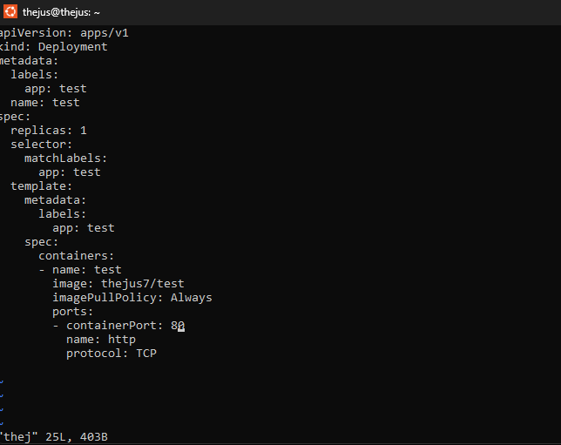

Thej1.txt

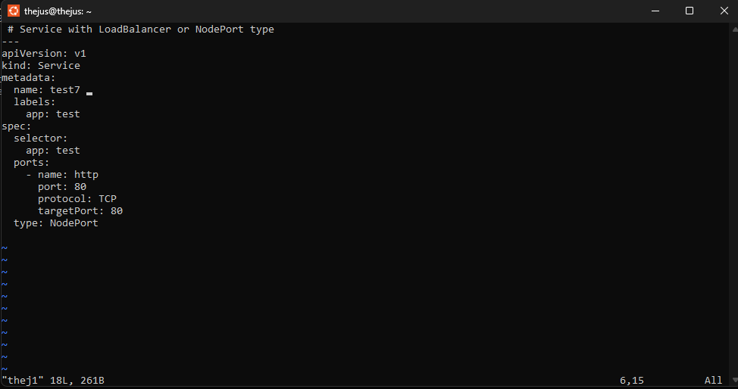

Creation and deployment



Output:

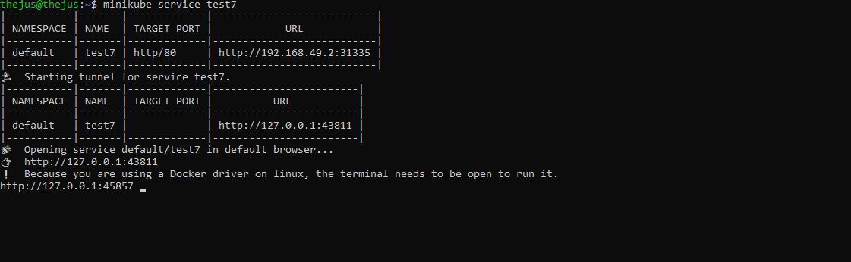

Output:

