TASK 5:

Definition: Maven is like a project manager for Java applications. Just like a manager

organizes tasks, resources, and deadlines, Maven organizes dependencies, builds, tests, and deployments, ensuring everything runs smoothly and efficiently.

Step 1: Install Java and Maven on Ubuntu

Step 2: Fork the eKart Repository on GitHub

# Step 3: Configure Jenkins Create a New Job in Jenkins

1. Open **Jenkins** in your browser.
2. Click on **New Item** → Select **Freestyle Project** → Name it Maven_task5 → Click **OK**. **Configure the Job**
   * **Set up Build Tools**: o Under **Global Tool Configuration**, add **Java** and **Maven** if not configured.

# Set GitHub Repository:

* + - Go to **Source Code Management** → Select **Git**. o Paste the forked repository URL.
    - Set the branch to main.

# Add Build Command:

* + - Go to **Build** → Add Build Step → Select **Invoke top-level Maven targets**.
    - Enter: clean package -DskipTests o Then **Build Now**. Step 4: Navigate to Jenkins Workspace

cd /var/lib/Jenkins ls

cd workspace ls

cd Maven_task5

cd target ls

cd ..

docker build -t eimg -f docker/Dockerfile . docker tag eimg thejus7/test

docker images

kubectl create deployment ekartfinal2 –image=thejus7/test –port 8070

kubectl expose deployment ekartfinal2 –type=NodePort –port=8070

minikube service ekartfinal2

Output and screenshots

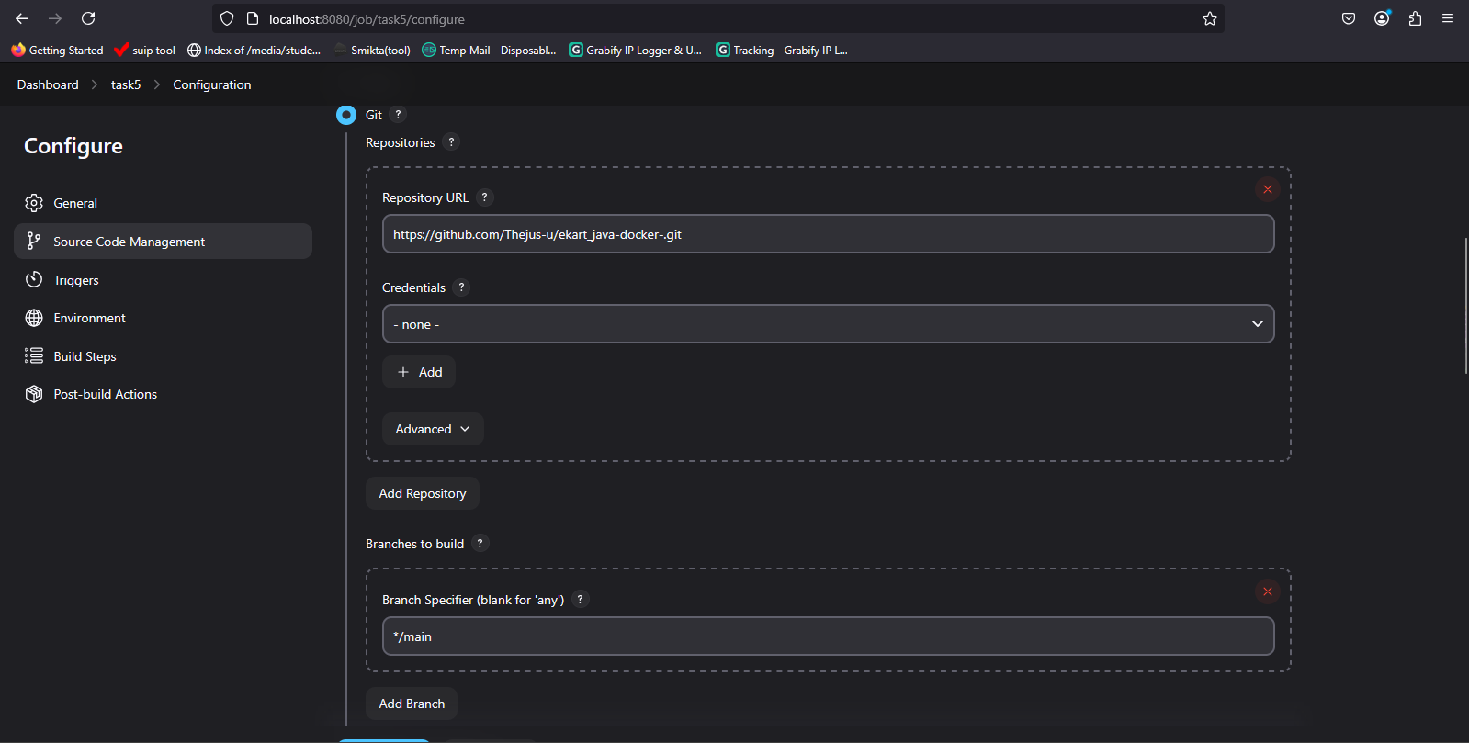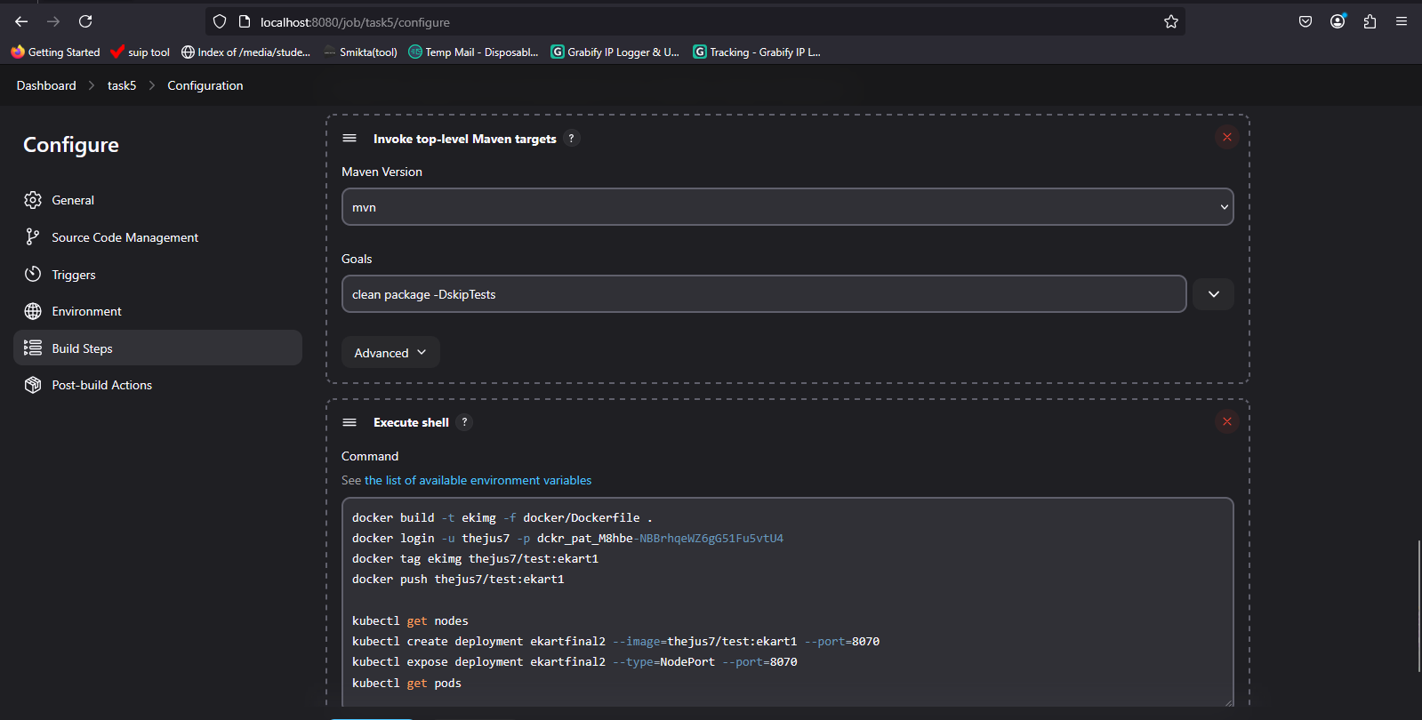

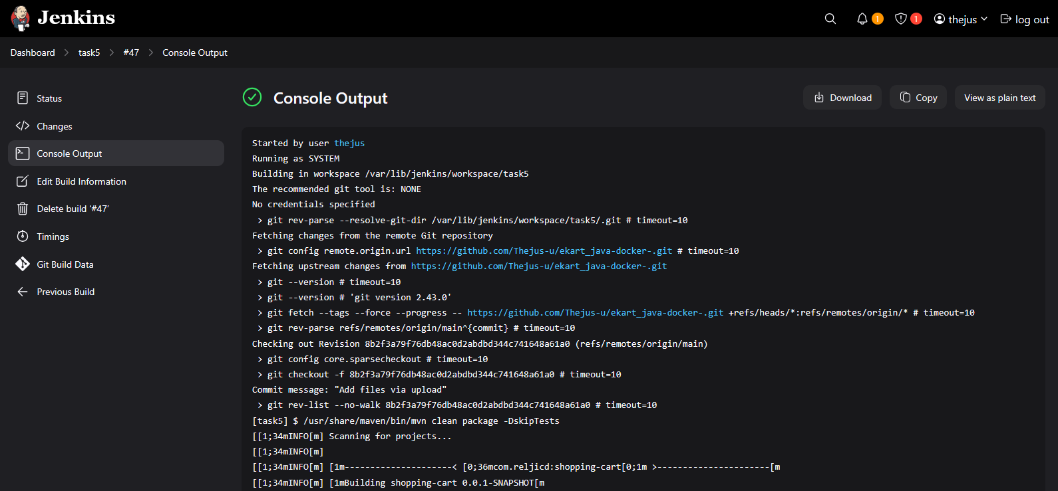

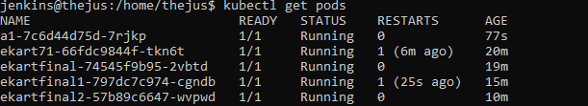

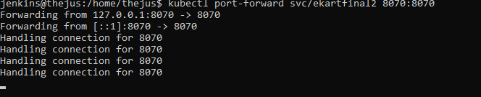

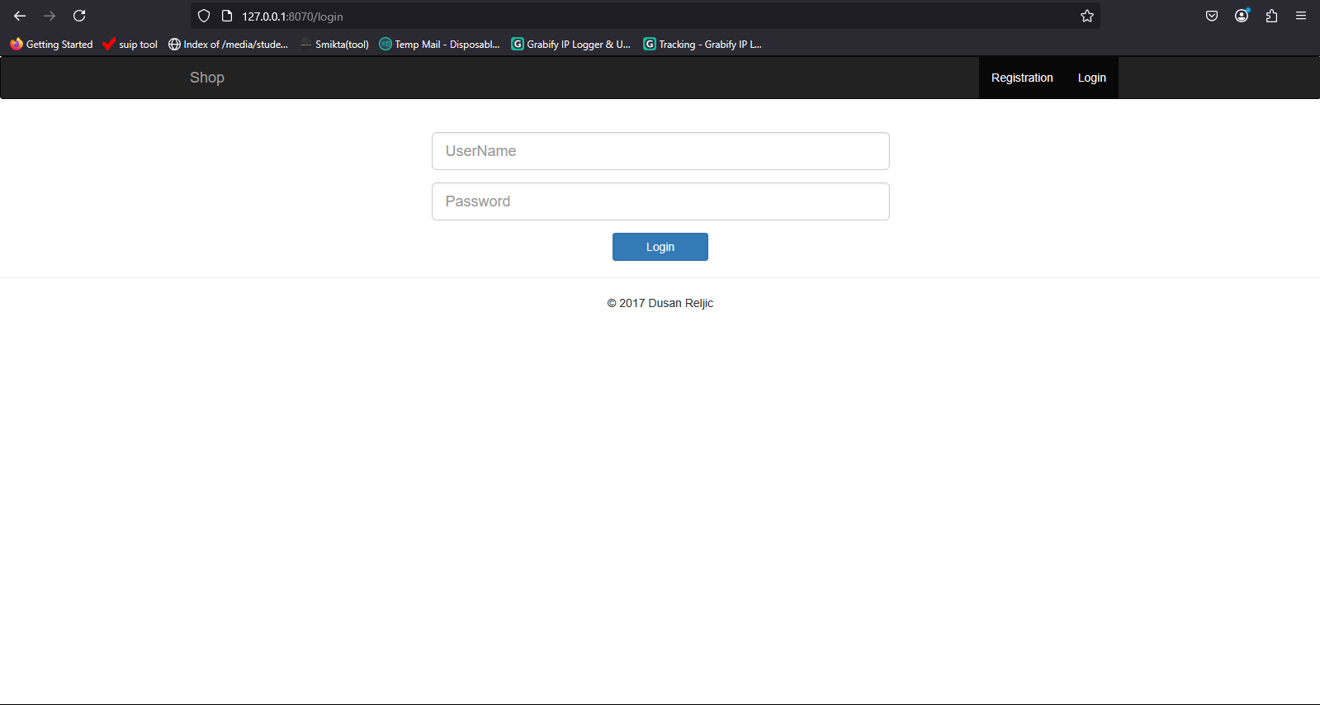

Output :