**Author(s)** T. Poruthikode Unnivelan

**General** Protocol 1 outlines the method to read, spatially sort, and save, as a GDF file, the signals from the 32 channel, 256 Hz EEG system.

Protocol 2 outlines the method to read, and perform a spectral analysis of multiple bands. It then saves the data in CSV files.

**References** OpenViBE Inria Database/ Documentation

**Timing** 15-30 minutes

**Preparation** Have theOpenViBE software downloaded on a compatible computer. Setup participant with the 32-node Electrode Cap, making sure that the bridge of the nose is 20 cm from Cz node.

**Materials** • Computer with OpenViBE software installed

* 32-node EEG Cap
* BioSemi Battery Box, Charger, AD-Box, USB2 Receiver

**Safety** Do not ingest Electrode Gel.

**Protocol 1** 1. Refer to the image below.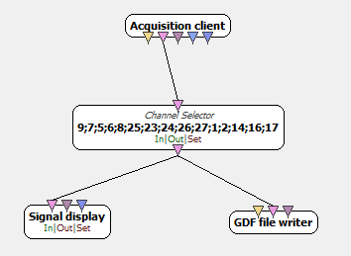

1. Using the search client on the right side of the program, search for the functions (boxes above).
   1. Acquisition client: Allows OpenViBE to connect to and read data from the EEG Cap.
   2. Channel selector: Filters the desired channels from the data. The numbers correlate to specific nodes on the EEG Cap.
   3. Signal display: Displays the different signals that it receives (In this case all the channels selected by the channel selector).
   4. GDF file writer: Saves the data as a .gdf file.
2. Instead of the Acquisition client, the use of the “Generic stream reader” box can allow to testing of the program.
3. Double click on the Channel selector and you will be directed towards a Configuration prompt for the box.

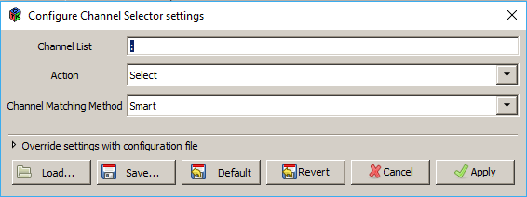

1. In the Channel List section, list out the desired channel numbers with a semicolon between each number. Below is a list of the numbers mapped to the nodes on the EEG Cap. Click Apply.

|  |  |  |  |  |  |  |  |
| --- | --- | --- | --- | --- | --- | --- | --- |
| 1:FP1 | 2:FP2 | 3:AF4 | 4.AF3 | 5:F2 | 6:F4 | 7:F3 | 8:F8 |
| 9:F7 | 10:FC6 | 11:FC2 | 12:FC1 | 13:FC5 | 14:C2 | 15:T8 | 16:C4 |
| 17:C3 | 18:T7 | 19:CP6 | 20:CP2 | 21:CP1 | 22:CP5 | 23:P7 | 24:P3 |
| 25:P2 | 26:P4 | 27:P8 | 28:PO3 | 29:PO4 | 30:O1 | 31:O2 | 32:O3 |

1. Double click on the GDF file writer box. Click on the small file box right of the Filename box, to search for a file location to save the data. Check for the .gdf file type ending.

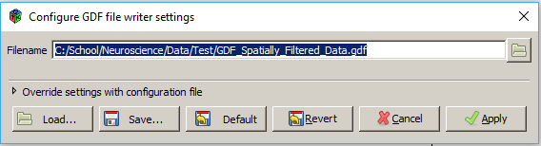

**Protocol 2** 1. Refer to the image below

.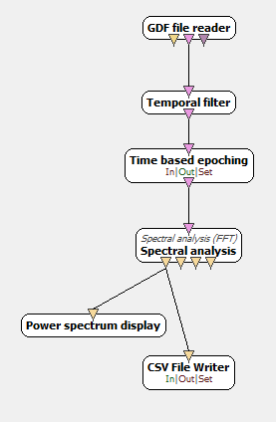

1. Using the search client on the right side of the program, search for the functions (boxes above).
   1. GDF file reader: Directs OpenViBE to the .gdf file saved through Protocol 1
   2. Temporal filter: Filters the data for certain brain frequencies.
   3. Time based epoching: Sections the data into timely proportions.
   4. Spectral analysis: Conducts a spectral analysis on the small samples of data.
   5. Power spectrum display: Displays the results from Spectral Analysis.
   6. CSV File Writer: Saves data from the spectral analysis into a .csv file (can be opened and edited by excel).
2. The use of the “Generic stream reader” can again be used to test the data.
3. Double click on the GDF file reader box and you will be directed towards a Configuration prompt for the box.

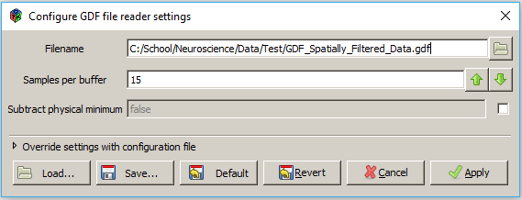

1. Use the small file box next to the Filename box to select the GDF data saved from Protocol 1. In the Samples per buffer, insert the number of channels selected in Protocol 1.
2. Double click on the Temporal filter box and you will be directed towards a Configuration prompt for the box.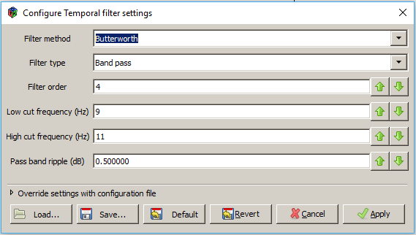
3. There are two choices for filter methods: Butterworth and Chebychev. Butterworth will allow some excess data in order to more accurately perform the temporal filter. Chebychev will cut off some of the needed data in order to keep the data more acute.
4. There are four types of filter types: band pass, band stop, high pass, and low pass. Band pass will collect all the data within the low cut and the high cut. Band stop will prevent data from within the low cut and the high cut. High pass and low pass will allow data that is higher than the high cut and lower than the low cut, respectfully, to be collected.
5. The default filter order is 4. The Low cut frequency and the High cut frequency allows for the modification of the frequency range to be collected.
6. Double click on the Time based epoching box and you will be directed towards a Configuration prompt for the box.

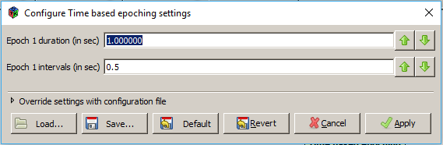

1. This allows for the modification of the Epoching duration and interval timing.
2. Double click on the Spectral Analysis box and you will be directed towards a Configuration prompt for the box.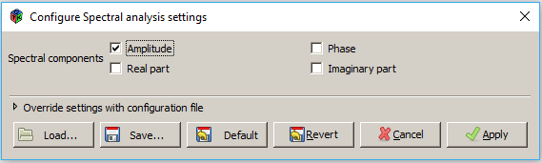
3. Click on the amplitude checkbox to conduct the spectral analysis on the amplitude. You may also conduct it on the Phase, Real part, or Imaginary Part.
4. Right click on the CSV file writer box. Go to “modify inputs”🡪”input stream”🡪”configure” to change the input type from Signal to Spectrum (the output of the Spectral Analysis).
5. Double click on the CSV file writer box. Click on the small file box right of the Filename box, to search for a file location to save the data. Check for the .csv file type ending.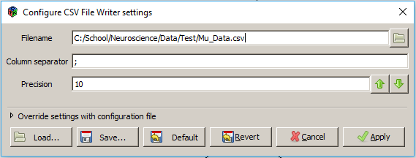
6. You may copy the branch from the temporal filter to the end of the branch for different frequencies. Connect the extra branches to the GDF file reader box’s center output (EEG Stream [Signal]).