**计算机程序设计基础（C++)**

**实验报告**

专业班级： 软工2班

学 号： 8209230203

姓 名： 宋佳仪

**实验报告成绩：**

|  |  |  |  |  |  |  |
| --- | --- | --- | --- | --- | --- | --- |
| **实验** | **实验一** | **实验二** | **实验三** | **实验四** | **实验五** | **总评** |
| **成绩** |  |  |  |  |  |  |

**批阅教师：**

**实验一、实验环境与简单程序设计**

**一、实验目的**

1、掌握集成开发环境，掌握C++程序的基本要素以及完整的C++程序开发过程。

2、掌握基本数据类型、运算符和表达式的使用。理解隐式转换和强制转换，理解数据超过该数据类型

表示范围时的溢出。掌握不同数据之间的混合算术运算中数据类型的转换。

3、变量的定义与常量的使用。

4、输入、输出的实现。

5、编译信息的理解与错误的修改。

6、简单程序的设计。

**二、实验内容**

熟悉C++编程环境，可以使用VS；对已经能熟练掌握C++开发环境的同学，可

以跳过本部分内容）

**1.编辑输入下列程序，找出下面代码的错误并改正：**

#include<iostream>

using namespace std;

int main()

{

Int i = k + 1;

cout << i++ << endl;

int i = 1;

cout << i++ << endl;

cout << "Welcome to C++"<<endl;

return 0;

}

**2.求圆锥的体积：要求键盘输入圆锥底的半径、锥高，使用标识符常量定义圆周率。**

(1)创建一个控制台项目

(2)在文件中输入程序内容，存盘

(3)编译、连接、运行；观察结果

**3**.**通过下面程序验证你所使用系统上运行的C++编译器中每个基本数据类型的长度。**

#include<iostream>

using namespace std;

int main()

{

cout << "char length:" << sizeof(char) << endl;

cout << "int length:" << sizeof(int) << endl;

}

**4.观察下面程序的执行结果。**

#include <iostream>

#include <iomanip>

using namespace std;

int main()

{

unsigned int testUnint = 65534;//oxfffe

cout << "output in unsigned int 1 type:" << testUnint<< endl;//<<oct(八进制)

cout << "output in char type:!" << static_cast<char>(testUnint) << endl;

cout << "output in short type:" << static_cast<short>(testUnint) << endl;//为什么结果为-2?:

cout << "output in int type:" << static_cast<int>(testUnint) << endl;

cout << "output in double type:" << static_cast<double>(testUnint) << endl;

cout << "output in double type:" << setprecision(4) << static_cast<double>(testUnint) << endl;

cout << "output in Hex unsigned int type:" << hex << testUnint << endl; //16进制输出

cout << "output in oct unsigned int type:" << oct << testUnint << endl;//8进制输出

float a = 2.56;//给实数a赋值

cout << "Number before conversion:" << a<<endl;

a = (int)a;//强制转换

cout <<"Number after conversion:"<< a << endl;//进行输出

system("pause");

return 0;

//自己编程测试一下将testUnint按8进制输出 << oct; 将一个实数转换成int, 观察结果。

}

**自己编程测试一下，将testUnint按8进制输出<<oct;将一个实数转换成int,观察结果。**

**5.编程，输入华氏温度，将其转换为摄氏温度后输出（保留两位小数）。**

**三、算法分析，程序结果**

1.#include<iostream>

using namespace std;

int main()

{

int k=0;

int i = k + 1;

cout << i++ << endl;

i = 1;

cout << i++ << endl;

cout << "Welcome to C++" << endl;

return 0;

}

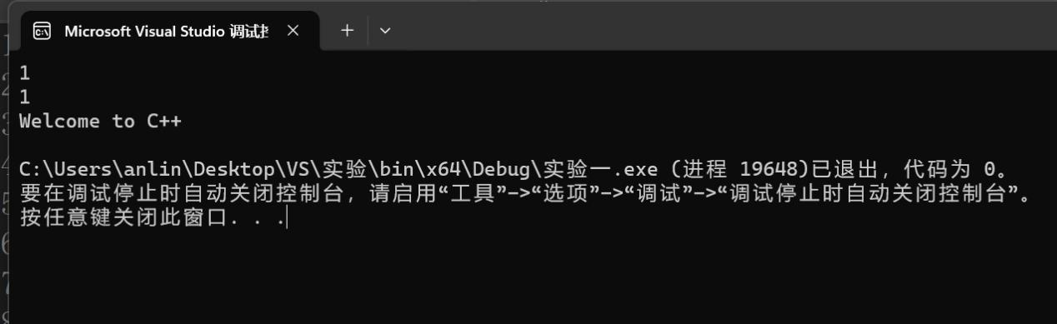

2.#include <iostream>

#define Π 3.14

using namespace std;

int main()

{

double r = 0.0, h = 0.0;

cout << "请输入圆锥底的半径：" << endl;

cin >> r;

cout << "请输入圆锥的高：" << endl;

cin >> h;

double V = 1.0/3.0*Π * r * r * h;

cout << "圆锥的体积为：" << V << endl;

cin.get();

}

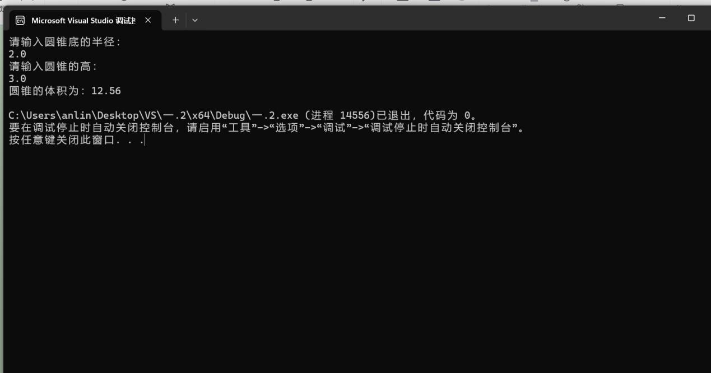

3.#include<iostream>

using namespace std;

int main()

{

cout << "char length:" << sizeof(char) << endl;

cout << "unsigned char length:" << sizeof(unsigned char) << endl;

cout << "signed char length:" << sizeof(signed char) << endl;

cout << "int length:" << sizeof(int) << endl;

cout << "unsigned int length:" << sizeof(unsigned int) << endl;

cout << "signed int length:" << sizeof(signed int) << endl;

cout << "short int length:" << sizeof(short int) << endl;

cout << "unsigned short int length:" << sizeof(unsigned short int) << endl;

cout << "signed short int length:" << sizeof(signed short int) << endl;

cout << "long int length:" << sizeof(long int) << endl;

cout << "signed long int length:" << sizeof(signed long int) << endl;

cout << "unsigned long int length:" << sizeof(unsigned long int) << endl;

cout << "long long length:" << sizeof(long long) << endl;

cout << "signed char length:" << sizeof(signed char) << endl;

cout << "bool length:" << sizeof(bool) << endl;

cout << "float length:" << sizeof(float) << endl;

cout << "double length:" << sizeof(double) << endl;

cout << "long double length:" << sizeof(long double) << endl;

cout << "wchar_t length:" << sizeof(wchar_t) << endl;

}

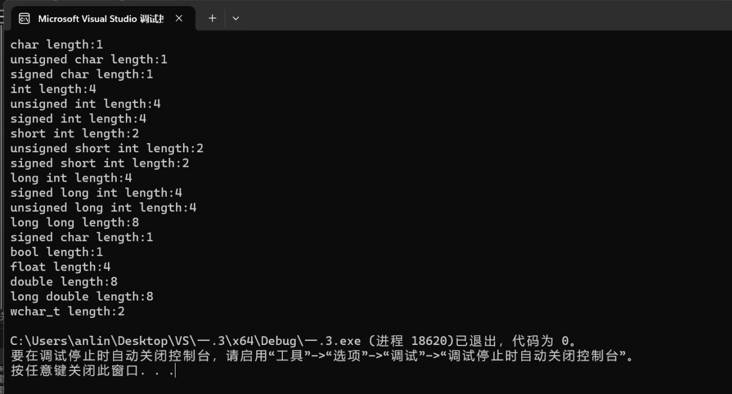

4.#include <iostream>

#include <iomanip>

using namespace std;

int main()

{

unsigned int testUnint = 65534;//oxfffe

cout << "output in unsigned int 1 type:" << testUnint<< endl;//<<oct(八进制)

cout << "output in char type:!" << static_cast<char>(testUnint) << endl;

cout << "output in short type:" << static_cast<short>(testUnint) << endl;//为什么结果为-2?:

cout << "output in int type:" << static_cast<int>(testUnint) << endl;

cout << "output in double type:" << static_cast<double>(testUnint) << endl;

cout << "output in double type:" << setprecision(4) << static_cast<double>(testUnint) << endl;

cout << "output in Hex unsigned int type:" << hex << testUnint << endl; //16进制输出

cout << "output in oct unsigned int type:" << oct << testUnint << endl;//8进制输出

float a = 0.0//给实数a赋值

cout << "转换前的数字：" << a<<endl;

a = (int)a;//强制转换

cout <<"转换后的数字："<< a << endl;//进行输出

system("pause");

return 0;

//自己编程测试一下将testUnint按8进制输出 << oct; 将一个实数转换成int, 观察结果。

}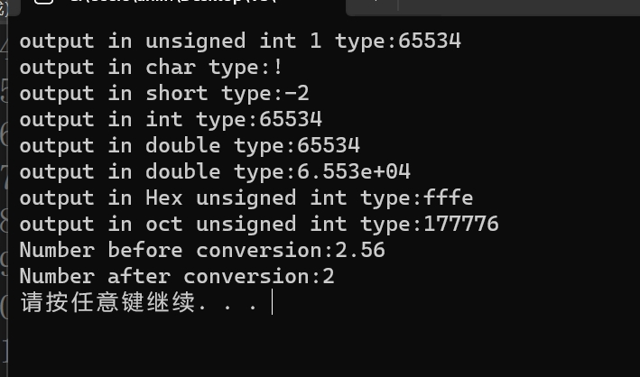

5.#include<iostream>

#include<iomanip>

using namespace std;

int main()

{

double F = 0.0;

cout << "Please enter the temperature in Fahrenheit:" << endl;

cin >> F;

double C = 0.0;

C = (F - 32.0) / 1.8;

cout << "Convert to Celsius temperature is:" << endl;

cout<< fixed << setprecision(2) << C <<"℃" << endl;

}

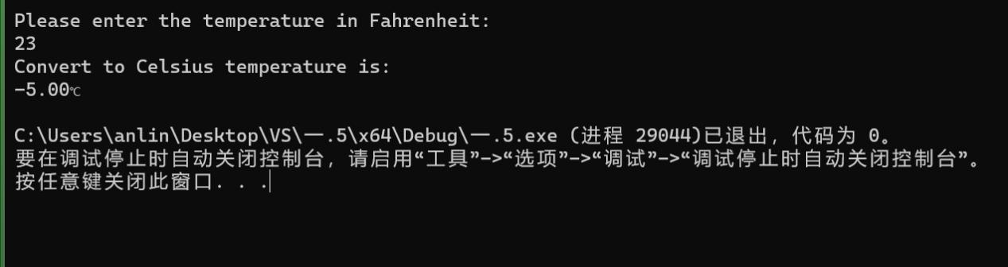

1. **遇到的问题与解决方法**

**问题：1.八进制转换格式不会**

1. **华氏与摄氏温度转换公式不明**

**方法：网络查询**

1. **体会**

**要善于利用网络资源，探索方法**

**实验二、数据结构**

**一、实验目的**

1、学习与掌握逻辑运算与逻辑表达式。

2、熟练掌握if、switch、while、do-while，for语句的语法结构与执行过程。

3、掌握选择、循环程序的设计方法

**二、实验内容**

1、输入一个字符，如果为小写，转换为大写输出，否则，输出其后继字符的ASCII码值。

2、输入x计算表达式的值：

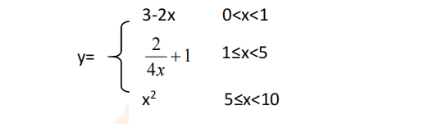

分别输入 0.2, 1, 5 , 0,观察输出结果。

1. 输入三角形的三条边，求周长，并判断该三角形是否为等腰三角形（提示：要三边是否可以构成三角形）。

4、 完成计算器程序，实现（+ - * / %）运算。考虑除数为 0 与运算符非法的情况。

5、输入一行字符，分别统计出其中英文字母、空格、数字字符和其它字符的个数。

提示：从键盘上读入一个字符给变量 c，判断 c 是属于哪种字符并计数，循环读入下个字符，直到回车换行字符'\n'为止。

cin，scanf（）都不能读入空格以及‘\n’字符，查找资料解决输入这两个字符的方法。

（这个题训练大家自主学习能力以及如何获取新知识、探索解决未知问题的能力。）

6、编写一个程序：从键盘上输入两个正整数，求 a 和 b 的最大公约数与最小公倍数。

7、使用循环结构输出下列图形：

*

**

***

****

*****

8、从键盘输入 a，用迭代法求 a 的平方根 x= *a* 。求平方根的迭代公式为：

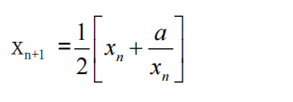

要求精确到|xn+1 - xn|<10 -5。

提示：迭代法是把 xn代入迭代公式右边，计算出 xn+1来，然后把 xn+1 作为新的 xn ，计算出新的 xn+1，如此重复，直到|xn+1 - xn|<10 -5 时，xn+1 为所求的平方根。可以把 a 作为 xn 的初始值。

思考：（1）如果输入 a 为负，在运行时会出现什么情况? 修改程序使之能处理任何的 a 值。

(2）能否|xn+1 -xn|<10 -10或更小? 为什么? 请试一下。

9、苹果每个 0.8 元，第一天买 2 个，第二天开始，每天买前天的 2 倍，直到购买的苹果数不超过100的最大值，求每天平均花多少钱。

**三、算法分析，程序结果**

1.

#include<iostream>

#include<cctype>

using namespace std;

int main()

{

char ch;

cout << "Please enter the letter:" << endl;

cin >> ch;

if (islower(ch))

{

ch = toupper(ch);

cout << "To convert the letter to uppercase is:" << ch << endl;

}

else

{

int x = int(ch);

int y = ++x;

cout << "The ASCII code for the character following the letter is:" <<y<< endl;

}

}

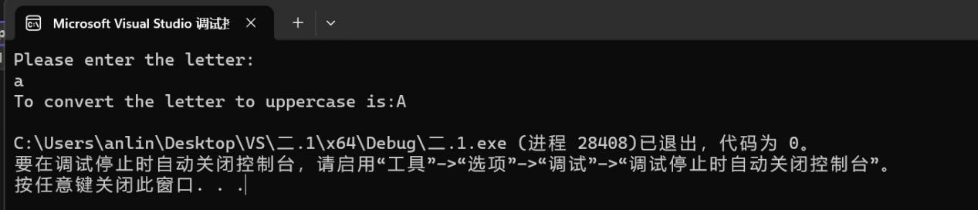

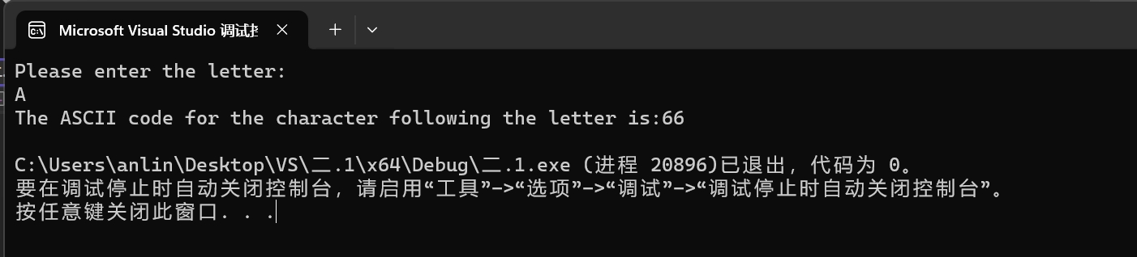

2.#include<iostream>

using namespace std;

int main()

{

float y = 0.0, x = 0.0;

cout << "Please enter the value of x:" << endl;

cin >> x;

if (0 < x && 1 > x)

{

float c = (-2) * x;

y = 3 + c;

cout << "The calculation results are as follows:" << y<<endl;

}

if (x >= 1 && x < 5)

{

float c = 4 * x;

y = 2 / c + 1;

cout << "The calculation results are as follows:" << y << endl;

}

if (x >= 5 && x < 10)

{

y = x * x;

cout << "The calculation results are as follows:" << y << endl;

}

}

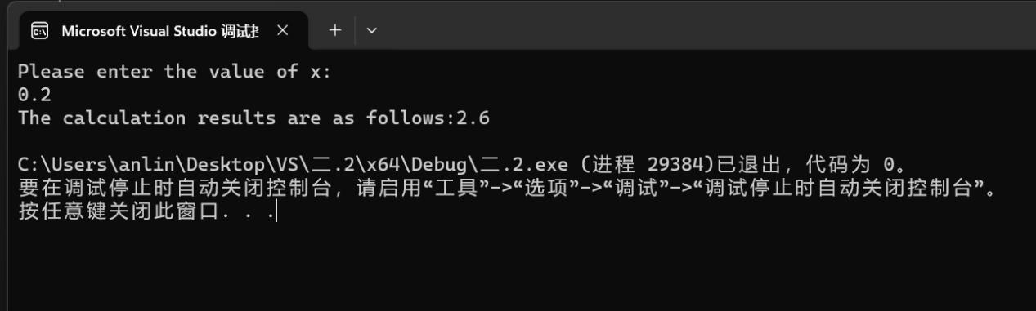

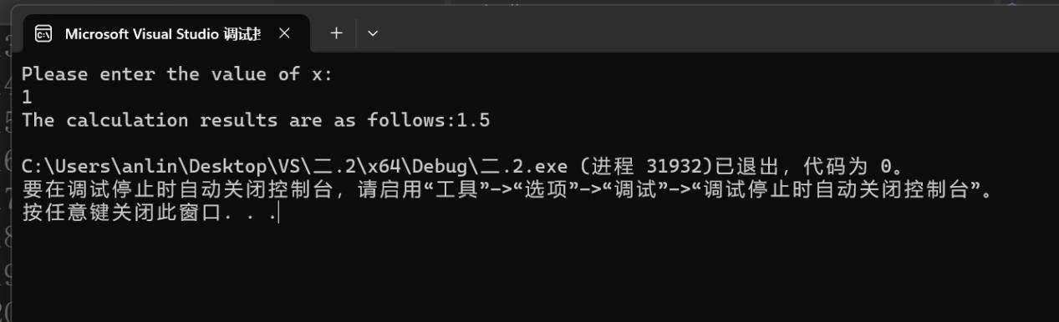

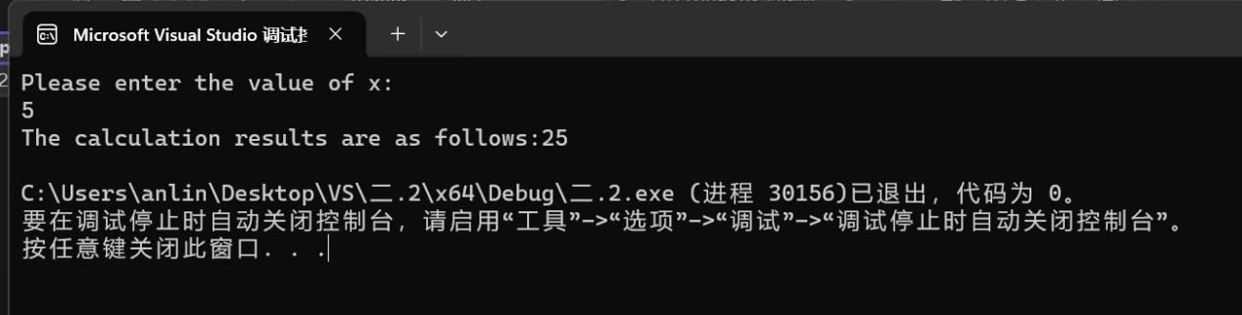

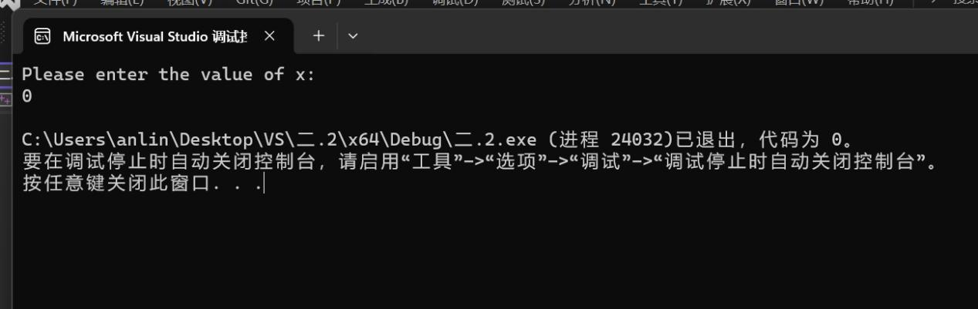

3.#include<iostream>

using namespace std;

int main()

{

int a, b, c, C;

cout << "Please enter the three sides of the triangle:" << endl;

cin >> a >> b >> c;

if (a + b <= c || a + c <= b || b + c <= a)

{

cout << "The triangle does not exist" << endl;

for (; a + b <= c || a + c <= b || b + c <= a;)

{

cout << "Please enter the three sides of the triangle again:" << endl;

cin >>a >> b >> c;

}

C = a + b + c;

}

if (a + b > c && a + c > b && b + c > a)

{

C = a + b + c;

}

if (a == c || a == b || b == c)

{

cout << "Triangles are isosceles triangles" << endl;

}

cout << "The circumference of the triangle is:" << C << endl;

}

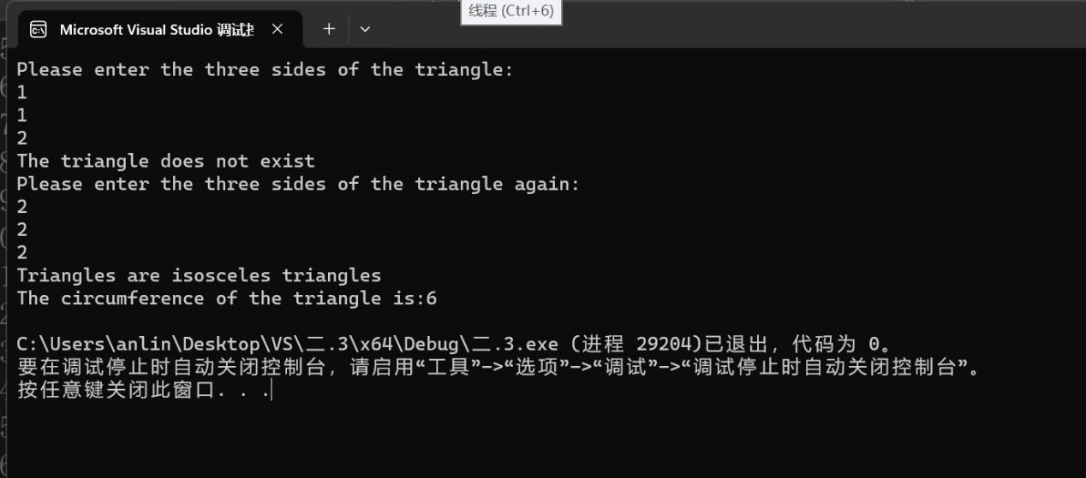

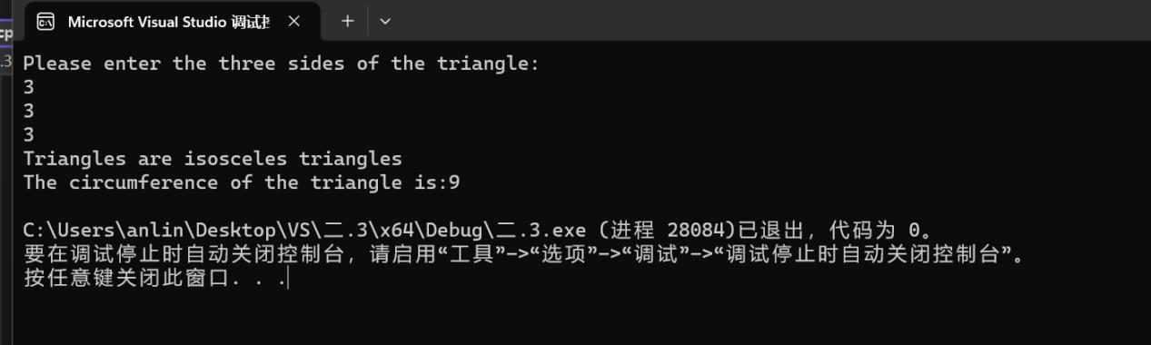

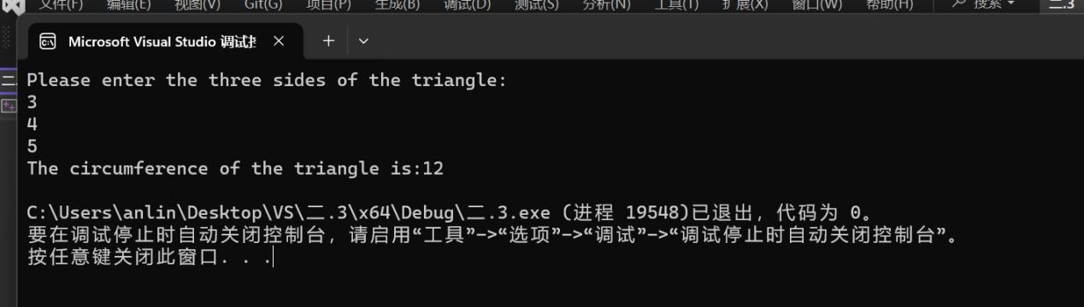

4.#include<iostream>

using namespace std;

int main()

{

int num1 = 0, num2 = 0, re = 0;

char op;

cout << "Please enter two numbers:" << endl;

cin >> num1 >> num2;

cout<<"Please enter the operation relation:" << endl;

cin >> op;

switch(op)

{

case '+':

re = num1 + num2;

cout << "The result is:" << re << endl;

break;

case '-':

re = num1 - num2;

cout << "The result is:" << re << endl;

break;

case '*':

re = num1 * num2;

cout << "The result is:" << re << endl;

break;

case '/':

if (num2 == 0)

{

cout << "Divisor cannot be 0, please re-enter:" << endl;

cin >> num2;

}

re = num1 /num2;

cout << "The result is:" << re << endl;

break;

case '%':

re =num1%num2;

cout << "The result is:" << re << endl;

break;

default:

cout << "The operation is invalid,please enter again" << endl;

break;

}

}

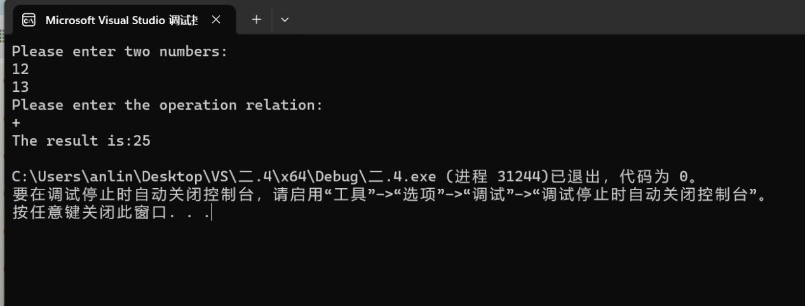

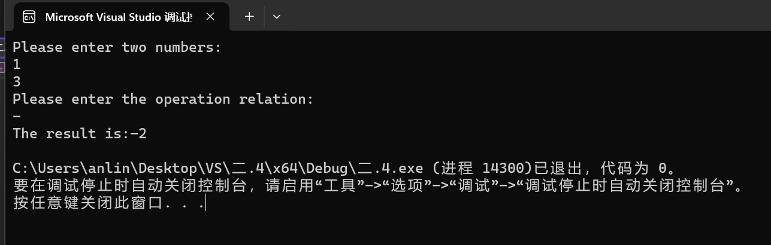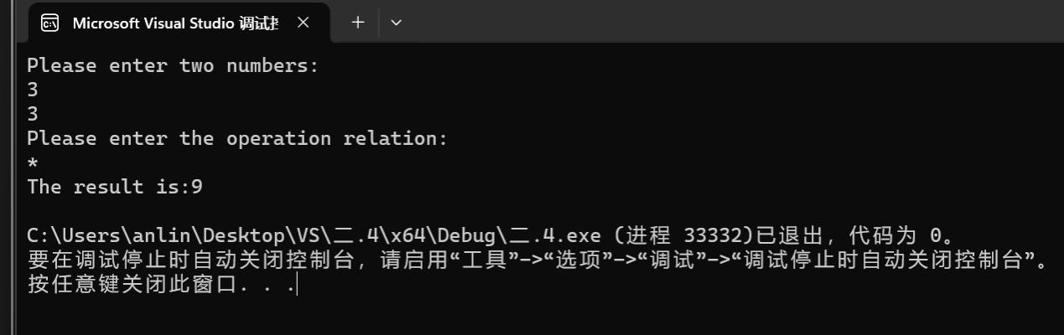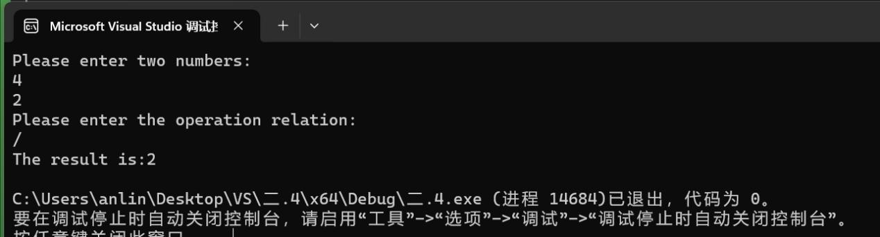

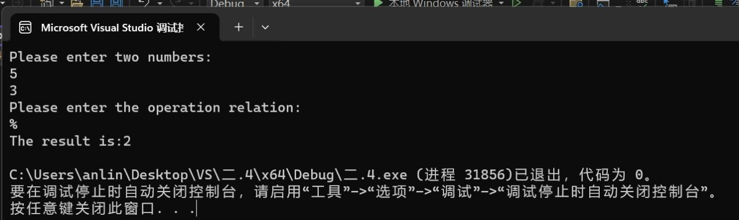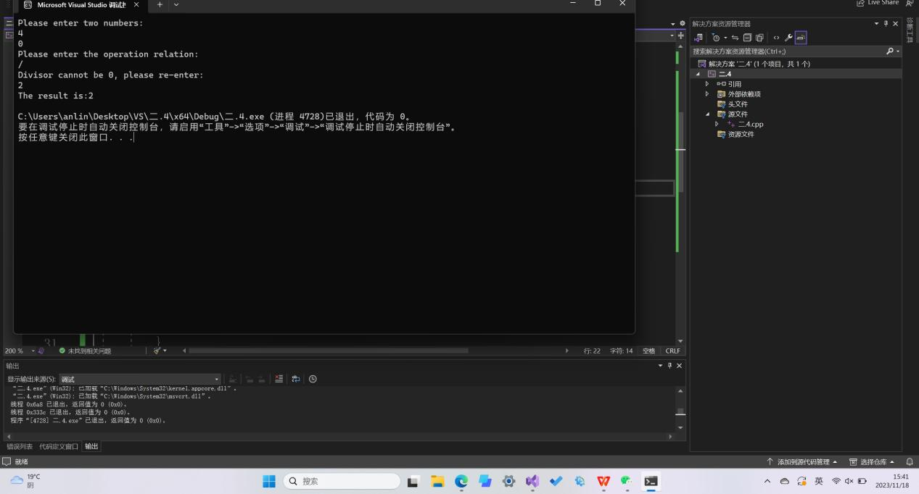



5.#include<iostream>

using namespace std;

int main()

{

char c;

int e = 0;//英文字母个数

int num = 0;//数字字符个数

int s = 0;//空格个数

int oth = 0;//其他字符个数

cout << "Please enter a line of characters:" << endl;

cin.get(c);

while (c != '\n')

{

if ((c >= 'A' && c <= 'Z')||(c >= 'a' && c <= 'z'))

{

e++;

}

else if (c >= '0' && c <= '9')

{

num++;

}

else if (c == ' ')

{

s++;

}

else

{

oth++;

}

cin.get(c);

}

cout << "The number of letters in English is:" << e << endl;

cout << "The number of numeric characters is:" << num << endl;

cout << "The number of Spaces is:" << s<< endl;

cout << "The number of other characters is:" << oth << endl;

}

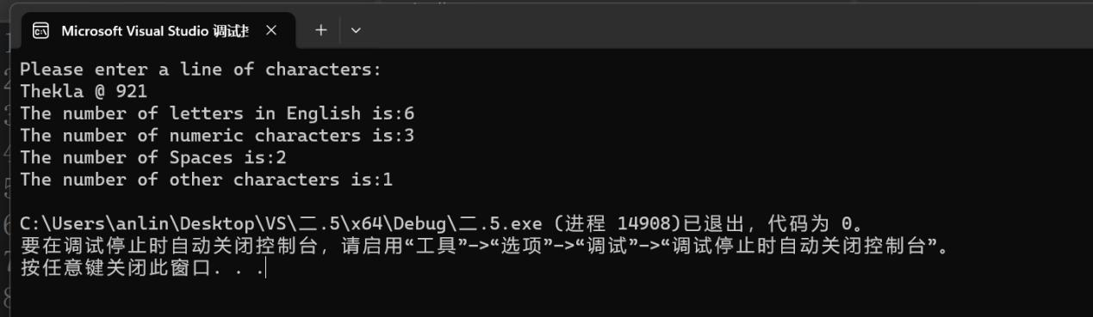

6.#include<iostream>

using namespace std;

int main()

{

unsigned int a, b;

unsigned int x,y;

unsigned int max = 0, min = 0;

cout << "Please enter two positive integers:" << endl;

cin >> x>> y;

if (x >= y)

{

a = x;

b = y;

}

else

{

a = y;

b = x;

}

//求最大公约数

for (int c = 1; c <= b; c++)

{

if (a % c == 0 && b % c == 0)

{

max = c;

}

}

cout << "The greatest common divisor is:" <<max<< endl;

//求最小公倍数

for (int d = a; d <= b*a; d++)

{

if (d % a == 0 && d% b == 0)

{

min = d;

break;

}

}

cout << "The least common multiple is:" << min<< endl;

}

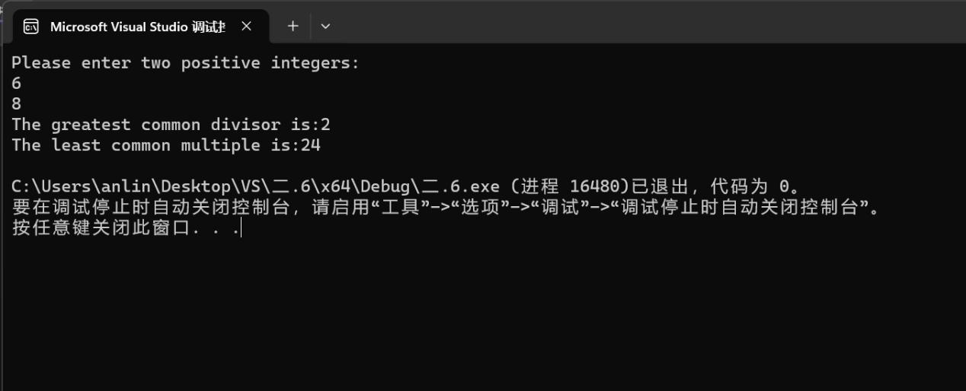

7.#include<iostream>

using namespace std;

int main()

{

for (int r=1; r <= 5; r++)

{

for (int i=0; i < r; ++i)

{

cout << "*" ;

}

cout << endl;

}

}

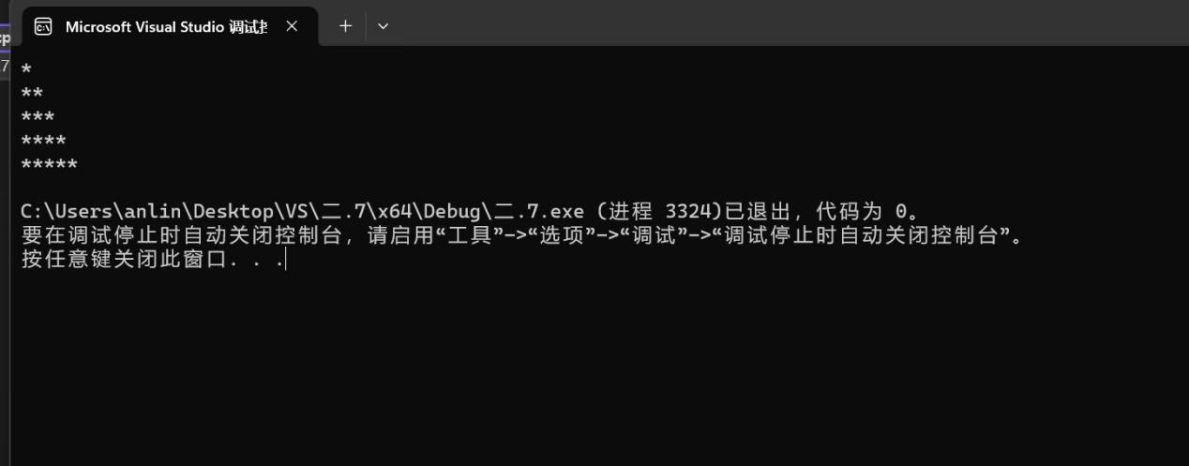

8.#include<iostream>

#include<cmath>

using namespace std;

int main()

{

//主要任务+问题1：

int a;

double x = 1.0, x1;

string str = "i";

cout << "Please enter a number:" << endl;

cin >> a;

if (a < 0)

{

double b = -a;

do

{

x1 = x;

x = (x1 + b / x1) / 2;

} while (fabs(x - x1) > 1E-5);

cout << "The square root of a is:" << x <<str<<endl;

}

if (a >= 0)

{

double b = a;

do

{

x1 = x;

x = (x1 + b / x1) / 2;

} while (fabs(x - x1) > 1E-5);

cout << "The square root of a is:" << x << endl;

}

//问题二：

cout << "Please enter a number:" << endl;

cin >> a;

if (a < 0)

{

double b = -a;

do

{

x1 = x;

x = (x1 + b / x1) / 2;

} while (fabs(x - x1) > 1E-5);

cout << "The square root of a is:" << x << str << endl;

}

if (a >= 0)

{

double b = a;

do

{

x1 = x;

x = (x1 + b / x1) / 2;

} while (fabs(x - x1) > 1E-10);

cout << "The square root of a is:" << x << endl;

}

return 0;

//答：无法实现，超过了float的长度。

}

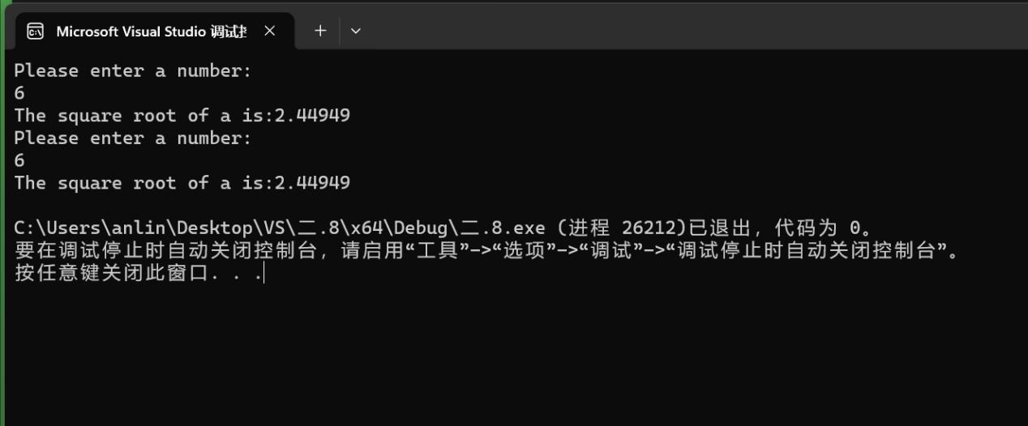

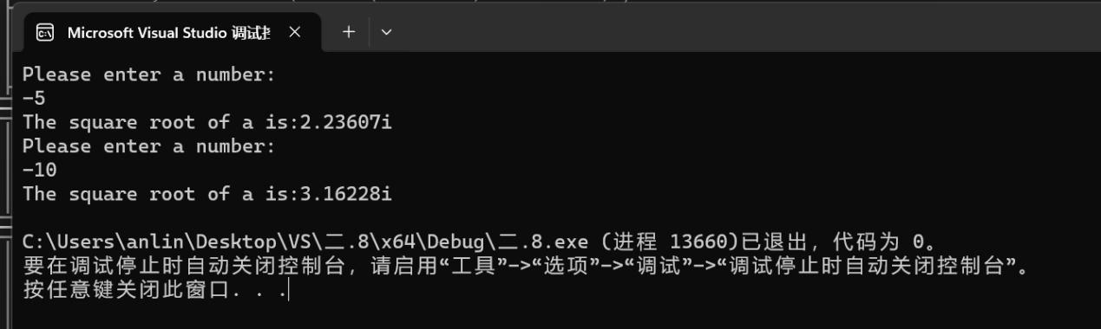

9.#include<iostream>

#include<cmath>

using namespace std;

int main()

{

float i, d;

float w, s, a;

d = 1.0; i = 2.0;

for (; 2*i <= 100;d++)

{

i = 2 * i;

}

s = 2 * (pow(2.0, d) - 1);

w = 0.8 * s;

a = w / d;

cout << "Number of apples purchased on the last day:" << i<<endl;

cout << "Total days of purchase:" << d << endl;

cout << "Average cost per day:" << a << endl;

}

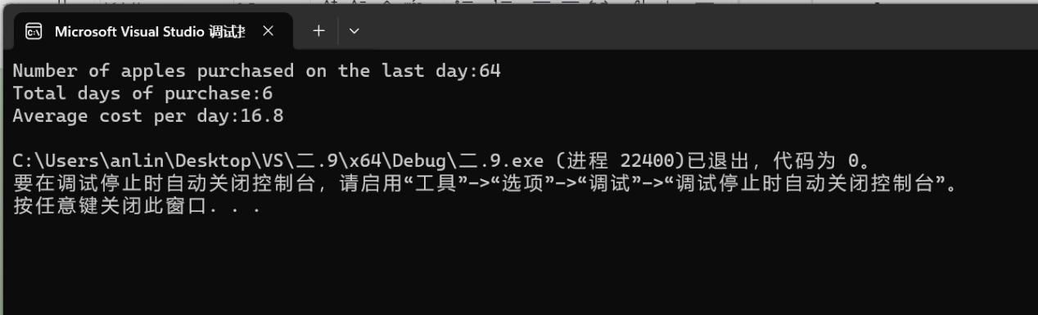

1. **遇到的问题与解决方法**

**问题：1.题意不明**

**2.计算器程序出结果是有多个数据**

**方法：1.与同学讨论**

**2.翻阅课本，发现应在case中加入break**

1. **体会**

**与他人多多交流，可以收获不同的理解；**

**课本是根本。**