Hardware & Peripherals for Our Project
PART A — TEAM: Hardware Plan
Project: Hospital Ward Management System
Team Members:
- Shynbulat Kazbek — 24B032123
- Bauyrzhanuly Kuanyshbek — 24B031691
- Chinaliyev Baigel — 24B032104
- Zhanserikuly Nurali — 24B031778
- Zhanat Rishat — 24B031775
1. User Action
A ward nurse taps their hospital ID badge on the ward nurse-station workstation to log in and acknowledge a high-priority patient-care alert. After acknowledgement, the system records the response time, stops the escalation timer and gives an audio confirmation.
2. Hardware Map
Device | Type | Purpose
Touchscreen Monitor | BOTH | The nurse touches the screen to open and acknowledge the alert. The screen also shows alerts, priority level and patient information.
RFID Badge Reader | INPUT | Reads the nurse's hospital ID badge to identify and log in the nurse.
Alert Speaker | OUTPUT | Plays a sound for high-priority and critical alerts and confirms acknowledgement.
Internal SSD | STORAGE | Stores local system data, logs and acknowledgement records if the network is temporarily down.
Network Adapter (Ethernet / Wi-Fi) | BOTH | Connects the workstation to the hospital network and sends/receives alerts and acknowledgements.

The touchscreen monitor is BOTH because it receives touch input from the nurse and also shows alerts and patient information.
3. Connections
The devices connect to the nurse-station workstation in different ways:
- Touchscreen Monitor → USB + HDMI
  - USB sends touch input.
  - HDMI sends the image to the screen.
- RFID Badge Reader → USB
  - Sends the nurse badge ID to the workstation.
- Alert Speaker → USB / 3.5 mm audio
  - Plays the alert sound and the acknowledgement confirmation.
- Internal SSD → Internal connection (SATA / NVMe)
  - Installed inside the workstation computer.
- Network Adapter → Ethernet (main) + Wi-Fi (backup)
  - Connects the workstation to the hospital network and the alert server.
Compatibility Risk
One compatibility risk is that the RFID badge reader may have a USB-C connector, while the workstation computer may only have USB-A ports. Also, the reader must support the same card frequency/standard (for example 13.56 MHz MIFARE) as the hospital ID badges.
If the devices are not compatible, the team will need an adapter or another reader model. To reduce this risk, we should test each device with the workstation and with real staff badges before buying all of them.
4. Security Rule
Only hospital-approved devices can be connected to the nurse-station workstation. Unknown USB devices (flash drives, phones, chargers) must not be connected, and unused USB ports must be disabled.
This rule is important because an unknown USB device may contain malware. One infected peripheral could stop alerts from arriving or leak confidential patient data, which directly affects patient safety.
5. Plan B
The RFID badge reader is one possible device that may fail.
If the badge reader stops working, the nurse can log in with their username and password (or PIN) on the touchscreen and acknowledge the alert normally. If the whole workstation fails, the nurse can acknowledge the alert on the ward tablet or hospital mobile app.
This means the nurse can still acknowledge the alert in time, before the 30-second escalation timer forwards it to a secondary nurse.

Lab 5 — Part B: Individual TCO Analysis
Student: Zhanat Rishat — 24B031775
Project: Hospital Ward Management System
Device: Network Adapter (Ethernet + Wi-Fi)
1. My Device
I chose the network adapter (Ethernet + Wi-Fi). It connects the nurse-station workstation to the hospital network and the alert server. Without it, no alerts arrive and no acknowledgements are sent, so it is very important for patient safety.
2. TCO — 1-Year Total Cost
Cost item | Cost (₸)
Purchase price (Ethernet + Wi-Fi adapter) | 15,000
Hidden cost 1: Ethernet cable + wall port installation | 10,000
Hidden cost 2: IT network configuration | 8,000
Hidden cost 3: Spare adapter (replacement reserve) | 7,000
Total 1-year TCO | 40,000

The hidden costs (25,000 ₸) are more than the purchase price (15,000 ₸).
3. Decision + WHY
I decided to use wired Ethernet as the main connection and Wi-Fi as a backup, instead of Wi-Fi only, because hospital Wi-Fi can be overloaded or blocked by thick walls and medical equipment. A wired connection is more stable and helps alerts reach the nurse within 2 seconds (NFR-01). Wi-Fi stays as a backup, so the workstation still works if the cable is damaged.
4. Evidence
My contribution: I wrote the network part of the Connections section and calculated the TCO for the network adapter.
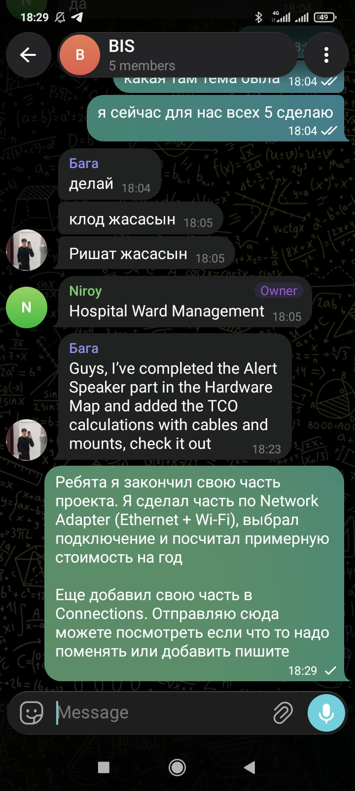
The screenshot shows the Connections section of our team document and my 1-year cost calculation for the network adapter.
What I learned
I learned that network hardware directly affects our non-functional requirements, and that a backup connection is part of Plan B thinking.

