Documentation

War tank project plan
Objective:
build a 2-player tank battle game with:
- WASD vs Arrow key controls,
- Indestructible obstacles,
- And Bouncing bullets

Timeline:
Week | Tasks
1 | Design core mechanics
2 | Implement tank movement
3 | Implement a shooting bullet and bouncing bullets
4 | And collisions
5 | Polish UI and fix bugs

Thinking Process(pseudocode):
// 1. INITIALIZATION

SETUP WebGL:
canvas = GET_CANVAS("canvas")
gl = GET_WEBGL_CONTEXT(canvas)
IF !gl: SHOW_ERROR("WebGL not supported")

DEFINE GEOMETRY:
// Tank vertices (body + turret)
tankVertices = [0,-0.02,0, 0.04,-0.02,0, ...]

// Bullet (circle with 20 segments)
bulletVertices = GENERATE_CIRCLE(radius=0.03, segments=20)

// Obstacle rectangle template
obstacleVertices = [-0.5,-0.5,0, 0.5,-0.5,0, ...]

DEFINE COLORS:
colors = [
[1,0,0], // Red (Player 1)
[0,0,1], // Blue (Player 2)
[0,1,0], // Green (Bullets)
[0,0,0] // Black (Obstacles)
]

CREATE BUFFERS:
vertexBuffer = gl.createBuffer(tankVertices)
bulletBuffer = gl.createBuffer(bulletVertices)
colorBuffer = gl.createBuffer(colors)

LOAD SHADERS:
vertexShader = COMPILE_SHADER("""
attribute vec3 position;
uniform vec2 tankPosition;
void main() {
gl_Position = position + tankPosition;
}
""")

fragmentShader = COMPILE_SHADER("""
uniform vec3 color;
void main() {
gl_FragColor = vec4(color, 1.0);
}
""")

shaderProgram = LINK_PROGRAM(vertexShader, fragmentShader)

// 2. GAME OBJECTS

CLASS Tank:
PROPERTIES:
x, y, rotation
speed = 0.005
bullets = []
controls = { up, down, left, right, shoot }
colorIndex

METHODS:
update(keys):
IF keys[controls.up]: MOVE_FORWARD()
IF keys[controls.down]: MOVE_BACKWARD()
IF keys[controls.left]: ROTATE_LEFT()
IF keys[controls.right]: ROTATE_RIGHT()
CHECK_WALL_COLLISIONS()
UPDATE_BULLETS()

shoot():
IF cooldown_ready:
ADD_NEW_BULLET()
PLAY_SOUND("shoot")

draw():
gl.bindBuffer(vertexBuffer)
gl.setUniform("position", [x, y])
gl.setUniform("color", colors[colorIndex])
gl.drawTriangles()

CLASS Bullet:
PROPERTIES:
x, y, speed, direction
lifetime = 4000ms

METHODS:
update():
MOVE_IN_DIRECTION()
CHECK_COLLISIONS()
IF lifetime_expired: REMOVE_SELF()

// 3. GAME SYSTEMS

PHYSICS_SYSTEM:
checkTankCollision(tank1, tank2):
IF distance(tank1, tank2) < tank1.radius + tank2.radius:
PUSH_APART(tank1, tank2)

checkBulletCollision(bullet, tank):
IF distance(bullet, tank) < bullet.radius + tank.radius:
tank.takeDamage()
bullet.destroy()

RENDERING_SYSTEM:
drawAll():
CLEAR_CANVAS()
DRAW_OBSTACLES()
FOR_EACH_TANK: tank.draw()
FOR_EACH_BULLET: bullet.draw()

// 4. GAME LOOP

FUNCTION gameLoop(deltaTime):
// Input
HANDLE_KEYBOARD_INPUT()

// Update
FOR_EACH_TANK: tank.update()
PHYSICS_SYSTEM.update()

// Render
RENDERING_SYSTEM.drawAll()

// Repeat
requestAnimationFrame(gameLoop)

// 5. EVENT HANDLERS

ON_KEYDOWN(event):
IF event.key == "ArrowUp": keys.up = true
IF event.key == " ": tanks[0].shoot()

ON_KEYUP(event):
IF event.key == "ArrowUp": keys.up = false

ON_CLICK("#resetButton"):
RESET_GAME()

// 6. MAIN

CREATE_TANKS:
player1 = new Tank(x=-0.8, controls=WASD, color=RED)
player2 = new Tank(x=0.8, controls=ARROWS, color=BLUE)

LOAD_SOUNDS:
shootSound = LOAD("shoot.wav")
hitSound = LOAD("hit.wav")

START_GAME:
gameLoop()
Diagrams:
A. Game design
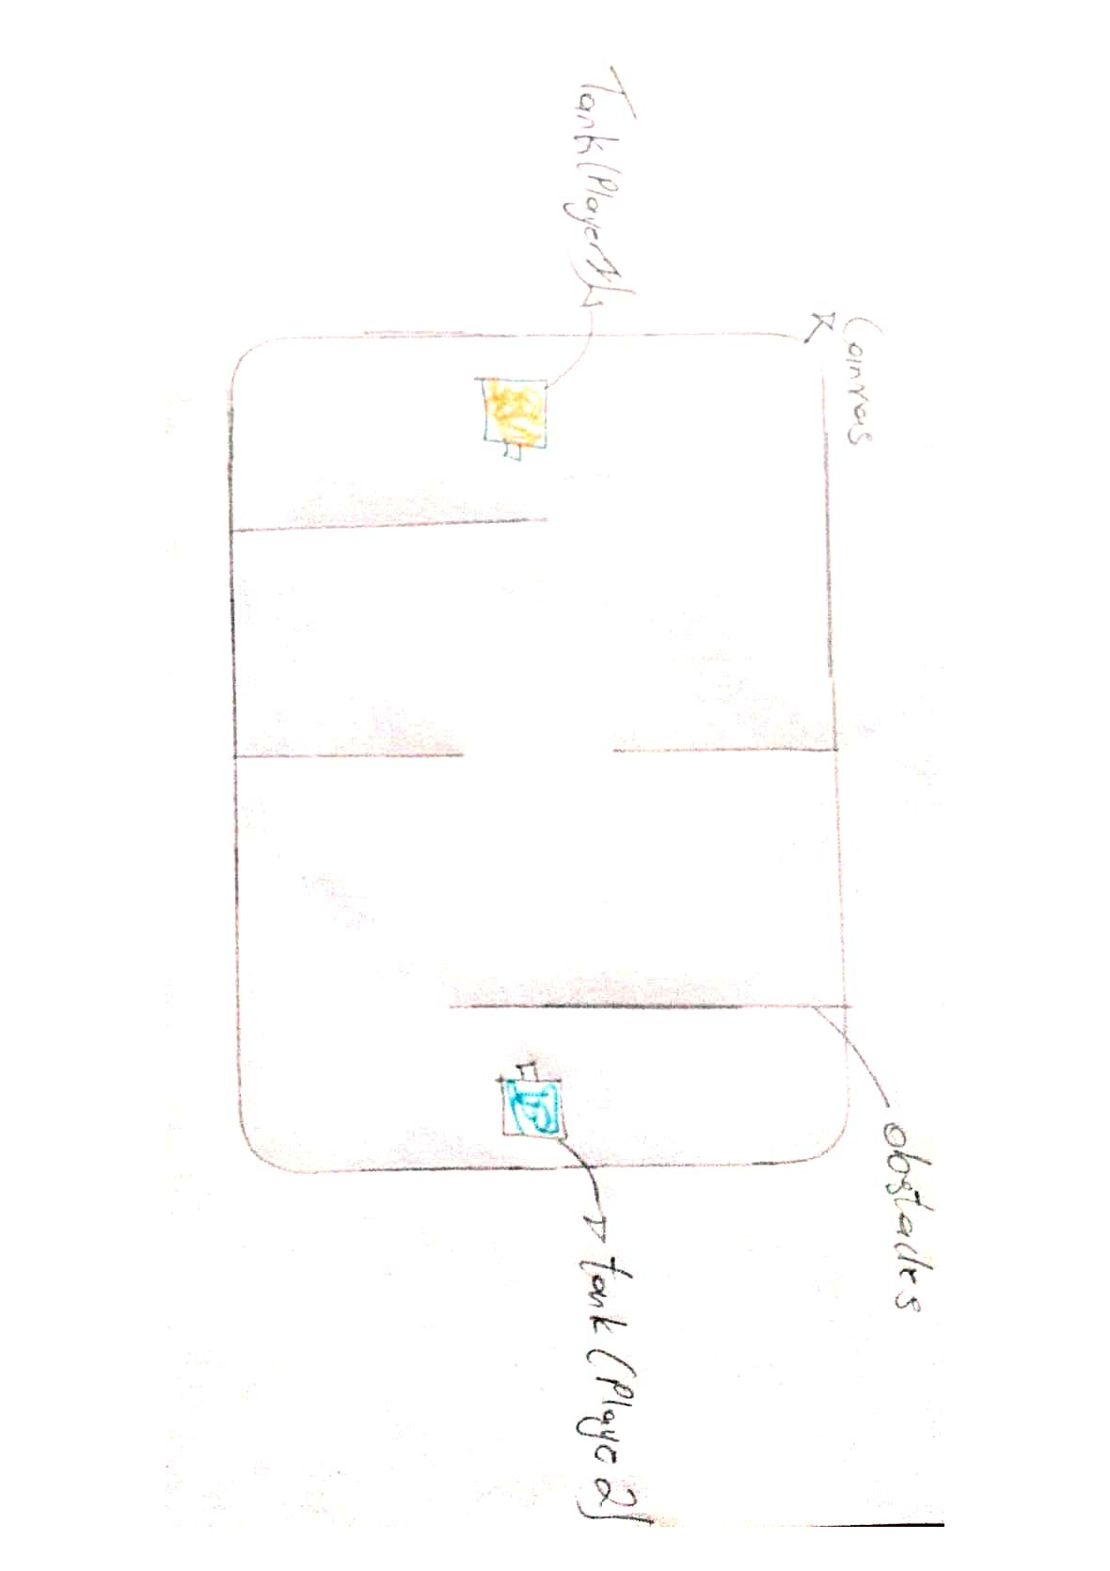
C. Game flow
Start game

Player input

Check collisions
Update position
Render Frame

How the game Works
A 2-player competitive tank battle built with WebGL where players control tanks to eliminate/shoot each other.
Core Mechanics
- Players:
  - Player 1: Red tank (WASD + SPACE)
W- Move Forward.
A- Move left.
S- Move Backwards.
D-Move right.
Space- shoot.
  - Player 2: Blue tank (Arrow Keys + ENTER)
Enter- shoot.
Arrows- complementary movements.
- Gameplay:
  - Move tanks and shoot bullets to hit the opponent.
  - First to 5 hits wins.
  - Bullets bounce off walls (realistic collisions).
- Technical Features:
  - WebGL Rendering: Custom shaders for tank/bullet rendering.
  - Physics: AABB collision detection for tanks/bullets/walls.
  - Audio: Background music and sound effects for actions.
- Obstacles:
  - Indestructible walls create strategic gameplay.
- Extras:
  - Score tracking
  - Game reset functionality
  - Music toggle
How It Works
- Game Loop: Continuously updates positions, checks collisions, and renders frames.
- Controls: Keyboard inputs trigger tank movement/shooting.
- Collisions: Bullets detect hits using distance-based checks.
Working Artifact
Folder Structure:
index1.html ---------- Menu-Game file,
Game.js -----------Main-Page file,
Index2.html ----------Main-game file,
WarTanks.js -----------Core logic,
Index3.html -----------Help/Game guide and controls file/web,
.dits(folder) -----------Planning files, background images and audio files
Minimal `index.html:
<!DOCTYPE html>
<html>
<head>
<title>WarTanks</title>
<link rel="stylesheet" href="style.css">
</head>
<body>
<canvas id="gameCanvas"></canvas>
<script src="game.js"></script>
</body>
</html>

