Lessons:

There are many lessons such as the importance of naming conventions, and the folder directors. Having so many assets and scripts in the projects.

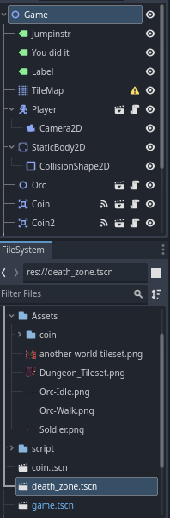

#1 - The importance of each item in the hierarchy. Which item is under another could have a great importance because the script is not able see the particle element.

Example is the camera is following the player.

#2 – Making bases of repetitive elements will make work go faster and provide each element with the same properties such as coins.

#3 – Every element or bodies are not actually collectible as they are only 2d objects. By adding these 2d objects collision properties, the objects are interactable. Example – Coins, the orc and the player.