INTERIM REPORT
Machine Learning and Spatial Analysis of Demographic Typology and
Education–Health Service Adequacy in Uva Province, Sri Lanka

[Your Name]
[Student ID]
[Department / Degree]
[Supervisor]
[Date]

Acknowledgement
I express sincere gratitude to my supervisor for guidance on framing the research problem and for comments on draft materials. I thank the Department of Census and Statistics, Sri Lanka, for publicly available small-area data, and colleagues who assisted with GIS data preparation. Any errors remain my own.

Abstract
This interim report presents progress on a study of Grama Niladhari (GN)–level demographic structure and its relationship to education- and health-relevant service access in Uva Province, Sri Lanka. Census 2012 age-band data are harmonised with network-based distances to the nearest school and hospital derived from GIS, together with optional facility-count indicators. Transparent proxies map census cohorts to education stages (preschool through senior secondary) and to elderly (65+) population shares for health-oriented analysis. Preliminary analysis covers 894 GN divisions (573 in Badulla District, 321 in Monaragala District), with successful distance linkage for 894 divisions. Descriptive statistics, correlation and scatter exploration, K-means clustering on education-stage composition, and hotspot flags combining high need with greater travel distance are reported. Results indicate substantial GN-level variation in age structure and in accessibility metrics, supporting the thesis aim of identifying typologies and priority areas for policy-relevant discussion. Limitations—including census vintage, imperfect alignment of single-year age bands with education stages, and name-based polygon linkage—are acknowledged. The final thesis will extend validation, mapping, and interpretation.

Table of Contents
Abstract .......................................................... ii
1. Introduction ................................................... 1
2. Literature Review .............................................. 2
3. Study Area and Data ............................................. 4
4. Methodology .................................................... 6
5. Preliminary Results ............................................ 8
6. Progress, Timeline, and Expected Outputs ........................ 12
References ........................................................ 13
Appendix: List of Figures .......................................... 14

1. Introduction
Balancing population need with the geographic availability of education and health services is a persistent policy concern in rural and peri-urban Sri Lanka. Uva Province, comprising Badulla and Monaragala Districts, combines plantation, paddy, and forest-edge settlements with towns and estate corridors. At sub-district scale, Grama Niladhari divisions provide a meaningful unit for small-area demographic profiling and for linking residents to nearest facilities along road networks.
National policy discourse often emphasises universal primary enrolment and expanding secondary completion, while simultaneously addressing population ageing and non-communicable disease burdens. Those challenges intersect spatially: communities with many children may face pressure on classrooms and safe routes to school, whereas communities with rising elderly shares may depend more heavily on outpatient and inpatient services that are sensitive to travel burden. Without small-area evidence, district averages can mask pockets of mismatch between need and proximity to infrastructure.
This research asks how GN-level demographic typology—particularly the mix of preschool, primary, junior-secondary, and senior-secondary age proxies, together with dependency and elderly shares—co-varies with measures of access such as network distance to the nearest school and hospital. The study does not equate distance with full “service adequacy,” which would require capacity, quality, and utilisation data; rather, it treats distance as one measurable dimension of accessibility alongside population structure.
The overall objectives are: (1) to construct a clean GN master dataset for Uva with harmonised demographics and access indicators; (2) to document limitations of using census age bands as proxies for education stages; (3) to explore patterns through exploratory data analysis and unsupervised clustering; and (4) to flag divisions that combine relatively high need (e.g. school-age or elderly share) with relatively long travel to services, as candidates for spatial prioritisation in discussion with planners.
The interim report scope is deliberately analytic rather than prescriptive: it summarises data preparation, preliminary patterns, and methodological choices so that supervisors and examiners can assess feasibility before the final dissertation submission.

2. Literature Review
Small-area demographic analysis using census data is well established for dependency ratios, ageing, and youth cohorts (United Nations, 2013; World Bank demographic indicators). In Sri Lanka, Census 2012 remains the authoritative source for GN-level population by five-year age group, though analysts must note the time lag relative to current service planning.
Education planners routinely work with official school-age definitions that do not map one-to-one onto census five-year bands. International and national literature therefore cautions against over-interpreting coarse cohorts as exact grade structures. The present study follows transparent mapping rules and states limitations explicitly so that readers can judge how strongly conclusions depend on those approximations.
Accessibility in health geography is commonly operationalised through distance, travel time, or two-step floating catchment methods (Luo & Qi, 2009; McGrail & Humphreys, 2014). Network distance from polygon centroids or representative points to nearest facility is a transparent simplification adopted in many student and applied GIS projects; it captures proximity but not congestion, transport mode, or facility capacity.
Recent GIS-enabled studies in similar contexts increasingly combine demand surfaces (population need) with supply layers (facility locations) to discuss equity. This project adopts a lighter specification—GN need proxies plus nearest-facility distance—to remain feasible within thesis time frames while still producing interpretable maps and tables for Uva.
Unsupervised clustering (e.g. K-means on standardised shares) supports typology building when labels are not available a priori (Everitt et al., 2011). Silhouette scores and cluster profile tables help choose cluster count and interpret groups in policy language. For compositional percentages, interpretation should avoid treating correlations as causal without spatial regression or further modelling—an avenue reserved for the final thesis.
Spatial autocorrelation implies that neighbouring GNs may resemble one another; exploratory correlation and scatter plots reported here are therefore preliminary. A fuller thesis chapter may employ spatial regression or sensitivity checks on weight matrices if the supervisory panel agrees on scope.

3. Study Area and Data

3.1 Study area
Uva Province lies in south-eastern Sri Lanka. The analysis is restricted to GN divisions within Badulla and Monaragala Districts, consistent with the available boundary layers and crosswalk tables used in the project.

3.2 Data sources
Demographic data: GN-level Census 2012 counts by five-year age bands, obtained via a project crosswalk file linking GN identifiers and division names to Uva districts. Where applicable, population totals and age columns were validated against row sums.
A small proportion of crosswalk name fields may be missing while `area_name` remains populated; analytical joins for distances rely on harmonised keys derived from the populated name column. Duplicate GN identifiers, if any, were removed by retaining the first occurrence and logging the count.
Accessibility data: CSV exports from QGIS network analysis giving, for each GN polygon, Euclidean or road-network distance (kilometres) to the nearest mapped school and hospital. Multiple polygons sharing a harmonised name were aggregated using the median distance for robustness.
Supplementary tables: optional facility counts per GN name (education and health) from project cleaning, used descriptively given high zero-inflation.
Boundary shapefiles for Badulla and Monaragala GN polygons underpin the distance calculations; the interim analysis consumes tabular exports rather than embedding geometry inside the statistical notebook, but final maps will be prepared in QGIS for visual communication.

4. Methodology

4.1 Feature construction
Classic broad groups: children (0–14), working-age (15–59), and elderly (60+) population counts and shares; broad dependency ratio as (children + elderly 60+) divided by working-age, expressed as a percentage.
Education proxies (with documented limitations): preschool share approximated by ages 0–4; primary by 5–9; junior-secondary proxy by 10–14 (includes age 14 in senior-secondary in reality); senior-secondary and collegiate proxy by 15–19. Total school-age combines these bands (0–19). Education dependency ratio uses total school-age relative to working-age 15–59. Health-focused elderly share uses ages 65 and above only.

4.2 Integration and quality checks
GN names were normalised (trim, lowercase, removal of trailing numeric suffixes from duplicate polygons) and merged between census and distance tables. Duplicate census GN codes were removed (first retained). Missingness and IQR-based outlier counts were tabulated for key variables; outliers reflect genuine heterogeneity across GNs rather than data errors in most cases.

4.3 Analysis methods
Descriptive statistics and visual summaries (histograms, boxplots, violins, scatter plots, correlation heatmaps) were produced in a reproducible notebook environment. K-means clustering used standardised features: preschool, primary, junior-secondary, and senior-secondary shares, log of total population, and broad dependency ratio; silhouette scores for k = 2…10 informed the choice of k. Priority flags identified divisions above the 75th percentile simultaneously on school-age share and school distance, or on elderly (65+) share and hospital distance, among rows with non-missing distances.

5. Preliminary Results

5.1 Sample and descriptive profile
The working GN sample comprises 894 divisions after cleaning. Mean total population per GN is approximately 1322 persons. Mean school-age share (0–19 proxy) is about 34.90% of population; mean share aged 65+ is about 7.00%. Mean broad dependency ratio is approximately 60.8%. Distance records could be linked for 894 of 894 GNs.
District comparison (aggregated means from preliminary tables): Badulla shows slightly higher mean broad dependency ratio and elderly (60+) share than Monaragala in this extract, while Monaragala exhibits comparable child shares; exact magnitudes should be read from exported district summary tables in the project outputs.
Data-quality diagnostics showed complete core age bands and totals for retained rows. A minority of optional crosswalk attributes exhibit higher missingness; they do not obstruct the main indicators. IQR-based outlier counts for ratios and population totals reflect legitimate tail behaviour (very small or very large GNs) rather than wholesale miscoding.

Table 1. Selected GN-level descriptive statistics (preliminary)
Indicator | Mean | Median | Notes
Total population | 1322.4 | 1181.5 | Per GN
School-age share (%) | 34.90 | 34.94 | 0–19 proxy
Elderly 65+ share (%) | 7.00 | 6.91 | Health focus
Broad dependency ratio (%) | 60.84 | 60.25 | 0–14 & 60+ vs 15–59
Education dep. ratio (%) | 56.21 | 55.83 | School-age vs 15–59
Distance to school (km) | 6.67 | 4.03 | Median per GN name
Distance to hospital (km) | 6.20 | 4.58 | Median per GN name
Table 1. Summary statistics for indicators used in the interim analysis.

5.2 Distribution of school-age share
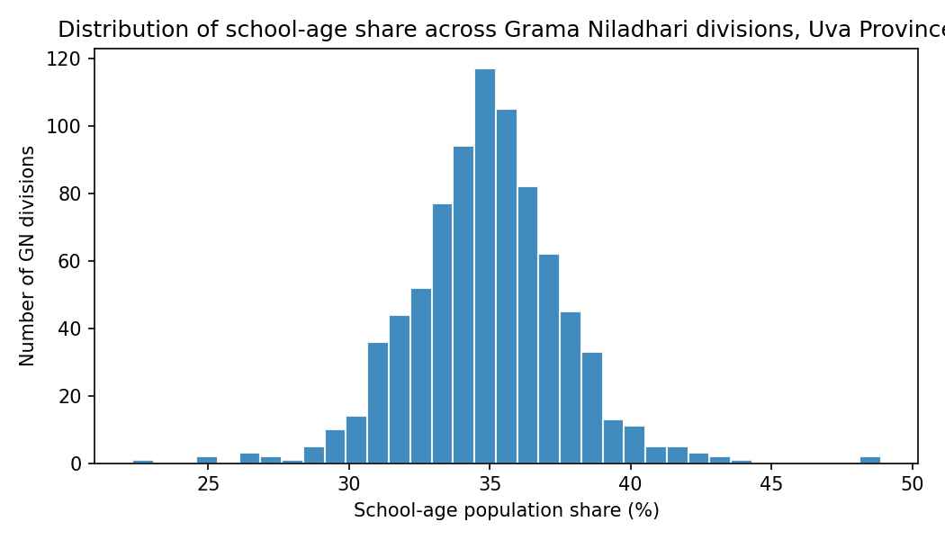
Figure 1. Histogram of school-age population share (%) across GN divisions, Uva Province.
The distribution is unimodal with modest spread around the mid-thirtieth percentile of total population, but the upper tail identifies GNs where children and youth (under the 0–19 proxy) comprise a substantially larger fraction—relevant when discussing pressure on classrooms and school access. The lower tail highlights divisions with comparatively fewer young people, which may face different service planning priorities.

5.3 Elderly share by district
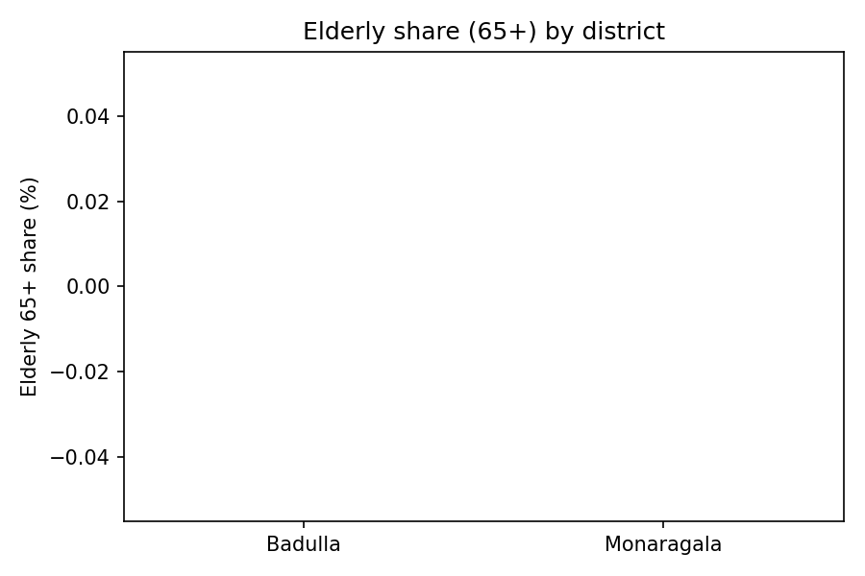
Figure 2. Boxplot of population share aged 65+ by district (Badulla vs Monaragala).
Comparing Badulla and Monaragala using the health-focused 65+ share illustrates inter-district differences in ageing intensity at GN scale. Median and quartile positions should be read together with map patterns, because summary boxes can obscure spatial clustering of elderly populations along valleys or estate lines.

5.4 Access vs need (illustrative)
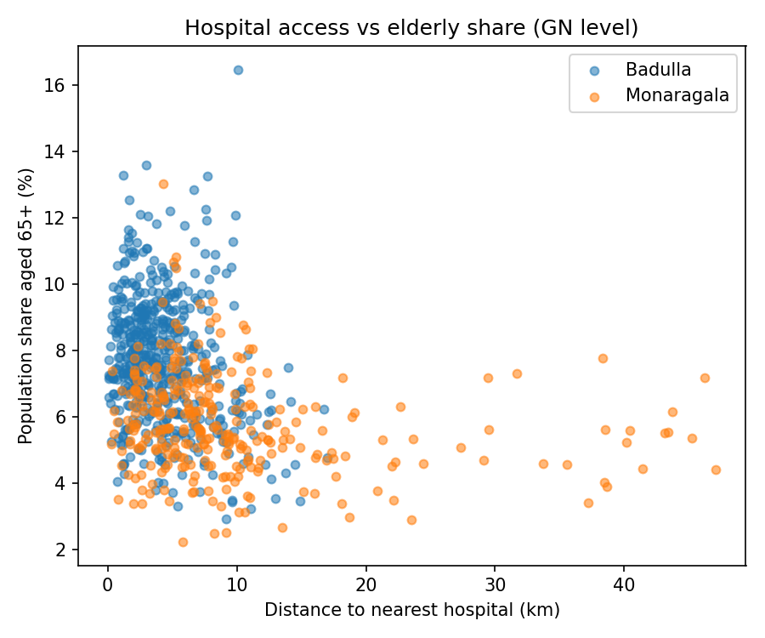
Figure 3. Scatter of hospital distance (km) versus elderly (65+) share, by district.
No strong linear relationship is expected a priori: high elderly share can occur in both well-served towns and remote villages. The scatterplot is nevertheless useful for identifying leverage points—divisions in the north-east quadrant (higher distance and higher elderly share) merit visual confirmation in GIS. Similar plots for school-age share versus school distance (not reproduced here to save space) underpin the education priority flag in the analytical notebook.

5.5 Preliminary typology (K-means)
K-means on education-stage shares, log population, and dependency ratio yielded separable clusters in preliminary runs (e.g. one cluster with relatively higher preschool/primary shares and another with different senior-secondary mix); silhouette analysis supported a small to moderate k. Cluster labels are exploratory and require interpretation alongside maps in QGIS.
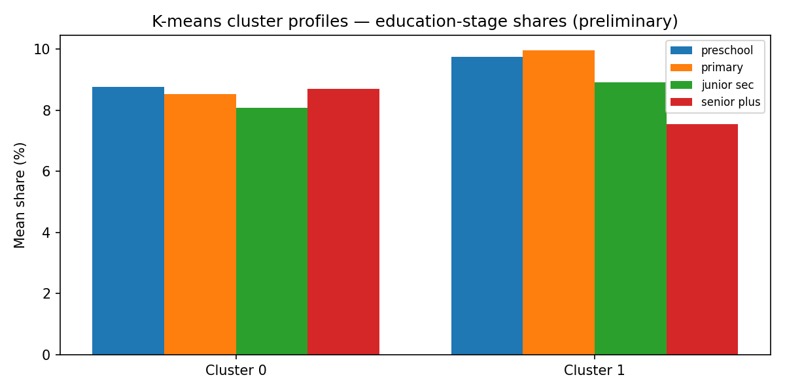
Figure 4. Mean education-stage shares by K-means cluster (preliminary typology).
Cluster profiles separate divisions with higher early-childhood and primary-weighted structures from those with relatively more mass in older school-age bands, holding population scale and dependency in the feature set. Naming clusters (e.g. “younger GN” vs “older school-age GN”) is deferred to the final thesis after spatial overlays and robustness checks.

5.6 Distance distributions
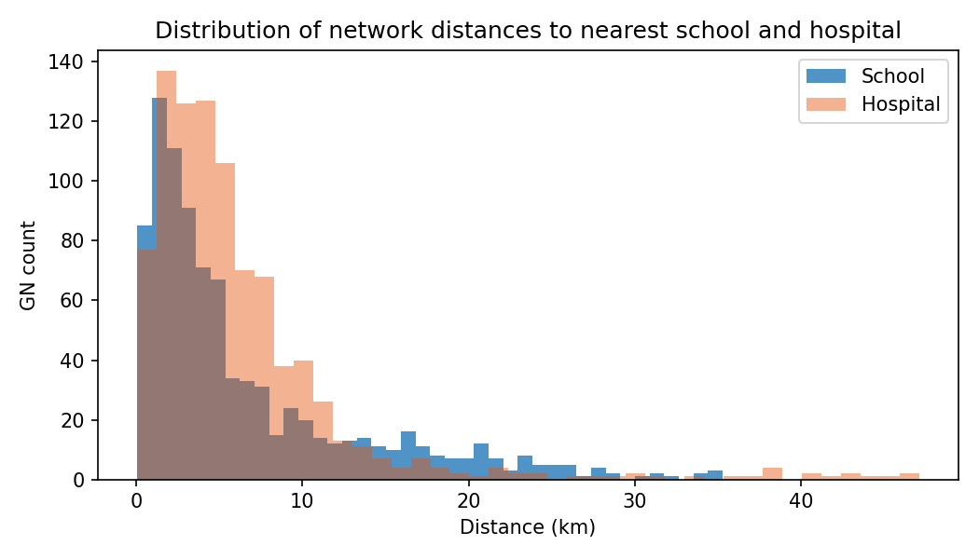
Figure 5. Overlaid histograms of distance to nearest school and nearest hospital (km).
School and hospital distance histograms typically show right skew: most GNs fall within a few kilometres of a facility, while a minority experiences very long nearest-facility distances—often in the Monaragala dry-zone fringes or remote hill-country pockets. Overlaying these layers with priority flags helps communicate inequality in access without overstating normative conclusions.

5.7 Priority divisions
In the current master export, 97 GN divisions met the dual-threshold hotspot definition (high need and high distance among matched rows). These should be cross-checked on maps and with local knowledge before any policy claim. Facility-count fields remain sparse at GN level in the merged table and are interpreted cautiously.

5.8 Limitations
Census 2012 is dated relative to 2025–2026; structural shifts (outmigration, ageing, school closures) are not captured. Education-stage variables are approximations from five-year bands and should not be read as exact grade enrolment. Distance metrics depend on the road network and facility layer used in QGIS; alternative facilities or routing assumptions would change numeric values.
Name-based linkage between census rows and multiple polygons can introduce measurement error when names are ambiguous or spelled differently; fuzzy matching mitigates but does not remove risk. Priority flags use percentiles computed on matched rows only and are screening tools, not definitive resource-allocation rules.

6. Progress, Timeline, and Expected Outputs
Completed: data harmonisation, feature engineering with documented proxies, exploratory analysis, clustering prototype, priority flags, and export of a master CSV/Parquet for mapping. Pending: final chapter drafting, refined spatial regression or sensitivity analysis if scope allows, integration of QGIS layout figures into the thesis, and supervisor-reviewed conclusions. Expected final deliverables include the full dissertation, reproducible notebook documentation, and a set of publication-style maps.
A provisional timeline for the remaining semester includes: (i) supervisor feedback on this interim document; (ii) production of final choropleth maps for clusters, distances, and priority flags; (iii) drafting of discussion and conclusion chapters linking findings to Sri Lankan policy documents; (iv) proofreading and formatting to faculty thesis guidelines.

7. Conclusion
This interim stage confirms that a GN-level analytical pipeline for Uva Province is feasible: census age structure can be harmonised with network-based accessibility metrics and summarised through descriptive, correlational, and clustering tools. Preliminary outputs already highlight heterogeneity across GNs and districts, and identify a subset of divisions for deeper spatial scrutiny.
The final thesis will emphasise mapped evidence, careful language on adequacy versus accessibility, and alignment with national education and health policy frameworks. Where the supervisory panel approves, additional modelling may strengthen inference; otherwise, the work stands as a rigorous descriptive and exploratory spatial-demographic case study for Uva Province.

References
- Everitt, B. S., Landau, S., Leese, M., & Stahl, D. (2011). Cluster Analysis (5th ed.). Wiley.
- Luo, W., & Qi, Y. (2009). An enhanced two-step floating catchment area (2SFCA) method for measuring spatial accessibility to primary care physicians. Health & Place, 15(4), 1100–1107.
- McGrail, M. R., & Humphreys, J. S. (2014). Measuring spatial accessibility to primary care in rural areas: Improving on the nearest neighbour approach. Health & Place, 26, 67–77.
- Department of Census and Statistics, Sri Lanka (2012). Census of Population and Housing — relevant GN tables.
- United Nations (2013). World Population Prospects: The 2012 Revision — methodological documentation.

Appendix: List of Figures (for thesis compilation)
Figure 1. Distribution of school-age share across GNs.
Figure 2. Elderly (65+) share by district.
Figure 3. Hospital distance vs elderly share.
Figure 4. K-means cluster profiles (education-stage means).
Figure 5. Histograms of school and hospital network distances.
Note: Additional notebook outputs (correlation heatmaps, pairplots of stage shares, PCA scatter of clusters, and top/bottom GN ranking tables) should be inserted in the final thesis PDF as needed. If a faculty-approved interim template from a peer is provided, section titles and page length can be aligned to that template in a revision.

