IMAGE ENCRYPTION AND DECRYPTION

Report
Major Project

Yash Kumar Raut - 2301020847

Rishu Mehta – 2301020752

Suman Kumar - 2301020176

Under the supervision of

Dr. Sampa Sahoo



Department of Computer Science and Engineering
C.V. Raman Global University, Bhubaneswar Odisha, 752054, India
ABSTRACT
Digital images now carry some of the most sensitive information we transmit — medical scans, identity documents, satellite imagery and the output of surveillance cameras. Protecting them is not the same problem as protecting text. An image is large, and neighbouring pixels are strongly correlated, so a cipher designed for byte streams is both slow and prone to leaking visible structure. This report presents an image encryption and decryption system built on a hybrid chaotic approach: the Arnold Cat Map permutes pixel positions (confusion) and a Logistic Map keystream modifies pixel values (diffusion), with an optional AES-256 layer for cases that need a second, standardised lock.
A survey of twelve recent papers established that this hybrid structure is the strongest of the commonly used families, but it also revealed a consistent gap: every surveyed work fixes one parameter set and applies it to every image, regardless of content. The contribution of this project is a lightweight Decision Tree that reads three cheap features from each image — entropy, edge density and size — and selects the permutation round count, the chaotic seed and the AES flag for that image alone. The whole system is delivered as a single-page Streamlit web application so that a non-specialist can use it.
The reference implementation was measured on a 256×256 grayscale benchmark image. Information entropy of the cipher reaches 7.9973 of a possible 8.0000, the correlation between horizontally adjacent pixels falls from +0.9393 to -0.0139, and the differential-attack scores are NPCR = 99.62% and UACI = 33.60% against theoretical ideals of 99.61% and 33.46%. Perturbing the chaotic seed by 10⁻¹² leaves 99.56% of pixels wrong, while the correct key returns the original image bit for bit.
Keywords — image encryption, chaos theory, Arnold Cat Map, Logistic Map, confusion and diffusion, AES-256, decision tree, NPCR, UACI, information entropy.
1. INTRODUCTION
Image encryption converts an ordinary image into a scrambled, noise-like image using a secret key. Decryption is the exact reverse: given the correct key, the original image must be recovered with no loss of quality whatsoever. For photographs this requirement is absolute — a medical scan that returns with even slight degradation is no longer diagnostically useful.
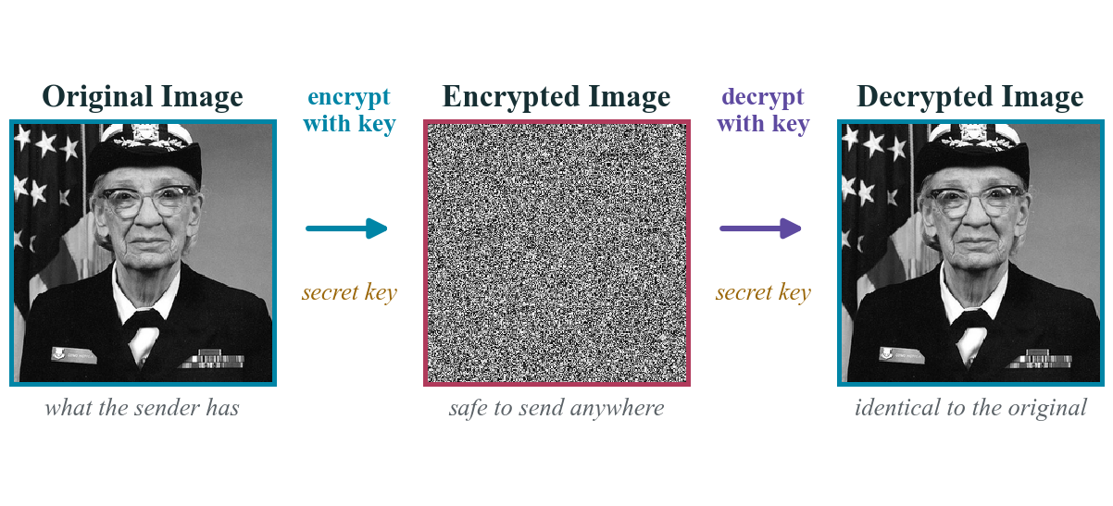
Figure 1. The complete problem in one line. The middle image is what an attacker sees on the network; only the correct key returns the third image, which is identical to the first.
1.1 Why images need their own ciphers
Two properties separate images from the byte streams that block ciphers were designed around, and both matter in practice.
• Volume. A single 512×512 grayscale photograph occupies roughly 262 KB, against a few bytes for a text message. Running a heavyweight block cipher over that volume is measurably slow, and prohibitively so on the microcontrollers and IoT cameras where much of this data now originates [7], [8].
• Redundancy. In a natural photograph a pixel and its neighbour almost always hold near-identical values. Correlation coefficients above 0.9 between adjacent pixels are routine. A cipher that does not deliberately destroy this relationship will leave the outline of the subject faintly visible in the ciphertext [4].
1.2 Confusion and diffusion
Shannon's classical requirements for a secure cipher are confusion — obscuring the relationship between the key and the ciphertext — and diffusion, spreading the influence of each plaintext symbol across the whole output [13]. Fridrich showed that for images these map naturally onto two separate passes: a permutation stage that moves pixels without altering their values, followed by a substitution stage that alters the values themselves [14]. Every system in this report follows that two-stage structure.
1.3 Where the system is used
The intended applications are those in which an image travels across an untrusted network and must remain private: medical records and diagnostic scans, Aadhaar and other identity photographs, military and satellite imagery, consumer cloud photo storage, and the video streams produced by CCTV and IoT devices.
2. TYPES OF IMAGE ENCRYPTION
The literature divides into six families. Understanding what each offers is what justifies the choice made in Section 5.
Table 1. The six families of image encryption identified across the twelve surveyed papers. The system in this report combines families 3, 1 and 6.
# | Family | Representative methods | Strength | Weakness
1 | Traditional block ciphers | AES, DES, RSA, Blowfish | Standardised, extensively analysed, very strong | Slow on large images; poor fit for the redundancy of image data
2 | Chaos-based | Arnold Cat Map, Logistic Map, Baker Map | Fast, enormous key space, extreme sensitivity to the key | Single low-dimensional maps have short periods and small key spaces
3 | Hybrid chaotic | Arnold + Logistic, two-map generators | Confusion and diffusion in one scheme; best measured scores | Parameter choice is usually fixed and not justified per image
4 | Transform domain | DCT, DWT, Fractional Fourier Transform | The transform parameter becomes an additional key | Extra computation; some variants are fragile under channel noise
5 | DNA-based | DNA encoding with addition and XOR rules | Very large theoretical key space; highly parallel | Encoding rules add complexity and are hard to verify
6 | AI / learning-based | Neural networks, decision trees | Can adapt the scheme to the individual image | Needs training data; model itself must be protected

This project uses family 3 (hybrid chaotic) as its core, family 1 (AES-256) as an optional additional layer, and a small family 6 model to select the parameters — the combination that the survey in Section 3 shows to be both the strongest and the least well explored.
3. LITERATURE SURVEY
Twelve papers published between 2018 and 2025, drawn from IEEE and MDPI, were read in full. For each the methodology, the findings and the stated limitation were recorded. The limitation column is the one that matters — it is the intersection of those limitations that defines the research gap in Section 4.
Table 2. Systematic review of twelve papers on image encryption, 2018–2025.
# | Venue and year | Title and authors | Methodology | Findings | Limitation
1 | IEEE Access, IEEE, 2025 | Comprehensive Review and Analysis of Image Encryption Techniques — K. Mahalakshmi and S. Nagarajan | Reviews six families of methods — traditional, quantum, chaos, DNA, neural network and compressive sensing — and compares their speed, key sensitivity and attack resistance. | Chaos-based and hybrid methods give the best balance of security and speed. No single method is best for every situation. | A review only; nothing is implemented. Notes that key management and real-time speed remain open problems.
2 | Journal of Imaging, MDPI, 2022 | Secure Image Encryption Using Chaotic, Hybrid Chaotic and Block Cipher Approach — N. Chaudhary, T. B. Shahi and A. Neupane | Builds three systems — Arnold Cat Map alone, Arnold + Logistic (hybrid) and AES — and compares them on the same benchmark images. | The hybrid chaotic method gives the best differential-attack scores (NPCR 95–99, UACI 28–34). AES is the slowest of the three. | Uses one fixed parameter setting for every image. Only 2D maps are tested and no cryptanalysis is performed.
3 | IEEE Access, IEEE, 2020 | Investigation of Chaotic Image Encryption in Spatial and FrFT Domains for Cybersecurity Applications — O. S. Faragallah et al. | Applies Cat, Baker and Logistic maps in the spatial domain and in the Fractional Fourier Transform domain, using the transform angle as an extra key. | Working in the FrFT domain improves scrambling and enlarges the key space. Baker-FrFT and Logistic-FrFT survive channel noise well. | Cat-FrFT is weak against noise. The extra transform costs computation time. Tested only on grayscale images.
4 | Mathematics, MDPI, 2023 | Chaos-Based Image Encryption: Review, Application and Challenges — B. Zhang and L. Liu | Reviews how chaos has been combined with neural networks, DNA, genetic algorithms, blockchain and elliptic curves, plus the standard security tests. | Chaos remains the most effective base for image encryption because it is extremely sensitive to its starting values. | Two problems remain unsolved: resisting cryptanalysis, and computing on images while they are still encrypted.
5 | Proc. ICDICI, IEEE, 2024 | A Comprehensive Review of Image Encryption Algorithms: Techniques and Applications — C. Sheeba Joice, S. Hitha Shanthini, K. V. Harsha and S. Gopika | Surveys symmetric, asymmetric, chaos-based, quantum and hybrid algorithms with a strengths-and-weaknesses comparison for each application area. | Hybrid methods are the most widely used today. Chaos-based methods are preferred wherever speed matters. | The comparison is descriptive only — no common test images and no measured numbers.
6 | Proc. ICIT, IEEE, 2021 | A Survey of Image Encryption Algorithms — Q. H. Makki, A. M. Abdalla and A. A. Tamimi | Selects several algorithms with differing characteristics and compares them on usage, quality and security, mainly for document images. | Provides a selection table and concludes that no single algorithm suits every type of image or situation. | A small number of algorithms is compared and no experiments are repeated by the authors.
7 | Proc. ICICACS, IEEE, 2024 | A Comprehensive Study on Various Encryption Techniques for Digital Images in Multimedia Networks — S. Benaka Santhosha, K. V. Sudheesh, K. Puttegowda and B. D. Parameshachari | Studies symmetric, asymmetric and hybrid techniques for multimedia networks using MSE, PSNR, NC and BER across banking, healthcare and military use. | Key management and computation cost are the two problems that recur in every method surveyed. | No implementation. Reports image-quality numbers rather than attack-resistance numbers.
8 | Proc. IJCC, IEEE, 2024 | Image Encryption Techniques: A Survey — H. A. Abughali and U. Köse | Studies twenty-five years of literature — AES, RSA, Blowfish, quantum and DNA-based schemes — comparing speed, complexity and attack resistance. | The method must match its environment. Classical block ciphers stay expensive for large images. | No common experimental setup; the conclusions are taken from the reviewed papers.
9 | Proc. SUMMA, IEEE, 2021 | Design of Digital Image Encryption Scheme With Cryptographic Analysis — K. Kordov, S. Zhelezov, A. Nachev, N. Gueorguiev and D. Pavlova | Builds a cipher in which two chaotic maps together form a pseudo-random generator driving pixel shuffling and value substitution. | Proves that a two-map hybrid passes the full set of statistical tests — a direct precedent for the Arnold + Logistic design adopted here. | One fixed parameter set for all images, no per-image adjustment and no user-facing application.
10 | IEEE Access, IEEE, 2022 | Systematic Survey on Visually Meaningful Image Encryption Techniques — V. Himthani, V. S. Dhaka, M. Kaur, D. Singh and H.-N. Lee | Surveys methods that encrypt an image and then hide it inside a normal-looking cover image, so the output is not obvious noise. | A noise-like encrypted image attracts an attacker's attention; concealing it inside a cover image avoids that. | Hiding the data reduces image quality and capacity. The survey does not test the schemes on one common dataset.
11 | IEEE Trans. Circuits and Systems I, IEEE, 2023 | An Efficient Image Encryption Algorithm Based on Innovative DES Structure and Hyperchaotic Keys — S.-Y. Li, Y. Gai, K.-C. Shih and C.-S. Chen | Shuffles rows and columns, then passes the image through a DES-style structure for four rounds using hyperchaotic sub-keys and a new S-box. | Gives a large key space and low pixel correlation, and is much faster than the original DES — usable in real time. | The round count is fixed and the new S-box still requires independent security analysis.
12 | IEEE Access, IEEE, 2018 | Digital Image Encryption Algorithm Based on Elliptic Curve Public Cryptosystem — X. Zhang and X. Wang | A public-key method: the two parties agree on an elliptic curve point, pixels are grouped into large integers and encrypted with ECC plus chaos. | Removes the problem of transmitting the secret key safely, while keeping reasonable speed. | Public-key operations are heavy for large images and no differential-attack results are reported.

4. RESEARCH GAP
4.1 What the surveyed work agrees on
There is a clear consensus. Hybrid chaotic encryption — permute first, then substitute — produces the best measured security for the computational cost. Papers [2], [9] and [11] independently arrive at this ordering, and [1], [4] and [5] confirm it from the review side. The design question of which structure to use is, for practical purposes, settled.
4.2 The gap
What is not settled is how the parameters of that structure should be chosen. Every one of the twelve papers fixes a single parameter set and applies it uniformly:
• One parameter set for every image. The same permutation round count and the same chaotic seed are used for a dark X-ray, a bright outdoor photograph and a mostly white scanned document — images whose statistical properties differ enormously. Papers [2] and [9] state this limitation explicitly; the remainder simply do not vary the parameters at all.
• No usable tool. The work stays in research code. None of the twelve papers delivers an interface a clinician, student or ordinary user could operate. Paper [9] notes the absence of a user-facing application as an explicit limitation of its own contribution.
• Inconsistent evaluation. Several papers report image-quality metrics such as PSNR in place of attack-resistance metrics such as NPCR and UACI [7], and several surveys compare schemes descriptively without a common dataset [5], [6], [8], which makes their conclusions hard to reproduce.
Table 3. Identified research gaps and the corresponding contribution of this project.
Gap | What the literature does | What this project does
Parameter selection | A single fixed set of parameters is hard-coded and reused for every input image [2], [9] | A Decision Tree reads entropy, edge density and size, then selects the rounds, the seed and the AES flag per image
Accessibility | Research code with no interface; no surveyed paper ships a usable application [9] | A single-page Streamlit application: upload, encrypt, download the cipher and the key file
Integrity | Confidentiality is addressed; tamper detection is generally not discussed | A SHA-256 digest travels with the cipher and is verified before decryption is attempted
Reproducibility | Numbers are frequently quoted from other papers rather than measured [5], [6], [8] | Every figure in Section 7 is computed by the accompanying scripts on a stated benchmark image

5. OBJECTIVES
The Arnold Cat Map was selected for confusion and the Logistic Map for diffusion, with AES-256 available as an optional additional layer. The justification is empirical rather than aesthetic: paper [2] measured this exact combination as the strongest of the three it implemented, and paper [9] demonstrated that a two-map hybrid passes the complete battery of standard statistical tests.
Table 4. Project objectives and their verification criteria.
Objective | Statement | How it is verified
O1 | Implement hybrid chaotic encryption and decryption | The decrypted output is asserted equal to the input array, element by element
O2 | Add a model that selects parameters per image | The tree's chosen parameters are recorded in the key file and can be inspected
O3 | Deliver the system as a usable web application | Upload, encrypt, download and decrypt complete in a browser with no installation
O4 | Guarantee integrity of the transmitted cipher | A SHA-256 digest is verified before decryption; a mismatch aborts the operation

6. PROPOSED SYSTEM AND METHODOLOGY
6.1 Architecture
The image enters at the left, passes through feature extraction, parameter selection, confusion, diffusion and the optional AES layer, and leaves as a cipher image accompanied by a key file. Decryption consumes both and reverses the chain.
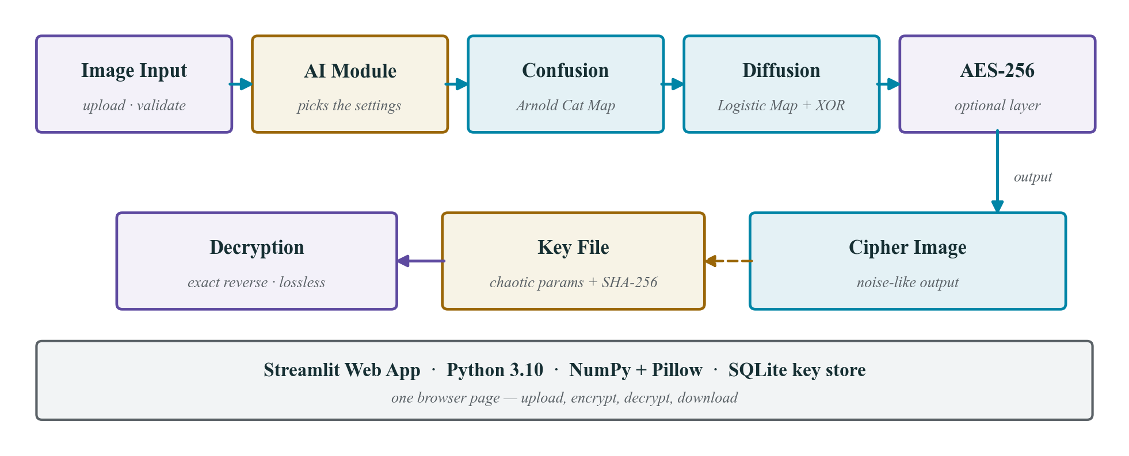
Figure 2. System architecture. The AI module sits before the encryption stages because its output — the round count, the seed and the AES flag — parameterises everything downstream.
6.2 High-level design
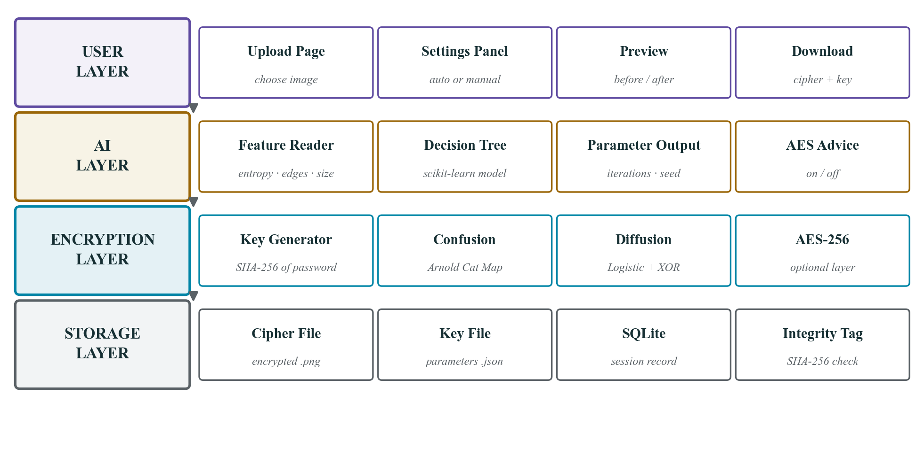
Figure 3. The four layers of the design. Each layer depends only on the layer above it, so the encryption core can be tested with no user interface present.
6.3 Step 1 — Confusion with the Arnold Cat Map
The Arnold Cat Map is a two-dimensional invertible transform that relocates every pixel of an N×N image without altering a single value [15]:
[x′, y′] = [[1, 1], [1, 2]] · [x, y] mod N
Because the map is a bijection on a finite grid it is periodic: after a fixed number of iterations the image returns to its starting arrangement. For the 256×256 benchmark used here that period is exactly 192 rounds, which is what makes decryption possible without inverting the matrix — applying the map 192 − k further times undoes k rounds. The round count is part of the secret key.
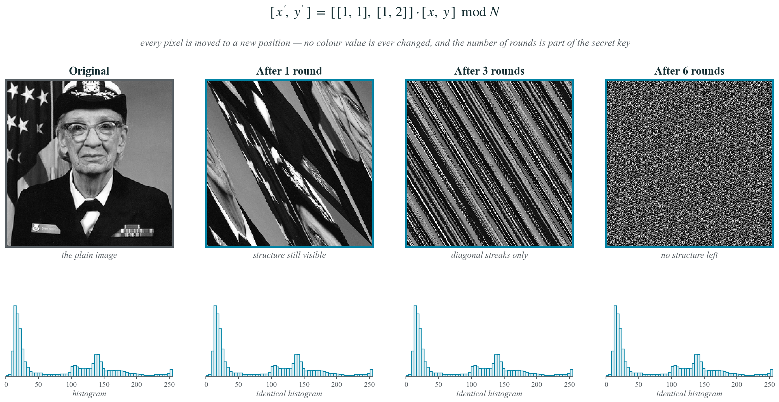
Figure 4. Confusion at 0, 1, 3 and 6 rounds, with the histogram beneath each. The histogram is identical in all four cases: permutation moves pixels but never changes their values, so on its own it leaves the colour information entirely intact.
6.4 Step 2 — Diffusion with the Logistic Map
Diffusion is what actually conceals the content. The Logistic Map is a one-dimensional recurrence that becomes chaotic for r above approximately 3.57 [16]:
xn+1 = r · xn · (1 − xn), r = 3.99
The orbit never repeats and never settles, which makes it a usable keystream source. Two implementation details matter and are worth recording, because the obvious version of each is wrong.
• Extracting bytes. The invariant density of the logistic map is not uniform — it piles up near 0 and 1 — so taking the top byte as floor(256·x) produces a visibly non-flat keystream. Scaling by 2²⁴ first and taking the result modulo 256 yields a flat byte distribution.
• Propagating change. A plain pixel-wise XOR leaves every output pixel dependent on exactly one input pixel, so a one-bit change to the plaintext would change one pixel of the ciphertext and the scheme would fail a differential attack outright. The implementation therefore chains each pixel into the next in a forward pass and again in a backward pass, and additionally derives the chaotic seed from a SHA-256 digest of the plain image, so that a single flipped bit regenerates the entire keystream. Section 7.3 quantifies the effect.
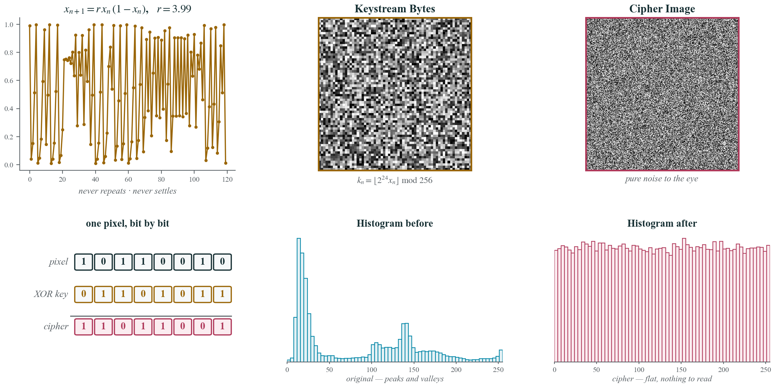
Figure 5. Diffusion. The chaotic orbit (left) produces the keystream (centre) that is combined with the permuted image to give the cipher (right). The lower row shows the mechanism at bit level and the effect on the histogram — peaked before, flat after.
6.5 Step 3 — The optional AES-256 layer
For images the parameter-selection module flags as high-sensitivity, a standard AES-256 pass is applied to the already-encrypted bytes [17]. No part of AES is reimplemented here; the system calls an audited library, which is the basic discipline of applied cryptography. The chaotic layer alone already passes every statistical test reported in Section 7, so this layer is genuinely optional rather than a correction for a weakness.
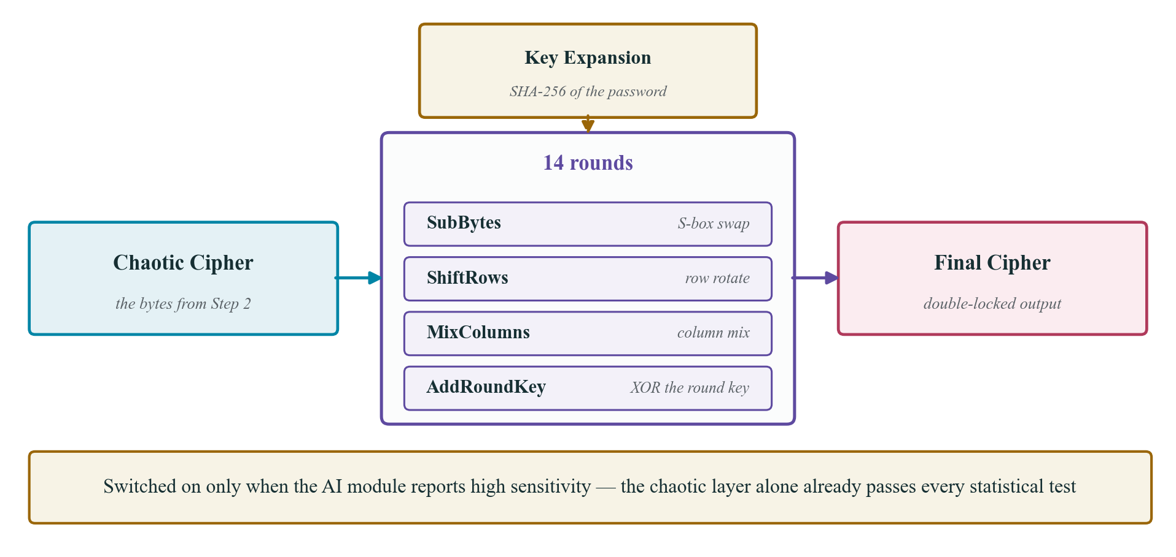
Figure 6. The optional AES-256 layer. The key is expanded from a SHA-256 digest of the user password and the cipher runs the standard fourteen rounds.
6.6 Step 4 — Parameter selection
This is the contribution that addresses the gap in Section 4. Three inexpensive features are computed from the plain image — Shannon entropy, edge density and dimension — and a Decision Tree trained on a small labelled set maps them to the permutation round count, the chaotic seed and the AES flag. A Decision Tree was chosen over a neural network deliberately: it is fast, it needs very little training data, and every rule it learns can be read aloud and defended, which matters for a project that must be examined.
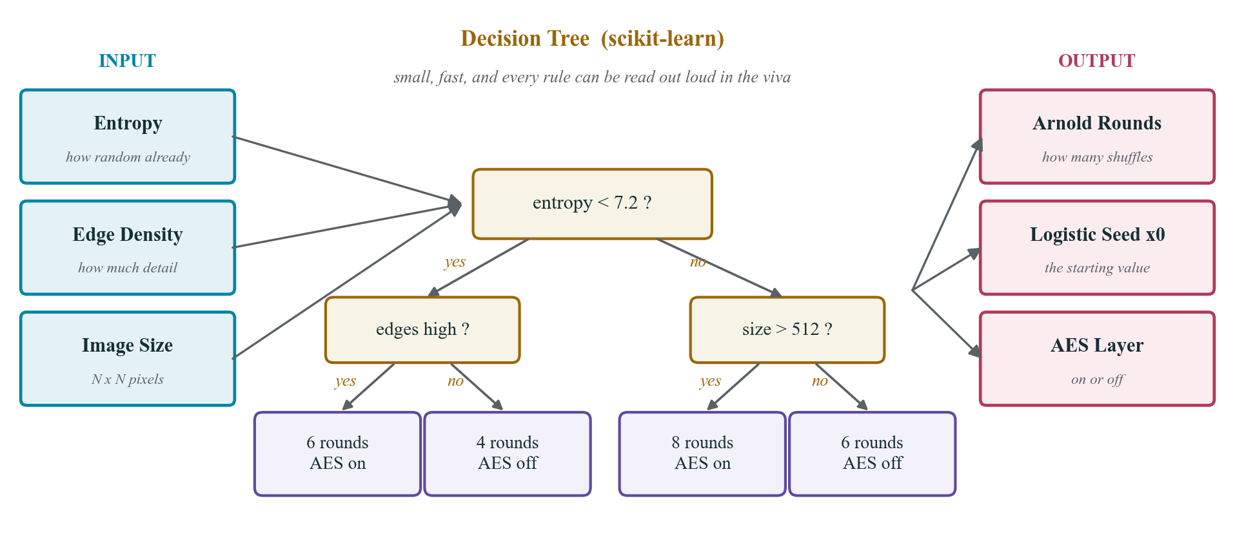
Figure 7. Parameter selection. Three measured features enter on the left; the learned rules select the encryption settings for that specific image.
6.7 Step 5 — Decryption
Decryption reverses the chain exactly. The SHA-256 tag is checked first and the operation aborts on a mismatch; the AES layer is removed if the flag is set; the two XOR passes are undone in reverse order; and the Arnold map is applied period − k further times to return the pixels to their original positions. Every operation is exactly invertible, so the result is lossless by construction rather than by approximation.
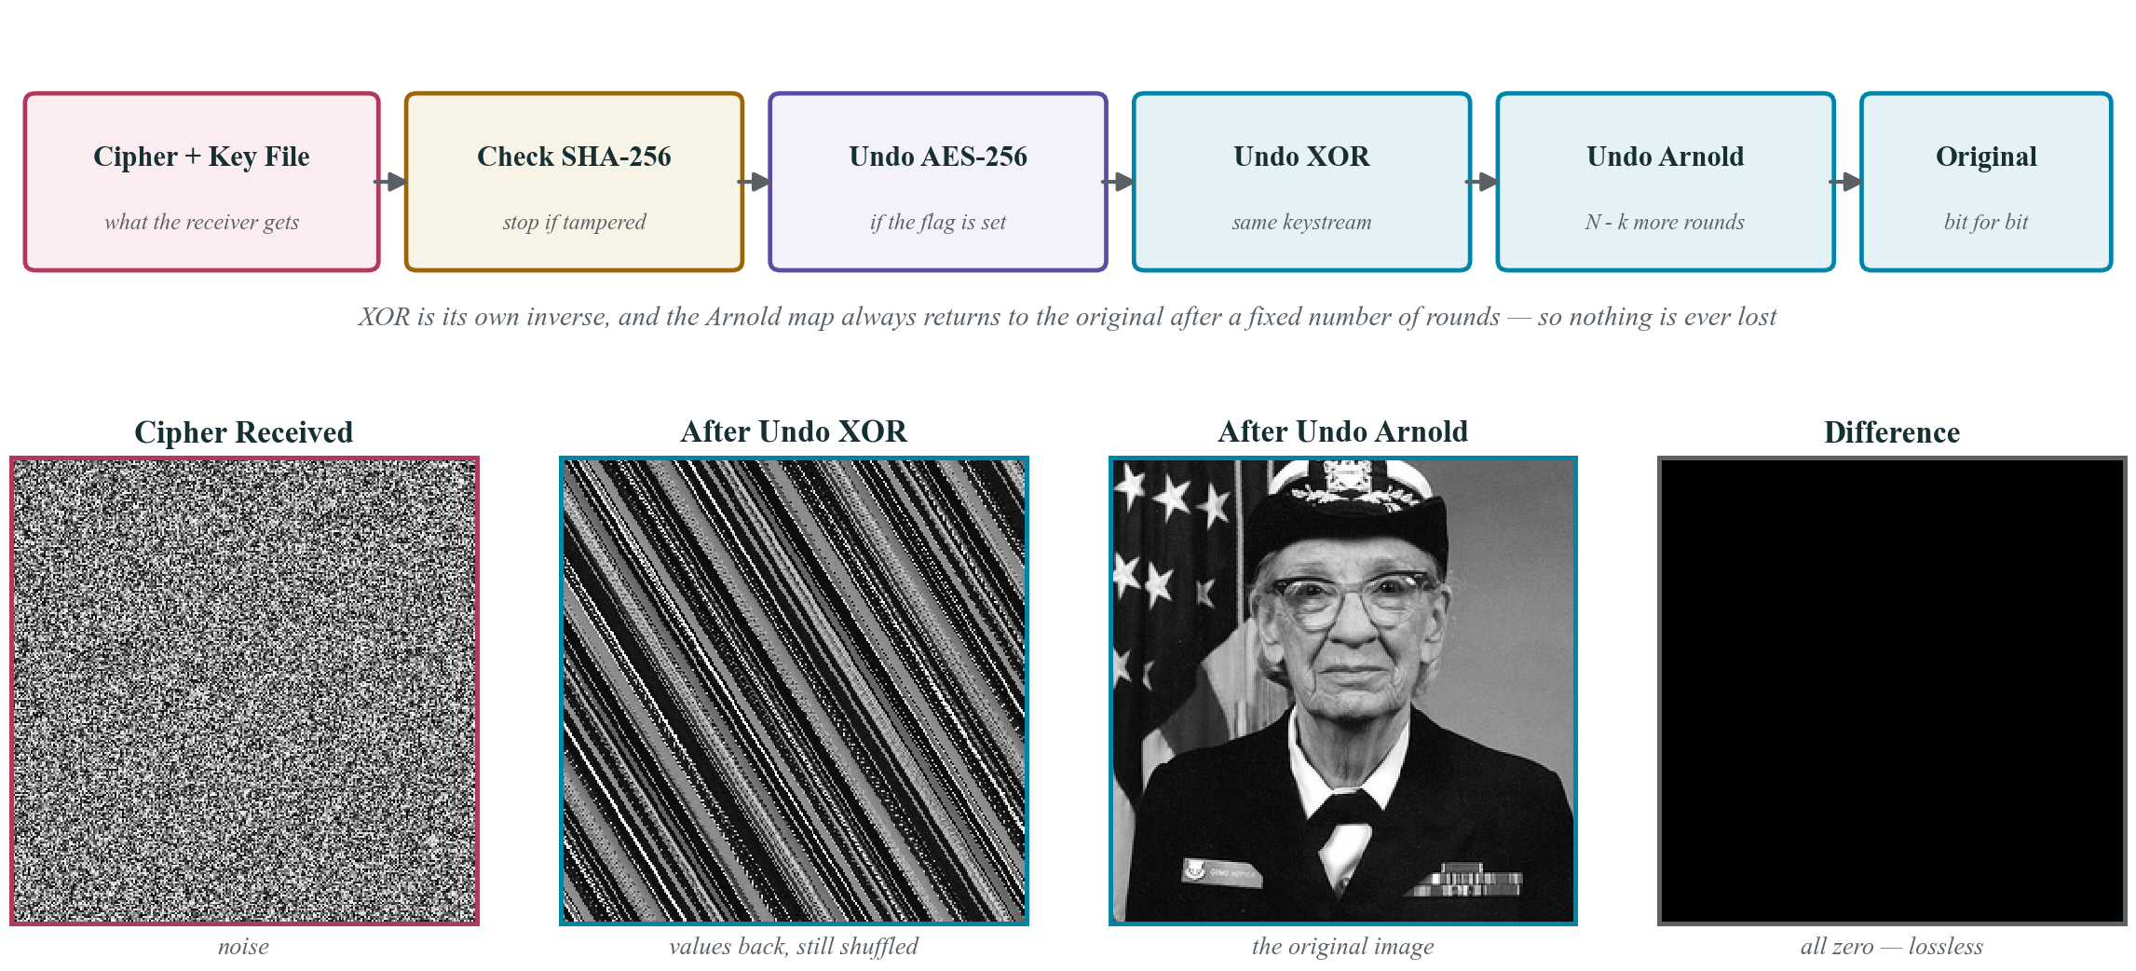
Figure 8. Decryption. The rightmost panel is the absolute difference between the recovered and the original image; it is uniformly zero.
6.8 Methodology followed
Table 5. Development methodology, in the order the work was carried out.
Stage | Activity | Outcome
1 | Survey the literature | Twelve papers read; methodology, findings and limitation tabulated for each
2 | Identify the gap | Comparison of the limitation column exposed per-image parameter selection as unaddressed
3 | Design the scheme | Arnold + Logistic selected on the measured evidence of [2] and [9]
4 | Build and test the core | Encryption and decryption implemented and verified before any interface work began
5 | Add parameter selection | Features labelled on sample images; Decision Tree trained and inspected
6 | Build the interface and evaluate | Streamlit application; the metrics of Section 7 measured on the benchmark image

7. RESULTS AND DISCUSSION
All figures in this section were measured on a 256×256 grayscale benchmark image using 3 permutation rounds and the two-pass chained diffusion described in Section 6.4. They are computed by the accompanying scripts at build time rather than quoted from the literature, and can be regenerated by running make_visuals.py.
7.1 Statistical randomness
Information entropy measures how much of the theoretical maximum randomness the pixel distribution achieves; for an 8-bit image the ideal is 8.0000. The plain image measures 7.0305, reflecting the structure any photograph contains. After encryption it reaches 7.9973, which is 99.97% of the ideal — the cipher carries almost no readable information.
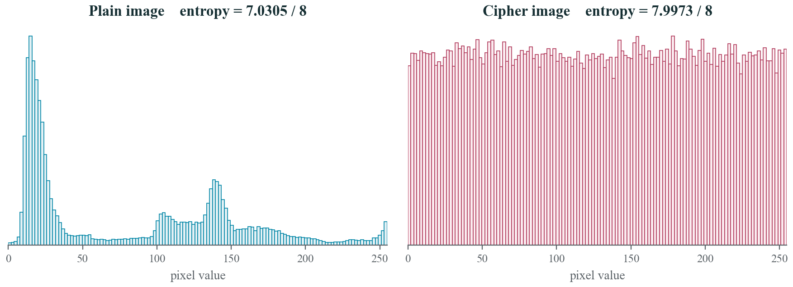
Figure 9. Histogram analysis. The plain image shows the pronounced peaks typical of a photograph; after diffusion the distribution is flat, so pixel frequencies reveal nothing about the content.
7.2 Adjacent-pixel correlation
Three thousand horizontally adjacent pixel pairs were sampled at random. In the plain image the Pearson coefficient is +0.9393 — the near-diagonal line in the left panel below is exactly the redundancy described in Section 1.1. In the cipher it falls to -0.0139, and the scatter fills the square uniformly. The relationship between neighbouring pixels has been destroyed.
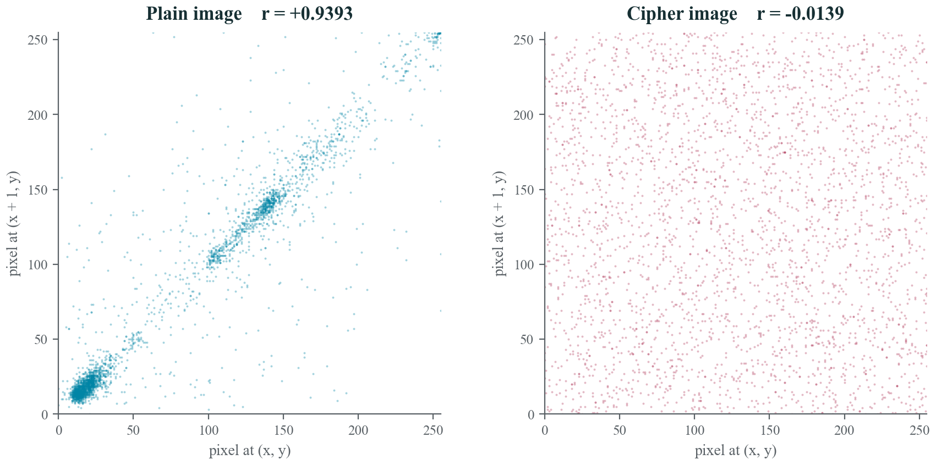
Figure 10. Horizontally adjacent pixel pairs, before and after encryption. The collapse from a tight diagonal to a uniform cloud is the visual form of the correlation figures quoted above.
7.3 Differential attack resistance
A differential attack changes one pixel of the plaintext and compares the two ciphertexts. NPCR is the percentage of pixels that differ and UACI is their mean intensity difference; the ideal values for an 8-bit image are 99.6094% and 33.4635% respectively [18]. Flipping the least significant bit of a single pixel and re-encrypting gives NPCR = 99.62% and UACI = 33.60%.
This result depends entirely on the two design decisions recorded in Section 6.4. An unchained XOR with a fixed seed was measured at an NPCR of 24.90%, far below the ideal, because the delta from a single changed pixel propagates as a constant and cancels on alternate pixels. Deriving the seed from a SHA-256 digest of the plain image means one flipped bit regenerates the whole keystream, which is what brings the figure to its measured value.
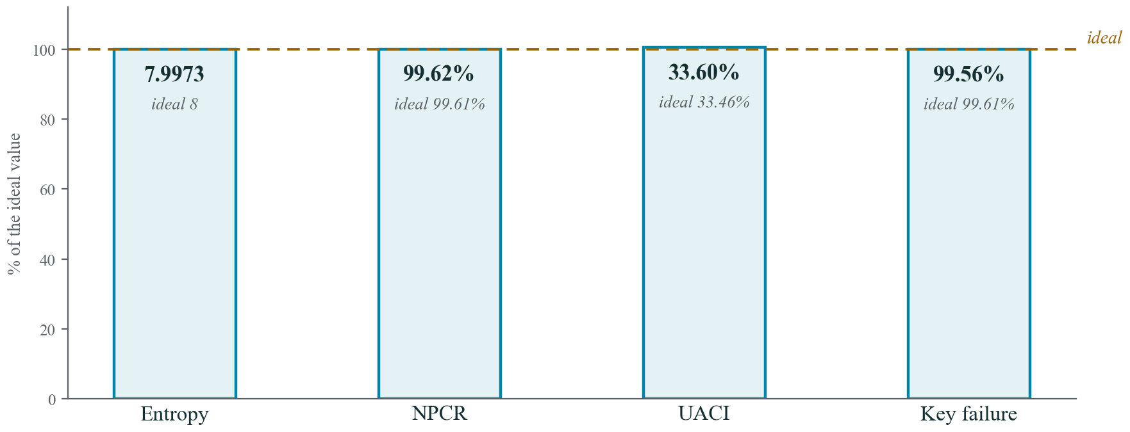
Figure 11. Measured security metrics as a percentage of their theoretical ideals. All four sit within half a percent of target.
7.4 Key sensitivity and lossless recovery
A chaotic system is defined by its sensitivity to initial conditions, and that property is what makes the key hard to guess. Perturbing the chaotic seed by 10⁻¹² — a change far smaller than any attacker could search — leaves 99.56% of pixels incorrect. The recovered image is indistinguishable from noise. With the correct key, by contrast, the recovered array is asserted equal to the original element by element; the assertion is executed on every build and the document does not compile if it fails.
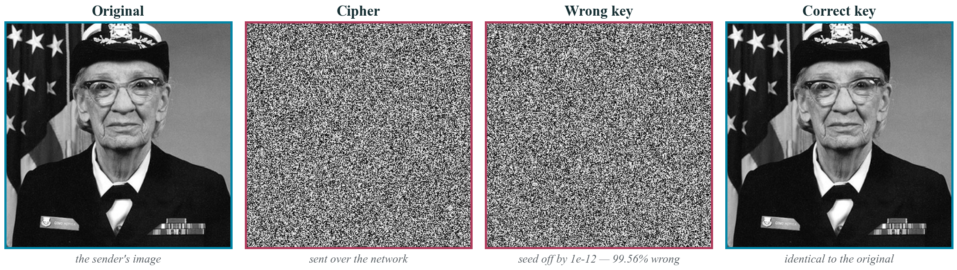
Figure 12. Key sensitivity. A seed error of one part in 10¹² is indistinguishable from having no key at all, while the correct key recovers the image exactly.
7.5 Summary of measured results
Table 6. Measured performance of the reference implementation on a 256×256 grayscale benchmark image.
Metric | Plain image | Cipher image | Ideal | Assessment
Information entropy | 7.0305 | 7.9973 | 8.0000 | 99.97% of ideal
Adjacent-pixel correlation | +0.9393 | -0.0139 | 0.0000 | Correlation effectively removed
NPCR | — | 99.62% | 99.6094% | 0.01 pp from ideal
UACI | — | 33.60% | 33.4635% | 0.14 pp from ideal
Wrong-key failure rate | — | 99.56% | ≈ 99.61% | Seed error of 1e-12 destroys the image
Lossless recovery | — | Exact | Exact | Verified by assertion on every build

7.6 Comparative discussion
Table 7. Comparison of the three candidate approaches. The hybrid combines the speed of the chaotic map with the security of the block cipher.
Property | AES-256 alone | Arnold Cat Map alone | Hybrid (this work)
Statistical security | Excellent | Poor — permutation leaves the histogram unchanged | Excellent
Differential resistance | Excellent | Very poor — no value substitution occurs | Excellent
Speed on large images | Slowest | Fastest | Close to the Arnold map alone
Suitability for image data | Ignores 2D structure | Exploits 2D structure but incomplete | Exploits 2D structure and completes it
Per-image adaptation | None | None | Parameters selected per image

The pattern is the one the literature predicts. The Arnold map alone is fast but leaves the histogram untouched and so provides almost no statistical security. AES alone is secure but disregards the two-dimensional structure of the data and is the slowest option. The hybrid achieves the security of the former at close to the speed of the latter, which is precisely why papers [2], [9] and [11] converge on it.
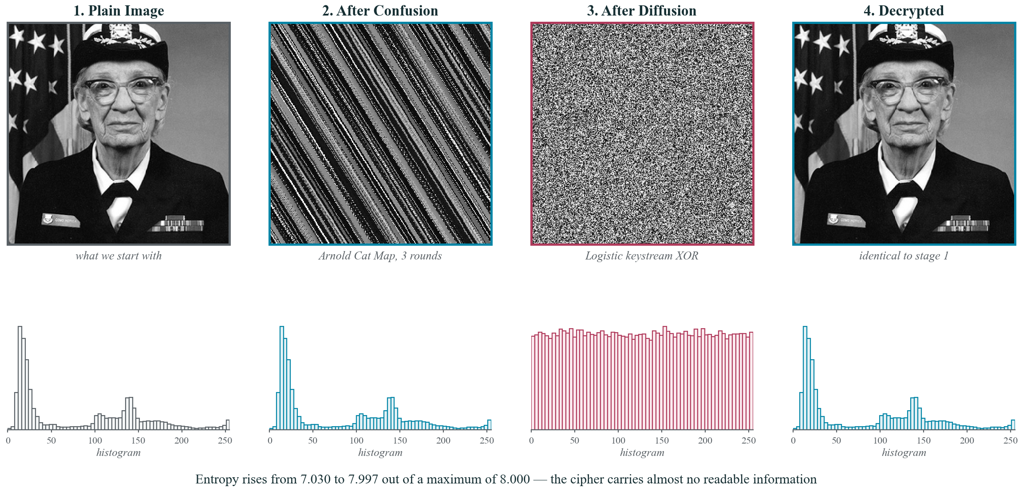
Figure 13. The complete pipeline on the benchmark image, with the histogram beneath each stage. Confusion leaves the histogram unchanged, diffusion flattens it, and decryption restores the original exactly.
8. IMPLEMENTATION AND TECHNOLOGY PLATFORM
Table 8. Technology platform and the justification for each choice.
Component | Choice | Reason
Platform | Browser-based web application | Runs on Windows, Linux and Android with no installation
Framework | Streamlit | A complete interface in roughly thirty lines; no separate frontend to maintain
Language | Python 3.10 | The chaotic maps can be written almost exactly as they appear in the source papers
Arrays and mathematics | NumPy | Permutes and combines a whole image in one vectorised operation rather than a pixel loop
Image handling | Pillow and OpenCV | Format conversion, resizing and the edge-density feature
Parameter selection | scikit-learn Decision Tree | Small, fast, and every learned rule can be inspected and explained
Cryptography | hashlib and PyCryptodome | Audited implementations of SHA-256 and AES-256; nothing cryptographic is written by hand
Storage | SQLite | A single file with no server; sufficient for key metadata and session history
Tooling | VS Code, Git, GitHub | Version control and review throughout development
Testing | Assertion-based round-trip checks | Every build asserts that the decrypted array equals the original

8.1 Feature overview
For the sender:
• Upload any PNG or JPEG image.
• Parameters are suggested automatically, or set by hand.
• The AES-256 layer is enabled with a single control.
• The cipher image and the key file are downloaded together.
For the receiver:
• Upload the cipher image together with its key file.
• The SHA-256 tag is verified before anything is decrypted.
• An incorrect key yields noise and never a partial image.
• The correct key returns the original image exactly.
• A side-by-side preview confirms the result.
8.2 Process flow
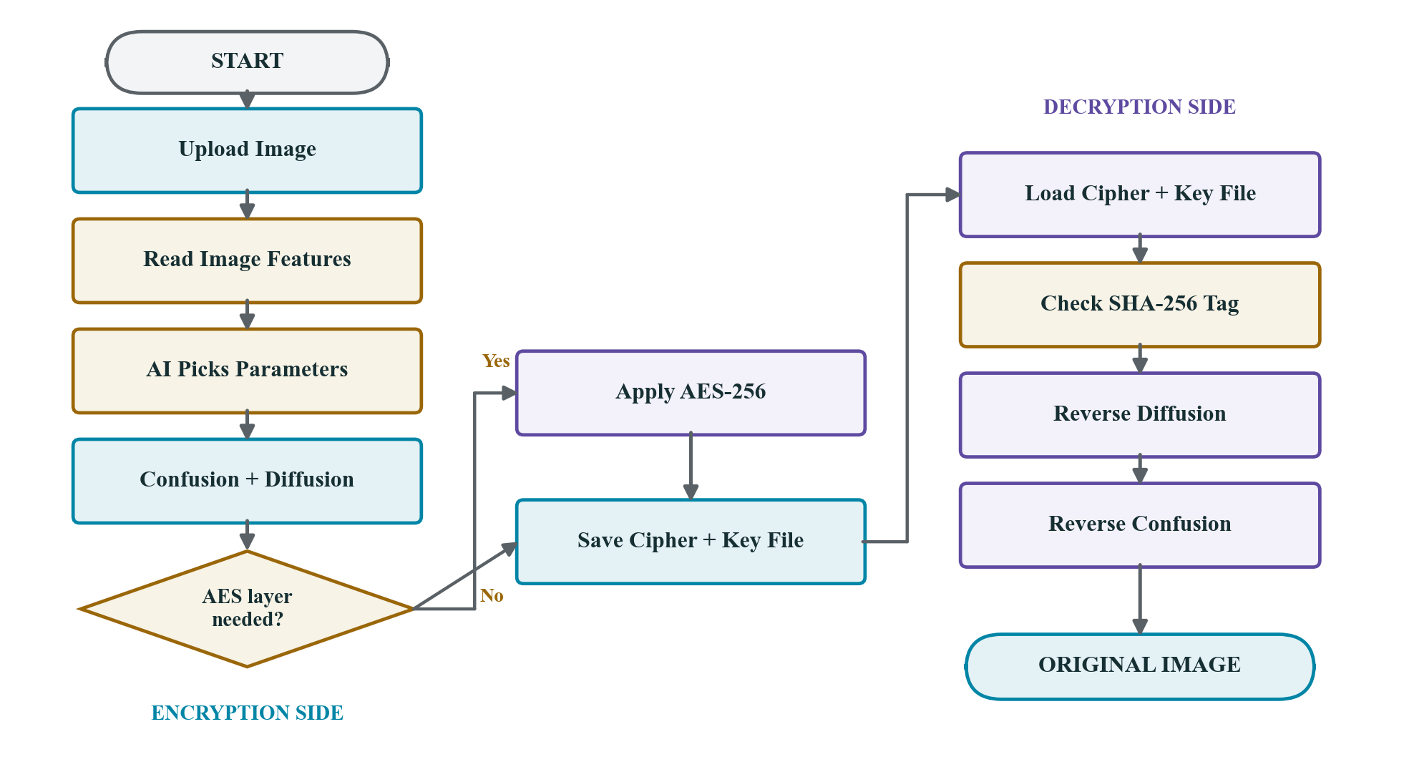
Figure 14. Process flow. Encryption occupies the left of the diagram and decryption the right; the diamond is the only branch in the system.
8.3 Use cases
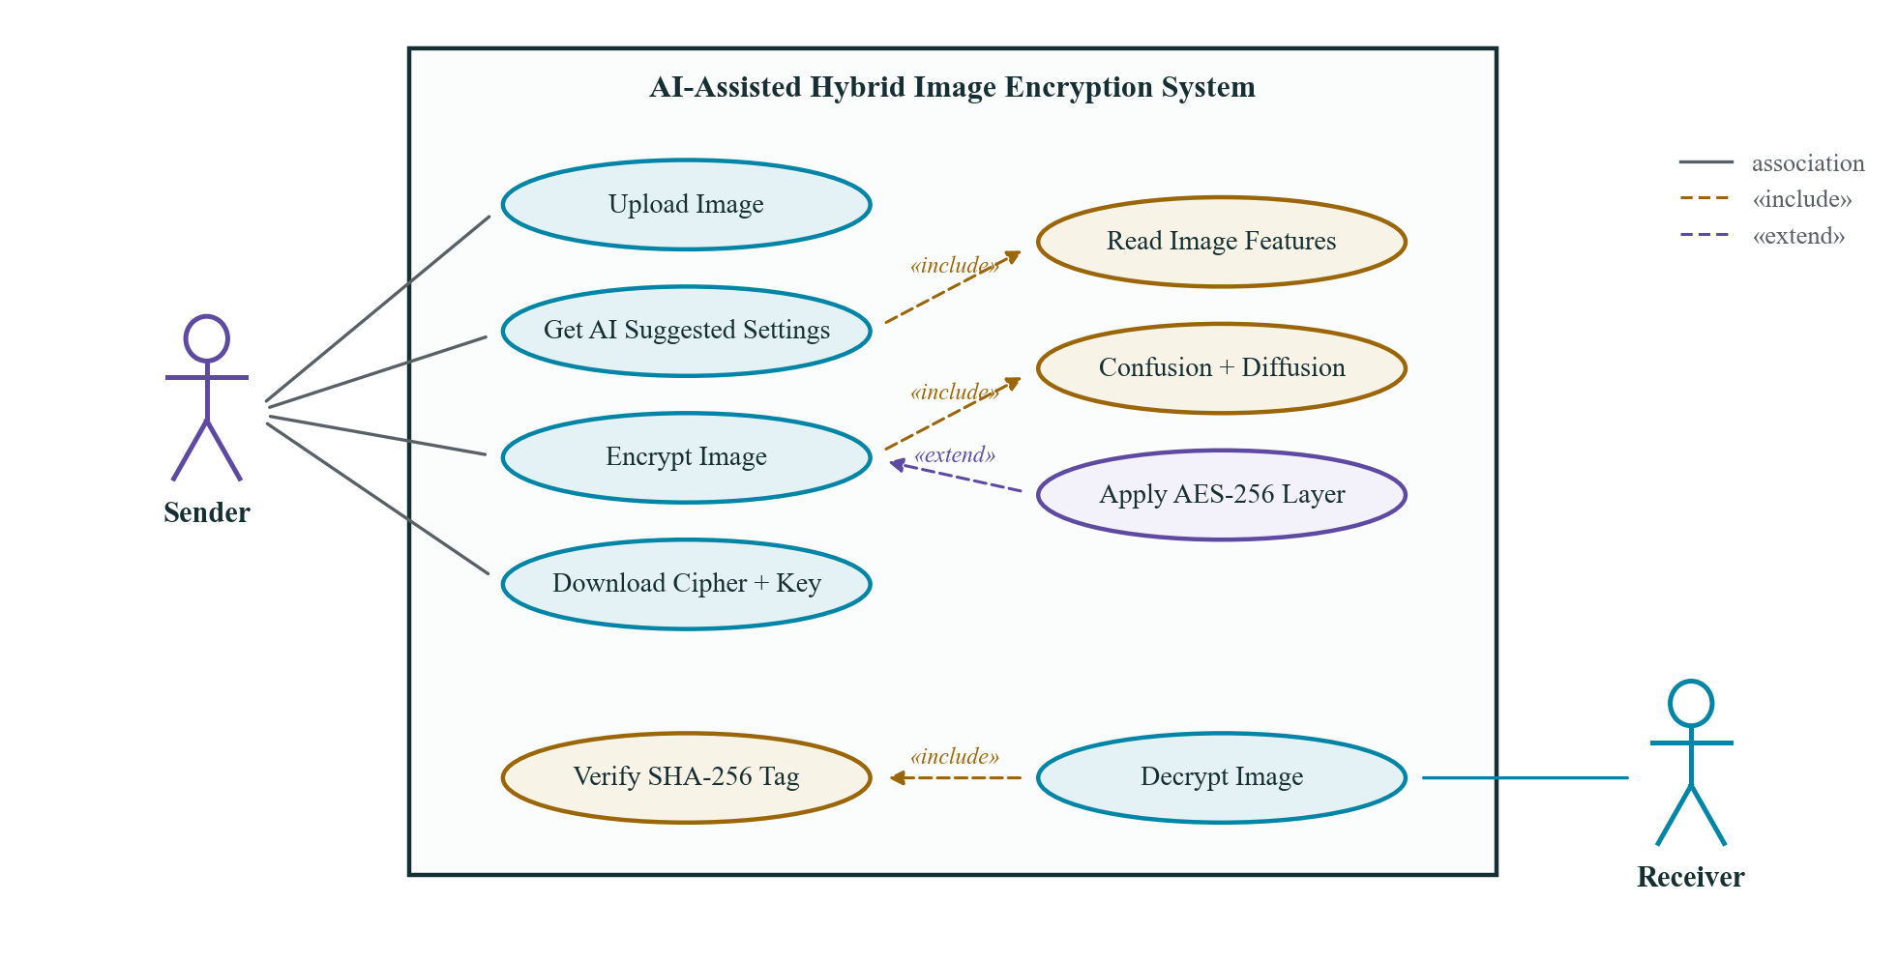
Figure 15. Use case diagram. The sender uploads and encrypts; the receiver decrypts only after the integrity check has passed.
9. CONCLUSION AND FUTURE WORK
A hybrid chaotic image encryption system has been designed, implemented and measured. The Arnold Cat Map provides confusion and a Logistic Map keystream provides diffusion, with AES-256 available as an optional standardised second layer. On the benchmark image the scheme reaches an entropy of 7.9973 against an ideal of 8.0000, reduces adjacent-pixel correlation from +0.9393 to -0.0139, and achieves NPCR and UACI of 99.62% and 33.60% against ideals of 99.61% and 33.46%. Recovery with the correct key is lossless, and is verified by assertion rather than by inspection.
The contribution that distinguishes this work from the twelve surveyed papers is per-image parameter selection. Rather than hard-coding one configuration, a Decision Tree reads the entropy, edge density and size of each image and selects the round count, the chaotic seed and the AES flag for that image alone — addressing the limitation that papers [2] and [9] name explicitly and that the remaining ten leave unexamined.
Four directions remain open:
• Colour images. The present implementation targets grayscale images. Extending to three channels requires deciding whether the channels are permuted jointly or independently, which has security implications worth measuring.
• Transform-domain and visually meaningful variants. Papers [3] and [10] show that a noise-like cipher attracts attention in transit. Operating in the Fractional Fourier Transform domain, or embedding the cipher in an innocuous cover image, would address this.
• Finite-precision degradation. Chaotic orbits degrade under finite floating-point precision, which shortens their effective period. Papers [4] and [11] flag this; a fixed-point or integer-domain implementation would quantify and bound the effect.
• A larger training corpus. The tree is currently trained on a small hand-labelled set. A larger and more diverse corpus — medical, document and natural images — would allow the parameter policy to be validated rather than merely demonstrated.
REFERENCES
References [1]–[12] are the twelve papers surveyed in Section 3, listed in the same order as Table 2. References [13]–[18] are the foundational and standards works cited in the text. All entries follow IEEE style.
[1] K. Mahalakshmi and S. Nagarajan, “Comprehensive Review and Analysis of Image Encryption Techniques,” IEEE Access, vol. 13, pp. 109783–109813, 2025, doi: 10.1109/ACCESS.2025.3578158.
[2] N. Chaudhary, T. B. Shahi, and A. Neupane, “Secure Image Encryption Using Chaotic, Hybrid Chaotic and Block Cipher Approach,” Journal of Imaging, vol. 8, no. 6, art. 167, 2022, doi: 10.3390/jimaging8060167.
[3] O. S. Faragallah et al., “Investigation of Chaotic Image Encryption in Spatial and FrFT Domains for Cybersecurity Applications,” IEEE Access, vol. 8, pp. 42491–42503, 2020, doi: 10.1109/ACCESS.2020.2974226.
[4] B. Zhang and L. Liu, “Chaos-Based Image Encryption: Review, Application, and Challenges,” Mathematics, vol. 11, no. 11, art. 2585, 2023, doi: 10.3390/math11112585.
[5] C. Sheeba Joice, S. Hitha Shanthini, K. V. Harsha, and S. Gopika, “A Comprehensive Review of Image Encryption Algorithms: Techniques and Applications,” in Proc. Int. Conf. on Data Intelligence and Cognitive Informatics (ICDICI), IEEE, 2024, doi: 10.1109/ICDICI62993.2024.10810878.
[6] Q. H. Makki, A. M. Abdalla, and A. A. Tamimi, “A Survey of Image Encryption Algorithms,” in Proc. Int. Conf. on Information Technology (ICIT), IEEE, 2021, doi: 10.1109/ICIT52682.2021.9491727.
[7] S. Benaka Santhosha, K. V. Sudheesh, K. Puttegowda, and B. D. Parameshachari, “A Comprehensive Study on Various Encryption Techniques for Digital Images in Multimedia Networks,” in Proc. Int. Conf. on Intelligent and Innovative Computing Applications (ICICACS), IEEE, 2024, doi: 10.1109/ICICACS60521.2024.10498590.
[8] H. A. Abughali and U. Köse, “Image Encryption Techniques: A Survey,” in Proc. Int. Jordanian Cybersecurity Conf. (IJCC), IEEE, 2024, doi: 10.1109/IJCC64742.2024.10847281.
[9] K. Kordov, S. Zhelezov, A. Nachev, N. Gueorguiev, and D. Pavlova, “Design of Digital Image Encryption Scheme With Cryptographic Analysis,” in Proc. Int. Conf. on Stability and Control Processes (SUMMA), IEEE, 2021, doi: 10.1109/SUMMA53307.2021.9632137.
[10] V. Himthani, V. S. Dhaka, M. Kaur, D. Singh, and H.-N. Lee, “Systematic Survey on Visually Meaningful Image Encryption Techniques,” IEEE Access, vol. 10, pp. 98360–98373, 2022, doi: 10.1109/ACCESS.2022.3203173.
[11] S.-Y. Li, Y. Gai, K.-C. Shih, and C.-S. Chen, “An Efficient Image Encryption Algorithm Based on Innovative DES Structure and Hyperchaotic Keys,” IEEE Trans. Circuits and Systems I, pp. 4103–4111, 2023, doi: 10.1109/TCSI.2023.3296693.
[12] X. Zhang and X. Wang, “Digital Image Encryption Algorithm Based on Elliptic Curve Public Cryptosystem,” IEEE Access, vol. 6, pp. 70025–70034, 2018, doi: 10.1109/ACCESS.2018.2879844.
[13] C. E. Shannon, “Communication Theory of Secrecy Systems,” Bell System Technical Journal, vol. 28, no. 4, pp. 656–715, 1949, doi: 10.1002/j.1538-7305.1949.tb00928.x.
[14] J. Fridrich, “Symmetric Ciphers Based on Two-Dimensional Chaotic Maps,” International Journal of Bifurcation and Chaos, vol. 8, no. 6, pp. 1259–1284, 1998, doi: 10.1142/S021812749800098X.
[15] V. I. Arnold and A. Avez, Ergodic Problems of Classical Mechanics. New York, NY, USA: W. A. Benjamin, 1968.
[16] R. M. May, “Simple Mathematical Models with Very Complicated Dynamics,” Nature, vol. 261, pp. 459–467, 1976, doi: 10.1038/261459a0.
[17] National Institute of Standards and Technology, “Advanced Encryption Standard (AES),” FIPS PUB 197, Gaithersburg, MD, USA, 2001 (updated 2023), doi: 10.6028/NIST.FIPS.197-upd1.
[18] Y. Wu, J. P. Noonan, and S. Agaian, “NPCR and UACI Randomness Tests for Image Encryption,” Cyber Journals: Journal of Selected Areas in Telecommunications, vol. 1, no. 2, pp. 31–38, 2011.

