1. In dashboard total user showing 69 in no. but actually it is showing only active users.
2. Status & Sorting function is not working in Sitemanager->pages
3. Sitemanager->pages in action->edit page   
   Spelling of Meta Information is wrongly written please correct. It is written as Meta Informartion
4. Refresh function is not working anywhere
5. Buttons were Next Previous   
   But it should be **first** Previous **then** Next

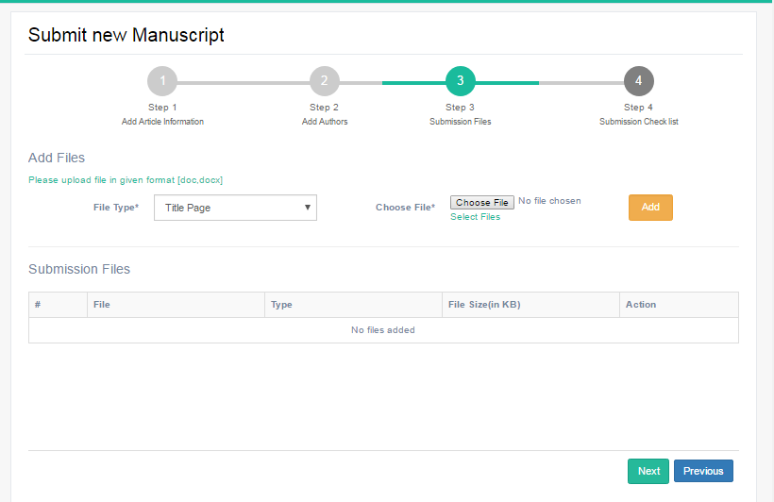

1. When we are deleting incomplete manuscript Notification came which contain message Do you want to delete the record which is wrong. It should be:   
   Do you want to delete this manuscript?

