Login Page

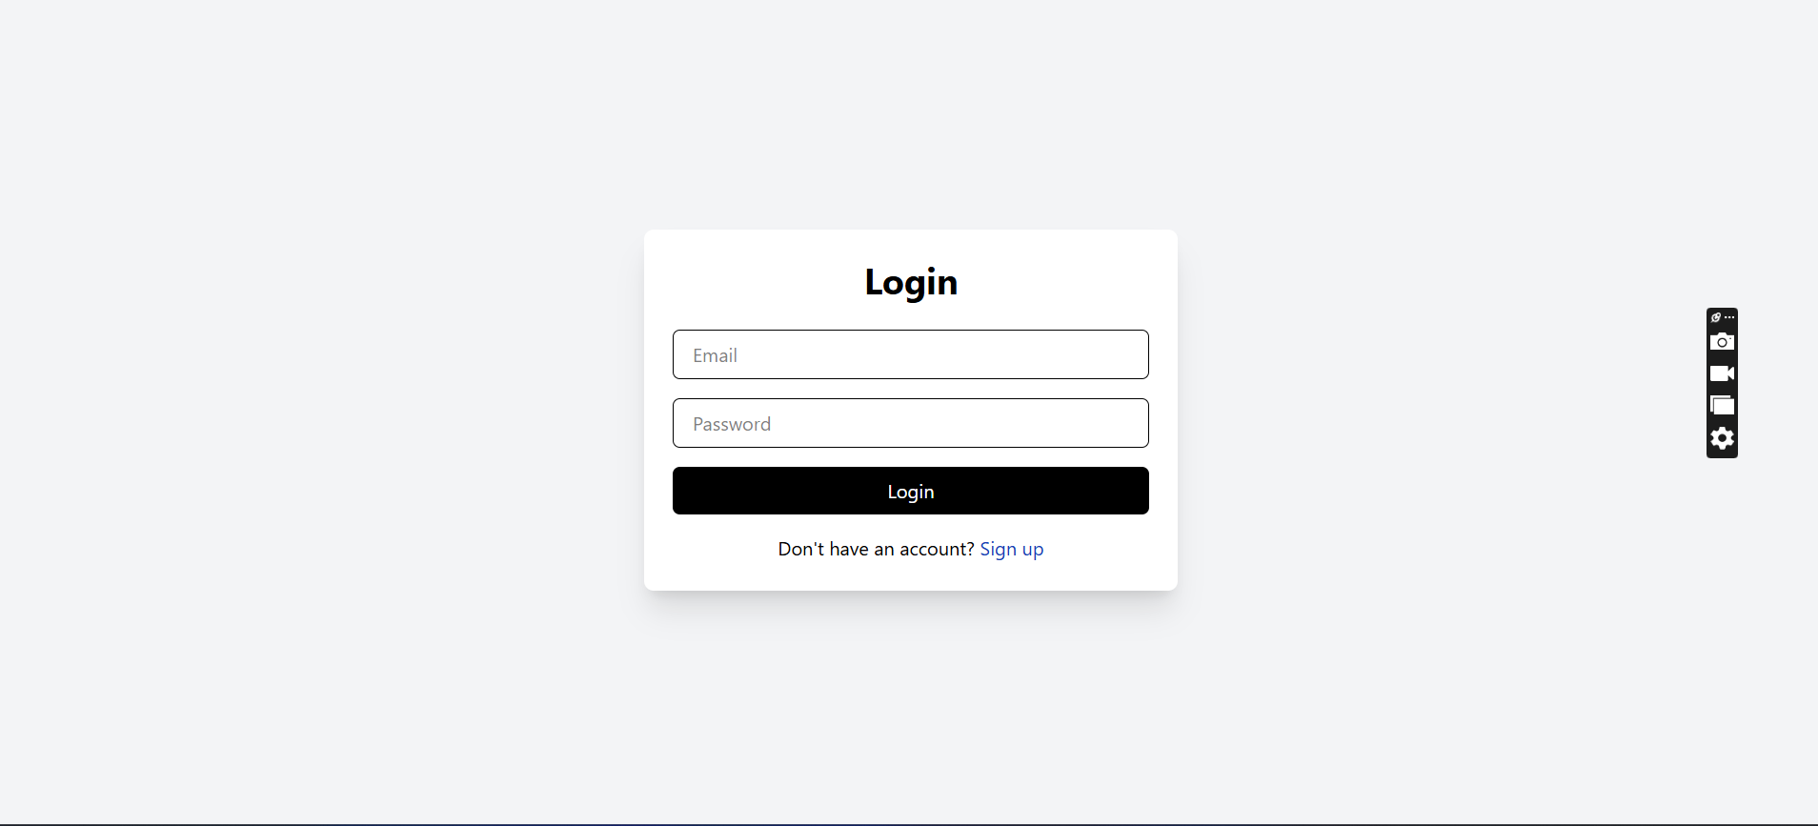

Sign up page

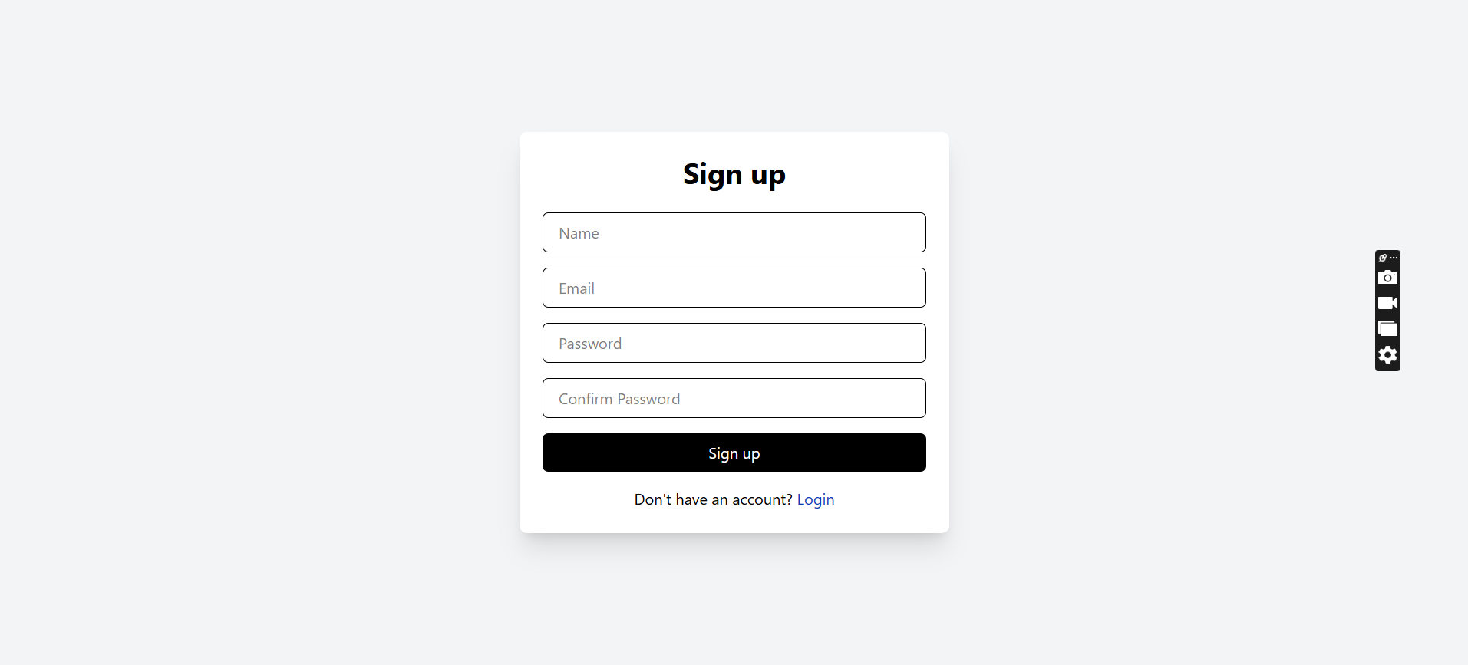

Home Page (Tasks View)

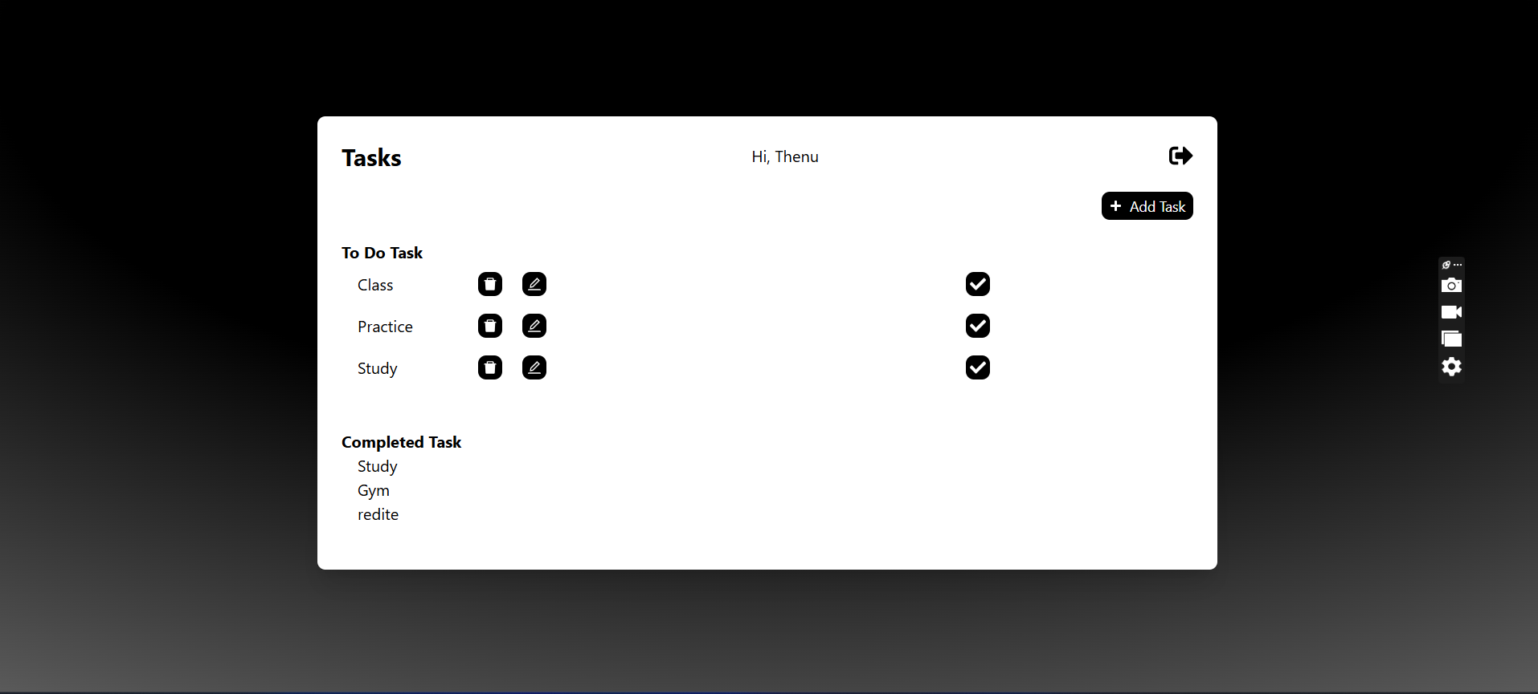

After Clicking add task button

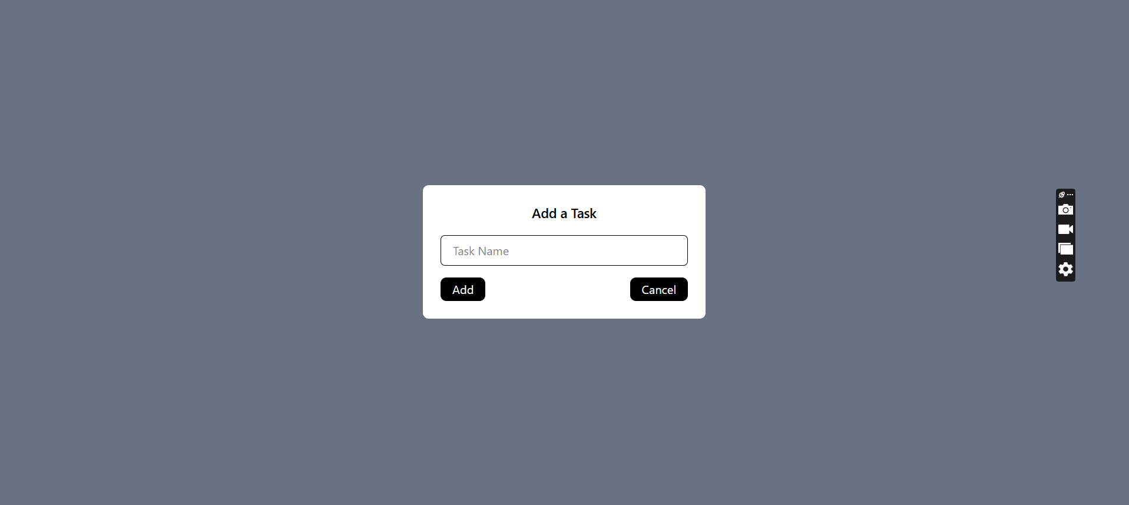

After clicking delete icon button

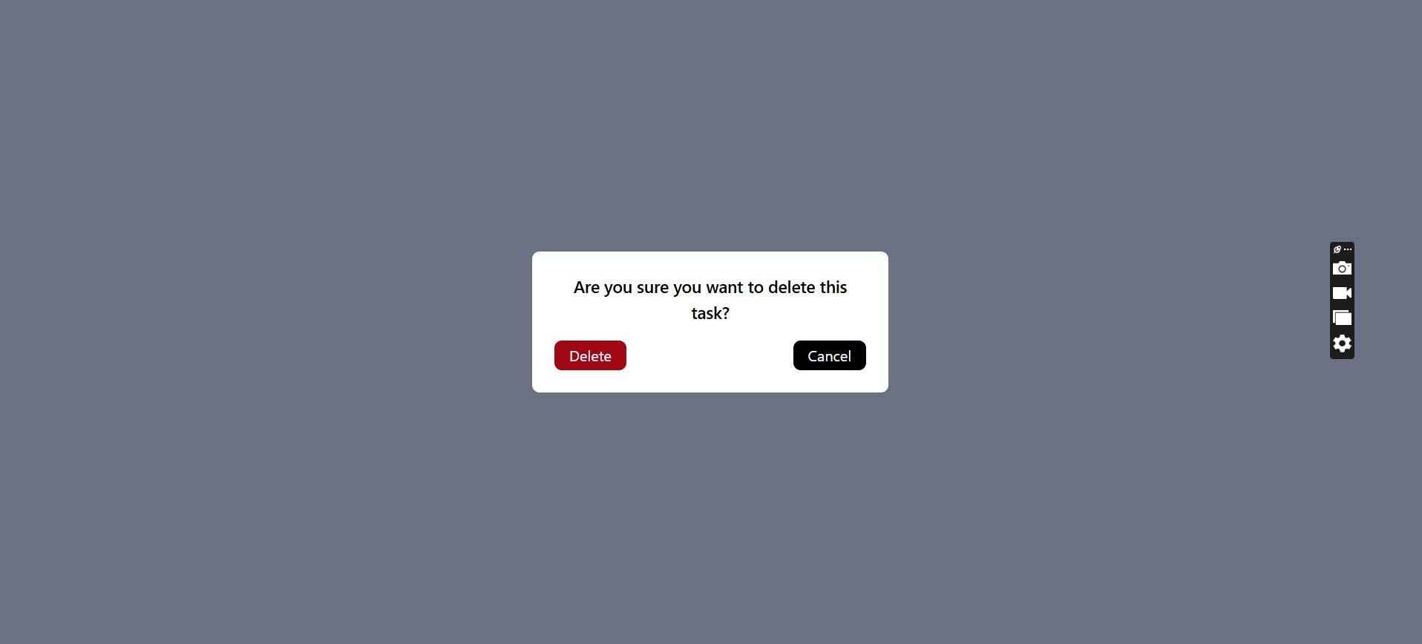

After clicking edit icon button

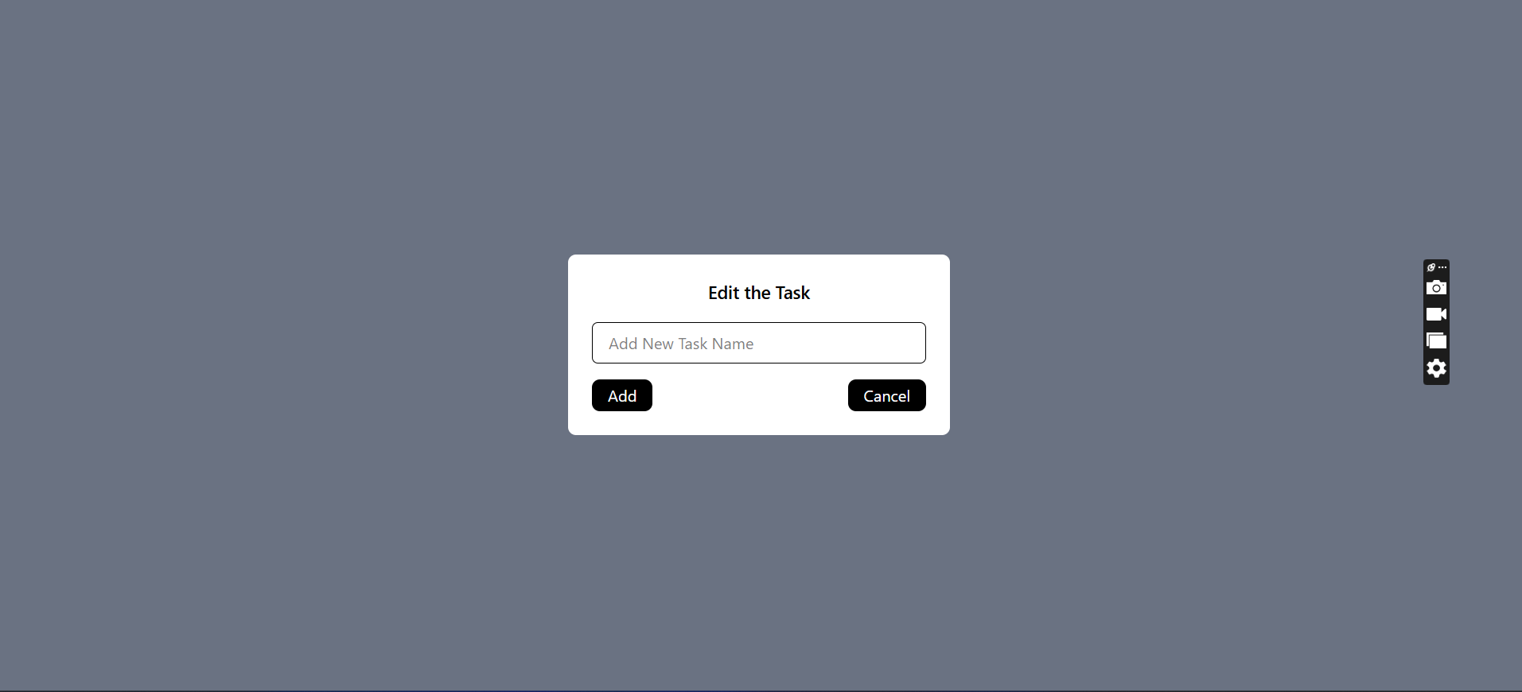

After clicking chek icon button  
  
By clicking logout button use can logout, and user redirect to the login page

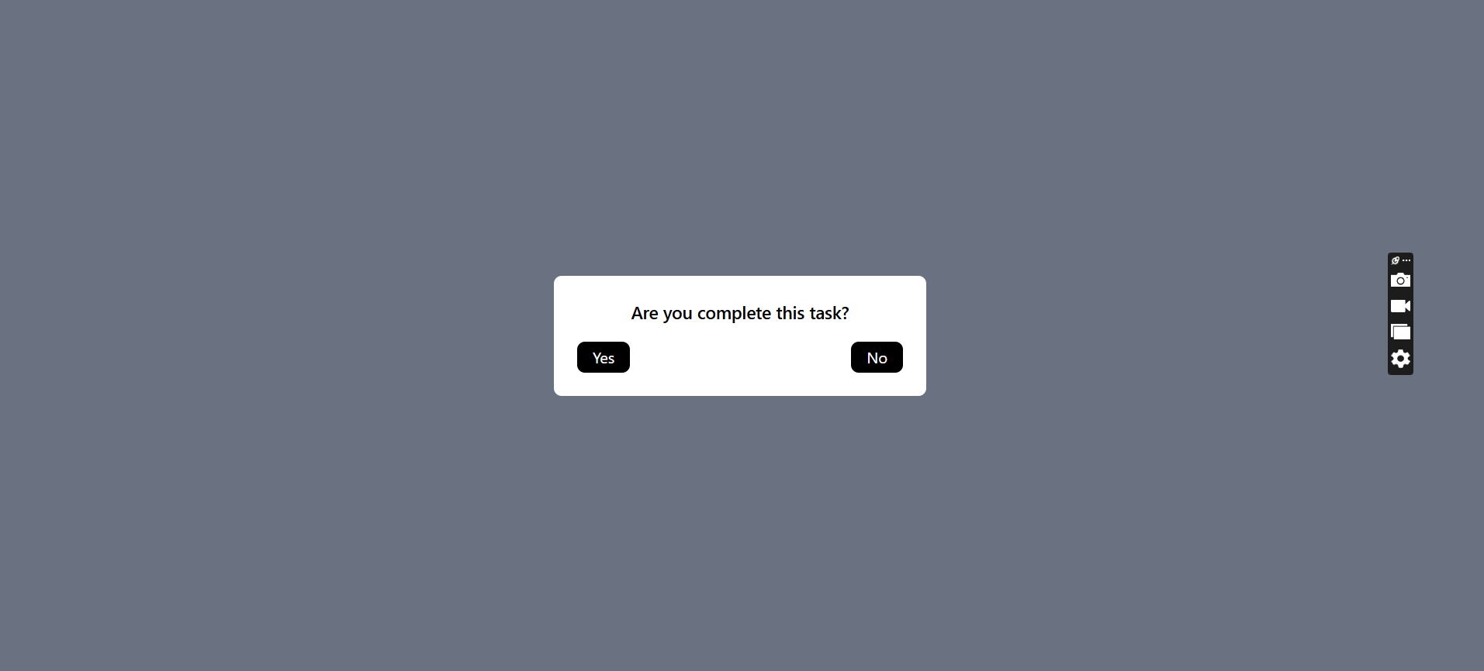

Added authenticate and authorization parts  
  
  
Following below instruction you can setup the application in your local machine  
______________

1.Techonologies used : React,MySQL,Laravel

2.Download the frontend & backend files from the git repository ( https://github.com/Thenuwara07/Spark_Test01.git )

3.Execute npm install on both files

4.Install MySQL Workbench

5.Connect the to DB using MySQL workbench; update the following details .env file (path: E:\MyProjects\Spark\test_01_BackEnd\.env)

    DB_CONNECTION=mysql

    DB_HOST

    DB_HOST

    DB_PORT

    DB_DATABASE

    DB_USERNAME

    DB_PASSWORD

6.Go to the backend file and execute php artisan migrate

7.Execute php artisan serve to run the backend

8.Execute npm run dev to run the frontend

9.Visit the corresponding link with localhost to use the app