Nanopore Ligation Sequencing – HMW DNA Competition Lab
Prepared by Theodore M. Nelson
Name: _______________________ CWID: _______________________

Introduction
In today’s lab, you will prepare a DNA sequencing library using high molecular weight (HMW) genomic DNA. This freshly extracted human DNA that has been carefully handled to preserve long fragment lengths.
You will use the Oxford Nanopore Ligation Sequencing Kit (SQK-LSK114) and MinION flow cells. This protocol preserves long DNA fragments and is ideal for generating ultra-long reads.

Experimental Goal (Competition)
Each group will: - Handle DNA as gently as possible - Prepare a sequencing library - Load a MinION flow cell
Goal: Generate the longest sequencing reads (highest read N50 / max read length)
This experiment emphasizes proper handling of HMW DNA, as mechanical stress (pipetting, vortexing) can fragment DNA and reduce read length.

Sample Metadata Table [Submitted]
# | Sample ID | 260/280 | Conc. (ng/µL) | Volume Used | Storage | Notes
1 | HMW_DNA_A | ___ | ___ | ___ µL | 4°C | ___
2 | HMW_DNA_B | ___ | ___ | ___ µL | 4°C | ___
3 | HMW_DNA_C | ___ | ___ | ___ µL | 4°C | ___

Q1: What does each wavelength within the 260 / 280 ratio measure?

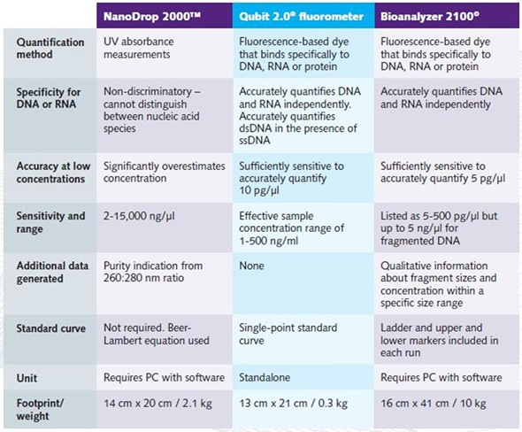
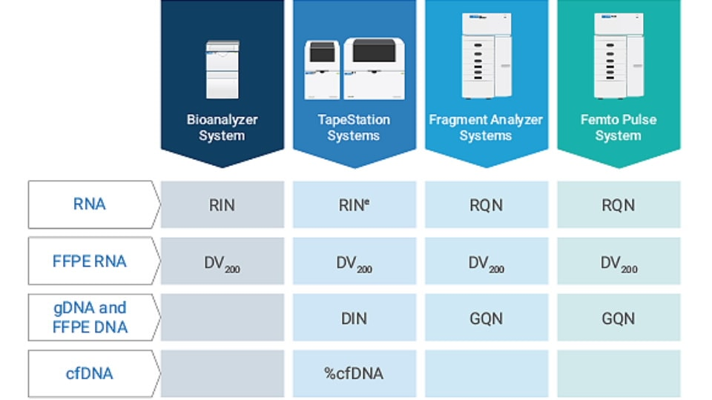

Sample Quality Control
Before sequencing, we assess DNA quality:
Key considerations for HMW DNA: - Fragment length should be as long as possible (>10 kb preferred) - Avoid degraded DNA (smearing toward short fragments) - Avoid contaminants (proteins, salts, phenol)

Why this matters:
- Nanopore read length directly reflects input DNA length
- Short fragments reduce read N50
- Handling damage (pipetting, vortexing) can shear DNA

Critical Handling Guidelines (VERY IMPORTANT)
To preserve long DNA fragments:
- Use wide-bore tips if available
- Pipette slowly and gently
- Avoid vortexing
- Mix by flicking or gentle inversion only
- Minimize number of pipetting steps

Q2: Why does pipetting damage high molecular weight DNA?

Library Preparation Protocol (SQK-LSK114 – Ligation Kit)

1. Prepare Input DNA
- Transfer ~1 µg HMW genomic DNA into a DNA LoBind tube
- Bring volume to ~47 µl with nuclease-free water
- Mix gently (NO vortexing)

2. DNA Repair and End-Prep
Prepare the following reaction:
Reagent | Volume
DNA | 47 µl
DNA Control (optional) | 1 µl
FFPE DNA Repair Buffer | 7 µl
DNA Repair Mix | 2 µl
End Prep Enzyme Mix | 3 µl
Total | 60 µl
- Mix gently by pipetting slowly
- Incubate:
  - 20°C for 5 min
  - 65°C for 5 min
- Perform AMPure bead cleanup
- Elute in ~61 µl nuclease-free water

Q3: What is the purpose of DNA repair and end-prep?

3. Adapter Ligation
Prepare ligation reaction:
Reagent | Volume
DNA | 60 µl
Ligation Adapter (LA) | 5 µl
Ligation Buffer (LNB) | 25 µl
DNA Ligase | 10 µl
Total | 100 µl
- Incubate 10 minutes at room temperature
Clean-up: - Use AMPure beads - Use Long Fragment Buffer (LFB) to enrich long DNA - Elute in ~25 µl

Q4: Why do we use Long Fragment Buffer (LFB) instead of Short Fragment Buffer (SFB)?

Flow Cell Priming & Loading (MinION)

Prepare Priming Mix
- 1,170 µl Flow Cell Flush (FCF)
- 30 µl Flow Cell Tether (FCT)
Load ~800 µl into flow cell and wait 5 minutes.

Prepare Library for Loading
Reagent | Volume
Sequencing Buffer (SB) | 100 µl
Library Beads (LIB) | 68 µl
DNA Library | 32 µl
Total | 200 µl

Load Flow Cell
- Slowly load library into inlet port
- Avoid introducing air bubbles

Q5: Why are air bubbles dangerous for nanopore sequencing?

Sequencing Setup in MinKNOW
- Start a new experiment
- Select Ligation Kit (SQK-LSK114)
- Enter sample details
- Start sequencing
Monitor in real time.

Q6: Why is real-time monitoring useful during sequencing?

Competition Analysis
After sequencing, compare across groups:
- Maximum read length
- Read N50
- Read length distribution

Q7: What handling steps likely influenced your results the most?

Post-Run QC and Flow Cell Reuse
- Wash flow cell shortly after run
- Store properly for reuse

Q8: What happens if the flow cell is not washed promptly?

Critical Thinking Questions
- Why is long-read sequencing particularly useful for genome assembly?
- What biological applications benefit from ultra-long reads?
- What are common causes of short reads in Nanopore sequencing?
- How could you computationally filter low-quality or contaminant reads?

Additional Notes / Observations
Record observations about: - DNA handling - Pipetting techniques - Sequencing performance - Differences between groups

