2002年北京高考英语真题及答案
本试卷分第一卷（选择题）和第二卷（非选择题）两部分。第一卷1至16页。第二卷17至20页。共150分。考试时间120分钟。

第一卷（三部分，共115分）
注意事项：
1.答第一卷前，考生务必将自己的姓名.准考证号.考试科目用铅笔涂写在答题卡上。
2.每小题选出答案后，用铅笔把答题卡上对应题目的答案标号涂黑。如需改动，用橡皮擦干净后，再选涂其它答案标号。不能答在试卷上。
3.考试结束，考生将本试卷和答题卡一并交回。

第一部分：听力（共两节，满分30分）
做题时，先将答案标在试卷上。录音内容结束后，你将有两分钟的时间将试卷上的答案转涂到答题卡上。

第一节（共5小题；每小题1.5分，满分7.5分）
听下面5段对话。每段对话后有一个小题，从题中所给的A.B.C三个选项中选出最佳选项，并标在试卷的相应位置。听完每段对话后，你都有10秒钟的时间来回答有关小题和阅读下一小题。每段对话仅读一遍。
例： How much is the shirt？
A.￡19.15.
B.￡9.15.
C.￡9.18.
答案是B。

l. What is the relationship between the speakers?
A.. Neighbors.
B. Boss and employee.
C. Doctor and patient.

2. Where does the conversation take place?
A. In a restaurant.
B. In a coffee shop.
C. In a clothing store.

3. What does the woman mean?
A. She can' t see it now.
B. She is eager to see it.
C. She wants the man to see it first.

4. What can we learn from the conversation?
A. The woman will go to the airport by taxi.
B. The woman is asking the man for help.
C. The woman's car has broken down.

5. What is the man doing?
A. Offering to do a favor.
B. Asking permission.
C. Asking for help.

第二节（共15小题；每小题1.5分，满分22.5分）
听下面6段对话或独白。每段对话或独白后有几个小题，从题中所给的A.B.C三个选项中选出最佳选项，并标在试卷的相应位置。听每段对话或独白前，你将有时间阅读各个小题，每小题5秒种；听完后，各小题将给出5秒钟的作答时间。每段对话或独白读书两遍。

听第6段材料，回答第6至7题。
6. Why does the man call the woman?
A. He wants to ask her to go out with him.
B. He wants to remind her of the concert.
C. He wants to help her with her study.

7.What can we learn about the woman?
A. She doesn’t really want to go.
B. She works hard at school.
C. She doesn’t like music.

听第7段材料，回答第8至9题。
8.Whom are the speakers talking about?
A. Their daughter.
B. Their student.
C. Their friend.

9.What is the man going to do?
A. Check Maria's homework.
B. Have a talk with Maria.
C. Call Maria's teacher.

听第8段材料，回答第10至11题。
l0. What does the man ask the woman to do?
A. Do the washing-up.
B. Set the table.
C. Dry the plates.

11.What is the woman offering to do on Monday?
A. Get a plate from her home.
B. Buy a new plate for the man.
C. Find another plate for the man.

听第9段材料，回答第12至14题。
l2. Why is the man making the telephone call?
A. He is inviting Mr. Boo to go to Australia.
B. He is giving information about Mr. Brown's flight.
C. He is fixing a time to meet Mr. Brown at the airport.

l3. When does Mr. Brown have to be at the airport?
A. By 8: 30.
B. By 9: 30.
C. By l0: 30.

14. What number can Mr. Brown call if there is a problem?
A. 33466820.
B. 33688202.
C. 33486220.

听第10段材料，回答第15至17题。
15. What is the man selling?
A. A boat.
B. A motor.
C. A pump.

l6. What is good about the product?
A. Its bottom is flat.
B. It is very powerful.
C. It is easy to carry.

17. What is the price of the product?
A. $99.
B. $500.
C. $599.

听第11段材料，回答第18至20题。
l8. What is the speaker's nationality?
A. Canadian.
B. American.
C. Japanese.

19.Why was she excited?
A. Because she liked to teach children.
B. Because it was her first visit to Japan.
C. Because she was paid to be a teacher for the first time.

20. How did she feel about the students' questions?
A. She felt angry.
B. She was moved.
C. She felt uncomfortable.

第二部分：英语知识运用（共两节，满分45分）
第一节 单项填空（共15小题；每小题1分，满分15分）
从A.B.C.D四个选项中，选出可以填入空白处的最佳选项，并在答题卡上将该项涂黑。
例：It is generally considered unwise to give a child ____he or she wants.
A. however B. whatever C. whichever D. whenever
答案是B。

2l. The little girl her heart out because she her toy bear and believed she wasn’t ever going to find it.
A. had cried; lost
B. cried; had lost
C. has cried; has lost
D. cried; has lost

22. We will be shown around the city: schools, museums, and some other places, ____other visitors seldom go.
A. what B. which C. where D. when

23. __ Excuse me, sir. Would you do me a favor?
__Of course. What is it?
__I____if you could tell me how to fill out this form.
A. had wondered B. was wondering
C. would wonder D. did wonder

24. It is so nice to hear from her. _____, we last met more than thirty years ago.
A. What's more
B. That is to say
C. In other words
D. Believe it or not

25. __When shall we start?
__Let's____ it 8:30. Is that all right?
A. set B. meet C. make D. take

26. All the People_____at the party were his supporters.
A. present B. thankful C. interested D. important

27. __Would you like to come to the dinner party here on Saturday?
__Thank you, I'd love to, _____ I' ll be out of town at the weekend.
A. because B. and C. so D. but

28. Be careful when you cross this very busy street. If not, you may ____run over by a car.
A. have B. get C. become D. turn

29. His mother had thought it would be good for his character to ____ from home and earn some money on his own.
A. run away B. take away C. keep away D. get away

30. It was raining heavily. Little Mary felt cold, so she stood_____ to her mother.
A. close B. closely C. closed D. closing

3l. __I heard they went skiing in the mountains last winter.
__It ____ true because there was little snow there.
A. may not be B. won' t he C. couldn’t be D. mustn’t be

32. __Mummy, can I put the peaches in the cupboard?
__No, dear. They don' t ____ well. Put them in the fridge instead.
A. keep B. fit C. get D. last

33. __What do you want____ those old boxes?
__To put things in when I move to the new flat.
A. by. B. for C. of D. with

34. __How do you deal with the disagreement between the company and the customers?
__The key____the problem is to meet the demand____by the customers.
A. to solving; making
B. to solving; made
C. to solve; making
D. to solve; made

35. __It's been a wonderful evening. Thank you very much.
__ _____.
A. My Pleasure
B. I'm glad to hear that
C. No, thanks
D. It's OK

第二节 完形填空（共20小题；每小题1.5分，满分30分）
阅读下面短文，掌握其大意，然后从36～55各题所给的四个选项（A、B、C和D）中，选出最佳选项，并在答题卡上将该项涂黑。
As a child, I was truly afraid of the dark and of getting lost; these fears were very real and caused me some uncomfortable moments.
Maybe it was the strange 36 things looked and sounded in my familiar room at night that 37 me so much. There was never total 38 , but a streetlight or passing car lights 39 clothes hung over a chair take on the 40 of a wild animal. Out of the corner of my 41 , I saw the curtains seem to move when there was no 42 . A tiny sound in the floor would seem a hundred times louder than in the daylight. My 43 would run wild, and my heart would beat fast. I would 44 very still so that the “enemy”would not discover me.
Another of my childhood fears was that I would get lost, 45 on the way home from school. Every morning I got on the school bus right near my home-----that was no 46 . After school, 47 , when all the buses were 48 up along the street, I was afraid that I'd get on the wrong one and be taken to some 49 neighborhood. On school or family trips to a pot or a museum, I wouldn’t 50 the leaders out of my sight.
Perhaps one of the worst fears 51 all I had as a child was that of not being liked
or 52 by others. Being popular was so important to me 53 , and the fear of not being liked was a 54 one.
One of the processes (过程) of growing up is being able to 55 and overcome our fears. Understanding the things that frightened us as children helps us achieve greater success later in life.
36. A. way B. time C. place D. reason
37. A. wounded B. destroyed C. surprised D. frightened
38. A. quietness B. darkness C. emptiness D. loneliness
39. A. got B. forced C. made D. caused
40. A. spirit B. height C. body D. shape
4l. A. eye B. window C. mouth D. door
42. A. breath B. wind C. air D. sound
43. A. belief B. feeling C. imagination D. doubt
44. A. lay B. hide C. rest D. lie
45. A. especially B. simply C. probably D. directly
46. A. discussion B. problem C. joke D. matter
47. A. though B. yet C. although D. still
48. A. called B. backed C. lined D. packed
49. A. old B. crowded C. poor D. unfamiliar
50. A. leave B. let C. order D. send
51. A. above B. in C. of D. at
52. A. protected B. guided C. believed D. accepted
53. A. then B. there C. once D. anyway
54. A. strict B. powerful C. heavy D. right
55. A. realize B. remember C. recognize D. recover

第三部分：阅读理解（共20小题；每小题2分，满分40分）
阅读下列短文，从每题所给的A、B、C、D四个选项中，选出最佳选项，并在答题卡上将该项涂黑。

A
One of the greatest killers in the Western world is heart disease. The death rate(率) from the disease has been increasing at an alarming speed for the past thirty years. Today in Britain, for example, about four hundred people a day die of heart disease. Medical experts know that people can reduce their chances of getting heart disease by exercising regularly, by not smoking, by changing their diets, and by paying more attention to reducing stress (压力) in their work.

However, Western health-care systems are still no paying enough attention to the prevention of the disease. There is a need for more programs to educate the public about the causes and prevention of heart disease. Instead of supporting such programs, however, the U. S. health-care system is spending large sums of money on the surgical (外科的) treatment for of the disease after it develops. This emphasis (强调) on treatment clearly has something to do with the technological advances that have taken place in the past ten to fifteen years. In this time, modern technology has enabled doctors to develop new surgical techniques. Many operations that were considered impossible or too risky (有风险的) a few years ago are now performed every day in U. S. hospitals. The result has been a huge increase in heart surgery.

Although there is no doubt that heart surgery can help a large number of people, some people point out that the emphasis on the surgical treatment of the disease has three clear disadvantages. First, it attracts interest and money away from the question of prevention. Second, it causes the costs of general hospital care to rise. After hospitals buy the expensive equipment that is necessary for modern heart surgery, they must try to recover the money they have spent. To do this, they raise costs for all their patients, not just those patients whose treatment requires the equipment. The third disadvantage is that doctors are encouraged to perform surgery----even on patients for whom. an operation is unnecessary----because the equipment and expert skills are there. A government office recently stated that major heart surgery was often performed even though chances of success were low. In one type of heart surgery, for example, only 15 percent of patients improved their conditions after the surgery. However, more than 100,000 of these operations are performed in the United States every year.

56. What effect has modern technology had on medicine?
A. It has reduced the costs of medical treatment.
B. It has helped save the lives of most patients.
C. It has encouraged doctors to do more heart surgeries.
D. It has helped educate people about the prevention of heart disease.

57. “To do this”(in Paragraph 3) means .
A. to help patients recover
B. to increase the number of heart surgeries
C. to get back the money spent on the equipment
D. to buy new equipment for the treatment of heart disease

58. The author would agree that .
A. more money should be spent on the prevention of heart disease
B. heart surgery has helped most patients improve their conditions
C. modern technology has made heart surgery more risky than before
D. the public have known a great deal about the causes of heart disease

59. What would be the best title for the passage?
A. The Greatest killer in the West
B. Heart Disease: Treat or Prevent
C. Modern Technology and Heart Surgery
D. Heart Surgery: Advantages and Disadvantages

B

LET YOUR LOVE FOR ANIMALS LIVE ON
As someone who loves animals, you care about what will
happen to them in the future. CSIA has been treating sick and
injured animals since 1938. It's hard to imagine what would
happen to the hundreds of thousands of pets who need us every
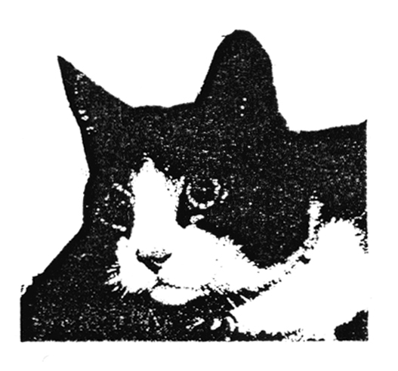
year if we no longer existed.
But in fact, we simply could not continue if it wasn't for a very special kind of gift people like you leave to us in their wills（遗嘱）.
Can we depend on your kindness too? If you haven't already done so, please consider including a gift to CSIA in your will. For free information on how to go about it, please call our helpline on 0800 8421950. Your love for animals can live on with a gift in your will to CSIA.
CSIA
for pets in need of vets（兽医）

60. This advertisement is trying to persuade people to .
A. buy a gift for a pet B. give money for animal care
C. work for an animal hospital D. treat sick and injured animals

6l. The advertisement is mainly aimed at .
A. vets B. zoo-keepers
C. old pet lovers D. animal hospital assistants

62. What is CSIA most likely to be?
A. A pet shop. B. An animal hospital.
C. A club for pet lovers. D. A training center for vets.

C
What am I doing with my daughter at home? Rather than read aloud from books, we go to dinner and have a very good time. This is usually when her Mom isn’t around, and this is when my little girl and I relate better. They're alone together so much. We're seldom alone. When we're alone together, she and I somehow behave differently. We learn about each other. She learns that I’m her father. I learn that she’s my daughter. It's a strange feeling, but any parent knows what I'm talking about when I say that I often look at my daughter and wonder just whose kid she is. Where'd she suddenly come from? And why on earth did she pick Laura and me for parents?

When my daughter and I are alone she'll hold my hand and say,“I just love you so much, Daddy!” She's so used to my leaving that when I tell her she and I are going to hang out all night, she gets this great look on her face and say, “We've got so much to do, Dad!” There's nothing like it in the world.

I want my relationship with my daughter to keep growing, so I've been giving my wife a couple of hundred dollars each week and making her go to the shopping center with her girlfriends, or something----anything!

But this closeness is not without its problems. When I'm sitting there playing with her Barbie doll（巴比娃娃）, washing her hair, a voice in me suddenly says, “I've got to get a drink and get out of here.” Right in the middle of all this pleasantness, the voice goes, “Look at yourself! You're washing dolls !”

63. Why does the husband give his wife so much money each week?
A. He wants her to buy more things for the family.
B. She can do whatever she likes with the money.
C. He can spend more time with his daughter.
D. She can spend more time with her friends.

64. Which of the following statements is true?
A. The father spends more time with the daughter than the mother does.
B. The daughter is happy when the father tells her he will be away.
C. The father is happy, hearing“We've got so much to do, Dad!”
D. The father is sure that the daughter is not his own.

65.What does the last paragraph tell us about the father?
A. He doesn't enjoy being with his daughter.
B. He doesn't like washing his daughter's hair.
C. He likes to enjoy himself by going out for a drink.
D. He has mixed feelings when he is with his daughter.

D
The tower of Big Ben, London's most famous building, has always leaned（倾斜）slightly, but construction work on a new line for the London Underground seemed likely to give the tower a real lean. Engineers have had to prop up (支撑) its base to prevent it from damaging the rest of the Houses of Parliament.

To control the tower's movement, engineers pumped grout (水泥浆) into the soil under the tower. The tower now leans an extra few centimetres, but the lean can only be seen by the most sharp-eyed observer.

Between l995 and l997, to lengthen the Jubilee line of the Underground, builders dug a 40-meter-deep hole just 3l metres north of the clock tower. And the new tube (underground) tunnels were even nearer to the tower. John Burland, who recently helped stop the increasing lean in the Leaning Tower of Pisa and was an adviser to the Jubilee line project, believed the work would affect the tower. In his opinion, no further lean should go beyond a safety limit of 27.5 millimetres over the existing lean of 220 millimetres.

To keep the lean within this limit, Burland told the British Association about the new method of pumping grout immediately under the base of the tower. More than 300 tons of grout were pumped in during construction. The tower's additional lean went between l0 and 25 millimetres, but never passed 27.5 millimetres.

After the construction work was completed in late l997, a review of movements in nearby walls showed that the building was in better shape than had been thought before and the safety limit was raised to 35 millimetres before any action needs to be taken.

Since 1997, the tower has continued to lean, Burland told Modern Construction. The latest measurements, taken this year, suggest that the tower's lean had just reached 35 millimetres. But following regular re-examinations of the tower, experts are sure that the tower has stabilised (稳定). A spokesman for London Underground says:“We understand the tower has stabilised and returned to its normal movement cycle.”
From Modern Construction, 16 September 2000

66. Which of the following drawings correctly shows how the propping up construction was carried out?
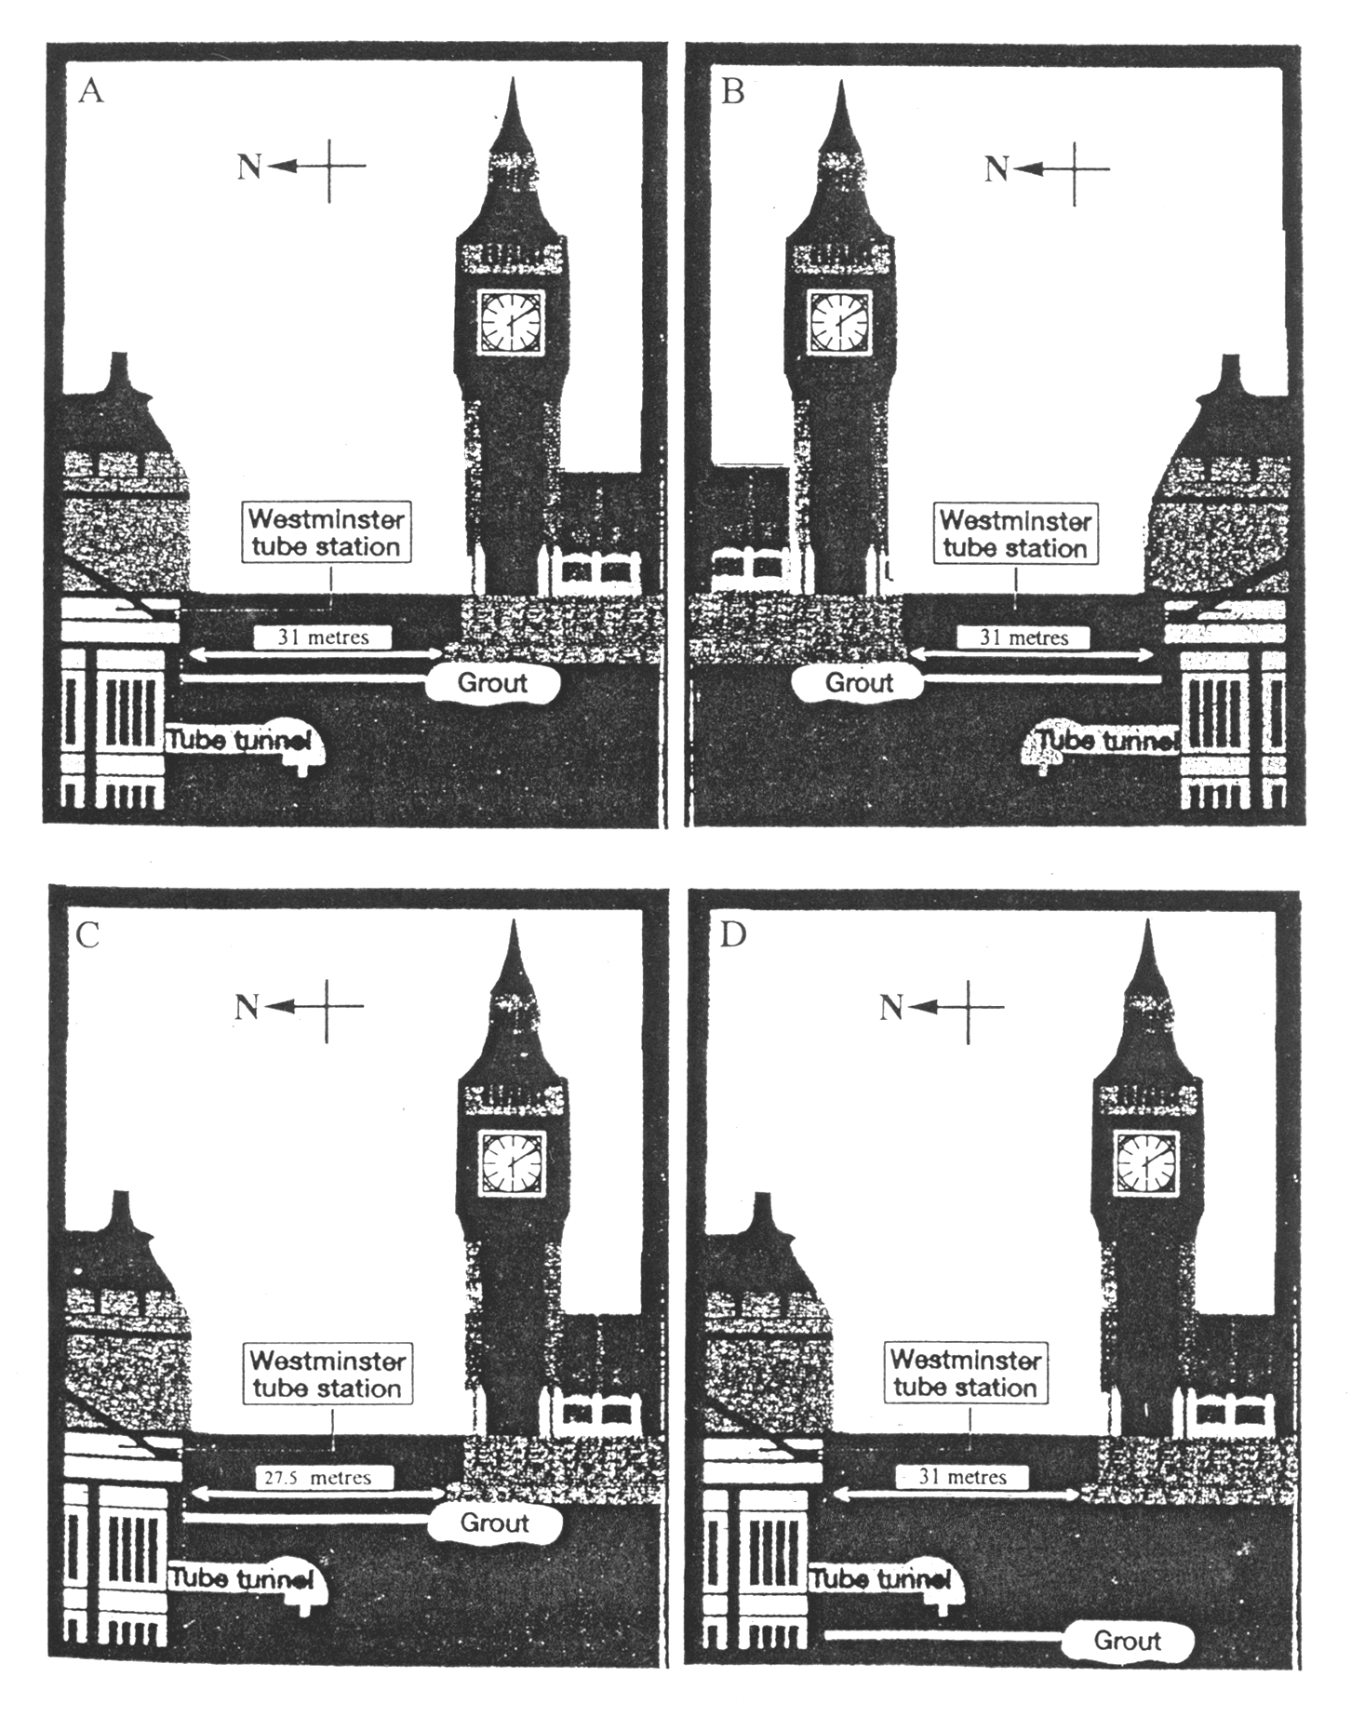
67. What does the word “review”(in Paragraph 5) mean?
A. Observation. B. Description.
C. Discussion. D. Re-examination.

68. Why was the propping up construction necessary?
A. To stop the tower of Big Ben from leaning.
B. To stop sharp-eyed people from seeing the lean.
C. To stop the Tower of Pisa from leaning too much.
D. To stop the clock tower from leaning beyond its safety limit.

69. What was the existing lean of the tower at the time when the article was written?
A. 220 millimetres. B. 255 millimetres.
C. 35 millimetres. D. 27.5 millimetres.

70. We can infer from the article that .
A. the tower of Big Ben will damage the Houses of Parliament
B. the Jubilee line should be stopped in Burland’s opinion
C. the writer is blaming Burland for making a mistake
D. the propping up work has proved to be successful

E
Since l989, Dave Thomas, who died at age 69, was one of the most recognizable faces on TV. He appeared in more than 800 commercials (商业广告) for the hamburger chain named for his daughter. “As long as it works,”he said in 1991, “I’ll continue to do those commercials.”

Even though he was successful, Thomas remained troubled by his childhood.“He still won't let anyone see his feet, which are out of shape because he never had proper-fitting shoes,” Wendy said in 1993. Born to a single mother, he was adopted（收养）as a baby by Rex and Auleva Thomas of Kalamazoo in Michigan. After Auleva died when he was 5, Thomas spent years on the road as Rex traveled around seeking construction work. “He fed me,”Thomas said,“and if I got out of line, he’d beat me.”

Moving out on his own at 15, Thomas worked, first as a waiter, in many restaurants. But he had something much better in mind. “I thought if I owned a restaurant,”he said,“I could eat for free.” A 1956 meeting with Harland Sanders led Thomas to a career as the manager of a Kentucky Fried Chicken restaurant that made him a millionaire in 1968.

In 1969, after breaking with Sanders, Thomas started the first Wendy’s Old Fashioned Hamburgers, in Columbus, Ohio, which set itself by serving made-to-order burgers. With 6,000 restaurants worldwide, the chain now makes $6 billion a year in sales.

Although troubled by his own experience with adoption, Thomas, married since 1954 to Lorraine, 66, and with four grown kids besides Wendy, felt it could offer a future for other children. He started the Dave Thomas Foundation（基金会）for Adoption in 1992.

In 1993, Thomas, who had left school at 15, graduated from Coconut Creek High School in Florida. He even took Lorraine to the graduation dance party. The kids voted him Most Likely to Succeed.

“The Dave you saw on TV was the real Dave,”says friend Pat Williams. “He wasn’t a great actor or a great speaker. He was just Joe Everybody.”

71. What is the article mainly about?
A. The life of Dave Thomas.
B. The dream of Dave Thomas.
C. The schooling of Dave Thomas.
D. The growth of Dave Tomas’s business.

72. What do we know about his childhood?
A. He lived a poor life. B. He had caring parents.
C. He stayed in one place. D. He didn’t go to school.

73. Choose the right time order of the following events in Thomas’s life.
a. graduated from high school
b. started his own business
c. became a millionaire
d. started a foundation
e. met Harland Sanders
A. e, b, c, d, a B. a, e, c, b, d
C. e, c, b, d, a D. a, e, b, c, d

74. “He was just Joe Everybody.”(in the last paragraph) means .
A. Dave was famous B. Dave was ordinary
C. Dave was showy D. Dave was shy

75. What is the name of Dave Thomas’s business?
A. Thomas’s. B. Wendy’s.
C. Lorraine’s. D. Rex’s.

第二卷（共35分）
注意事项：1.第二卷共4页，用钢笔或圆珠笔直接答在试卷上。
2.答卷前将密封线内的项目填写清楚。
第四部分：写作（共两节，满分35分）
第一节 短文改错（共10小题；每小题1分，满分10分）
此题要求改正所给短文中的错误。对标有题号的每一行做出判断：如无错误，在该行右边横线上画一个勾（√）；如有错误（每行只有一个错误），则按下列情况改正：
该行多一个词：把多余的词用斜线（∕）划掉，在该行右边横线上写出该词，并也用斜线划掉。
该行缺一个词：在缺词处加一个漏字符号（∧），在该行右边横线上写出该加的词。
该行错一个词：在错的词下划一横线，在该行右边横线上写出改正后的词。
注意：原行没有错的不要改。
What should you do when your parents become angry? If your 76.
parents got mad, try to have a conversation with them 77.
about it. Remembering not to shout at them. They usually 78.
will try to change, but they will take some time because 79.
they get angry all their life, and that is all they know. You 80.
might have to change for your method a couple of times. 81.
Do any nice things for your parents that they don’t expect 82.
—like cooking, doing the dishes, washing clothes, or clean 83.
the floors. If this doesn’t work, bring in friend that you 84.
feel comfortable, and have him or her help you. 85.

第二节 书面表达（满分25分）
你和李明参加了一次野外生存训练。以下5幅图画表现了野外训练活动的过程，请根据图示写一篇英文日记。
注意：1. 词数100左右；
2. 日记的开头与结尾已为你写好。
生词：指南针：compass n.
手电筒：flashlight n.
急救包：first-aid kit
宿营地：campsite n.
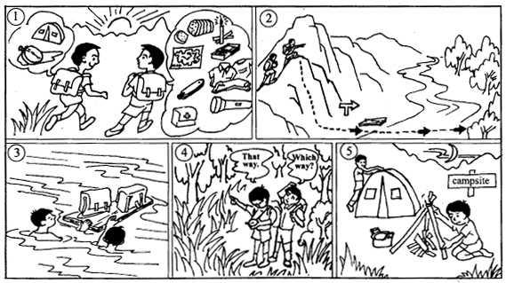
Saturday, May 4, 2002
Li Ming and I took part in a wilderness survival program yesterday, and it has been one of the most unforgettable experiences since high school.

The two of us spent the night in the forest.
We learned to use knowledge gained in classroom training to solve problems. It was quite an experience for us both, which I’ll never forget for the rest of my life.

参考答案
第一、二、三部分（Key to 1－75）：
1.C 2.A 3.B 4.C 5.B 6.A
7.A 8.A 9.B 10.C 11.B 12.B
13.A 14.C 15.A 16.C 17.A 18.B
19.C 20.C 21.B 22.C 23.B 24.D
25.C 26.A 27.D 28.B 29.D 30.A
31.C 32.A 33.D 34.B 35.A 36.A
37.D 38.B 39.C 40.D 41.A 42.B
43.C 44.D 45.A 46.B 47.A 48.C
49.D 50.B 51.C 52.D 53.A 54.B
55.C 56.C 57.C 58.A 59.B 60.B
61.C 62.B 63.C 64.C 65.D 66.A
67.D 68.D 69.B 70.D 71.A 72.A
73.C 74.B 75.B

第四部分：
第一节：
What should you do when your parents become angry? If your 76. √
parents got mad, try to have a conversation with them 77. get
about it. Remembering not to shout at them. They usually 78. Remembre
will try to change, but they will take some time because 79. it
they get angry all their life, and that is all they know. You 80. lives
might have to change for your method a couple of times. 81. for
Do any nice things for your parents that they don’t expect 82. some
—like cooking, doing the dishes, washing clothes, or clean 83. cleaning
the floors. If this doesn’t work, bring in ∧friend that you 84. a
feel comfortable∧, and have him or her help you. 85. with

第二节：
一、内容要点：
1. 出发
2. 背包中的物品
3. 爬山
4. 过河
5. 找路
6. 宿营
二、说明：
1. 内容要点可用不同方式表达。
2. 对紧扣主题的适当发挥不予扣分。
三、One possible version:
Saturday, May 4, 2002
Li Ming and I took part in a wilderness survival program yesterday, and it has been one of the most unforgettable experiences since high school.
Early in the morning, we set out. Li Ming was carrying a compass and a tent in his backpack, and in mine there was a flashlight, a map, a knife, a first-aid kit, some matches, candles, food, and clothing.
On the way to the campsite, we climbed a hill, and then we swam across a river, pushing the backpacks on a large piece of wood we had found by the river.
As we got into a forest, we lost our way. Luckily, we found the right direction with the compass.
By the time we arrived at the campsite, it had already been dark. Li Ming then put up the tent, and I made a fire and started cooking.
The two of us spent the night in the forest.
We learned to use knowledge gained in classroom training to solve problems. It was quite an experience for us both, which I’ll never forget for the rest of my life.

