2005年北京高考英语真题及答案
第Ⅰ卷（选择题 共115分）

注意事项：
1．答第Ⅰ卷前，考生务必将自己的姓名、准考证号、考试科目涂写在答题卡上。
2．每小题选出答案后，用2B铅笔把答题卡上对应题目的答案标号涂黑。如需改动，用像皮
擦干净后，再选涂其他答案标号。不能答在试卷上。

第一部分：听力理解（共两节，30分）
第一节（共5小题；每小题1.5分，共7.5分）
听下面5段对话。每段对话后有一道小题，从每题所给的A、B、C三个选项中选出最佳选项。听完每段对话后，你将有10秒钟的时间来回答有关小题和阅读下一小题。每段对话你将听一遍。
例：What is the man going to read?
A．A newspaper. B．A magazine. C．A book
答案是A。
1．What is the man going to do tonight?
A．Go to the cinema. B．Attend a meeting. C．Watch TV at home.
2．Where does the conversation take place?
A．In a shop. B．In a museum. C．In a restaurant.
3．What time will the speakers get to Beijing?
A．At 11:00. B．At 12:30. C．At 12:45.
4．Is the man going to the party?
A．No. B．Sure. C．Maybe.
5．What does the woman ask the man to do?
A．Tell her what the problem is.
B．Repair the computer for her.
C．Send someone to help her.
第二节（共5小题；每小题1.5分，共22.5分）
听下面6段对话或独白。每段对话或独白后有几道小题，从每题所给的A、B、C三个选项中选出最佳选项中选项。听每段对话或独白前，你将有6秒钟时间阅读每小题。听完后。每小题将给出5秒钟的做答时间。每段对话或独白你将听两遍。
听第6段材料，回答第6至7题。
6．How is the man feeling?
A．Disappointed. B．Encouraged. C．Delighted.
7．What will the man probably do tonight?
A．Have a meeting. B．Go to a party. C．Fly to the US.
听第7段材料，回答第8至9题。
8．What did the speaker want to be when she was little?
A．A doctor. B．A banker. C．A teacher.
9．What helped the speaker decide to take her present job?
A．Her schooling. B．Her parents’ wish. C．Her work experience.
听第8段材料，回答第10至11题。
10．To listen to film or ticket information, which button should you press?

A． B． C．
11．How many people can go and see a film if you pay $ 17?
A．3. B．4. C．5.
听第9段材料，回第第12至14题。
12．What are the speakers talking about?
A．An interview. B．A meal. C．A job.
13．What time of the day is it now?
A．Morning. B．Afternoon. C．Evening.
14．How is the man feeling?
A．Tired. B．Nervous. C．Hopeless.
听第10段材料，回答第15至17题。
15．Who is the woman speaking to?
A．A police officer. B．A man on the street. C．A newspaper reporter.
16．Where was the woman’s camera stolen?
A．Outside an ice cream place.
B．Outside a restaurant.
C．Outside her home.
17．What does the thief look like?
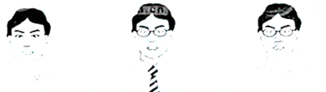
A B C
听第11段材料，回答第18至20题。
18．What are the students going to do on Wednesday?
A．See a film. B．Play sports. C．Go sightseeing.
19．When are the students leaving for London?
A．Friday. B．Saturday. C．Sunday.
20．What is the purpose of the man’s talk?
A．To welcome the students to the center.
B．To inform the students of the arrangements.
C．To tell the students the rules they should follow.
第二部分：知识运用（共两节，45分）
第一节 单项填空（共15小题；每小题1分，共15分）
从每题所给的A、B、C、D四个选项中，选出可以填入空白处的最佳选项，并在答题卡上将该项涂黑。
例：It’s so nice to hear from her again. , we last met more than thirty years ago.
A．What’s more B．That’s to say C．In other words D．Believe it or not
答案是D
21．It is often said that teachers have very easy life.
A．不填；不填 B．不填；a C．the; 不填 D．the; a
22．—Somebody wants you on the telephone.
— no one knows I’m here.
A．For B．And C．But D．So
23．This girl is Linda’s cousin.
A．pretty little Spanish B．Spanish little pretty
C．Spanish pretty little D．little pretty Spanish
24．He more than 5,000 English words when he entered the university at the age of 15.
A．has learned B．would have learned
C．learned D．had learned
25．It’s the present situation in poor areas that much higher spending on education and training.
A．answers for B．provides for C．calls for D．plans for
26．He have completed his work; otherwise, he wouldn’t be enjoying himself by the seaside.
A．should B．must C．wouldn’t D．can’t
27．Scientists think that the continents always where they today.
A．aren’t; are B．aren’t; were C．weren’t; are D．weren’t; were
28．It’s necessary to be prepared for a job interview. the answers ready will be of great help.
A．To have had B．Having had C．Have D．Having
29．As soon as he comes back, I’ll tell him when and see him.
A．you will come B．will you come C．you come D．do you come
30．When asked by the police, he said that he remembered at the party, but not .
A．to arrive; leaving B．to arrive; to leave
C．arriving; leaving D．arriving; to leave
31．—Why did you leave that position?
—I a better position at IBM.
A．offer B．offered C．am offered D．was offered
32．The prize of the game show is $30,000 and an all expenses vacation to China.
A．paying B．paid C．to be paid D．being paid
33．I’d like to arrive 20 minutes early I can have time for a cup of tea.
A．as soon as B．as a result C．in case D．so that
34．I couldn’t do my homework with all that noise .
A．going on B．goes on C．went on D．to go on
35．—Why does she always ask you for help?
—There is no one else , is there?
A．who to turn to B．she can turn to C．for whom to turn D．for her to turn
第二节 完形填空（共20小题；每小题1.5分，共30分）
阅读下面短文，掌握其大意，从每题所给的A、B、C、D四个选项中，选出最佳选项，并在答题卡上将该项涂黑。
Dear Laura,
I just heard you tell an old story of gift giving and unselfish love in your program. You doubted that such unselfish love would happen in today’s world. Well, I’m here to give you 36 .
I wanted to do something very 37 for my fifteen – year – old son, who has always been the perfect child. He 38 all summer to earn enough money to buy a used motorcycle. Then, he spent hours and hours on it 39 it looked almost new. I was so 40 of him that I bought him the shiniest helmet and a riding outfit.
I could 41 wait for him to open up his gift. In fact, I barely slept the night before. Upon awakening. I went to the kitchen to 42 the coffee, tea, and morning goodies. In the living room was a beautiful keyboard with a 43 : “To my wonderful mother, all my love, your son.”
I was so 44 . It had been a long – standing joke in our family that I wanted a piano so that I could 45 lessons. “L earn to play the piano, and I’ll get you one” was my husband’s 46 .
I stood there shocked, crying a river, asking myself how my son could 47 this expensive gift.
Of course, the 48 awoke, and my son was thrilled（激动的）with my reaction. Many kisses were 49 , and I immediately wanted him to 50 my gift.
As he saw the helmet and outfit, the look on his face was not 51 what I was expecting. Then I 52 that he had sold the motorcycle to get me the keyboard.
Of course I was the proudest mother 53 on that day, and my feet never hit the ground for a month.
So I wanted you to know, that kind of love still 54 and lives even in the ever – changing world of me, me, me!
I thought you’d love to 55 this story.
Yours,
Hilary
P.S. The next day, my husband and I bought him a
new “used” already shiny motorcycle.
36．A．hope B．advice C．support D．courage
37．A．polite B．similar C．special D．private
38．A．played B．studied C．traveled D．worked
39．A．after B．before C．unless D．until
40．A．sure B．fond C．proud D．confident
41．A．perhaps B．really C．almost D．hardly
42．A．start B．cook C．set D．serve
43．A．note B．notice C．word D．sign
44．A．disturbed B．confused C．astonished D．inspired
45．A．give B．take C．draw D．teach
46．A．reason B．request C．comment D．response
47．A．present B．afford C．find D．order
48．A．neighbor B．building C．home D．house
49．A．exchanged B．experienced C．expected D．exhibited
50．A．tear B．open C．check D．receive
51．A．purely B．basically C．obviously D．exactly
52．A．realized B．remembered C．imagined D．supposed
53．A．only B．still C．ever D．even
54．A．works B．exists C．matters D．counts
55．A．send B．publish C．share D．write
第三部分：阅读理解（共20小题；每小题2分，共40分）
阅读下列短文，从每题所给的A、B、C、D四个选项中，选出最佳选项，并在答题卡上将该项涂黑。
A
Chances
I really love my job because I enjoy working with small children and like the challenges and awards from the job. I also think my work is important. There was a time when I thought I would never have that sort of career（职业）.
I wasn’t an excellent student because I didn’t do much schoolwork. In my final term I started thinking what I might do and found I didn’t have much to offer. I just accepted that I wasn’t the type to have a career.
I then found myself a job. Looking after two little girls, It wasn’t too bad at first. But the problems began when I agreed to live in, so that I would be there if my boss had to go out for business in the evening. We agreed that if I had to work extra hours one week, she’d give me time off the next. But unfortunately, it didn’t often work out. I was getting extremely tired and fed up, because I had too many late nights and early mornings with the children.
One Sunday, I was in the park with the children, and met Megan who used to go to school with me, I told her about my situation. She suggested that I should do a course and get a qualification（资格证书）if I wanted to work with children. I didn’t think I would be accepted because I didn’t take many exams in school. She persuaded me to phone the local college and they were really helpful. My experience counted for a lot and I got on a part – time course. I had to leave my job with the family, and got work helping out at a kindergarten.
Now I’ve got a full – time job there. I shall always be thankful to Megan. I wish I had known earlier that you could have a career, even if you aren’t top of the class at school.
56．What is the author’s present job?
A．Working part – time in a college.
B．Taking care of children for a family.
C．Helping children with their schoolwork.
D．Looking after children at a kindergarten.
57．When staying with the two girls’ family, the author .
A．was paid for extra work B．often worked long hours
C．got much help from her boss D．took a day off every other week
58．Why did the author leave her first job?
A．She found a full – time job.
B．She was fed up with children.
C．She decided to attend a part – time course.
D．She needed a rest after working extra hours.
59．What has the author learned from her own experiences?
A．Less successtul students can still have a career.
B．Qualifications are necessary for a career.
C．Hard work makes an excellent student.
D．One must choose the job she likes.
B
Good tool design is important in the prevention of overuse injuries. Well – designed tools and equipment will require less force to operate them and prevent awkward（别扭的）hand positions. They will allow the worker to keep the elbows（肘）next to the body to prevent damage to the shoulder and arm.
Overuse injuries can therefore be prevented or reduced if the employer provides, and workers use:
●power tools rather than having to use muscle（肌肉）power
●tools with specially designed handles that allow the wrist（手腕）to keep straight
(See Figure 1). This means that hands and wrists are kept in the same position as they would be if they were hanging relaxed at a person’s side
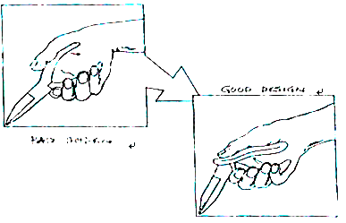
Figure l. Bend the tool, not the wrist
●tools with handles that can be held comfortably by the whole hand. This means having a selection of sizes – remember that tools that provide a comfortable firm hold for a person with a very large hand may be awkward for someone with a very small hand. This is a particularly important consideration for women who may use tools originally designed for men.
●tools that do not press fingers (or flesh) between the handles, and whose handles do not have sharp edges or a small surface area.
60．What is the best title for the passage?
A．Good Tool Design for Women.
B．Importance of Good Tool Design.
C．Tool Design and Prevention of Injuries.
D．Overuse of Tools and Worker Protection.
61．Which of the following describes a well-designed tool?
A．It’s kept close to the body. B．It fully uses muscle power.
C．It makes users feel relaxed D．It’s operated with less force.
62．What is Figure 1 used to show?
A．The effective use of the tool.
B．The way of operating the tool.
C．The proper design of the handle.
D．The purpose of bending the wrist.
63．In choosing tools for women, _________ of the handle is the most important.
A．the size B．the edge C．the shape D．the position
C
How could we possibly think that keeping animals in cages in unnatural environments－mostly for entertainment purposes－is fair and respectful?
Zoo officials say they are concerned about animals. However, most zoos remain “collections” of interesting “things” rather than protective habitats(栖息地). Zoos teach people that it is acceptable to keep animals bored, lonely, and far from their natural homes.
Zoos claim(声称) to educate people and save endangered species(物种), but visitors leave zoos without having learned anything meaningful about the animals’ natural behavior, intelligence, or beauty. Zoos keep animals in small spaces or cages, and most signs only mention the species’ name, diet, and natural range(分布区). The animals’ normal behavior is seldom noticed because zoos don’t usually take care of the animals’ natural needs.
The animals are kept together in small spaces, with no privacy and little opportunity for mental and physical exercise. This results in unusually and self-destructive behavior called zoochosis. A worldwide study of zoos found that zoochosis is common among animals kept in small spaces or cages. Another study showed that elephants spend 22 percent of their time making repeated head movements or biting cage bars, and bears spend 30 percent of their time walking back and forth, a sign of unhappiness and pain.

Furthermore, most animals in zoos are not endangered. Captive breeding(圈养繁殖) of endangered big cats. Asian elephants, and other species has not resulted in their being sent back to the wild. Zoos talk a lot about their captive breeding programs because they do not want people to worry about a species dying out. In fact, baby animals also attract a lot of paying customers. Haven’t we seen enough competitions to name baby animals?
Actually, we will save endangered species only if we save their habitats and put an end to the reasons people kill them. Instead of supporting zoos, we should support groups that work to protect animals’ natural habitats.
64．How would the author describe the animals’ life in zoos?
A．Dangerous. B．Unhappy. C．Natural. D．Easy.
65．In the state of zoochosis, animals _________.
A．remain in cages B．behave strangely
C．attack other animals D．enjoy moving around
66．What does the author try to argue in the passage?
A．Zoos are not worth the public support.
B．Zoos fail in their attempt to save animals.
C．Zoos should treat animals as human beings.
D．Zoos use animals as a means of entertainment.
67．The author tries to persuade readers to accept his argument mainly by _________.
A．pointing out the faults in what zoos do
B．using evidence he has collected at zoos
C．questioning the way animals are protected
D．discussing the advantages of natural habitats
68．Although he argues against zoos, the author would still agree that __________.
A．zoos have to keep animals in small cages
B．most animals in zoos are endangered species
C．some endangered animals are reproduced in zoos
D．it’s acceptable to keep animals away from their habitats
D
Language as a System of Symbols
Of all systems of symbols(符号), language is the most highly developed. It has been pointed out that human beings, by agreement, can make anything stand for anything. Human beings have agreed, in the course of centuries of mutual(相互的) dependency, to let the various noises that they can produce with their lungs, throats, tongues, teeth, and lips systematically stand for certain happenings in their nervous systems. We call that system of agreements language.
There is no necessary connection between the symbol and that which it stands for. Just as social positions can be symbolized by feathers worn on the head, by gold on the watch chain, or by a thousand other things according to the culture we live in, so the fact of being hungry can be symbolized by a thousand different noises according to the culture we live in.
However obvious these facts may appear at first glance, they are actually not so obvious as they seem except when we take special pains to think about the subject. Symbols and the things they stand for are independent of each other, yet we all have a way of feeling as if, and sometimes acting as if, there were necessary connections. For example, there are people who feel that foreign languages are unreasonable by nature: foreigners have such funny names for things, and why can’t they call things by their right names? This feeling exhibits itself most strongly in those English and American tourists who seem to believe that they can make the natives of any country understand English if they shout loud enough. Like the little boy who is reported to have said: “Pigs are called pigs because they are such dirty animals,” they feel the symbol is inherently(内在地) connected in some way with the things symbolized.
69．Language is a highly developed system of symbols because human beings _________.
A．have made use of language for centuries
B．use our nervous systems to support language
C．have made various noises stand for any events
D．can make anything stand for anything by agreement
70．What can we conclude from Paragraph 2?
A．Different noise may mean different things.
B．Our culture determines what a symbol stands for.
C．The language we use symbolizes our social positions.
D．Our social positions determine the way we are dressed.
71．In Paragraph 3, “take special pains” probably means “________”.
A．try very hard B．take our time
C．are very unhappy D．feel especially painful
72．The example of the little boy is used to show that ___________.
A．adults often learn from their young
B．“pig” is a dirty word because pigs are dirty
C．words are not connected with the things they stand for
D．people sometimes have wrong ideas about how language works
E
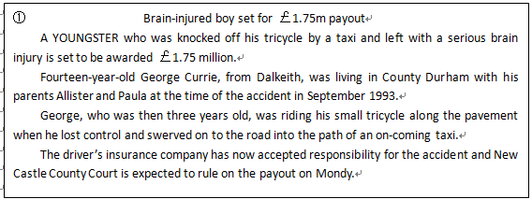
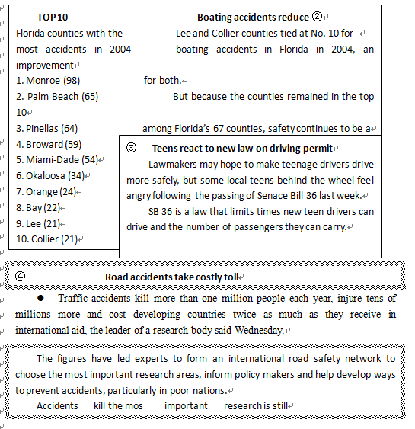
pavement: 人行道
swerve: 突然转向
insurance: 保险
73．What does Passage ① tell us about the boy?
A．He was injured in the head when he was 14.
B．He has waited for the payout for a long time.
C．He has lived in the same place since the accident.
D．He was run over by a taxi when riding on the pavement.
74．What can we learn about Lee and Collier counties from Passage ②?
A．They both became safe places.
B．They won the same place in a race.
C．They had the same number of accidents.
D．They joined hands in reducing accidents.
75．Which passage would give more information on the prevention of road accidents?
A．① B．② C．③ D．④
第Ⅱ卷（共35分）
注意事项：
1．用钢笔或圆珠笔直接答在试卷上。
2．答卷前将密封线内的项目填写清楚。

第四部分：书面表达（共两节，35分）
第一节 情景作文（20分）
美国中学生Jeff将要来你所在的红星中学学习中文，经协商安排住在你家。假设你是李华，请给Jeff写一封信，按照下图顺序介绍他来中国后的生活安排。
注意：1．信的开头已为你写好。
2．词数不少于60。
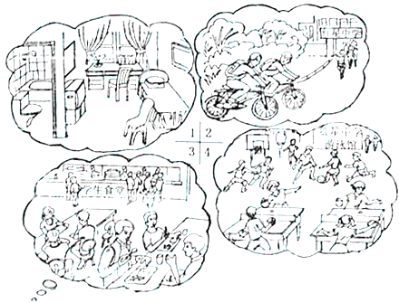
Dear Jeff,
I’m Li Hua from Beijing Hongxing Middle School. I’m very happy to learn that you’re going to stay with my family while you’re in Beijing.
Best wishes,
Li Hua
第二节 开放作文（15分）
请根据下面提示，写一篇短文。词数不少于50。
In your English class, the teacher shows this picture of a little boy looking into a mirror, and asks the class to discuss it. Your classmates have different understandings.
Look at the picture carefully and tell the class how you understand the picture. Write what you would say on the next page.
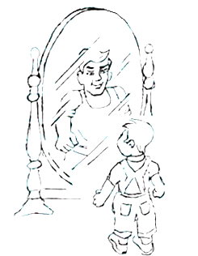

英语（北京卷）参考答案
1—5 CABCC 6—10 ABACA 11—15 BAABA 16—20 BCBCB
21—25 BCADC 26—30 BCDAC 31—35 DBDAB 36—40 ACDDC
41—45 DAACB 46—50 DBDAB 51—55 DACBC 56—60 DBCAC
61—65 DCABB 66—70 AACDB 71—75 ADBCD
第四部分：书面表达（共两节，35分）
第一节 情景作文（20分）
一、内容要点：
1．住房
2．上学
3．就餐
4．锻炼
二、说明
1．内容要点可用不同方式表达
2．对紧扣主题的适当发挥不予扣分。
三、One possible version:
Dear Jeff,
I’m Li Hua from Beijing Hongxing Middle School. I’m very happy to learn that you’re going to stay with my family while you’re in Beijing.
While you are here, we’ll provide you with a room of your own with a bed, a desk, a couple of chairs and a TV. You’ll also have your own bathroom. Our school is quite close to our home, so we could go to school together by bike. At noon we’ll eat at the school dining hall. I’m sure you’ll like the delicious Chinese food there, and enjoy talking with friends over lunch. Classes in our school usually finish at 4 in the afternoon. You can then join other students in playing ball games or swimming. It’ll be a lot of fun.
If you have any questions or requests, please let me know. We’ll try our best to make your stay here in Beijing a pleasant experience.
Best wishes,
Li Hua
第二节 开放作文（15分）
One possible version:
We can see in the picture a little boy standing in front of a mirror. He’s letting his imagination fly. What he sees in the mirror is not his physical self but what he will be like in twenty years. Although he is small and short now, he believes he will grow up to be a tall and strong young man like Yao Ming, who he admires. I think this picture tries to tell us that we should always look into the future with hope and confidence.

